Hawk-Dove Game Assignment

Familiarize yourself with how the Excel sheet works; make sure you understand the evolutionary reasoning behind enforcing a fitness difference of zero!

Part 1. Use the sheet to enter numbers for different costs (Injury) while keeping the benefits (Win) the same. Solve for the equilibrium frequency of hawks and doves. Record your data on the second worksheet, something like this:

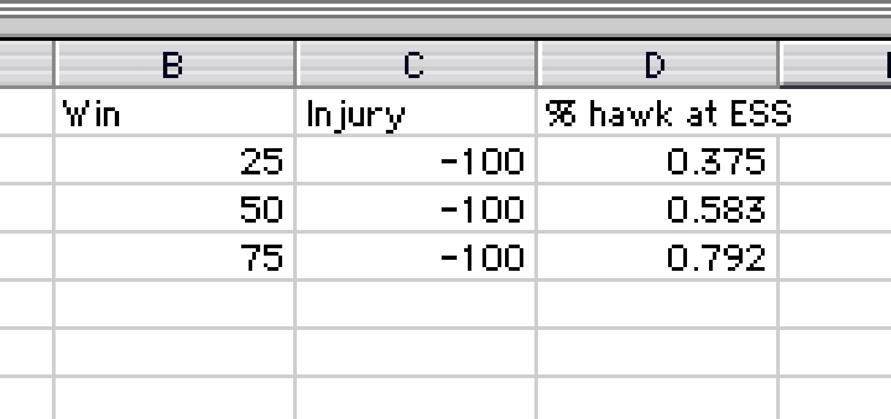

Change the value of winning and solve for results for at least 10 data points. Graph the relationship between value of winning and ESS proportion hawks.

Part 2. Do the same thing changing the cost of injury while holding the value of winning constant.

Write a journal style research report, including Introduction (theory as well as project), Methods, Results, and Discussion.

