SOLAR BRIEF SHEET:
UNDERSTANDING ACADEMIC PLAN CODES

The term, “Academic Plan,” is used to refer to majors within the SOLAR system.

A system of codes is used to define Academic Plans. Use this brief sheet to learn more about the system of code number and letters used to denote SOLAR Academic Plan codes.

[SEE ALSO the useful tip at the end of this document about searching for Academic Plans within your Academic Group (college).]

Each Academic Plan code (for example, the major code 898744B) contains six numbers and a letter, which represent the following information:

89 | 87 | 44 | B

ACADEMIC GROUP  (college) | ACADEMIC ORGANIZATION  (department) | CONCENTRATION | CAREER
Academic Plan Code Elements

ACADEMIC PLAN  CODE ELEMENT | INDICATE(S)
First Two Numbers | Academic Group (college) to which the plan belongs
Second Two Numbers | Academic Organization (department) to which the plan belongs
Last Two Numbers | specific concentration within the academic organization
Letter | Academic Career  (for example, undergraduate or graduate) attached to the plan

ACADEMIC GROUP  (College) | CODE | ACADEMIC ORGANIZATION  (Department) | CODE
Arts, Media & Communication | 12 | Art | 04
Arts, Media & Communication | 12 | Cinema & Television Arts (RTVF) | 75
Arts, Media & Communication | 12 | Communication Studies | 93
Arts, Media & Communication | 12 | Journalism | 08
Arts, Media & Communication | 12 | Music | 28
Arts, Media & Communication | 12 | Theatre | 39

ACADEMIC GROUP  (College) | CODE | ACADEMIC ORGANIZATION  (Department) | CODE
Business & Economics | 23 | Accountancy | 07
Business & Economics | 23 | Business Law | 07
Business & Economics | 23 | Economics | 39
Business & Economics | 23 | Finance, Real Estate | 07
Business & Economics | 23 | Management | 07
Business & Economics | 23 | Marketing | 07
Business & Economics | 23 | Systems & Operations | 07

ACADEMIC GROUP  (College) | CODE | ACADEMIC ORGANIZATION  (Department) | CODE
Education | 45 | Deaf Studies | 05
Education | 45 | Educational Leadership | 09
Education | 45 | Educational Psychology | 06
Education | 45 | Elementary Education | 06
Education | 45 | Secondary Education | 06
Education | 45 | Special Education | 06

ACADEMIC GROUP  (College) | CODE | ACADEMIC ORGANIZATION  (Department) | CODE
Engineering & Computer Sciences | 56 | Civil & Applied | 24
Engineering & Computer Sciences | 56 | Computer Science | 12
Engineering & Computer Sciences | 56 | Electrical & Computer | 24
Engineering & Computer Sciences | 56 | Manufacturing & Management | 24
Engineering & Computer Sciences | 56 | Mechanical | 24

ACADEMIC GROUP  (College) | CODE | ACADEMIC ORGANIZATION  (Department) | CODE
Health & Human Development | 34 | Child Development | 03
Health & Human Development | 34 | Communication Disorders & Sciences | 12
Health & Human Development | 34 | Environmental & Occupational Health | 16
Health & Human Development | 34 | Family Environmental Sciences | 30
Health & Human Development | 34 | Health Sciences | 21
Health & Human Development | 34 | Kinesiology | 57
Health & Human Development | 34 | Leisure Studies & Recreation | 84
Health & Human Development | 34 | Physical Therapy | 21

ACADEMIC GROUP  (College) | CODE | ACADEMIC ORGANIZATION  (Department) | CODE
Humanities | 67 | Asian American Studies | 03
Humanities | 67 | Chicano/A Studies | 65
Humanities | 67 | English | 15
Humanities | 67 | Modern & Classical Languages and Literatures | 25
Humanities | 67 | Liberal Studies | 50
Humanities | 67 | Liberal Studies | 51
Humanities | 67 | Liberal Studies | 52
Humanities | 67 | Linguistics | 55
Humanities | 67 | Philosophy | 70
Humanities | 67 | Religious Studies | 75
Humanities | 67 | Women’s Studies | 90

ACADEMIC GROUP  (College) | CODE | ACADEMIC ORGANIZATION  (Department) | CODE
Science and Mathematics | 78 | Biology | 06
Science and Mathematics | 78 | Chemistry | 19
Science and Mathematics | 78 | Geological Sciences | 45
Science and Mathematics | 78 | Mathematics | 58
Science and Mathematics | 78 | Physical Science | 71
Science and Mathematics | 78 | Physics and Astronomy | 84

ACADEMIC GROUP  (College) | CODE | ACADEMIC ORGANIZATION  (Department) | CODE
Social & Behavioral Sciences | 89 | Anthropology | 24
Social & Behavioral Sciences | 89 | Geography | 38
Social & Behavioral Sciences | 89 | History | 52
Social & Behavioral Sciences | 89 | Pan-African Studies | 10
Social & Behavioral Sciences | 89 | Political Science | 66
Social & Behavioral Sciences | 89 | Psychology | 73
Social & Behavioral Sciences | 89 | Sociology | 87
Social & Behavioral Sciences | 89 | Urban Studies & Planning | 94

ACADEMIC CAREER | CODE
Undergraduate | B
Masters | M
Second Bachelor’s | T
Minor | R
Transitory | V

TIP –
Use Academic Group and Organization Codes
to Look Up Academic Plans

- If you need to enter an academic plan code into an Academic Plan field and you’re not sure what code to enter, click the Lookup icon that displays beside the Academic Plan field.

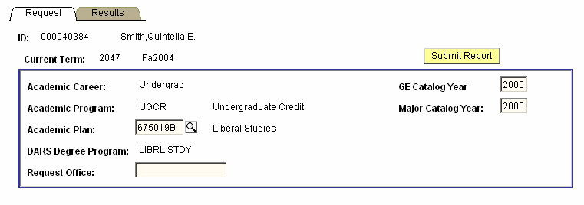

- On the lookup page that displays, enter the two-digit academic group (college) code, and if you want a narrower search, follow the academic group code with the two-digit academic organization (department) code). Click the Lookup button, and click the View All link to display all of the search results.

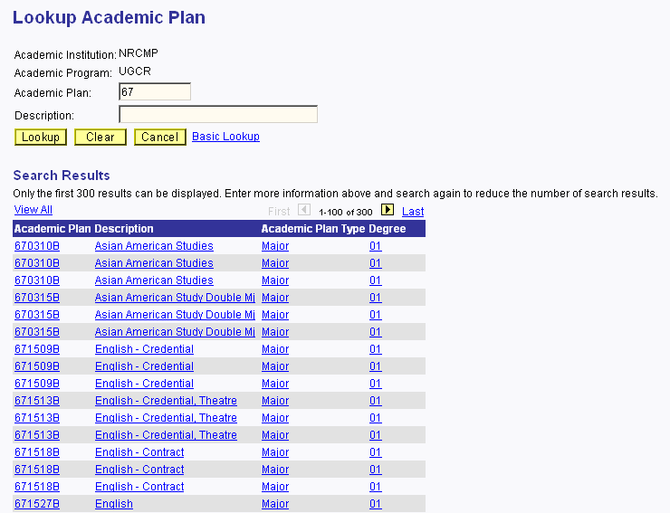

- Click an academic plan code link, and the code is automatically entered into the Academic Plan field.

