SOLAR Quick Guide:
Add a New Instructor /
Update an Existing Instructor

Publication of SOLAR Support for Faculty and Staff/ITR/User Support Services

SOLAR Support Services for Faculty and Staff
8 am to 5 pm, Monday through Friday
phone: 818/677-7267
email: solarsupport@csun.edu

SOLAR Support for Faculty and Staff provides documentation, training, and support for staff and faculty who use SOLAR applications including the Schedule of Classes, Student Inquiry, Advisement, SOLAR Services for Faculty, and APDB.

For more information visit the SOLAR Support Services website at www.csun.edu/ITR/SOLAR

DOCUMENT HISTORY—SOLAR Quick Guide: Add a New Instructor
DATE | ACTION | PAGE REFERENCES, IF ANY
08/16/04 | Published

Copyright © 2004 by California State University, Northridge. All rights reserved.
Information in this book is subject to change without notice. No part of this document may be reproduced or transmitted in any form or by any means, electronic or mechanical, for any purpose, without the express written permission of California State University, Northridge.
Trademarks
Product and company names herein may be the trademarks of their respective owners.
Table of Contents

Add a New Part-Time Instructor, TA, or GA 5
Add a New Full-Time, Volunteer, or Adjunct Instructor / Update an Existing Instructor 5

Add a New Part-Time Instructor,
TA, or GA
- Complete new hire processing for the part-time instructor as dictated by procedures set by the CSUN PeopleSoft Human Resources team.
- Follow the steps enumerated in the next section of this document, “Add a New Full-Time, Adjunct, or Volunteer Instructor / Adjust Instructor Information.”

Add a New Full-Time, Volunteer, or Adjunct Instructor / Update an Existing Instructor
- Select Manage Student Records>Establish Courses>Setup>Instructor/Advisor Table.
The search page displays.

- Enter the instructor ID, and then select the Search button.

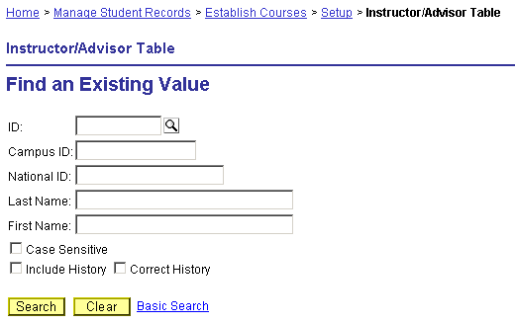

The system searches the campus database of faculty, staff, and students.
- If there is an exact match, the Instructor/Advisor Table component displays with instructor information populating some fields.
- If there are partial matches, a list of search results displays. Click the instructor name to display the Instructor/Advisor Table component.

NOTE: If no match is found for a paid faculty member, contact the PeopleSoft Human Resources/Financials Help Desk at extension 6685 or pshelp@csun.edu and ask staff if the faculty member has been hired into the PeopleSoft HR system.
If no match is found for a volunteer or adjunct instructor, contact SOLAR Support for Faculty and Staff at solarsupport@csun.edu or extension 7267.

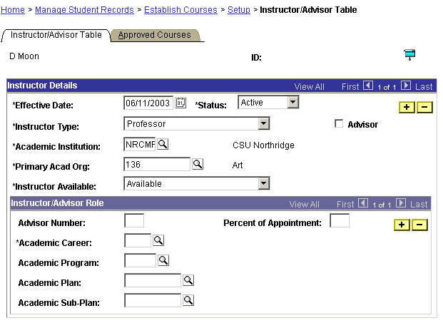Instructor/Advisor Table component: Work with the Effective Date, Status, Instructor Type, Academic Institution, Primary Acad Org, Instructor Available, and Academic Career fields and the Approved Courses tab to add a new instructor.

- Select the Instructor/Advisor Table tab if it is not already selected, and enter values into the page’s fields using information in the following table:

FIELD | INSTRUCTIONS
Effective Date | ● If you are adding a new instructor, enter a date that is at least one day before the first date of the academic term for which the instructor begins the instructional assignment and not earlier than today’s date.  For example, if the academic term begins 9/1/2005 and today is 7/15/2005, select 8/31/2005.  (For the summer session, select a date that is at least one day before the first date of the first summer school session and not earlier than today’s date.)  CAUTION: If you need to select an effective date that is prior to today’s date, contact SOLAR Support at x7267.  For example, if today is 10/15/2005, and the academic term to which you want to assign an instructor began 9/1/2005, contact SOLAR Support for Faculty and Staff.  ● If you are updating or adjusting information for an existing instructor, first, click the Add a Row button in the Instructor Details portion of the Instructor/Advisor Table page, and then enter a date that is at least one day before the first date of the academic term for which the instructor begins the instructional assignment and not earlier than today’s date.  If you are updating or adjusting information for an existing instructor, use the Add a Row button in the Instructor Details portion of the page, then enter an effective date and other information into the new row.
Status | If it is not already selected, select Active from the drop-down menu.
Instructor Type | Use the drop-down menu to select a field value.
Academic Institution | NRCMP
Primary Acad Org | Enter your Academic Organization (department) code.
Instructor Available | Select Available from the drop-down menu.
Academic Career | Enter Undergraduate or Graduate.  NOTE: If the instructor teaches both Undergraduate and Graduate classes in the Academic Organization, add another Instructor/Advisor Role by clicking the Add a Row button in the Instructor/Advisor Role portion of the page, and select the additional academic career value.

CAUTION: DO NOT click the Save button until all information is entered on both the Instructor/Advisor Table page and Approved Courses page.

- Select the Approved Courses tab.

- Enter the Academic Organization code in the Acad Org field to make the instructor available to teach class sections in that Academic Organization (department).

If the instructor is available to teach class sections in more than one Academic Organization, click the Add a Row button in the Course Description area of the page and enter an additional Academic Organization code in the Acad Org field of the new row.

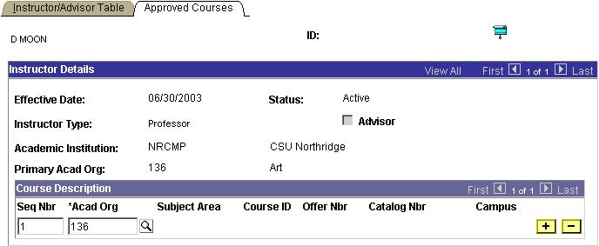

- When you are finished entering the academic organization(s) associated with an instructor, click the Save button.

CAUTION: DO NOT click the Save button until all information is entered correctly on both the Instructor/Advisor Table page and Approved Courses page.

- Select Home>Manage Student Records>Establish New Courses>Use>Term Workload.
The Find an Existing Value page displays.

- Enter the instructor ID or last name into the available fields, and then select the Search button to search for term workload data for an instructor.
- If no data is retrieved, “no matching values were found” displays on the Find an Existing Value page:
- Click the Add a New Value link. An Add a New Value page displays.
- Enter the instructor ID into the available field, and then click the Add button.
The Term Workload page opens with a new row displayed on the Workload Assignment page.
- Proceed to the next numbered step.

- If data is retrieved, the Term Workload page for the instructor displays with one or more rows on the Workload Definition row counter.
Search for the current term by using the row counter to view the Term field for each row, and follow the instructions in the table below:

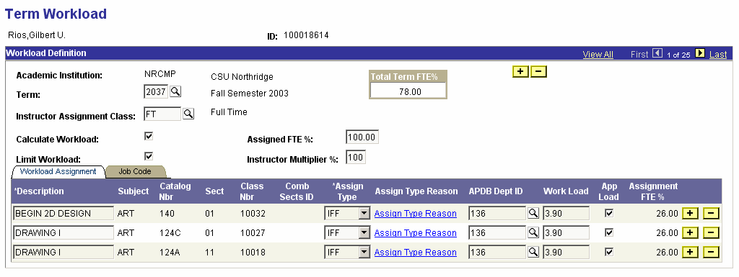

Term Workload page: Work with the row counter buttons, the Add a Row button in the Workload Definition portion of the page, and the Workload Assignment tab as needed.

CONDITION | ACTIONS
If the correct term is found... | a. Verify that the correct entry, FT, PT, TA, GA, or VOL, is entered in the Instructor Assignment Class field. Adjust the value as needed.  b. Click the Save button.  c. Proceed to the final numbered step.
If the correct term IS NOT found... | ● Click the Add a Row button that displays in the Workload Definition portion of the page.  CAUTION: DO NOT click the Add a Row button that displays on the Workload Assignment tab.  A new row displays on the Workload Assignment page.

- Enter values in the Term field and Instructor Assignment Class field using information in the following table:

FIELD | INSTRUCTIONS
Term | Enter the four-digit academic term, or click the Lookup button and select the academic term from a list of valid values.
Instructor Assignment Class | Enter FT, PT, TA, GA, or VOL, or click the Lookup button and select an instructor designation from a list of valid values.

- Click the Save button.

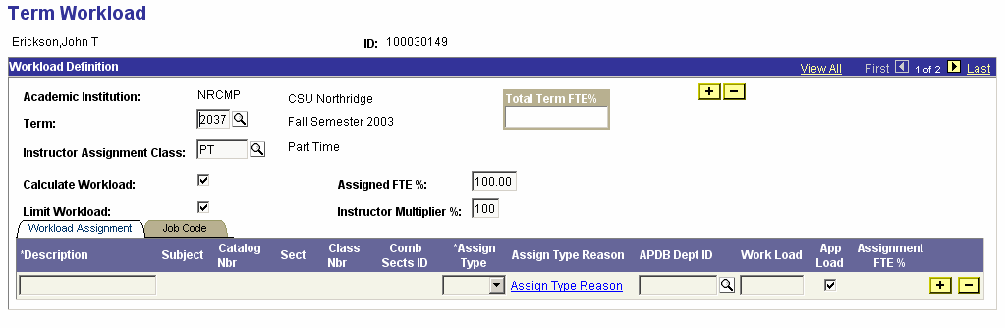
Term Workload page: Assign term workload information for an instructor by using the Term and Instructor Assignment Class fields after ensuring that a new row displays on the Workload Assignment tab.

- Use the Schedule of Classes component or the Schedule Class Meetings component to go to the Meeting Pattern portion of the Meetings page and assign an instructor to a class section.
(For information about using the Meetings page see the “Adjusting Meetings” and “Scheduling Meetings” sections of the Schedule of Classes Business Process Guide.)

