Stressed Out? Ready For Some Relief?
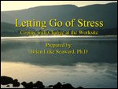
In this presentation...
This presentation was prepared exclusively for WELCOA members by Brian Luke Seaward, PhD, one of the nation's most respected authorities on stress and its influence on our health. Beautifully illustrated with his photography, this presentation will help you provide your employees with an uplifting and practical wellness experience to assist them in managing this important aspect of their health.

