Wellness Centers Organizational Scan Org. #:

Name:
Medical Wellness Center
Tagline:
None.

University/Location:
University of Miami
Miami, Florida

Contact Info:
Clinical Research Building Garage
1120 NW 14th Street
Miami, FL 33136
Phone: 305-243-7600
Fax: 305-243-7602
Email: medwellness@med.miami.edu

Website:
http://wellness.med.miami.edu/x7.xml

Logo:

Mission:
Our mission is to discover and promote the importance of wellness programs for the continuing health and productivity of our members. We are committed to the education, motivation, and support of our members on their journey toward a healthier lifestyle.

Vision:
Not specified.

Values:
Not specified.

Wellness defined:
What is Wellness?
It takes more than physical exercise to maintain good health. Balance is the key to leading a healthy lifestyle. Wellness is the dynamic process of becoming aware of, taking responsibility for, and making choices that directly contribute to one's well being and that of the common good. It is the integration of body, mind and spirit and the ongoing development of one's own meaning in life.
Because the goal of achieving optimal health is achieved by way of “striking a balance” in relation to these 8 dimensions, the Wellness Center offers classes such as meditation, stress management, smoking cessation, and nutrition education. Many of the programs are free and open to the general public.
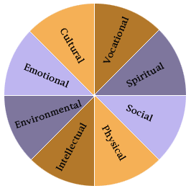
click on the individual wellness components to view an explanation and its relevance to the achievement of optimal health.

Distinctive features:
Affliliated with Miller School of Medicine.

Description:
Open to employees, students, and community.

Services:
Personal wellness classes and professional training.

Programs:
Corporate Run
Integrative Medical Symposium
Be Smoke Free: Smoke cessation program
Meditation Classes
Walking Canes: Walking program for whole community
Fitness Classes

Other Info:

