Wellness Centers Organizational Scan Org. #:

Name: ISU Wellness Center

Tagline:
None

University/Location:
Idaho State University, Pocatello, Idaho

Contact Info:

Wellness Center
Idaho State University
921 S. 8th Avenue
STOP 8109
Pocatello, Idaho 83209
208-282-2117
208-282-4903 FAX
wellness@isu.edu
Website:
http://www.isu.edu/wellness/mission.shtml

Logo:

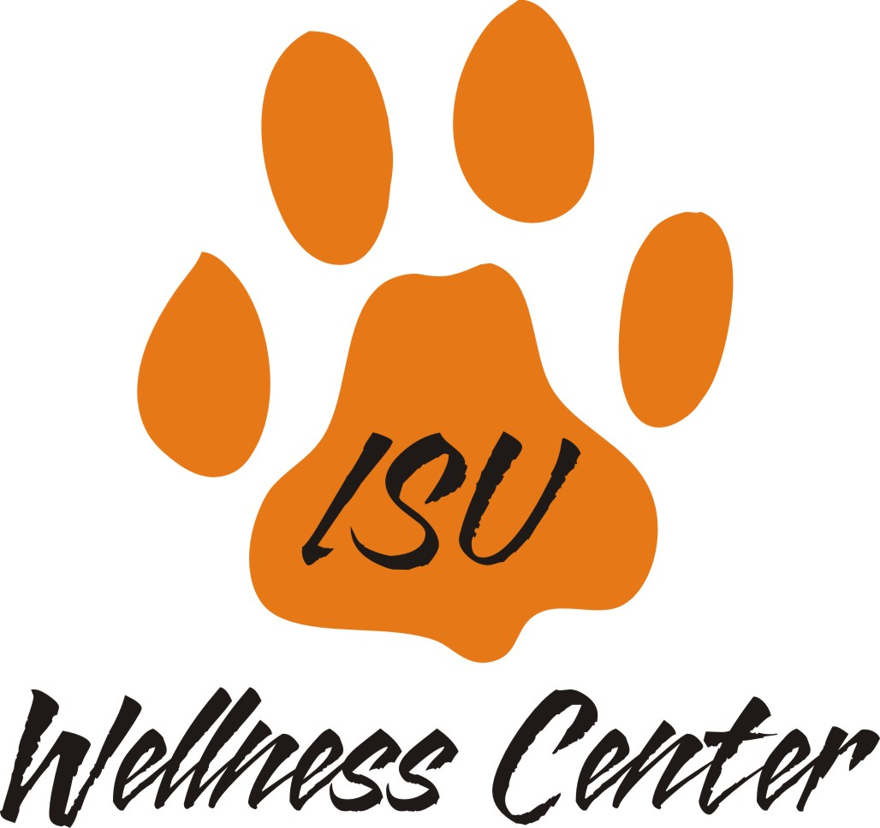

Wellness Center
Mission:
The mission of the Wellness Center is to promote a collaborative approach to personal and community health through health promotion, educational programming, and service to the ISU community. We are committed to provide opportunities that facilitate and support growth in the multiple dimensions of health: physical, mental, emotional, spiritual, social and environmental.
Vision:
None stated

Values:
The ISU Wellness Center operates in accordance with the Standards of Practice for Health Promotion in Higher Education developed by the American College Health Association.
Wellness defined:
Not specified

Distinctive features:
Employee and student wellness programs spread across several program.

Description:
The goals of the Wellness Center are to:
- offer programs and services emphasizing awareness, prevention, and positive health behavior change,
- provide current and accurate information on personal and community health issues,
- foster a campus environment supportive of a healthy lifestyle, and
- provide knowledge and skills to improve and maintain health that may enhance academic and/or work performance.
Services:
Employee wellness
First aid and safety
Fit-N-Phat
Fitness Assessments
Fun Walk/Run
GET FIT
Nutrition counseling

Programs:
Campus Recreation
Student Health Center
Counseling and Testing Center
Janet C. Anderson Gender Resource Center

Other Info:

