Wellness Centers Organizational Scan Org. #: 35

Name: Student Wellness Center

Tagline: Achieving Wellness Through Balance in All Areas of Life

University/Location: Utah State University

Contact Info: Phone: 435.797.1010
Fax: 435.797.8010
Email: ryan.barfuss@usu.edu
Ryan Barfuss - Prevention Specialist

Website: http://www.usu.edu/swc/

Logo:

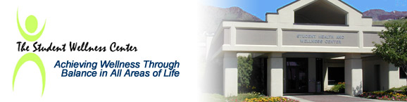

Mission: The Student Wellness Center's mission is to assist students, staff, and faculty in the development of life skills necessary to enhance their personal wellness and ability to be successful in the five areas of life which are: Physical; Mental/Emotional; Social; Economical, and Spiritual.

Vision: n/a

Values: n/a

Wellness defined: "Wellness must be a prerequisite to all else. Students cannot be intellectually proficient if they are physically and psychologically unwell." Ernest Boyer (Campus Life: In Search of Community)

Distinctive features: Includes clinical services.
Significant focus on alcohol & drug abuse issues.

No mention of physical fitness or mental health.

Every two years a survey is taken among USU students to assess alcohol and drug usage, attitudes, perceptions and negative consequences among college students. The survey is a random, statistically significant, representative sample.

Description: The Student Health and Wellness Center
The Student Health Service provides a clinic for primary care for the students of Utah State University. To accomplish this, we utilize the services of doctors, nurse practitioners, physicians assistants, nurses, laboratory technologists, health educators, pharmacists, dietitians and psychologists. We are here to help you achieve and maintain wellness.

Services: Health & Wellness Educational Programs and presentations.
Student Peer Education & Mentoring Groups
Programs and Awareness campaigns (drug, alcohol, spring /summer breaks, etc.)
In-service training (signs/symptoms of alcohol & drug abuse)
Referral services
Alcohol & Other Drug Education 17 hour class
Support Groups (12 step)
Research

Programs: Low-Cost Alcohol and other Substance Use Screenings and Education
Free Smoking Cessation Programs
Free Preventative Health Information and Health Education Materials
Dietetics
SAAVI: Free Consultation and Support for Victims of Violence or Sexual Assault

Other Info: n/a

