Wellness Centers Organizational Scan Org. #: 9

Name: Wellness Center

Tagline: Your Wellness is Our Focus

University/Location: Morehead State University, Morehead, KY

Contact Info: (606) 783.2083

Website: http://www.moreheadstate.edu/wellness/

Logo:
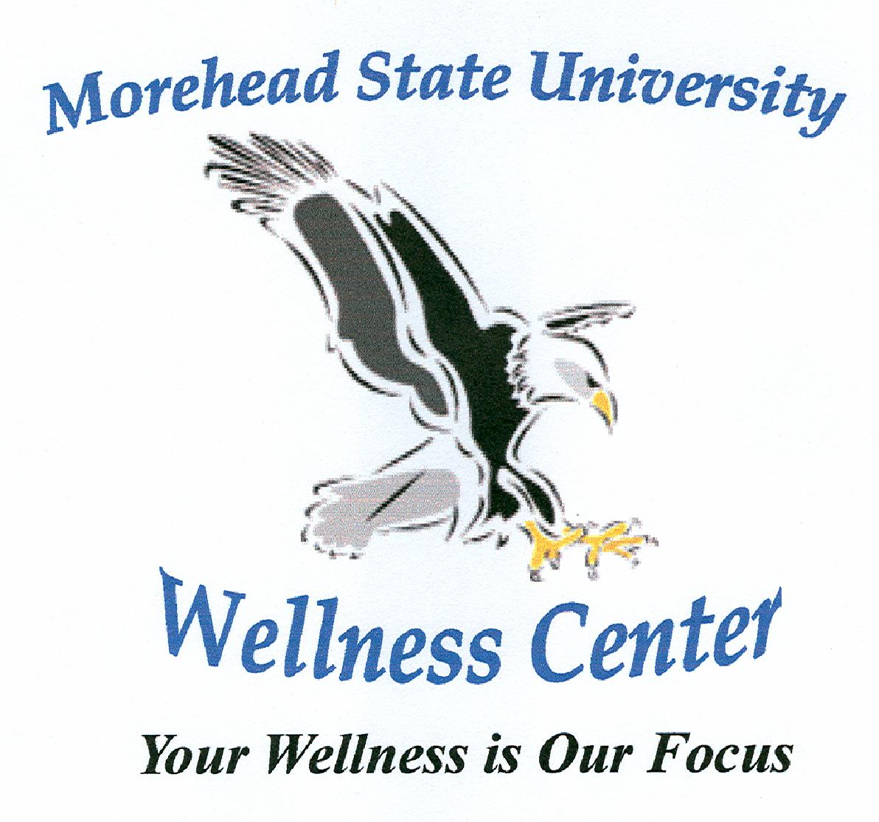

Mission: n/a

Vision: n/a

Values: n/a

Wellness defined:

Distinctive features: Incentive programs are offered every year. These programs are typically organized by students completing an internship at the Wellness Center, but are overseen by the Wellness Center Director and Assistant Director.

Description: n/a

Services: n/a

Programs: Presentations: "Starting and Sticking with an Exercise Program"; "Get a Handle on Stress"; "Tennis Clinic". Iron EaglesTriatholon, Fitness Yoga, Body Sculpting and Core Toning, 5K Training, Fit Eagle 5K, Water Aerobics

Other Info: n/a

