**Q1.** Aggregate planning refer to the following problem.

|  |  |  |  |  |  |  |  |
| --- | --- | --- | --- | --- | --- | --- | --- |
|  | | PERIOD | | | | | |
| DEMAND | | 1 | |  | 2 |  | 3 | |
|  | | 100 | |  | 160 |  | 140 | |
| CAPACITY | |  | |  |  |  |  | |
| Regular | | 70 | |  | 100 |  | 100 | |
| Overtime | | 20 | |  | 20 |  | 20 | |
| Subcontracting | | 10 | |  | 10 |  | 10 | |
|  | |  | |  |  |  |  | |
| Production costs |  | |
| Regular time: | $11 | |
| Overtime: | 14 | |
| Subcontracting: | 18 | |
| Inventory carrying cost per period | 3 | |
| Backorder cost per period | 6 | |

Fill the un-shadowed cells (with heavy boarder-lines) in the following table.



**Q2.** The goal of this system is to maximize profit. The weekly demand for P and Q are 110 units and 60 units, respectively. There are four resources, A, B, C and D, used by the production system to meet demand. These resources are shared among the various operations as shown in the figure.

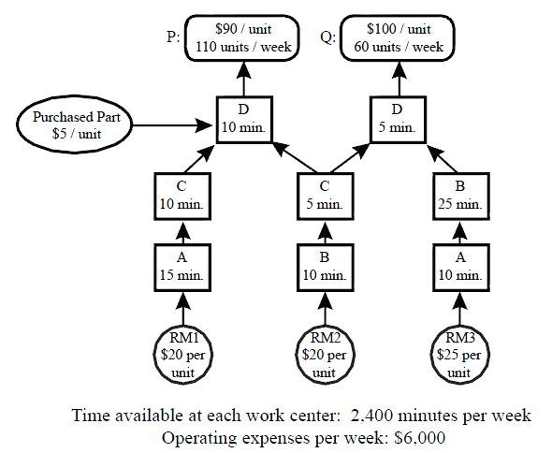

Resource A takes 15 minutes to process one unit of raw material RM1. That unit is next processed by resource C for 10 minutes before it is material is ultimately used to make one unit of product P. Resource A also processes raw material RM3 and this material is ultimately used to make one unit of product Q. Resource D is an assembly operation that does the final operation for both products. To produce a unit of Q, resource D uses a unit of WIP from resource C and a unit of WIP from resource B, and takes 5 minutes to perform the assembly operation. When resource D assembles one unit of product P it also uses a purchased part costing $5 to complete the assembly operation. Other pertinent data are presented in the figure. In particular, it should be noted that each resource operates independently for 2,400 minutes each week, and that operating expenses, totaling $6,000, are incurred at the end of each week. Assume XP and XQ as the decision variables of this problem.

1. The Objective function of this problem is
2. Write all the constraints and show if we can satisfy the demand? How? why?

Given the following Sensitivity Report



1. Which constraint is the most valuable to relax? Is it an external Constraint or an internal one?
2. Based on the information given in the above table, how many units of product Q do you produce?
3. Based on the information given in the above table, what is the value of the objective function produce based on the information given in the above table? ( Please be careful)