**Questions 19 to 21** refer to the following problem.

|  |  |  |  |  |  |  |  |
| --- | --- | --- | --- | --- | --- | --- | --- |
|  | | PERIOD | | | | | |
| DEMAND | | 1 | |  | 2 |  | 3 | |
|  | | 100 | |  | 160 |  | 140 | |
| CAPACITY | |  | |  |  |  |  | |
| Regular | | 70 | |  | 100 |  | 100 | |
| Overtime | | 20 | |  | 20 |  | 20 | |
| Subcontracting | | 10 | |  | 10 |  | 10 | |
|  | |  | |  |  |  |  | |
| Production costs |  | |
| Regular time: | $11 | |
| Overtime: | 14 | |
| Subcontracting: | 18 | |
| Inventory carrying cost per period | 3 | |
| Backorder cost per period | 6 | |

We have prepared a portion of cost table which shows the cost of one unit of product produced using one of the three alternatives of regular time, overtime, and subcontracting. The table also shows the unit cost of each alternative produced in a month for demand of that month or demand of a previous month or demand of a latter month..

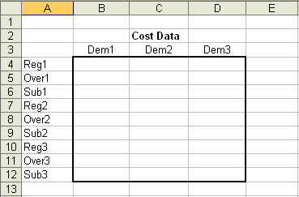

**Question 19:** What do you type in cell B4

1. 11
2. 3
3. 6
4. 14
5. 18

**Question 20:** What do you type in cell B12

1. 9
2. 17
3. 20
4. 25
5. 30

**Question 21:** What do you type in cell D8

1. 3
2. 14
3. 20
4. 9
5. 17

**Question 22.** At the end of Game 1 you become disabled to access the game in the last 50 days. After these final 50 days and when the game finally ended:

1. Each machine is automatically sold for $10,000 each
2. All machines are automatically sold for a total of $100,000
3. Machines with higher production capacity are sold for higher prices
4. Remaining machines have no value
5. Machine prices depend on market demand

**Question 23.** In Game 2

1. you can change EOQ and ROP
2. you can change priorities at station2
3. machines can be sold at higher prices than game 1
4. all of the above
5. only A and B

**Question 24.** How many pricing contracts are in Game 2?

1. one
2. two
3. three
4. four
5. none of the above