The goal of this system is to maximize profit. The weekly demand for P and Q are 110 units and 60 units, respectively. There are four resources, each has 2400 minutes per week. Operating expenses per week: $7000

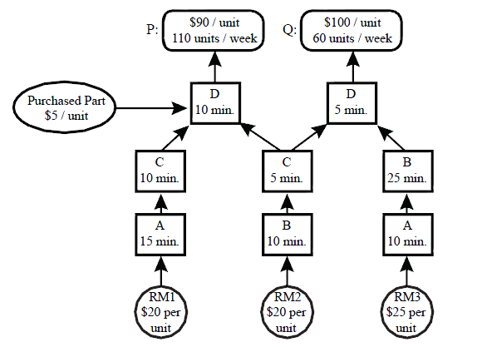

a) Find the optimal solution .

b) Suppose we can increase the market of product P by one unit. How much will it increase the profit?

Suppose shadow prices are as follows (**these are not the exact shadow proces of this problem as you have found one of them in the previous part – Just suppose they are**)

Resource A : 0

Resource B : 2

Resource C : 0

Resource D : 0

Market P : 30

Market Q : 0

How much profit do we make?