**Activity-Based Costing at Hitchcock, Kubrick, and Lean Inc.**

Activity-Based Costing provides an opportunity for obtaining **a better approximation of the product cost** than standard cost accounting systems can. The basic principle of the ABC system is “activities consume costs, and products consume activities.” The difference between standard cost accounting and ABC is that in standard cost accounting, products “consume” overhead costs. In contrast, the ABC system instead assumes that activities consume costs (that may or may not add value to the product). Activity-Based Costing is a methodology that identifies costs associated with activities and links these costs to products based on how the products consume those activities. Rather than allocate the total cost of operating a resource directly to a range of products, ABC identifies the specific activities that go into making a specific product and attempts to determine the cost of those activities.

The accountant first enumerates all overhead activities and their costs. ABC uses multiple cost drivers to guide allocations more accurately than an allocation method that uses a single cost driver. ABC allocates activities and their costs into one of four categories: unit-level, batch-level, product-level, and facility-level. Using different cost drivers to allocate costs results in a less arbitrary allocation of overhead costs. Moreover, since ABC uses more meaningful cost drivers to drive the allocation of costs, it is arguably better than standard cost accounting for measuring performance.

However, improved tracking accuracy comes with a cost.

**HKL, Inc.** Three home-maintenance specialists, A. Hitchcock, S. Kubrick, and D. Lean, have banded together to form HKL, Inc., based in New Orleans, Louisiana, where demand for home maintenance services is high. HKL offers the following types of services: Plumbing (Product-1), Window Cleaning (Product-2), Gutter Guard Installation (Product-3), and Landscaping (Product-4).

The total monthly wages for these three men is $18,000, including benefits. These wages are categorized as administrative overhead costs. The non-administrative overhead costs, including rental charges, truck fleet maintenance, marketing & advertising, and depreciation, amount to $9,000 monthly.

**Administrative costs = 18,000 per month. Non-administrative costs =9,000 per month.**

HKL is seeing ample demand for all its products, but there is a shortage of qualified workers. Adhering to a motto, "Teach Your Children Well," that they have preached ever since their younger days, Hitchcock, Kubrick, and Lean have employed their children, five high-school graduates, to run their home maintenance operations.

These **five employees** are **each** paid a competitive salary of **$2,000** **per month,** including benefits. In return, the employees are each expected to work **200 hours a month**, giving HKL a **total of 1,000 hours of available capacity**. **HKL has thus fixed its labor rate to be $2,000/200 = $10 per labor hour**. The following table presents the current demand, the average time per job, and some revenue/cost data for the services offered by HKL based on data gathered over the past six months and the current number of jobs that HKL completes each month for each type of service.

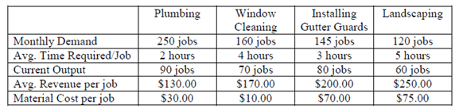

HKL currently completes an average of 90 Plumbing, 70 Window Cleaning, 80 Gutter Guards, and 60 Landscaping jobs monthly. For this output level, HKL uses up (90 x 2 + 70 x 4 + 80 x 3 + 60 x 5) = 1,000 hours of labor, which effectively accounts for all the available capacity.

**Applying Activity-Based Costing to HKL, Inc.**

Hitchcock, Kubrick, and Lean are happy with Birds, 2001-a- [Space Odyssey, and Lawrence of Arabia, but are](http://www.google.com/url?sa=t&rct=j&q=&esrc=s&frm=1&source=web&cd=1&cad=rja&ved=0CC8QFjAA&url=http%3A%2F%2Fen.wikipedia.org%2Fwiki%2F2001%3A_A_Space_Odyssey_(film)&ei=S45TUqSwM8qArAHUqYD4AQ&usg=AFQjCNHRMCiJJo_1clRHL1_cgT_gBSxyKQ&sig2=5KpmUVH2WE5n3zGJumJfMA&bvm=bv.53760139,bs.1,d.cGE) not happy with the standard costing system. They think the problem lies with the cost driver used to allocate the overheads. They want to use Activity-Based Costing and allocate administrative overhead costs based on the actual time and effort spent by the managers on the various products. They also want to allocate the non-administrative overhead cost using labor hours as the cost driver instead of the old cost driver that was based on production volume.

Hitchcock gathers data on the time the three men spend on the various products. (This data-gathering process involves some effort on his part and incurs some additional cost; the additional cost is ignored.) **The data shows that the administrators allocate their time to the four products: Plumbing: 30%; Window Cleaning: 35%; Gutter Guards: 20%; and Landscaping: 15%. Therefore, the administrative costs will be allocated to the four lines of activities based on the above percentages.**

Based on this data, Kubrick calculates **the administrative overhead cost allocated to Plumbing as $18,000 x 0.30 = $5,400. Since there are 90 Plumbing jobs completed each month, the administrative overhead allocated to each plumbing job is $5,400/90 = $60**. The administrative overhead cost is allocated to each of the other types of services similarly, and Table 3.3 shows the resulting allocation.

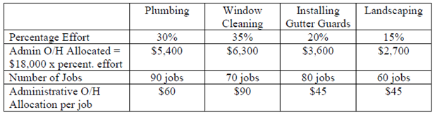

Next, Lean uses labor hours as the cost driver to allocate the non-administrative overhead cost. The total non-administrative overhead cost is $9,000, and the total available labor capacity is 1,000 hours, so non-administrative overhead is charged at $9,000/1,000 = $9 per labor hour. Since Plumbing takes 2 hours, the Non-administrative overhead cost allocated to a Plumbing job is = $9 x 2 = $18. The allocation for the other three types of services proceeds similarly.

1. Using ABC costing, compute the profit of each of the four products under the current production plan of Prod-1 (90), Prod-2 (70), Prod-3 (80), and Prod-4(60).
2. Compute the total profit under this plan.
3. Given the available market of Prod-1 (250), Prod-2 (160), Prod-3 (145), and Prod-4 (120), in the framework of your ABC costing, what is your proposed optimal production plan? How many of each job do you accept and deliver? Prod-1 (?), Prod-2 (?), Prod-3 (?), and Prod-4 (?).
4. How much profit do you make under your proposed optimal production plan?