**`**



**RFP Number:** 11-011-C1

**Project Title:** Project Scheduling Assistance

**Name and Address of Proposer:**

Michael H. Azma,

Managing Partner

Genesis Technology Services Group LLC.

3311 Starline Dr.

Rancho Palos Verdes, CA, 90275

Phone: (310) 514-2000, Fax: (310) 424-2990

Email: [MAzma@GenesisGroupLLC.net](mailto:MAzma@GenesisGroupLLC.net)

**In Collaboration with:**

Professor Ardavan Asef-Vaziri

Department of Systems and Operations Management,

College of Business and Economics, California State University

18111 Nordhoff Street, Northridge, CA, 91330-8378Phone: 818-677-3637

**Email:** [ardavan.asef-vaziri@csun.edu](mailto:ardavan.asef-vaziri@csun.edu)



*We are pleased to submit this proposal in response to your RFP 11-011-C1, to provide a description of how we could address your needs for technical assistance in project management/scheduling services, to provide highly effective support for your program and project management activities.*

*Based on our extensive experience in providing project management related consulting and training services, we recognize the significance of securing the right consulting resources to assist you in overseeing the successful completion of the portfolio of projects deemed vital in carrying out your mandated planning program activities in a timely manner. Therefore, we strongly feel that by being a small consulting firm, consisting of highly experienced and knowledgeable management and technical consultants, we could provide you with the right resources throughout your program in a very cost- and service-effective manner.*

*In addition to our own consulting staff, we have also teamed up with Professor Ardavan Asef-Vaziri of the department of Systems and Operations Management of California State University, to collaborate on this proposal as well as participate in consulting services on this project.*

*We look forward to having the opportunity to discuss your project needs in more details to explore the possibility of partnering with you in your future endeavor.*

-----------------------------------------------------

Michael H. Azma

Managing Partner

GTSG LLC

3311 Starline Dr.

Rancho Palos Verdes, CA, 90275

Phone: 310-514-2000, Fax: 310-424-2990

Email: MAzma@GenesisGroupLLC.net

**1- Background Information**

The Southern California Association of Governments (SCAG) is structured as a Joint Powers Authority governed by 84 member Regional Council, responsible for planning activities for the counties in southern California including Ventura, Los Angeles, Orange, Riverside, San Bernardino and Imperial counties.

The scope of the SCAG’s planning activities include addressing issues related to transportation, solid waste management, air quality and housing in regional areas, or those mandated by the federal government or SCAG’s governing board.

In any given year, the ongoing planning activities of SCAG requires the successful and timely completion of a number of sequential or concurrent projects (ranging from 50 to 100) to be carried out at different locations with their own local project managers and resources.

The overall critical success factor in meeting the planning requirements of SCAG is to establish a highly effective structure to manage the execution of all underlying projects in a way to assure their successful completion while meeting their scope of work, budget and time constraints as well the high quality of project deliverables expected from their completion.

As is standard in the industry, the most effective structure for managing a high budget, multi-project environment is the establishment of a Program Management Office (PMO) to oversee the successful execution of the entire portfolio of defined projects. Through the structure of the PMO, the Program Management Officer is enabled to oversee and coordinate the execution of all projects through close working relationship with all assigned project managers to:

* Develop and establish project plans for each project as well as the high level plan for the entire program in an integrated fashion to meet the overall scope of work as well as the time and budget constraints
* Monitor the execution of all projects to identify and rectify any issues and problems associated with the timely delivery of project deliverables as well as challenges in meeting budget and scope constraints.
* Closely Monitor the utilization of resources and budget expenditure to detect any potential issues and take proactive measures to rectify the situation and/or minimize the impact
* Establish and reinforce effective change management processes to deal with the unexpected project changes, resource allocation and availability issues as well as scope creep to mitigate any potential risks on the timely delivery of the required deliverables
* Establish and maintain highly effective Quality Assurance processes to ensure all project deliverables meet the rigorous QA specifications and standards while using a proven methodology.
* Compile, distribute and present all required status reporting and progress reports at all levels.

**Table of Contents**

|  |  |
| --- | --- |
| **1- Technical Approach** | 4 |
| **1. Scope of Work along with the process for executing the requirements and objectives of the project.** | 4 |
| **2. Difficulties expected or anticipated in performing the tasks, and how to overcome or mitigate against those difficulties.** | 4 |
| **3. Detailed schedule for completion of the work, segments of the project, milestones, and significant events.** | 6 |
| **4. The extend to which the Scope of Work will exceed 100% of the stated objectives discussed in the RFP.** | 7 |
| **2- Project Tasks** | 10 |
| **1. Develop detailed schedules for 30 - 40 Planning and Information Technology Projects using Microsoft Project (SCAG already owns the software).** | 10 |
| **1. a) Produce schedule task details, network logic and durations.** | 10 |
| **1. b) Determine inter-project constraints.** | 11 |
| **1.c) Schedule input for inter-project constraints.** | 12 |
| **2. Assist SCAG staff in using Microsoft Project software to monitor schedule performance.** | 13 |
| **3. Assist with OWP Development, including providing Scope of Work training (how to write comprehensive work scopes).** | 15 |
| **4. Train staff on use of MS Project Scheduling software.** | 18 |
| **5. Assist staff with SCAG’s monthly OMS progress reporting and Quarterly Progress Reporting (upload of data).** | 21 |
| **6- Assist SCAG staff in using Microsoft Project software to monitor schedule performance.** | 21 |
| **3. Cost Proposal** | 22 |
| **4. Profile of the firm** | 23 |
| **5. References** | 30 |
| **6. SCAG’s Consulting Agreement** | 31 |

**2- Technical Approach**

The primary objectives of SCAG in executing its Overall Work Program (OWP) are to ensure that:

* All planning activities and their related projects/tasks are carried out in a well structured, integrated, consistent and coordinated manner to assure their successful completions within the allocated budget and time schedule
* Project deliverables support Federal and State mandated program deadlines
* The program results meet the expectations of the Regional Council

To support the above objectives, project management/scheduling assistance consulting services is needed within the following project framework.

**Project Objective and Scope of work**:

The main objective of this project is to secure the project management consulting and training services help SCAG in the following areas:

1. **Project Management Support Services**:

To provide assistance in all phases of the Project Management methodology for 30-40 IT projects by using MS Project as the project management tool.

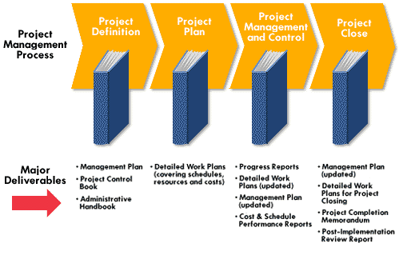

*Figure 1 – Project Management Phases*

The required consulting services during the Project Management phases, (as shown in figure 1), are as follows:

**Phase 1 & 2: Project Definition and Project plan**

During the project definition and project plan phases, the consultant(s) are expected to work with local project managers to review and/or provide assistance in some or all of the following activities:

* Define/refine the assigned scope of work and projects
* Select and customize the appropriate project blueprint and methodology
* Prepare the work breakdown structure (WBS) and related tasks and deliverables
* Identify resources and skill sets needed for each task and deliverables
* Prepare estimates for the required effort level for each task
* Identify inter-project dependencies and constraints
* Prepare initial project plan and schedule, network logic and charts
* Through several iterations, revise the preliminary project plan based on Critical Path analysis, resource availability, workload balancing, Inter-project dependency evaluation, inclusion of holidays and vacation plans as well as risk assessments to prepare the final version of the project plan and schedule to be included in the project charter for review and approval.

The tasks, deliverables and the constraints of the project plan are shown below.

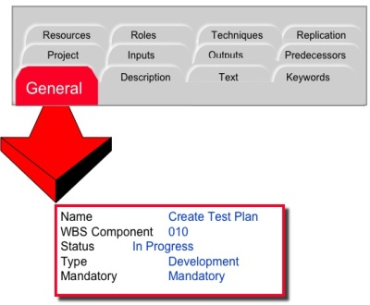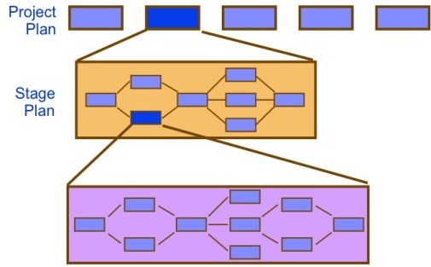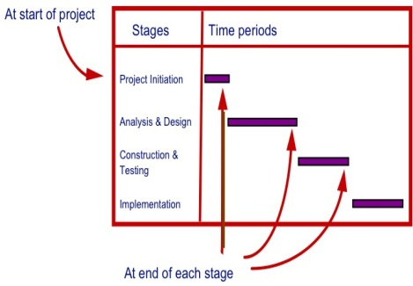

**Phase 3 & 4 – Project Management & Control and Close phases**

During Project Management and Control phase, the consultant(s) are expected to assist project managers and staff in some or all of the following areas to help**:**

* Update project plans and schedules on a timely basis
* Monitor schedule performance
* Identify tasks and deliverables which are off target
* Review and assess the impact of any delays in completing any project deliverables on the overall project as well as the overall program
* Explore alternative approaches in mitigating project risks associated with any deviations between the planned versus actual target dates on project tasks
* Generate status reports on a weekly, monthly and quarterly basis
* Generate any additional supplementary status reporting charts, graphs and tables.

The consolidated

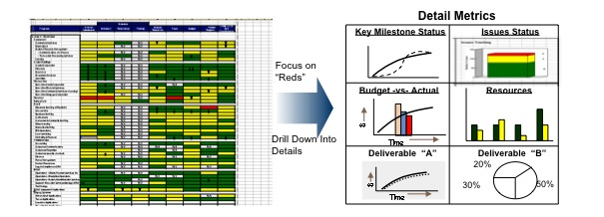

1. **Training staff on MS Project**

The consultant(s) are expected to provide knowledge transfer and training services on the use of MS Project for project planning and scheduling. Based on our experience, we propose to conduct MS Project training through the development and presentation of 10 lectures with hands on training on MS Project. These lectures will be developed in PowerPoint slides and delivered using lectures recorded in Camtasia Studio. It should be noted that when a lecture is recorded in Camtasia Studio, the PowerPoint slides, the voice of the Consultant, curser movement, and any other material written on the monitor (using Smart Podium) would appear in the recorded lectures. SCAG staff will simply listen to the lectures at their own appropriate times with the ability to stop and rewind the lectures. The recorded lectures will be on the following topics:

**(i) MS Project Basics.** Start MS project, create project plan, create a project plan, define the project calendar, define tasks, define priorities, and organize tasks into phases.

|  |  |
| --- | --- |
| Picture 2 |  |

**(ii) Establish Resources and Assign Resources to Tasks.** Establish human, material, capital (equipment, building, etc.), and financial resources. Establish recourse scheduled availability, net availability, and consumption rate. Assign resources to tasks.

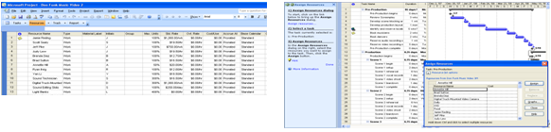

**(iii) Refine the Project Plan.** Apply a task calendar to individual tasks, change task types, split a task, establish recurring tasks, apply task constraints, review the critical path network (CPN), and view resource allocation over time.

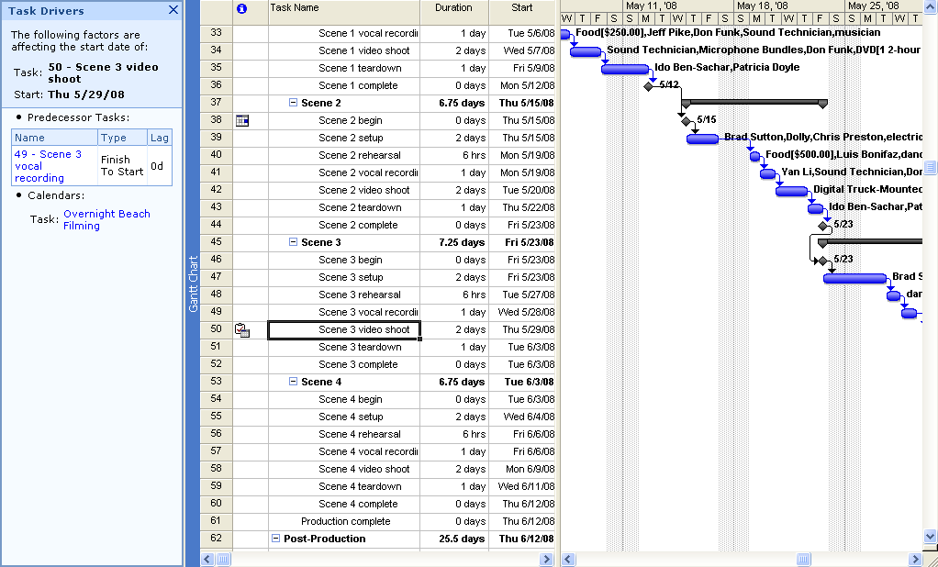

**(iv) Project Information.** Sort, group, and filter project data and information. Customize and print views and reports. Format a Gantt chart, draw a Gantt chart, create and edit tables and custom views.

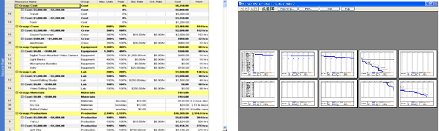

**(v) Project Tracking – Fundamentals.** Establish project baselines, track projects as scheduled, enter completion percentages, track time-phased actual work, identify over budget tasks and resources, and identify and schedule problems.

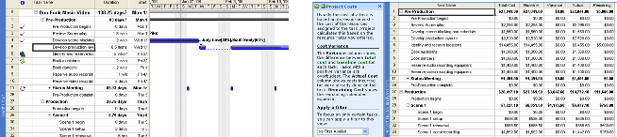

**(vi) Project Tracking – Fine Tuning Tasks and Resources.** Manage task constraints and dependencies, set deadline dates, and establish tasks priorities. Enter resource consumption and cost rates, assign multiple pay rates for a single resource, apply different cost rates per assignment, specify resource availability at different times, resolve resource over allocation, level resource allocation.

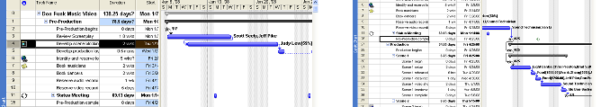

**(vii) Advanced Topics -** **Project Plan Optimization**. Project plan optimization, advanced project plan formatting, advanced project plan tracking, and working with resource pools. In addition we will introduce SCAG staff to the probabilistic concepts in project management, including Program Evaluation and Review Technique (PERT) and its implementation in MS Project, as well as Simulation Concepts.

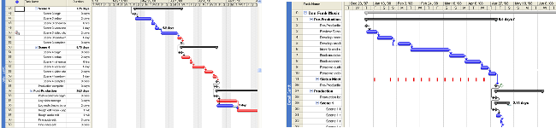

**(viii) Managing Multiple Projects.** Manage consolidated projects; create dependencies between projects, integrating MS Project with Other Applications.

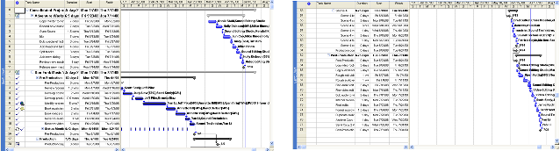

1. **Customize MS Project to SCAG needs.**



**Knowledge Transfer**

In addition to the training on the use of MS Project for project management and scheduling, if needed, we are prepared to offer additional training on Project Management related topics as described below.

Through training and project activities, we could work with the project staff to:

1. Increase and implement their knowledge of Project Management for better planning, control, and problem solving of the current projects.
2. Create templates to facilitate planning and scheduling of future projects using knowledge developed through classifying, planning, scheduling, and controlling current projects.
3. Integrate Project Management as a fundamental component on all categories of current and future SCAG projects.
4. Improve their ability to screen and classify projects into several categories. This classification will enable SCAG to better manage each category of projects as an integrated Program Management system.

**2. Difficulties expected or anticipated in performing the tasks, and how to overcome or mitigate against those difficulties.**

1. Major difficulties of the project could be the differences in background and knowledge of SCAG staff in Project Management. Differences in the background and knowledge of SCAG staff in Project Management create two potential problems. At one extreme, some SCAG staff are exceptionally knowledgeable in Project Management. At the other extreme, they have little experience with Project Management. Staff that are exceptionally knowledgeable may become complacent, or object to concepts that are incongruent with their experience. Staff with little or no experience in Project Management may feel overwhelmed. To mitigate against the disparate levels of knowledge, the material has been structured in levels of increasing difficulty. In conjunction with in-person training, the material is presented in a multi-media format which allows users to learn at their own pace. Staff with more intimate knowledge of Project Management can use the material for quick review, while less experienced staff have the ability to review the material multiple times before advancing. For experienced staff that object to principals due to personal experience, statistical proofs will demonstrate quantitatively how and why the concepts of Project Management work.

(ii) Diversification in the definition of tasks and activities in each of the SCAG projects. Projects by definition are unique endeavors. Therefore, the project management tools presented are universally applicable to a wide range of projects. SCAG staff will learn in which classification each of their projects fall and the inherit complexities of each. A standard process will be developed to identify all the aspects of the projects as they are related to Project and Program planning and control. A Project-Program Identification Charter will serve as a template to summarize the following aspects of every SCAG project: (1) Overview; the purpose of the project and its goals, deliverables, major milestones, economic and competitive impacts. (2) Methodology; technical and managerial approaches, relationship with other projects. (3) Contractual Aspects; type of the agreement, reporting requirements, technical specs, delivery dates, penalties, process for changes. (4) Schedules; outline of all schedules and milestones, project action plan, and WBS. (5) Human and Capital Resource; types of personnel requirement, timing, training, capital resources. (6) Evaluation Methods; procedures and standards for evaluating project—how information will be collected, stored, monitored. (7) Potential Problems; potential risks to project progress, contingency planning to prevent or soften the impacts of some problems. This information is then used to break down the project into a standard WBS template, define the precedence relationships of each unified activity on a node precedence diagram, demonstrate the resource requirements of each activity, and conduct a baseline analysis.

1. Unreliability of the progress reports. It is common practice for progress reports not to reasonably represent the actual progress when project task durations cover several reporting periods. To overcome this problem we (a) standardize task definitions, (b) prepare a WBS template for all projects which are similar in nature, (c) and most importantly define small tasks in the work package (the lowest layer of the WBS) as either 0% to 100% complete. This minimizes the number of incomplete tasks in the progress reports and removes discretion from reporting progress percentages. A strong emphasis will be placed on SCAG’s initiative to utilize Project Management and MS Project as an integral part of their operations forward moving.

**3. Detailed schedule for completion of the work, segments of the project, milestones, and significant events.**

1. Training in the basic concepts of Project Management. This will be done through 5 teaching and case study sessions in each of the SCAG offices in each of the six counties. The material covers the concepts of: (1) Project and Project Management, Matrix Organization and Project Teams and Linear Responsibility Charts, Work Breakdown Structure (WBS), Mind Mapping, Concurrent Engineering and Integration Management, Design Structure Matrix (DS) and Interface Maps. (2) Project Budgeting, Project Life Cycle, Top-down and Bottom up budgeting, Activity Budgeting vs. Project-Program Budgeting, Learning Curves, Forecasting.
2. Training MS Project. This will be done through 8 recorded online lectures in Basic, Intermediate, and Advance topics in MS Project. Lectures can be viewed by participants at any time. A more detailed explanation of the material covered under this task will be stated in section 3.2.
3. Understanding the nature of SCAG projects in the three dimensions of (a) Goals, Specifications and Quality, (b) Time Schedule, and (c) Budget and Required Resources. This is accomplished through meeting with SCAG staff responsible for each project.
4. Moving from manual project planning and control to and MS Project-based planning and control. This will be done by entering all existing manually planned projects into MS Project. Development of user-friendly templates will aid in the continuing use of MS Projects once training has concluded. For each project under consideration, we will prepare its standard WBS template, define the precedence relationships, prepare the project network, identify the critical path and the critical chain, identify resource requirements of each activity, prepare resource requirement curve for the duration of the project, and conduct a project base-line analysis.
5. Work with SCAG staff in preparing periodic and exceptional reports. These reports cover key performance variables such as Planned value (the baseline cost of scheduled work), Actual cost of work performed, Budgeted cost of work performed, Schedule variance, Cost variance, Total variance, Schedule performance index, and Cost performance Index. It will also include critical chain analysis and analysis of project buffers and feeding buffers.
6. Implementation of online MS Project reports so functional managers can share progress of their work in real time.
7. Preparation of overall SCAG Program progress reports as well as progress reports for each segment of SCAG’s overall program.

**4. This Scope of Work meets 100% of the stated objectives discussed in this RFP. In addition we will introduce SCAG Project Management to the Critical Chain Project Management Concepts.**

In addition to conventional methodologies embedded into MS project, such as Critical Path Network (CPN) and Critical Path Method (CPM), and Problem Evaluation and Review Technique (PERT), we introduce SCAG staff to the Critical Chain Project Management (CCPM) technique which. This is the state of the art in project planning and control developed by Eliahu Goldratt on the foundations of the Theory of Constraints and the well known book “The Goal”. Some of these concepts are summarized below:

**Task Durations.** A project is a composed of three types of work: Known Work + Known Unknown Work + Unknown Work. Due to unknowns, task durations are highly variable. Therefore, people in charge of estimating activity durations usually give a number that they expect to have a 10% chance or less of missing. Therefore, there is a high probability (90% or more) that the true task duration is actually less than the given number. Artificially inflated task times reduce productivity and unnecessarily inflate budgets. CCPM strives to motivate people to give a number they have a high probability (50% or more) of missing. The idea is to pool task buffers and allow the tasks to use the buffer only if they need it. A pictorial representation of pooling task buffers is shown below.



It can be mathematically shown that the buffer for the critical chain is smaller than the summations of the buffers required for all the tasks on the critical chain. Problem Evaluation and Review Technique (PERT) has a partial – but not very clear - view on this property. We will clarify that (i) protecting task times with buffers will degrade on-time performance, (ii) providing specific due date to complete each specific task is against a systematic approach, and (iii) aggressive-but-possible task times increase on-time completion of the projects.

**Activity Completion Syndromes.** We will show the impact of Parkinson’s Syndrome, Continue to Polish Syndrome, and Student Syndrome as portrayed by Goldratt on extending the duration of activities.

Parkinson ’s syndrome

i

Student Syndrome

i

Continue to Polish Syndrome

i

Progress

Progress

Time

Progress

Time

Time

**Multitasking.**  In many situations, existing project work is not completed before new projects shift priorities, which leads to multi-tasking. The problems from one project cascade into the new project, and there is constant pressure to increase staff for peak loads. Therefore, a project’s most likely completion time is much larger than the sum of the averages of the tasks making up its longest path (due to synchronization or due to task dependencies). It can be shown when multi-tasking (switching between tasks), the duration of each task is longer than if each task was performed in a linear fashion, only starting one task after the first task has been completed.



**Pipelining**. The concept is to start the tasks not ASAP, but based on the availability of the most constrained resource. The most heavily loaded shared resource (constraint), also determines the project due dates. This will also reduce multitasking.



**Integration of Constrained Resources and the Critical Path**. We will determine the impact of the limited resources on the duration of the project. An example of integrating resource constraints and CPM to find the critical chain, as well as determining project and feeding buffers is below. Given CPM computation, the project will take 15 weeks, and all tasks are on the critical path. If the project was scheduled for 20 weeks, there is a 5 week project buffer.



Integrating limited resources into CPM computations leaves a project buffer of 2 weeks and feeding buffers of 3 weeks each.



If necessary, we will also implement an unlimited resource algorithm to level the resourse requirements throughout the duration of the project.

**3. Project Tasks**

**1.** Develop detailed schedules for 30 - 40 Planning and Information Technology Projects using Microsoft Project (SCAG already owns the software).

**1. a)** Produce schedule task details, network logic and durations.

In close communication with SCAG staff we will:

1. First study the scope of work and define the comprehensive characteristics of each project in the three dimensions of specification-quality, time, and budget. As stated in the previous sections, a standard process will be developed to identify all the aspects of the projects as they are related to Project and Program planning and control. A template will be developed summarize: (1) Purpose of the project and its goals, deliverables, major milestones, economic and competitive impacts, (2) Technical and managerial approaches, relationship with other projects, and (3) Types of the agreements, reporting requirements, technical specs, delivery dates, penalties, process for changes.
2. We will then use this knowledge to develop a typical work-breakdown-structure (WBS) for the project in each category. The WBS defines the details of the project in a hierarchical approach; each level is a more detailed representation of the higher level. The lowest level (referred to as work package) is the most detailed definition of the project activities. Each element of the WBS is defined in terms of its goal as well as the required time, budget, and resources. An example of the first layer of a WBS for an exclusive truck road feasibility analysis is below.



In the second layer of this WBS, the stakeholder’s perception, for example, may be broken down as follows:



1. After the WBS, we will create a Critical Path Network (CPN) by defining the precedence of the activities. Critical chains are also identified and analyzed.
2. Next, we prepare the MS Project baseline for each of the 30 - 40 Planning and Information Technology Projects. The baseline will include the critical path network, the deterministic duration of the project, earliest and latest start and end dates for each activity, and the probability of completing the project on time. The base-line of each project will also contain the Planned Value (baseline cost of scheduled work) also known as Budgeted Cost of Work Scheduled (BCWS). The BCSW shows the expected progress of the project and the budget absorbed based on the initial schedule or the most recent information. Graphically, the BCSW is generally an S-shaped curve. Progress advances slowly, and then accelerates at an increasing rate until work hits an inflection point mid-way through the project. At this point, progress advances at a decelerating rate until the project is complete. Though S-Shaped Planned Value cures are the most common, certain projects with intensive pre-planning phases, such as information technology projects, have J-shape curves. This means slight constraints in the later stages of the project can have a profound impact on the project quality, budget, and time.
3. Finally, we will prepare the required resource utilization curves for the main resources of all projects. This will include types of personnel requirement, timing, training, and required capital resources as well as input components and material resources. We also provide resource requirement curve representing consumption of each resources at deferent time periods over the duration of the project.

**1. b) Determine inter-project constraints.**

The time required to complete a project, availability of key resources, cost of resources, and timing of solutions to technological problems will be identified as inter-project constraints. Besides the conventional methodologies embedded into MS Project, such as Critical Path Network (CPN) and Critical Path Method (CPM), and related knowledge such as Problem Evaluation and Review Technique (PERT) , we will also use the Critical Chain Project Management (CCPM) technique discussed above.

**1.c) Schedule input for inter-project constraints.**

Working closely with SCAG staff, the Consultants will meet with selected team members of each project to discuss the constraints found in our consulting, request feedback from SCAG staff, and request input for additional unidentified constraints.

Input will be provided to resolve inter-project constraints in the three dimensions of:

1. **Specifications-Quality**. Technical difficulties, quality problems, scope creep, inter-functional complications, technological breakthroughs, intra-team conflict, and eco-system changes will be reported.
2. **Cost.** Not enough resources, Scope change, inadequate budget, poor reporting, delay in decision making and correction actions, changes in the cost of resources.
3. **Time.** Long time to respond/resolve difficulties, unrealistic estimate of duration of activities, incorrect sequencing of activities, unavailability of some resources, delay in collecting required data/information, difficulties in merging points of several activities/authorities, change orders, changes in federal, state, or local regulations.

**Integration nodes and Synchronization Delays.** In the conventional methodologies such as critical path network (CPN) and critical path method (CPM) embedded into MS project, only activity dependencies are considered. However, duration of a project is determined not only by task dependencies but also by synchronization at the integration nodes (activities with several immediate precedence). For example, if the expected duration of each task in the project below is 15 days, then according to CPM computations, the duration of both projects are 30 days. But in this computation we only considered dependencies and not integrations.



Task durations are highly variable, the 30 days is expected value. Given uncertainties involved in estimating task durations, the actual task durations may vary from 5 to 25 days. In the first project, the start of task 3 is defined by the actual duration of task 1. In the second project, the start of task 3 is defined by the maximum of the actual duration of both tasks 1 and 2. Synchronization of task 1 and 2 is imperative for on-time completion of the second project. We will cooperate with SCAG staff to recognize the importance of controlling (i) Synchronization Delays, (ii) Integration (assembly) points, and (iii) integration of the CPM with the availability of resources.

**Buffer Management.** Allocate resources to tasks based on buffer burn rate. In the project example 3.2.1(b), each activity has a 2/18, or an 11%, project buffer. Task 1 and task 4 have 3/5 = 60% and 3/4 = 75% feeding buffers, respectively. Tasks 2, 3, and 5 are on the Critical Chain. The critical chain activities that have consumed faster than project buffer rate are outlined in red, while those consuming slower than project buffer rate are outline in green. SCAG staff will need to allocate more time and effort to the activities outlined in red.

We will also assist SCAG staff on identifying and managing the risks associated with each project and the overall risk associated with the Program. Some of the basic concepts are

1. Risk Management Planning; Risk Identification, and Risk Analysis: evaluating the seriousness (magnitude) and likelihood (probability) or a risk using qualitative and quantitative approaches, Risk Response Planning, Risk Monitoring and Control.
2. Failure Mode and Effect Analysis (FMEA); A list of the ways project might fail, evaluation of severity (S) of each failure, estimation of the likelihood (L) of each failure occurring, estimation of ability to detect each failure (D), calculation of the Risk Priority Number (RPN), and sorting projects by their RPNs.
3. Development of a Contingency Plan for when a project may fail; Includes who is in charge, what resources are available to the person in charge, and the logical flow of activities once a back-up plan has been initiated.

**2. Assist SCAG staff in using Microsoft Project software to monitor schedule performance.**

Under this task we will assist SCAG staff in collecting data regarding progress of tasks, entering data into MS Project, updating MS Project based on the collected data, and comparing the actual progress to baselines. We will assist and cooperate with SCAG staff to produce three types of reports:

1. Routine and Periodical; reports that are issued on a periodic basis or at milestones.
2. Exception; reports that are generated when an usual condition occurs.
3. Special Analysis: reports that result from studies commissioned to look into unexpected problems

In addition to all the data collection, analysis, and report preparations explained in the previous sections, we will also train SCAG staff on how to conduct Earned Value Analysis using the information provided by MS Project for individual projects as well as for the overall SCAG program and its sub-segments. SCAG staff will be able to compare Current Project statuses with Baseline Plans. Earned Value reports will be prepared periodically for each individual project as well as for the SCAG program as a whole. Work scheduled is measured using budgeted (based) cost. Work performed is measured using (i) actual cost, and (ii) budgeted (based) cost. Key performance variables will be computed to evaluate the performance of the projects as well as the overall program. They include:

1. Planned Value (PV), the baseline cost of scheduled work; a.k.a. Budgeted Cost of Work Scheduled (BCWS).
2. Actual cost of work performed (Also shown by AC).
3. Earned Value (EV), budgeted cost of work performed (a.k.a. BCWP).
4. Schedule variance: Value of work completed - Value of scheduled work.
5. Cost Variance: Value of work completed - Actual Expenditures.
6. Total Variance: Cost Variance – Schedule Variance.

Performance variables will also be evaluated in the following ratios:

1. Schedule Performance Index: SPI = EV / PV.
2. Cost Performance Index: CPI = EV / AC.

Budget At Completion, Estimate At Completion and To Completion will be applied. Schematic representation for each project as well as for the SCAG program as a whole will be prepared. A sample of these representations is shown below:



Both over-managed and under-managed projects result in higher deviations in the three dimensional space of specifications, time, and cost. It is important to understand the difference between (i) common cause variation: “in-control” or normal variation, and (ii) special cause variation: variation caused by forces that are outside the system. Treating common cause variation as if it were special cause variation degrades the system’s performance. Therefore, key decisions in controlling performance in project management such as (i) the optimal review frequency and (ii) the appropriate acceptance levels at each review stage are discussed.

Finally, SCAG staff will be able to report (i) Schedule Slippage; the difference between actual completion date and the planned date. Slippage may cause additional costs for SCAG through a domino effect. (ii) Resource Utilization; the percentage of a resource actually used. SCAG may prefer balanced utilization among most of the resource types. (iii) Incomplete Activities; the volume of work waiting to be processed because there is a shortage of some resource. For each specific project, the responsible SCAG staff will have a better understanding not only of which critical activities and resources should be monitored and measured, but of how and when.

**3. Assist with OWP Development, including providing Scope of Work training (how to write comprehensive work scopes).**

In addition to SOW training, we also work with SCAG staff in the following directions.

**I) Creation of time, budget, and resource templates for future projects developed through mining and data-basing knowledge gained from classifying current projects.**

All projects by definition are unique. However, one of the Consultant’s main tasks in this project is to find the appropriate point on the continuum between particularity and commonality. While each individual project is aimed at meeting a specific need of SCAG, it is the Consultant’s objective to identify common activities among a set of projects in each specific category. This knowledge is used to develop a typical work-breakdown-structure (WBS) for the projects in each category. The WBS includes the (i) time, (ii) resource, (iii) budget, and (iv), life cycle type (S shape or J shape) of the work package forming a set of activities for each project. This WBS template can be applied to all current and future projects in each category of projects. Such fill-in-the-blank templates greatly simplify schedules for future projects. Simultaneously, templates ensure important steps and activities are not overlooked. Furthermore, the project plan can be continuously improved and enhanced as the organization gains additional experience with these projects. Implementation of Project Management techniques will not only more clearly organize SCAG’s projects, it will also unearth and utilize the collective knowledge gained through previous and current projects and allow that knowledge to be applied systematically to future endeavors.

**II) Development of a hybrid project budgeting support system**

A “top-down” budgeting support system will be developed both for comparison of present projects and more importantly for budgeting of future projects. In top-down budgeting, executives and managers use their collective experience to estimate the major activity costs of a project. This estimated budget is moved down to middle-managers in charge of further distributing the budget for their assigned activity. This budget trickles down until all activities identified by the WBS are budgeted. Though individual activities may have a larger margin of error, top-down budgeting is quite accurate at the bottom-line. Using the knowledge base developed from current projects we will create an automated, continually improving top-down budgeting approach which will serve as a guideline for the manual “bottom-up” budgeting by SCAG staff. This hybrid project budgeting and support system will result in more accurate budget forecasts.

**(III) Development of a project classification for Program Management**

Where Project Management is the ability to coordinate activities and resources for the completion of a unique deliverable, Program Management is the ability to coordinate and evaluate all of an organization’s projects. The Consultant will study SCAG’s projects and classify them into 4 categories: (a) *Derivative projects:* Produces deliverables onlyincrementally different in product or process from existing offerings. Ex. planning solid-waste disposal for a new housing development. *Platform projects:* Major departures from existing offerings which become "platforms" for the next generation of SCAG projects. Ex. Developing new standards for air quality control. *Breakthrough projects*: Newer ideas that are proprietary to the industry or organization, or something that SCAG has been developing over time. Ex. Inland ports or truck-only roads. *R&D projects*: Blue sky, visionary endeavors oriented toward using newly developed technologies, or existing technologies in a new manner. Ex: New highway infrastructure to facilitate inter-vehicle communication.

Classification allows SCAG to: (a) View the mix of projects, (b) Analyze and adjust the mix of projects, (c) Assess the resource requirement indicated by the size, timing, and number of projects, (d) Identify and adjust the gaps in the categories, sizes, and timing of the projects, and (e) Identify potential career paths for developing project managers. A schematic representation of the distribution of projects (see example below) can also help SCAG to (a) Assess resource availability, (b) Reduce the project and criteria set, (c) Prioritize the projects within categories, (d) Select the projects to be funded and held in reserve, and (e) Implement the projects.



**3. Cost Proposal**

This project will be staffed by the Faculty of the College of Business and Economics, current students and recent graduates of CSUN’s MBA Program, and senior students and recent graduates of the department of Systems and Operations Management.

Salary



Mileage  
On the average there will be one trip per month to each of the five counties and two trips per year to Imperial. Two people will carpool to San Bernardino and Riverside to save costs. Round trip from CSUN to:

Los Angeles: 45 miles Ventura: 100 miles

Orange: 140 miles San Bernardino/Riverside: 175 miles

Riverside 180 miles Imperial: 470 miles

The average mileage per month is therefore 45+100+140+175 + 80 = 540.



Profile of GTSG LLC

Genesis Technology Services Group LLS (GTSG LL) is a private management-consulting firm, offering technology enabled business solutions to clients in financial services, manufacturing and logistics, energy and utility and transportation industries as well as public sector.

**GTSG LLC Project Principal: Michael H. Azma**

A results-oriented, seasoned information technology professional with strong leadership and technical skills and over 25 years of experience serving global institutions in USA, Europe and Asia in Utilities (Gas & Electric), Energy, Petroleum, Chemicals, Pharmaceutical, Manufacturing, Transportation, Distribution, Logistics as well as Financial Services (Banking and Insurance). Broad experience in directing diverse projects in:

**Strategic Planning/Business Reengineering** – Developing strategic plans, process reengineering and business modeling (data and process models) initiatives to transition business and IT organizations, processes, workflows and software systems from their existing business models (AS IS business models) to far more customer centric cost- and service-effective business models (TO BE Models) to:

* Improve enterprise products/services through the implementation of highly effective processes to replace existing broken and/or ineffective processes
* Identify and prioritize key initiatives to redesign business models, processes and workflows based on the balanced score card metrics and customer focus strategy
* Identify opportunities for leveraging technology to enhance the delivery of products and services
* Integrate fragmented organizational processes and technology solutions
* Establish and monitor performance metrics for ongoing process improvement opportunities
* Better align resources supporting corporate strategic objectives
* Implement cost- and service-effective operational, budget and resource plans, software package and technology selection, integrated applications and scalable infrastructure.

**Program/Project and Change Management –** Establishment and successful utilization of highly effective program/project management methodology to oversee timely delivery of key initiatives through:

* Pragmatic change and cultural management, mentoring, team work and conflict resolution approaches
* The implementation of quality and risk management measures to minimize/mitigate project risks
* Monitoring effective participation of business groups, progress, resource utilization and budget expenditure of all key concurrent initiatives

**Design & Implementation –** The design, implementation and integration of key IT initiatives including CIS (Customer Information System), eBusiness, eCommerce, CRM, data warehouse and data marts, decision support, business intelligence, knowledge management, sales & marketing, Supply Chain/ERP (accounting & finance, distribution, inventory management & MRP, logistics, shipping, export/import), PRM (Partner Relationship Management), Budgeting and Forecasting, Human Resources & Legal, Business Intelligence and Competitive Information Systems.

**IT Operations Management -** Directing key initiatives to enhance IT operations including more effective Application Design and integration (package selection, web-enabled application prototyping and design, modeling tools, object oriented design & development, Rapid Application Development, QA & testing), maintenance & production, scalable hardware, WAN, LAN and infrastructure.

Significant interface with corporate executives, line managers, consulting firms and vendors with extensive experience in:

* Leading executive seminars and presentations and facilitating JAD and strategy sessions
* Developing proposals and business/technology requirements and documents
* Preparing and managing budget plans

Excellent communication and management skills with the strong ability to enhance client satisfaction and productivity through partnership with clients, using best practices in project management & team building.

**EDUCATION**

M.S., Engineering & Operations Research, Columbia University, New York, NY.

B.S., Engineering & Computer Sciences, Worcester Polytechnic Inst., Worcester, Ma

**PROFESSIONAL BACKGROUND:**

* **Genesis Technology Services Group LLC.**, Los Angeles, CA, ***Managing Partner***
* **Aeon Group LLC,** Los Angeles, CA, ***Principal***
* **IBM Global Services**, USA***: Executive Consultant***
* **KPMG LLC**, Los Angeles, CA: ***Principal***
* **James Martin & Co**., USA and Asia: ***Principal***
* **Zenith Insurance Co**., Woodland Hills, CA: ***IT Director***
* **ITCS**, Morristown, NJ : ***Principal***
* **Exxon Corp.** Florham Park, NJ: ***Project Manager***

**Some of the related accomplishments include:**

* Program Management for an international commercial banking client to establish and manage the central program management office to manage a sizable portfolio of inter-related, concurrent business and technology projects to completely transform the credit management and processing for the banking client. The scope of the project included all related business and technology operations of the bank covering all its national and international branches. The primary objective of this multi-year project was to totally transform the credit processing operations through process analysis and modeling, process innovation, establishing more effective business rules and providing access to key data on the timely basis for more effective decision making at the executive and operational levels. The project was carried out at multi-locations with a team of 65 consultants and the banking senior level staff from the business and technology divisions. The overall project had been mandated by the IMF and World Bank.
* Program Management consulting services for a leading Mortgage Banking client to migrate its mortgage origination and processing operations from their existing legacy system based to a more effective e-technology enabled approach to offer more timely and efficient processing of all mortgage applications, reduced paperwork and more streamlined processes. In addition to the business aspects of the project, the scope of this initiative included the establishment of more effective project management and application development methodologies to incorporate best practices, more effective QA and governance related to the system migration and roll out. This multi-year project was carried out through highly effective coordination and project management to direct all the activities of the project staff at local as well as outsources locations.
* Directing a mission critical initiative to manage a large portfolio of multi-year projects for a leading international distribution firm to substantially enhance the business operations of the clients to achieve higher profitability and return on investment, more effective business processes, enhanced customer services and higher productivity at all levels. The scope of the project covered all business operations including storage, order processing, inventory management, finance and accounting, information technology and product distribution. The project team consisted of over 50 business and technology consultants working on a number of concurrent and sequential activities to conduct process analysis and modeling, process design and improvement, application design and development, systems integration, implementation and roll out, knowledge transfer and extensive training for business and technology staff.
* Managing the post-merger technology integration program of two large commercial and retail banking institutions including the integration and consolidation of all information technology and data center resources, application portfolio, technology infrastructure and related subsystems. The scope of work covered the entire IT departments and resources of both banks as well as all workstations and deployed technology at the headquarter and banking branches nationwide. This 18-month project was carried out through the coordinated effort of over 42 professional staff to ensure smooth and successful transition of all related operations

**CSUN Project Principal**: Ardavan Asef-Vaziri

**Ardavan Asef-Vaziri** is an associate professor in the Department of Systems and Operations Management. He received his B.S. from the Department of Industrial Engineering at Arya-Meher University of Technology in 1975. His M.S. is in Engineering Management and was obtained from the University of Southern California in 1977. His Ph.D. is in Industrial Engineering with a focus Systems Design and Operations Management was received from the University of Toronto in 1997. Dr. Asef’s research revolves around applications of optimization and simulation in facility logistics, freight transportation, business process flows, and project management. He is a three time winner of the Faculty Publication Award at the College of Business and Economics in the academic years 2007-8, 2008-9, and 2009-10. Dr Asef-Vaziri is a five time winner of the CSUN Research, Scholarship, and Creative Activity Award, 2004-5, 2006-7, 2007-8, 2008-9, and 2009-10. He was also a winner of the College of Business Research and Grant Award in academic years 2006-7, 2007-8, 2008-9, and 2009-10. Dr. Asef-Vaziri’s publications have appeared in IIE Transactions, European Journal of Operations Research, Journal of Operational Research Society, International Journal of Flexible Manufacturing Systems, Computers and Operations Research, International Journal of Production Research, Journal of Maritime Economics and Logistics, International Journal of Agile Systems and Management, among others. He is a member of the Institute of Operations Research and Management Science and a senior member of the Institute of Industrial Engineering. Dr. Asef was recognized as the College of Business & Economics Research Fellow of 2009 which is the most prestigious award given in the college (<http://www.csun.edu/ua/publicrelations/atcsun/pdf/csun4.20.09.pdf>). Besides reviewing papers for most prestigious journals in his field of research, Dr. Asef is also a referee for the National Science Foundation’s research grants. Dr. Asef-Vaziri has been involved in teaching and consulting in Project Management since early 80s when he was a faculty at Sharif University of Technology (once referred to as the finest undergraduate engineering institute in the World by the president of the Stanford University, see the clip at <http://www.youtube.com/watch?v=s957W6jomBc> ) . Dr. Asef-Vaziri started teaching Project Management in conjunction with implementation of PROJACS (the state of the art project planning and control system developed by IBM), over the years he contributed in developing time management, cost management, and material management software for personal computers. In the past 10 years, Dr. Asef-Vaziri has taught project management in the institutes such as Marquette University, University of Houston, Marshal School of business at the University of Southern California, and California State University. MS project was integrated in the teaching of the concepts such as Project Selection; Project Portfolio Process; Project Activity Planning; Project Action Plan; WBS; Project Budgeting and Cost Estimation; Scheduling, CPM, PERT, and Simulation; Constrained Resource Allocation, Unconstrained Resource Leveling, Project Crashing and Optimization, Monitoring and Information Systems; Project Control; Auditing and Project Termination.His recent Transportation research grants are from METRANS, (Metropolitan Transportation) the Leonard Transportation Center, TXDoT (Texas Department of Transportation), and CCDoTT (Center for Commercial Deployment of Transportation Technology).

**RESEARCH GRANTS**

$49,995,The Leonard Transportation Center, 2009. Dedicated Freight Corridors in Southern California: Design, Construction, and Implementation Issues. PI.

$5,000, The Leonard Transportation Center, 2008. A Decision Support Tool for Locating an Inland Port in the Inland Empire. PI.

$90,000, METRANS, 2006. Integrating Inland Ports into the Intermodal Goods Movement System for Ports of Los Angeles and Long Beach. Co-PI with Professor Mansour Rahimi at USC.

$131,064, Texas Department of Transportation, 2003. Evaluation of Ramp Metering Algorithms. Co-PI with Dr. Nadeem Chaudry at Texas Transportation Institute (TTI).

$34,000, Center for Commercial Deployment of Transportation Technology (CCDoTT), 1999. A 3D simulation Model for Evaluation of AGVS in Maritime Terminals. Co-PI with Professor Berok Khoshnevis at USC.

$50,000, METRANS, 1999. A 3D simulation Model for Evaluation of AS/RS in Maritime Terminals. Co-PI with Professor Berok Khoshnevis at USC.

**MOST RECENT PUBLICATIONS**

Asef-Vaziri A., M. Kazemi, and K. Eshghi, 2010. An Ant Colony System for Enhanced Loop-Based Aisle-Network Design of Vehicle-Based Automated Unit-Load Transport Systems. European Journal of Operational Research, To appear*.*

Asef-Vaziri A. and G. Laporte, 2009. Integration of Operational Policies into the Design Phase of a Material Handling Network. International Journal of Advanced Operations Management, Vol. 1(1), pp 108- 134.

Rahimi, M. , A. Asef-Vaziri, and R Harrison, 2008. An Inland Port Location-Allocation Model for a Regional Intermodal Goods Movement System. Journal of Maritime Economics and Logistics, Vol. 3(19), pp 362-379.

Asef-Vaziri A., B. Khoshnevis, and M. Rahimi, 2008. Design and Analysis of an Automated Container Handling System in Seaports. International Journal of Agile Systems and Management, Vol. 3(1), pp112-126.

Asef-Vaziri A. and M. Goetschalckx, 2008. Dual Track and Segmented Single Track Bidirectional Loop Guidepath Layout for AGV Systems. European Journal of Operational Research, Vol. 186(3), pp 972-989.

Asef-Vaziri A., and N. G. Hall, and R. George, 2008. The Significance of Deterministic Empty Vehicle Trips in the Design of a Unidirectional Loop Flow Path. Computers and Operations Research, Vol. 35(5), pp 1546-1561.

Asef-Vaziri A., and R. Ortiz, 2008. The Value of the Shortest Loop Covering all Work-Centers in a Manufacturing Facility Layout. International Journal of Production Research, Vol. 46(3), pp 703-722.

Asef-Vaziri A., G. Laporte, and R. Ortiz, 2007. Exact and Heuristic Procedures for the Material Handling Circular Flow Path Design Problem. European Journal of Operational Research, Vol. 176(2), pp 707-726.

Asef-Vaziri A., 2007. Comparison of Deterministic and Stochastic Dispatching Policies in the Design Phase of a Material Handling Network. Progress in Material Handling Research: 2007, pp 1-14.

Asef-Vaziri A. and G. Laporte, 2005. Loop-Based Facilities Planning and Material Handling*.* European Journal of Operational Research, Vol. 164(1), pp 1-11.

**CITATION OF PAPERS AND REVIEW OF PAPERS FOR LEADING JOURNALS**

A simple search on SCORPUS shows that there are close to 100 citations of Dr Asef-Vaziri’s papers in prestigious and leading journals. He is a referee for prestigious journals such as: Transportation Science, Management Sciences, European Journal of Operations Research, IIE Transactions, International Journal of Flexible Manufacturing Systems Computer and Operations Research, Journal of Engineering Design and Automation, Canadian Journal of Operations Research Society (CORS), among others.

**PRESENTATION AT NATIONAL CONFERENCESS**

At least two presentations per year. National conferences such as: Transportation Research Forum, Annual National Urban Freight Conferences, Institute for Operations Research and management Sciences (INFORMS) Annual Meetings, Institute of Industrial Engineering Research Conferences, Winter Simulation Conferences, International Material Handling Research Colloquiums, Manufacturing and Service Operations Management Conferences, among others.

**5. References**

Dr. Dan Middleton. Program Manager, Texas Transportation Institute, 3135 TAMU, College Station, Texas 77843-3135

Tel. 979-845-7196, FAX, 979- 845-9356, email, [d-middleton@tamu.edu](mailto:d-middleton@tamu.edu)

Mr. Rob Harrison, Deputy Director and Senior Research Scientist, Center for Transportation Research (CTR), 3208 Red River, Suite 200, Austin, Texas 78705

Tel. 512-232-3113, FAX, 512-232-3153, email [harrison@mail.utexas.edu](mailto:harrison@mail.utexas.edu)

**6. SCAG’s Consulting Agreement**