CALIFORNIA STATE UNIOVERSITY, NORTHRIDGE
College of Business and Economics
Department of Systems and Operations Management
SOM666 - Project Planning and Policy
Summer 2010
Dr. Ardavan Asef-Vaziri

Final Exam
August, 11, 2010

Time: 100 Minutes

Name: (please print)

There are 10 questions and 15 sub-problems each weighing 4 points.

This is a closed-book, closed-notes exam. A 4 by 6 guide sheet is allowed.
Sharing materials with other students is not allowed.

You may use a simple calculator. No laptops nor PDAs are allowed.

Please sign here to indicate that you have adhered to university policies regarding ethical behavior in preparing for and completing this exam.

Good Luck
Please write clearly. Thanks

Q1. Clearly explain the two types of matrix organization:

(i) Strong (or hard):

Specific person/persons or a person fraction from functional areas are assigned to the project. Mr. Smith

(ii) Weak (or soft):

Instead of a specific person, a specific skill or capacity is assigned. Sr. software Eng.

Q2. Regarding the Design Matrix Structure
- Contrast Gantt chart or network precedence diagrams to Design Matrix Structure.

The primary function of Gantt charts and precedence diagrams is to coordinate the execution of tasks and activities in well structured projects. The Design Structure Matrix considers the importance of the flow of information.

- What is the meaning of the above the diagonal elements of the Design Matrix Structure.

Preceding activities need information from the following activities

Q3. Would you expect a task in a manufacturing plant that uses lots of complex equipment to have a learning curve coefficient closer to 70%, or to 95%? Explain clearly.

If we assume by complex we mean automated, then the plant would have a slower learning rate of perhaps 95 percent.

(ii)
On the other hand, if by complex it is assumed that workers need a great deal of skill to operate the equipment, then a faster learning rate of 70 percent would be expected.

Q4. As indicated in our slides, a structured approach to help identify, prioritize, and manage risk covers 3 attributes. However, in our class discussion we also added one other attribute. What are these attributes?

- The probability of each failure occurring
- Severity of each failure occurring
- Ability to detect each failure
- Ability to have corrective action
Q5. Clearly describe the two main reasons of using Mean Absolute Deviation (MAD).

- To compare two or more forecasting techniques

- Std Dev of forecast is 1.25 MAD

Q6. Clearly describe the two main reasons of using Tracking Signal.

- To see if random variations are between UCL and LCL

- To see if there are systematic Errors

Q7. What purpose(s) might be served by using each of the following priority rules for allocating scarce resources?

- Minimum slack first.
The minimum slack priority rule … is used to minimize the number of late activities.

- As late as possible.
Starting a task as late as possible … preserves resources and delays cash flows as long as possible.

Q8. In bottom up budgeting, the coefficient of variation is higher at higher levels of the WBS. Is this true or false? Explain clearly.

Suppose a task at level 3 is composed of two tasks at level 4. Suppose budget of each tasks at level 4 has mean of 100 and StdDev of 20. The aggregate task at level 3 has mean of 100+100 = 200 and a variance of 400+400 = 800 ➔ StdDev = 28.28
28.28/200 < 20/100

Q9. The most four set of important information shown in Wheelwright and Clark (1992) project positioning graph are:

- If the Mix of Projects is reasonable.
- If the project mix is aligned with the corporate strategy
- If the sizes of projects are reasonable
- If the organization has enough key resources

Q10. Which of the following is NOT a characteristic of effective project team members?
a) They are technically competent
b) They are politically sensitive
c) They have a strong orientation to their discipline
d) They have a strong goal orientation
e) They have high self-esteem
P1. A project has three sequential tasks.

a) The duration of the first task follows Uniform distribution with parameters of 50 and 100 days. Using rand() = 0.65, generate a random instance of the duration of the first task.

X = 50+50*.65 = 82.5

b) The duration of the second task follows Normal distribution with a mean of 100 and standard deviation of 15 days. Using rand() = 0.56, generate a random instance of the duration of the second task.

X = 100+15Z
Probability 0.56, we can read the z value from the table
Z = 0.15
X= 102.25

c) The duration of the third task follows Triangular distribution with parameters of: optimistic 3 days, most likely 5 days, and pessimistic 9 days. Using rand() = 0.7 generate a random instance of the duration of the third task.

$$\frac{m−a}{b−a}=\frac{5−3}{9−3}=\frac{1}{3}$$

Rand()=0.7 >= 1/3 → right side

$$9−\sqrt{(9−5)(9−3)(1−0\text{.}7)}$$

$$9−\sqrt{(\text{24})(0\text{.}3)}$$

= 9-2.68
= 6.32
P2. Consider the following project. The numbers are the durations of the activities.

9
10
15
15
19
A
B
C
D
E
G
H
F
I
4
4
4
5
10
4
4
8
8
8
8
8
10
10
10
12
12
16
15
15
16
15
19
19
19
19
18
0
0
21
21

Activity | A | B | C | D | E | F | G | H | I
Earliest Start | 0 | 4 | 4 | 8 | 8 | 10 | 15 | 15 | 19
Latest Start | 0 | 5 | 4 | 8 | 12 | 10 | 16 | 15 | 19

a) Suppose extra budget is allocated to this project. With this extra money you can either reduce the duration of activity H or activity G by 2 days (either 2 days, or nothing). Which activity do you crash?? Why?
Crash H because it is on the critical path.

b) Given your decision in the above question (crash either H or G by exactly two days), what is the new duration of the project?
20 Days

c) Now forget crashing the activities (ignore questions c and d), suppose the variance of the activities are as follows:
Activity | A | B | C | D | E | F | G | H | I
variance | 3 | 4 | 3 | 2 | 2 | 4 | 2 | 2 | 2

For what due date is there at least 96% probability to complete the critical path? In your final answer, ignore the second digit after the decimal point.

z= 1.75
$1\text{.}\text{75}=\frac{(D−\text{21})}{\sqrt{\text{16}}}$ → 7=D-21 → D= 28

P3. Given the following network, the probability of completing the critical path in 19 days or less is 75%. The probability of completing the project in 19 days or less is 66%.
START
END
B
D
C
A
Activity | Time
 | Mean | Standard Deviation
A | 4 | 2
B | 12
C | 10
D | 3 | 1

a) Compute the standard deviation of activity B. In your final answer, ignore the second digit after the decimal point.

(19-16)/σ_{CP} = Z_{0.75} = 0.67 ➔ σ_{CP} = 3/0.67 = 4.478

2² + x² = 4.478² ➔ 4 + x² = 20 ➔ x² = 16 ➔ x = 4

b) Compute the standard deviation of activity C. In your final answer, ignore the second digit after the decimal point.

P(project) = P(path1) *P(Path2) = 0.66 = .75*P(path2) ➔ P(path2) = 0.88
(19-13)/σ_{path2} = Z_{0.88} = 1.17 ➔ σ_{CP} = 6/1.17 = 5.13
1² + x² = 5.16² ➔ 1 + x² = 26.32 ➔ x² = 25.32 ➔ x = 5

P4. A project scheduled to finish in 12 months, at a cost of $600K. Earned Value statistics at the end of month 3 is given below

Month | BCWS | ACWP | BCWP
3 | 100K | 120K | 75K
Given the procedures discussed in class regarding optimistic and pessimistic estimates.

- Suppose the progress rate of the remainder of the project will be the same as the past performance (a pessimistic view) . How long does it take to complete this project?

SPI = 75/100 = 0.75
Time at completion = 12/0.75 = 16 months

- Suppose the cost rate of the remainder of the project, with exception of current budget overrun, will stay as scheduled (an optimistic view). What would be the total cost of the project?

600-75+120 = 645

P5. We have one unit of each of the three resources of Resource A, Resource B, and Resource C. The contract of the following project indicates that the duration of the project is 18 weeks.

Task | Precedence | Duration | Resource
Task1 | - | 5 weeks | Resource A
Task2 | - | 3weeks | Resource B
Task3 | Task1 | 3 weeks | Resource B
Task4 | Task2 | 6 weeks | Resource A
Task5 | Task3 and Task4 | 4 weeks | Resource C

a) Compute the project buffer.

b) Suppose 50% of task 1 was completed in 3 days. What color is assigned to this task? Why?

P6. Given the following project, activity c can be crashed in either 0 or 2 days.

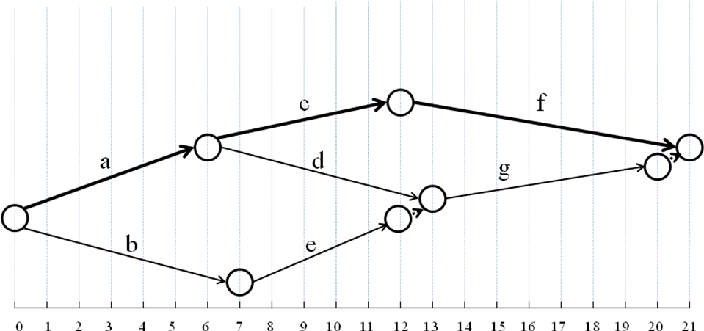

Activity | Predecessor | Time(N) | Time(C) | Cost(N) | Cost(C)
a | - | 6 | 5 | 60 | 105 | 45
b | - | 7 | 4 | 50 | 110 | 20
c | a | 6 | 4 | 100 | 160 | 60
d | a | 7 | 7 | 30 | 30 | -
e | b | 5 | 4 | 70 | 85 | 15
f | c | 9 | 7 | 40 | 110 | 35
g | d,e | 7 | 4 | 50 | 95 | 15

- What is the total cost of completing this project in 21 days?

- How do you crash the project for 1 day? What is the crashing cost?

Crash f for $35

- How do you crash the project for 2 days? What is the crashing cost?
- c + g = 60 + 15 = $75

