CALIFORNIA STATE UNIOVERSITY, NORTHRIDGE
College of Business and Economics
Department of Systems and Operations Management
SOM666 - Project Planning and Policy
Summer 2010
Dr. Ardavan Asef-Vaziri

Final Exam
August, 11, 2010

Time: 100 Minutes

Name: (please print)

There are 10 questions and 15 sub-problems each weighing 4 points.

This is a closed-book, closed-notes exam. A 4 by 6 guide sheet is allowed.
Sharing materials with other students is not allowed.

You may use a simple calculator. No laptops nor PDAs are allowed.

Please sign here to indicate that you have adhered to university policies regarding ethical behavior in preparing for and completing this exam.

Good Luck
Please write clearly. Thanks

Q1. Clearly explain the two types of matrix organization:

(i) Strong (or hard):

(ii) Weak (or soft):

Q2. Regarding the Design Matrix Structure
- Contrast Gantt chart or network precedence diagrams to Design Matrix Structure.

- What is the meaning of the above the diagonal elements of the Design Matrix Structure.

Q3. Would you expect a task in a manufacturing plant that uses lots of complex equipment to have a learning curve coefficient closer to 70%, or to 95%? Explain clearly.

(ii)

Q4. As indicated in our slides, a structured approach to help identify, prioritize, and manage risk covers 3 attributes. However, in our class discussion we also added one other attribute. What are these attributes?

Q5. Clearly describe the two main reasons of using Mean Absolute Deviation (MAD).

Q6. Clearly describe the two main reasons of using Tracking Signal.

Q7. What purpose(s) might be served by using each of the following priority rules for allocating scarce resources?

- Minimum slack first.

- As late as possible.

Q8. In bottom up budgeting, the coefficient of variation is higher at higher levels of the WBS. Is this true or false? Explain clearly.

Q9. The most four set of important information shown in Wheelwright and Clark (1992) project positioning graph are:

Q10. Which of the following is NOT a characteristic of effective project team members?
a) They are technically competent
b) They are politically sensitive
c) They have a strong orientation to their discipline
d) They have a strong goal orientation
e) They have high self-esteem

P1. A project has three sequential tasks.

a) The duration of the first task follows Uniform distribution with parameters of 50 and 100 days. Using rand() = 0.65, generate a random instance of the duration of the first task.

b) The duration of the second task follows Normal distribution with a mean of 100 and standard deviation of 15 days. Using rand() = 0.56, generate a random instance of the duration of the second task.

c) The duration of the third task follows Triangular distribution with parameters of: optimistic 3 days, most likely 5 days, and pessimistic 9 days. Using rand() = 0.7 generate a random instance of the duration of the third task.

P2. Consider the following project. The numbers are the durations of the activities.

H
4
4
4
A
B
C
D
E
G
F
I
2
3
2
4
5
5

a) Suppose extra budget is allocated to this project. With this extra money you can either reduce the duration of activity H or activity G by 2 days (either 2 days, or nothing). Which activity do you crash?? Why?

b) Given your decision in the above question (crash either H or G by exactly two days), what is the new duration of the project?

c) Now forget crashing the activities (ignore questions c and d), suppose the variance of the activities are as follows:
Activity | A | B | C | D | E | F | G | H | I
variance | 3 | 4 | 3 | 2 | 2 | 4 | 2 | 2 | 2

For what due date is there at least 96% probability to complete the critical path? In your final answer, ignore the second digit after the decimal point.

P3. Given the following network, the probability of completing the critical path in 19 days or less is 75%. The probability of completing the project in 19 days or less is 66%.
START
END
B
D
C
A
Activity | Time
 | Mean | Standard Deviation
A | 4 | 2
B | 12
C | 10
D | 3 | 1

a) Compute the standard deviation of activity B. In your final answer, ignore the second digit after the decimal point.

b) Compute the standard deviation of activity C. In your final answer, ignore the second digit after the decimal point.

P4. A project scheduled to finish in 12 months, at a cost of $600K. Earned Value statistics at the end of month 3 is given below

Month | BCWS | ACWP | BCWP
3 | 100K | 120K | 75K
Given the procedures discussed in class regarding optimistic and pessimistic estimates.

- Suppose the progress rate of the remainder of the project will be the same as the past performance (a pessimistic view) . How long does it take to complete this project?

- Suppose the cost rate of the remainder of the project, with exception of current budget overrun, will stay as scheduled (an optimistic view). What would be the total cost of the project?

P5. We have one unit of each of the three resources of Resource A, Resource B, and Resource C. The contract of the following project indicates that the duration of the project is 18 weeks.

Task | Precedence | Duration | Resource
Task1 | - | 5 weeks | Resource A
Task2 | - | 3weeks | Resource B
Task3 | Task1 | 3 weeks | Resource B
Task4 | Task2 | 6 weeks | Resource A
Task5 | Task3 and Task4 | 4 weeks | Resource C

a) Compute the project buffer.

b) Suppose 50% of task 1 was completed in 3 days. What color is assigned to this task? Why?

P6. Given the following project, activity c can be crashed in either 0 or 2 days.

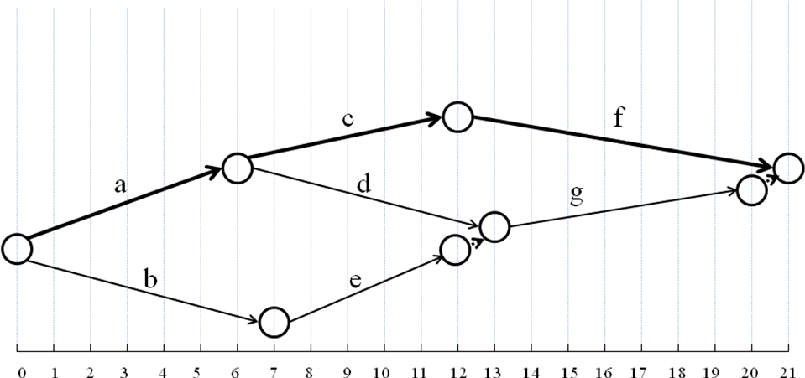

Activity | Predecessor | Time(N) | Time(C) | Cost(N) | Cost(C)
a | - | 6 | 5 | 60 | 105
b | - | 7 | 4 | 50 | 110
c | a | 6 | 4 | 100 | 160
d | a | 7 | 7 | 30 | 30
e | b | 5 | 4 | 70 | 85
f | c | 9 | 7 | 40 | 110
g | d,e | 7 | 4 | 50 | 95

- What is the total cost of completing this project in 21 days?

- How do you crash the project for 1 day? What is the crashing cost?

- How do you crash the project for 2 days? What is the crashing cost?

