UNIVERSITY OF SOUTHERN CALIFORNIA
Marshall School of Business
Department Information and Operations Management
IOM580 - Project Management
Spring 2009
Dr. Ardavan Asef-Vaziri

Final Exam
May 12, 2009

Time: 2 Hours

Name: (please print)

This exam consists of 10 problems and a total of 25 question. Each question weights at 4 points. There are 12 pages, including this page.

This is an open-book, open-notes exam. You may use a simple calculator.

No laptops nor PDAs are allowed.

Sharing materials with other students is not allowed.

Please sign here to indicate that you have adhered to university policies regarding ethical behavior in preparing for and completing this exam.

Please include ALL your computations. Good Luck
Please write in a way that I can read it. Thanks.
Please write in a way that I can read it. Thanks.
Please write in a way that I can read it. Thanks.

P1[12 points]. In formulation of the Southern Care Hospital case as a linear program model, we defined a set of binary variables Xij such that
Xij = 1 if task i is assigned to employee j and 0 otherwise.

a) What difficulty did we have in solving the problem using the solver and how did we resolve it?

There were too many variables that we defined. We eliminated 3 columns and we realized that in the absence of these 3 columns no assignment was given to 3 other columns. Therefore in the presence of the first 3 columns we eliminated, solver was able to find a solution.

b) The number of employees assigned to this project was restricted to 4. How was this constraint implemented in the model? As long as SOLVER solution is concerned, what was the main difference between the decision variables defined for this constraint and our original Xij decision variables?

Σ_{j}Y_{j} <= 4
Xij by themselves came out 0 or 1. We did not need to explicitly declare them binary, but Yi came out as a real number, so we put them as binary.

c) The number of the black belt employees assigned to this project was restricted to 1. How this part of the model was handled?

Joanna: This part of the model was handled automatically. Solver assigned only one BB to the project. We did not need to declare Yi+Yj<=1
Also Yi+Yj =1 is wrong

P2 [20 points]. Consider the following project. The numbers are the durations of the activities.

H
4
4
4
A
B
C
D
E
G
F
I
2
3
2
4
5
5

9
10
15
15
19
A
B
C
D
E
G
H
F
I
4
4
4
5
10
4
4
8
8
8
8
8
10
10
10
12
12
16
15
15
16
15
19
19
19
19
18
0
0
21
21

Activity | A | B | C | D | E | F | G | H | I
Earliest Start | 0 | 4 | 4 | 8 | 8 | 10 | 15 | 15 | 19
Latest Start | 0 | 5 | 4 | 8 | 12 | 10 | 16 | 15 | 19

a) Fill the earliest start row in the above table.

b) Fill the latest start row in the above table.

c) Suppose extra budget is allocated to this project. With this extra money you can either reduce the duration of activity H or activity G by 2 days (either 2 days, or nothing). Which activity do you crash?? Why?

Crash H because it is on the critical path.

d) Given your decision in the above question (crash either H or G by two days), what is the new duration of the project?

20 Days
e) Now forget crashing the activities (ignore questions c and d), suppose the variance of the activities are as follows:
Activity | A | B | C | D | E | F | G | H | I
variance | 3 | 4 | 3 | 2 | 2 | 4 | 2 | 2 | 2

For what due date is there at least 96% probability to complete the critical path? In your final answer, ignore the second digit after the decimal point.

z= 1.75
$1\text{.}\text{75}=\frac{(D−\text{21})}{\sqrt{\text{16}}}$ → 7=D-21 → D= 28

P3 [8 points]. Given the following network, the probability of completing the critical path in 19 days or less is 75%. The probability of completing the project in 19 days or less is 66%.
START
END
B
D
C
A
Activity | Time
 | Mean | Standard Deviation
A | 4 | 2
B | 12
C | 10
D | 3 | 1

a) Compute the standard deviation of activity B. In your final answer, ignore the second digit after the decimal point.

(19-16)/σ_{CP} = Z_{0.75} = 0.67 ➔ σ_{CP} = 3/0.67 = 4.478

2² + x² = 4.478² ➔ 4 + x² = 20 ➔ x² = 16 ➔ x = 4

b) Compute the standard deviation of activity C. In your final answer, ignore the second digit after the decimal point.

P(project) = P(path1) *P(Path2) = 0.66 = .75*P(path2) ➔ P(path2) = 0.88
(19-13)/σ_{path2} = Z_{0.88} = 1.17 ➔ σ_{CP} = 6/1.17 = 5.13
1² + x² = 5.16² ➔ 1 + x² = 26.32 ➔ x² = 25.32 ➔ x = 5

P4 [16 points]. Suppose that you had a project that was targeted to finish in 12 months, at a cost of $600K. Earned Value statistics at the end of month 3 is given below

Month | BCWS | ACWP | BCWP
3 | 100K | 120K | 75K
Given the procedures discussed in class regarding optimistic and pessimistic estimates.

- What is your optimistic estimate for budget to completion (ETC) of this project?

BAC = 600-75 = 525
Or

CV = 75-120 = -45
EAC= 600+45 = 645
ETC = 645-120 = 525

- What is your pessimistic estimate for budget to completion (ETC) of this project?

CPI = 75/120 = 0.625
EAC = 600/0.625 = 960
960-120 = 840

- What is your optimistic estimate for time to completion of this project?

SPI = 75/100 = 0.75
3=3/0.75 = 4 ➔ 4-3 = 1
12-3+1 = 10

- What is your pessimistic estimate for time to completion of this project?

SPI = 75/100 = 0.75
Time at completion = 12/0.75 = 16 months
Time to Completion = 16-3 = 13 months

P5[8 points]. A project has two sequential tasks. They both follow Triangular distribution with duration parameters of: optimistic 3 days, most likely 5 days, and pessimistic 9 days.

a) Using rand() = 0.2 generate a random instance of the duration of the first task.

$$\frac{m−a}{b−a}=\frac{5−3}{9−3}=\frac{1}{3}$$

Rand()=0.2 <= 1/3 → left side

(m-a)(b-a) = 2(6) = 12
$$x=3+\sqrt{\text{12}×0\text{.}2}=4\text{.}\text{55}$$

b) Using rand() = 0.7 generate a random instance of the duration of the second task.

Rand()=0.7 >= 1/3 → right side

$$9−\sqrt{(9−5)(9−3)(1−0\text{.}7)}$$

$$9−\sqrt{(\text{24})(0\text{.}3)}$$

= 9-2.68
= 6.32

P6[8 points] . The board of directors of IOM580 Development Corporation is considering capital investments to be included in their program. There are 25 candidate projects to be included in the project portfolio. Partial selection of a project is NOT possible.
A binary variable Xi has been defined, which is 1 if project i is included in the portfolio and is 0 otherwise.

- Write a single constraint to show: If project 11 in undertaken both projects 3 and 4 must be undertaken.

X3+X4>= 2X11

- Write a single constraint to show: If both projects 3 and 4 are undertaken, project 11 must be undertaken.
X3+X4<= 1+X11

P7[ 8 points]. We have one unit of each of the three resources of Resource A, Resource B, and Resource C. The contract of the following project indicates that the duration of the project is 20 weeks.

Task | Precedence | Duration | Resource
Task1 | - | 5 weeks | Resource A
Task2 | - | 8 weeks | Resource B
Task3 | Task1 | 7 weeks | Resource B
Task4 | Task2 | 4 weeks | Resource A
Task5 | Task3 and Task4 | 3 weeks | Resource C

a) Compute the project buffer.

b) Compute and identify the feeding buffer(s).

3 weeks
3 weeks

Project buffer= 2 weeks
Feeding buffers = 6 weeks

P8 [4 points]. Draw activity on ARROW (AOA) network for the following project

Task Preceding
Task
B -
A -
D B,A
C B
E C,D

A
B
C
D
E

P9[8 points]. Given the following project, activity c can be crashed in either 0 or 2 days.

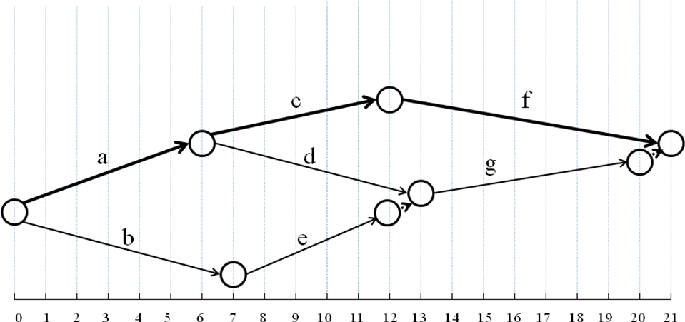

Activity | Predecessor | Time(N) | Time(C) | Cost(N) | Cost(C)
a | - | 6 | 5 | 60 | 105
b | - | 7 | 4 | 50 | 110
c | a | 6 | 4 | 100 | 160
d | a | 7 | 7 | 30 | 30
e | b | 5 | 4 | 70 | 85
f | c | 9 | 7 | 40 | 110
g | d,e | 7 | 4 | 50 | 95
45
20
60
-
15
35
15

- How do you crash the project for 1 day? What is the crashing cost?

Crash f for $35

- How do you crash the project for 2 days? What is the crashing cost?

c + g = 60 + 15 = $75

P10 [8 points].

a) Will all activities on a noncritical path have the same slack? Why or why not?

No, all activities on the same non-critical path will not necessarily have the same slack.

This is because a particular activity may be on multiple paths. When an activity is on more than one path, its slack is determined by the path with the least amount of slack.

b) What purpose(s) might be served by using each of the following priority rules for allocating scarce resources?

As late as possible.

Shortest task duration time first.

Minimum slack first.

a. Starting a task as late as possible … preserves resources and delays cash flows as long as possible.
b. Allocating resources to tasks with the shortest durations … first maximizes the number of tasks that can be completed within a certain time period.
c. The minimum slack priority rule … is used to minimize the number of late activities.

