UNIVERSITY OF SOUTHERN CALIFORNIA
Marshall School of Business
Department Information and Operations Management
IOM580 - Project Management
Spring 2009
Dr. Ardavan Asef-Vaziri

Final Exam
May 12, 2009

Set A

Time: 2 Hours

Name: (please print)

This exam consists of 10 problems and a total of 25 questions. Each question weights at 4 points. There are 12 pages, including this page.

This is an open-book, open-notes exam. You may use a simple calculator.

No laptops nor PDAs are allowed.

Sharing materials with other students is not allowed.

Please sign here to indicate that you have adhered to university policies regarding ethical behavior in preparing for and completing this exam.

Please write in a way that I can read it. Thanks.
Please include ALL your computations. Good Luck

P1[12 points]. In formulation of the Southern Care Hospital case as a linear program model, we defined a set of binary variables Xij such that
Xij = 1 if task i is assigned to employee j and 0 otherwise.

a) What difficulty did we have in solving the problem using the solver and how did we resolve it?

b) The number of employees assigned to this project was restricted to 4. How was this constraint implemented in the model? As long as SOLVER solution is concerned, what was the main difference between the decision variables defined for this constraint and our original Xij decision variables?

c) The number of the black belt employees assigned to this project was restricted to 1. How this part of the model was handled?

P2[20 points]. Consider the following project. The numbers are the durations of the activities.

H
4
4
4
A
B
C
D
E
G
F
I
2
3
2
4
5
5

Activity | A | B | C | D | E | F | G | H | I
Earliest Start
Latest Start

a) Fill the earliest start row in the above table.

b) Fill the latest start row in the above table.

c) Suppose extra budget is allocated to this project. With this extra money you can either reduce the duration of activity H or activity G by 2 days (either 2 days, or nothing). Which activity do you crash? Why?

d) Given your decision in the above question (crash either H or G by two days), what is the new duration of the project?

e) Now forget crashing the activities (ignore questions c and d), suppose the variances of the activities are as follows:
Activity | A | B | C | D | E | F | G | H | I
variance | 3 | 4 | 3 | 2 | 2 | 4 | 2 | 2 | 2

For what due date is there at least 96% probability to complete the critical path?

P3[8 points]. Given the following network, the probability of completing the critical path in 19 days or less is 75%. The probability of completing the project in 19 days or less is 66%.

START
END
B
D
C
A
Activity | Time
 | Mean | Standard Deviation
A | 4 | 2
B | 12
C | 10
D | 3 | 1

a) Compute the standard deviation of activity B. In your final answer, ignore the second digit after the decimal point.

b) Compute the standard deviation of activity C. In your final answer, ignore the second digit after the decimal point.

P4 [16 points]. Suppose that you had a project that was targeted to finish in 12 months, at a cost of $600K. Earned Value statistics at the end of month 3 is given below.

Month | BCWS | ACWP | BCWP
3 | 100K | 120K | 75K

Given the two procedures discussed in class regarding optimistic and pessimistic estimates.
- What is your optimistic estimate for budget to completion (ETC) of this project?

- What is your pessimistic estimate for budget to completion (ETC) of this project?

- What is your optimistic estimate for time to completion of this project?

- What is your pessimistic estimate for time to completion of this project?

P5 [8 points]. A project has two sequential tasks. They both follow Triangular distribution with duration parameters of: optimistic 3 days, most likely 5 days, and pessimistic 9 days.

a) Using rand() = 0.2 generate a random instance of the duration of the first task.

b) Using rand() = 0.7 generate a random instance of the duration of the second task.

P6[8 points]. The board of directors of IOM580 Development Corporation is considering capital investments to be included in their program. There are 25 candidate projects to be included in the project portfolio. Partial selection of a project is NOT possible.
A binary variable Xi has been defined, which is 1 if project i is included in the portfolio and is 0 otherwise. Write the following constraints:

- If project 11 is undertaken both projects 3 and 4 must be undertaken.

- If both projects 3 and 4 are undertaken, project 11 must be undertaken.

P7 [8 points]. We have one unit of each of the three resources of Resource A, Resource B, and Resource C. The contract of the following project indicates that the duration of the project is 20 weeks.

Task | Precedence | Duration | Resource
Task1 | - | 5 weeks | Resource A
Task2 | - | 8 weeks | Resource B
Task3 | Task1 | 7 weeks | Resource B
Task4 | Task2 | 4 weeks | Resource A
Task5 | Task3 and Task4 | 3 weeks | Resource C

a) Compute the project buffer.

b) Compute and identify the feeding buffer(s).

P8 [4 points]. Draw activity on ARROW (AOA) network for the following project

Task Preceding
Task
B -
A -
D B, A
C B
E C, D

P9 [8 points]. Given the following project, activity c can be crashed in either 0 or 2 days.

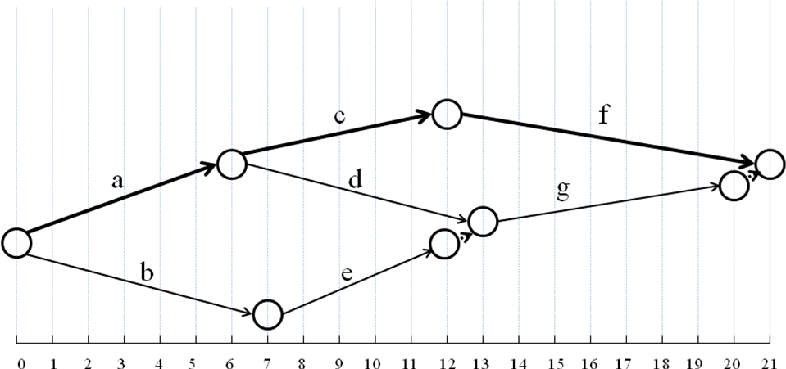

Activity | Predecessor | Time(N) | Time(C) | Cost(N) | Cost(C)
a | - | 6 | 5 | 60 | 105
b | - | 7 | 4 | 50 | 110
c | a | 6 | 4 | 100 | 160
d | a | 7 | 7 | 30 | 30
e | b | 5 | 4 | 70 | 85
f | c | 9 | 7 | 40 | 110
g | d,e | 7 | 4 | 50 | 95

- How do you crash the project for 1 day? What is the crashing cost?

- How do you crash the project for 2 days? What is the crashing cost?

P10 [8 points].

a) Will all activities on a noncritical path have the same slack? Why or why not?

b) What purpose(s) might be served by using each of the following priority rules for allocating scarce resources?

As late as possible.

Minimum slack first.

