

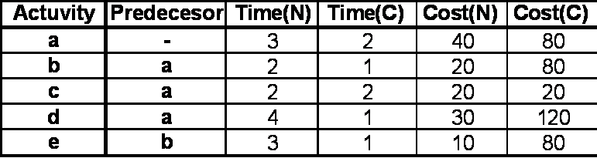

1. Compute the total cost of completing this project in 7 days. Include **ALL** your computations.

) Compute the total cost of completing this project in 6 days. Include **ALL** your computations.