Project/Project information /start date etc
Enter data and precedence (Table 5-2 page 149)
A 5 -
B 4 -
C 3 a
D 4 a
E 6 a
F 4 b,c
G 5 d
H 6 d,e
I 6 f
J 4 g,h

Add Start and End
View/View Bar
View/zoom/entire project
Network, right click on white background, allow manual position
To see the slacks
View/more/view/Detail Gantt
Or
Table/Schedule
Project/filter/critical
Summary Task: Table 3-5 or 5-3?
PERT Analysis
View/Toolbars/PERT Analysis
Click on Pert Entry sheet icon
To transform all times in a unique unit
Tools/Options
Schedule Tab ➔ select weeks
The schedule tab is where you modify the default settings for entering tasks.
Ignore Duration for now, these will be calculated
Ignore Resource Names, we will learn this in a later lesson
Duration is now in weeks… 1day/5days= .2wks
Enter data from Table 5-6
Click on Pert Calculate icon
Click Yes ( you may want to save the pre-existing project before doing this, as it will overwrite any previous entries in duration).
Calendar
Standard calendar: 8 hrs/wk, 5days/wk
Click on calendar icon
Month/week/ custom (to choose a specific time interval)
⬅ ➔ forward backward buttons
To modify calendar structure ➔ Format/TimeScale
Here we can modify: (Monthly, daily, & weekly titles, Display all days/work days, Date boxes, shading, and more)
To Create 2^{nd,} 3rd, …. Calendars
Tools/change working time
Select create new calendar
Name your calendar: Type the name of your calendar
Make a copy of Standard
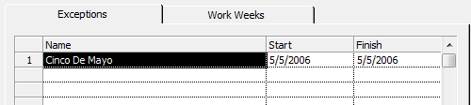
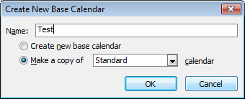
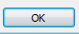

Click on detail bottom
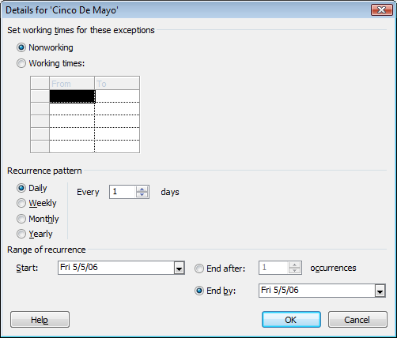

You can also Modify the schedule for the work week: (hypothetical, get off @ 1 on Fridays)
Choose the Work Weeks Tab (in the same Change Working Time box)
Enter the Name, Start date, and End date (in this ex., Early Fridays will apply for the length of the project).
Early Friday. Recurrence: weekly
Apply project calendar to the entire project
Project/Project Information/ Calendar dropdown/select calendar/OK
In the calendar view you can now see changes have been applied. May 5 no longer scheduled, Early Friday
Gantt and Network also updated
WBS

Part 2
From 5 days a week to 7 days
Tools/ Change Working Time/ Work Weeks/Details/ Select all seven days/ Set days to specific Working Times/Set the whole week to an 8 hour shift/ OK

