**1. [2 points].**  Why are the benefits of Aggregate Project Plan?

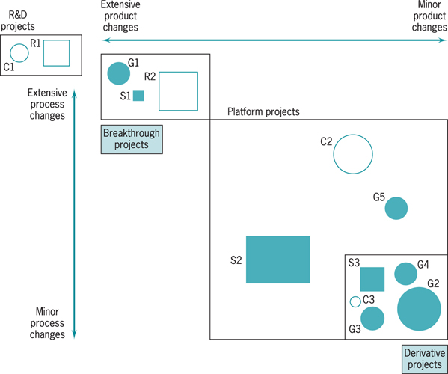

a) to make sure that our projects fit our strategic position

b)

c)

**2. [2 points]** According to our class discussion, what is an action plan?

**3.[2 points].** What is WBS?

**4. [2 points}** what information is represented in design structure matrix?

**5. [2 points].** An activity has uniform distribution between 15 and 25 days. Using rand()=0.25 generate an instance of the duration of this activity.