Chapter 3
Problem 24. Prepare an action plan using MSP with the steps that must be completed before Vern Toomey can contact outsourcing vendors. If Vern starts on August 1, 2005, how long will it take to get ready to contact outsourcing vendors?

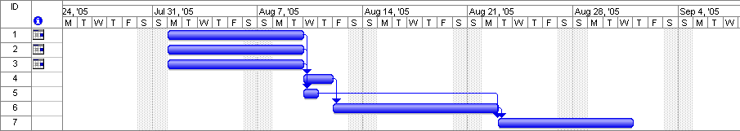

Based on the information in the Gantt chart it would be Tuesday, August 23, '05 before Vern would be able to contact vendors for the outsourcing proposals,

