**Chapter 2**

**Process Flow Analysis**

**The Little’s Law: The Core Concept in Business Processes Engineering**

***Eyes must be washed; to see things differently. Sohrab Sepehri, Persian Poet, 1928–1980.***

The key problems of this chapter can be accessed at

<http://www.csun.edu/~aa2035/CourseBase/Process/Process2018/1.ProcessKeyProblems.pptx>

If you use a tablet or Mac, please make sure to open the slides using keynotes, otherwise, if you open them by default, the animations are not retained.

The recorded lectures – if any- are embedded inside the PowerPoint slides. Have the slides in the slide show mode, wait for the page to get activated, then click on the play arrow. Alternatively, and especially if you use tablet or Mac, you may copy and paste the link at the bottom of the page into a browser.

The excel worksheet – if any- are embedded inside the PowerPoint slides. By clicking on them, the excel page and excel interface will open. Alternatively, you may right-click and open the worksheet.

**Introduction.** It has been reported that U.S. residents spend close to 40 billion hours per year waiting in lines. Even at the cost of $15 per hour, this adds up to $600 billion per year. Add that to the cost, the frustration, and the irritation people feel when waiting in lines. In this chapter, we study the relationship between Throughput (the rate at which people or product enter and leave a system), Flow Time (the amount of time they spend in the system), and Inventory [the number of flow units (people or products) in the system].

**Problem1. The Coffee Shop.** A manager of a local coffee shop close to the Reseda and Plummer intersection has realized that during busy hours, the entrance door on average opens two times per minute to let in 2 customers per minute. In a stable system, if two customers enter per minute, two customers should leave per minute. In the short run, we may have variations, but over a long period, input should be equal to output. It is possible that in 5 minutes, ten customers come in and 12 customers go out. However, over a long period (even a day), the output cannot exceed input because how can the difference be generated? Similarly, the output cannot be less than input because, over a long period, there will be no room in the coffee shop (or even in a large stadium). It is possible that in 5 minutes, ten customers come in and eight customers go out. However, over a full day, input cannot exceed output. In stable systems, flow units come in as input, leave the system as output, and input per unit of time is equal to output per unit of time. In our example, if, on average, two customers come in per minute, then two customers, on average, should leave the system.

**a) What is the throughput of the coffee shop?**

Every minute, two customers enter, and two customers leave — R= 2 customers per minute.

**Throughput (R)** is the average flow rate in a stable system where the average input is equal to average output over an extended period. Throughput is expressed as a number with a time unit attached to it (e.g., per minute, per hour, per day, per month, etc.).

**Inventory (I)** is the number of flow units in the system (e.g., customers in a coffee shop, students at CSUN, cars for sale on a lot, etc.).

During the corresponding hours in the coffee shop, on average, there are five customers in the store (system), four are waiting in line (buffer) to order, and one is with the server.

**b) What is the inventory (I) in the coffee shop?**

On average, there are five customers in the coffee shop. Inventory is 5. I = 5.

**c) How long, on average, is a customer in your coffee shop (inventory expressed in the unit of time)?**

**Flow Time (T)** is the time it takes input to become an output. It is the time a flow unit spends within a system.

Before a customer steps in the system, there are five other customers in the system. The moment she steps into the line for service, one fully served customer leaves the system. That is, there are always five people in the system. Our incoming customer at the beginning has four people in front of them, then 3 in front and one behind, then 2 in front and two behind, then 1 in front and three behind, then no one in front and four behind her. At the instance when she steps out of the system, just in the fraction of second stepping out, she looks over her shoulder.

How many people are behind her? 5.

At what rate did they come in? 2 per minute.

How long does it take five people to come in if they arrive at the rate of 2 per minute?

1 minute 2 customers

How many minutes (T) 5 customers

T= (1×5)/2 🡺 T = 2.5 minutes.

On average, a customer spends 2.5 minutes in the coffee shop; flow time (T) is 2.5 minutes. Each customer enters the coffee shop, spends 2.5 minutes on average and then leaves. In the above computation, the flow time (T) is defined in minutes because R was in minutes. R carries a time unit with it, i.e., 2/minute, 2(60) = 120/hour, and, if a day is 8 hours, it can also be expressed as 2(60)(8) = 960/day. **However, remember: inventory (I), does not carry a time unit, it is always a number.**

Now, let us generalize

1 time unit R flow units

How many time units (T) I flow units

T= I/R 🡺 RT= I.

**The Little’s Law** is expressed as Throughput x Flow Time = Inventory.

R×T = I or T = I/R or R = I/T

**A Fundamental Insight.** Note, that the Little’s Law, T=I/R, is nothing more than a unit conversion, converting numbers into time. It turned **5 units** of inventory into **2.5 minutes** of inventory. Suppose we have **100** units of item A, and **1000** units of item B. What item do we have more of? In the count dimension, item B has a higher inventory. Suppose we use 4 units of item A per day (RA= 4/day), and 200 units of item B per day (RB=200/day). In the time dimension, we have (T=100/4), **25** days inventory of item A, and (T=1000/200) **5** days inventory of item B. On the time dimension, the inventory of item A is larger than the inventory of item B. It takes more time to consume the inventory of item A, compared to that of consuming item B. In addition to measuring inventory in count and time dimensions, we can measure it on the third dimension of value. How much money is invested in the inventory of each item? There is even a fourth dimension. How much space (i.e. in a warehouse)?

**Value**

**Units**

**INVENTORY**

**Time**

**Space**

**If you have had difficulty understanding this problem, we encourage you to watch the recorded lecture and PowerPoint slides at**

[**http://www.csun.edu/~aa2035/CourseBase/Process/Process2018/0.ProcessBasics.pptx**](http://www.csun.edu/~aa2035/CourseBase/Process/Process2018/0.ProcessBasics.pptx)

**Problem 2. The Coffee Shop—Extended.** Let us go back to our prototype example. Suppose after the initial waiting line in the coffee shop, to pay or get standard items such as a black coffee, there is a second waiting line for exotic hot and cold beverages such as lattes, cappuccinos, etc. Suppose R is still 2 customers per minute, and still, on average, there are 5 customers in the first line waiting to pay for their order and get their non-exotic coffee or other items already available on the shelves (made-to-stock, or MTS items). In addition, suppose 2 out of the 5 customers place their order and then go on to wait in the exotic order line which needs preparation (make-to-order or MTO items). Therefore, 40% of the customers place exotic orders. A pictorial representation of the process is illustrated below.

Exotic order customers

40%%

40%

All customers

Ordinary order customers

60%%

1. **What is the flow time of the first line?**

Each customer spends 2.5 minutes in the first line (as determined in the first problem).

1. **What is the throughput of the customers in the exotic order line?**

The throughput of the second line is 40% of 2 customers per minute. That is 0.4(2) = 0.8 customers per minute, or 0.8(60) = 48 customers per hour, or 0.8/60 = 0.13333 customers per second. **Note that it is not 40% of 5, but 40% of 2**. Indeed, 40% of those 5 people will go to the second line, but there are two points to mention. First, 40% of the inventory will go to the second line, but not suddenly. They will go at the rate of 0.4(2) = 0.8. Second, there are always 5 people in the first line, no matter the rate at which they go into the second line.

1. **What is the inventory (I) of the exotic order line?**

Inventory of the second line, as given in the graph, is 4. The problem gives it. It is always 4, no matter whether we state R in minutes, seconds, or hours.

1. **What is the flow time of a person who orders regular coffee?**

We have already done this computation. It is T=I/R = 5/2= 2.5.

1. **What is the flow time of a person who orders exotic coffee?**

The person who orders exotic coffee has already spent 2.5 minutes in the first line. For the time in the second line, we again apply Little’s Law where R=0.8 and I =4.

R x T = I 🡺 0.8 x T = 4 🡺 T=5 minutes (since T is 0.8 per minute.).

T (first line) = 2.5, T (second line)= 5 minutes.

T (exotic order)= 2.5 + 5 = 7.5 minutes.

**f) What is the flow time of a prototype customer (flow unit)?**

In general, a prototype flow unit does not exist in reality. It is a melted version, a weighted average, of all of the flow units. In this example, it is a customer who is 60% a person who gets an MTS item and 40% a customer who gets an MTO item.

There are several ways to answer this question. We show three of them:

**Procedure 1 (Micro) -**

60% simple order: T = 2.5.

40% exotic order: T=2.5+5= 7.5.

An average customer is 60% a simple order person (2.5 minutes.), and 40% an exotic order person (7.5 minutes).

T = 0.6(2.5) + 0.4(7.5) = 4.5 minutes. We can use the SUMPRODUCT function in excel if the summation of weights is equal to 1. If it is not, then we will use SUMPRODUCT and then divide it by the SUM of the weights.

**Procedure 2 (Micro/Macro) -**

Everyone goes through the first process and spends 2.5 minutes.

60% spend no additional time and leave. 40% spend 5 additional minutes.

0.6(0) ordinary order customers + 0.4(5) exotic order customers = 2 minutes

2.5 (every customer) + 2 (exotic orders) = 4.5 minutes.

**Procedure 3 (Macro- the most logical) -**

The throughput of the system is 2 customers per minute. There are 9 flow units in the system (5 in the first and 4 in the second line).

R x T= I 🡺 2 x T = 9 🡺 T = 4.5 minutes

The throughput of the coffee shop (system) is 2 per minute, or 120 per hour, or 720 per day (assuming 6 busy hours per day), or 1/30 per second. However, inventory in the system is **always 9.**

**If you had difficulties understanding this problem, we encourage you to go through problems E1 and E3 on the following slides.** <http://www.csun.edu/~aa2035/CourseBase/Process/Process2018/1b.ProcessAdditionalProblemsBasic.pptx>

**Problem 3. David Nazarian College of Business and Economics (DNCBE).** Over the past 10 years, on average, there were 1600 incoming students per year at DNCBE. On average, the headcount of students enrolled over the same period was 7200.

**a) On average, how long does a student spend in DNCBE (average time to graduation)?**

RT=I 🡺  1600T = 7200 🡺 T = 4.5 years

While at first glance, this number appears to be better than the surrounding programs, we should note that it is for transfer and freshmen students combined. In fact, 40% of the students are freshmen, and the rest are transfer students. In addition, according to the data from CSUN*,* the time to graduation (the duration of time from the first day of starting the college education to the day of graduation) for freshmen students on average, is 2.25 times that of the transfer students.

**b) How long does it take freshman students to graduate? How long does it take transfer students to graduate?**

T = Time to graduation for a transfer student (60% of all students).

2.25T = Time to graduation for a freshman (40% of all students).

Average time to graduation for all students = 4.5 years.

All students comprise of 40% freshman and 60% transfer, and this can be represented by the following equation:

0.6T+0.4(2.25T) = 4.5 years 🡺 0.6T +0.9T = 4.5 years 🡺 1.5T = 4.5 years 🡺 T = 3 years

Time to graduation for a transfer student = 3 years.

Time to graduation of for a freshman student = 3(2.25) = 6.75 years.

Out of the 1600 incoming students per year, on average, 25% are accounting majors, 20% marketing, 20% management, 15% finance, and the rest are other majors. The business school has 2200 accounting students, 1200 marketing students, 1200 management students, and 1400 students in all other majors except finance. The rest of the 7200 headcounts of the college students are in the finance department.

**c) On average, how many accounting students graduate each year?**

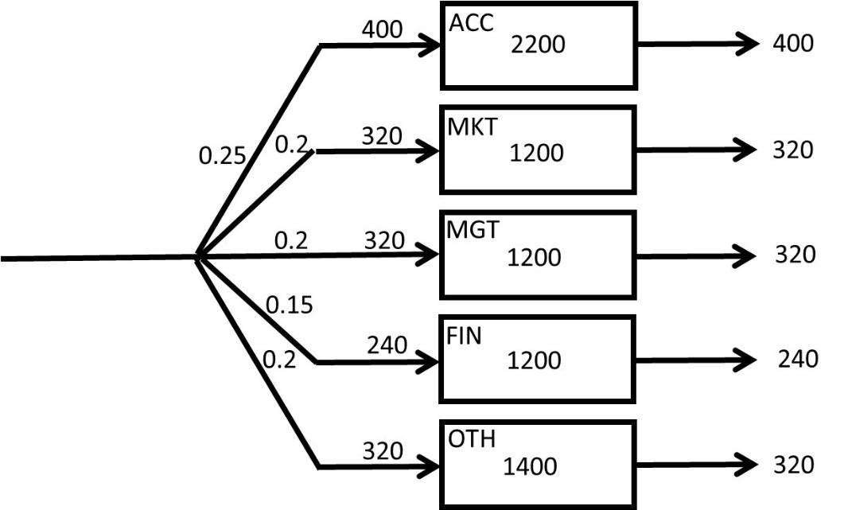

If 25% of the 1600 students enter and exit per year, then the throughput for the accounting department is: RACC = 0.25(1600) = 400 per year.

**d) How long, on average, does it take a finance student to graduate (what is the flow time of a finance student)?**

RFIN = 0.15(1600) = 240/year.

IFIN = 7200-(2200+1200+1200+1400) = 1200 students.

TFIN = 1200/240 = 5 years.

**e) On average, which major takes the longest time to graduate and which major takes the shortest time to graduate?**



Longest = Accounting (5.5 years)

Shortest = Marketing and Management (3.75 years).

1. **Using part (a), prove that your computations in part (g) are correct.**

We have time to graduation for all the five groups and their relative weights. We may use

SUMPRODUCT function to compute 0.25(5.5) + 0.2(3.75) + 0.2(3.75) + 0.15 (5) + 0.2(4.375) = 4.5.

We had the information that 40% of the incoming students are freshmen, and the rest are transfer students. Sadly, we have the additional information that there are 12.5% dropouts, where 10% are freshmen and the rest transfers. The time to graduate for freshmen students, on average, is 2.25 times that of the transfer students. The average time that the dropouts spend in DNCBE is 1.5 years. The average time for transfer students that dropout is 0.75 years.

**How long does it take freshman students to graduate?**

T: time to graduation for a transfer student @60%-2.5% = 57.5%.

2.25T: time to graduation for a freshman student @40%-10% = 30%.

1.5: Time to drop-out for a freshman@10%

0.75: Time to drop-out for a transfer@2.5%

0.025(0.75)+0.1(1.5)+0.575T+0.3(2.25T)=4.5

0.16875+0.575T+0.675T=4.5

1.25T=4.5-0.16875 =4.33125

T=3.465

Time to graduation for a transfer student = 3.465 years

Time to graduation for freshman student = 2.25T

Time to graduation for freshman student = 2.25(3.465) = 7.8 years

**If you had difficulties understanding this problem, we encourage you to watch the recorded lecture of a very similar problem posted on** [**https://youtu.be/gFNYXGye4Jo**](https://youtu.be/gFNYXGye4Jo)

**The PowerPoint slides are on the Process Key Problems posted at the beginning of this chapter.**

**Problem 4. CSUN&UCLA Fresh Juice Stands.** A recent CSUN graduate has opened up a cold beverage stand, CSUN-STAND, in Venice Beach. She works 8 hours a day and observes that, on average, 320 customers are visiting the CSUN-STAND every day. She also notes that, on average, a customer stays in line at the stand for 6 minutes.

**a)** How many customers, on average, are waiting at CSUN-STAND?

1. **4**
2. 2.75
3. 3.75
4. 3.25
5. 4.25

She is thinking about running a marketing campaign to boost the number of customers. She expects that the number of customers will increase to 480 per day after the campaign. She wants to keep the line short at the stand and hopes to have only 2 people waiting on average. Thus, she decides to hire an assistant.

**b)** What is the average time a customer will wait in the system after all these changes?

1. 4 min.
2. 3 min.
3. **2 min.**
4. 1 min.
5. none of the above

**c)** After the marketing campaign, a recent UCLA graduate opens up a competing cold beverage stand. The UCLA graduate is not as efficient as the CSUN graduate is, so customers must stay an average of 10 minutes at “UCLA-STAND.” Suppose there is an average of 3 customers at UCLA-STAND. The total number of customers for both CSUN- and UCLA- STANDs remains at 480 per day, as it was after the marketing campaign. Now it is divided between the CSUN- STAND and UCLA- STAND. How many are fewer customers visiting CSUN-STAND per day?

1. 177 customers per day
2. **144 customers per day**
3. 166 customers per day
4. 155 customers per day
5. 133 customers per day

**If you had difficulties understanding the problem, we encourage you to watch the recorded lecture of a problem very similar to this problem, recorded at** [**https://youtu.be/QjS_K1zcmw0**](https://youtu.be/QjS_K1zcmw0)

**The PowerPoint slides are on the Process Key Problems posted at the beginning of this chapter.**

**Problem 5. Academic Technology Help Desk.**

**Original Process:** A help-desk administrator at CSUN receives 2000 emails per month requesting assistance. Assume there are 20 working days per month. On average, 100 unanswered emails are waiting in the mailbox of Administrator A (Admin-A).

What is the average flow time for handling a request?

R= 2000/20 = 100 per day.

RT=I 🡺 100T= 100 🡺 T = 1 day

**New Process:** To help reduce the number of unanswered emails, CSUN hired two more administrators to the help-desk department. In the new process, Administrator A (Admin-A) responds to 60% of the emails **to-satisfaction**, without further investigation. 10% of the remaining emails are forwarded to Administrator B (Admin-B), and the rest to Administrator C (Admin-C). On average, 50 emails in the email box of Admin-A, 20 in the email box of Admin-B, and 20 are waiting in the email box of Admin-C. Additionally, Admin-C responds to 80% of the emails sent to him to-satisfaction, and he considered the rest of the emails as **out-of-scope** of the help-desk responsibilities. Admin-B responded to half of the emails sent to him to-satisfaction, and the rest of the emails out-of-scope.

1. Compute average flow time
2. Compute average flow time at Admin-A
3. Compute average flow time at Admin-B
4. Compute average flow time at Admin-C
5. Compute average flow time of an out-of-scope response
6. Compute average flow time of a response to-satisfaction



**a) Compute Average Flow Time**

I = Ia + Ib + Ic= 50 + 20 + 20 = 90

R = 2000 per month or 2000/20 = 100 per day or 100/8 (working hours) = 12.5 per hour

I is always 90. It does not carry a time unit.

T = I/R = 90/12.5 = 7.2 hours. It is in hours because R was calculated per hour.

**b) Compute Average Flow Time for Admin-A:**

Throughput RA = 12.5 emails/per hour

Average Inventory IA = 50 emails

TA = 50/12.5 = 4 hours with Admin-A

**c) Compute Average Flow Time for Admin-B:**

Throughput RB = 0.1 (12.5) = 1.25 emails/hour

Average Inventory IB = 20 emails

TB = 20/1.25 = 16 hours with Admin-B

**d) Compute Average Flow Time for Admin-C:**

Throughput RC = 0.3 (12.5) = 3.75 emails/hour

Average Inventory IC = 20 emails

TC = 20/3.75 = 5.33 hours with Admin-C

**Additional Information Derived from the Problem:**

One flow unit at a very macro level = Email

2000 flow units/per month at very micro level = each specific email

In the Original Process, there are two flow units: To-satisfaction and Out-of-scope

In the New Process, there are five flow units: To-satisfaction (Admin-A), To-satisfaction (Admin-B), To-satisfaction (Admin-C), Out-of-scope (Admin-B), and Out-of-scope (Admin-C).

To-satisfaction (Admin-A): A

To-satisfaction (Admin-B): A, B

To-satisfaction (Admin-C): A, C

Out-of-scope (Admin-B): A, B

Out-of-scope (Admin-C): A, C

TA = 4 hours, TB = 16 hours, TC = 5.33 hours.

We also need percentages for each of the five flow units.



**e) Compute Average Flow Time of an Out-of-scope Email:**

Out-of-scope (Admin-B): A, B 🡺 4+16 = 20 Out-of-scope -A: 5%

Out-of-scope (Admin-C): A, C 🡺 4+5.33 = 9.33 Out-of-scope -B: 6%

[0.05(20) +0.06(9.33)]/ (0.05+0.06) = 14.18

**f)** **Compute Average Flow Time of a Response to-satisfaction:**

To-satisfaction –A: A 🡺 4 @ 60%

To-satisfaction –B: A, B🡺 4+16=20 @ 5%

To-satisfaction –C: A, C 🡺 4+5.333=9.333 @ 24%

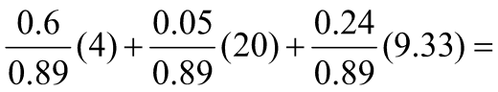

= 6.34

**Check our computations:**

Average flow time of an application

0.89(6.34) +0.11(14.18) = 7.2

**If you had difficulties understanding this problem, we encourage you to go through a very similar problem. The PowerPoint slides are in the Process Key Problems posted at the beginning of this chapter. Part1 of the recorded solution is at** [**https://www.youtube.com/watch?v=TauGBb5xbVs**](https://www.youtube.com/watch?v=TauGBb5xbVs) **The rest of the recorded solution is at** [**https://youtu.be/pyFq8JDHljM**](https://youtu.be/pyFq8JDHljM)

**Problem 6. SAMOAK Industries.** SAMOAK family has been in industrial developments for close to a century. They got the idea of smooth flow from Henry Ford and took it to a new dimension of time-based competition. The following data represents the inputs and outputs at one of their plants throughout 50 days. Assume that the plant is working 24 hours 7 days a week.



[**http://www.csun.edu/~aa2035/CourseBase/Games/1.Flow-Time-Game-Inclass.xlsx**](http://www.csun.edu/~aa2035/CourseBase/Games/1.Flow-Time-Game-Inclass.xlsx)

**Questions:**

1. Compute the end of the day inventory for all days.

2. Compute descriptive statistics for input, output, and inventory.

3. Estimate flow time.



**LFT-Game1 Questions.**

Here is an example of what I expect in your Game 1 first 50 days report.

1. **Demand.** You can provide two or perhaps four numbers regarding the demand in the past 50 days and your expectations for the near future.
2. **Capacity.** You can provide 3 numbers representing the capacity of the machines.
3. **Inventory.** You can provide one number as the average inventory in the first 50 days.
4. **Flow time.** You can provide one or perhaps two numbers as your estimate of the average flow time in the first 50 days.

**Solving the following problem is not mandatory. You may solve it if you wish.**

**Problem 7. Northridge Hospital.** On Average 80 patients per hour arrive at a hospital emergency room (ER).

All patients first register through an initial registration process. On average, there are 9 patients in the registration waiting line (RgBuff). The registration process takes 6 minutes. A triage nurse practitioner then examines the patients.

On average, there are 2 patients waiting in the triage waiting line (TrBuff). The triage classification process takes 5 minutes.  
On average, 91% of the patients are sent to the Simple-prescription process, and the remainder is sent to Hospital-admission.  
On average, 6 patients are waiting in the Simple-prescription waiting line (SpBuff) in front of this process.

A physician spends 6 minutes on each patient in the Simple-prescription process.  
Unfortunately, on average, 2 patients per hour are sent to the Hospital-admission buffer (HsBuff) after being examined for 6 minutes in the Simple prescription process.  
On average, 0.9 patients are waiting in the HsBuff.  
A physician spends 25 minutes on each patient in the Hospital-admits process.

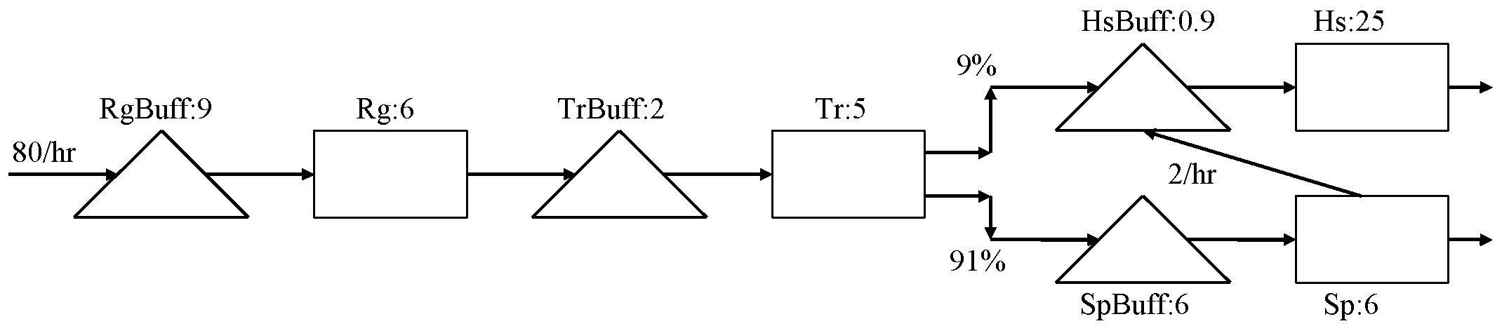

 

7.2/hour and 0.12/minute on the left table are incorrect. Why?

Because 7.2 is 9% of 80. However, the input in HsBuffer and HsProc is not 7.2.

Is it more or less?

It is more because 2 patients per hour are directed from SpProc (Simple-prescription process) to HsBuss (Hospital-admission waiting line).

Therefore, the numbers adjusted on the right table are 7.2+2=9.2 per hour or 0.15333 per minute.

Now if we look at the rows of the table, each contains two elements of the Little’s Law, and finding the third one is trivial. However, we need to note that since flow time (T) is stated in minutes, we cannot use R per hour, but R per minute. The rest is just T=I/R and I=RT, as summarized in the following table:

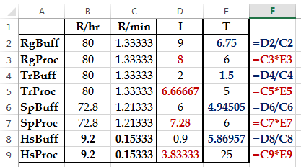

Now we have everything needed to compute the average flow time.

Note that we cannot just add all times, because 100% of flow units do not go through each and every process.

It is instead required to add the inventories, which is equal to 43.68.

Now we have a black box, and for the time being, we do not care what is happening inside it. However, we know that 80 flow units per hour enter and exit this black box, and on average, there are 43.68 flow units inside the box. Then by virtue of the Little’s Law,

RT=I 🡺 80T = 43.68 🡺 T=0.546.

0.546 what?

Hours because R is stated in terms of hours. If you want it in minutes, just multiply it by 60.

Alternatively, you may have R= 1.33333 per minute, instead of 80 per hour. Therefore,

1.33333T=43.68 🡺 32.76 minutes.

What is the flow time of the patients with a simple prescription? In addition, what is the flow time of the patients who are hospital admitted? There is only one type of simple prescription patient. Nevertheless, the hospital admitted patients are of two types; those admitted directly and those who wrongly go through the simple prescription process and then are redirected to hospital admission.



Common: 6.75+6+1.5+5 = **19.25**

TSP= 19.25+**10.95** = **30.2**

TPA1= 19.25 +**30.87** = 50.12 ……(7.2 PA patients out of 9.2 PA patients)

TPA2= 19.25 +**10.95** +**30.87** = 61.07 (2 PA patients out of 9.2 PA patients)

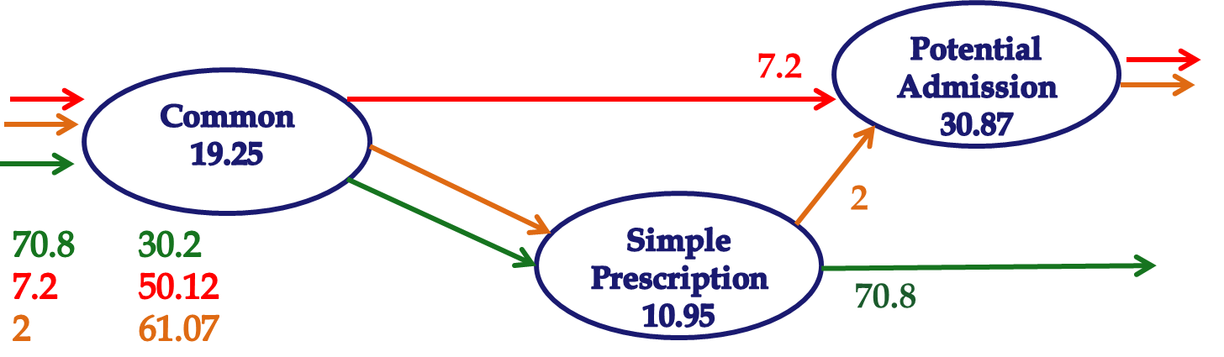

TPA = 50.12(7.2/9.2) + 61.07(2/9.2) =

TPA = 50.12(0.782609) + 61.07(0.217391) = **52.5**

We already have the average flow time

T = I/R = 43.68/ (80/60) = 32.76

T= 30.20(70.8/80) + 50.12 (7.2/80) + 61.07 (2/80)

**T = 32.76**

**If you are looking for more challenging problems, we encourage you to go through the problems posted at**

<http://www.csun.edu/~aa2035/CourseBase/Process/Process2018/2b.ProcessAdditionalProblemsAdvanced.pptx>

<http://www.csun.edu/~aa2035/CourseBase/Process/Process2018/2.ProcessKeyProblemsSet2.pptx>

**Problem 8. SAMOAK Industries.** SAMOAK family has been in industrial developments for close to a century. They got the idea of smooth flow from Henry Ford and took it to a new dimension of time-based competition. The following data represents the inputs and outputs at one of their plants throughout 6 weeks. Each column of the following tables represents 7 days of a week, a total of 42 days. Assume that the plant is working 24 hours 7 days a week. Each column of these matrices is corresponding to a week, where the first row is the first day of the week. Analyze these data, and estimate the average inventory and average flow time of this process.



[**http://www.csun.edu/~aa2035/CourseBase/Games/Game1-Book-FlowTime42.xlsx#page1**](http://www.csun.edu/~aa2035/CourseBase/Games/Game1-Book-FlowTime42.xlsx#page1)

 

**Note. Sometimes you have data in a long column in an excel sheet and want to transform it into a matrix (table) to put into a report. Sometimes we have a table in a report and like to transform it into a column of data in an excel sheet. To learn how to do these using functions such as ROWS, COLUMNS, INT, MOD, INDEX, and MATCH, you may watch the lecture at** [**https://www.youtube.com/watch?v=G_M3i2XVKmo&t=27s**](https://www.youtube.com/watch?v=G_M3i2XVKmo&t=27s) **The excel file is at** [**Descriptive Statistics-exl**](http://www.csun.edu/~aa2035/CourseBase/Probability/S-1-DescriptiveSTAT/DescriptiveSTAT.xlsx) **on tab 6.TurnArrayToMatrix. The excel file of this problem is at** [**Prepare for the Game**](http://www.csun.edu/~aa2035/CourseBase/Games/Game1Data.xlsx) **Tab 2. 2. AveInvFlow. On this tab, I have also shown how to transform the long column of data into a table.**

The input and output data are in columns B and C of the Excel file, respectively. Since we need to compute inventory, the inventory of the first day is the difference between the input and output on the first day, i.e., 2-1= 1. The inventory of day 42 is the summation of the input in the first 42 days minus the summation of the output in the first 42 days, i.e., 99-97 =2. We compute the summation of input in each day in column D by using the function =SUM ($B$2:B2) on the first day. If we copy this formula down to day 42, it will appear as =SUM($B$2:B43). However, for output data, we cannot copy this formula to the next column, because it will appear as SUM($B$2:C2) in the first day, and SUM($B$2:C43) in the last day. We can fix this problem by replacing =SUM($B$2:B2) by =SUM(B$2:B2). That is to replace $B$2 with B$2. Now if we copy =SUM(B$2:B2) from column D to column E, we will have =SUM(C$2:C2), and in the last row of column D we will have =SUM(C$2:C43). Now we can compute inventory in each day, in column F, by subtracting the total output from total input in each day. The formulas are shown below

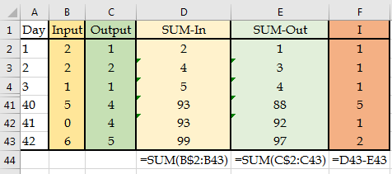

Descriptive Statistics for output and inventory are shown below



Because the average output is R=2.31, and average inventory is I=1.31, the estimated flow time is 2.31T=1.31 which equals 0.57 days or 13.6 hours. If we exclude the days when output was 0, SUM(RANGE)/COUNTIF(RANGE, “>0”), we will get another approximation of throughput, which is 2.43. In that case, the average flow time reduces to 0.54, or 13 hours. The actual flow time measured directly was 0.52 days or 12.53 hours.

However, over the 6 weeks, they are almost equal.