**SOM 307: COURSE STUDY GUIDE**

**PREPARED BY THE SOM307 STUDENTS OF DR. ASEF-VAZIRI, SPRING 2016**

Contents

**I.** **EXCEL SKILLS: LINE/SCATTER GRAPHS, ROWS AND COLUMNS, INDEX, MATCH** 2

***A.*** ***Line and Scatter Graphs*** 2

***B.*** ***Rows and Columns*** 4

***C.*** ***Index*** 4

***D.*** ***Match*** 5

**II.** **STANDARD DEVIATION & VARIATION, WEIGHTED AVERAGE, LIMITS** 6

**Question #1: Standard Deviation and Variation** 6

**Question #2: Weighted Average** 11

**Question #3: Limits** 13

**III.** **RANDOM VARIABLES AND UNIFORM DISTRIBUTION** 14

**A.** **Discrete and Continuous Random Variables:** 14

**B.** **Uniform Probability Distribution:** 15

**IV.** **Uniform, Normal, and Standard Normal Distributions** 19

**A.** **Uniform Distribution** 19

**B.** **Normal Distribution** 20

**C.** **Standard Normal Probability Distribution** 21

**V.** **Moving Average, Exponential Smoothing, Regression** 25

**A.** **Moving Average:** 25

**B.** **Exponential Smoothing:** 25

**C.** **Regression:** 26

**VI.** **STANDARD NORMAL DISTRIBUTION** 27

**Example** 28

**VII.** **EXPONENTIAL AND POISSON PROBABILITY DISTRIBUTIONS** 29

**A.** **Exponential Probability Distribution** 29

**B.** **Poisson Probability Distribution** 30

**VIII. Regression, Exponential & Poisson Distributions, and Exponential Random Variable** 31

**IX. Forecasting for Regression and Seasonality** 33

1. **EXCEL SKILLS: LINE/SCATTER GRAPHS, ROWS AND COLUMNS, INDEX, MATCH**
2. ***Line and Scatter Graphs***

|  |  |
| --- | --- |
| **Line Graphs** | **Scatter Graphs** |
| Show change over time | Show paired numerical data |
| Show change in continuous variables | Show correlation between variables |
| X-axis doesn’t have numerical value (year, ID number | X-axis has numerical value |

***How to Make a Line Graph***

*Source: IPEDS: National Center for Education Statistics*

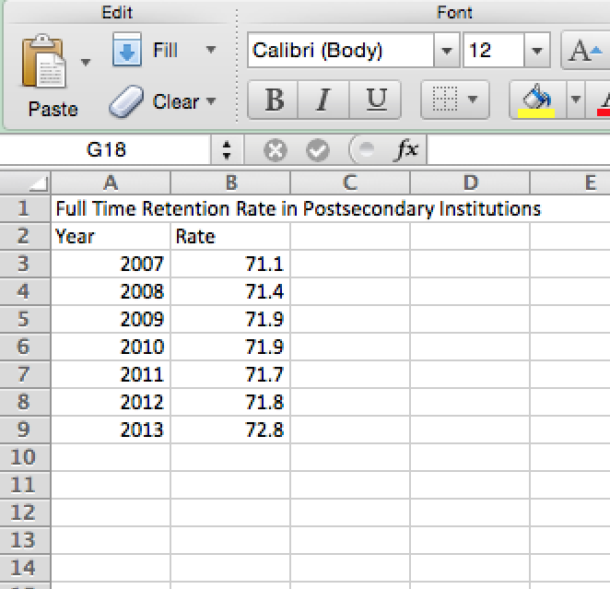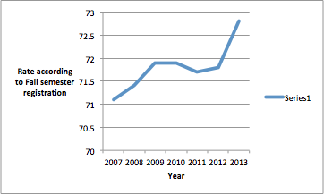

To start, you should have two sets of data, one for the X-axis and Y-axis

1. Go to the “Charts” tab and select the line graph option. Select one set of data for your X-axis and one for the Y-axis. You can either type the cells in or copy and paste them.
2. To write a title, legend, and labels for the axes, click the “Chart Layout” tab, select Format, and select each element that want to create.

***How to Make a Scatter Graph***

You should have your data ready to be able to insert the graph.

1. Go to the “Charts” tab and select the scatter graph option. Select one set of data for the X-axis.
2. To write a title, legend, and labels for the axes. Click the “Chart Layout” tab, select Format, and select each element that want to create.

To edit later, you can right click the graph and click “Select Data” which brings you to this menu.

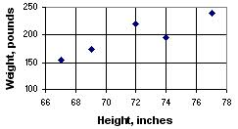

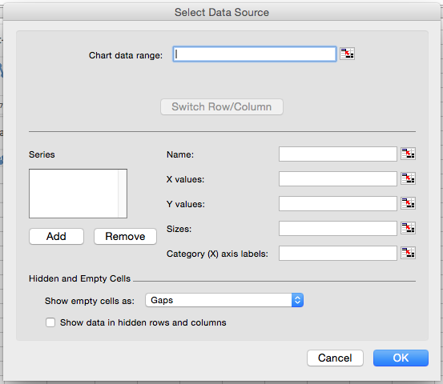

Once you have finished editing the labels you will see the extent of correlation, if any, between the values.

To represent things like mean, median and mode, you can always go back to the “Select Data Source” menu and click “Add” under the “Series” option. These will all be represented with their own series.

For the sake of explanation let’s take Median as an example. The “X values:” will be the actual value associated with Median. The “Y values:” will be where you want Median to appear on the chart with respect to the Y values. 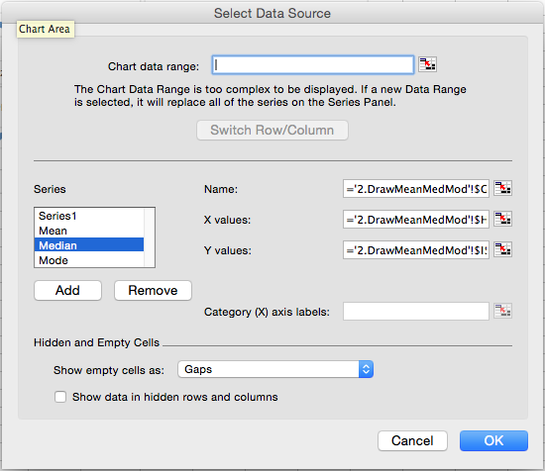

1. ***Rows and Columns***

There are multiple ways to make rows and columns:

1. Type each number in each cell. Ex: 1, 2, 3, 4, 5 in each cell.

2. Type a number in a cell and in the next cell add 1 to the previous cell. Ex: Cell A1 contains the number 1, cell A2 formula will be “**=A1 +1”** and drag the cell down/across for the desired amount of numbers.

3. Type 1 in a cell and go into the series options for the cell. Set the “step value” and “stop value” to your desired sequence of numbers. Then choose either rows or columns. Ex: Step value = 1 and stop value = 10.

4. Type **“=ROWS($A$1:A1)”** or **“=COLUMNS($A$1:A1)”** then copy down/across the formula to the desired amount of rows or columns. To make the first cell absolute, highlight the cell and press F4.

1. ***Index***

To make a sequence of numbers in rows and columns in a section:

Starting at the first cell: A1

Type **“=ROWS($A$1:A1)+10*(COLUMNS($A$1:A1)-1)”** this will ensure that the first number will start at 1. Again to make sure the first cell is absolute, highlight the cell and press F4.

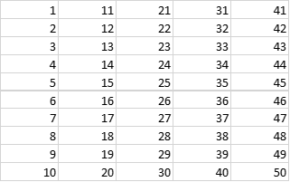

That is how to do a basic box of numbers in sequence. To choose from a series of numbers:

Using the “index” function will allow you to choose the series of numbers you wish to use.

Type “index” in front of the formula we just created to choose the series of numbers.

**“=INDEX($G$1:$G$50,ROWS($A$1:A1)+10*(COLUMNS($A$1:A1)-1)”** This formula assumes that we have a list of numbers in cells G1 thru G50 that we are choosing from.

1. ***Match***

To locate how many numbers are the same in a series of numbers you use the match function: Type **“=MATCH(458,G1:G50,0)”** This will locate how many times the number 458 is in my series of numbers from my previous list of numbers in cells G1 thru G50.

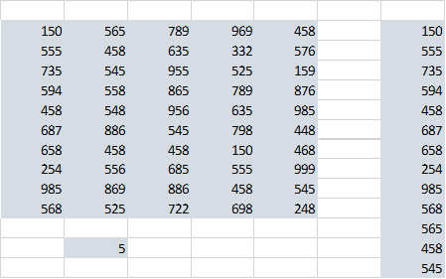

In the example above, the number 458 was located 5 times in my series of numbers.

1. **STANDARD DEVIATION & VARIATION, WEIGHTED AVERAGE, LIMITS**

**Question #1: Standard Deviation and Variation**

Standard Deviation is a measurement of the variation between individual subjects in a population. It is calculated by finding the distance of each individual number from the mean; therefore, the first step is to find the weighted average mean of the numbers as done below:  
**1)** Each value in column A is multiplied by its respective probability in column b. The results in column C are then added to find the weighted average mean (steps 2 and 3).

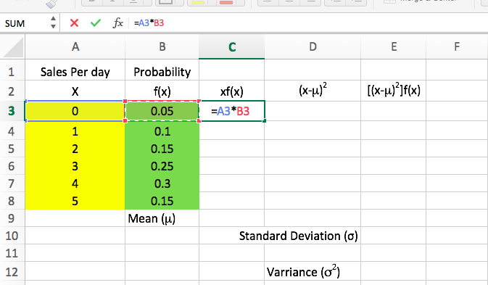

**2)**

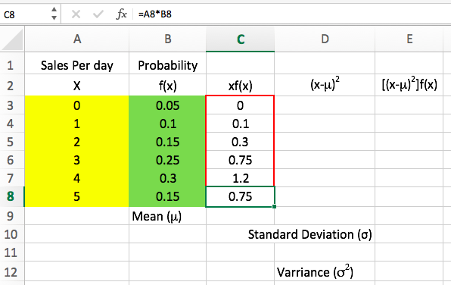

**3)**

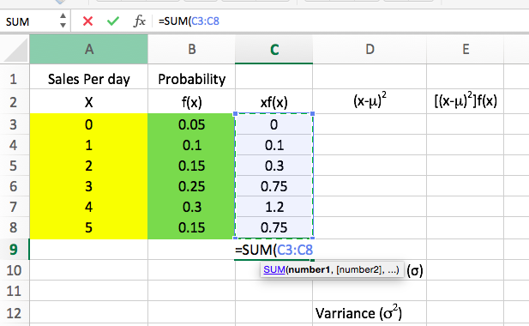

**4)**

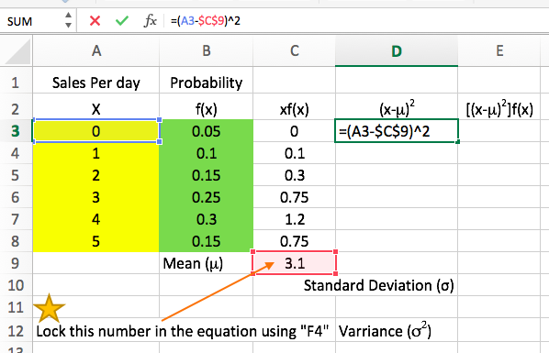

**5)** Next the distance of each value from the mean must be computed. This is done by taking each value x and subtracting from it the mean. To avoid the cancelling effect of positive and negative values, these differences are then squared. These results are put in Column D.

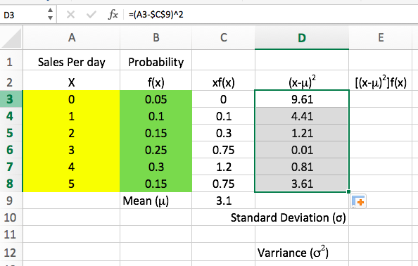

**6)** The results in column D are multiplied by the respective probabilities in column B and then are added. This value, 1.89, is the variance. The Standard Deviation is the square root of the Variance.

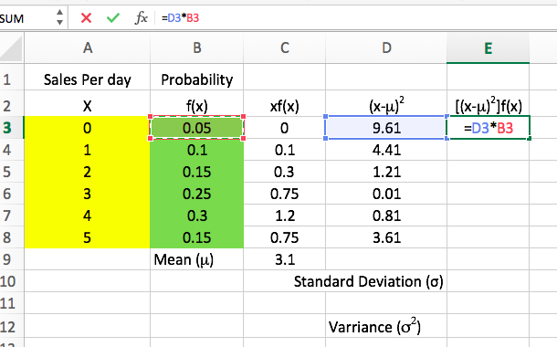

**7)**

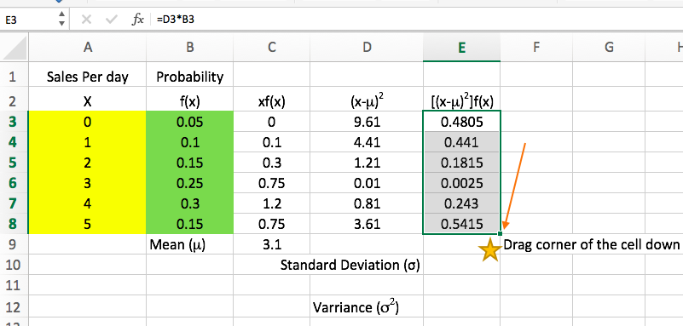

**8)**

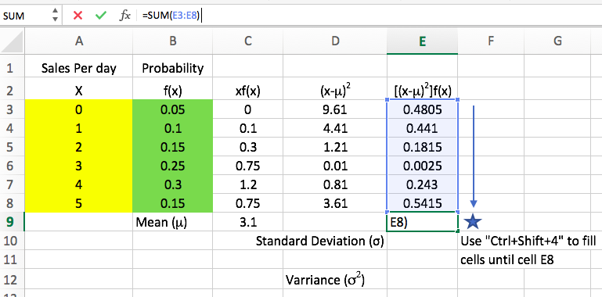

**9)**

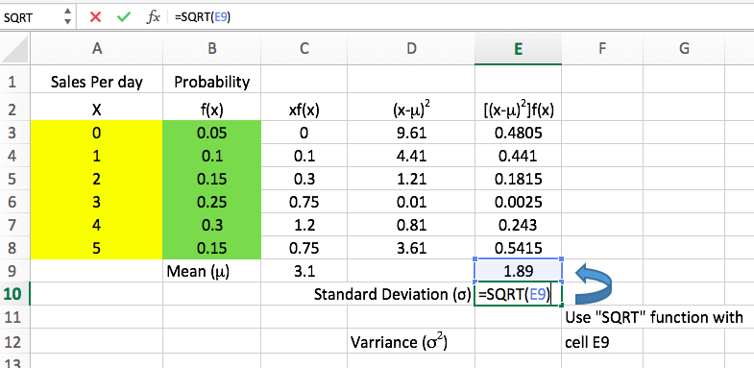

**10)**

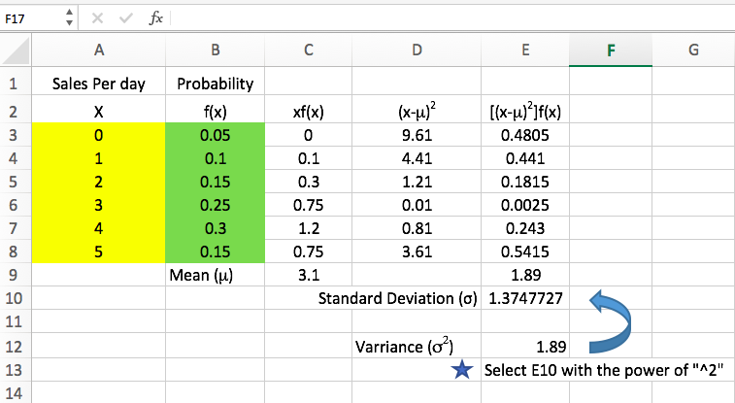

**11)**

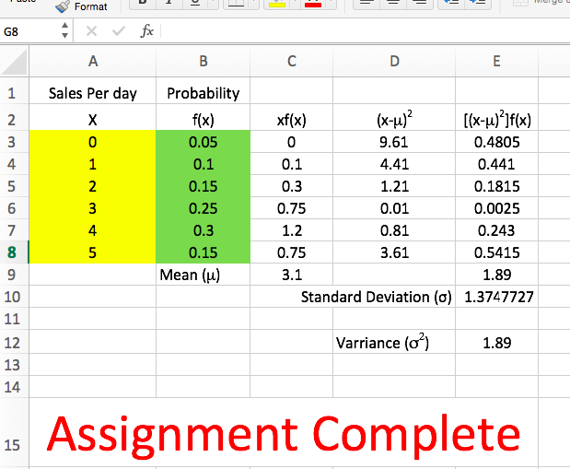

**Question #2: Weighted Average**

**1)** The average grade in the class is the weighted average of each category. The percentage weight in column A is multiplied by the percentage grade on the assignment in column B to determine the percentage points towards the overall grade shown in column C.

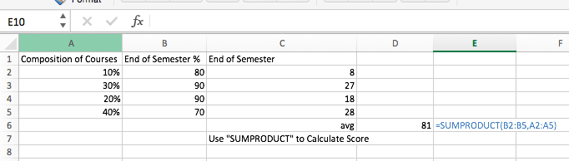

**2)** If everything in the class EXCEPT the final has been completed, then only 60% of the overall grade has been determined. Therefore, we must take the total grade points completed so far, 53, and divide it by 60%. The result shows that of the work completed so far, the student has earned 88% but 40% of the grade remains to be determined.

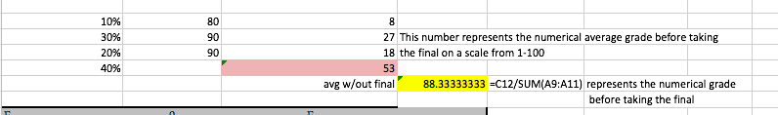

**3)** The question is, since 53% of the overall grade has been earned (88% of the first 60%) what percentage of the remaining 40% needs to be achieved in order to get an overall score of 86%. This is computed below and can also be represented mathematically as:

.53 + .4X = .86

.4 X = .33 (This shows that 33% of the remaining 40% must be earned to get 86%)

.33/.4 = .825

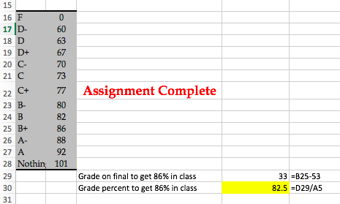

**Question #3: Limits**

**1)**

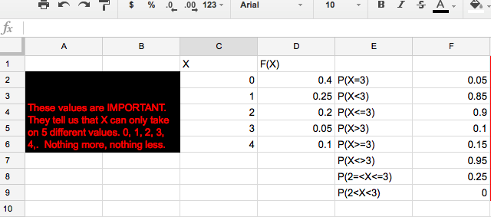

**2)**

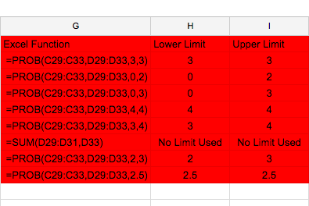

**3)**

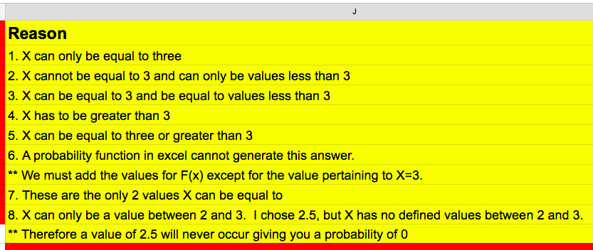

1. **RANDOM VARIABLES AND UNIFORM DISTRIBUTION**
2. **Discrete and Continuous Random Variables:**

* A random variable is a numerical, or quantitative description describing the results of a simulation or experiment.
* There are two types of random variables, discrete and continuous.
  + Discrete variables can take the form of finite or infinite values, typically used to count something.
    - An example of a discrete random variable could be the age of students in the CSUN MBA Program (example: 25, 27, 31, 38 years old)
  + Continuous variables consist of any numerical value in an interval or collection of intervals that is typically a result of an experiment that measures something.
    - An example of a continuous random variable could be the amount of water in the CSUN SRC swimming pool (example: 12,091.85792315… gallons)

1. **Uniform Probability Distribution:**

* A uniform probability distribution suggests that between any two variables in an interval, the probability of any of those variables occurring is equal.
  + An example of an experiment with a uniform probability distribution is the outcome of rolling a die.
    - In this example, the result of the experiment has can be any variable between 1 and 6, and any variable in that interval has the same probability of occurring.
    - The graph representing the probability distribution would look like a rectangle with the sides being at 1 and 6, with a height of f(x).
      * f(x)= 1/the number of possible outcomes, which is 6.
        + In this case, f(x) would be .167
      * By finding the area of the rectangle one can determine the probability of any of these values occurring.
      * The probability of the result being less than 4 would be the difference of 4 and 1 multiplied by f(x), which is .167
        + With this, the probability of rolling a die and getting a value less than 4 would be .5, or 50%.
  + To solve such a problem in an Excel spreadsheet is very simple to do using the difference of Minimum and maximum functions.We’ll use this excel sheet for examples.
  + 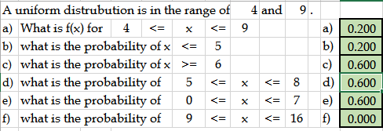
    - =Abs((Min(Range maximum,prob max) - Max(ProbMin, RangeMin))*f(x)
    - looking at example “c” for a uniform range of 4-9, in order to find the probablility of 0≤x≤8, one would type
    - 
    - 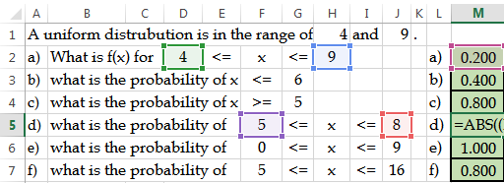
      * + The range maximum is H2 or 9
        + the range minimum is J5 or 4
        + The probability maximum is D2 or 8
        + The probability min is F5 or 5
        + f(x)= 1/(9-4) or .2, or simply M2
        + So, the probability of 5≤x≤8 in the uniform range of 4&9, is .6, as shown above.
    - Using still this same concept, we can also find upper and lower bound of percentiles.
* 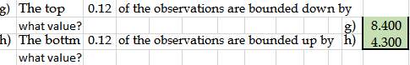
  + For example, looking at example “g”, we will use the formula

= RangeMax - %/f(x)

 or 9-.12/.2 = 8.4

*for bottom percentiles you use

=Range Min + %/f(x) or 4+ .12/.2 = 4.3

* This can become useful in situations where you must maximize profits in sales transactions. We turn to examples j&k.

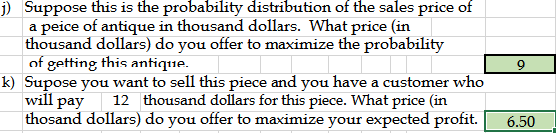

* Still using a uniform distribution between 4&9, J tells us, to offer $9,000, the maximum value of the antique, in order to maximize the probability of getting the piece.
* Now, in K, a customer offers $12,000 for the piece, how much should you be willing to spend in order to maximize the profit for yourself on this piece? The 7, or $7,000 was found by using the following formula:
  + (Amount offered fro max probability Min of range)/2
    - (9,000+4,000)/2 which is 6,500
  + So now to figure out your profit, Amount offered,12, - price offered for maximum profit , 6.5, to give you a profit of $5,500.
  + The probability of this occurring is the difference between your price offered for maximum profit, K, and range minimum, 4 multiplied by f(x), .2
    - =(6.5-4)*.2 =.5

In this class session, we also learned about **overage and underage costs** and how they can help us find the **optimum service level or service quantity using uniform distributions**.

* First, let’s look at the equations
* Underage Cost, or Cu = Sales Price- Purchase Price
* Overage Cost, or Co = Purchase Cost- Salvage Value
* Service Level = Cu/ (Cu+Co) or (Q-a)/(b-a), where Q is optimum quantity, a is the range minimum, and b is the range maximum.
* Ex 1. “Swell Productions is sponsoring an outdoor conclave for owners of collectible and classic Fords. The concession stand in the T-Bird area will sell clothing such as official Thunderbird racing jerseys. Suppose the probability of jerseys sales quantities is uniformly (and continuously) distributed between 100 and 400. Suppose sales price is $80 per jersey, purchase cost is $40, and unsold jerseys are returned to the manufacturer for $20 per unit. How many Jerseys Swell Production orders? “
  + Cu= 80-40 = 40
  + Co= 40-20 =20
  + SL = 40/(40+20) = ⅔
* Now we will use SL to find Q using the second formula of SL.
  + ⅔ = (Q-100)/(400-100)
    - Using simple algebra, we find that Q = 300

**Some key points to remember when making business decisions are:

1. If underage cost increases, move right, order more.
2. If overage cost increases, move left, order less.

**URV Generation in Excel**

Creating a series of discrete random variables within a certain range can be made easy in excel using the round and random functions.

= round(1+(rangeMax -1)*rand(),0)

* Ex: How to generate random numbers between 1 & 38
  + 
  + The Round function is used to ensure we get discrete integers only. the “0” in the round function communicates that you want 0 spots after the decimal point, hence again, discrete intervals.

1. **Uniform, Normal, and Standard Normal Distributions**

**In this lecture we learned about 3 different distributions, however, we focus on uniform distribution and normal distribution.**

1. **Uniform Distribution**

* Is sometimes known as a rectangular distribution, this distribution has a constant probability; any outcome has the same probability of happening as any other outcome.
* To calculate the height of a uniform distribution you use the formula: F(x)=1/B-A, where B is the maximum value in the distribution and A is the minimum value in the distribution.

|  |  |  |
| --- | --- | --- |
| P(x) | **=** | **{0 for x<a; 1/(b-a) for a<=x<=b; 0 for x>b** |
|  |  |  |

For Example:

If we have a uniform distribution that width measures 0 to 5 we can calculate the height by simply using the formula F(X) = 1/b-a, f(x) = 1/(5-0) =.02. This height represents the probability of any outcome occurring.

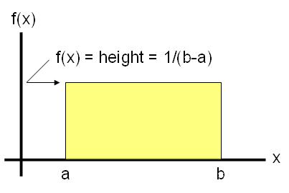

**To create a uniform distribution on excel, using random variables we do as follow.**

1. You create a column that says Uniform and start with a 0 (1st Column). After that you go to Series and in the step value you enter the numbers that you are interested on (for example: STEP VALUE 0.01, STOP VALUE 5) and press column.
2. Then you create another column with the title F(X) (2nd Column), in this column we use =1/ (a-b), then we drag down the number calculated.
3. To create a graph we go to INSERT then we look at our graphs and go to INSERT AREA CHART and click on the first one.
4. Then we click on the graph and go to SELECT DATA (Chart Design Tab) and click on EDIT HORIZONTAL ACCESS and CLICK ON UNIFORM DATA (1st Column). Then click OKAY.
5. **Normal Distribution**

* Normal Distribution has its own mean (µ “mu”), standard deviation (σ “sigma), all normal distributions have the same basic bell shape.
* It is symmetric – you can cut it in half and it mirrors the same distance from its mean
* Mean and Median are the same
* The standard normal distribution is a normal distribution with µ=0 and σ =1
* [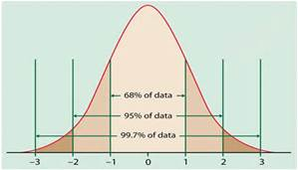](http://www.bing.com/images/search?q=empirical+rule&view=detailv2&&id=FC05AAC4C05233D99D1929397B1D6C41D6BDFAAB&selectedIndex=1&ccid=QDZdTVIF&simid=608015744771886291&thid=OIP.M40365d4d520563eaf76c43f25bff05e4H0)Empirical Rule is used in the normal distribution below.
* 68% will fall within the first Standard Deviation
* 95% within the first two Standard Deviation
* 99.7% will fall within three Standard Deviation

**Normal Distribution – two types of random variables**

1. Discrete Random Variables - (count things) for example, number for heads in a 10 coin flip, number of females of democrats in a sample.
2. Continuous Random Variable :
3. – (based on measurements) unaccountability infinite number of values (values within an interval on the real line) many possible values. For example, time to complete a task, exam score – complete a task is continuous because it can take you 5 min – 3 hours not a specific time to count (continuous).
4. A continuous random variable X has a normal distribution if its value falls into a smooth (continuous) curve with a bell-shaped pattern.

***Changing an x-value to a z-value – z-formula***

STEPS: To find Probabilities for a Normal Distribution

1. Draw a picture of the distribution
2. Translate the problem into one of the following: p(X<a), p(X>b), or p(a<X<b). Shade the area on your picture.
3. Standardize to a Z score formula using the

Z-formula:

Z=x- µ/σ

1. Look up the z-score on the Z-Table and find its corresponding probabilities (USE Z-TABLE)

5a. If you need a “**less than”** probability (**p(X<a) you are done**)

5b.If you need a “**greater than**” probability p(X>b) take 1- result from step 4.

1. If you need a “between –two-values” probabilities – that is, p(a<X<b) – do Steps 1-4 for b (the larger of the two values) and again for a (the smallest of the two and subtract the results)
2. **Standard Normal Probability Distribution**

A random variable that has a normal distribution with properties of mean (**μ**) = 0 and a standard deviation (σ) =1, has a **standard normal probability distribution**.  Letter *z* designates this particular normal random variable.

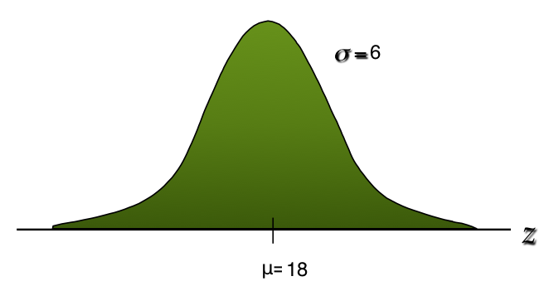

***Example***

**Mean (μ) =18**

**Standard deviation (σ) =6**

**If P(x ≥ 22) =?**

**Distance from the mean is 4 (22-18)**

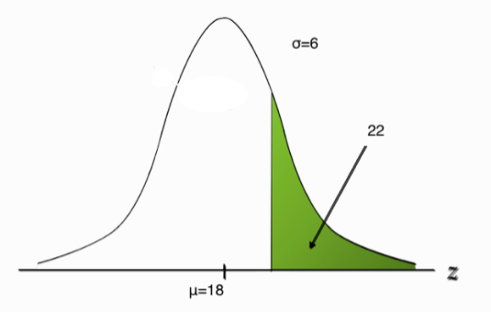**Positive is**

**right-tailed and negative is left-tailed.**

**22-18/6 = 4/6 or z=0.66666 standard deviation to the right**

**Use excel to find P(x ≥ 22) =?**

**Distance from the mean is 4 (22-18)**

**Positive is right-tailed and negative is left-tailed.**

**22-18/6 = 4/6 or z=0.66666 standard deviation to the right**

**Use excel to find P(x ≥ 22) =?**

**Distance from the mean is 4 (22-18)**

**Positive is right-tailed and negative is left-tailed.**

**22-18/6 = 4/6 or z=0.66666 standard deviation to the right**

***Use excel to find P(x ≥ 22) =?***

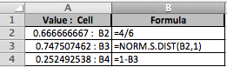**Z Value=0.666666667** or 0.67

**Probability to the left: P (z≤22) = 0.747507462, which equals 75%.**

**Probability to the right: P(z ≥ 22) of  0.252492538, which P(x ≥ 22) equals 25%.**

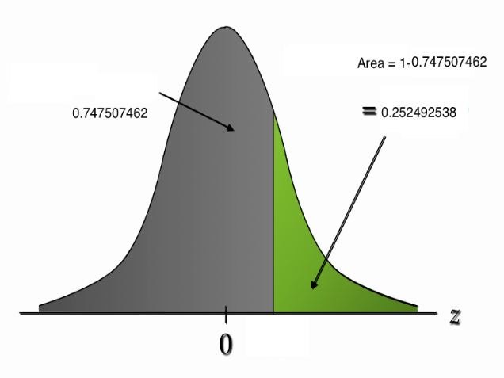

Using Excel to find the probability of a stock out if the *z* value of a probability =.5

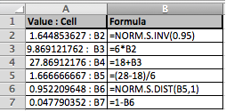

1.644853627 or 1.64 is the *z* value of probability .5

9.869121762 or 9.87 is to the right

28 (27.86912176 rounded) need to be in stock in order to be 95% sure you will not be out of stock

0.047790352 probability of a stock out, which is 4.7% (less than 5%)

Raising the re-order point from 22 to 28, the probability of stock out decreases from .22 to .5

200 = average demand during lead time

28 = standard deviation during lead time

What level of inventory should be ordered with 90% confidence that there will not be a stock-out?

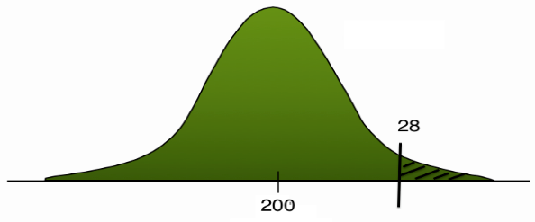

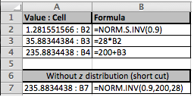

By using excel it was determined the level of inventory that should be ordered with a 90% confidence that there will be no stock out is 235.8834438.

**Example:**

X= 24000

* = 20000 (average)

σ = 5000 (SD)

=NORM.DIST(24000,20000,5000,1)

= 0.788145 (The P on the left side of 24000 - each time the inventory level drops to 24,000 units the company needs to replace order)

In 78.81 % of the order cycles, the warehouse will not have a stock out. Risk = 21.19. (The P on the right side of the 24000)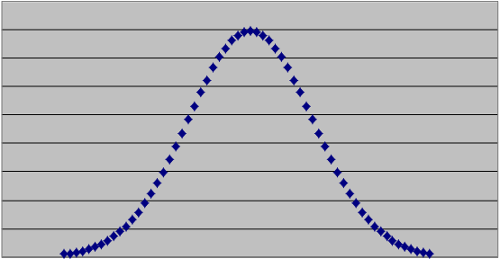

20000

Probability of

Excess inventory

78.81

24000

21.19

Probability of

Out of stock

An electronics superstore is carrying a 60” LEDTV for the upcoming Christmas holiday sales. Each TV can be sold at $2,500. The store can purchase each unit for $1,800. Any unsold TVs can be salvaged, through end of year sales, for $1,700. The retailer estimates that the demand for this TV will be Normally distributed with mean of 150 and standard deviation of 15. How many units should they order?

Note: If they order 150, they will be out of stock 50% of the time.

Which service level is optimal? 80%, 90%, 95%, 99%??

Cost =1800, Sales Price = 2500, Salvage Value = 1700 **(2500-1800=1700)**

Underage Cost = Marginal Benefit = p-c = **2500-1800 = 700**

Probability of

Shortage



0.125

1.15

0.875

Probability of

Excess inventory

(Cu+Co)=700+100=800

Optimal Service Level = SL* = P(**LTD** ≤ ROP) = Cu/(Cu+Co)

P(X>=N)= 7/8

Or in NVP Terminology SL* = P(**R** ≤ Q*) = Cu/(Cu+Co)=700/800 = 0.875 ( On Excel sheet, type 700/800 then push ENTER, it would come out 0.875, this is the P and would be on the left side.)

=NORM.INV(0.875,150,15) then push ENTER, it would come out about 167 units.

LTD =N(150,15)

ROP = LTD + Isafety

= LTD + zσLTD ROP = 168

= 150+1.15(15)

Isafety = 17.25 = 18 Risk = 12.5%

1. **Moving Average, Exponential Smoothing, Regression**  
   1. **Moving Average:**

* Frequently centered, it is more convenient to use past data to predict the following period directly.
* If you want to forecast demand for May with a 4-month moving average for example, we can take the average sales from Jan, Feb, Mar, and Apr.
  + January sales= 100, February sales= 120, March sales= 140, and April Sales=210; n=4 (number or periods)
  + **Forecast for May =** (100 + 120 + 140 + 210)/4 = 570/4 = **142.5**
* The longer the moving average period, the more the random elements are smoothed, but lags the actual demand.
* In a forecasting model using simple moving average the shorter the time span used for calculating the moving average, the closer the average follows volatile trends.

*Double click on the file below to view examples of Moving Average:*



* 1. **Exponential Smoothing:**
* Exponential Smoothing is as forecast technique that computes a weighted moving average of the current actual demand and forecast.
* Exponential Smoothing is the most used forecasting technique. The most recent occurrences are more indicative of the future (highest predictable value) than those in the more distant past. We should give more weight to the more recent time periods when forecasting. Each increment in the past is decreased by (1-alpha). **The higher** the alpha, the more closely the forecast follows the actual demand.
* Ex: A prior forecast demand was 230, a related actual demand was 250, and a smoothing constant alpha of 0.1, what is the exponential smoothing forecast for the following period?
  + **Forecast =** 230 + 0.1 x (250-230) = **232**

*Double Click on the file below to view examples of Exponential Smoothing:*



* 1. **Regression:**
* Can be used to test the relationship between X-variables and Y-variables (the strength of the relationship reflects the ability to predict the dependent variable based on a change in the independent variable). A strong relationship means that Y can be forecasted based on X. (For, example, an R2 of .9 means that 90% of the change in Y can be explained by a change in X).
* To run a regression, click the Regression tool in the Statistic Analysis Tool Pack on Excel ( If *Data Analysis*  does not appear under the *Data* tab, then you have to activate the Add-in by going to *File*, *Options*, *Add-ins*, *Analysis Tool Pack*) then select *regression* from the list andfill in the X and Y variables.
  + This will give you a summary output which will include a R2 (R-squared) value
  + A **high** R square means the X and Y variables have a strong relationship between them
  + A **low** R square value means the X and Y variables do not have a strong relationship
* Also included in the summary output will be a P-value
* In order for the X and Y variables to have a strong relationship, they need a high R square along with a low P-value
  + P-value should be less than 1, and the smaller the value the stronger the relationship is between the X and Y variables. Generally a P value of less than .05 is considered significant.

*Double click on the file to view a sample data set and regression:*



1. **STANDARD NORMAL DISTRIBUTION**

Standard Normal Distribution

Definitions:

x= variable between -∞ and ∞

𝜇=mean between -∞ and ∞

𝝈=Standard Deviation >0

𝝈2=Variance >0

Normal Distribution equation:

x~N(𝜇,𝝈2)= x is distributed normally with mean 𝜇 and variance 𝝈2 where 𝜇=0 and 𝝈2=1.

The probability is the area under the curve.

How to standardize normal distribution:

x - 𝜇

𝝈

Example ppt pg 24

A random variable **x** with mean of **𝜇** , and standard deviation of **σ** is multiplied by **2** generates the random variable **y**=2x.

We already know that x: (**𝜇 ,** **σ**)

Then **y**=2x → y:(**2𝜇 , 2σ**)

.**𝜇**= 10,000 (0.05) = 500 **σ** = 10,000 (0.05) = 500

Excel function =norm.inv(rand(), mean, Standard Deviation)

=norm.inv(rand(), 500,500)

Example PPT pg 40

Lead time = 5 days

Average daily demand = 50

StdDev of daily demand = 10

**𝜇**=50x5=250

**σ** = 50x1=50

Adding 2 random variables

y=x1+x2

.Mean = **𝜇**(y**)**= **𝜇 (**x1) + **𝜇(**x2) = 2**𝜇**

Variance = 𝝈2(y)= 𝝈2(x1) + 𝝈2**(**x2) = 2𝝈2

StdDev = 𝝈(y)= √ $2$ (𝝈)

D=200 StdDev=25 LT=25 @90%

D=50 StdDev=10 LT5 @90%

.Mean = **𝜇**(y**)**= **200+50**

Variance = 𝝈2(y)= 𝝈2(x1) + 𝝈2**(**x2) = 2𝝈2  ?????

StdDev = 𝝈(y)= √ $5$ (𝝈) ??????

**Example**

At Dot Com, a Large retailer of popular books demand is constant at 32,000 books per year. the cost of placing an order at 32,000 books over year. the cost of placing order to replenish stock is $10, and the annual cost of holding is $4 per book, Stock is received five working days after an order has been placed. No backordering is allowed. assume 300 working days a year.

What is Dot Com’s optimal order quantity?

EOQ= (2(32,000)(10)4) = 400 units

What is the optimal number of orders per year?

DEOQ = 32000 / 400 = 80 orders / year

What is the optimal interval (in working days) between orders?

TBO = EOQ D = 400 / 32000 = .0125 year

convert .0125 yr 300 days /year = 3.75 days

What is demand during the lead time

L = 5

d=32000300= 106.67 or 106 per week

DDLT =dL= 106.67(5) = 533.35 or 533 units

What is the reorder point?

R = demand during lead time = d L = 106.675

Optimal reorder point is 533.35 or 533 units

What is the inventory position immediately after an order has been placed?

EOQ = 400 , R = 533

400 + 533 = 933

1. **EXPONENTIAL AND POISSON PROBABILITY DISTRIBUTIONS**
   * 1. **Exponential Probability Distribution**
2. Times between arrivals
3. Distance between two variables
4. Time required or duration to complete or execute certain matters
5. Used primarily of service and inter-arrival times.
6. Mean and Standard Deviation are equal.
7. Exponential Probability Distribution is always skewed to the right with a measure of 2

Exponential Distribution=

Definition: Exponential distribution with parameter

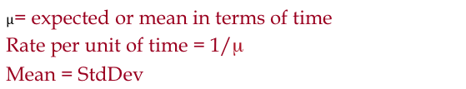

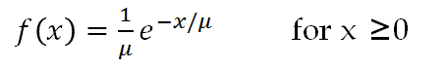

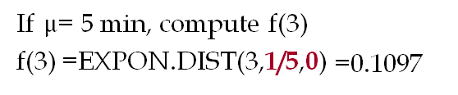

* + 1. **Poisson Probability Distribution**

1. Number of speed bumps on a given street interval.(Lassen St. through Nordhoff)
2. Number of vehicles arriving at an In-n-Out drive through
3. Used also to indicate amount of calls of tickets to a music concert
4. Used to indicate an estimation of the number of occurrences through a given interval.
5. Discrete random variable (infinite amount:1,2,3 etc.)
6. Probability the same for intervals equaling the same length.
7. Poisson provides an appropriate description of the number of occurrences within a given interval.
8. The occurrence or non-occurrence of in any interval is independent of any other occurrence or nonoccurrence in any other interval
9. No stated upper limit. Probability function applicable for discrete integer numbers x=1, 2, 3 etc.
10. X value will become large enough so that f(x) will become zero in practical instances.



Formulas and Rules

*x* = the number of occurrences in an interval

*f(x)* = the probability of *x* occurrences in an interval

*m* = mean number of occurrences in an interval

*e* = 2.71828

*x*! = *x*(*x* – 1)(*x* – 2) . . . (2)(1)

*Double click icon to view Examples of these distributions:*



**VIII. Regression, Exponential & Poisson Distributions, and Exponential Random Variable**

Review:

1. Regression Report: Using the “Data Analysis” tool under “data,” create a report using X and Y values.

1. Important items to look at:

Intercept coefficient, x variable coefficient, x variable p-value, Rsquare, Standard error. (*In regression standard deviation is standard error)

Beginning:

2. Exponential & Poisson Distributions

A)

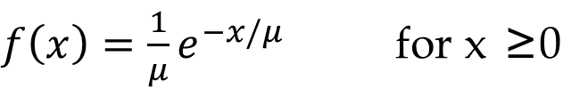

B) $µ$ = expected or mean in terms of time

Rate per unit of time = 1/μ

Mean = StdDev

Example: If a person comes every 3 weeks, then the rate= 1/3

*Careful: Lambda = 1/ 𝜇

1. In excel:

(𝑥)=1/𝜇 𝑒^(−𝑥/𝜇) = Expon.dist(x,1/ 𝜇, 0)

(𝑥)=1- 𝑒^(−𝑥/𝜇) = Expon.dist(x,1/ 𝜇, 1)

0= Height of the curve

1= Probability

(𝑥≥𝑋1)=1−(𝑥≤𝑋1)=1−1+𝑒^(−𝑥/𝜇) = 1-1+ 𝑒^(−𝑥/𝜇) = Exp (−𝑥/𝜇)

1. Using Solver:

Set Objective: (−𝑥/𝜇)

Click on “Value of” : 100%- percentage you are looking for

By changing Variable Cells: Pick a cell.

3. Exponential Random Variable

A)

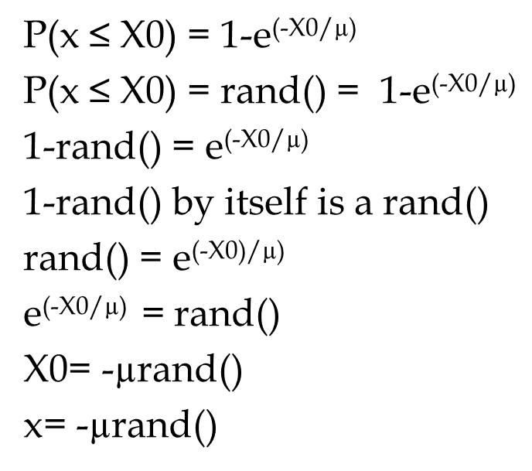

1. Creating a set of random numbers

To create numbers ranging from **a**(the small number) to **b**(the largest number)

We do: a(b-a)Rand()

If we have mean and standard deviation, and we want the numbers rounded, then we use:

Uniform:

=Round(mean+(Stdv-mean)* rand(), 1)

Normal:

=Norm.inv(Rand(), mean, Stdv)

Exponential:

= - 𝜇*Ln(Rand())

4. Exponential & Poisson

Exponential= between occurrences

Poisson = per interval

1. Poisson distribution

In order to find the Poisson distribution we excel.

Poisson.Dist(x, mean, 0 OR 1)

1. 1 = true = Cumulative = Probability of **X** or less

0 = False = Probability = exactly **X**

**IX. Forecasting for Regression and Seasonality**

Today we are starting with our actual data

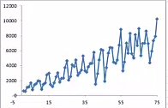

We are trying to get to a graph with our real data along with the forecast.

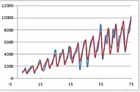

We want to make the procedure independent of data so it can work with any set of data. Looking at the graph we see a pattern. It goes in sets of five points, starting low making its way up and then back to low again. This shows us seasonality, with periods of low sales and high sales. Since it renews every five periods we assume periodicity is 5 periods.

The next steps would be to remove the seasonality, find a trend, forecast a trend, and then add back seasonality. One way to remove seasonality is to get the average of each of the five periods. We take the centered moving average by finding the average by getting the average of the five periods in relation to the third number. We will then add the moving average to the graph.

1)Click on the points on the graph

2)Right click and choose select data

3)Click add

4)Select the moving average column for your X-Values and keep your original X-Values.

This gives us information without the seasonality.

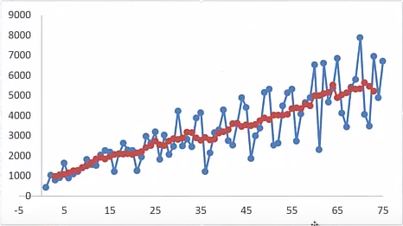

Next we use regression analysis to estimate the trend of the data we just put on the graph. There are two ways to do this. The first way

1)Go to the data tab

2)Choose data analysis and pick the regression

3)Select your averages column as your Y-Value

4)Keep your original X-Values

The benefit to this way is that we get key factors like coefficient of determinations, standard error, and P- Values. The downside to this way is that there is less flexibility. If we change some of our data, it will not show in our regression. From our regression analysis, there are key factors that we look at. First off we take a look at our coefficients. We call them b0(intercept) and b1(X Variable), and we use them to create our equation (Y=b0+b1*X). Another important number is R Squared. Since this number is a decimal, we want it as close to one as we can get it. The observation tells us how many numbers we used to calculate the regression. The standard error represents the standard deviation of our forecast. We also want to look at the P-Value of b1. This number we want as small as possible (close to zero).

Next we will create a regression line for our graph. We create our equation from earlier in the next column. Make sure to lock your b0 and b1 since you will be dragging it down.

1)Right click on the graph and select data

2)We select the data we just created as our Y-Value

This is what it looks like when you add the regression line to the original data

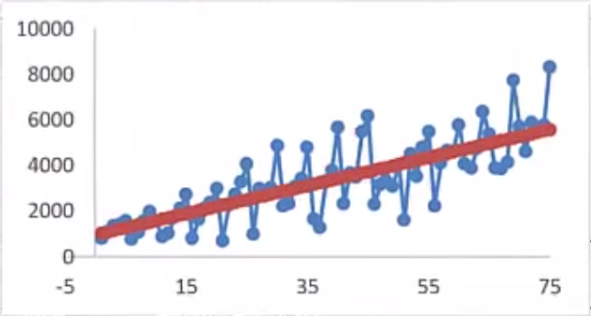

When you add all the data to one graph you get:

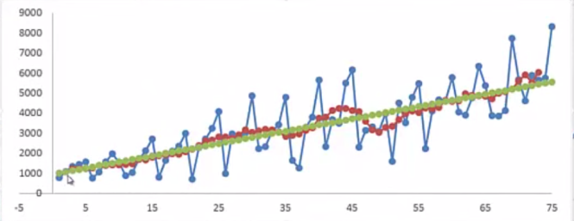

The second method is to use the trend equation in excel (=TREND(y-values,x-values,known x)). The benefit to this is that if a number changes in your original data, it automatically changes in your trend function. The downside to this method is that it does not provide you with additional information like the regression does. This gives us the regression line. To find the seasonality we divide our original data by our regression data. You then average every fifth number that you get from this information. Copy this down to get the seasonality for each of the five periods.

Our last step is adding the seasonality back into the graph. We do this by multiplying the regression information by the corresponding seasonality for the period. Make sure to use VLOOKUP to get the right corresponding seasonality. This will get us our final forecast.