**Teaching Time Series and Regression Analysis in Classes of Business Analytics Using Data from the Ports of Los Angeles and Long Beach**

**Ardavan Asef-Vaziri**

David Nazarian College of Business and Economics

California State University, Northridge. 18111 Nordhoff Street, Northridge, CA 91330-824

Email: [aa2035@csun.edu](mailto:aa2035@csun.edu)

**ABSTRACT**

The combined ports of Los Angeles and Long Beach in California are among the world's top ten busiest container ports. The data on the volume of activities in these ports provide an excellent dataset to teach time series and regression analysis. We use 26 years of data on the activities of these ports to teach forecasting models, including moving averages, exponential smoothing, trend-adjusted exponential smoothing, and regression analysis. We also use 312 monthly data for teaching seasonality-enhanced regression, multivariate seasonality regression using dummy variables, and trend and seasonality-adjusted exponential smoothing. Excel functions and formulas are fully embedded in the models we develop. We have learned when theoretical concepts are taught through real-life applications, they positively impact students' mental presence and intellectual engagement inside the classrooms. This manuscript can be used as teaching material or a case study in a business analytics foundation or a supply chain analytics course.

**Keywords:** freight transportation; ports of Los Angeles and Long Beach, predictive analytics, time series analysis, moving average, trend and seasonality adjusted exponential smoothing, seasonality enhanced regression.

**1. INTRODUCTION**

Competitive firms need forecasting to develop integrated resources and processes; nourish multi-dimensional and structurally integrated capabilities; understand the revolving business eco-system; create value; and reshape the business organization towards achieving the plans of the enterprises. Marketing, finance, and operations are the three key building blocks of manufacturing, service, and distribution systems. Planning, organizing, budgeting, executing, and controlling are the primary responsibilities of the three key managers. Operations Managers need forecasting for capacity planning, inventory management, and scheduling. Financial Managers need forecasting for investment analysis, revenue and cost analysis, and cash flow planning. Marketing Managers need forecasting for pricing, sales force planning, and promotions. Good forecasting facilitates matching customer value propositions with product attributes, and product attributes with process competencies in the four-dimensional space of cost, quality, time, and variety. While marketing, finance, and operation managers may be interested in forecasting different variables, they have a common interest in the volume of activities and investment plans. They are all interested in long-term and short-term forecasts for strategic, tactical, and operational decisions.

Table 1 shows the world's container port throughput (in twenty-foot equivalent units- or TEUs) in ten countries and ten ports. The combined ports of Los Angeles and Long Beach (LA/LB) are ranked 10th in the world. They comprise the largest port complex in the Western Hemisphere.

**Table 1. Container port and country rankings**



Approximately 1/3 of US seaborne containers move through the LA/LB ports. According to the International Trade Outlook, the value of two-way trade in Southern California customs exceeded 10% of total US international trade in goods. Around 75% of this value passes through to LA/LB ports.

The inbound and outbound volumes of the loaded and empty containers in LA/LB ports provide an attractive data set to teach the basics of time series and analytics. This manuscript is a complete teaching material for time series and regression analysis.

We have learned when theoretical concepts are taught through real-life applications, they positively impact students' mental presence and intellectual engagement inside the classrooms. Our study is especially fit for California's business schools. Only the California State University (CSU) and the University of California (US) systems home close to 800,000 students. The Institute for Advanced Analytics has ranked four California cities in the top 57 cities nationwide, representing the number of data scientists/business analysts. Another objective of this paper is to constitute a bridge between port administrations looking for good quantitative research and econometricians eager to apply their skills to the complex world of modern ports.

Excel functions and formulas are fully embedded in the models we develop. We include additional mathematical manipulations, Excel formulas, and visualization capabilities in four appendices. Our spreadsheet models can serve as templates for other real-life applications.

This manuscript can be used as teaching material or as a case study to enhance teaching materials. We have used it as teaching material in an undergraduate course in business analytics foundations and as a case study in a supply chain analytics graduate course. While we use the total volume of loaded and empty inbound and outbound containers, all data are included for four combinations of inbound, outbound, loaded, and empty volumes. Finally, we hope the work can answer many questions port administrations usually have when trying to understand the research they have commissioned to third parties, often at a very high cost.

We will have a short literature review in Section 2. In Section 3, we estimate yearly port throughput levels using moving averages and exponential smoothing. Measures of forecast accuracy and variability are discussed in Section 4. The level and trend for yearly data are discussed in Section 5 using linear regression and trend-adjusted exponential smoothing. Section 6 estimates monthly data's level, trend, and seasonality using seasonality-enhanced regression analysis, multivariate seasonality regression using seasonal dummy variables, and trend and exponential seasonality smoothing. Conclusions follow in Section 7. In Appendix A, we implement Excel's functional and visualization capabilities by examining a general any-period moving average and its dynamic tables and graphs. In Appendix B, we review the basic mathematics of Exponential Smoothing. Appendix C explains the foundations of the computation of Regression metrics in Excel and provides insight for piecewise regression analysis. All our Excel worksheets are in Appendix D.

**2. LITERATURE REVIEW**

Time series analysis and regression form1-2 chapters in almost all operations management books. In this study, we have benefited from Chase, Aquilano, and Jacobs (2000), Stevenson (2014), Cachon and Terwiesch (2020), and especially Chopra (2019) and Iravani (2021).

**3. HISTORICAL DATA IN LA/LB PORTS AND FORECASTING CHARACTERISTICS**

Time series analyzes past data to identify systematic and random components.; to extend systematic components into the future and provide measures of variability. We use 26 years of data on the total inbound and outbound volume of loaded and empty containers in LA/LB ports to experience moving averages, simple exponential smoothing, trend-adjusted exponential smoothing, and regression analysis. We also use 312 monthly data for seasonality-enhanced regression, multivariate seasonality regression using dummy variables, and trend and seasonality-adjusted exponential smoothing. Excel functions and formulas are fully embedded in these computations.

**3.1 Historical Data at LA/LB Ports**

Table 2 presents parts of 26 years of monthly data for LA and LB, including loaded inbound, loaded outbound, empty inbound, and empty outbound - 312 records with 2496 fields.

**Table 2. 26-Years Monthly TEUs handling in LA/LB Ports**

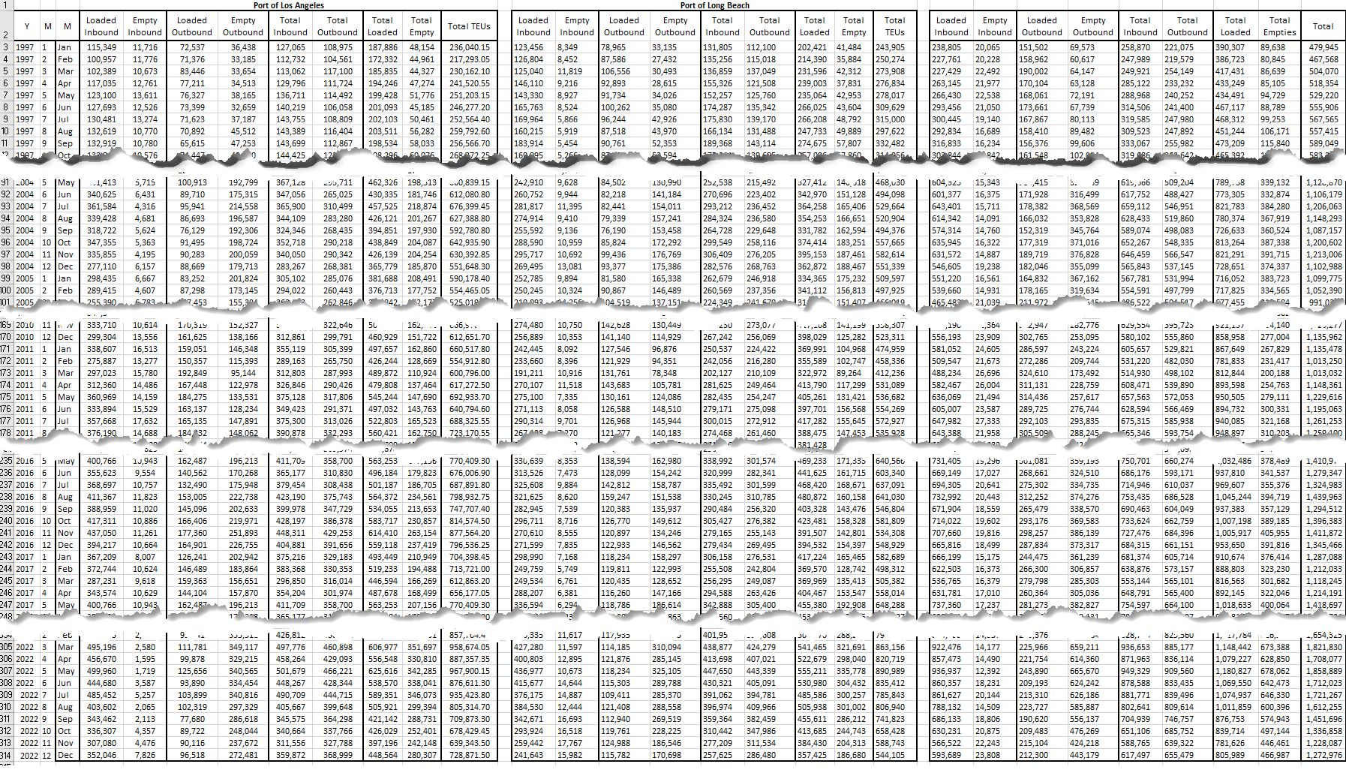

Using the Excel SUMIF function, the monthly data are summarized and pictorially presented in Table 3. The data are in 1000 TEUs; the last digit was rounded to zero. Details of all Excel formulas with a gray background are shown in the following tables.

**Table 3. 26-Year Container Handling at LA/LB Ports**

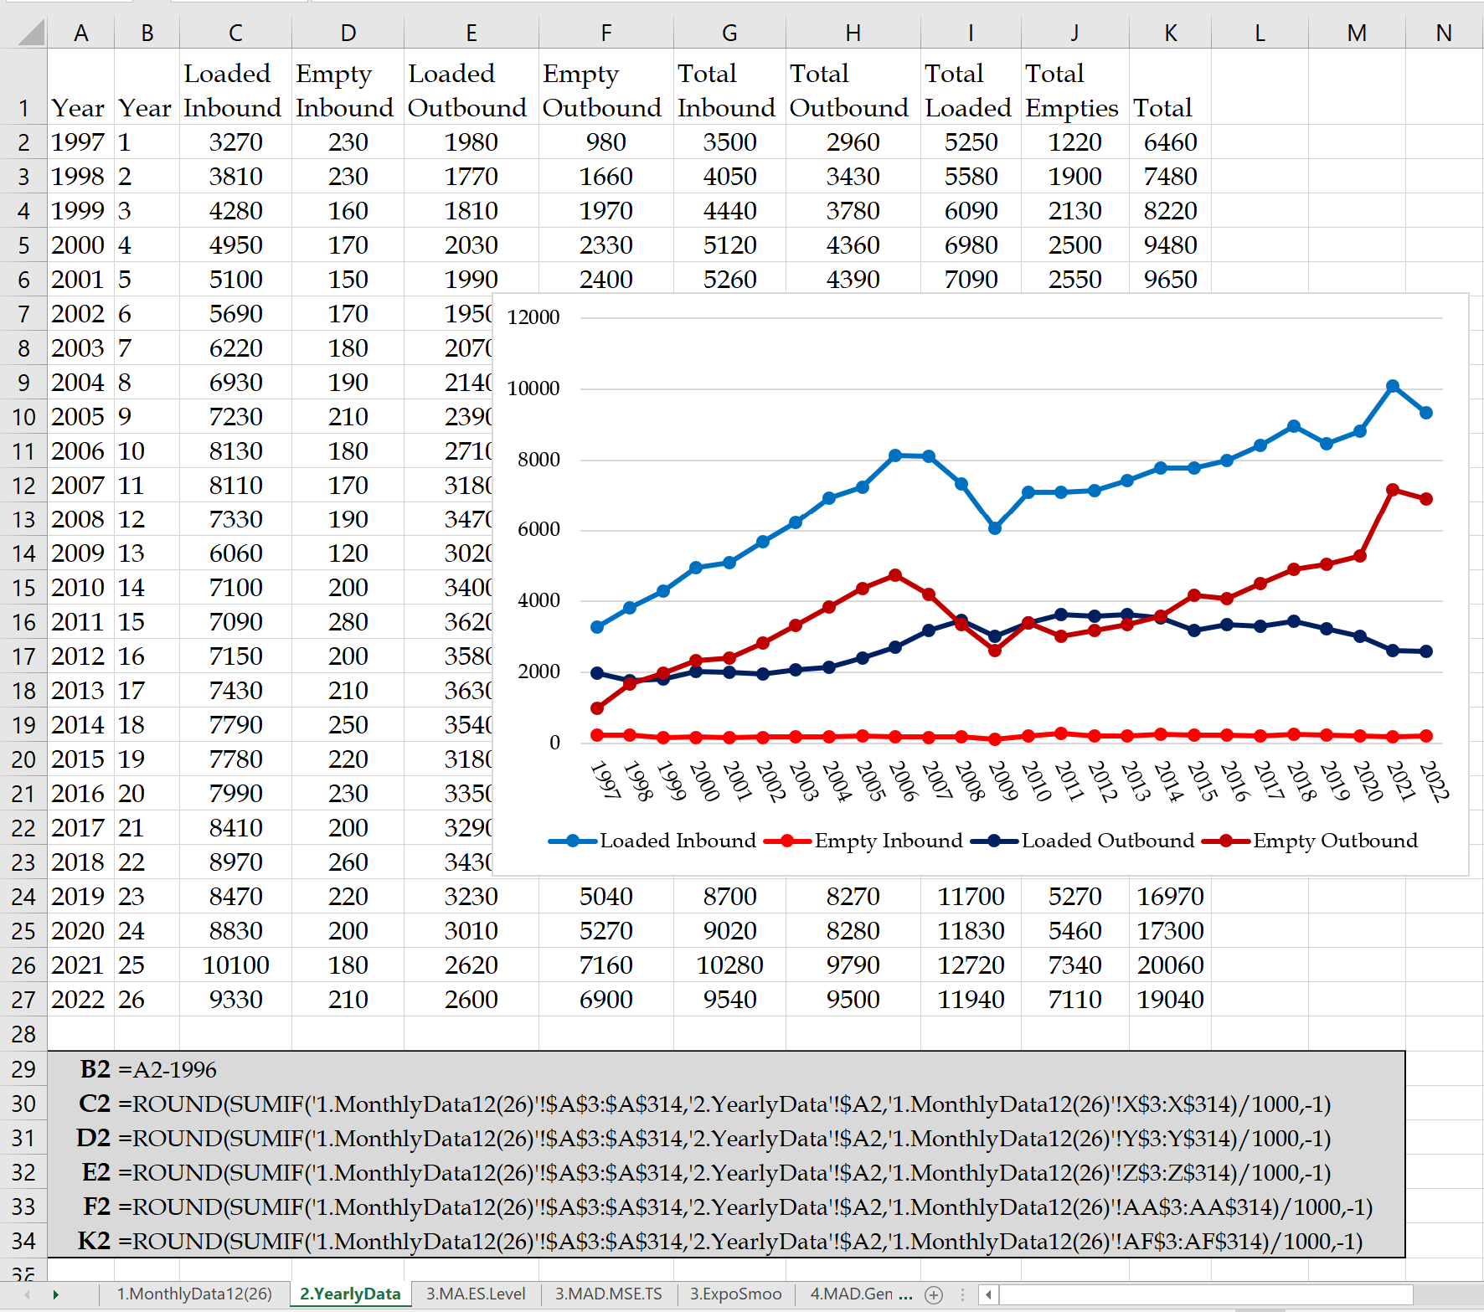

**3.2 Characteristics of Forecasting Techniques**

All forecasting techniques have three main characteristics in common.

**(I) Forecasts always deviate from actual observations**. Since the world is not deterministic – at least to us – all forecasts are almost always inaccurate Forecasts provide the average value for the variable of interest – sales or demand. Demand is a random variable usually following Poisson distribution estimated by Normal distribution. Thus, besides the average demand, we need a measure of variability- standard deviation, variance, or coefficient of variation. If the average forecast for the next period is F, and the standard deviation of F is S, the coefficient of variation CV= S/F provides a measure of variability; the lower the coefficient of variation, the more confident we are with the forecast.

**(II) Forecasts of aggregate values are more accurate than individual item forecasts.** Aggregate forecasts reduce variability. The forecast for all container ports in the world is more accurate than the forecast for US container ports, the forecast for US container ports is more accurate than the forecast for California's ports, and the forecast for California's ports is more accurate than the forecast for the port of Oakland in Northern California. Aggregate forecasts reduce the relative variability with respect to the average forecast. One can intuitively understand that the forecast for the summation of two products is more accurate than the forecast for each product because the high demand for one product may compensate for the low demand for the other. From a mathematical point of view, the variance of the sum of two variables is equal to the sum of the variances of the two variables. Therefore, the standard deviation of the summation of the two variables (the numerator of CV) is less than the sum of the two standard deviations. If the standard deviations of the following year's volume of activities in each of LA and LB ports are equal and are shown by σ, then the variance for the volume of activities in the combined port is = σ2+σ2= 2σ2. Therefore, the next year's activities volume standard deviation for the combined LA/LB ports is not 2σ butSQRT(2)σ.

**(III) Long-term forecasts are less accurate than short-term forecasts.** Forecast accuracy diminishes as we look further into the future. As we get closer to the demand time, we get better information and make better predictions. The forecast for next year's LA/LB activities is more accurate than the forecast for ten years in the future.

**3.3. Impact of Characteristics of Forecasting Techniques on LA/LB Ports Throughput.**

What are the competing edges of LA/LB ports? Deepwater facilities for post-Panama ships containing close to 20,000 containers? State-of-the-art on-dock facilities to transfer containers between ship and train? Intermodal transfer between sea, rail, and road? Consolidation and distribution facilities for trans-loading from 20- and 40-foot containers to 56-foot containers allowed on California roads? According to Leachman (2010), the characteristics of forecasting techniques are one of the key reasons behind the attractiveness of LA/LB ports.

As pictorially shown in Figure 1, shipping containers from the far east to the East Coast may take 4 weeks. This shipment takes 2 weeks to the west coast and 2-4 weeks from the far-east to the mid-US. For shipments from the far-east to the east coast, one needs to forecast the demand of the east-coast four weeks in advance. But the demand forecast two weeks in advance is enough for shipping to the west coast. According to forecasting characteristics (III), the west-coast demand forecast for east-cost will be more accurate since it is less into the future than east-Asia.

**Figure 1. Forecasting-Based Competing Edges of LA/LB Ports**

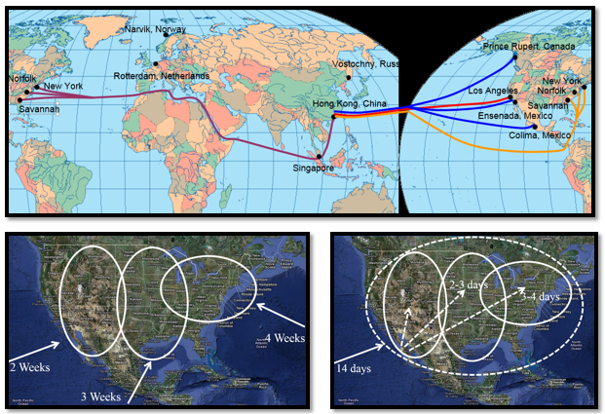

Furthermore, according to forecasting characteristic (II), forecasting the US aggregate demand is more accurate than forecasting demand for any smaller region in the US. Therefore, instead of forecasting for the three regions 14, 21, and 28 days ahead, one may forecast the total US aggregate demand 14 days ahead. It will take 1-3 days to drayage the containers to the three regions. Instead of estimating the demand of the east coast alone, which is less accurate than the demand for the whole US, and instead of forecasting it four weeks ahead, one can forecast for 14+3 days ahead with more accuracy.

**4. CURRENT LEVEL AND FORECAST FOR THE NEXT PERIOD**

In this section, we estimate the level of demand using moving averages and exponential smoothing. By using these two techniques, we can forecast for the next period. We also provide estimates for the standard deviation of demand. The forecast for all other future periods remains the same as the next period (a straight line) until new data is added. In Section 5, we include trends, and in Section 6, we include seasonality in the levels estimated in this section. All the formulas in all tables are summarized in a set of cells with a gray or white background.

**4.1. Basics of Moving Average**

Given the annual volume of container handling at the LA/LB ports, a progressive (or naïve) analyst may assume last year's demand as the demand forecast for this year. That is F27 = A26. A conservative and perhaps irrational analyst may consider the average of all years as the demand forecast for next year. That is F5 = (A4+A3+A2+A1)/4, F6 = (A5+A4+A3+A2+A1)/5, F27 = AVERAGE (A26+A25+……+A2+A1).

Ordinary people, however, may stay between these two extremes and estimate the demand for the next year based on the observations in the past n-periods. An n-period moving average forecast for year 26 is defined as MA26 =AVERAGE(A26, A25, ……, A26-n). The forecast for year 27 is then defined as the n-period moving average in year 26; F27 = MA26. The 4-period moving average forecast in year 27 equals the 4-period moving average in year 26; F27 = (A26+A25+ A24+A23)/4. In general, Ft+1 = (At+At-1+ …… + At-n)/n. Note that the n-period moving average first appears in period n, while the n-period moving average forecast first appears in period n+1. In Appendix A, we develop a general dynamic formula applicable to every n-period moving average, along with dynamic tables and graphs.

**4.2. Exponential Smoothing**

In exponential smoothing, the forecast for the next period equals the forecast for this period plus a fraction of the gap between the actual and forecast values in this period. Ft+1 = Ft + α( At - Ft ), where 0 ≤ α ≤ 1. A minor manipulation can modify it to Ft+1 = (1-α) Ft + αAt. That is, the forecast for the next period is the weighted average of the forecast and actual for this period. Exponential smoothing smooths the gap between the actual demand and its forecast.

To start, we need to have a forecast for period 1. There are at least three ways to compute F1. (*i*) F1=A1, (*ii*) F1= average of all existing actual values, (*iii*) F1= intercept of the linear regression line (discussed later) passing the existing actual values. We assume F1=A1.

For α=0.5, the formula is transformed into Ft+1 = 0.5Ft + 0.5At = (Ft + At)/2. The forecast for the next period is equal to the average of the actual and the forecast for that period. For α=1, the formula is transformed into Ft+1 = At. To forecast the next period, we set it equal to the actual for this period. For α=0, the formula is transformed into Ft+1 = Ft. To forecast, the next period is the same as the forecast for this period.

We usually start with α=0.5 and use an optimization tool, such as Excel's standard SOLVER add-ins or Data Table, to find the optimal α minimizing one of the metrics discussed in the next section. In Appendix B, we show that exponential smoothing is the weighted average of all pieces of data where the weights get smaller and smallest on the older data. Exponential smoothing forecasts using α=0.5 are in column F of Table 4. This table also shows the graph for alternative forecasting techniques that can be prepared using Excel's scatter graph or line chart. Key formulas are shown in the gray box.

**Table 4. Alternative Moving Average and Exponential Smoothing Forecasts.**

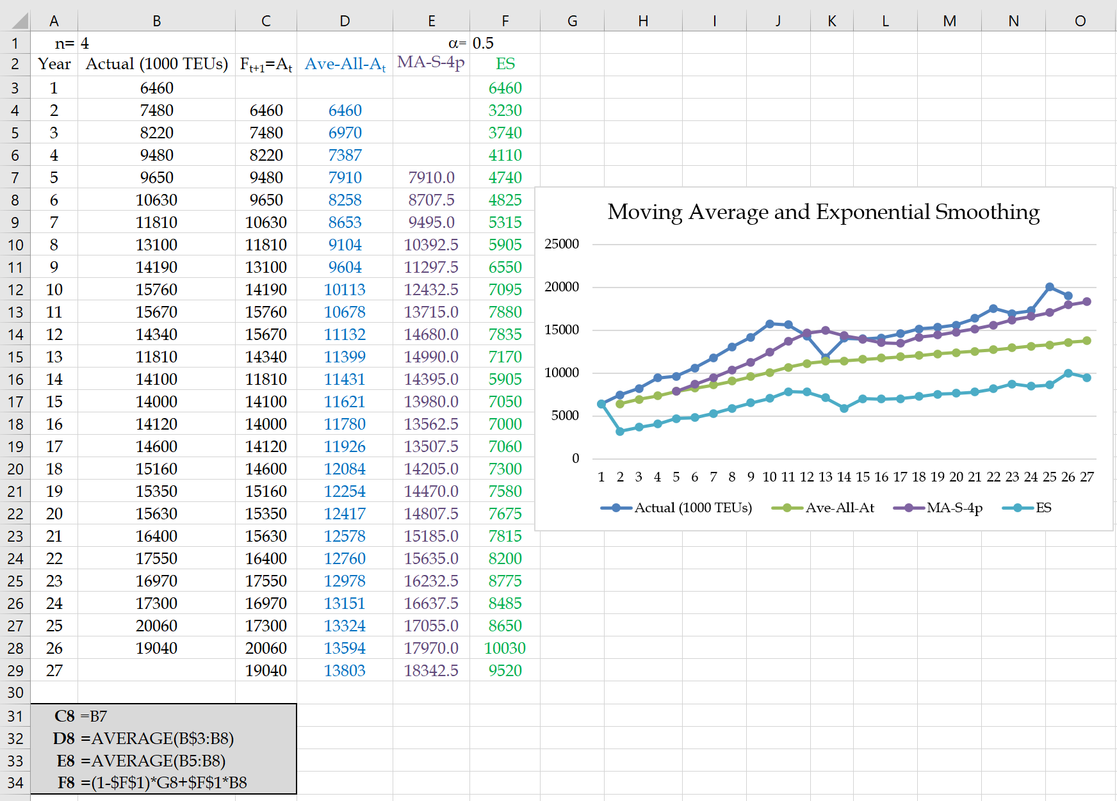

**4.4. Age of data in Moving Average and Exponential Smoothing**

A 4-period moving average forecast can be computed only after period 4, and then it is set as the forecast for period 5; F5=MA4. The newest piece of data in F5 belongs to period 4 and is 1 period old. The oldest data belongs to period 1 and is 4 periods old. Therefore, in a 4-period moving average, the age of data is (1+4)/2 = 2.5 periods. In an n-period moving average, the age of data is (n+1)/2 periods.

The age of data in Exponential Smoothing is 1/α (it is proved in Appendix B). Given 2.5 as the age of data in a 4-period moving average, the data in an exponential smoothing with 1/α =2.5, i.e., α =0.4, has the same age. An exponential smoothing forecast with α = 0.6667 is equivalent to a 2-period moving average forecast, and an exponential smoothing forecast with α = 0.1 is equivalent to a moving average forecast with about 19 periods. The smaller the α (i.e., the larger the number of periods in the moving average), the higher the tendency to smooth out the recent fluctuations. Larger values for α (i.e., the smaller the number of periods in the moving average) result in higher responsiveness to recent fluctuations. A value of α = 1 represents a trend in the past few years and states that the best forecast for the following year's volume of activities is the actual of the current year.

**5. Measuring Forecast Accuracy and Variability**

In this section, we provide foundations to answer two questions. How to measure the suitability of a forecasting technique for a specific dataset? How can one compare the quality of several forecasting techniques for a specific dataset?

**5.1. A Basic Forecast Accuracy and Variability Measure**

Given the actual data and forecast (At and Ft) and error (Et = At - Ft), we define the sum of forecast error SFE = SUM(Et) and average error BIAS = AVERAGE(Et). Since the error values are positive or negative, they cross each other out in a forecasting method. Therefore, SFE and BIAS are expected to be small and close to zero. A forecasting approach may be considered of high quality on the foundations of SFE and BIAS. At the same time, there may be significant gaps between actual and forecast values in both positive and negative directions. WE can resolve this problem by considering the absolute value of the gaps. Mean Absolute Deviation (MAD) is defined as MAD = AVERAGE(ABS(Et )).

MAD serves two essential purposes. First, it compares two or more forecasting techniques and identifies the best based on the lowest MAD value. Second, 1.25MAD provides an estimate of the standard deviation of the demand forecast. We may use any forecasting method to compute Ft+1 as our estimate for the average demand in the next period. We also provide 1.25 times the most recent MAD as the standard deviation of the forecast for the next period. In other words, At+1 ~N(Ft+1, 1.25MADt); demand for the next period follows a normal distribution with an average of Ft+1 and a standard deviation of 1.25MADt.

Tracking signal (TS) is defined as SFE divided by MAD. It is a positive or negative number divided by a positive number. If the parameters are identified correctly, the summation of all errors has an expected value of zero. TS should be close to zero while jumping up and down on the positive and negative sides due to randomness in the actual data. We can also define the upper control; limit (UCL) and lower control limit (LCL) for TS=SFE/MAD. In some textbooks, it is stated that TS moves between LCL=-4 and UCL=+4. In Appendix B, we will mathematically prove that the limits of +4 are incorrect.

TS serves two essential purposes. First, we expect it to stay within UCL and LCL that we define over time. Second, we do not expect a pattern over time. For example, we do not expect to see an always positive or consistently negative TS. In the first case, our forecasting technique underestimates the demand (we have the summation of At-Ft in the numerator); in the second case, it overestimates the demand. We also do not expect to see a cyclic pattern since there may be seasonality in the data that we have not incorporated into our forecasting.

Sometimes we may assign a higher weight to positive gaps than to a negative gap. In the latter case, we are over stock, while in the first case, we have lost sales. Usually, the cost of overstock is less than the cost of lost sales. In these cases, we may assign a coefficient greater than 1 to positive Et=At-Ft values. We may also benefit from the insight into a problem recognized as the newsvendor problem - to find a good tradeoff coefficient of underestimating and overestimating demand.

**4.2. Alternative Forecast Accuracy and Variability Measures**

An alternative approach to removing negative signs is to square the errors and replace MAD with Mean Squared Error (MSE) = AVERAGE(Et2). MSE prevents large gaps between forecast and actual values since the errors are squared. MAD computation was more straightforward when implemented long before calculators and sliding rulers. However, working with an absolute value in mathematical expressions is difficult. It is not difficult to deal with squared values in mathematical expressions. The square root of MSE provides another estimate for the standard deviation of the forecast. That is At+1 ~N(F t+1, SQRT(MSE t)).

There is also a third method that we refer to it as Mean Absolute Relative Deviation (MARD). Instead of averaging |Et| values, we average |Et|/At values. For example, a |Et| of 10 states that there were 10 units of deviations between At and Ft. If At is 200, then 10 relative to 200 is a .05 (or 5% gap). In MARD, the relative absolute gaps (relative to the demand) are computed instead of the absolute gaps. There are still other methods. For example, we may minimize the maximum absolute deviation between actual and forecast. Table 5 shows the computations of error (E), the sum of forecast error (SFE), average error (BIAS), absolute error, MAD, TS, MSE, and MARD for exponential smoothing with α=0.5.

**Table 5. All Metrics for Forecast Accuracy and Reliability**

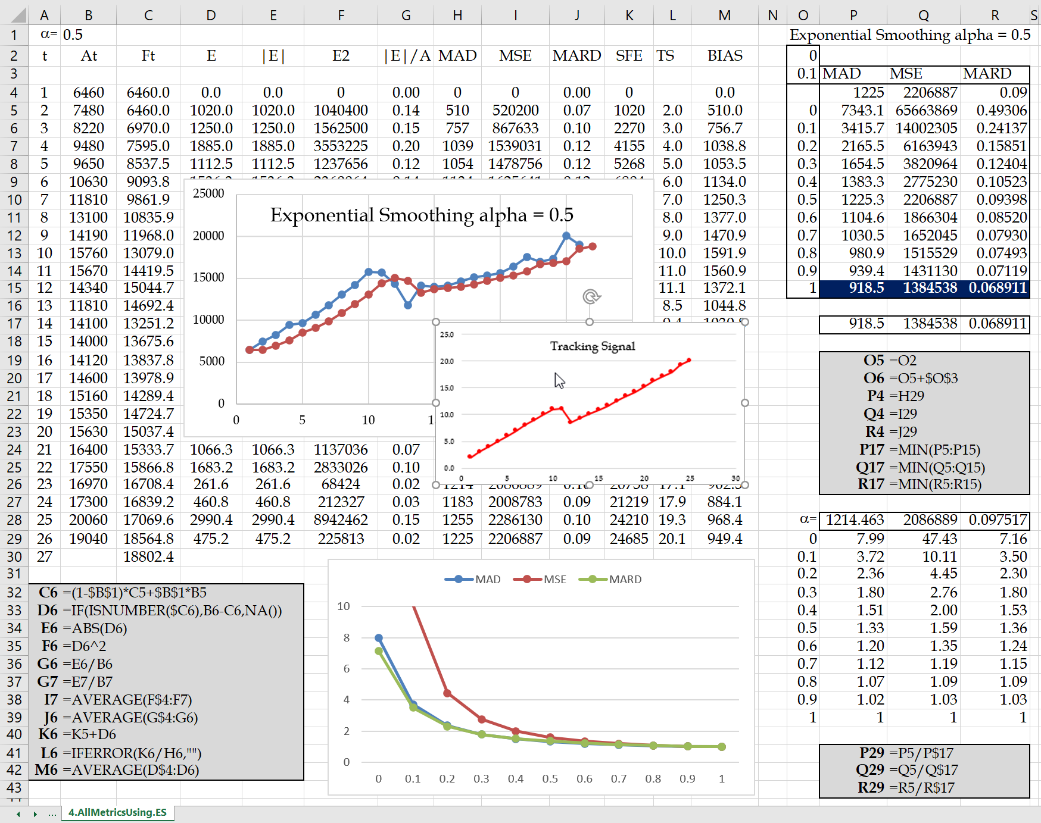

**4.4. Optimal α Value**

The optimal α valuecan be computed in at least two ways. (*i*) SOLVER and (*ii*) Data Table. For SOLVER, the objective function is set to one of the three measures of MAD, MSE, or MARD (in cells H29, I29, and J29) to be minimized, and α cell B1 is the changing cell to minimize the objective function value. For the Data Table, we set cells P4, Q4, and R4 equal to cells H29, I29, and J29, respectively. The set of α values are typed one column to the left of MAD and start from one cell below MAD. Using a formula, we can find the value of α in the Data Table to as many as the decimal point that may be desired in SOLVER. This is done by typing the starting α value of 0 and the increment in two arbitrary cells (such as cells O2 and O3 in this example). We then set O5=O2 and O6=O2+$O$3 and copy down from 0 to 1. After setting O4 to R15, 🡪 Data 🡪 What-if Analysis 🡪 Data Table. Since alternative α values are typed in a column (not in a row), inside the column input cell, we point to B1, where the α value is placed. We then find the α value corresponding to the minimal MAD (or MSE or MARD) value. Suppose the α value for the minimal MAD is 0.7. To estimate α with more decimal points we can set cell O2 to 0.65 and O3 to 0.001 and find the minimal α in the range of 0.65 to 0.74. We can continue this procedure to as many decimal points as we wish; to find answers as precisely as SOLVER with Data Table.

Optimal α computations using both solver and Data Table for all three metrics) and normalization (divide each by the minimal value in that column) of these metrics as (changes are included in Table 5). The reader is encouraged to look into all the formulas in gray cells. We have also used conditional formatting to highlight the minimal values. The Tracking Signal curve for α =0.5 is also shown in Table 5.

The reason for an upward tracking signal is the positive overall trend of actual data. That is why the moving average recommends n=1, and exponential smoothing recommends α=1. When the tracking signal shows a continual or increasing positive trend, we may add a constant to the forecast value. In Table 6, we implemented a two-dimensional Data Table to find the optimal value for α = 0.66 plus a constant of 495 to be added to the forecast to minimize MAD. The computations for exponential smoothing and the essential formulas are shown in Table 6.

**Table 6. Forecasting Measures under Optimal α and a Constant for Exponential Smoothing**

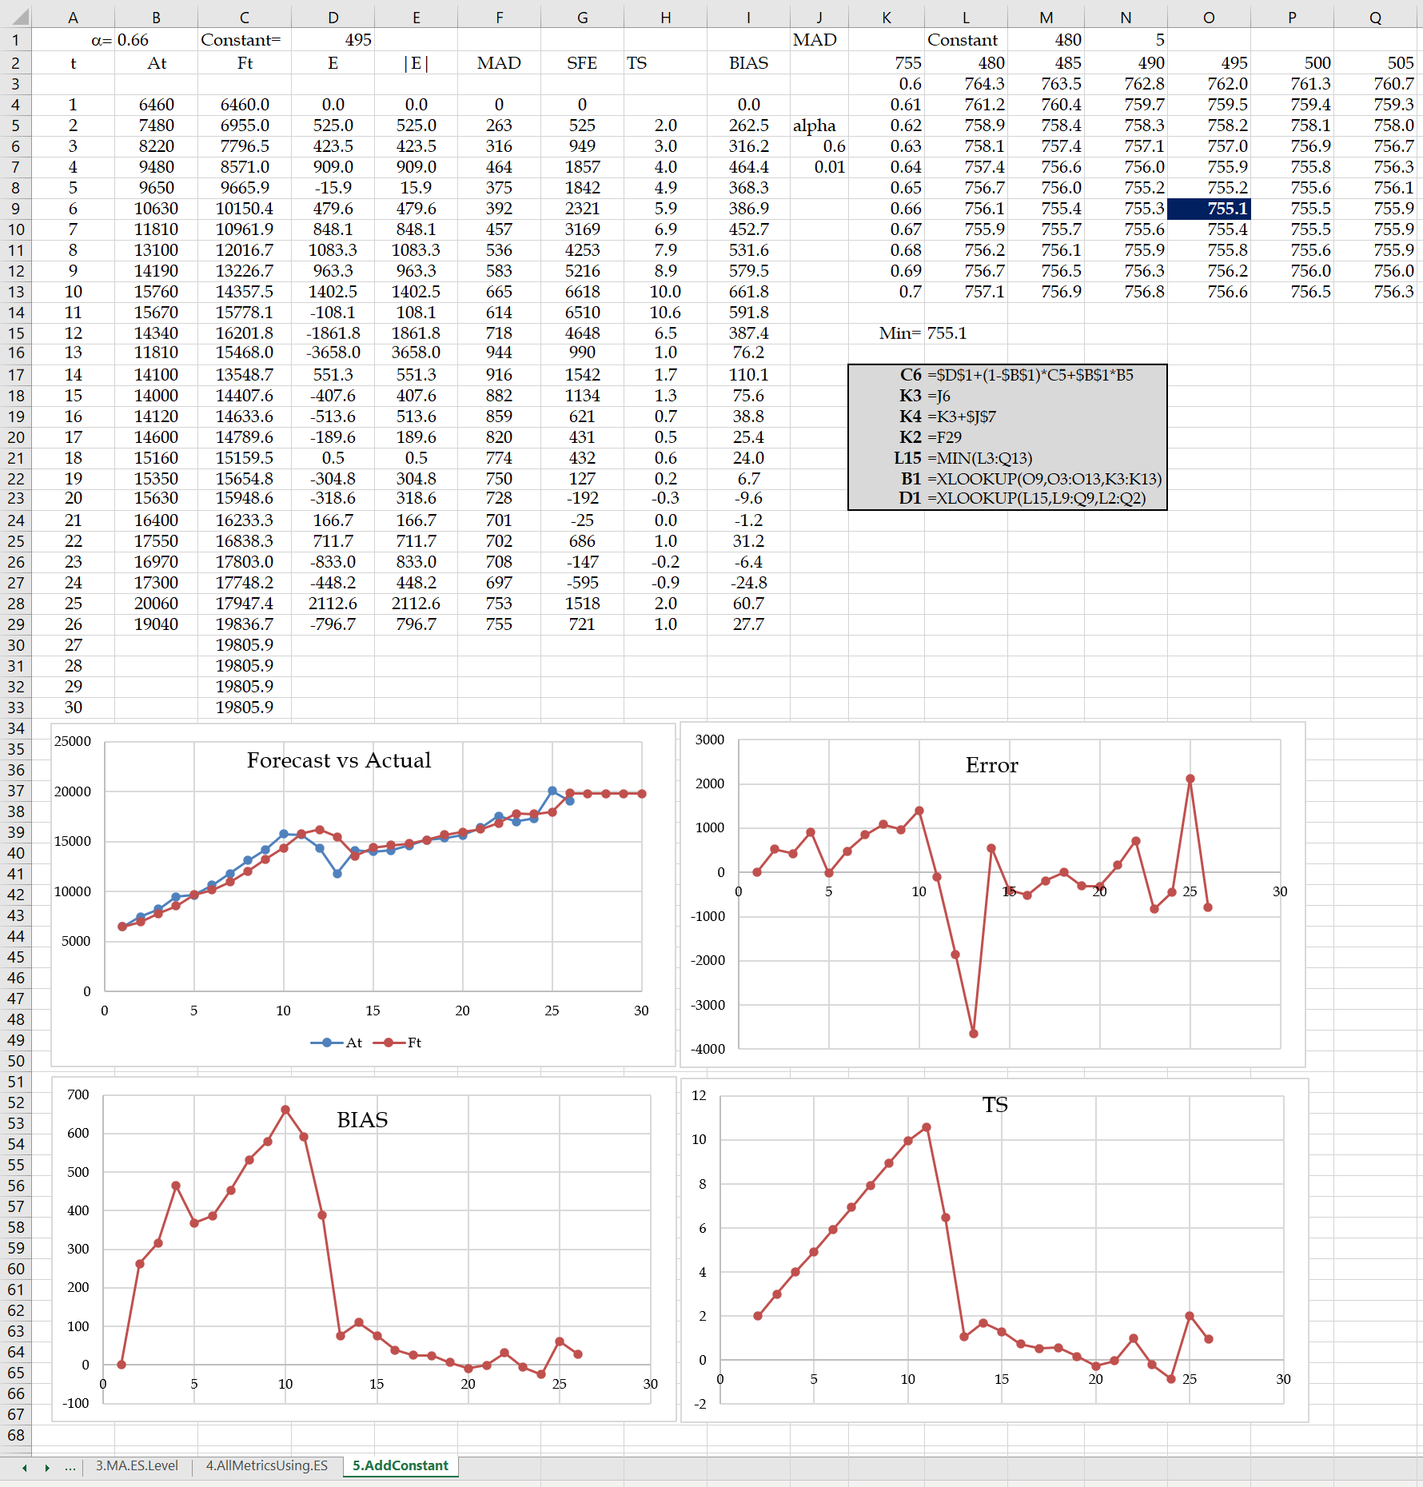

**4.5. Stationary vs. Non-Stationary Data.**

In our dataset, the optimal α for all three metrics is equal (this is not the case most of the time) and is equal to 1 (this is not a general observation). Since we have an upward trend almost in all years, an α=1, and therefore Ft+1=At is the best solution. Moving average and Exponential Smoothing are appropriate for stationary data. We can draw the Cumt = SUM(At) function to check whether data is stationary. The data is stationary if Cumt is close to a line. Figure 2 shows Cumt for our data is distant from a line. We will later discuss trend-adjusted exponential smoothing and regression for data with a trend.

**Figure 2. Stationary vs. Non-Stationary Data**

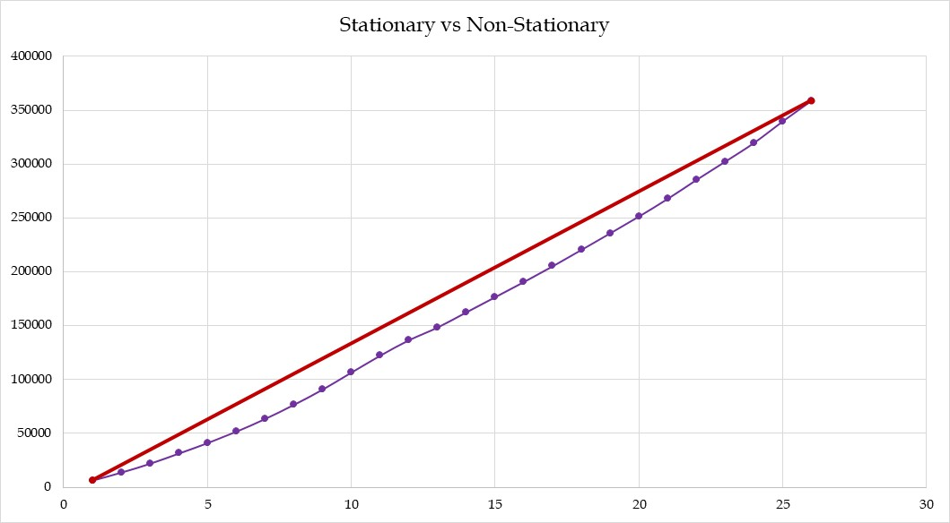

**5. LEVEL AND TREND**

This section reviews (*i*) Bi-variate linear regression and (*ii*) Trend adjusted exponential smoothing.

**5.1. Bi-variable Linear Regression.**

The bi-variable linear regression is generally stated as y=b0+b1x. Our specific case can be stated as Ft = b0 +b1t. While we could have continued with the actual years, we set t equal to the current year minus 1996 for simplicity. Nevertheless, no matter how we enumerate the years, while we will have different values for b0 and b1, all the analyses and the shape of the regression line remain the same. Alternative linear regression computations are explained below and are summarized in Table 7.

**Procedure-1. Add Trend Line.** After drawing the data in a scatter graph, we can right-click on the graph and choose to add a trendline. Options of exponential, linear, logarithmic, polynomial, power, and moving average will appear. We chose liner. We also check the display equation and display the R-squared value on the chart. The scatter graph shows the regression equation y = 419.22x + 8143.6 and R² = 0.8418.

**Procedure-2. Data Analysis Add-Ins.** Choose Data Tab 🡪Data Analysis 🡪 Regression. In the next table, enter the Y variable (At), then X variables (t), and select the cell that will be in the east-north of the table (we select cell E1). This approach is not recommended for bi-variable linear regression since we must prepare a new table once a number is changed. Excel functions perform better and are updated as a change is made in the data. As it is shown in the seasonality-enhanced multi-variable regression, Data Analysis Add-Ins is a good choice for bi-variable non-linear and multi-variable linear and non-linear cases,

**Procedure 3. Excel Functions.** Excel formulas are entered into the Data Analysis Add-Ins output to simplify explanations. There are mainly INTERCEPT, SLOPE, RSQ, STEYX, and CORREL functions that we have added to the table. All the formulas are shown in the gray cells. The larger the R-square (0≤R2≤1), the more reliable the regression line. If the distance between the two blue numbers in the bottom part of the table does not cover zero, there is a relationship between Y and X (b1≠0). If the blues number in the top part of the table is less than 0.05, with more than 95% confidence, not both b0 and b1 are zero.

**Procedure 4. Using More Fundamental Computations in Excel.** In Appendix C, we will provide fundamental insight into the computation of regression metrics through computing SST, SSE, and SSR, as well as a piecewise regression.

**Table 7. Alternative Linear Regression Computations**

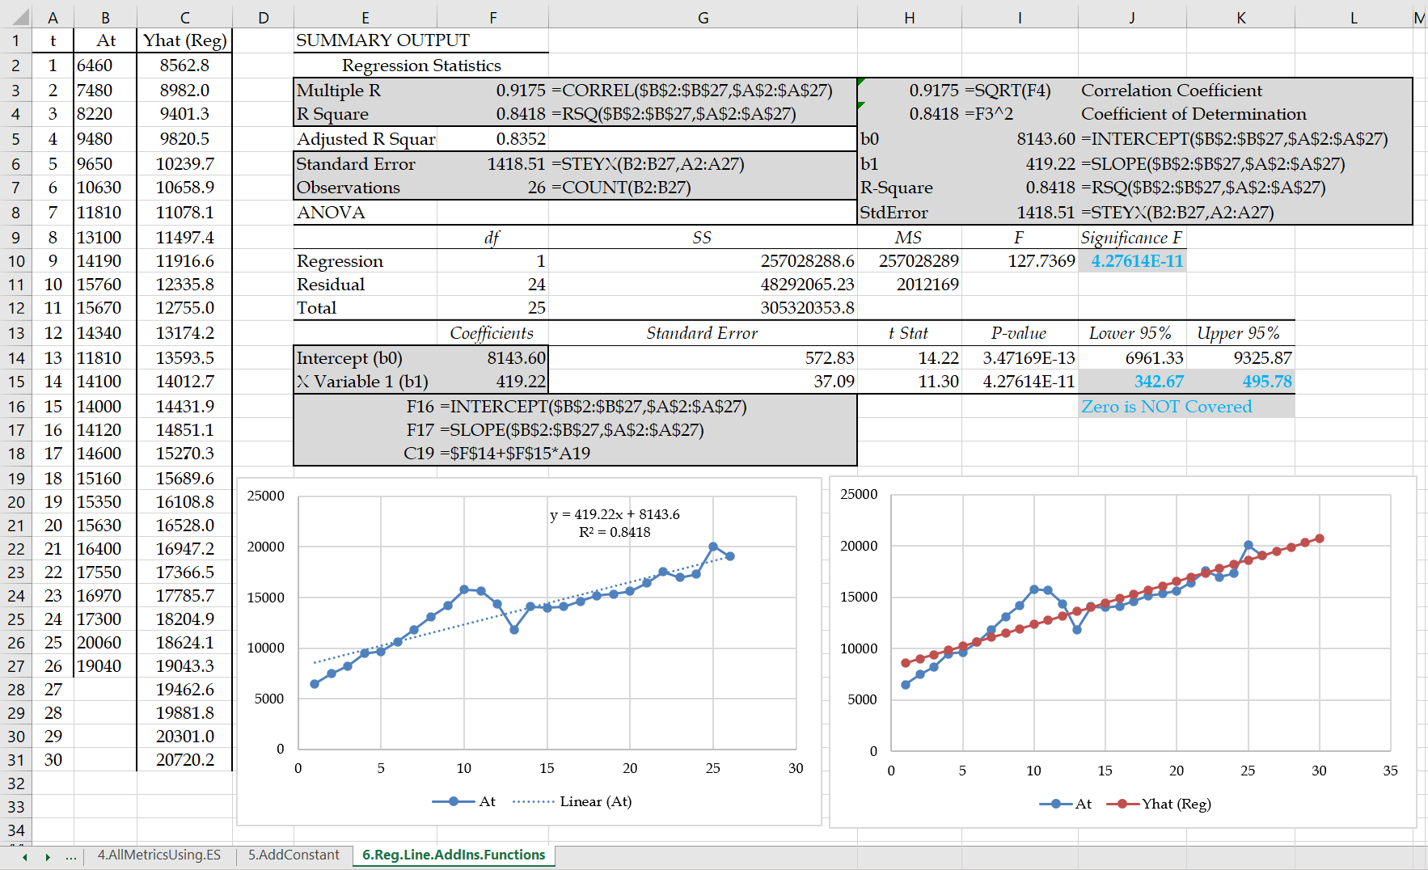

**5.2. Trend Adjusted Exponential Smoothing.**

Trend-adjusted exponential smoothing is defined as Ft+1 = Lt + Tt, where Lt and Tt are the level and trend in period t as defined in Chopra (2019) based on Holt (1957).

Lt+1 = αAt+(1-α)(Lt+Tt)

Tt+1 = β(Lt+1 -Lt) +(1- β)Tt

Trend-adjusted exponential smoothing, or double exponential smoothing, smooths out the level and trend of this period based on the level and trend of the previous period and the actual observation in this period.

Starting L0 and T0 can be computed in two ways. We may set L0 as the demand in the first period and T0 as the demand of the last period minus the demand of the first period divided by (N-1). In our case, L0 =A1= 6460, and T0=(A26-A1)/(26-1)= 503.2 (proposed in Iravani, 2021). Alternatively, we may set L0 as the intercept of the regression line and T0 as its slope. L0 = b0= 8143.6, and T0=b1 =419.2 (proposed in Chopra 2019). We follow the first approach. We start from α = 0.5 and β = 0.5 and then use SOLVER or a two-dimensional Data Table to find the optimal values of α = 0.87 and β =0, as shown in Table 8. Compared to simple exponential smoothing, the MSE and other metrics are lower, and the extension to future periods carries a trend and is not a straight line. Compared to regression, we have a smooth curve going up and down instead of a straight line.



We can also combine linear regression and trend-adjusted exponential smoothing in the form of Ft = γFTrend-Adjusted.ES + (1-γ)FLinear-Regression. The optimal γ value minimizing the MSE of the forecasts from the actual values can then be obtained using SOLVER or Data Table.

**Table 8. Trend Adjusted Exponential Smoothing Computations**

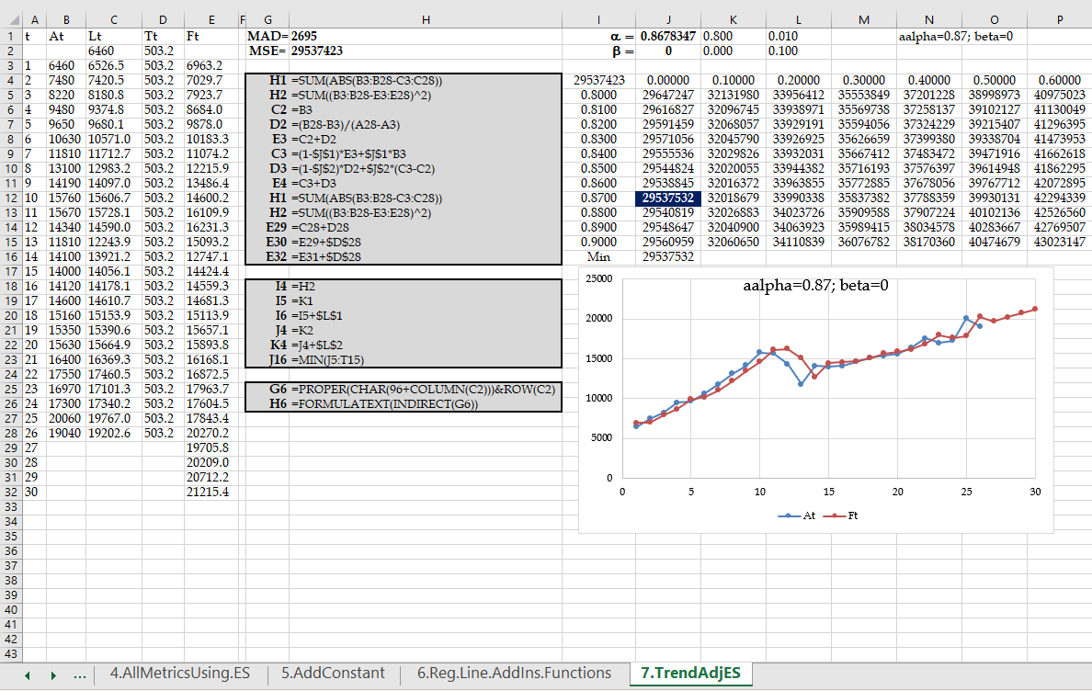

**6. LEVEL, TREND, AND SEASONALITY**

In this section, we review (*i*) seasonality-enhanced bi-variable linear regression, (*ii*) seasonality-enhanced multi-variable regression using dummy variables, and (*iii*) trend and seasonality-adjusted exponential smoothing.

**6.1. Seasonality Enhanced Bi-Variable Linear Regression.**

Our approach is recognized as Winter's Model (Chopra 2019). The monthly data shown in Table 2 for 12(26) months (in 1000 TEUs) are copied into Table 9. We consider a periodicity of 12, where periods repeat every 12 months. One may add three months of data and consider the periodicity of four seasons, periodicity of 7 days over a week, or periodicity of 24 hours a day.

**Table 9. Computations for Static Seasonality Enhanced Bi-Variate Linear Regression**

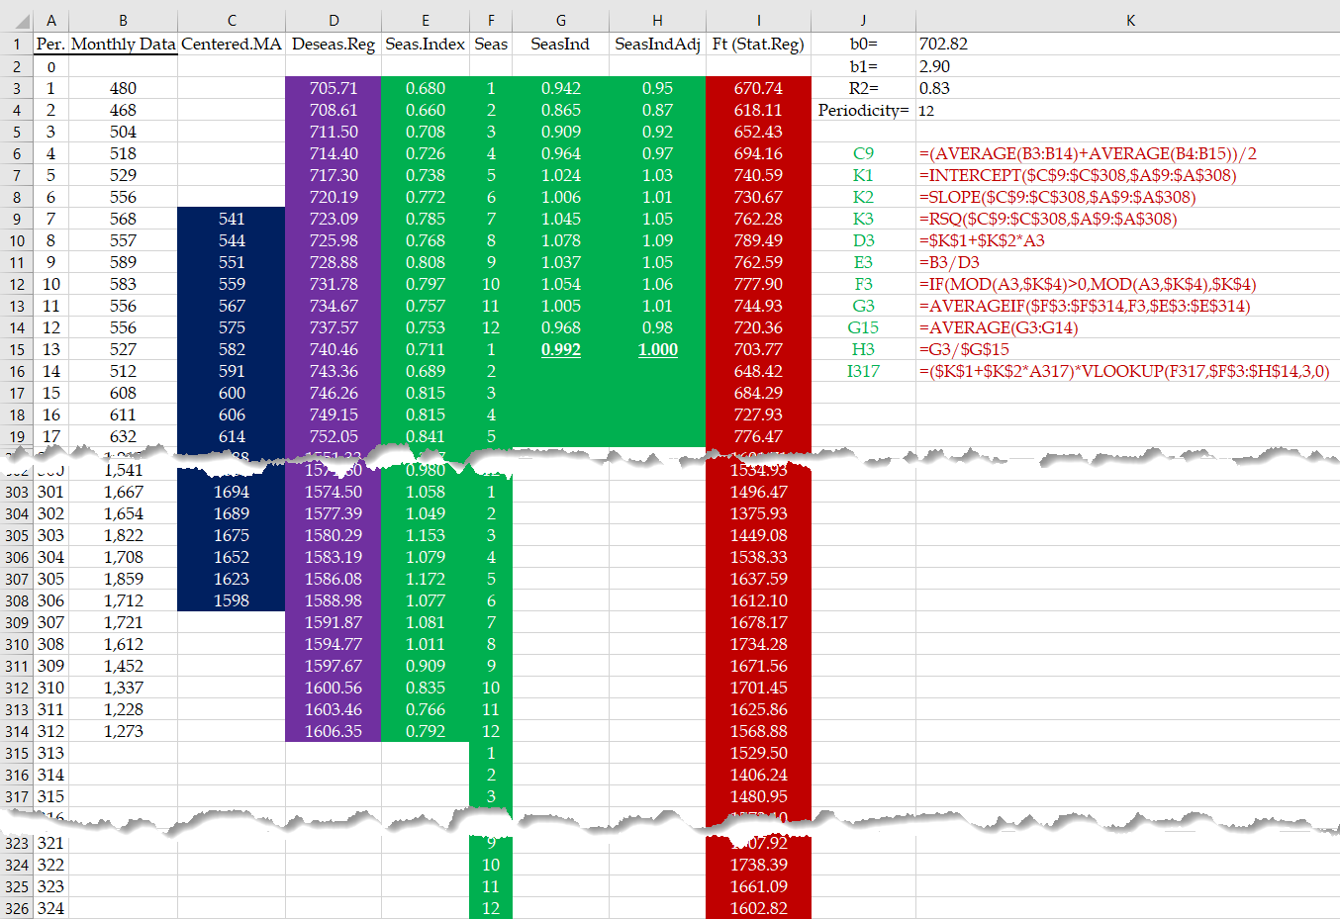

When we compute the average of 12 months, it is pure of seasonality since high and low seasons cross each other out. This is true for any other periodicity; the average of all seasons does not contain seasonality. Instead of placing the moving average of n seasons in front of the last season (as we did in our moving average computations), we place it at the center of the data incorporated in each moving average; centered moving average.

**Step 1. Removing Seasonality.** If we were considering seasonality over 7 days of weeks since 7 is odd, we could have placed the average in front of period 4, compared the actual period 4 with the centered moving average, and estimated the seasonality of period 4. But there is no middle period for even periodicity. Therefore (and the procedure is the same for all other even periodicities), we first compute the average of the 12 months and assume it is placed at the boundary of months 6 and 7. We also compute the period 2 to period 13 average and assume it is at the boundary of months 7 and 8. Next, we compute the average of these two centered moving averages and place it in front of period 7, representing the unseasonal activity volume at period 7. We then copy this formula down to 6 months to the last months. We will generally have the centered moving average for all periods minus periodicity.

**Step 2. Trend in the Deseasonalized Data.** We apply linear regression on months 7 to 306 to find the level and trend of the data pure of seasonality. It leads to b0, b1, and R2, as shown in columns K of Table 9. The Excel worksheet also shows the formulas for all other computations (as they follow).

**Step 3. Seasonality Indices.** We divide the actual data of each month by the value obtained from the regression line applied to the deseasonalized data (At/Yt). The ratios are estimates of the seasonality index in all 12(26) months. By averaging all seasonality indices of each month, the average seasonality index of January (S1) to December (S12) is computed. The average of the average seasonality indices for all 12 months must equal 1; therefore, to normalize, we divide the average seasonality index of each month by the average of the averages. These computations are in columns G and H.

**Step 4. Trend and Seasonality Adjusted Forecasting.** Finally, we put seasonality back on the deseasonalized regression line and forecast the future. Ft = (b0+b1t)*St, where St has the same monthly value over all years. All formulas are clearly explained in Table 9. The results of the four steps of this process are schematically represented in Figure 3. The above analysis shows that the monthly seasonality is from a minimum of 0.87 to a maximum of 1.09. In a similar analysis, one may study daily seasonality (periodicity of 30) or hourly seasonality (periodicity of 24).

**Figure 3. Four Key Steps in Static Seasonality Enhanced Bi-Variable Linear Regression.**

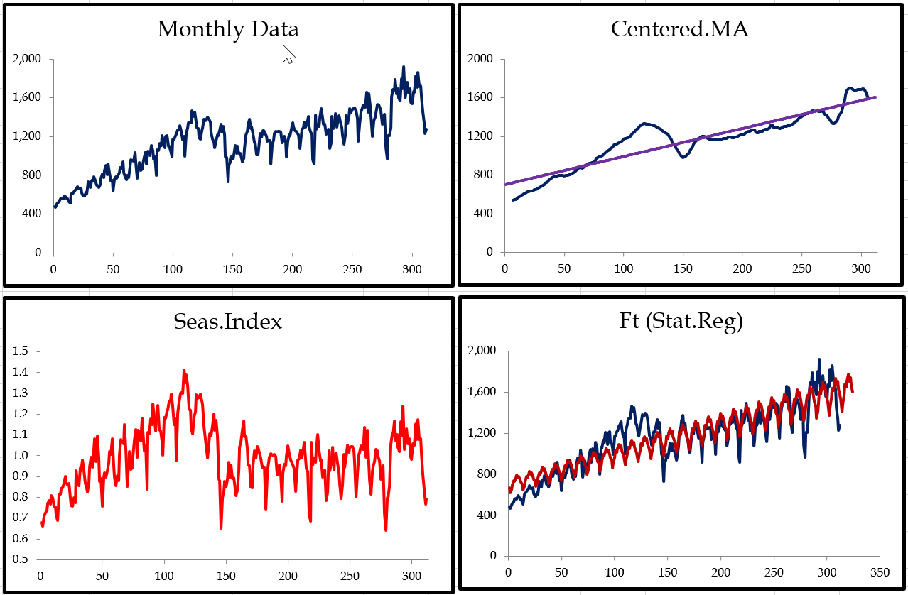

**6.2. Seasonality Enhanced Multiple Regression Using Dummy Variables.**

By implementing a set of binary dummy variables, we use multi-variable regression for another version of static seasonality analysis. For each month, we define a binary variable, which is 1 if we are in that month and 0 otherwise. For periodicity of n periods, we need n-1 dummy binary variables. We compare other periods with a period of choice, where our choice does not affect the analysis outcomes. Since we analyze monthly data over the years, periodicity is 12. We define 11 binary variables for January to November. We will have our Y variable as the volume of activity in the corresponding month, our X variable as the month counter (from 1 to 312), and 11 dummy binary variables. Excel's Data Analysis Add-ins require the independent variables to be in contiguous cells. We, therefore, copy the month variables adjacent to the dummy variables. We can have them before or after the dummy variables. Compared to bi-variable regression, instead of a single column for X variables, we select 12 columns. The output and all the essential formulas are shown in Table 10. The reader may pay attention to the formula to generate 0s and 1 for the dummy variables in each month and, more importantly, to multiply the row of the decision variables by the column of regression coefficients (by using dynamic arrays and transposing one of the two vectors).

**Table 10.** **Seasonality Enhanced Multi-Variable Regression Computations.**

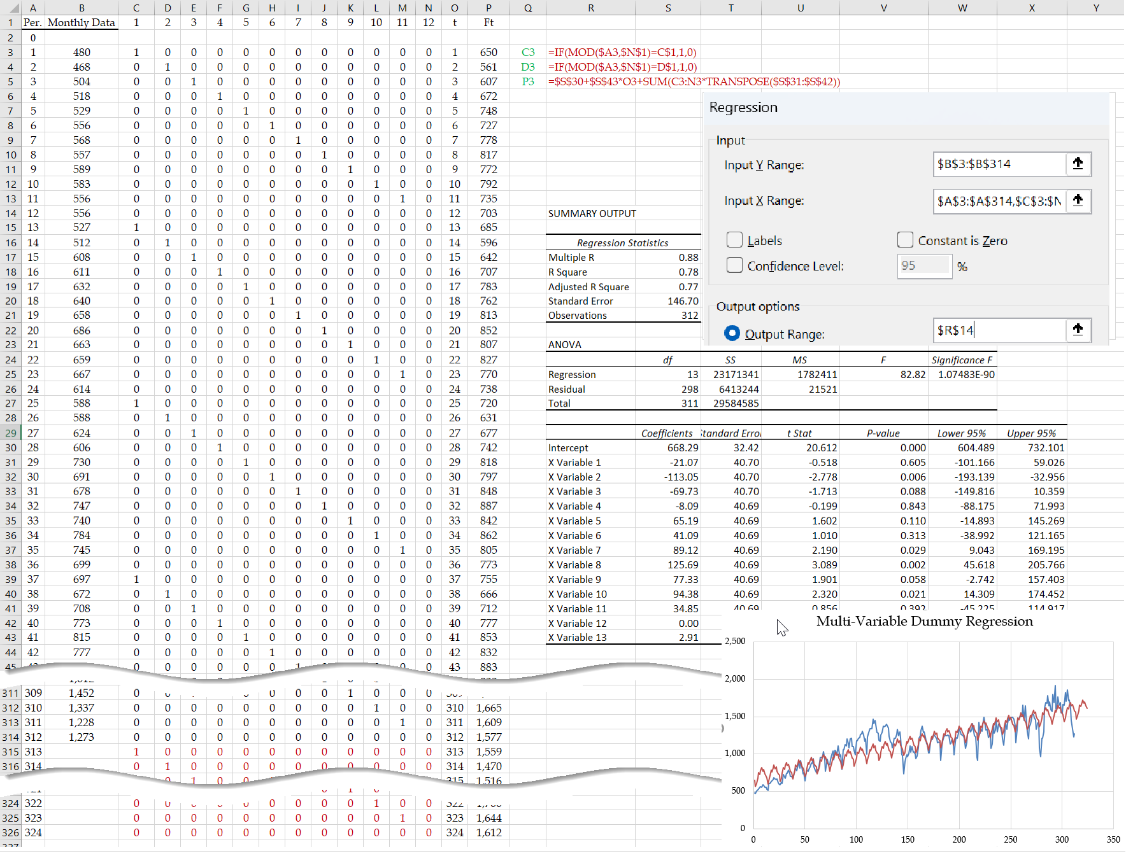

**6.3. Trend and Seasonality Adjusted Exponential Smoothing.**

In the two previous approaches, we used the term static seasonality. Static means we estimate seasonality for all months and keep them as they are; seasonality indexes and all other model parameters remain unchanged. In this third approach, we update seasonality indices (as well as level and trend) as we move forward. It extends the trend-adjusted exponential smoothing (Winter, 1960, Chopra, 2021). The reader may look into the graphs of the three approaches' output to visualize the dynamism inside this third approach.

By applying linear regression on the 12-month centered moving average implemented in seasonality-enhanced bi-variable linear regression, we first estimate the level (L0 =INTERCEPT) and trend (T0=SLOPE) in month zero. We also use static seasonality indexes computed in seasonality-enhanced bi-variable linear regression (Chopra 2021). Alternatively, we may set L0 equal to the average demand in the first 12 months. Given LN as the average of the last 12 months, we set T0=(LN-L0)/(12(N-1)). For seasonality, we may divide the demand of each of the first 12 months by the average of these months and assume them as the seasonality indexes for the first 12 months (Iravani 2021). While the second approach is easier with fewer computations to estimate the starting parameters, since we already have the results as described in the seasonality-enhanced bi-variable linear regression section, we follow the first approach and copy L0, T0, S1, ….S12 from Table 9 into Table 11. We first set α=0.5, β=0.5, and γ=0.5.

**Step 1. Compute Lt.** Given L0 = 702.82, T0= 2.9, and S1= 0.95; F1 =( L0 + T0)S1 = (702.82+ 2.9)* 0.95 = 670.74. We now move forward to compute L1, T1, F2, and S13, then L2, T2, F3, and S14, and so on. In all exponential smoothing models, we always have one component multiplied by a parameter (α, β, or γ), added to another component multiplied by 1 minus α, β, or γ. The 1 minus part is always easier to compute. We have L0 = 702.82, T0= 2.9. Our forecast for level in month 1 is L1= L0 + T0= 705.71. This needs to be multiplied by (1-α). That is, L1=(1-0.5)* 705.71. But what is the part that had to be multiplied by α? It is not 480. That is why the computation of the component multiplied by 1 minus α, β, or γ is easier. The actual month 1 data of 480 contains seasonality. We need to remove seasonality. Since S1= 0.95, month 1 is a low season. We must divide the actual data by S1 to remove seasonality; 480/0.95 =504.97. Therefore, L1 =(1-α)(L0+T0)+ α(A1/S1) = (1-0.5)(702.82+2.9)+ α(480/0.95) = 605.34.

**Step 2. Compute Tt.** Our forecast for T1 is T0. It is multiplied by (1-β) to form the first component of T1. What is the actual T1? It is the difference between L0 and L1 and should be multiplied by β. Therefore T1=(1-β)T0+β(L1- L0) = (1-0.5)* 2.90+0.5(605.34-702.82)=-47.29.

**Step 3. Compute Ft+1.** The forecast for the next period is simply Ft+1=(Lt+Tt)*St+1. For month 2, it is F2=(L1+T1)*S2 = (605.34-47.29)0.872 = 486.78.

**Step 4. Compute St+p.** Since periodicity is 12 (p=12), we need to compute S1+12. We first have (1-γ) times forecast. Our forecast for period 13 is the same as period 1; S1=0.96. What is the actual seasonality in period 1? It is the actual data divided by L1= L0 +T0. That is A1/L1 = 480/705.71 =0.68. Therefore, S13=(1-γ)*S1+γ(A1/L1) = (1-0.5)(0.96)+0.5(0.68) = 0.82.

Table 11 shows all the key formulas and curves related to trend and seasonality-adjusted exponential smoothing components.

**Table 11.** **Seasonality Enhanced Multi-Variable Regression Computations.**

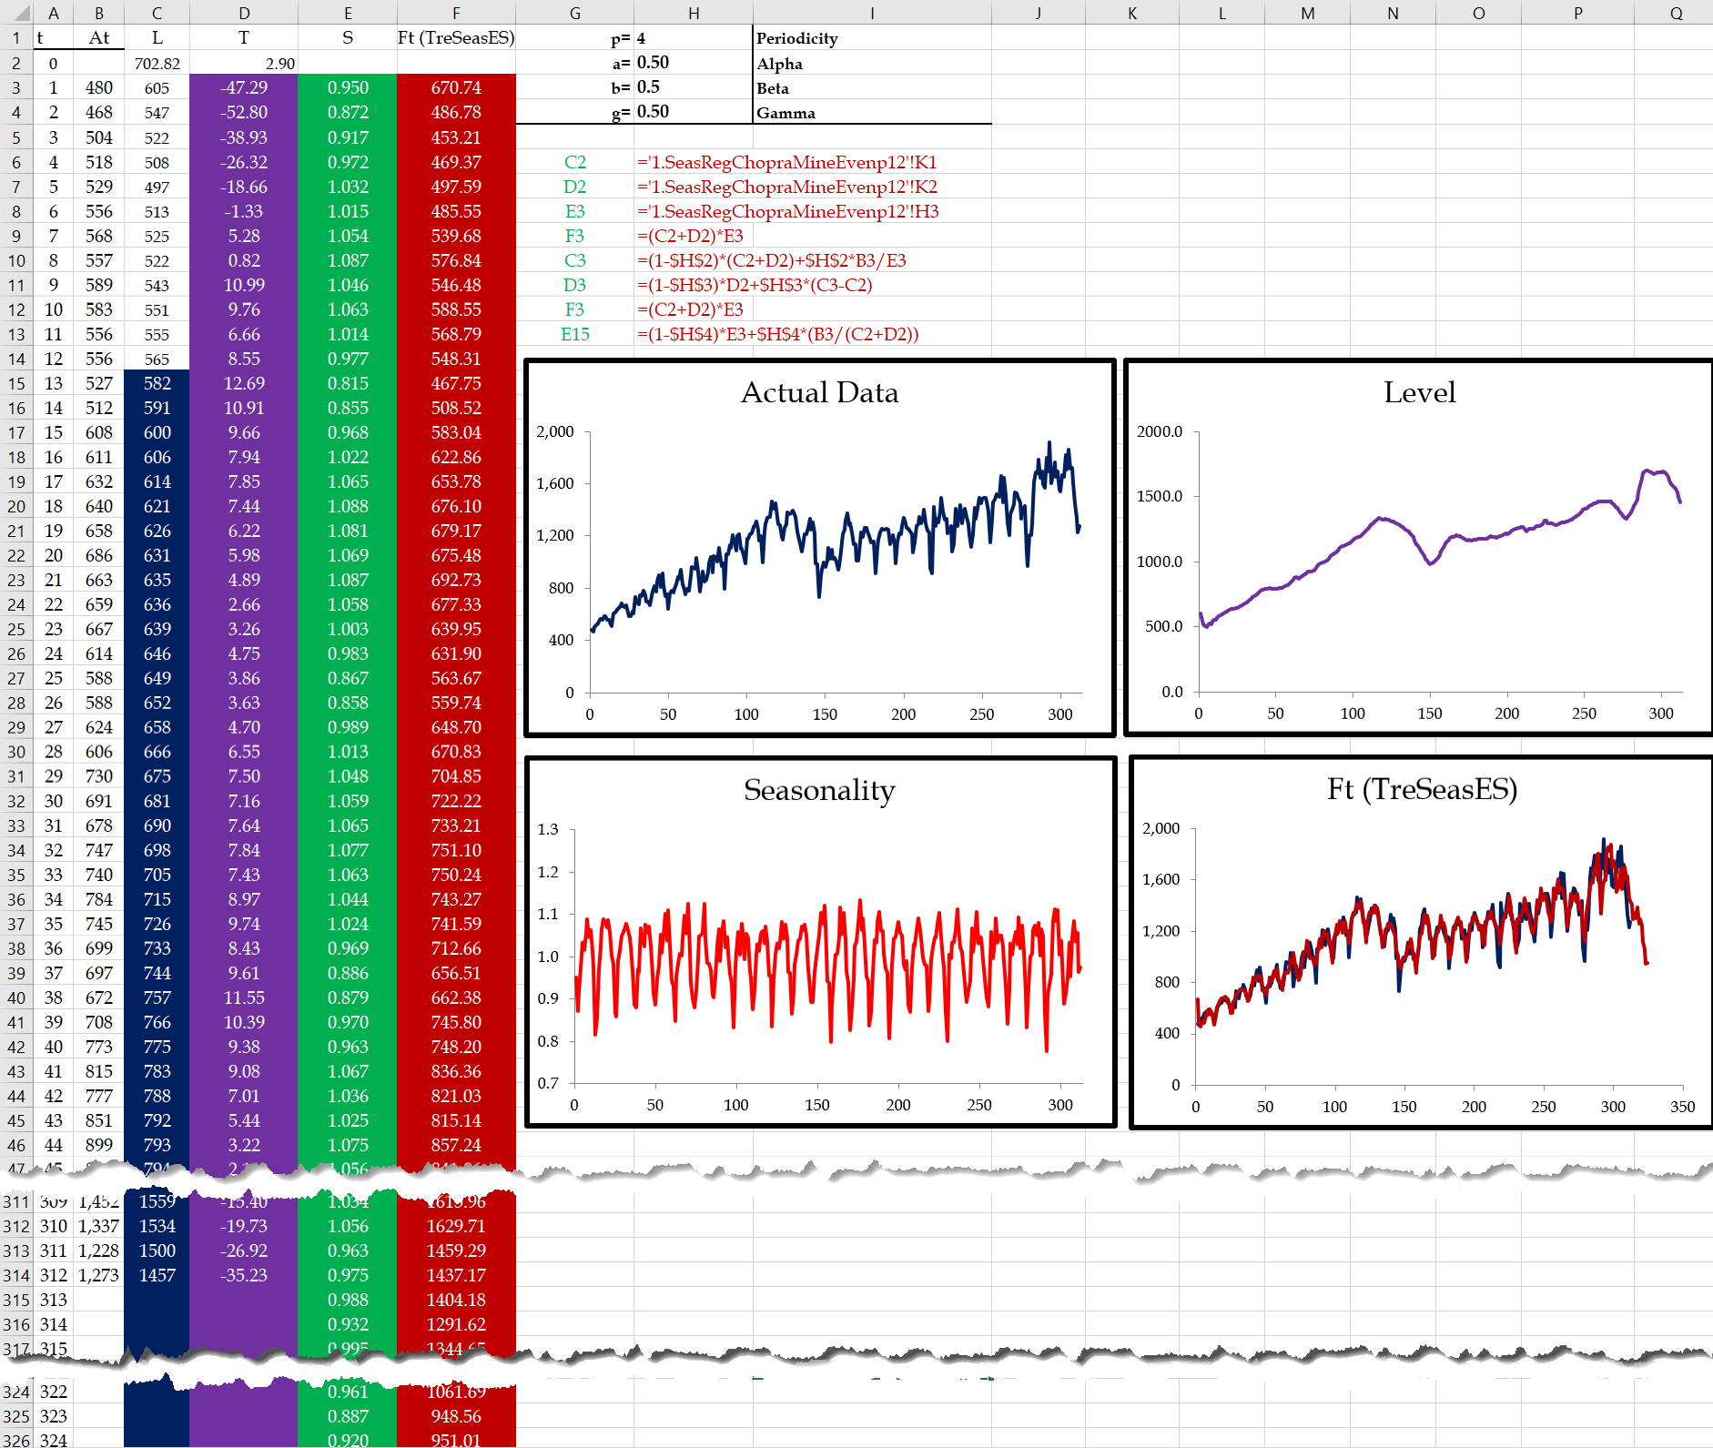

**7. CONCLUSIONS.**

We reviewed and integrated several time series and regression analysis techniques. This manuscript can be used as teaching material or as a case study to enforce the teaching material. While we had our analysis on total loaded and empty for both inbound and outbound throughput, all the data are available to repeat the combination for four combinations of inbound, outbound, loaded, and empty volumes. The same is true for applying these procedures – and the Excel templates – on other data sets.

**Appendix A. Computation of Metrics and Drawing the Graphs for an Any-Period Moving Average.**

We may develop a general formula applicable to any number of periods in a moving average computation. Consider a 4-period moving average forecast in periods 25 and 26 and examine the differences.

F26 = MA25 = (A25+A24+A23+ A22)/4 = (A25+A24+ A23)/4 + A22/4

F27 = MA26 = (A26+A25+A24+ A23)/4 = A26/4 + (A25+ A24 +A23)/4.

Therefore, F27 = F26 + A26/4 - A22/4. Generally, F(t+1) = Ft + (At– At-n)/n. Our forecast for the next period is equal to the forecast for this period (the moving average of the previous period) plus this period's actual data minus the oldest piece of data used on the forecast for the previous period divided by n.

Suppose we enter the number of periods in the moving average is in cell A1 and set it to any number between 2 and 25. Suppose we set it =RANDBETWEEN(2,12); the result is 4 when entered. We now look into the formula in period 6 in row 9 in Table A1. We have the previous forecast and previous actual in row 8, but what is the oldest data in the previous forecast? It is in the row t-n of the actual data. In our example is the data in row 8-4=4 of the Excel sheet. We can use the Excel INDEX function to find the element in a specific row of a vector. IF(A8<$A$1,"",IF(A8=$A$1,AVERAGE(B$4:B8),C8+B8/$A$1-INDEX(B$4:B8,A8-$A$1)/$A$1)) is the forecast formula in cell C9. If the previous year is before year 4, a " " is entered to leave the Excel cell blank. If the previous year is year 4, the average of the actual data for the first four years (from row 4 to 8) is computed and set to the forecast for year 5 (in row 8 of the Excel sheet). For cell C9 which corresponds to year 6>4, we have C8+B8/$A$1-INDEX(B$4:B8,A8-$A$1)/$A$1. Where INDEX(B$4:B8, A8-$A$1) will find the oldest piece of data used in the forecast; INDEX(B$4:B8,5-4) = INDEX(B$4:B8,1) = B4 = 6460. The actual for the previous period is B8 = 9650, and the forecast for the previous period is C8 = 7910. Therefore, the forecast for this period C9= 7910+(9650-6460)/4 =8707.5. The table is adjusted for any number less than 26 that may appear in cell A1.

Since we draw the curves related to some of the columns in Table A1, a " " for the starting years that are less than or equal to the random year that appears in cell A1 will show a Y-value of zero while it is empty and not zero. To resolve this, we replace " " with NA(). To avoid #NA appearing in the table, we use formula-based conditional formatting and switch the font color to white using the IFERROR function for #NA cells. Accordingly, Table A1 and Figure A1 are adjusted automatically no matter what random numbers between 2 and 25 appear in cell A1. Alternatively, we could have the fonts of these columns colored white and switch the font color to black using the ISNUMBER function in conditional formatting.

**Table A1. Computation and Evaluation of an Any-Period Moving Average.**

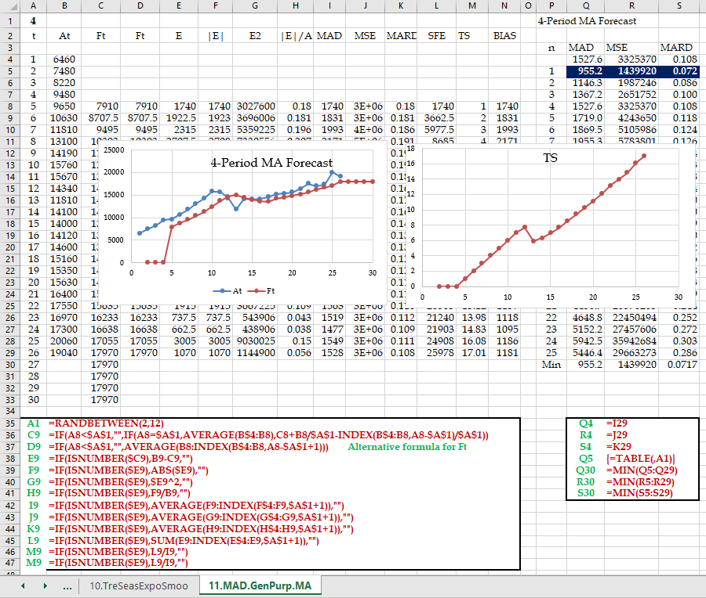

Column D provides an alternative formula for an any-period moving average as follows D9=IF(A6>=$A$1, AVERAGE(B6:INDEX($B$4:$B$30,A6-$A$1+1)),NA()). That is due to the magic inside the AVERAGE(B6:INDEX($B$4:$B$30,A6-$A$1+1) formula. We benefit from this formula in columns E to M to compute the metrics only when the data exist and do not show anything for other years in the graphs, as shown in Figure A1. All the key formulas of Table A1 are re-emphasized by the green and red cells with white backgrounds.

**Figure A1. Flexible Graphs for Computation and Evaluation of an Any-Period Moving Average.**

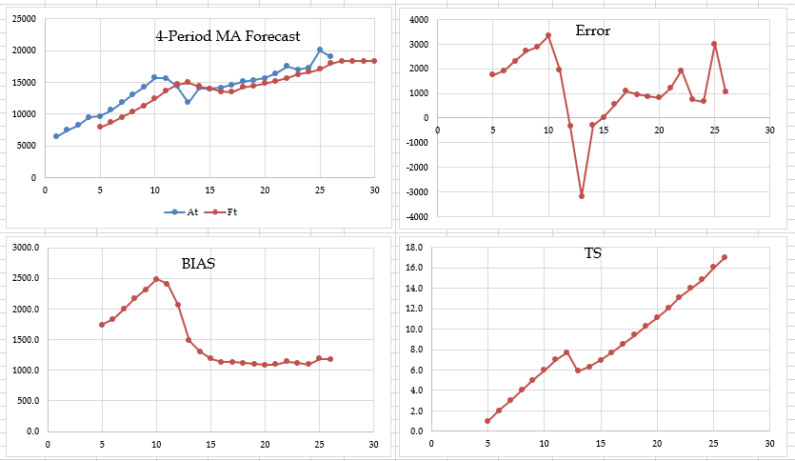

Given the new any-period moving average formulas, selecting the number of periods and adding a constant may reduce the gap between the actual data and forecasts. Table A2 shows computations for adding a constant and the number of periods in the moving average using a two-dimensional Data Table for MAD minimization (n= 12, K=220). It can be similarly applied to MSE and MARD minimization.

**Table A2. Two-Dimensional Data Table to Add a Constant to an Any-Period Moving Average.**

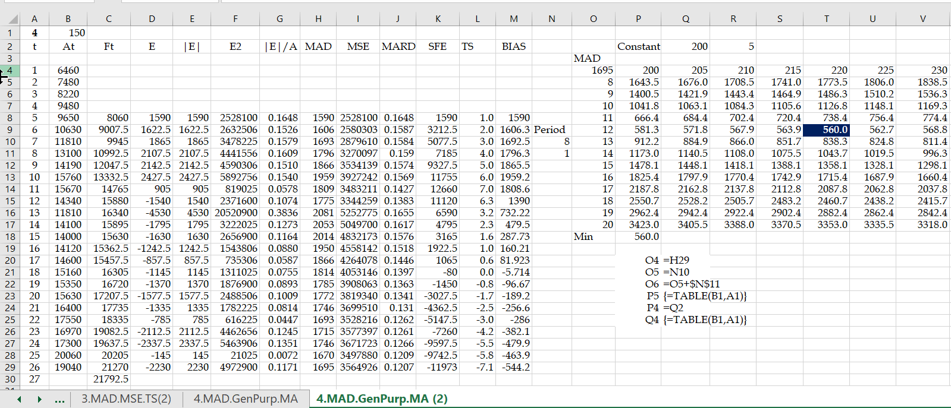

Furthermore, we can add flexibility to our table and graphs by updating them as soon as new data is available. We first put column A in a dynamic form by using =IF(OR(ISNUMBER(B5),ISNUMBER(C5)),A4+1,NA()). If we have actual or forecast value in the corresponding row, the year number will appear otherwise NA(). We then add flexible graphs using the OFFSET function to define dynamic name ranges and then use dynamic name ranges as X and Y of scatter graphs. We define a dynamic range name for the actual data as =OFFSET(click on B4,,,count(B4:B53)). Note that we need to do this in the range name window (not copy and paste from elsewhere) to have =OFFSET('11c.MAD.GenPurp.MA-B'!$B$4,,,COUNT('11c.MAD.GenPurp.MA-B'!$B$4:$B$53)). Fortunately, we can copy this and paste it for other dynamic ranges in other columns. The only change needed is to replace $B$4, and only $B$4, by $A$4, $A$4, $D$4, $H$4, $M$4 in t, Ft, E, BIAS, and TS columns. There is no need to change COUNT('11c.MAD.GenPurp.MA-B'!$B$4:$B$53) since it counts the rows containing data and is the same for all columns. Note that we must also type in t, Ft, E, BIAS, and TS as the names of the corresponding name ranges referred to by OFFSET functions.

We then need to go to each Ft vs. At, E, BIAS, TS, and any other chart we may need and replace the static reference with a dynamic reference. For example, we have ='11c regarding Ft vs. At chart.MAD.GenPurp.MA-B!$A$4:$A$30, ='11c.MAD.GenPurp.MA-B!$B$4:$B$30, and ='11c.MAD.GenPurp.MA-B!$C$4:$C$30 for series X and two Y values. We replace them with ='11c.MAD.GenPurp.MA-B!t, ='11c.MAD.GenPurp.MA-B!At, and ='11c.MAD.GenPurp.MA-B!Ft, respectively. As new actual data is entered into the table, the table and all its graphs are updated dynamically.

**Appendix B. Exponential Smoothing Basic Mathematics.**

In this Appendix, we show that (*i*) exponential smoothing is a weighted moving average and (*ii*) the age of data is 1/α.

**B.1. Exponential Smoothing a Weighted Moving Average.**

The following analytical manipulations show that Exponential Smoothing is a Weighted Moving Average.

F1 = A1

F2 = (1-α)F1 +αA1 🡺 F2 = (1-α)A1 +αA1 🡺F2 = A1

F3 = (1-α)F2 +αA2 🡺 F3 = (1-α)A1 +αA2

F4 = (1-α)F3 +αA3 🡺 F4 = (1-α)((1-α)A1 +αA2) +αA3 🡺 F4 = (1-α)2A1 +α (1-α)A2+αA3

F5 = (1-α)F4 +αA4 🡺 F5 = (1-α)3A1 +α ( (1-α)2A2+α( (1-α)A3+ αA4

Ft+1 = αAt +α(1 – α)At–1 +α(1 – α)2At–2 + α(1 – α)3 At–3 + α (1 – α)4At–4 .…+ α (1 – α)t-1A1

The sum of the weights are

S= α +α(1 – α) +α(1 – α)2 + α(1 – α)3 + α (1 – α)4.…+ α (1 – α)t-1

= α(1 – α) +α(1 – α)2 + α(1 – α)3 + α (1 – α)4.…+ α (1 – α)t

S-(1-α)S = α- α (1 – α)t 🡺 αS = α(1- (1 – α)t) 🡺 S = 1- (1 – α)t

When t increases, (1 – α)t goes to 0, and the sum of the weights S=1.

**B.2. Age of Data in Exponential Smoothing.**

Through the following analytical manipulations, we show that the age of Data in Exponential Smoothing is 1/α.

Weights= α, α(1 – α), α(1 – α)2, α (1 – α)3, α(1 – α)4,……,α(1 – α)t-1

Ages = 1, 2, 3, 4, ………..t

Weights × Ages = 1α*+* 2α(1 – α)+ 3α(1 – α)2+ 4α(1 – α)3+ 5α(1 – α)4+……+ *t*α(1 – α)t-1

Weights × Ages = α(1+ 2(1 – α)+ 3(1 – α)2+ 4(1 – α)3+ 5(1 – α)4+……+ *t*(1 – α)t-1)

We have shown *S* = α(1+ (1 – α)+(1 – α)2+(1 – α)3+(1 – α)4+……+(1 – α)t-1) =1

1+ (1 – α)+(1 – α)2+(1 – α)3+(1 – α)4+……+(1 – α)t-1 =1/α

Derivation with respect to α

0-1-2(1 – α)1-3(1 – α)2-4(1 – α)3-……-(t-1)(1 – α)t-2 =-1/α2

α(1+2(1 – α)1+3(1 – α)2+4(1 – α)3+……+(t-1)(1 – α)t-2 )=1/α

**B.3. UCL and LCL in Tracking Signal are larger than +4**

Forecast error Et =At-Ft is a random variable with a mean of 0. MAD estimates the error forecast's standard deviation. StdDev(Et) = 1.25MAD (for example, Duncan, 2007}.

Et = Normal (0,1.25MAD)

If x = Normal(µ,σ) 🡺 Sum (x) = Normal(µ, SQRT(N)σ)

StdDev [Sum(Et)] = SQRT(N)StdDev (Et)

Et = Normal (0,1.25MAD)

Sum (Et) = N~(0, SQRT(N)1.25MAD)

3 ≥ (∑Et -0)/(SQRT(N)1.25MAD)) ≥ -3.

+ 3SQRT(N)1.25 ≥ (∑Et -0)/MAD ≥ - 3SQRT(N)1.25.

+ 3.75SQRT(N) ≥ (∑Et -0)/MAD ≥ - 3.75 SQRT(N)

Therefore, Tracking Signal TS= ∑Et/MAD with samples of size N is normally distributed around 0, and UCL = 3.75 SQRT(N) and LCL =-3.75 SQRT(N).

**Appendix C. Foundations of Computation of Regression Metrix in Excel (b0, B1, SST, SSE, SSR).**

One may design a regression line by minimizing MAD, MSE, MAX(ABS(Error)), or any other measure. Conventionally, regression equations are designed based on MSE minimization (least-square method). We compute MSE or SSE (Sum of Squared Errors) and use SOLVER to find the optimal b0 and b1 (which are in cells J16 and J17 in Table A1) to find the optimal values for the SSE ( cell D28) objective function. After computing the forecasts in column C using arbitrary but reasonable b0 and b1 (in cells J16 and J17), we form column D (the square of the error in each row) and add them to form SSE in cell D26. We then use SOLVER (we can use DataTable too) to find optimal b0 and b1 to minimize SSE (or MSE). These optimal values (in cells J16 and J17) are the same as we found using the first three approaches in the regression section. It provides insight into least-squared computations and other regression metrics. Cell D26 can also be computed using dynamic arrays without referencing any values in column D (we can even delete column D). Look at the significant power of dynamic arrays in cell J19 for direct SSE computations.

**Table A1. Direct Computation of Regression Coefficients and Key Metrics.**

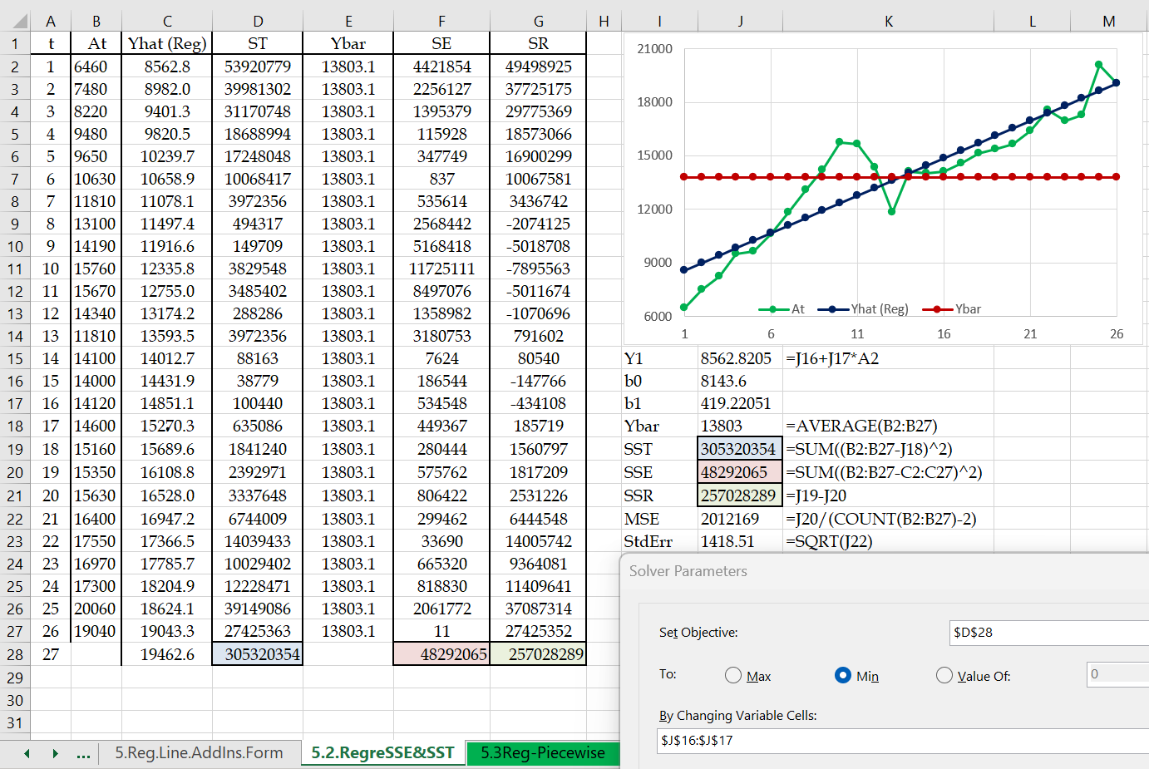

In Regression Analysis, we usually compute three SST, SSE, and SSR metrics. SST is the summation of the squares of the gap between each piece of data with the average. Table C1 shows the gap between the green curve (actual data) and the red curve (average of all data). The total squared error measures how each data element differs from the average. We then have SSE, the squared gap between the green curve (actual data) and the blue curve (regression data). The total squared error measures how each data element differs from the value obtained on the regression line. The difference between these two (SSR) represents how well the regression line could replace the average line representing the data. The reader may compare the computations in cells D28, F28, and G28 with those of J19, J20, and J21 to better understand dynamic arrays (and may delete columns D, E, F, and G).

R-squared is computed as SSR/SST, reaching the same value as computed directly using the RSQ function. The MSE (and Standard Error) computations in regression slightly differ from what we discussed earlier. When you benefit from other statistics extracted from the same data set in the computation of an average, you use degrees of freedom. In the computation of SSE, we have used two parameters b0 and b1. Therefore, we lose two degrees of freedom when we average SSE over n years (26 in this example). Therefore, MSE is not SSE/26 but SSE/(26-2).

Given the background provided in this Appendix, we can apply a piecewise regression to find b01, b11, b02, and b12 for the first and second piece of the regression line and T as the year to switch from the first regression line to the second. The above five items form the changing cells, and MSE is the objective function to be minimized. The result is shown in Figure A1.

**Figure A1. Piecewise Regression on LA/LB ports Annual Data.**

**Appendix D. All Worksheets Used in This Study.** Since there are many computations in different worksheets of this workbook, recalculating all elements on all pages slows down the process. It is recommended to move each worksheet to an individual workbook.

**References**

Cachon, G. and Terwiesch, C., 2020. Matching Supply and Demand: An Introduction to Operations Management. 4th Edition, McGraw-Hill. ISBN: 978-0-07-808665-5.

Chase, R. B., Aquilano, N. J., and Jacobs, R. F., 2000. Irwin/McGraw-Hill, ISBN 10: 0072395303ISBN 13: 9780072395303.

Chopra, S., 2019. Supply Chain Management, Pearson, ISBN 978-0-13-473188-9.

Duncan, R. M., 2007. CFPIM, Training Manager, E/Step Software Inc. <http://www.estepsoftware.com/papers/madrsquare.pdf>

Holt, C. C., 1957. Forecasting seasonals and trends by exponentially weighted averages (ONR Memorandum No. 52). Carnegie Institute of Technology, Pittsburgh USA. <https://www.sciencedirect.com/science/article/abs/pii/S0169207003001134?via%3Dihub> Retrieved 7/12/2023.

Iravani, S.M.R., 2021. Operations Engineering and Management: Concepts, Analytics, and Principles for Improvement. McGraw-Hill. ISBN 978-1-260-46183-1.

Leachman, R.C., 2010. Port and Modal Elasticity Study, Final Report, Southern California Association of Governments.



Port of Los Angeles Statistics. <https://www.portoflosangeles.org/> Last Checked 7/12/2023.

Port of Long Beach Statistics. <https://polb.com/> Retrieved 7/12/2023.

Stevenson, W. J., 2014. Operations Management. 12th Edition, McGraw-Hill. ISBN: 978-0078024108.

The Institute for Advanced Analytics (North Carolina State University). Survey of Graduate Degree Programs in Analytics. http://analytics.ncsu.edu/?page _id=4184. Retrieved 7/12/2023.

Winters, P. R., 1960. Forecasting sales by exponentially weighted moving averages. Management Science, 6(3), 324–342. <https://pubsonline.informs.org/doi/10.1287/mnsc.6.3.324> Retrieved 7/12/2023.