**7. Re-Order Point**

**Introduction.** In the previous chapter, we discussed how much to order. Under an optimal policy, when there is no price discount, we order the EOQ, and in presence of price discounts, we order either EOQ or more than EOQ. As long as cost is our main concern, we never order less than EOQ. Why? Because our total ordering and carrying costs increases, and furthermore, we may jump up to a higher price curve. This is not the case for quantities higher than EOQ, since while again, our total ordering and carrying costs increases; we can never be lifted to a higher purchasing price. Nevertheless. If we are concerned with flow time rather than cost, we may order less than EOQ since T= R /the average cycle inventory, and I is Q/2. Therefore, the smaller the Q, the shorter the flow time. In the previous chapter, we will study when to order. In case of periodic inventory policy, we always order at the start of a period, e.g. start (or end) of every week, start (or end) of every month. However, in perpetual or continuous (as opposed to periodic) inventory system, reorder point is defined in terms of quantity, not in terms of time. Instead of ordering whenever the end of the period is reached, we order when inventory-on-hand reaches a specific level. This defines the Re-Order-Point (ROP). In the previous chapter, we discussed how much to order (EOQ), in this chapter we discuss when to order (ROP).

In a perpetual or continuous reviewing inventory system, reorder point is when inventory-on-hand drops to a predetermined quantity. In the EOQ model, we assume that there is no variation in demand, i.e. demand is known and is constant. In this case, the average demand during lead-time is equal to actual demand during lead-time. **Lead-time** is the time interval from the time an order is placed until the time that it is received. Therefore, if demand is fixed. Reorder point is a point when inventory-on-hand is equal to demand during lead-time.

**Problem 1- Constant Demand, No Safety Stock.** Average demand for a product is 40 units per day with a lead-time of 4 days. There is no variation in demand or in lead-time. As we start consuming that inventory, it will gradually go down. The re-order point (ROP) is when inventory-on-hand is equal to the constant demand during the lead-time. ROP = 4(200) = 600. Hence, whenever inventory drops to 800, we place an order. The demand during those 4 days is exactly 800 units. We will receive the order exactly in 4 days when inventory-on-hand is 0.

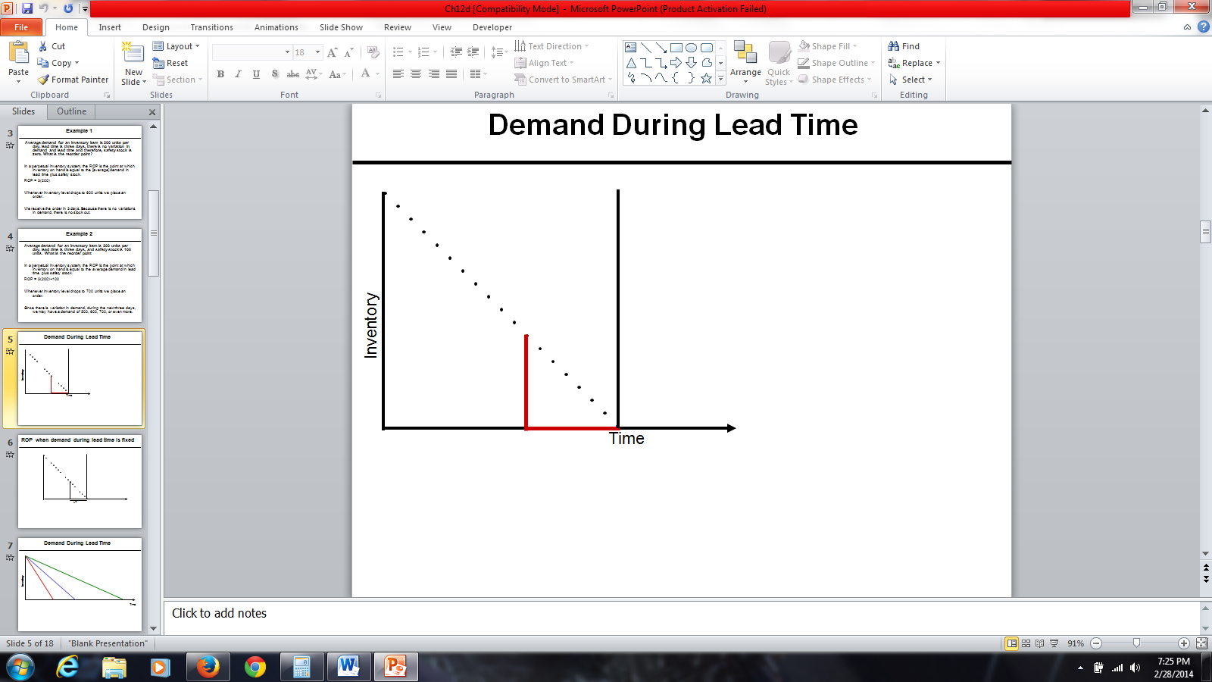

The situation changes when demand shows variations. If demand is a variable, average demand during lead-time (*LTD*) differs from actual demand during the lead-time (***LDT***). (Note that we used bold font for the actual demand during the lead-time, which is a random variable, and regular fonts with the same letters for the average demand. Throughout this study guide, a random variable and its average are identified using the same characters, where the bold font is used for the random variable and regular font for average. When variability exists in the demand or lead-time, it is possible that the actual demand to be less than average or more than average demand. We need the average demand during lead-time (LTD) and its standard deviation (LTD). The greater the variability of demand during lead-time, the greater the probability of the gap between actual demand during lead-time (**LTD**) and average demand during lead-time (LTD). Therefore, we need additional inventory to reduce the risk of shortages. The additional inventory is known as safety stock (Is).

**Understocking** is not good because customers come and when we tell them that we do not have the product, we will then have dissatisfied customers.  This will lead to a loss of sales, and the customer may go to another vendor forever.

**Overstocking** is not good either because it has three types of costs: financial costs, physical costs, and obsolescence costs. *Financial costs*, instead of having our money in a city or in a profitable business, we put it in inventory.  *Physical cost,* our inventory should be put in safe keeping somewhere.  Thus, we either lease a warehouse or allocate a portion of our shop to a physical location of these products.  And finally we may have *obsolescence cost* , if we purchase for a large amount of inventory for a product that eventually gets low consumer demand, we may never be able to sell them; thus rendering the product obsolete.

**Problem 2- Constant Demand plus Safety Stock.** Average demand for an inventory item is 40 units per day. Lead-time is 4 days, and safety stock is 100 units. What is the reorder point? In a perpetual inventory system, the reorder point is the point at which inventory-on-hand is equal to the average demand during lead-time plus safety stock. Since lead-time is 4 days, average demand during lead-time is 4(200) =800 plus safety stock, *ROP= LTD+Is* = 800+100= 900. When inventory level drops to 900 units, we place an order. We receive the order when inventory on hand is 100 units.

In presence of variability, we assume ***LTD*** follows a Normal distribution. This is a direct implication of the central limit theorem; summation (or average) of a set of variables of any kind, tends to have normal distribution. If I order at a point when inventory-on-hand is equal to *LTD*, because normal distribution is a symmetric bell-shaped curve, the probability of ***LTD*** *≥ LTD* is 50% and probability of ***LTD*** *≤ LTD* is 50%. Therefore, if we order at the point when inventory-on-hand is equal to average demand during the lead time, there is 50% probability that demand during lead time exceeds the average demand during the lead time. In real life, we do not like to reply to 50% of our orders that we are out of stock. If we are out of stock, we will lose the profit that we could have made through the sale. Furthermore, if a customer comes to the store once or twice and is told that the product is not available, this customer may switch to another vendor. The client’s store loyalty is lost. For this reason, usually retailers, manufacturers, and distributors do not want a 50% probability of shortage. They want 1%, 5%, or 10%. Therefore, we would like to have a probability of 99%, 95%, or 90% to be able to fulfill the demand. We order when inventory-on-hand is greater than the average demand during lead-time. That is instead of 50% service level and 50% risk, we like to have, for example, 90% service level (SL) and 10% risk. Safety stock is what you have to add to the average demand during the lead-time to increase SL to above 50%. We order EOQ (or any other Q that we may prefer) when inventory on the hand is equal to average demand during lead-time plus safety stock. When you order at this level of inventory-on-hand, it will reduce the probability of stock out during the lead-time.

Since in real life, there is variation in demand during the next four days, our demand is not 800. It may be less than 800 or more than 800. No matter daily demand follows what distribution, in the virtue of the central limit theorem, we may assume that the total demand over a set of several days, follow Normal distribution.

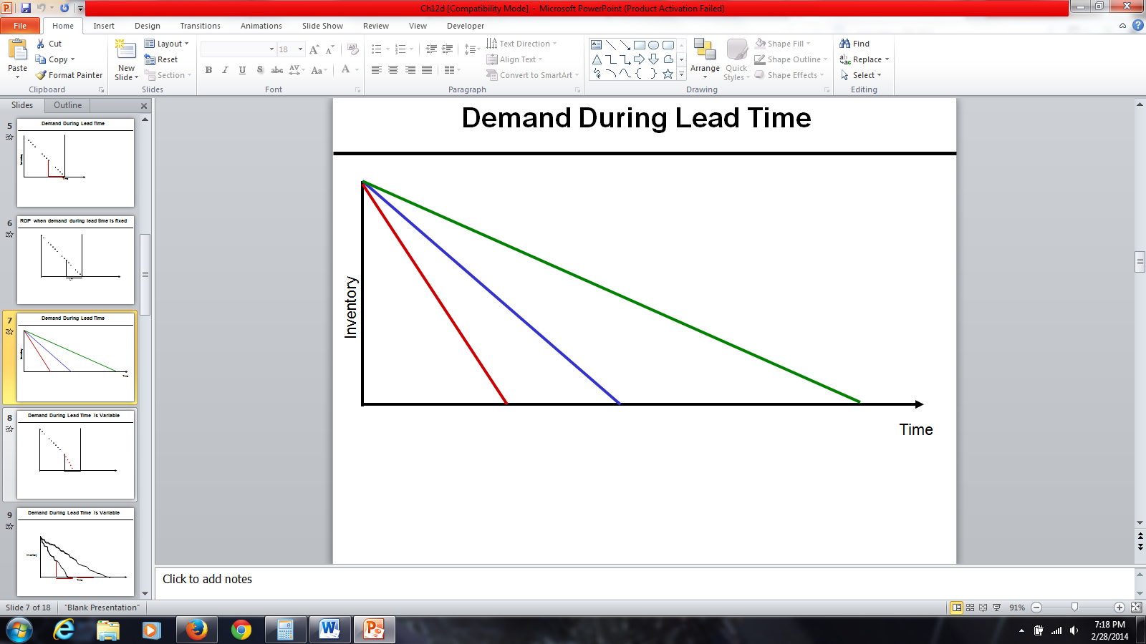This graph shows three different consumption rates for the same inventory-on-hand. The blue line shows the expected consumption rate. We will receive the order when the blue line crosses the horizontal black line it is possible to consume the inventory at a faster or slower rates. Suppose rather than consuming it at the speed represented by the blue line, we consume it at the speed of the red line. Thus, we would be reaching the reorder point sooner. Alternatively, we may consume it with a slower rate, such as that of the green line. Then it takes more time to reach the reorder point. In all three cases, whenever inventory reaches to the level equal to the average demand during the lead-time plus a safety stock, we place an order.

**Problem 3- Variable Demand During Lead Time Plus Safety Stock.**

Average demand during the lead-time, LTD, is 200 and standard deviation of demand during lead-time, LTD, and is 25. Service level is 90%. Compute safety stock (Is) and reorder point (ROP).

If we set our ROP equal to the average demand during lead-time (LTD), there is 50% probability to be out of stock and 50% probability to be over stock. Usually cost of under stock is higher than cost of under stock. That is why we do not like to set our reorder point at the level equal to the demand during lead-time. We first need to know what 90% service level (SL) means. If it was 50% that would have meant no safety stock and ROP =LTD. Since it is greater than 50%, that means we need to go to the right; we need to have our ROP larger than LTD. How much larger? We measure it in term of how many standard deviations. How many standard deviation should we go to the right such that the probability of falling on the left is 90%? This is not a difficult question; we need to check standard normal distribution for 90%.

1.281551566 =NORM.S.INV(0.9)

We need to go 1.281551566 standard deviations to the right. Since our standard deviation is 25, therefore, we need to go 25(1.281551566) = 32.04 ≈ 33 unit to the right. Is = 33.

ROP = LTD +Is 🡺 ROP = 200+32 = 232

What is our service level? It is a little higher than 90% because we rounded 32.04 up to 33. It is easy to know the service level since we have moved 33/25 = 1.32bstandard deviations to the right. Therefore the service level is 0.906582491 =NORM.S.DIST(1.32,1). Our service level is 0.65% more than 90%.

We are here

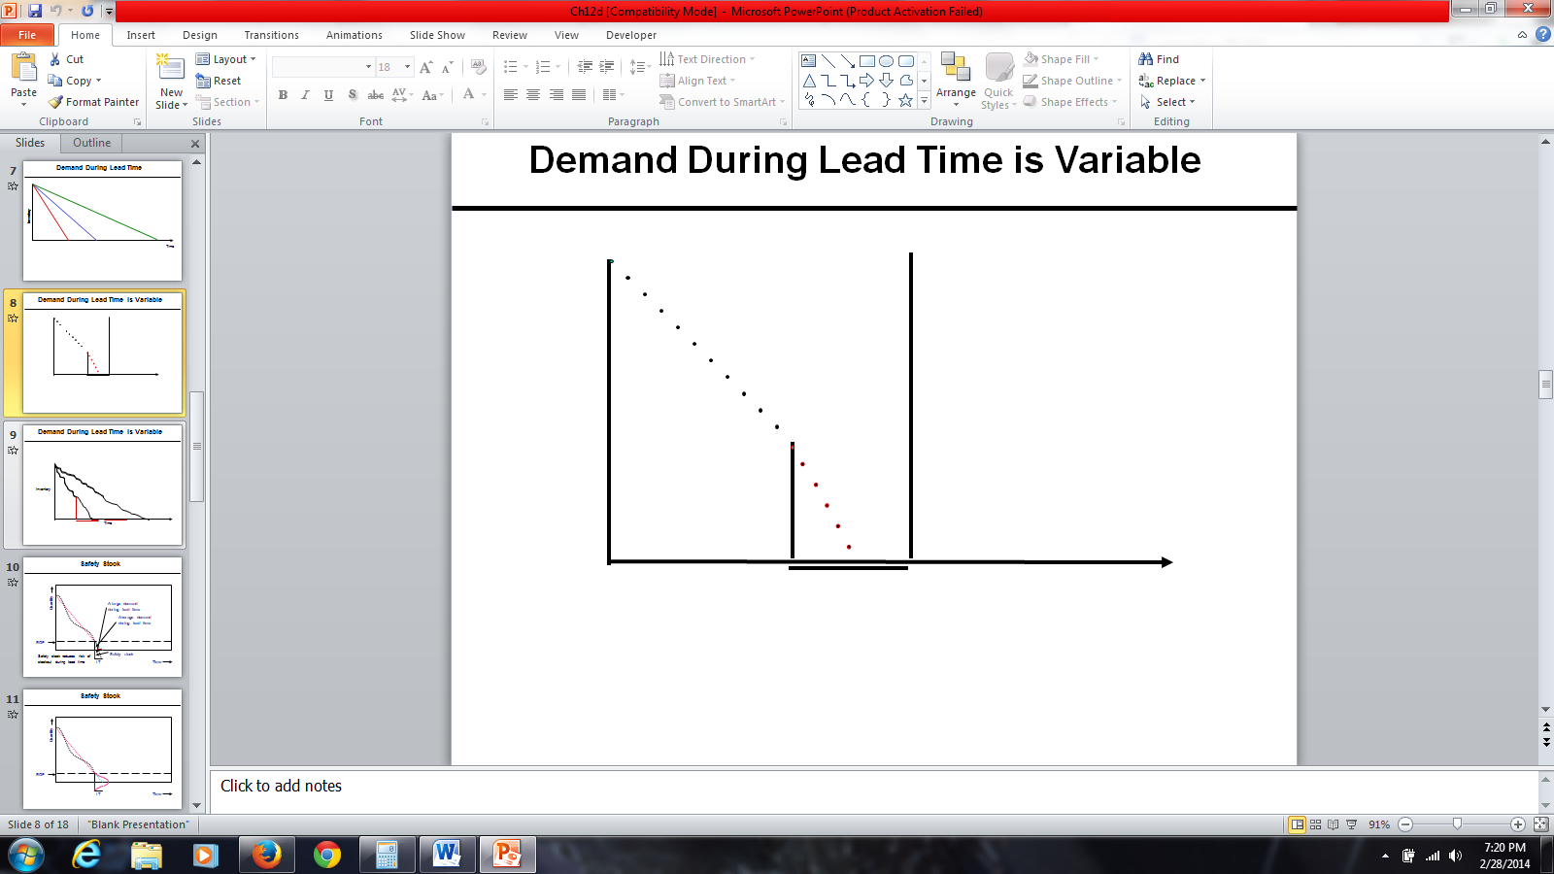Suppose we have reached the reorder point, have placed an order, but the demand has immediately taken off. In this case, we consume the inventory before we get the placed order. We expected to consume the inventory at the same linear rate before placing the order, and we expected to get the placed order exactly when inventory-on-hand reaches 0. Nevertheless, who can guarantee that customers will come to the store based on the rate we have assumed? Therefore, it is possible that the product is consumed at a faster rate. Any customer who comes to the store asking for the product will not be able to purchase it because there will be no inventory-on-hand for the product in question. Thus, the customer will have to wait until the inventory arrives.

In general, customers do not come to the store to ask for a product in a linear fashion. There might be more or less customers, depending on the day. In contrast to the basic assumptions of the inventory model that demand is known and constant, the demand follows random distributions. If only average demand is known, we will need a computation for EOQ based on average demand. However, some days we may have more orders and other days we may not. It is not unfair if one assumes that, the daily demand follow Poisson distribution. In the figure, the first linear has a steeper slope, thus inventory drops quickly. In the second linear, the slope is less steep than the first, thus inventory drops slowly. As soon as inventory-on-hand reaches to the level in which we think inventory-on-hand is enough for average inventory during lead-time, we place an order. We expect to receive the order at this point, and consume this inventory at this rate. It is possible that we consume it at a faster rate. In that case, we will be out of stock for a certain amount of time. Suppose we reach the reorder point, but the demand after that was quite high. Therefore, before we get the next order, the entire inventory-on-hand was consumed. Alternatively, the demand may be less than the average demand that we have assumed. We expect to consume the inventory in a linear fashion, and we expect that by the next order, inventory-on-hand is equal to 0. Nevertheless, if we consume the inventory at the lower rate, we would still have inventory-on-hand by the arrival of the next order.

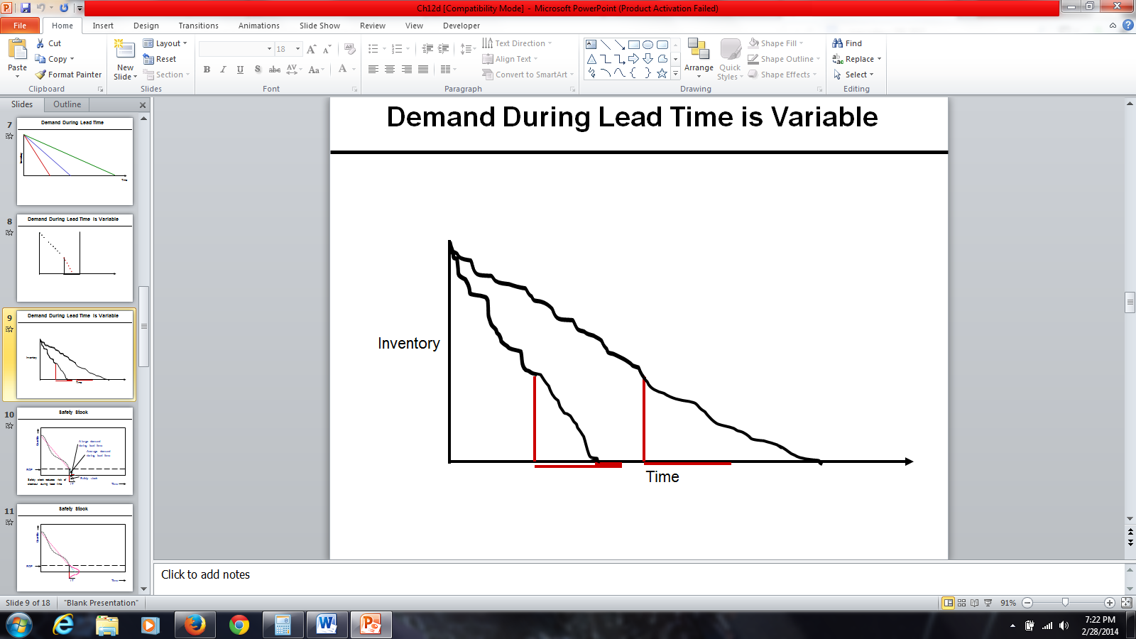

Figure 5: Demand During Lead Time is Variable

**Safety Stock**

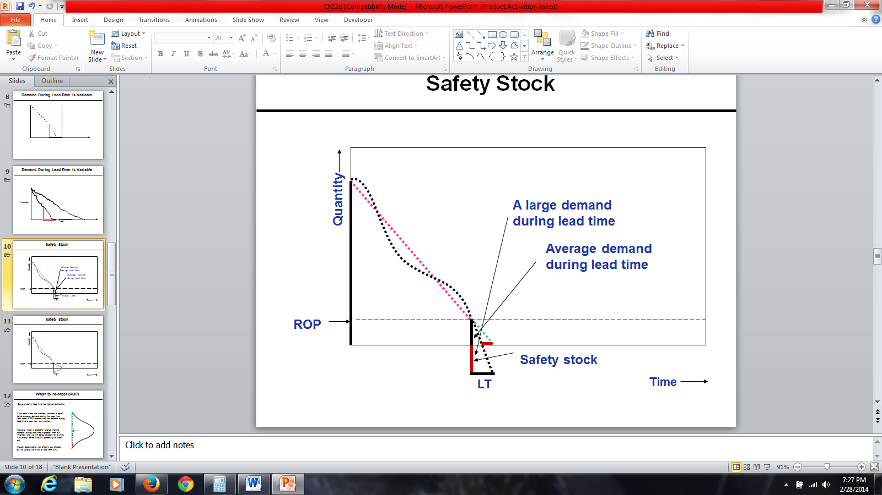

Figure 6: Safety Stock

Why do we need safety stock? We need safety stock because we want to reduce the probability of being short of stock. The y-axis shows quantity (inventory-on-hand). The x-axis represents time. This is the order that I have received; it is either EOQ or greater than EOQ. It does not contain anything about when to order. It is either EOQ, or if we have a price discount, it is possible that it is greater than EOQ to take advantage of price discount. How much to order and when to order are completely different concepts.

We consume inventory in a non-linear fashion (a curve), which sometimes is steep or mild. To find the slope of this line, we will use average inventory. The vertical axis displays quantity and the horizontal axis displays time. In this pictorial representation, we want to show how inventory is consumed over time. It is either EOQ or if there is a price discount, it may be something more than EOQ to take advantage of price discount. In Figure 6, we assume that it is consumed in a linear fashion. It may be consumed either at a rapid rate or at a gradual rate. The slope of the line is equal to average demand. Therefore, we assume that it is consumed in a linear way with this slope, but in reality, it may be consumed in a rate lower than that rate or in a rate higher than that rate. Therefore, while actual demand is non-linear, we assume it is linear because we want to model it and get some conclusions, some guidelines from that model. Do not forget whenever we want to model a portion, we need to simplify it. Then based on that simplifications, we would be able to develop a mathematical formulation and collect information about the simplified version of the real world. However, later we need to incorporate at least some parts of complexities of real world into our simple model.

Whenever inventory-on-hand reaches average demand during lead-time, we place an order. The reorder point is a point in which inventory-on-hand is equal to average demand during the lead-time. It is possible that during lead-time the demand is quite higher than what is expected, which depends on the slope of the line. Because demand during lead-time was quite higher than the average demand, at this point inventory reaches 0. Therefore, for this much of time, which is almost half of the lead-time, we don’t have any product to give to customers. Therefore, in order to reduce this probability, we need a safety stock. Safety stock reduces risk of stock out during the lead-time. That is why we add to average inventory during lead-time.

Figure 7 represents an illustration of safety stock with inventory-on-hand when we received the order along with the reorder point when we reorder. The reorder point is equal to average demand during lead-time. We expect to consume this inventory at the average rate, and therefore we may go back this many days. Demand during the lead-time is not constant. Demand during lead-time has normal distribution. That amount is only average of the demand during lead-time. Actual demand during lead-time could be any of these numbers. If it is more than average, probability of stock out is 50%. If we want probability of stock out not to be 50%, but to be a smaller amount, then we will add safety stock. We order not at the point when inventory-on-hand is equal to 0 but at the point when inventory-on-hand is equal to average demand during lead-time.

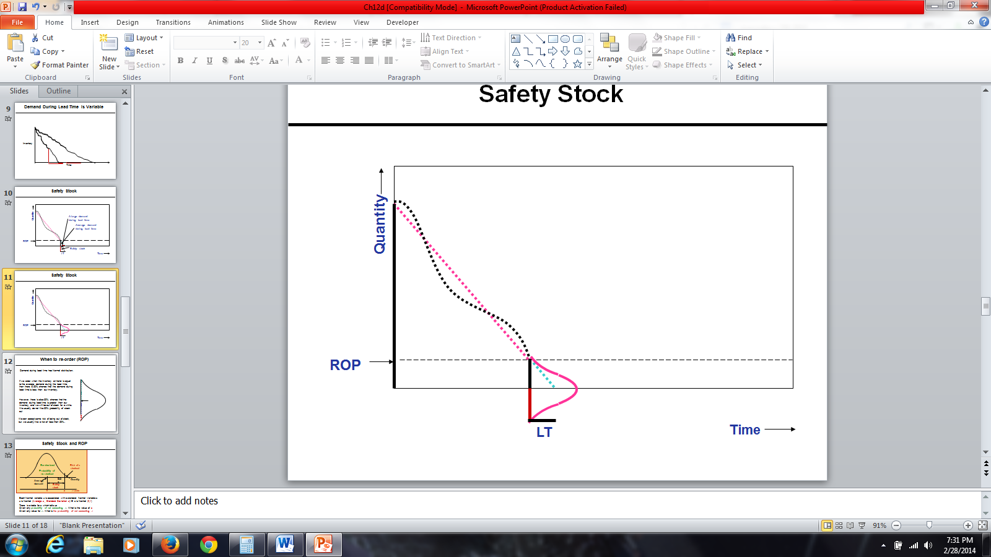

Figure 7: Safety Stock

Figure 8 illustrates a simple graph of reorder point. We assume demand during lead-time has a normal distribution. This middle arrow is the average. There is 50% probability that demand is less than this average, and there is 50% probability that demand is greater than this average. Therefore, if we order at the point when inventory-on-hand is equal to average demand during the lead-time, there is 50% probability that the demand during lead-time is less than this average. It is also possible that demand during lead-time is greater than average demand during lead-time. There is 50% possibility that demand is greater than the average demand. Demand could be greater than the average demand. In all of these cases, we want to be able to satisfy the demand. We do not want the probability of facing shortage to be 50%. We want it to be less than 50 percent. With 100% probability, we can satisfy all the demand. Therefore, we are ready to accept some risk to be out of stock. We want that risk probability that we will not be able to satisfy demand to be 1%, 5 %, 10%, but not 50%.

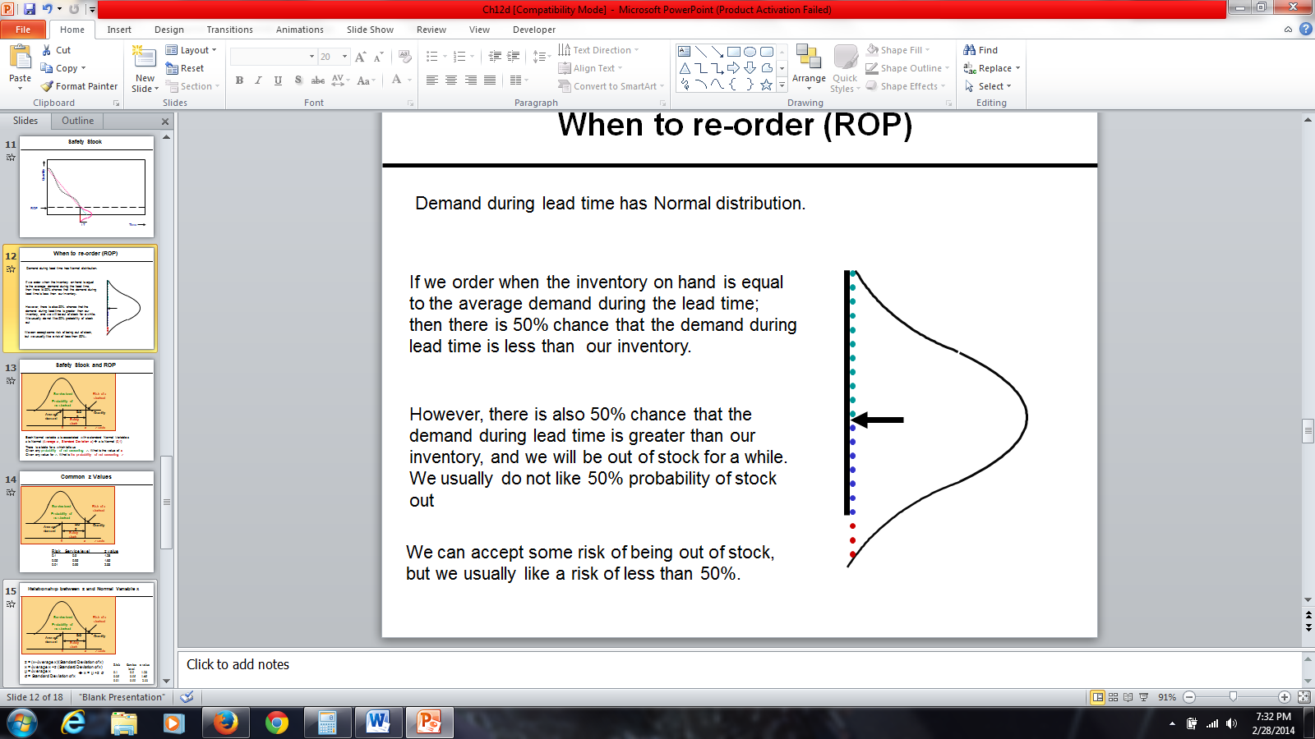

Figure 8: Re-Order Point

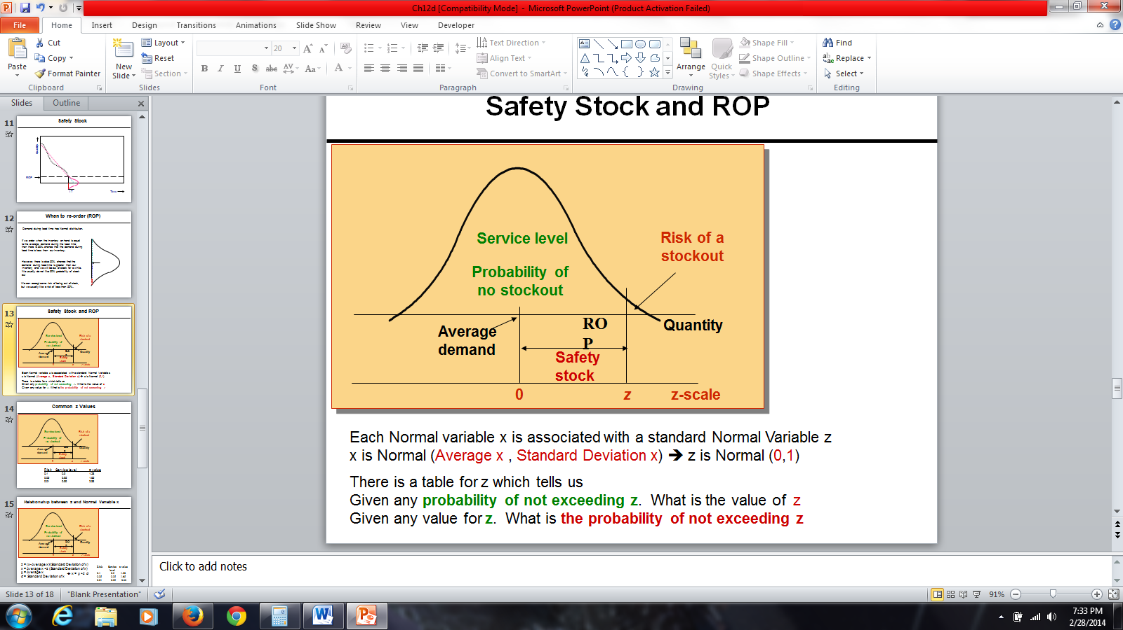

Figure 9: Safety Stock and ROP

Figure 9 represents a normal distribution. This is average demand during lead-time. We are ready to accept this much risk to be out of stock. This risk could be 1%, 5%, 10%, depending on managerial policies. Probability of no stock out is quite high. Risk or probability of stock out is quite low compared to this probability. This is what we call a service level. If probability of risk is 5 %, service level is 95%. If probability of risk is 1%, service level is 99%. If probability of risk is 10%, service level is 90%. If management says with 90% probability we want to be able to satisfy the demand during lead-time, we are ready to accept the risk of 10%. This is the safety stock, which is added to average inventory to ensure that this probability is less than 50 %.

Demand during lead-time is a normal variable X. What do you know about this variable? It is normal, so its distribution is bell-shaped. When we say it is a normal variable X, we should also know its average, which we could say is a hundred units during lead-time, and we should have its standard deviation. When we talk about a normal variable, we know it is normal and has a specific mean, which could be anything, and has a specific standard deviation. This normal variable, this random normal variable has two attributes, mean, and a standard deviation, which could be any number. A normal variable X is associated with a standard normal variable Z. What is the attributes of a normal variable X? It has a mean, an average, and a standard deviation. But those two attributes in standard normal variable Z are 0 and 1, therefore, standard normal variable Z has mean of 0, and a standard deviation of 1. Given any probability of not exceeding a specific Z, that table will give us the value of Z. However, this Z is a standard normal variable. It is not the variable X that we are looking for and it is specific average and specific standard deviation.

Therefore, if we know the service level or risk, which is one service level, then we can compute a specific Z, which is related to that risk and that service level. If we know a specific Z, we can find out what the service level is for that specific Z and what the risk is for that specific Z. The table in Figure 10 gives us service level and risk. While we are talking about a general normal variable with a specific average and a specific standard deviation, there is a relationship, which connects that general normal variable, X with a standard normal variable Z. We need this mapping because we do not have a table of probabilities for all types of normal variables, such as different averages and different standard deviations. However, we have that table for standard normal variable, which has mean of zero and a standard deviation of one. In addition, we have a relationship, which transforms any normal variable with any mean and any standard deviation into standard normal variable.

Therefore, if risk is 10%, service level is 1 minus 10%, which is 90%, and if we go to normal table, it will tell us Z value is 1.28. The Z value for the probability of service level is 90% and probability of risk is 10%, the specific Z is 1.28. If the average demand during lead-time was 0, standard deviation of lead-time was 1, inventory-on-hand is 1.28, and then there is 90% probability that we could satisfy all the demand. There is 10% probability that we cannot satisfy all the demand. We usually do not have Z distribution for my demand during the time. We have normal distribution, which can easily transform into Z distribution or standard normal distribution. The standard normal distribution table tells us if risk is 5% and service level is 95%, then your Z value is 1.65. If risk is 1% and service level is 99%, then the Z value is 2.33. So it simply tells us that the Z value for which the probability of being greater than Z is 1%, and the probability of being less than or equal to Z is 99%.

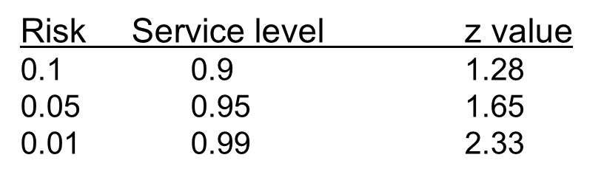

Figure 10: Common z Values

If we take any normal variable X, subtract it from its average, and divide it by its standard deviation, we get Z value. We can find what Z is for each of the different percentages of risk. Therefore, we can find average demand during lead-time, the standard deviation of demand during lead-time. Hence, we can find the reorder point. X is equal to average X + Z times the standard deviation of X. Mu is average of X. Sigma is the standard deviation of X. X is equal to Mu + Z times sigma. Therefore, if we know Z, we can transform it into X. If we have X, we can transform it into Z. Given any service level or any risk, we can easily compute Z value.

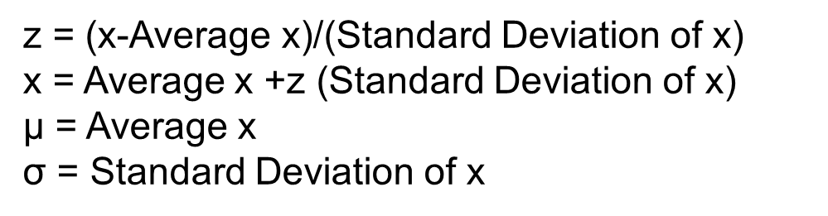

Figure 11: Relationship between z and Normal Variable x

LTD is lead-time demand. Reorder point is average lead-time demand + Z times the standard deviation of lead-time demand. Reorder point is equal to average lead-time demand + Z times the standard deviation of lead-time demand, which is what we call safety stock. If we only reorder at a point, when inventory-on-hand is equal to average lead-time demand, then probability of stock out is 50%. However, if we add safety stock to it and reorder at the point where the inventory-on-hand is equal to average lead-time demand + safety stock, then the probability of stockout would be quite low. It could be 10 %, 5 %, or 1%. Therefore, if you want probability of stockout to be 10%, you will find 1.28, which is Z. Then you would take that Z and you multiply it by the standard deviation of lead-time demand and that would be safety stock. Then you add it to average lead-time demand, and that would give you the reorder point. If you order at that reorder point, probability of stockout would be 10%.

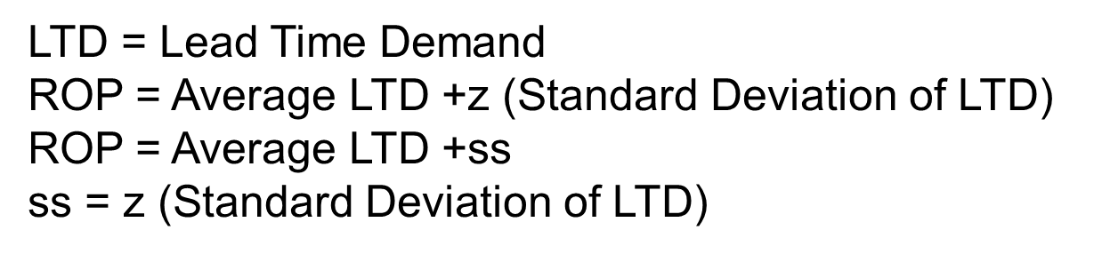

Figure 12: Relationship between z and Normal Variable ROP

**Demand for a car is 14 per week over 7 days a week. Lead-time is 2 days; there is no variation in demand and lead-time. Safety stock is 0. What is the reorder point?**

**Solution: demand/n (1400/7)=200.**

**ROP= 2(200)=400.**

**Whenever inventory level drops to 200 units, we place an order. We should receive the order in 2 days.**

1. **Average demand for an inventory car part (tires) is 400 units per day, lead-time is 2 days and safety stock is 50 units. What is the reorder point?**

**Solution: ROP=lead time (average demand)+safety stock.**

**Therefore, 2(400)+50 = 850.**

**Whenever inventory level drops to 850 units, we place an order. Since there is variation in demand, during the next two days we may have a demand of 650, 750, 850, or even more.**

**True or False?**

1. **Safety stock reduces risk of stock out during lead-time. (True)**
2. **If we order when inventory-on-hand is less than the average demand during the lead time, then there is 50% chance that the demand during time is less than out inventory (False)**

**Practice Set #2**

1. **At Bed Bath & Beyond, customers purchase on average 21,000 Magic Bullets machines per week. The lead-time is 20 days. Assuming zero safety stock. Compute ROP.**

**Isafety=0**

**L=10**

**R= (21,000U units/week) X (1week/7days)=3000 units/day**

**Solution: ROP= LTD+Isafety**

**ROP=LTD+0**

**ROP=L x R**

**ROP= 20 x 3000=60,000**

1. **The following week, the Magic Bullet gained media popularity. Customers at Bed Bath & Beyond demanded on average 105,000 Magic Bullets per week. The lead-time increased to a month during the month of February. Assuming 50,000 safety stock. Compute ROP.**

**Isafety=50,000**

**L= 28 days (during the month of February, there are always 28 calendar days)**

**R=(105,000 units/week) x (1 week/7days)=15,000 units per day**

**Solution: ROP= LTD+Isafety**

**ROP= LTD+50,000**

**ROP= (28 x 15,000) +50,000=470,000**

1. **After a great success with the Magic Bullet, Bed Bath & Beyond decided to introduce a new product called the Pocket Hose. After a successful introduction, customer began to demand on average 1,000 units per day. The standard deviation of demand is 5 per day, and the lead-time is 10 days. Compute ROP at 90% service level. Compute safety stock (round to nearest dollar) Assume demand is variable and lead-time is fixed.**

**Questions to think about:**

**What is the average demand during the lead-time?**

**What is standard deviation of demand during lead-time?**

**L: Lead Time**

**R: Demand per period (per day, week, month)**

**R: Average Demand per period (day, week, month)**

**σR: Standard deviation of demand (per period)**

**LTD: Average Demand during Lead Time**

**LTD = L × R**

**σLTD: Standard deviation of demand during lead-time**

σ_LTD=√L σ_R

**L: 10 days**

**R: 1,000 units/day**

**σR: Standard deviation of daily demand =5**

**LTD: Average Demand During Lead Time**

**LTD = L × R = 10 × 1,000 = 10,000**

**σLTD: Standard deviation of demand during lead-time**

σ_LTD=√10 (5)=15.811

**Solution:**

**SL = 90% 🡺 z = 1.28**

**x = μ + z σ**

**ROP= LTD +z σLTD**

**LTD = 10,000**

**σLTD = 15.811**

**Thus,**

**ROP= 10,000+ 1.28 × 15.811**

**ROP= 10,000 + 20**

**ROP = 10,020.**

**Isafety = 20**

1. **Use the same information provided on problem 3. However, assume that demand is fixed and lead-time is variable.**

**If Lead time is variable and Demand is fixed**

**L: Lead Time**

**L: Average Lead Time = 10 days**

**σL: Standard deviation of Lead time = 5 days**

**R: Demand per period = 1,000 per day**

**LTD: Average Demand During Lead Time**

**LTD = 10 × 1,000 = 10,000**

**σLTD: Standard deviation of demand during lead-time**

σ_LTD=10,000(5) =50,000

σ_LTD=Rσ_L

**LDT = 10,000**

**σLTD = 50,000**

**SL = 90%**

**z =1.28**

**Thus,**

**ROP = LTD +zσLTD**

**ROP = 10,000 +1.28(50,000)**

**ROP = 320 + 64,000**

**Isafety = 64,000**

**5.) At the Arbor Grill, average lead-time demand for potatoes (to make French fries) is 18,000 units. Standard deviation of lead-time demand is estimated to be 9,000 units. The store can only order a 7-day supply, 21,000 units, each time the inventory level drops to 26,000 units. Due to its limited space, suppose holding cost is $3 per unit per year.**

**LTD = 18,000, *σLTD* = 9,000, ROP = 26,000, H=$3, R = 3,000 / day, Q or EOQ = 21,000.**

**a) Compute the service level.**

**ROP = LTD + Isafety 🡺 Isafety = 26,000 – 18,000 = 8,000**

**ROP = LTD +z *σLTD* 🡺 Isafety = z *σLTD* =8000**

**z(9,000) = 8,000 🡺 z = 8,000/9,000 = 0.89**

**z =0.89 🡺 P(z ≤ Z) = 0.8133 = 81.33%**

**In 81.33 % of the order cycles, Arbor Grill will not have a stock-out. Risk = 18.67%.**

**b) Compute the cycle inventory, and average inventory.**

**At reorder point, we order 21,000 units.**

**Icycle = Q/2 = 21,000/2 = 10,500**

**Isafety = 8,000**

**Average Inventory = I = Icycle + Isafety =10,500 + 8,000 = 18,500.**

**c) Compute the total holding costs per year.**

**H(Average Inventory) = H(I) = 3 × 18,500 = 55,300/year**

**d) Compute the average flow time.**

**R = 3,000 / day, I = 18,500**

**RT = I 🡺3000T = 18,500**

**T = 6.167**

**6.167 days**

**6.)Wilson Inc. produces a 3-week supply of its FIFA World Cup Soccer Ball Model when stock on hand drops to 400 units. It takes 1 week to produce a batch. Orders average 350 units per week, and standard deviation of forecast errors is estimated at 175 units.**

**ROP=400, L=1 week, LTD 350/week, σ_LTD=175, Q=3(350)**

**LTD = N(350, 175).**

**ROP = LTD + Isafety**

**ROP = LTD +z *σLTD***

**400= 350+z(175)**

**50 = 175z**

**z = 50/175 = 0.29, Thus, risk is 61.41%**



|  |  |  |  |  |  |  |
| --- | --- | --- | --- | --- | --- | --- |
| SL | % change | Z | σLTD | Is =zσLTD | % change | ROP = LTD +Is |
| 0.8 | 100 | 0.84 | 175 | 147 | 100 | 497 |
| 0.9 | 113 | 1.28 | 175 | 224 | 152 | 574 |
| 0.95 | 119 | 1.64 | 175 | 288 | 195 | 638 |
| 0.99 | 124 | 2.33 | 175 | 407 | 276 | 757 |