**PROCESS FLOW ANALYSIS**

Date: March 10, 16

Team 1: Probabilities Inc

Members: Michael Hartley, Sandhia Pakkattil, Michael Sabin, Michael Weinberg

**Process Flow Analysis**

**Problem 1**

**“The Coffee Shop”**

You enter the Pepperdine bookstore to buy your textbooks. At this time of day, the entrance door opens 12 times per minute; 6 times for new students to come in, 6 times for students to leave.

***a) What is throughput, R, of this system?***

Every minute, six students come in and six students leave. Therefore,

**Solution**

**R = 6 students/minute**

***b) There are 18 students in the check-out line, how long does it take you to pay for your books and leave?***

**Solution**

Applying Little’s Law, Throughput (R) x Flow Time (T) = Inventory (I). Therefore,

T = 18 students in line / 6 students per min

**T = 3 minutes**

Now suppose there is an additional waiting line for online-order pickups. Suppose R is still 6 students per minute, and there are still 18 students on average in the first line to pay for their textbooks. 40% of the Students have made an online pre-purchase and must proceed from the first line to the second line for online-order pickups. There are six students in this second line.

***c) What is the flow time of a student who orders online?***

**Solution**

Students spend 3 minutes in the first line. T1 = 3 minutes.

Throughput of the second line is R= 0.4(6) = 2.4 students per minute.

Inventory of the second line is 6 students. Therefore,

R x T2 = I => 2.4 x T2 = 6 => T2 = 2.5 minutes

Store bought book, T = 3 minutes, online-order T = T1 + T2

T = 5.5 minutes

***d) Assume a student is not only buying a book in-store, nor only made an online purchase, but s/he is both. What is the flow time of this student?***

Applying Little’s Law to the entire system, R x T = I

6 students/min x T = 24 students

**Solution**

T = 4 minutes

Alternatively (self check):

60% students buy in store and take 3 minutes

40% students pre-order online and take 5.5 minutes

.6*3+.4*5.5=4 minutes

**Problem 2**

**Monetary Flow**

For the new *euro* introduction in 2002, Wim Duisenberg had to decide how many new *Euro* coins to stamp by 2002. Euroland’s central banks’ cash-in-coins handling was estimated at €300 billion per year. The average cash-in-coins holding time by consumers and businesses was estimated at 2 months. How many *Euro* coins were to be made?

**Solution**

R = 300 billion Euros/yr

T = 2 months = 1/6 yr

I = ?

Applying Little’s Law, R x T = I

300 billion euros/yr x ( 1/6 yr) = I

I = 50 billion Euros

**Problem 3:** The Pepperdine Westlake Campus recently opened a break room with an assortment of coffee, snacks, soda, and water. Assume it is open 10 hours a day. The administration observes that on average 300 students go in and out of the break room every day. They also observe that on average a student stays about 4 minutes.

Question 1: How many students on average are waiting in the break room?

4 minutes

300/day ->

30/hour->

.5/minute

300/day ->

30/hour->

.5/minute

? = 2

R = 300 in 10 hours 🡺 R = 300/10 = 30 per hour

R = 30/60 = 0.5 per minute

T = 4 minutes

RT = I 🡺 I = 0.5(4) = 2 students are waiting

The Pepperdine administration is remodeling the break room to include more amenities to increase the number of students that utilize it per day. They expect the number of students to increase to 600 per day after the remodel. The administration would like to keep the line short with only 1 student waiting on average. Thus, one of the new amenities is an additional coffee station.

Question 2: What is the average time a student will wait in line after all these changes?

? = 1 minute

600/day ->

60/hour->

1/minute

600/day ->

60/hour->

1/minute

1

R = 600 in 10 hours 🡺 R = 600/10 = 60 per hour

R = 60/60 = 1 per minute

I = 1

Average time a student will wait:

RT = I 🡺 T = I/R = 1/1 = 1 minute

Question 3: After the remodel and steady stream of students, the administration has decided to expand the Westlake Campus even more to include an on-site Starbucks. However, only one worker will staff the Starbucks so students must wait an average of 10 minutes. Suppose there is an average of 4 students waiting. The total number of students for both the break room and Starbucks remains at 600 per day, as it was after the remodel. But now it is divided between the break room and Starbucks. By how much has the amount of students at the break room decreased?

**Starbucks**

10 minutes

? = 240/day

? = 240/day

4

At Starbucks we have:

I = 4 people and T = 10 minutes

RT = I 🡺 R(10) = 4 🡺 R= 4/10= 2/5 per minute R = 60(2/5) = 24 students per hour or 24(10 hours per day) = **240 students/day**

Activity at the break room has decreased by 240 students/day

Questions 5 to 6: Pepperdine’s Graduate Financial Aid Department processes 1,000 applications per year. Assume 50 weeks per year. The average processing time is 5 weeks. 50% of all the applications received are for the Merit Scholarships, 20% for the Endowed Scholarships, 10% for Private Scholarships and Grants, and the remaining are for Loans. On average, there are 40 Merit, 20 Endowed, 12 Private & Grants, and some Loan applications in the process.

Question 4: What is the average number of applications that are in the process?

R per week = 1,000/50 = 20 applications/week

RT = I

I = 20(5) **= 100 applications waiting**

5 weeks

1000 -> 20/week

1000 -> 20/week

? = 100

Question 5: How long, on average, does it take to process a Merit Scholarship application?

?

.1

.2

.5

**20**

**Merit (40) Scholarships**

**Endowed (20)**

**Scholarships**

**Private (12)**

**Scholarships**

**& Grants**

**Loans (?)**

I = 40 Merit Scholarships

R = 0.5(20) =10/week

RT = I 🡺 (10)T = 40

T = 40/10= **4 weeks**

Question 6: How long, on average, does it take to process a Loan application?

.2

.1

.2

.5

**(28)**

?

**20**

**Merit (40) Scholarships**

**Endowed (20)**

**Scholarships**

**Private (12)**

**Scholarships**

**& Grants**

**Loans (?)**

Average # of applications in process = 100

100– 40 (Merit) –20 (Endowed) –12 (Private Scholarships & Grants) = 28

Average # of applications for a Loan: I = 28

Loan applications are 1- 0.5-0.2-0.1 = 0.2 of all applications

R = 0.2(20) = 4

RT = I 🡺 T = I/R 🡺 T = 28/4= **7 weeks**

**Problems 5**

**Email Problem**

Linda receives 2000 emails per month. 60% of the emails did not require a response. The rest needed further investigation. The system can handle an average of 200 Emails. Assume 20 working days per month. What is the average flow time?

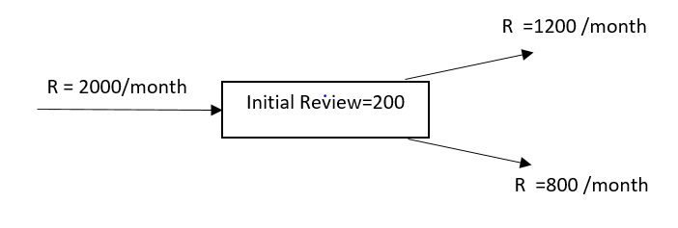

R = 2000 /month or 100 per day.

I =200

T = I/R = 200/100 =2 days.

Or average flow time is 2 days

Linda has an assistant now. Of the emails that come in, Linda deletes 10% right away and assigns 50% to her assistant for review. The rest she will review herself. Once reviewed the emails are either deleted or responded to. Assume there are 20 working days in a month.

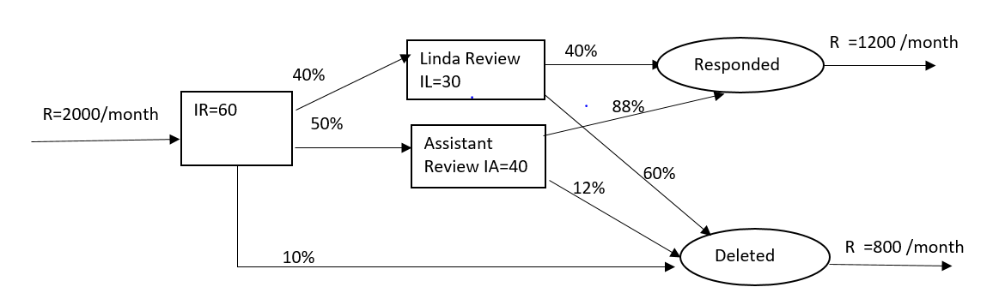

Given R =2000 /month =2000/20 per day =100 per day

Total Inventory =IR+IL+IA =60+30+40 =130 units.

The total inventory is less than the prior case.

Since R is a constant, and since I is reduced, T will be reduced.

T= I/R =130/100= 1.3 days.

After hiring the assistant, average flow time had reduced from 2 days to 1.3 days.

Let’s find the following

Compute average flow time.

Compute average flow time at Initial Review Process.

Compute average flow time for Linda.

Compute average flow time for assistant.

Compute average flow time of an email to respond.

Compute average flow time of an email to delete.

1. Average Flow time for Initial Review = TR= IR/R = 60/100 =0.6 days
2. Average Flow time for Linda’s review
3. Throughput for Linda’s process = RL =100*0.4=40 Emails per day
4. Average Inventory =IL=30
5. Hence Average Flow time for Linda’s process=TL = 30/40 =0.75 days
6. Average Flow time for Assistance’s process
   1. Throughput for Assistance process = RA =100*0.5=50 Emails per day
   2. Average Inventory =IR=40
   3. Hence Average Flow time for Assistance’s process=TA = 40/50 =0.8 days
7. The routing of each flow unit in the most granular level
   1. IR IL Accepted
   2. IR IL Deleted
   3. IR IA Accepted
   4. IR IA Deleted
   5. IR Deleted

The percentages of each of the above 5 flow units

* 1. 100% 100%*40% 100%*40%*40%

=> 100% 40% 16%

Same as in f) , the following percentages of the flow can be calculated.

* 1. 100% 40% 24%
  2. 100% 50% 44%
  3. 100% 50% 6%
  4. 100% 10%

This can be represented as in the following flow chart.

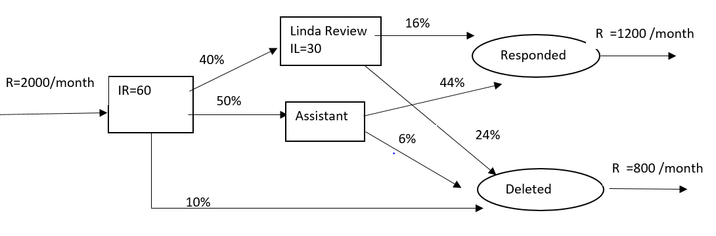

1. Average Flow time for Linda and Assistant to respond

Total time for Linda to do her review =TR+TL=0.6+0.75 =1.35 days with percentage 16%

Total time for Assistance to do the review =TR+TA =0.6+0.8 =1.4 days with percentage 44%

Hence Average time to respond mail =(1.35*16%+1.4%*44%)/(16%+44%) = 1.3867 days

1. Average flow time for Linda and Assistance to delete the emails

Time for Initial deletion = TR =0.6 with percentage of 10%

Total time for Linda to delete email =TR+TL=0.6+0.75 =1.35 days with percentage 24%

Total time for Assistance to delete =TR+TA =0.6+0.8 =1.4 days with percentage 6%

Hence Average time to respond mail =(0.6*0.1+1.35*24%+1.4%*6%)/(10%+24%+6%) = 1.17 days

1. Check for Average time to complete the process = T

(Average time for responding)* (% of response)+(Average time of deletion )* (percentage of deletion) =1.387*0.6 +1.17*0.4 =1.3 days as calculated before.

**Problem 6**

**Project Problem**

Probabilities Inc. has an average of 150 new deliverable projects proposed to initiate every month. First, projects are budgeted; then they are sent to Development. All the projects that are going in will eventually be completed. 30% of these projects are critical and the rest are non-critical. On average 10 projects are waiting to get the budget estimate and 30 are already budgeted, but waiting to start IT development.

Budgeting will take an average of 2 days per project. The IT department has to spend 4 days for the critical projects and 12 days for the non-critical projects. Assume 30 days a month.

a) Draw the flow process chart

b) On average how long a will it take to complete a project?

c) On average how many projects are there for ABC Corporation?

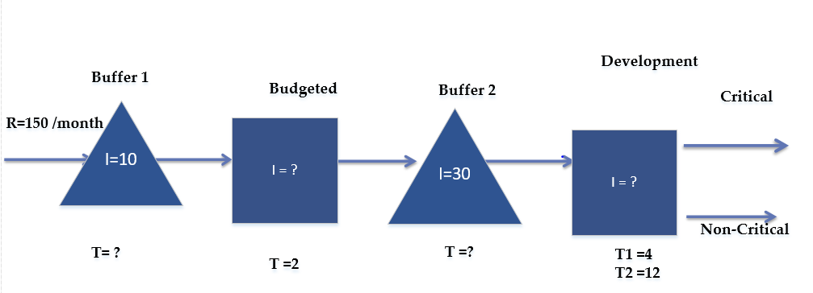

|  |  |  |  |  |  |  |  |  |  |
| --- | --- | --- | --- | --- | --- | --- | --- | --- | --- |
|  | R | R per day | I | T in days |  | |  |  |  |
| Waiting Buffer 1 | 150 | 5 | 10 | 2 | T=I/R =10/5 | | |  |  |
| Budget Est | 150 | 5 | 10 | 2 |  | |  |  |  |
| Waiting Buffer2 | 150 | 5 | 30 | 6 |  | |  |  |  |
| Development | 150 | 5 | 48 | 9.6 | TD=30% *4+70%*12 |  |
| Average time of completion of the project |  |  |  | 19.6 | 2+2+6+9.6 | | |  |  |

The updated flow chart with the numbers filled in is as follows



Total Inventory = 10+10+30+48 =98  
Average flow time = 2+2+6+9.6 = 19.6 days  
Average Flow time (Recheck) =I/R =98/5 = 19.6 days

**Scenario 2**

**As before-**

* 150 new deliverable projects proposed to initiate every month.
* On average 10 projects are waiting to get the budget. Budgeting will take an average of 2 days per project.

**Change-**

* The project management appoints a new Analyst. The new analyst will evaluate and categorize the projects as critical or non-critical. It will take a day for the analyst to do this.
* On Average there are 30 projects waiting for evaluation of the analyst.
* They also expect that there are 5 and 15 projects waiting in the development for critical and non-critical, respectively.
* **As before-**
* 30% of the projects are critical and the rest are non-critical. The assumption is the analyst’s classifications are 100% accurate.

|  |  |  |  |  |
| --- | --- | --- | --- | --- |
|  | **R** | **R per day** | **I** | **T in days** |
| Waiting Buffer 1 | 150 | 5 | 10 |  |
| Budget Est | 150 | 5 |  | 2 |
| Waiting Buffer 2 | 150 | 5 | 30 |  |
| Analyst | 150 | 5 |  | 1 |
| Waiting Buffer3 | 45 | 1.5 | 5 |  |
| Dev-Critical (CR) | 45 | 1.5 |  | 4 |
| Waiting Buffer4 | 105 | 3.5 | 15 |  |
| Non Critical (NCR) | 105 | 3.5 |  | 12 |

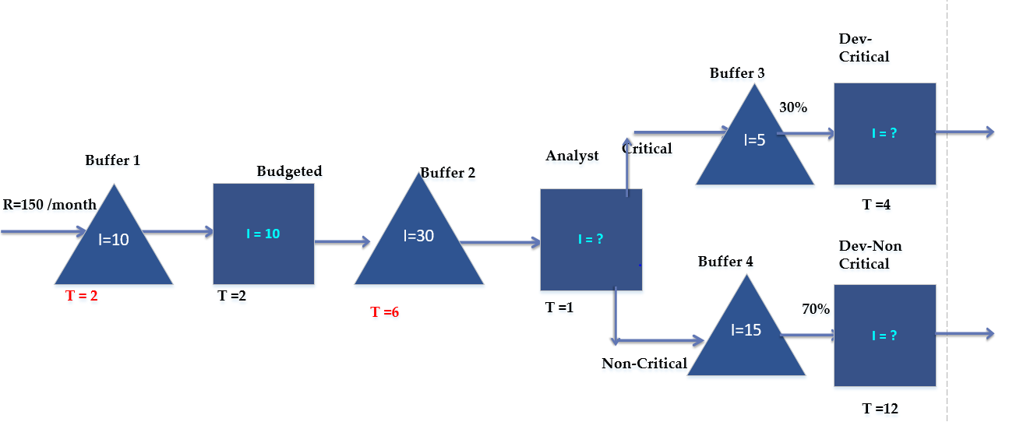

Using the Little’s Law, I= RT, the empty cells can be calculated as

|  |  |  |  |  |
| --- | --- | --- | --- | --- |
|  | **R** | **R per day** | **I** | **T in days** |
| Waiting Buffer 1 | 150 | 5 | 10 | 2 |
| Budget Est | 150 | 5 | 10 | 2 |
| Waiting Buffer 2 | 150 | 5 | 30 | 6 |
| Analyst | 150 | 5 | 5 | 1 |
| Waiting Buffer3 | 45 | 1.5 | 5 | 3.33333 |
| Dev-Critical (CR) | 45 | 1.5 | 6 | 4 |
| Waiting Buffer4 | 105 | 3.5 | 15 | 4.28571 |
| Non Critical (NCR) | 105 | 3.5 | 42 | 12 |

* Total Number of projects in the system = 10+10+30+5+5+6+15+42 = 123
* Average flow time =I/R =123/5 = 24.6 days
* Micro Method
  + TCR = 2+2+6+1+3.333+4 =18.333 (30% of the population)
  + TNCR=2+2+6+1+4.286+12 =27.286 (70% of the population)
  + Average flow time =0.3*18.333+0.7*27.286=24.6 days

**Scenario 3**

As before everything is same, but the assumption that the analyst’s recommendation for categorizing Critical and Non-Critical is 100% has been changed.

After going thru, the Development in Non-Critical category, it was discovered that the analyst’s estimate on 70% was inaccurate. The estimate to be in Non-Critical is really 65% and the rest should be critical.

1. Draw the Flow chart
2. What is the total Inventory?
3. What is the average flowtime?

|  |  |  |  |  |
| --- | --- | --- | --- | --- |
|  | **R** | **R per day** | **I** | **T in days** |
| Waiting Buffer 1 | 150 | 5 | 10 | 2 |
| Budget Est | 150 | 5 | 10 | 2 |
| Waiting Buffer 2 | 150 | 5 | 30 | 6 |
| Analyst | 150 | 5 | 5 | 1 |
| Waiting Buffer3 |  |  | 5 |  |
| Dev-Critical (CR) |  |  | 0 | 4 |
| Waiting Buffer4 | 105 | 3.5 | 15 | 4.28571 |
| Non Critical (NCR) | 105 | 3.5 | 42 | 12 |

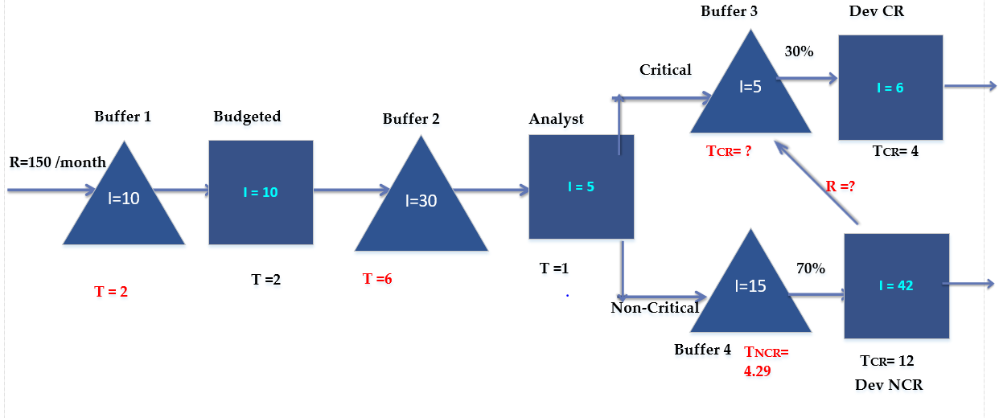

|  |  |  |  |  |
| --- | --- | --- | --- | --- |
|  | **R** | **R per day** | **I** | **T in days** |
| **Waiting Buffer 1** | **150** | **5** | **10** | **2** |
| **Budget Est** | **150** | **5** | **10** | **2** |
| **Waiting Buffer 2** | **150** | **5** | **30** | **6** |
| **Analyst** | **150** | **5** | **5** | **1** |
| **Waiting Buffer3** | **52.5** | **1.75** | **5** | **2.85714** | R= 45+0.05*150 |
| **Dev-Critical (CR)** | **52.5** | **1.75** | **7** | **4** |
| **Waiting Buffer4** | **105** | **3.5** | **15** | **4.28571** |
| **Non Critical (NCR)** | **105** | **3.5** | **42** | **12** |

* Total number of projects in the system = 10+10+30+5+15+42+5+7 =124
* Average flow time (Macro Method) =I/R =124/5 = 24.8 days
* Average flow time (Micro Method 1)
  + TCR1 =2+2+6+1+2.857+4 = 17.857(30% of total)
  + TCR2 =2+2+6+1+2.857+4+4.286+12 = 34.143 (5% of total)
  + TNCR =2+2+6+1+4.286+12 = 27.286 = (65% of total)
  + Average flow time =0.3*17.857+0.05*34.143+0.65*27.286 =24.8 days (Recheck)