**Process Flow Engineering**

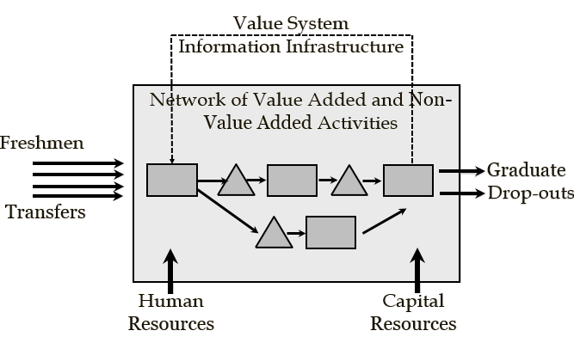

**Problem-Based Learning Study Guide**

**Ardavan Asef-Vaziri**

**Systems and Operations Management**

**David Nazarian college of Business and Economics**

**The Little’s Law: The Core Concept in Business Processes Engineering**

It has been reported that U.S. residents spend close than 40 billion hours per year waiting in lines. Even at a cost of $15 per hour, this adds up to $600 billion per year. Add that to the cost, the frustration, and the irritation people feel when waiting in lines. In this chapter, we study the relationship between Throughput (the rate at which people or product enter and leave a system), Flow Time (the amount of time they spend in the system), and Inventory [the number of flow units (people or products) in the system].

**Problem1. The Coffee Shop.** A manager of a local coffee shop close to the Reseda and Plummer intersection has realized that during busy hours, the entrance door on average opens 2 times per minutes to let in 2 customers per minute. In a stable system, if 2 customers enter per minute, two customers should leave per minute. In the short run, we may have variations, but over a long period, input should be equal to output. It is possible that in 5 minutes, 10 customers come in and 12 customers go out. However, over a long period (even a day), output cannot exceed input, because how can the difference be generated? Similarly, output cannot be less than input, because over a long period, there will be no room in the coffee shop (or even in a large stadium). It is possible that in 5 minutes, 10 customers come in and 8 customers go out. However, over a full day, input cannot exceed output. In stable systems, flow units come in as input, leave the system as output, and input per unit of time is equal to output per unit of time. In our example, if, on average, two customers come in per minute, then two customers, on average, should leave the system.

**a) What is the throughput of the coffee shop?**

Every minute, 2 customers enter, and two customers leave. R= 2 per minute.

**Throughput (R)** is the average flow rate in a stable system where the average input is equal to average output over an extended period. Throughput is expressed as a number with a time unit attached to it (e.g. per minute, per hour, per day, per month, etc.).

**Inventory (I)** is the number of flow units in the system (e.g. customers in a coffee shop, students at CSUN, cars for sale on a lot, etc.).

During the corresponding hours in the coffee shop, on average, there are 5 customers in the store (system), 4 are waiting in line (buffer) to order, and one is with the server.

**b) What is the inventory (I) in the coffee shop?**

On average, there are 5 customers in the coffee shop. Inventory is 5. I = 5.

**c) How long on average is a customer in your coffee shop (inventory expressed in unit of time)?**

**Flow Time (T)** is the time it takes an input to become an output. It is the time a flow unit spends within a system.

Before a customer steps in the system, there are 5 other customers in the system. At the instance she steps into the line for service, one fully served customer leaves the system. That is, there are always 5 people in the system. Our incoming customer, at the beginning, has 4r people in front of her, then 3 in front and 1 behind, then 2 in front and 2 behind, then 1 in front and 3 behind, then no one in front and 4 behind her. At the instance when she steps out of the system, just in the fraction of second stepping out, she looks over her shoulder.

How many people are behind her? 5.

At what rate they came in? 2 per minute.

How long does it take 5 people to come in, if they arrive at the rate of 2 per minute?

1 minute 2 customers

How many minutes (T) 5 customers

T= (1×5)/2 🡺 T = 2.5 minutes.

On average, a customer spends 2.5 minutes in the coffee shop; flow time (T) is 2.5 minutes. Each customer enters the coffee shop, spends 2.5 minutes on average, and then leaves. In the above computation, the flow time (T) is defined in minutes because R was in minutes. R carries a time unit with it, i.e., 2/minute., 2(60) = 120/hour., and, if a day is 8 hours, it can also be expressed as 2(60) (8) = 960/day. **However, remember: inventory (I), does not carry a time unit with it, it is always a number.**

Now, let us generalize

1 time unit R flow units

How many time units (T) I flow units

T= I/R 🡺 RT= I.

**The Little’s Law** is expressed as Throughput x Flow Time = Inventory.

R×T = I or T = I/R or R = I/T

**A Fundamental Insight.** Note, that the Little’s Law, T=I/R, is nothing more than a unit conversion, converting numbers into time. It turned **5 units** of inventory into **2.5 minutes** of inventory. Suppose we have 100 units of item A, and 1000 units of item B. What item do we have more of? In the count dimension, item B has a higher inventory. Suppose we use 4 units of item A per day (RA= 4/day), and 200 units of item B per day (RB=200/day). In the time dimension, we have (T=100/4), 25 days inventory of item A, and (T=1000/200) 5 days inventory of item B. On the time dimension, the inventory of item A is larger than the inventory of item B. It takes more time to consume the inventory of item A, compared with that of item B. We can measure inventory still on a third dimension. How much money is invested in the inventory of each item?

Units

Value

Inventory

Time

**If you have had difficulty understanding this problem, we encourage you to watch the recorded lecture at** [**https://youtu.be/bEM6z27bdWA**](https://youtu.be/bEM6z27bdWA) **The PowerPoint slides are at** [**Process Flow Measures Basics**](http://www.csun.edu/~aa2035/CourseBase/Process/ProcessFlowBasics/1_ProcessBasics.pptx)**.**

**Problem 2. The Coffee Shop—Extended.** Let us go back to our prototype example. Suppose after the initial waiting line in the coffee shop, to pay or get standard items such as a black coffee, there is a second waiting line for exotic hot and cold beverages such as lattes, cappuccinos, etc. Suppose R is still 2 customers per minute, and still, on average, there are 5 customers in the first line, waiting to pay for their order and get their non-exotic coffee or other items already available on the shelves (made-to-stock, or MTS items). In addition, suppose 2 out of the 5 customers place their order and then go on to wait in the exotic order line which needs preparation (make-to-order or MTO items). Therefore, 40% of the customers place exotic orders. A pictorial representation of the process is illustrated below.

Exotic order customers

40%%

40%

All customers

Ordinary order customers

60%%

1. **What is the flow time in the first line?**

Each customer spends 2.5 minutes in the first line (as determined in the first problem).

1. **What is the throughput of the customers in the exotic order line?**

Throughput of the second line is 40% of 2 customers per minute. That is 0.4(2) = 0.8 customers per minute, or 0.8(60) = 48 customers per hour, or 0.8/60 = 0.13333 customers per second. Note that it is not 40% of 5, but 40% of 2. Indeed, 40% of those 5 people will go to the second line, but there are two points to mention. First, 40% of the inventory will go to the second line, but not suddenly. They will go at the rate of 0.4(2) = 0.8. Second, there are always 5 people in the first line, no matter what rate they go into the second line at.

1. **What is the inventory (I) of the exotic order line?**

Inventory of the second line, as given in the graph, is 4. It is given by the problem. It is always 4, no matter whether we state R in minutes, seconds, or hours.

1. **What is the flow time of a person who orders regular coffee?**

We have already done this computation. It is T=I/R = 5/2= 2.5.

1. **What is the flow time of a person who orders exotic coffee?**

The person who orders exotic coffee has already spent 2.5 minutes in the first line. For the time in the second line, we again apply the Little’s law where R=0.8 and I =4.

R x T = I 🡺 0.8 x T = 4 🡺 T=5 minutes (since T is 0.8 per minute.).

T (first line) = 2.5, T (second line)= 5 minutes.

T (exotic order)= 2.5 + 5 = 7.5 minutes.

**f) What is the flow time of a prototype customer (flow unit)?**

A prototype flow unit, most of the time, does not exist in reality. It is a melted version, a weighted average, of all of the flow units. In this example, it is a customer who is 60% a person who gets an MTS item and 40% a customer who gets an MTO item.

There are several ways to answer this question. We show three of them.

**Procedure 1 (Micro) -**

60% simple order: T = 2.5,

40% exotic order: T=2.5+5= 7.5.

An average customer is 60% a simple order person (2.5 minutes.), and 40% an exotic order person (7.5 minutes).

T = 0.6(2.5) + 0.4(7.5) = 4.5 minutes. We can use SUMPRODUCT function in excel as long as the summation of weights is equal to 1. If it is not, then we will use SUMPRODUCT and then divide it by the SUM of the weights.

**Procedure 2 (Micro/Macro) -**

Everyone goes through the first process and spends 2.5 minutes.

60% spend no additional time and leave. 40% spend 5 additional minutes.

0.6(0) ordinary order customers + 0.4(5) exotic order customers = 2 minutes

2.5 (every customer) + 2 (exotic orders) = 4.5 minutes.

**Procedure 3 – (Macro- the most logical)**

Throughput of the system is 2 per minute. There are 9 flow units in the system (5 in the first and 4 in the second line).

R x T= I 🡺 2 x T = 9 🡺 T = 4.5 minutes

The throughput of the coffee shop (system) is 2 per minute, or 120 per hour, or 720 per day (assuming 6 busy hours per day), or 1/30 per second. However, inventory in the system is **always 9.**

**If you have had difficulties, understanding this problem we encourage you to go through problems 2 and 4 on pages 5-14 of the following slides.** [**Assignment Process Basics Set1 Problems**](http://www.csun.edu/~aa2035/CourseBase/Process/Assignments/AssignmentAndPractice/ProcessFlowProblemsSet1.pptx)

**Problem 3. David Nazarian College of Business and Economics (DNCBE).** Over the past 10 years, on average, there were 1600 incoming students per year at DNCBE. On average, the headcount of students enrolled over the same period was 7200.

**a) On average, how long does a student spend in DNCBE (average time to graduation)?**

RT=I 🡺  1600T = 7200 🡺 T = 4.5 years

While at first glance, this number appears to be better than the surrounding programs, we should note that it is for transfer and freshmen students combined. In fact, 40% of the students are freshmen, and the rest are transfer students. In addition, according to the data from CSUN by numbers, the time to graduation (the duration of time from the first day of starting the college education to the day of graduation) for freshmen students on average, is 2.25 times greater than that of transfer students.

**b) How long does it take freshman students to graduate? How long does it take transfer students to graduate?**

T = Time to graduation for a transfer student (60% of all students).

2.25T = Time to graduation for a freshman (40% of all students).

Average time to graduation for all students = 4.5 years.

All students comprise 40% freshman and 60% transfer, and this can be represented by the following equation:

0.6T+0.4(2.25T) = 4.5 years 🡺 0.6T +0.9T = 4.5 years 🡺 1.5T = 4.5 years 🡺 T = 3 years

Time to graduation for a transfer student = 3 years.

Time to graduation of for a freshman student = 3(2.25) = 6.75 years.

Out of the 1600 incoming students per year, on average, 25% are accounting majors, 20% marketing, 20% management, 15% finance, and the rest are other majors. The business school has 2200 accounting students, 1200 marketing students, 1200 management students, and 1400 students in all other majors except finance. The rest of the 7200 head count of the college students are in the finance department.

**c) On average, how many accounting students graduate each year?**

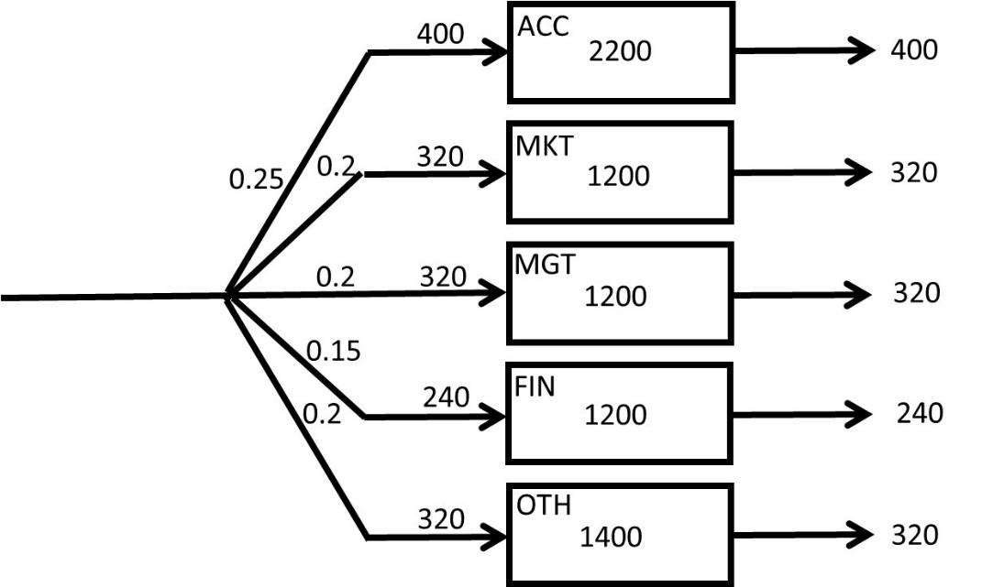

If 25% of the 1600 students enter and exit per year, then the throughput for accounting department is: RACC = 0.25(1600) = 400 per year

1. **How long, on average, it takes a finance student to graduate (what is the flow time of a finance student)?**

RFIN = 0.15(1600) = 240 /year

IFIN = 7200-(2200+1200+1200+1400) = 1200 students.

TFIN = 1200/240 = 5 years

1. **On average, which major takes the longest time to graduate and which major takes the shortest time to graduate?**



Longest = Accounting (5.5 years)

Shortest = Marketing and Management (3.75 years).

1. **Using part (a), prove that your computations in part (h) is correct.**

We have time to graduation for all the five groups, and their relative weights.

SUMPRODUCT 0.25(5.5) + 0.2(3.75), 0.2(3.75), 0.15 (5), 0.2(4.375) = 4.5.

We had the information that 40% of the incoming students are freshmen, and the rest are transfer students. Sadly, there are 10% dropouts. The time to graduate for freshmen students, on average, is 2.25 times that of the transfer students. The time that the dropouts spend in DNCBE is half of that of transfer students.

1. **How long does it take freshman students to graduate?**

You start with the time it takes for a dropout to leave DNCBE:

T: time to graduation for a transfer student @60%.

Then you know that transfer students take twice the time of a dropout to graduate:

0.5T: CSUN-life for a dropout @10%.

In addition, freshman graduate at 2.25 times the amount of time it takes a transfer student to graduate:

4.5T: Time to graduate for a freshman @40%.

However, wait, the percentages of students in your data add up to more than 100%?

10%+60%+40% = 110%

We need to have the total weight = 100%, but it is now 110%. How can we accomplish this?

The flow time for an average student is:

0.5T (10/110) +T (60/110) +2.25T (40/110) which is equal to 1.41T

The average time to leave DNCBE, for an incoming student, is still 4.5 years. Therefore,

1.41T = 4.5 years 🡺 T = 3.2 years

T = time to graduation for a transfer student = 3.2 years.

0.5T = the time a dropout spends at DNCBE = 3.2/2= 1.6 years.

2.25T= time to graduation for a freshman: 2.25(3.2) = 7.2 years.

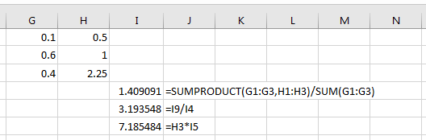

**If you have had difficulty understanding this problem, we encourage you to watch the recorded lecture posted on** [**https://youtu.be/gFNYXGye4Jo**](https://youtu.be/gFNYXGye4Jo) **The PowerPoint slides are on pages** **15-19 on** [**Assignment Process Basics Set1 Problems**](http://www.csun.edu/~aa2035/CourseBase/Process/Assignments/AssignmentAndPractice/ProcessFlowProblemsSet1.pptx)

**Problem 4. CSUN&UCLA Fresh Juice Stands.** A recent CSUN graduate has opened up a cold beverage stand, CSUN-STAND, in Venice Beach. She works 8 hours a day and observes that, on average, there are 320 customers visiting the CSUN-STAND every day. She also notes that, on average, a customer stays in line at the stand for 6 minutes.

**a)** How many customers, on average, are waiting at CSUN-STAND?

1. **4**
2. 2.75
3. 3.75
4. 3.25
5. 4.25

She is thinking about running a marketing campaign to boost the number of its customers. She expects that the number of customers will increase to 480 per day after the campaign. She wants to keep the line short at the stand and hopes to have only 2 people waiting, on average. Thus, she decides to hire an assistant.

**b)** What is the average time a customer will wait in the system after all these changes?

1. 4 min.
2. 3 min.
3. **2 min.**
4. 1 min.
5. none of the above

**c)** After the marketing campaign, a recent UCLA graduate has opened up a competing cold beverage stand. The UCLA graduate is not as efficient as the CSUN graduate is, so customers must stay an average of 10 minutes at “UCLA-STAND.” Suppose there is an average of 3 customers at UCLA-STAND. The total number of customers for both CSUN- and UCLA- STANDs remains at 480 per day, as it was after the marketing campaign. Now it is divided between the CSUN- STAND and UCLA- STAND. How many fewer customers are visiting CSUN-STAND per day?

1. 177 customers per day
2. **144 customers per day**
3. 166 customers per day
4. 155 customers per day
5. 133 customers per day

**If you have had difficulty understanding the problem, we encourage you to watch the recorded lecture at** [**https://youtu.be/QjS_K1zcmw0**](https://youtu.be/QjS_K1zcmw0) **The PowerPoint slides are on pages 20-24 at** [**Assignment Process Basics Set1 Problems**](http://www.csun.edu/~aa2035/CourseBase/Process/Assignments/AssignmentAndPractice/ProcessFlowProblemsSet1.pptx)

**Problem 5. Academic Technology Help Desk.**

Original Process: A help-desk administrator at CSUN receives 2000 emails per month requesting assistance. Assume there are 20 working days per month. On average, 100 unanswered emails are waiting in the mailbox of this Administrator A (Admin-A).

What is the average flow time for handling a request?

R= 2000/20 = 100 per day.

RT=I 🡺 100T= 100 🡺 T = 1 day

New Process: To help reduce the number of unanswered emails, CSUN hired two more administrators to the help-desk department. In the new process, Administrator A (Admin-A) responds to 60% of the emails **to-satisfaction**, without further investigation. 10% of emails are forwarded to Administrator B (Admin-B), and the rest to Administrator C (Admin-C). On average, 50 emails are waiting in the email box of Admin-A, 20 in the email box of Admin-B, and 20 are waiting in the email box of Admin-C. Additionally, Admin-C responds to 80% of the emails sent to him to-satisfaction, and he considered the rest of the emails as **out-of-scope** of the help-desk responsibilities. Admin-B responded to half of the emails sent to him to-satisfaction, and he found the rest of the emails out-of-scope.

1. Compute average flow time
2. Compute average flow time at Admin-A
3. Compute average flow time at Admin-B
4. Compute average flow time at Admin-C
5. Compute average flow time of an out-of-scope response
6. Compute average flow time of a response to-satisfaction



**a) Compute Average Flow Time**

I = Ia + Ib + Ic= 50 + 20 + 20 = 90

R = 2000 per month or 2000/20 = 100 per day or 100/8 (working hours) = 12.5 per hour

I is always 90. It does not carry a time unit.

T = I/R = 90/12.5 = 7.2 hours. It is in hours because R was calculated per hour.

**b) Compute Average Flow Time for Admin-A:**

Throughput *Ra*= 12.5 emails/per hour

Average Inventory *Ia* = 50 emails

*Ta* = 50/12.5 = 4 hours with Admin-A

**c) Compute Average Flow Time for Admin-B:**

Throughput *Rb*= 0.1 (12.5) = 1.25 emails/hour

Average Inventory *Ib* = 20 emails

*Tb* = 20/1.25 = 16 hours with Admin-B

**d) Compute Average Flow Time for Admin-C:**

Throughput *Rc*= 0.3 (12.5) = 3.75 emails/hour

Average Inventory *Ic* = 20 emails

*TC* = 20/3.75 = 5.33 hours with Admin-C

**Additional Information Derived from the Problem:**

One flow unit at a very macro level = Email

2000 flow units/per month at very micro level = each specific email

In the Original Process, there are two flow units: To-satisfaction and Out-of-scope

In the New Process, there are five flow units: To-satisfaction (Admin-A), To-satisfaction (Admin-B), To-satisfaction (Admin-C), Out-of-scope (Admin-B), and Out-of-scope (Admin-C)

To-satisfaction (Admin-A): A

To-satisfaction (Admin-B): A, B

To-satisfaction (Admin-C): A, C

Out-of-scope (Admin-B): A, B

Out-of-scope (Admin-C): A, C

TA = 4 hours, TB = 16 hours, TC = 5.33 hours.

We also need percentages of each of the five flow units



**e) Compute Average Flow Time of an Out-of-scope Email:**

Out-of-scope (Admin-B): A, B 🡺 4+16 = 20 Out-of-scope -A: 5%

Out-of-scope (Admin-C): A, C 🡺 4+5.33 = 9.33 Out-of-scope -B: 6%

[0.05(20) +0.06(9.33)]/ (0.05+0.06) = 14.18

**f)** **Compute Average Flow Time of a Response to-satisfaction:**

To-satisfaction –A: A 🡺 4 @ 60%

To-satisfaction –B: A, B🡺 4+16=20 @ 5%

To-satisfaction –C: A, C 🡺 4+5.333=9.333 @ 24%

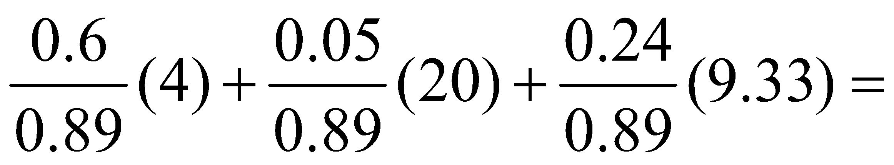

= 6.34

**Check our computations:**

Average flow time of an application

0.89(6.34) +0.11(14.18) = 7.2

**If you have had difficulties understanding this problem, we encourage you to watch the recorded lecture at** [**https://www.youtube.com/watch?v=gFNYXGye4Jo**](https://www.youtube.com/watch?v=gFNYXGye4Jo) **The PowerPoint slides are on pages 1-9 at** [**Assignment Process Basics Set2 Problems**](http://www.csun.edu/~aa2035/CourseBase/Process/Assignments/AssignmentAndPractice/ProcessFlowProblemsSet2.pptx)

**Problem 6. Northridge Hospital.** 80 patients per hour arrive at a hospital emergency room (ER).

All patients first register through an initial registration process. On average, there are 9 patients in the registration waiting line (RgBuff). The registration process takes 6 minutes. A triage nurse practitioner then examines the patients.

On average, there are 2 patients waiting in the triage waiting line (TrBuff). The triage classification process takes 5 minutes.  
On average, 91% of the patients are sent to the Simple-prescription process, and the remainder to Hospital-admission.  
On average, 6 patients are waiting in the simple prescription waiting line (SpBuff) in front of this process.

A physician spends 6 minutes on each patient in the Simple-prescription process.  
Unfortunately, on average, 2 patients per hour are sent to the Hospital-admission buffer (HsBuff) after being examined for 6 minutes in the Simple prescription process.  
On average, 0.9 patients are waiting in the HsBuff.  
A physician spends 25 minutes on each patient in the Hospital-admits process.

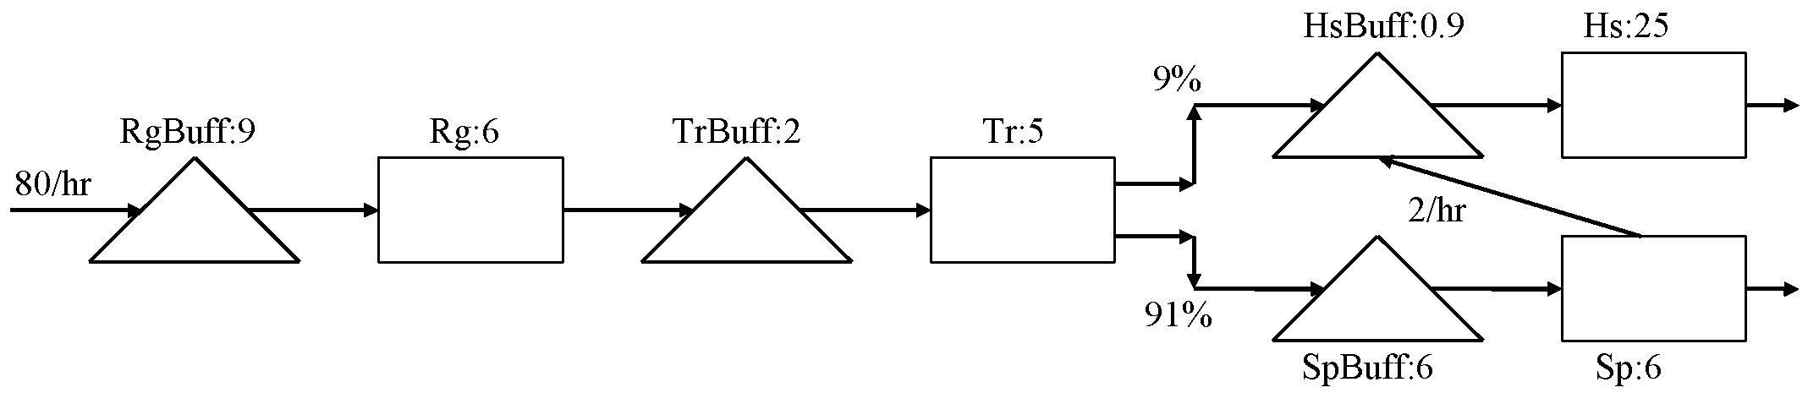

 

7.2/hour. and 0.12/minute on the left table are incorrect. Why?

Because 7.2 is 9% of 80. However, the input in HsBuffer and HsProc is not 7.2.

Is it more or less?

It is more, because 2 patients per hour are directed from SpProc (simple prescription process) to HsBuss (hospital admission waiting line).

Therefore, the numbers as adjusted on the right table are 7.2+2=9.2 per hour or 0.15333 per minute.

Now if we look at the rows of the table, each contains two elements of the Little’s law, and finding the third one is trivial. However, we need to note that since flow time (T) is stated in minutes, we cannot use R per hour, but R per minute. There rest is just T=I/R and I=RT, as summarized in the following table:

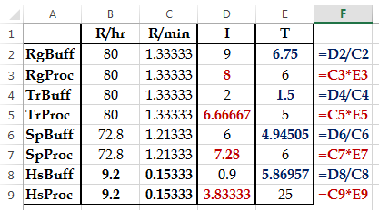

Now we have everything needed to compute the average flow time.

Now, that is not to add the times, because 100% of flow units do not go through each and every processes.

It is instead required to add the inventories, which is equal to 43.68.

Now we have a black box, and for the time being, we do not care what is happening inside it. However, we know that 80 flow units per hour enter and exit this black box, and on average, there are 43.68 flow units inside the box. Then by virtue of the Little’s law,

RT=I 🡺 80T = 43.68 🡺 T=0.546.

0.546 What?

Hour, because R is stated in terms of hours. If you want it in minutes, just multiply it by 60.

Alternatively, you may have R= 1.33333 per minute, instead of 80 per hour. Therefore,

1.33333T=43.68 🡺 32.76 minutes.

What is the flow time of the patients with simple prescription? In addition, what is the flow time of the patients who are hospital admitted? There is only one type of simple prescription patient. Nevertheless, hospital admitted patients are of two types; those admitted directly, and those who wrongly go through simple prescription process and then are redirected to hospital admission.



Common: 6.75+6+1.5+5 = **19.25**

TSP= 19.25+**10.95** = **30.2**

TPA1= 19.25 +**30.87** = 50.12 ……(7.2 PA patients out of 9.2 PA patients)

TPA2= 19.25 +**10.95** +**30.87** = 61.07 (2 PA patients out of 9.2 PA patients)

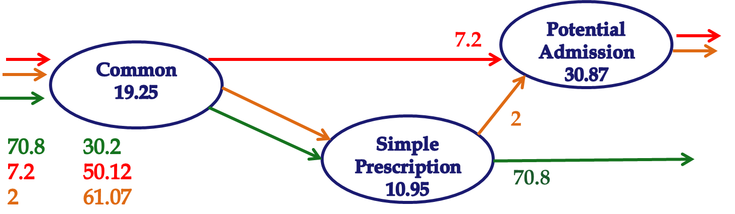

TPA = 50.12(7.2/9.2) + 61.07(2/9.2) =

TPA = 50.12(0.782609) + 61.07(0.217391) = **52.5**

We already have the average flow time

T = I/R = 43.68/(80/60) = 32.76

T= 30.20(70.8/80) + 50.12 (7.2/80) + 61.07 (2/80)

**T = 32.76**

However, over the 6 weeks, they are almost equal.

**If you have had difficulties, understanding this problem we encourage you to go through the PowerPoint slides on can be accessed on pages 10-26 at** [**Assignment Process Basics Set2 Problems**](http://www.csun.edu/~aa2035/CourseBase/Process/Assignments/AssignmentAndPractice/ProcessFlowProblemsSet2.pptx)

**Problem 7. SAMOAK Industries.** SAMOAK family has been in industrial developments for close to a century. They got the idea of smooth flow from Henry Ford and took it to a new dimension of time-based competition. The following data represents the inputs and outputs at one of their plants over a period of 6 weeks. Each column of the following tables represents 7 days of a week, a total of 42 days. Assume that the plant is working 24 hours 7 days a week. Each column of these matrices is corresponding to a week, where the first row is the first day of the week. Analyze these data, and estimate the average inventory, average flow time, and capacity of this process.

 

**Note. Sometimes have data in a long column in an excel sheet and want to transform it into a matrix (table) to put into a report. Sometimes we have a table in a report and like to transform it into a column of data in an excel sheet. To learn how to do these using functions such as ROWS, COLUMNS, INT, MOD, INDEX, and MATCH, you may watch the lecture at** [**https://www.youtube.com/watch?v=G_M3i2XVKmo&t=27s**](https://www.youtube.com/watch?v=G_M3i2XVKmo&t=27s) **The excel file is at** [**Descriptive Statistics-exl**](http://www.csun.edu/~aa2035/CourseBase/Probability/S-1-DescriptiveSTAT/DescriptiveSTAT.xlsx) **on tab 6.TurnArrayToMatrix. The excel file of this problem is at** [**Prepare for the Game**](http://www.csun.edu/~aa2035/CourseBase/Games/Game1Data.xlsx) **Tab 2. 2. AveInvFlow. On this tab, I have also shown how to transform the long column of data into a table.**

The input and output data are in columns A and B of the Excel file, respectively. Since we need to compute inventory, the inventory of the first day is the difference between the input and output in the first day, i.e., 2-1= 1. The inventory of day 42 is the summation of the input in the first 42 days minus the summation of the output in the first 42 days, i.e., 99-97 =2. We compute summation of input in each day, in column C, using the function =SUM($B$2:B2) in the first day. If we copy this formula down to day 42, it will appear as =SUM($B$2:B43). However, for output data, we cannot copy this formula to the next column, because it will appear as SUM($B$2:C2) in the first day, and SUM($B$2:C43) in the last day. We can fix this problem through replacing =SUM($B$2:B2) by =SUM(B$2:B2). That is to replace $B$2 by B$2. Now if we copy =SUM(B$2:B2) from column D to column E, we will have =SUM(C$2:C2), and in the last row of column D we will have =SUM(C$2:C43). Now we can compute inventory in each day, in column F, by subtracting Total output from total input in each day. The formulas are shown below

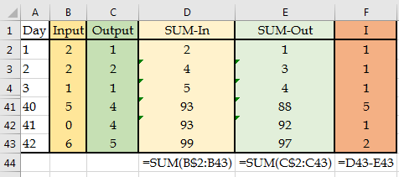

Descriptive Statistics for output and inventory are shown below



Because the average output is R=2.31, and average inventory is I=1.31, the estimated flow time is 2.31T=1.31 🡺 0.57 day or 13.6 hours. If we exclude the days when output was 0, SUM(RANGE)/COUNTIF(RANGE, “>0”), we will get another approximation of throughput, which is 2.43. In that case, the average flow time reduces to 0.54, or 13 hours. The actual flow time measured directly was 0.52 days, or 12.53 hours.

**Chapter 3. Capacity**

**Whenever you feel that you do not follow the text, you may watch my lecture on capacity at** [**Capacity Lecture Recorded.**](https://www.youtube.com/watch?v=JEee_woDAAY) **The PowerPoint slides can be accessed at** [**Capacity PowerPoints**](http://www.csun.edu/~aa2035/CourseBase/Capacity/Capacity.pptx)**.**

In this chapter, we will discuss both the capacity of an operation and the capacity of a process. We also define terms such as Bottleneck, Utilization, and Throughput.

**Problem 1.** A process is composed of two sequential activities A and B.



**a) Compute the Theoretical Flow Time**.

The **theoretical flow time** of this process is = 5 + 10 = 15. Theoretically, it takes a flow unit (a patient, a product, etc.) 15 minutes to flow from input form into output form.

**b) How do we compute the Flow Time of the process?**

We do not know the **Flow Time** of this process. The flow time is the **activity** times plus the buffer times. This is represented as **Rectangle** (representing value-added activities) times and **triangle** times (representing non-value-added buffers or waiting lines). **Buffer or Waiting** times are usually 10, 20, and 100 times of the activity times. We will discuss flow time in future chapters.

Activity Time (or **Work Content**) of Activity-A = 5 min. We also refer to it as **Tp of Activity-A.**

Activity Time (or **Work Content**) of Activity-B = 10 min. We also refer to it as **Tp of Activity-B.**

If each activity is completed using a single resource, for example, if Resource-1 is assigned to Activity-1, and Resource-2 is assigned to Activity-2, then the **Unit Load of Resource-1 is 5 minutes** and the Unit Load of Resource-2 is 10 minutes. We also refer to 5 minutes as **Tp or Unit Load of Resource-1** and to 10 minutes as **Tp or Unit Load of Resource-2.**

**Tp: When applied to an activity, is called Work Content, Activity Time, or Activity Load.**

**Tp: When applied to a resource, is called Unit Load or Resource Load.**

**c) Compute Effective Capacity of each resource.**

TheEffective Capacity (or simply Capacity)of a Single Resource Unit is equal to 1 divided by its unit load, or 1/Tp. The Unit Load of Resource-1 is 5 minutes. If Resource-1 can complete 1 Activity-A in 5 minutes, how many units it can complete in 1 minute?

Unit Time

1. 5

X 1

X = (1 × 1)/5 = 1/5

In 1 minute, it can complete 1/5 Activity-A. That is 1/Tp.

Capacity of the single resource unit of **Resource-1 = 1/Tp = 1/5 per minute or 60(1/5) = 12 per hour.** Capacity of the single resource unit of Resource-2 = 1/Tp = 1/10 per minute or 60(1/10) = 6 per hour. If we had two units of Resource-1, we would have referred to them as the **Resource Pool** of Resource-1.

**d) What is the Capacity of the process?**

**The Capacity of the process = Rp = min {1/5, 1/10} = 1/10 per minute or Rp = min {12, 6} = 6 per hour.**

**A chain is as strong as its weakest link.** Bottleneck is the resource unit (resource pool) with the minimum effective capacity.

**The capacity of a process is equal to the capacity of its bottleneck.**

**Capacity is the maximum stable flow rate. During periods of heavy congestion, throughput reaches the capacity, but in most of the time Throughput < Capacity.**

**e) What is the Cycle time of this process?**

Cycle time (CT) is the duration of time that the process needs between completing two consecutive flow units. It is not the flow time. It depends on the number of sequential operations and, indeed, on the capacity of the process (bottleneck). The higher the capacity, the shorter the cycle time. If the capacity is 6 per hour, then the process has the capability to send a product out (or complete a service) every 60/6 = 10 minutes; cycle time is 10 minutes.

We can achieve the same outcome using 10-minute cycles by using Cycle time = 1/Capacity. Capacity was 6 per hour or 1/10 per minute. CT (Cycle time is then equal to 1/6 hour or 1/(1/10) = 10 minutes.

**In a synchronized operation we will have Throughput = Demand. The Demand (that our process gets), which is equal to our Throughput, is always less than Capacity.**

Suppose that the throughput in our problem is R = 5 per hour (or 1/12 per minute).

**f) Compute Capacity Utilization.**

Capacity Utilization (or simply Utilization) of a Resource Pool = Throughput/Capacity of a resource pool 🡺 U = R/Rp

Process Utilization (or simply Utilization) of the process

U= Throughput/Capacity of the bottleneck resource pool 🡺 U = 5/6

**g) Compute Takt Time.**

Cycle time is the amount of time that the process **needs** between completing two consecutive flow units. It depends on capacity; CT = 1/Rp.

Takt time (TT) is the amount of time that the process **has** between completing two consecutive flow units. Takt Time is related to Throughput (Demand). If the throughput is 5 per hour, then the process has a 60/5 = 12 minutes. Takt time is 12 minutes; this means the system has 12 minutes to send the next flow unit out. In general, Takt time = 1/Throughput. Throughput is 5 per hour or 1/12 per minute.

TT = 1/(Throughput) = 1/5 hour or 60(1/5) = 12 minutes, or 1/(1/12) = 12 minutes.

**Demand = Throughput ≤ Capacity**

**Takt Time ≥ Cycle Time**

**R ≤ Rp, where TT ≥ CT**

**Cross-Training (Pooling).** If we cross-train Resource-1 and Resource-2 so that each resource can perform both Activities A and B, then things may change. Usually, if we assign only one task or a limited number of tasks to a resource, the resource becomes specialized and efficient. But if several tasks are assigned to a resource, efficiency goes down. To illustrate this reality, consider drawing 20 of each of the following shapes. First try drawing 20 of the first shape under each other (in the same color), then 20 of the second shape in the next column adjacent to your already drawn shapes, and then continue for the third, fourth, and fifth shapes. Now you have 20 rows and 5 columns of drawings of 5 shapes each in its assigned color. Now let’s prepare the same thing in a different way.



This time, first draw the 5 shapes (each in its corresponding color), then go to the next row and repeat what you did in the first row, and then repeat for the next 18 rows.

Which procedure took more time? Drawing all 20 instances of each shape together or switching between the shapes? That is the difference between specialty and flexibility. Cross-training and pooling leads to flexibility. Flexibility means longer processing times (larger Tp). However, it does not necessarily mean lower capacity (smaller Rp).

Returning back to our process with two activities, suppose that when both activities are assigned to both resources, the efficiency of both workers go down. Perhaps that is due to setup for switching from one activity to the other. Suppose that when task 1 is assigned to each of the two resources, in the new situation, it takes 6 minutes instead of 5 minutes. Also, suppose that when task 2 is assigned to each of the two resources, it takes 12 minutes instead of 10 minutes.

**h) Compute capacity under cross-training.**

Now we have a Resource Pool that contains two Resource Units. The Unit Load of the Resource Pool = 6 + 12 = 18 minutes. We also refer to it as **Tp of the Resource Pool**. Again, note that there is a different naming for Tp. When Tp is referring to an activity, we call it the **activity time** (or work content). When Tp is referring to a resource, we call it the **Unit Load of the Resource** (or load of a flow unit on a resource).

Given the unit load of 18 minutes, the capacity of a single Resource unit = 1/18 flow units. But we also need a unit of time. Since Tp is 18 minutes, the capacity of a single resource unit is 1/Tp = 1/18 per minute.

Capacity of a single Resource unit = 60(1/18) = 3.333 flow units per hour.

However, there are **2** resource units in the resource pool. Therefore, the capacity of the resource pool is 2(1/18) = 1/9 per minute, or 2(3.333) = 6.666 per hour. While the total unit load increased from 5 + 10 to 18, the capacity did not decrease, but rather it increased by about 11%. That is the power of **cross-training, pooling, and centralization.**

**Problem 2.** We are making batches of muffins. There are three sequential activities: A (preparation), B (baking), and C (packaging and labeling). There are three resources: you and your friend (human resources), and the oven (capital resource).

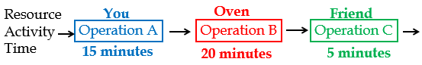

To produce each batch of muffins, you prepare the material, and put the batch in the oven (there is only a single oven, and it can only bake one batch at a time). Then your friend takes the batch out, and completes packaging and labeling. The processing time at each operation is given above. Estimating the processing times is the subject of motion and time studies. This system works for 4 hours, that is, 4 × 60 = 240 minutes.

**Compute the capacity of each resource, the capacity of the process, and the utilization of each resource if throughput is at 100% capacity of the process, the cycle time, and the takt time.**

**Capital Resources—**Fixed Assets such as land, buildings, facilities, machinery, oven, etc.

**Human Resources—**People such as operators, assemblers, engineers, waiters, chefs, customer-service representatives, you, your friend, etc. Each activity may require one or more resources, and each resource may be allocated to one or more activities. A resource, a baker, may be used by several activities such as mixing, kneading, and forming dough. An activity like loading an oven may require multiple resources such as a baker and an oven.

**Resource Unit—**An individual resource (chef, mixer, oven), or a combination of different individual resources, for example, an operating room.

Capacity (per hour): You: 60/15 = 4, Oven: 60/20 = 3, Friend: 60/5 = 12

**Process Capacity = Min {4, 3, 12}** = **Capacity of the bottleneck = 3 per hour.**

Each hour we produce 3 units. Starting from the second unit, every 60 minutes, 3 units may enter, pass, and leave the process. We refer to this 60/3 = 20 as the average interarrival time, average interdeparture time, or cycle time.

We computed the capacity/hour. We could also have computed the capacity per minute:

Capacity/minute: You: 1/15 per minute, Oven: 1/20 per minute, Friend: 1/5 per minute.

Process Capacity = Min {1/15, 1/20, 1/5} = 1/20.

Capacity of the bottleneck = 1/20 per minute. Each minute we produce 1/20 units. In 20 minutes, we can send out, or take in, one product. Twenty minutes is the interarrival time, interdeparture time, and cycle time.

1. **How long does it take to produce a batch of muffins?**

In formal terms, the question is asking what is the **flow time** in this process? We cannot yet determine this because we also need the waiting times.

1. **How long does it *theoretically* take to produce a batch of muffins?**

In formal terms, the question is asking what is the **theoretical flow time** in this process?

Theoretical Flow Time = 15 + 20 + 5 = 40

1. **How often does a batch of muffin could enter (exit) this process?**

In formal terms, what is the **cycle time** of this system?

The following shows the timeline for each activity—A, B, and C—in a three-batch baking process, where $B_{1}$ is batch 1, $B_{2}$ is batch 2, and $B_{3}$ is batch 3. Please note that we do not allow inventory in the process, and therefore Activity A may need to wait for the availability of the oven (Activity B) before preparing for the next batch.

$$B_{3}$$

Wait

Wait

$$B_{2}$$

$$B_{1}$$

A

55

50

35

30

Time

15

Wait

$$B_{3}$$

$$B_{2}$$

$$B_{1}$$

B

75

55

35

15

Time

Wait

Wait

Wait

$$B_{3}$$

$$B_{2}$$

$$B_{1}$$

C

80

75

Time

60

55

40

35

$$B_{3}$$

Complete

$$B_{2}$$

Complete

$$B_{1}$$

Complete

You prepare a batch and place it in the oven at minute 15. You then start the next batch and complete it at minute 30. The oven is still baking the first batch. It will be done at minute 15 + 20 = 35.

At minute 35, your friend can take the first batch out of the oven, and after 5 more minutes, at minute 40, he is done. The **first batch exits at minute 40.** The oven is the **bottleneck** since you and your friend need 15 and 5 minutes, respectively, but the Oven needs 20 minutes. At minute 35 you can put the second batch in the oven. Your friend takes it out of oven at minute 35 + 20 = 55 and then sends it out of the process at minute 60. That is 60 − 40 = 20 minutes after the first batch. Similarly, the third batch exits at minute 80.

Therefore, the capability of the process regarding the time between exits of two consecutive batches, the cycle time, is?

**Cycle time = Max {15, 20, 5} = 20.** The oven is the bottleneck.

Or we can do it in a long way:

* Capacity = Min {1/15, 1/20, 1/5} = 1/20
* Cycle time = 1/Rp = 1/(1/20) = 20 min.

Cycle Time: Starting from 0 vs. Continual

**d) How many batches can you produce per day?**

**Case 1, Starting from 0.** We have **4 × 60** minutes. It takes you **40** minutes to produce the first batch. In the remaining 240 − 40 = 200 minutes, given the cycle time is 20 minutes, we produce 1 batch per 20 minutes, and that gives us 10 batches in 200 minutes. We produce 1 + 10 = 11 per 4 hours. We could also have said that in the first 40 minutes, we produced 1 batch and in the next 200 minutes we produced 1/20 batch per min. That is 1 + 200(1/20) = 11 per 4 hours.



**Case 2, Continual.** Suppose we are not producing muffins, but something else, such that at the start of each day there is work-in-process (WIP) from the previous day in the system. For example, suppose it is a small portion for a painting and you can make that part ready today, and put it into the oven at the start of the next day. What is the capacity (or maximum Throughput)?

The flow time is 40 minutes. The cycle time is 20 minutes. Therefore, capacity is 1/20 per minute. In 4 hours, it is 240(1/20) = 12.

**By now we should know the terms Flow Time, Cycle Time, and Capacity.**

**e) What is the Utilization of the oven if the process works at full capacity**?

The oven is always working. Every 20 minutes, 1 batch comes and 1 batch leaves. Utilization of the oven is 1 or 100%.

In each 20 minutes, you only work 15 minutes. Your utilization is 15/20 = 0.75 or 75%. In each 20 minutes, your friend only works 5 minutes. Your friend’s utilization is 5/20 = 0.25 or 25%.

Utilization: You: 3/4 = 0.75, Oven: 3/3 = 1, Friend: 3/12 = 0.25.

**Increasing the capacity?** Relaxing the bottleneck by increasing the level of resources. **Increasing the level of resources?** Adding a resource unit to a resource pool. Our oven resource pool contains only one single resource unit. By increasing its level, we mean to get a second oven.



**Resource Pool—**A collection of **interchangeable** resource units that can perform an identical set of activities. Processing time = Tp = 20 minutes.

Resource Pool contains 2 Resource units; c = 2, and unit load is 20 mins, Tp = 20 mins.

Capacity of a resource unit = 1/20 per minute or 60(1/20) = 3 per hour.

Capacity of a resource pool = 2(1/20) = 1/10 per minute, or 60(1/10) = 6 per hour.

**f) What is the cycle time (after how many minutes a product can exit this system)?**

If every one minute produces 0.1 unit, then how many minutes are required to produce one unit? 1/0.1 = 10. Cycle time is 10 minutes.

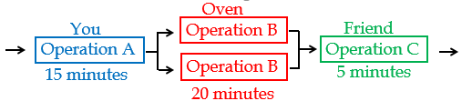

**g) Compute capacity of each of the three resource pools.**

**Capacity of Resource Unit (batch/min) Y: 1/15, O: 1/20, F: 1/5**

**Capacity of Resource Pool (batch/min) Y: 1/15, O: 2/20, F: 1/5**

**Process Capacity = Capacity of the bottleneck = 1/15 per minute. Now, you are the bottleneck.**

Each minute the system produces 1/15 units. In 15 minutes, we can send out or take in one product.

Interarrival time = interdeparture time = cycle time = 15 min.

**h) Compute the utilizations, if the process can work at 100% capacity.**

Utilizations are:

U-Y = (1/15)/(1/15) = 1,

U-O = (1/15)/(1/10) = 0.67,

U-F = (1/15)/(1/5) = 0.33.

Capacity of each resource pool in one hour is **Y: 60(1/15) = 4, O: 60(2/20) = 6, F: 60(1/5) = 12.**

Process Capacity = 4 per hour. Every hour the system produces 4 units. In 15 minutes, we can send out or take in one product. Interarrival time, interdeparture time, cycle time = 15 minute.

Utilizations are: U-Y = 4/4 = 1, U-O = 4/6 = 0.67, U-F = 4/12 = 0.33.

**Two Ovens plus Cross-Functional Workers.** Suppose you and your friend are flexible resources who can do both activities 1 and 3. Suppose the unit loads (Tp) remain the same.

Resource Human Resources Capital Resources

Time 5 + 15 20

Capacity 60(2/20) = 6 60(2/20) = 6

Cross-functional workers and resource pooling are great operational strategies. However, in this specific example, we need to be careful. If the process works at 100% capacity, then utilization of all resources is 100%. This strategy is very risky as a small variation can reduce the capacity significantly. We will later show that no system can produce at 100% capacity and the more bottlenecks, the lower the actual throughput.

**Resource Pooling—**Combining separate resource pools into a single more flexible pool that is able to perform several activities. To transform specialized resources into general-purpose resources, we can cross-train workers and use general-purpose machines.

**Resource Pooling** is a powerful operational tool that can significantly affect **not only capacity and throughput** but also **flow time**.

Problem 3. Four consecutive activities: Two human resources (H-1 and H-2) and two capital resources (K-1 and K-2). Flow units pass the four resources in the following sequence: H-1, K-1, H-2, and K-2. Unit loads Tp1 = 8, Tp2 = 3, Tp3 = 6, Tp4 = 10.

H-1

(8 min.)

K-1

(6 min.)

H-2

(3 min.)

K-2

(10 min.)

**Compute the capacity of each resource per minute, capacity of the process, and utilization at 100% capacity. Then increase the capacity by increasing the level of the bottleneck and by cross-training. In cross-training, assume that Tp remains the same for all resources.**

Specialization and one resource unit at each activity:

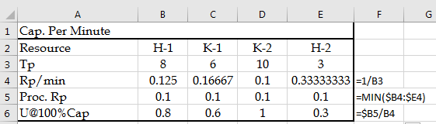

The same computations in a different way:



Specialization and two resource units in K-2 single pool:

H-1

(8 min.)

K-1

(6 min.)

H-2

(3 min.)

K-2

(10 min.)

K-2

(10 min.)



Cross-Training at H (resources H1 and H2 are now in resource pool H), and a single resource unit at each K:

H-1 & H-2

(8 + 3 = 11 min.)

K-1

(6 min.)

K-2

(10 min.)



**Do you know the general relationship between theoretical flow time and cycle time?**

The number of sequential operations is ≥ (Flow Time)/(Cycle Time)

The minimal number of sequential operations is = (Flow Time)/(Cycle Time) rounded up.

**Problem 4.** This problem is based on the prototype example in our reference book MBPF. MamossaAssaf Inc. fabricates garage doors. Roofs are punched in a roof punching press (15 minutes per roof) and then formed in a roof forming press (8 minutes per roof). Bases are punched in a base punching press (3 minutes per base) and then formed in a base forming press (10 minutes per base), and the formed base is welded in a base-welding machine (12 minutes per base). The base subassembly and the roof then go to final assembly, where they are welded together (10 minutes per garage) on an assembly welding machine to complete the garage. Assume one operator at each station.



**My lecture on solution to this problem is available at** [**Solution to the problem4.Recorded**](https://www.youtube.com/watch?v=MEA-IjczmLA)**. You may watch the lecture or read the text. The PowerPoint Slides are also available at [Assignment Capacity Problems.](http://www.csun.edu/~aa2035/CourseBase/Capacity/CapacityAssignment.pptx)**

**a) What is the Theoretical Flow Time? (The minimum time required to produce a garage from start to finish.)**



**b) What is the capacity of the system in terms of garages per hour?**

**R-Punch: 1/15 per minute or 4 per hour**

R-Form: 1/8 per minute or 7.5 per hour

B-Punch: 1/3 per minute or 20 per hour

B-Form: 1/10 per minute or 6 per hour

Welding: 1/12 per minute or 5 per hour

Assembly: 1/10 per minute or 6 per hour

**Therefore, R-Punch is the bottleneck, and the Process Capacity is 4 flow units per hour.**

**c) If you want to increase the process capacity, which is the activity process that you would put some additional resources toward?**

**Obviously, the R-Punch, because increasing capacity of any other resource is a mirage.**

**d) Compute utilization of all the resources at the full process capacity. Although in the real life, it is impossible for a process to perform at its 100% capacity, assume that the throughput is equal to the process capacity. Throughput = 4. Compute utilization of all resources.**

R-Punch Utilization = 4/4 = 100%.

R-Form Utilization = 4/7.5 = 53.33%.

B-Punch Utilization = 4/20 = 20%.

B-Form Utilization = 4/ 6 = 66.67%.

Welding Utilization = 4/5 = 80%.

Assembly Utilization = 4/6 = 66.67%

**e) What is the utilization of the most utilized and least utilized resources?**

The most utilized resource is obviously R-Punch. Its utilization is 100%.

However, utilization of the bottleneck in the real world is never 100% because no process can have a throughput equal to its capacity. In reality, utilization of all the resources will be less than what we have computed for this problem. **This process can never produce 4 flow units per hour continually.**

What is utilization of the least utilized resource? Interestingly, our other Punch machine, B-Punch is the least utilized resource. U = 20%.

**f) Relaxing the bottleneck by lifting its level (i.e., adding a new R-Punch resource). Suppose we double the capacity of the bottleneck by adding the same capital and human resources. What is the new capacity of the system?**



R-Punch: a single resource unit, 1/15. Two resource units, 1/15 + 1/15 = 2/15 per minute or 8 units per hour. In general, Rp = c/Tp.

R-Form: 1/8 per minute or 7.5 per hour

B-Punch: 1/3 per minute or 20 per hour

B-Form: 1/10 per minute or 6 per hour

**Welding: 1/12 per minute or 5 per hour**

Assembly: 1/10 per minute or 6 per hour

**Process Capacity is 5 per hour.**

**g) We doubled the capacity of the bottleneck, but the capacity of the system increased by only 25%. This situation is an example of what managerial experiment?**

1. When we relax a bottleneck, the bottleneck shifts to another operation. The bottleneck shifts from R-Punch to Welding.
2. Diminishing Marginal Return. By increasing input, the output will not increase linearly.

**h) Pooling and Cross-Training. Now, suppose we return to the original situation in which we have a single machine and a single operator at each operation. Suppose we pool R-Punch and B-Punch machines and we cross-train their operations. We form a new resource pool named Punch in which both R-Punch and B-Punch operations are done in this resource pool. What is the new capacity of the system?**

In the new process, similar resources in the Punch resource pool have been assigned to R-Punch and B-Punch activities. The process can be represented as follows:



We have pooled two special-purpose resources of R-Punch and B-Punch into a resource pool of Punch, which can perform both R-Punch and B-Punch activities. In practice, when two special-purpose resources are pooled into a more general-purpose resource pool, we observe an increase in the unit loads. However, for the purpose of simplicity, we assume that 15 minutes and 3 minutes remain the same and the total unit load of Punch resource pool stays at 15 + 3 = 18. We also use the following representation.



The capacity of the process is computed as follows:

Punch: 2/18 per minute or 6.67 per hour

R-Form: 1/8 per minute or 7.5 per hour

B-Form: 1/10 per minute or 6 per hour

Welding: 1/12 per minute or 5 per hour

Assembly: 1/10 per minute or 6 per hour

**Process Capacity is increased to 5 per hour, without adding any new resource.**

**i) This situation is an example of what managerial experiment?**

1. Cross-training and pooling can increase the capacity.
2. Usually cost of cross-training and pooling is lower than the cost of adding the second resource unit.

**j) Productivity Improvement—Method, Training, Technology, and Management.** Now suppose by (i) investing in improved jigs and fixtures (technology), (ii) implementing a better method of doing the job, (iii) training our human resources, and (iv) better managing human, capital, and information resources, we can reduce the welding time from 12 minutes to 10 minutes. **What is the new capacity of the system?**



Process Capacity is now increased to 6 per hour.

**k) Why is it impossible to work at 100% of capacity?**

There are 3 bottlenecks. This is a risky situation. Any of the bottlenecks could cause the throughput of the system to fall below 6 per hour. Suppose the input to a bottleneck resource is not ready and the resource stays idle waiting for input for 5 minutes. Assume the resource is a physician and the patient has not shown up yet. Alternatively, suppose Punch fails to provide input to B-Form for 1 hour, or B-Form fails to feed Weld, or Weld fails to feed Assembly—That hour of capacity perishes. The more bottlenecks exist in the system, the higher the probability of not meeting the capacity. In addition, the system has three bottlenecks, but they are back-to-back, that is, one bottleneck feeds the next one.

**l) Is flow time at risk?**



Both paths to the last bottlenecks are critical. They can both increase the flow time.



**Lessons learned throughout this problem:**

1. When a bottleneck resource is relaxed, the bottleneck shifts to another resource.

2. By doubling the bottleneck resource, the capacity usually does not double. This could be interpreted as diminishing marginal return situation.

3. One other way to increase capacity is cross-training (for human resources) and pooling (for capital resources).

4. Usually cost of cross-training and pooling is lower than the cost of adding the second resource unit.

5. One other way to increase capacity is to reduce unit load. (i) Investing in improved jigs and fixtures (technology), (ii) implementing a better method of doing the job, (iii) training our human resources, and (iv) better managing human, capital, and information resources.

6. Processes cannot work at 100% capacity. Capacity is perishable—It is lost if input is not ready. The more the bottleneck resources, the lower the utilization.

7. Convergence points are important in managing the flow time. The more convergence points, the higher the probability of the flow time exceeding the average flow time.

**Problem 5. SAMOAK Industries.** SAMOAK family has been in industrial developments for almost a century. They got the idea of smooth flow from Henry Ford and took it to a new dimension of time-based competition. The following data represents the inputs and outputs at one of their plants over a period of 6 weeks. Each column of the following tables represents 7 days of a week, a total of 42 days. Assume that the plant is working for 24 hours during 7 days a week. Each column of these matrices is corresponding to a week, where the first row is the first day of the week. Analyze these data and estimate the average inventory, average flow time, and capacity of this process.

 

**a) What is the capacity of this process?**



**The Excel file of this problem is at** [**Prepare For The Game**](http://www.csun.edu/~aa2035/CourseBase/Games/Game1Data.xlsx) **Tab 3. Capacity.**

The input and output data are in columns A and B of the Excel file, respectively.

If we look at the daily output, we see 5 units of outputs on day 42. We may conclude that the capacity is at least 5. However, in several other days, such as days 25–27, although the beginning inventory is greater than 0 and the ending inventory is also greater than 0, we have not produced 5 units. Therefore, we can just conclude that the capacity of the process is about 5 units. The process blue print is shown below. The incoming flow units go to the first station, next to the second, and last to the third. From the third station, they go back to the second station, and after processing in this station, they will leave the system in the form of output.

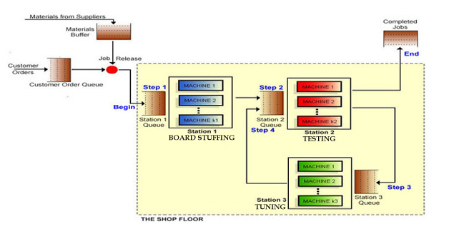

The utilization data for the three stations are shown in [**Prepare for the Game**](http://www.csun.edu/~aa2035/CourseBase/Games/Game1Data.xlsx) **Tab 4.1, 4.2, and 4.3.** You may prepare a descriptive statistic table similar to what we provided below.

   

Compute the capacity of each station.

U = R/Rp

Average U at the three stations are 0.513, 0.813, and 0.206. Average R is 2.31.

Capacity of station 1 is 0.513 = 2.31/Rp1 🡺 Rp1 ≈ 4.5.

Capacity of station 3 is 0.206 = 2.31/Rp2 🡺 Rp3 ≈ 11.2.

What about station 2?

Capacity of station 3 is NOT 0.183 = 2.31/Rp23 🡺 Rp3 ≠ 11.2. Why?

**2.31**

**2.31**

**2.31**

**2.31**

**2.31**

**2.31**

**2.31**

Capacity of station 3 is 0.183 = 2 × 2.31/Rp23 🡺 Rp3 ≠ 22.4.

Station 1 is the bottleneck. You may compute the Tp of each station by using Tp = 1/Rp. You need to be careful about two things.

1. If there are more than one machine in a station, say if there are c machines in a station, flow time is c/Rp.
2. The flow time is in days because Rp is per day. You need to either divide Rp by 24 or multiply Tp by 24.

**Problem 6.** The following graph shows a production process for two products: AA and BC. Station D and E are flexible and can handle either products. Regardless of the type of the product, Station D can finish 100 units per day. Station E can finish 90 units per day. Station A works only for Product A and has a capacity of 60 units per day. Station B and C are only for Product BC and have a capacity of 75 and 45 units per day, respectively. The demand for each product is 50 units per day.

**a) Which stations are the bottleneck?**

1. Stations A and C
2. Stations B and C
3. Stations C and D
4. Stations D and E
5. Stations C and E

**b) If the system can work at the process capacity, which of the following is NOT true?**

1. The utilization of machine A is at least 75%
2. The utilization of machine B is at least about 53%
3. The utilization of machine B is at most 60%
4. The utilization of machine D is 90%
5. All of the above

E 🡺 We can produce at most 90 AA and BC.

C 🡺 We can produce at most 45 BC.

We may produce all combinations from 50 AA and 40 BC to 45 AA and 45 BC.

1. We produce at least 45 AA: 45/60 = 75%
2. We produce at least 40 BC: 40/75 = 53.33%
3. 45/75 = 60%
4. 90/100 = 90%

**For more problems, the reader may look at**

**[Assignment Capacity Problems](http://www.csun.edu/~aa2035/CourseBase/Capacity/CapacityAssignment.pptx)**

[**Assignment Capacity Problems—More**](http://www.csun.edu/~aa2035/CourseBase/Capacity/CapacityAssignment2.pptx)

**The reader is referred to the following link for better understanding of flow time in a nondeterministic world:** [**https://www.youtube.com/watch?v=wqjGsLsadOo&t=870s**](https://www.youtube.com/watch?v=wqjGsLsadOo&t=870s) **In this video, we will discuss the impact of interrelated activities, convergence points, and resource dependability on flow time. Flow time analysis also has extensive applications in project management. The reader is invited to watch the following video for better understanding of nondeterministic project scheduling:** [**https://www.youtube.com/watch?v=7IEfN5OqtQ0&t=24s**](https://www.youtube.com/watch?v=7IEfN5OqtQ0&t=24s)

**Chapter 4. Throughput**

**Throughput first, Inventory Second, Living in Cost World Last (Leaving Cost World First)**

In this chapter, we will discuss Throughput and review Capacity. We will also review concepts such as Bottleneck and Utilization, and introduce Capacity Waste Factor (CWF).

Throughput is the number of flow units that pass through the process per unit of time. We assume that we produce for demand and Throughput is equal to Demand. In a synchronized system, Throughput = Demand, that is R=D.

**Steps in computing Throughput.**

1. Observe the process for a number of periods.
2. Measure the number of flow units that are processed per unit of time.
3. Compute the average number of flow units per unit of time.

**Indirect way of computing Throughput: R = I/T.**

Throughput is the average flow rate. Capacity is the maximum sustainable flow rate. In periods of heavy congestion, Throughput is equal to Capacity for a short period, in all other times, Throughput < Capacity. Throughput cannot be equal to Capacity for a long period, i.e. Utilization cannot be equal to 1 except for short periods.

Imagine a freeway where all the cars are driving exactly 65 mph, and the distance between each car is only 1 inch. As long as everyone maintains a speed of exactly 65 mph, that is fine. However, can they do that? What happens if just one car hits the breaks? How long does it take to clean the freeway? Do cars move on the freeway easier when Utilization is 1 and they are moving bumper to bumper, or when 50% of the freeway is empty, U = 0.5, or when U = 0.25? How much traffic jam an accidents may create in each of these situations?

Cycle Time is defined in relation with Capacity, and is measure of internal capability. CT=1/Rp.

Takt Time is defined in relation to Demand or Throughput, and is a measure of external demand. Takt means pace in German. If demand = 12/hour, then we assume the Throughput = 12/hour.

Takt Time = 1/Demand = 1/Throughput = 1/R.

Takt Time = 1/12 hour or 60(1/12) = 5 minutes.

**R= Min {Ra, Rp}, since Ra <Rp, 🡺 Takt time = 1/Ra > Cycle Time =1/Rp**

**Average inter-arrival time = Ta = 1/Ra = 1/R** **= Average inter-departure time**

Sometimes, a manager may state that his machines have takt time of X minutes. This statement is incorrect. Machines have cycle time. Capacity is related to cycle time. Takt time is a measure of external demand; it has nothing to do with the internal capacity. In a synchronized system, Takt time is the time each station has to send one flow unit to the next station. Cycle time is the time the bottleneck (s) need to send the next product out. TT is always greater than CT since Rp is always greater than R.

Chapter 5 is on **flow time minimization**. Chapter 4 is on **throughput maximization**.

Chapter 4 and 5 are both **“time” minimizations**. Why?

By trying to increase throughput, we will minimize Takt time. Therefore, Chapter 5 is on **flow time minimization**. Chapter 4 is on **takt time minimization**.

**Problem 1.** On the last column of the left table below, we have work content (activity time) of five sequential activities (Tp of each activity).

**Activity Time or work content of an activity (Tp).** The amount of time the activity needs to be completed once on a specific resource. This includes a share of all distractions such as maintenance, repair, setup, etc. They are all inside Tp; it is the effective unit load, not the theoretical unit load.

 

The third and fifth activities are done on a single resource, therefore regarding the resources, we have four Tp values.



**Unit Load of a Resource Unit (Tp**) – The amount of time the resource works to process each flow unit. That is summation of the work content (activity time) of all activities assigned to the resource. This includes a share of all distractions such as maintenance, repair, setup, etc. It is an effective unit load, not the theoretical unit load.

Unit Load of Resource-3 = Work Content of Activity-3 + Work Content of Activity-5

Tp of Resource-3 = Tp Activity-3 + Tp Activity-5

Tp of Resource-3 = Unit Load of Resource-3 = 6+2 = 8

Effective Capacity of a Resource Unit is computed as Rp= 1/unit load = 1/ Tp in the same unit of time as Tp is defined.

If in a **Resource Pool** we have two resource units, then the Effective Capacity of a Resource Pool is 1/Tp+1/Tp = 2/Tp. If in a resource pool we have c resource units, then the Effective Capacity of a Resource Pool is c/Tp. If there are c Resource Units in the Resource Pool then the capacity of the resource pool is Rp=c/Tp, per the time unit in which Tp is defined.



Unit load of claim processor is 8 min. Capacity is 1/8 = 0.125 units per minute. If we multiply 0.125 by 60 (minutes per hour), the capacity is then 7.5 per hour. Capacity of a single resource unit is 1/Tp per the time unit as Tp stated. If each resource unit has a capacity of 1/8 and if we have 12 resources units (c=12) in our resource pool of claim processor, then the capacity of the resource pool is c/Tp = 12/8 = 1.5 per minute, or 90 per hour. Following the same computations, capacity per minute of all four resource pools are shown in the fourth column.

Bottleneck – The resource pool with the minimum effective capacity.

Effective capacity of a process: Effective capacity of the bottleneck; i.e. 1 flow unit per minute or 60 per hour.

The bottleneck is the mailroom clerk. One way of increasing capacity is to cross-train Claims Supervisor to help Mailroom clerk! An excellent example of how companies can increase capacity, especially in peak periods, by cross training, is UPS.

This is done at UPS headquarters whereas all managers have been trained to work at line in peak times during high seasons.

**100% Utilization is a High Risk.** Suppose the throughput of the system is 400 per day, (capacity is 480 per day). All the components of the previous table remain the same in the following table. Utilizations are computed in the last column.



Theoretical Flow Time = 1+5+8+2.5 🡺 **FT = 16.5**

Capacity = 1/min. 🡺 Cycle Time = 1/1 minute 🡺 CT = 1.

Demand = 5/6 per minute 🡺 Throughput = 5/6 per minute.

Takt Time = 1/Demand = 1/Throughput = 5/6 per minute

Takt Time = 1/(5/6) = 🡺 TT = 1.2 minutes

**If you have difficulty in understanding this problem, you may access the PowerPoints slides at** [**Throughput**](http://www.csun.edu/~aa2035/CourseBase/Throughput/1.Throughput.pptx) **and the recorded lecture at** [**Throughput.Recorded**](https://youtu.be/L5YcxWY66Pg)**.** [**The first 25 minutes of the lecture, and its corresponding slides cover Problem 1. The last 25 minutes of the lecture, and its corresponding slides cover Problem 2.**](https://youtu.be/L5YcxWY66Pg)

**Problem 2.** Suppose all the assumptions remain the same. However, there are two types of billing: Physician claims 60%, Hospital claims 40%. Unit loads of Physician claims are shown in column 2 and Hospital claims are shown in column 3. Unit load of a prototype flow unit is 0.6 (Physician claim unit load) + 0.4 (Hospital claim unit load). Therefore, the unit load of the data entry clerk is 0.6(5) +.4(6) = 5.4 minutes. Unit load of the remaining resources are computed following the same way. Now the effective capacity of the process is reduced to 400 per day. 400 units of a product which of 60% Physician claim and 40% Hospital claim; that is 240 Physician claims and 160 Hospital claims per day.



R= Ra 🡺 Takt time = 1/Ra

Average inter-arrival time = Ta = 1/Ra = 1/R = Average inter- exit time

In a synchronized system, Takt time is the time each station has to send one flow unit out to the next station.

**Problem 3. Capacity Waste Factor (CWF).** Reconsider the following example where Activities A and B are handled by resources 1 and 2 respectively**.**



Tp of Activity-A, referred to as work content of activity-A, is 5 min., and Tp of Activity-B, referred to as work content of Activity-B, is 10 min. Tp of Resource-1, referred to as unit load of resource-1, is 5 min., and Tp of Resource-2, referred to as unit load of Resource-2, is 10 min.

Now suppose Resource-A has a Capacity Waste Factor (CWF) of 40%, and Resource-B has a Capacity Waste Factor (CWF) of 25%. That means out of what we have as Tp of Resource-1, 25% of it is waste, and the rest is the Theoretical Unit Load.

Unit Load (1-CWF) = Theoretical Unit Load.

Theoretical unit load of Resource-1 =ThUL = Tp(1-CWF) = 5(1-0.4) = 3 minutes.

Theoretical unit load of Resource-2 =ThUL = Tp(1-CWF) = 10(1-0.25) = 7.5 minutes.

Alternatively, if we had 3 and 7.5 as theoretical unit loads of Resource-1 and Resource-2, their unit load, Tp, could have been computed as

Tp= ThUL/(1-CWF)

Resourc-1 Tp= 3/(1-0.4) = 5 mins.

Resourc-2 Tp= 7.5/(1-0.25) = 10 mins.

Note that if we do not consider the CWF, then we are talking about the theoretical capacity. If we take CWF into account, then we are talking effective capacity or simply capacity.

**Problem 4.** A law firm processes shopping centers and medical complexes contracts. There are four Paralegals, three Tax lawyers and two Senior Partners. The unit loads of the resources to handle one standard contract is given below. Assume 8 hours per day, and 20 days per month.

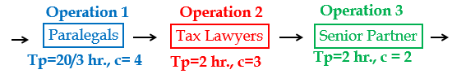

It takes a Paralegal 20 hours to complete 3 contracts. That is 20/3 = 6.667 hours to complete a contract. It takes a Tax lawyer 2 hours to complete a contract. It takes Senior Partner 2 hours to complete a contract.

a) Compute the Flow Time of a contract.

6.667+2+2=10.667. This is not the flow time. It is the Theoretical Flow Time.

Flow Time = Theoretical Flow Time + Waiting times

Flow Time = 10.67 + Waiting times. We do not know the waiting times yet.

Compute the Capacity of each of the three Resource **Pools.**

A Paralegal can complete 1 contract in 20/3 = 6.667 hours.

How many contracts in one hour? 1/6.667 = 0.15

How many contracts can all the Paralegals complete in one hour?

There are 4 Paralegals: c = 4

Four Paralegals 4(0.15) = 0.6 contracts per hour.

We could have also said that Tp = 6.6667 hours.

Capacity of one resource unit is 1/Tp.

Capacity of one resource unit is 1/6.667 = 0.15.

Capacity of all resource units: Rp=c/Tp where c=4 and Tp = 6.667

Rp = 4/6.667 = 0.6 per hour

Capacity of the resource pool is **0.6** contracts **per hour**.

It is 8(0.6) = **4.8** contracts **per day**

A Senior Partner can complete 1 contract in 2 hours.

How many contracts in one hour? 1/2 = 0.5

How many contracts can all the Senior Partners complete in one hour?

There are two Senior Partners: c = 2

Therefore, Senior Partners 2(0.5) = 1 contract per hour

We could have also said that Tp = 2.

Capacity of one resource unit is 1/Tp.

Capacity of one resource unit is 1/2 = 0.5.

Capacity of all resource units: Rp=c/Tp where c=2 and Tp = 2

Rp = 2/2 = 1 per hour

Capacity of the resource pool is **one** contract **per hour**.

It is 8(1) = **8** contracts **per day**

c) Compute the capacity of the process.



d) Compute the cycle time?

4.8 units in 8 hours.

Cycle time = 8/4.8 = 1.67 hours

Alternatively, 1/0.6 =1.67 hours

d) Compute the average inventory.

Let us look at the utilization of the three stations

Station Capacity Throughput Utilization

Station 1 4.8 4.8 4.8/4.8 = 1

Station 2 12 4.8 4.8/12 = 0.4

Station 3 8 4.8 4.8/8 = 0.6

On average one person with a resource in Station 1, 0.4 person with a resource in Station 2, and 0.6 person with a resource in Station 3

Inventory with the processors is 1+ 0.4+0.6 = 2

On average there are two flow units with the processors; Inventory in the processors (Ii)

Now let us look from another angle; from the Little’s Law point of view

RT=I 🡺 R= 4.8 per 8 hours or 0.6 per hour

T =10.67 hours 🡺 I = 0.6(10.67) = 6.4

6.4 vs 2? Where is my mistake?

1(4) + 0.4(3) +0.6(2) = 6.4

e) There are 150 cases in November. Can the company process all 150 cases?

150/20 = 7.5 per day 🡺 4.8 (Capacity) < 7.5 (Demand).

f) If the firm wishes to process all the 150 cases available in November, how many professionals of each type are needed?

# of paralegals required = 7.5/1.2 = 6.25

# of tax lawyers required = 7.5/4 = 1.875

# of tax lawyers required = 7.5/4 = 1.875

These could be rounded up to 7, 2 and 2

We need 7, 2, and 2. We have 4, 3, and 2. We may hire three additional paralegals.

Alternatively, we may hire just two and for a total of six paralegals.

How much overtime for 0.25 paralegal who works eight hrs. /day?

0.25(8) = 2 hours total overtime.

There will be 6 paralegals; overtime pf each = 2/6 = 1/3 hour

Alternatively, 20 minute per paralegal. PLUS some safety Capacity.

Now suppose Throughput is 3.6 contracts per day.

Compute the average inventory.

Station Capacity Throughput Utilization

Station 1 4.8 3.6 3.6/4.8 = 0.75

Station 2 12 3.6 3.6/12 = 0.3

Station 3 8 3.6 3.6/8 = 0.45

Managerial Observation: Note that the utilization of bottleneck resource is not necessarily 100%.

On average

0.75 person with a resource in Station 1

0.3 person with a resource in Station 2

0.45 person with a resource in Station 3

Station Rp R U c Ip

Station1 4.8 3.6 0.75 4 4* 0.75 = 3

Station2 12 3.6 0.3 3 3* 0.3 = 0.9

Station3 8 3.6 .45 2 2*0.45 = 0.9

I = 3+0.9+0.9= 4.8

Let us check it through the Little’s Law

Theoretical Flow Time = 6.66667+2+2= 10.66667

RT=I 🡺 3.6(10.66667/8) = I 🡺 I = 4.8

(3.6/8)(10.66667) = 4.8

Now suppose there are 16.8 contracts waiting in different waiting lines? What is the Flow Time?

RT=I🡺 3.6*T= 16.8+4.8 = 21.6 🡺 3.6T = 21.6🡺 T=6 days.

**If you have difficulty in understanding this problem, you may access the PowerPoints slides at** [**Throughput Part 2**](http://www.csun.edu/~aa2035/CourseBase/Throughput/2.ThroughputPart2a.pptx)**a-Problem**  **and the recorded lecture at** [**Throughput Part2a-Problem.Recorded**](https://youtu.be/iIT9VWpdqY4)**.**  **[The first 25 minutes of the lecture, and the last slides, covers Problem 1, and the last 5 minutes covers an extension of the problem. We encourage you to watch, at least, the last 5 minutes.](https://youtu.be/L5YcxWY66Pg)**

**Capacity Waste Factor (CWF).** Effective capacity of a resource unit is 1/Tp. Unit load Tp is an aggregation of the productive as well as the wasted time.

Tp includes share of each flow unit of capacity waste and detractions such as

Resource breakdown

Maintenance

Quality rejects

Rework and repetitions

Setups between different products or batches

We may want to turn our attention to waste elimination; and segregate the wasted capacity. Theoretical capacity is the effective capacity net of all capacity distracts.

Activity time

Capacity is computed based on the Unit Load

Theoretical Flow Time is computed based on Activity Time

Then what is Flow Time?



**Unit Load, Activity time, Capacity, Theoretical Flow Time**

Flow Time Ti + Tp

Flow time includes time in buffers

Capacity does not care about buffer times



**Flow Time Capacity does not care about buffer times**

Theoretical Unit Load, Theoretical Activity Time

Theoretical Capacity is computed based on the Theoretical Unit Load (ThUL)

Theoretical Flow Time is NOT computed based on Theoretical Activity Time

Very Theoretical Flow Time is computed based on theoretical Activity Time ThUL (1+CWF) = Unit Load (Tp),

**30 mins.**

**Theoretical Unit Load, Theoretical Activity Time, Theoretical Capacity,**

**Very Theoretical Flow Time**

An operating room (a resource unit) performs surgery every 30 min, Tp = 30 min. Tp includes all the distracts. We also refer to it as the Unit Load.

Effective capacity is 1/30 per min or 60/30 =2 per hour.

On average, 1/3 of the time is wasted (cleaning, restocking, changeover of nursing staff and fixing of malfunctioning equipment).

Capacity Waste Factor (CWF) = 1/3.

Theoretical Unit load = Tp*(1-CWF) =30(1-1/3) = 20 min.

Tp = Unit Load = ThUnit Load / (1-CWF) = 20/ (1-1/3) = 30

Theoretical Capacity = c/ThUnit Load

Effective Capacity = Capacity = c/Unit Load.

Theoretical Capacity = 1/20 per minute or 3 per hour.

Effective Capacity = Theoretical Capacity (1-CWF)

**Problem 5.** A law firm processes (*i*) shopping centers and (*ii*) medical complexes contracts. The time requirements (unit loads) for preparing a standard contract of each type along with some other information is given below. In November 2012, the firm had 150 orders, 75 of each type. Assume 20 days per month, and 8 hours per day. CWF at the three resource-s are 25%, 0%, and 50%, respectively.



1. What is the effective capacity of the process (contracts /day)?

Paralegal: Theoretical Unit Load (50%Sh 50% Med): 0.5(4) +0.5(6) = 5 hrs.

Theoretical Capacity = 1/5 per hr.

Capacity Waste Factor (CWF) = 0.25

Unit Load = Tp = 5/(1-0.25) = 20/3 hrs.

Effective Capacity = Capacity = 1/ (20/3) = 3/20 per hr.

Tax Lawyer: Theoretical Unit Load 0.5(1) +0.5(3) = two hrs.

CWF = 0

Theoretical Unit Load = Tp = 2 hrs.

Theoretical Capacity = 1/2 per hr.

Effective Capacity = Capacity = 1/2 per hr.

Senior Partner: Theoretical Unit Load 0.5(1) +0.5(1) = one hrs.

Theoretical Capacity = 1/1 = 1 per hr.

CWF = 0.5

Unit Load = Tp = 1/(1-0.5) = 2 hrs.

Effective Capacity = Capacity = 1/2 per hr.





**PowerPoints of this problem are available at** [**Throughput Part 2b**](http://www.csun.edu/~aa2035/CourseBase/Throughput/2.ThroughputPart2b.pptx)**.**

## Chapter 5. Inventory management

**Importance of Inventory.** Poor inventory management ***hampers operations*, *diminishes customer satisfaction*, and *increases operating costs***.  A typical firm probably has about ***25% of its current assets*** in inventories or about ***90% of its working capital*** (the difference between current asset and current liabilities). For example, 20% of the budgets of hospitals are spent on medical, surgical, and pharmaceutical supplies. For all hospitals in the U.S., it adds up to $150 billion annually.  The average inventory in the U.S. economy is about $1.13 trillion, and that is for $9.66 trillion of sales per year. In the virtue of the Littles Law, 9.66T=1.13; each dollar spend in U.S. economy spends at least 1.13/9.66 = 0.115 year or about 1.38 months in inventory. We used the term “at least” because cost of goods sold (CGS) is less than sales revenue. If we assume that, the CGS is 2/3 of the sales revenue, or 6.44 trillion. Then each dollar spend in U.S. economy spends about 1.13/6.44 = 0.172 year or more than two months in different forms inventory (raw material, work in progress, finished goods, goods in transport, etc.)

There are *two types* of inventory counting systems**; P**eriodical **and Pe**rpetual.

In **periodical inventory system**, the available inventory is counted at the beginning of each period (end of the previous period). The required amount for the current period is computed, and the difference is ordered to satisfy the demand during the current period.   You may imagine it as a one-bin system: there is one bin in which a specific raw material, part, component, or products is stored.  We can look and see how full the bin is, and how much is empty.   Each time, we only order enough to refill the single bin.  The quantity that is ordered each time is variable, it depends on how much is needed to fill the bin, but the timing of order is fixed. The Re-order point (ROP) – when we reorder, is defined in terms of time.  It is the beginning of the period. The *advantage* is that the timing is fixed. In additions, we can order for many items at the same time. Our ordering costs may go down because of ordering for several items at the same time. The *disadvantage* of this system is that during the whole period, we have no information about inventory, because we only check it in the end of the current period, which is the beginning of the next period.

**Perpetual Inventory Systems.** In perpetual inventory system, when inventory reaches reorder point, we order a specific quantity. As opposed to the periodic inventory system, the quantity of order is fixed, where the timing of the order is variable.  We usually order an economic order quantity, which we will discuss later, when inventory on hand reaches ROP. The ROP is defined in terms of quantity, or inventory on hand (or inventory position).  You may imagine it as a two-bin system.  Whenever the first bin gets empty, we order enough raw material, parts, components, or products to fill it.  While waiting to get what we have ordered, we start using the inventory of the second bin. The benefit of this system is that it keeps track of inventory continuously.

Economic Order Quantity. Inventory models are perfect examples of applying mathematical models to real world problems.  In this section, we discuss how to compute economic order quantity (EOQ). The EOQ computation is an example of trade-off in operations management. Trade-off between ordering cost and carrying cost.

**Problem 1: Q and EOQ.** Consider a computer distribution firm with four retail stores in Northridge, Topanga, Sherman Oaks Galleria, and Glendale Americana. Each store at each mall sells an average of 40 laptops per day. Assume 30 working days per month. The cost of each laptop computer is $800. Each time a store places an order to get a set of products; the ordering cost (cost of placing and order plus transportation cost, which is independent of the volume of order) is $1500 ***per order***. The carrying cost (including financial, physical, and obsolescence costs) of storing ***one unit of product for one year*** is 15% of the cost. That is 0.15(800) = $120 ***per unit per year***. Assume a year is 360 working days, and a month is 30 working days.

The manager of Northridge-Store orders every 5 days, and manager of Topanga-store orders once a month. Which one do you follow?

Since the manager of Northridge-store orders every 5 days, she needs to place 360/5 = 72 orders per year. Each time 40(5) = 200 units.

The ordering cost is independent of the volume ordered, and it is ***$1500 per order***. That is 72(1500) =$108000. If the number of orders was not an integer, for example if we had ordered every 7 days and each time 7(40)=280 unites, the number of orders would have come out to 51.43 . In that case, the manager still places 52 orders. The cost of 51.43 orders, about $77145, will count towards this year’s costs, and the cost 0.57 order, about $855, accounts for the next year’s ordering costs. In our basic inventory model, one basic assumption is that everything remain the same from year to year.

Manager of Topanga-store orders every month. She needs to place 12 orders per year. Each times 40(30) =1200; total of 12(1500) = $18000 ordering cost. As order size, Q, goes up, number of orders, R/Q goes down. The cost per order, S, is constant, and does not depend on the order quantity. The following curve shows the relationship between ordering quantity and ordering costs. As order size, Q goes up, the number of orders, and therefore the ordering cost, SR/Q, comes down.

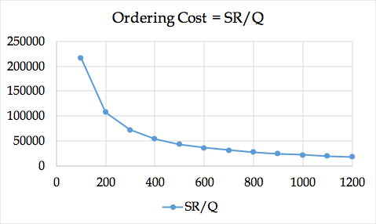

You are the manager of the Glendale-store; do you follow Topanga-store or Northridge-store policy?

We do not know; we need carrying cost.

The manager of Northridge-Store orders 200 laptops per order. Therefore, there will be a maximum of 200 units, which gradually goes down at the rate of 40 units per day and reaches zero at the end of day 5 (start of day 6). Exactly at the same time, a new order of 200 units will arrive. The average inventory is (200+160+120+80+40+0)/6 =100. Since the pattern is linear (decreases at a constant rate), we can just get the first and last number and average them (200+0)/2 = 100. The same pattern of changes in inventory level, as shown below, is repeated every month.

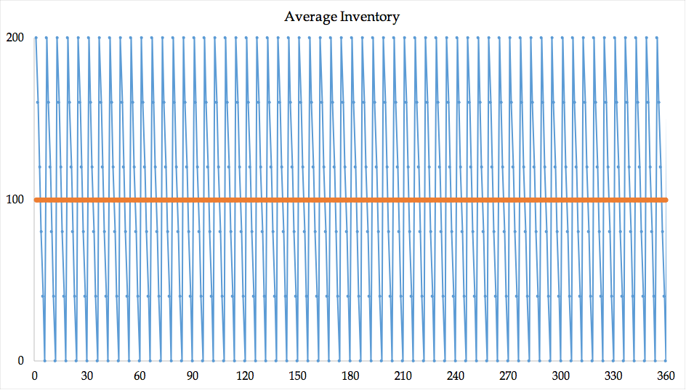

The average inventory in the first cycle (5 days) is 200/2 = 100. Since the pattern is repeated, the average inventory in each of the following cycles is also 100. In general if each time we order Q units, and if the inventory at the end of the period is zero, then the average inventory is (Q+0)/2 = Q/2. We refer to Q/2 (half of the order size) as cycle inventory. If we keep a safety stock of Is, the cycle inventory is still Q/2, while the average inventory is Q/2 + Is. Why? We will show it later.)Cost of carrying one unit of inventory for one year is $120. Since the average inventory 100 units, thus inventory carrying cost is 120(100) = $12000.

The manager of Topanga-store orders 40(30) =1200 units once a month. Therefore, there will be a maximum of 1200 units which gradually goes down at the rate of 40 units per day and finally at the end of day 30 (start of day 31) it reaches 0. The average inventory is then 1200/2 = 600. The same pattern as shown below is repeated every month.

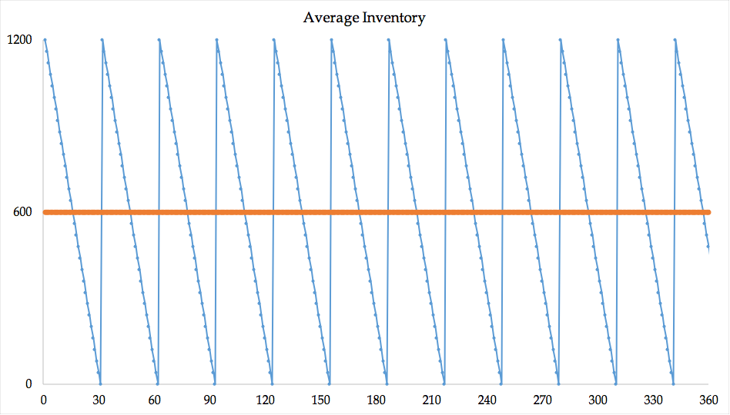

The average inventory during a single moth is 1200/2 = 600 units, the same pattern is repeated every month, thus, the average inventory per year is 600. Cost of carrying one unit of inventory for one year is $120, which means the inventory carrying cost is 120(600) = 72000. As order size goes up, maximum inventory and average inventory go up. Since carrying cost per unit per year is constant, as order quantity goes up, inventory carrying (or holding) costs go up.

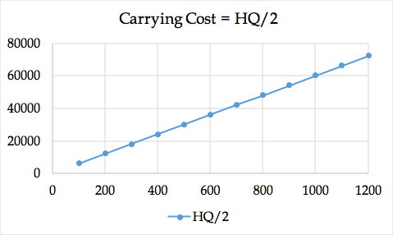

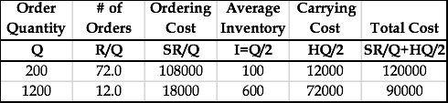

Out of these two practices, we follow the Topange-store’s policy because its total cost is smaller.

We can compute ordering costs (OC), carrying costs (CC) and total costs (TC) for alternative Q values.

Review of the parameters.

Demand per year = D = R = 360(40) = 14400 units.

Ordering cost per order = S = $1500 per order.

Carrying cost (holding cost) = $120 per unit per year

Order quantity = Q

# of orders = R/Q

Ordering cost =SR/Q

Average Inventory = Q/2

Carrying cost = HQ/2

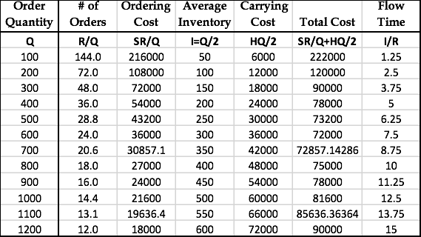

It can be shown that Economic Order Quantity (EOQ) is at the point where ordering cost and carrying cost equate. That is

1500(14400/Q) = 120Q/2 🡺 Q^2 = 2*1500*14400/120 ➔ EOQ = 600.

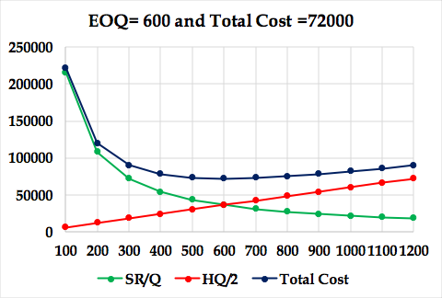

EOQ can be computed independently. We chose to remember it through equity of costs, since it is easier and makes us independent of memorizing the EOQ formula. While memorizing things or just having the formula and plugging in the numbers may look easier, understanding the logic behind formulas, even just a small piece of it, adds more value to our knowledge. For us, deriving EOQ using equality of the two costs is enough. One may derivate is independently, by derivation the total cost term of SR/Q+HQ/2 with respect to Q and set the derivative equal to zero.

**What we learned.** Here we have some points to mention.

As Q goes up, SR/Q goes down.

As Q goes up, HQ/2 goes up.

In the above model, we considered inventory holding costs and ordering costs. There are two other inventory related costs.

**Purchasing Costs** are defined ascosts for purchased items, and pure variable costs (materials and supplies, direct energy, but not human resource costs) for a production item. In our model, we assumed that purchasing costs in independent of order quantity. Over a period we need to order D (or R) units, if purchasing price is P (our pure variable cost is V), out total purchasing (production) cost is PR (or VR). It does not depend on Q (the quantity we order each time). We will later present inventory discount models where the purchase price (or variable costs) depends on the quantity ordered (or produced).

We assumed that the purchase price of the product is independent of the volume ordered. Note that no matter how many units we order each time, over one year we need to order D=R=14400 units.

In the formula, instead of demand (or throughput) per year, we can have demand (or throughput) per month or per day. In all cases, S remains, as it is, $1200 in this example. However, we need to change H to 120/12= $10 per month, or (if a year is 360 days) to 120/360 = 0.333 per day. I the Littlefield game, it may provide more insight if instead of demand per year and carrying cost per year, we implement demand per month and carrying cost per month.

We do not teach OM as isolated islands. Recall the Little’s Law. Throughput is equal to demand and we can show it by D or R. Average inventory is Q/2. In the virtue of the Little’s law, RT=Q/2, therefore, the flow time is Q/2R year. Since the optimal order quantity is 600 units, and demand (or throughput) is 40 per day, therefore, 40T=600/2, that is flow time T= 7.5 days.

EOQ is a mathematical formula for a portion of real world**.**  In this model, we assume that we only have one single product.  Demand is known, and is constant throughout the year.  For example, we know that we need 5,000 units of product per year, and if a year is 50 weeks, then 1/50 of this number is needed every week, that is 100 per week.  If a week is 5 days, 1/5 of whatever we need per week we need per day. Demand is known and it is constant.  Every day, every minute, every hour, we have the same demand as any other minute, hour, or day.

Each order is received in a single delivery.  When we order, we have a waiting period or a lead time. This could be one day, 2 days, and 3 days. It is known, and it is fixed.  After lead-time, we receive the inventory that we have ordered. If lead-time is three days, as soon as our inventory reaches a level that we need for 3 days, then we order.  Because demand is fixed and constant, at the second our inventory reaches 0, we get the product, and we replenish.

There are only two costs involved in this model: **ordering cost,** cost of ordering and receiving the order; and **holding** or **carrying costs,** costs to carry an item in inventory for one year.  Unit cost of product does not play any role in this model because we do not get a quantity discount.  It does not matter if we order one unit or one million units, the price is the same.

**Shortage costs.** These costs include lost profit and loss of goodwill. If we have stockouts, we may lose potential profits as well as customer loyalty. Models have been developed to include these costs in the EOQ models. We do not discuss these models. However, we will discuss shortage costs (underage costs) in our re-order point model.

**The excel file of this problem can be accessed at** [**Order-Quantity-Probs**](http://www.csun.edu/~aa2035/coursebase/inventory/sg-orderquant/eoq-sguide.xlsx) **The name of the worksheet is 1.EOQ-Q.**

**If you have the slightest difficulty on this subject, I encourage you to watch my recorded lecture at** [**Inventory Model: Basic Recorded**](http://www.csun.edu/~aa2035/CourseBase/Inventory/Inventory.ToShare/Ch12a.html) **This lecture includes more examples**

**The PowerPoint slides of the lecture can be accesses at** [**Inventory Model: Basic.**](http://www.csun.edu/~aa2035/coursebase/inventory/ch12a.ppt) **More assignment problems can also be accessed at** [**Assignment Inventory Basics Problems**](http://www.csun.edu/~aa2035/CourseBase/Inventory/InventoryProblems/ProblemInventoryBasics.pptx) **For this part you may only solve Problems 1-2.**

**Problem 2: Centralization and Pooling.** In this example, if all the parameters are the same for all four retail stores, S = $1200, R = 14400 per year (1200 per month or 40 per day), H=$120 per unit per year ($10 per unit per month, 33.333 cents per day). As we computed above, under these parameters, it is at the benefit of each store to order 600 at a time.

**Under optimal policy of Q= 600, how many orders a store places per year?**

R=14400, Q =600 ➔ # of Orders per year = 14400/600 = 24 times.

What is the length of each cycle? Cycle is the time interval between two orders.

24 orders per year, how often do we order? 1/24 year.

1/24 year is 360(1/24) = 15 days.

Alternatively, we could have said, demand per day is 40, we order 600, therefore, 600/40 = 15 days.

**What is the flow time?**

R = 14400 per year, or 1200 per month, or 40 per day.

I = Max Inventory divided by 2. I = Q/2 = 600/2 = 300. We also refer to Q/2 as cycle inventory. When we do not carry safety stock, cycle inventory is equal to average inventory. They differ in presence of safety stock.

Flow time

T = 300/14400 = 3/144 year.

Alternatively, T=300/1200 = 1/4 month.

Alternatively, T=300/40 = 7.5 days.

Alternatively, we could have said the time interval between two orders is 15 days. The first unit ordered will leave almost immediately; therefore, it will spend 0 days in the system. The last unit of an order will leave after 15 days (at the end of the cycle when the next order is about to arrive). Therefore, a unit, on average, spends (0+15)/2 = 7.5 days in the system.

Let us summarize. Each store orders 600 units at each order. They all together order 4(600) = 2400 per order. Average inventory among all four stores is therefore, 2400/2 = 1200. Throughput is 4*14400 per year, or 4*1200 per month, or 160 per day. Flow time, as computed earlier, can be recomputed as 1200/160 = 7.5 days. Each store orders in 15 days intervals.

**Centralization and Pooling.** We refer to the preceding ordering system of the four retail stores as Decentralized system. Now let us consider a centralized system. In a centralized system, the demand or throughput is 4(14400) = 57600 laptops per year. Inventory carrying costs remains the same. Ordering costs usually increases but not in the direct proportion of the demand, i.e., it does not become four times. For example, a truck, instead of having a round trip to a single store, needs to pass through multiple stations of all four stores. In this example for the purpose of simplicity, we assume that the ordering cost remains the same at $1500 per order. Now let us compute EOQ for all warehouses.

Therefore, all stores order 1200 per order that is 300 per store.

Average inventory in all stores is 600 units compared to 1200 in the decentralized case. That is 50% reduction in inventory.

Average flow time is 600/(4*40) = 3.75 compared to 7.5 days in the decentralized case. That is 50% reduction in flow time.

Total cost of decentralized systems for a single warehouse is

1500(14400/600)+120(600/2) = 3600+3600 =7200

Total cost of the decentralized systems for all four warehouses is 4(7200) = 28800 per year.

Total cost of the centralized systems for all four warehouses per year is

1500[(4×14400)/1200]+120(1200/2) = 7200+7200= 14400. The total costs has decreased by 50%

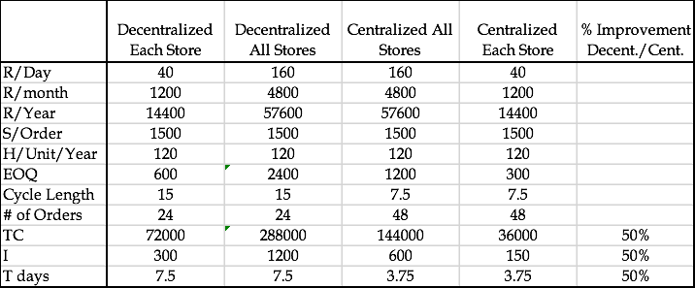

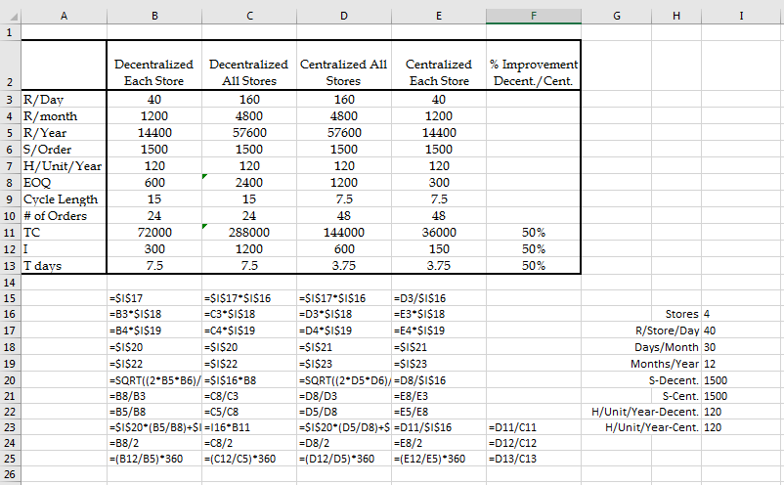

**Why we need to reduce inventory?** There are times where inventory may be at the detriment of a company. For instance, a company with a large work in process and finished goods inventory may discover that the market is shifting from one product to another product. In this case, the company will have a large amount of work in process and finished goods inventory of a product when customers have already shifted to another product.  Thus, the company will have *two choices*.

One choice is to **fire-sell** all inventories and finished goods what they have, which involves the selling of goods at extremely discounted prices. A drawback to fire selling is that it may turn into a significant loss because the inventory is potentially sold at 30 percent, 20 percent, or even 10 percent of their actual value. The second way is that they could sell their finished goods and at the same time, turn their work in process into sellable finished goods. Unfortunately, this means that there would be a lot of delay in entering the product into the market, and the company could lose a substantial portion of market share. Therefore, in both of these alternatives, they lead to loss. Thus, what is the message? We need to reduce our inventory as much as possible; we need to have minimal inventory.

Inventory adversely affects all competitive edges (Price/Quality/Variety/Time).

**Inventory has cost (**physical carrying costs, financial costs).

**Inventory has risk of obsolescence (**due to market changes, due to technology changes).

**Inventory leads to poor quality (**feedback loop is long).

**Inventory hides problems (**unreliable suppliers, machine breakdowns, long changeover times, too much scrap).

**Inventory causes long flow time, not-uniform operations**

We try to reduce inventory.

(a) By reducing EOQ

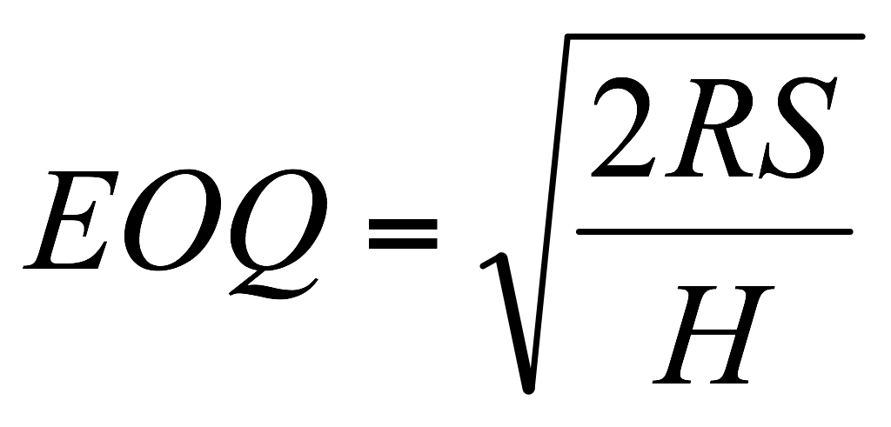

To reduce EOQ we may **↓R, ↓ S, ↑H**

Two ways to reduce average inventory

- Reduce S

- Postponement, Delayed Differentiation

- Centralize

S does not increase in proportion of Q

EOQ increases as the square route of demand.

- Commonality, modularization and standardization is another type of Centralization

**If centralization reduces inventory, why not everybody does it?**

* Higher shipping cost
* Longer response time
* Less understanding of customer needs
* Less understanding of cultural, linguistics, and regulatory barriers

These disadvantages my reduce the demand

**Please solve the rest of the problems at** [**Assignment Inventory Basics Problems**](http://www.csun.edu/~aa2035/coursebase/inventory/inventoryproblems/probleminventorybasics.pptx)

**Problem 3: Inventory Model with Price discount.**

|  |
| --- |
| [Inventory Discount Model](http://www.csun.edu/~aa2035/CourseBase/Inventory/Ch12b.ppt) |
| [Inventory Discount Model Recorded](http://www.csun.edu/~aa2035/CourseBase/Inventory/Inventory.ToShare/Ch12b.html) | |
| [Assignment Inventory Discount Model](http://www.csun.edu/~aa2035/CourseBase/Inventory/InventoryProblems/ProblemInventoryDiscount.pptx) | | |

**Two Mathematical Proofs- Total Cost and Flow Time of Q and EOQ.**

**Inventory Classification**. There are three types of inventory. Input inventory is composed of raw materials, parts, components, and sub-assemblies that we buy from outside. In-process inventory are parts and products, sub-assemblies and components that are being processed; part, products, sub-assemblies, and components that are there to decouple operations. For example, assume that operation B follows operation A. In order to not completely have operation B dependent on operation a, we may put a little bit of inventory between those two. In addition, the third type of in-process inventory is when we realize that if we buy at large volumes, we get lower expense due to economies of scale. Then we have output inventory. We need to have some inventory, because when customers come, we cannot ask them to wait (at least most of the time). The best strategy is to have a low flow time in which I can deliver manufactured product and give it to the customer. However, we are not there yet. Therefore, I should have inventory on shelf when customers come so that I can satisfy demand. Sometimes, the demand in one season is high and in another season is low. In this case, I should produce in low season and put it in inventory to satisfy demand in high season. Another type of output inventory is pipeline or transit inventories. This refers to products that are in a pipeline from manufacturing plants to warehouses, distribution centers, or retailers. The huge volumes of inventory on our highways are pipeline or in transit inventories.

Understocking is not good because we will not have enough products to satisfy demand. Customers will be dissatisfied, which will lead to a loss of sales. The customer may go to another vendor forever.

Overstocking is not good either because it has three types of costs: financial costs, physical costs, and obsolescence costs. Financial costs: Instead of having our money in a city or in a profitable business, we put it in inventory. Physical cost: Our inventory should be put in safe keeping somewhere. Thus, we either lease a warehouse or allocate a portion of our shop to a physical location of these products. Finally, we may have obsolescence cost: If we purchase for a large amount of inventory for a product that eventually gets low consumer demand, we may never be able to sell them. This renders the product obsolete.

A Classification Approach: ABC Analysis. In ABC analysis, the question is which type of inventory counting system is preferred? Is it periodical or perpetual? Perpetual is always better but more expensive because we need an automated system to continuously count our inventory. Therefore, we may conduct an ABC analysis.

Example: Here are our 12 parts (see Figure 3). Here is the annual demand of each part. Here is the unit cost of each part. If we multiply them, we will get the annual value of all items in our inventory system in our warehouse. If we sort them in non-increasing order, we will see that two items, which is 2 divided by 12 (15 to 20 percent of items), form 67 percent of the annual value. In addition, here, 7 items divided by 12 (about 55 percent of items), form 6 percent of the value. These are group C. These are group A and obviously, these are group B. For group A, we use perpetual. Fir group C, we may use periodical. For group B, we can use one of the two options.

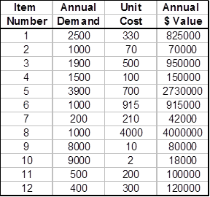 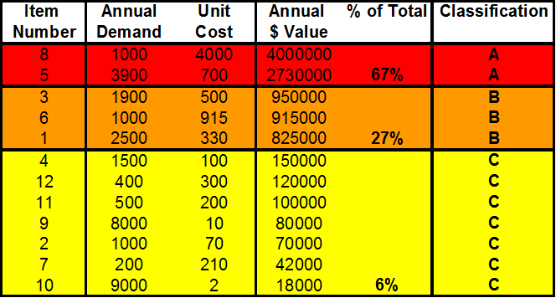

Example 1a. Here we have 12 different video games along with their list of annual demand and unit cost. Using these values, we can find the annual dollar value, the percentage of their value, and then classify them as A, B, or C to see which type of inventory counting system is preferred.

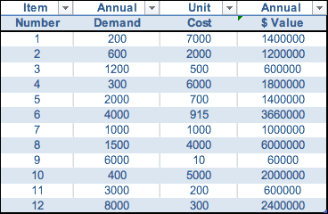

Total cost of any Q.

TCQ = SR/Q + HQ/2`

Total Cost of EOQ? The same as above, but can also be simplified

+ *=*

===

=

**Flow time when we order of any Q?**

Throughput = R, average inventory I = Q/2

RT = Q/2 ➔ T = Q/2R

Flow time when we order of EOQ?

Total Cost of EOQ? The same as above, but can also be simplified

**I = EOQ/2**

**===**

**T = I/R**

***T* = = =**