**Process Flow Engineering**

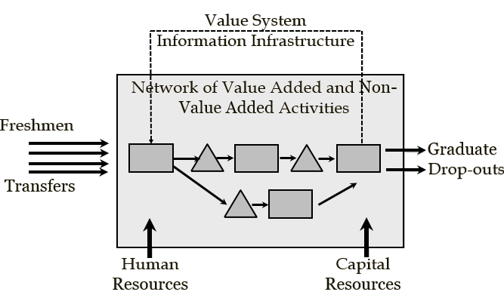

**Problem-Based Learning Study Guide**

**Ardavan Asef-Vaziri**

**Systems and Operations Management**

**David Nazarian college of Business and Economics**