Team 7:

Khieu, Kimberly

Le, Mingkiet

Morris, Steven

Santizo, Bryan

Inventory Models

## Importance of Inventory

Today, we will talk about inventory models.  **Inventory models** are perfect examples of applying mathematical models to real world problems.  In general, an organization’s inventory is a very prominent cost, for example, 20 percent of the budgets of hospitals are spent on medical, surgical, and pharmaceutical supplies. For all hospitals in the United States, it adds up to $150 billion annually.  The average inventory in the United States economy is about $1.13 trillion, and that is for $9.66 trillion of sales per year.

However, there are times where inventory may be at the detriment of a company. For instance, a company with a large work in process and finished goods inventory may discover that the market is shifting from one product to another product. In this case, the company will have a large amount of work in process and finished goods inventory of a product that customers have already shifted to another product.  Thus the company will have *two choices*.

One choice is **to fire-sell** all inventories and finished goods what they have, which involves the selling of goods at extremely discounted prices. A drawback to fire-selling is that it may turn into a significant loss because the inventory is potentially sold at 20 percent, 10 percent, or 30 percent of their actual value. The second way is that they could sell their finished goods and also at the same time, turn their work in process into sellable finished goods. Unfortuately, this means that there would be a lot of delay in entering the product into the market, and they a company could lose a substantial portion of market share. Therefore, in both of these alternatives, they lead to loss. Thus, what is the message? We need to reduce our inventory as much as possible; we need to have minimal inventory.

## Inventory Classified

There are three types of inventory.  **Input inventory** is composed of raw materials, parts, components, and sub-assemblies that we buy from outside. **In-process inventory** are parts and products, sub-assemblies and components that are being processed; part, products, sub-assemblies, and components that are there to decouple operations.  For example, if operation B follows operation A, in order to not completely have operation B dependent on operation A, we may put a little bit of inventory between those two.  And the third type of in-process inventory is when we realize that if we buy at large volumes, we get lower expense due to economies of scale.

Then we have **output inventory**.  We need to have some inventory “over there,” because when customers come, we cannot tell them “wait, I will make your product.”  The best strategy is if I can have such a low flow time in which I can deliver manufactured product and give it to the customer, but we are not there yet.  Therefore, I should have inventory on shelf when customers come to satisfy demand.  Also, sometimes, the demand in one season is high and in another season is low; therefore, I should produce in low season and put it in inventory to satisfy demand in high season. Another type of output inventory is our products that are in a pipeline from manufacturing plants to warehouses or to distribution or to retailers. If you look at the huge volumes of inventory on our highways, those are **pipeline** or **in transit inventories.**

## Inventory

Poor inventory management *hampers operations*, *diminishes customer satisfaction*, and *increases operating costs*.  A typical firm probably has about 30 percent of its *current assets* in inventories or about 90 percent of its *working capital* (and working capital as you may remember from accounting and from finance is the difference between current asset and current liabilities). Using 90 percent of working capital, they may switch to another company forever or another vendor.

**Understocking** is not good because customers come and when we tell them that we don’t have the product, we will then have dissatisfied customers.  This will lead to a loss of sales, and the customer may go to another vendor forever.

**Overstocking** is not good either because it has three types of costs: financial costs, physical costs, and obsolescence costs. *Financial costs*, instead of having our money in a city or in a profitable business, we put it in inventory.  *Physical cost,* our inventory should be put in safe keeping somewhere.  Thus we either lease a warehouse or allocate a portion of our shop to a physical location of these products.  And finally we may have *obsolescence cost* , if we purchase for a large amount of inventory for a product that eventually gets low consumer demand, we may never be able to sell them; thus rendering the product obsolete.

## Periodic Inventory [Counting] Systems

We have *two types* of inventory systems—inventory counting systems.  One of them is called periodical.  The other is called perpetual.  In **periodical inventory system,** at the beginning of each period, the existing inventory level is identified and the additional required volume to satisfy the demand during the period is ordered.  So the quantity of order is variable, but the timing of order is fixed.  It is the beginning of each period.  **Re-order point (ROP)** – when we reorder, is defined in terms of time.  It is the beginning of the period.

How do we order?  At the beginning of the order – at the beginning of the period, we go and look at our inventory.  You may imagine it like a one-bin system, that is, there is one bin and our products are in there.  We can look and see that it is filled up to this point and the remainder is empty, so I order that much.   Each time, we order enough to refill the single bin.  The quantity that I order each time depends on how much I need to fill the bin, but the timing is exact.  It is at the beginning of the period.  Reorder point is defined in terms of time.

**Figure 1. Periodic Inventory: One-Bin System**

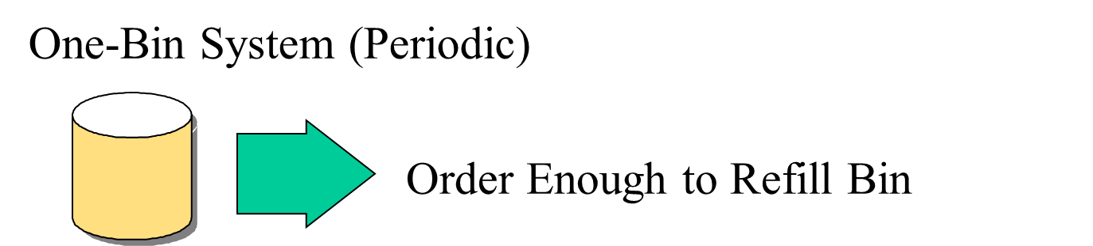

The *disadvantage* of this system is that during this period, we don’t have information about our inventory.  I don’t look at that virtual bin during the period.  I only look at it at the end of each period, which is the beginning of the next period.  The *advantage* is because our inventory counting system counts for a lot of items at one day, then at one day I could order for a lot of items. So then WE make orders for many items at the same time.  My ordering cost will perhaps go down because of it.

## Perpetual Inventory Systems

**Perpetual inventory system** is entirely different.  When inventory reaches reorder point, we order a specific quantity, and usually we order **economic order quantity (EOQ),** which we will discuss later.  The quantity of order, unlike periodic inventory system is fixed, but the timing of the order is variable.  Whenever our inventory has reached a specific level, we will order.  Reorder point is defined in terms of quantity, or inventory on hand.  So you may think of it as a virtual two-bin system.  Whenever the first bin gets empty, we order enough products to fill this first order.  While we are waiting to get this product, we are using the inventory of this bin. A perpetual inventory system is like a two-bin system in which when one bin gets empty, we order enough to fill it up.  The other one was a single bin at the end of each period where we look to see how much we need and we order that much.  The benefit of this system is that it keeps track of removal from inventory continuously.

**Figure 2. Perpetual Inventory: Two-Bin System**

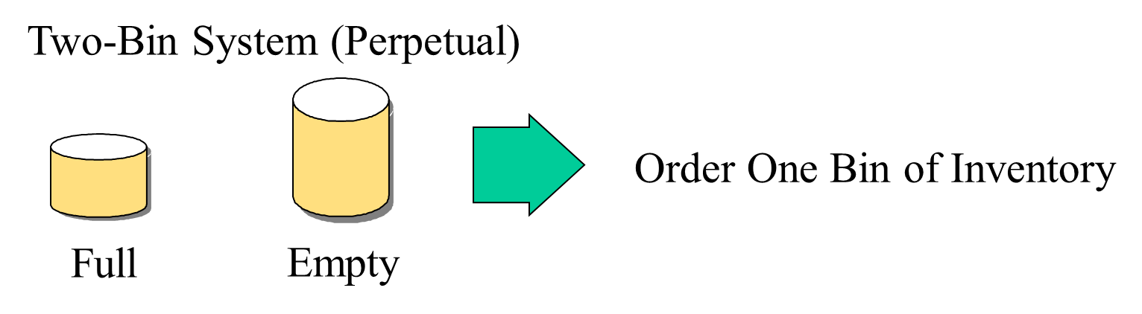

## A Classification Approach: ABC Analysis

In **ABC analysis**, the question is which type of inventory counting system is preferred?  Is it periodical or perpetual?  Perpetual is always better but more expensive because we need an automated system to continuously count our inventory.  Therefore, we may conduct an ABC analysis.

**Example 1.**

Here are our 12 parts (see Figure 3).  Here is the annual demand of each part.  Here is the unit cost of each part.  If we multiply them, we will get annual value of all items in our inventory system in our warehouse.  If we sort them in non-increasing order, we will see that two items, which is 2 divided by 12, which is something between 15 to 20 percent of items, form 67 percent of the annual value. And here, 7 items divided by 12 is a little more than 50 percent, say 55 percent of items, form 6 percent of the value.  These are group C.  These are group A and obviously these are group B.  For group A, we use perpetual, and group C, we may use periodical, and for group B, one of the two options.

**Figure 3. ABC Analysis**

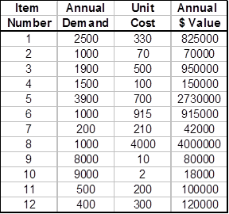 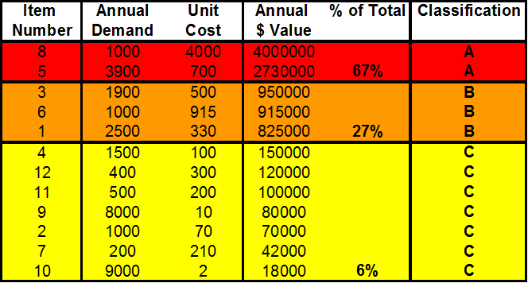

**Example 1a.**

Here we have 12 different video games along with their list of annual demand and unit cost. Using these values, we can find the annual dollar value, the percentage of their value, and then classify them as A, B, or C to see which type of inventory counting system is preferred.



## The Basic Inventory Model: Economic Order Quantity

Now we reach to our basic inventory model, which we try to develop a mathematical formula for a portion of real world, and this model is called **economic order quantity**, or **EOQ.**  In this model, we assume that we only have one product; only a single product.  Demand is known, and demand is constant throughout the year.

So for example, we know that we need 5,000 units of product per year, and if a year is 50 weeks, then 1/50 of this number, we need every week.  If a week is 5 days, 1/5 of whatever we need per week we need per day, so demand is known and it is constant.  Every day, every minute, every hour, we have the same demand as any other minute, hour, or day.

Each order is received in a single delivery.  When we order, we should wait for a lead time, one day, 2 days, 3 days, it is known, and it is fixed.  After lead time, we receive the inventory that we have ordered. Therefore, as soon as inventory is on hand, reach to demand during lead time as soon as our inventory is equal to what we need for lead time and if lead time is three days, as soon as our inventory reaches a level that we need for 3 days, then we order.  During those 3 days, because lead time is fixed, after 3 days, we will get the product.  And because demand is fixed and constant, at the second we get the product, our inventory reaches 0, and then we replenish.

There are only two costs involved in this model: **ordering cost,** cost of ordering and receiving the order; and **holding** or **carrying costs,** costs to carry an item in inventory for one year; cost to count one item in inventory for one year.  Unit cost of product does not play any role in this model because we do not get a quantity discount.  It does not matter if we order one unit or one million units, the price is the same.

## The Basic Inventory Model

Allow us to give you an example and this will clarify the topic we are going to discuss.

**Example 2.**

Annual demand for a product is 9600 units.

D = 9600

Annual carrying cost per unit of product is $16.

H = 16

Ordering cost per order is $75.

S = 75

Annual demand for a product is 9,600 units (D), so we need 9,600 units per year.  In every minute of a year, we need the same number of units as another minute.  So D, which is demand, is equal to 9,600.  Annual carrying cost per unit of a product is $16 per unit per year (H). What does it mean?  If we have one unit of inventory in our warehouse and if we keep it for one year, it costs us $16.  That includes, for example, financial cost, physical cost of holding this inventory, and obsolescence cost.  That is, $16 per unit per year, or inventory carrying cost.  And we show it by H, and that is equal to 16.  Ordering cost per order is $75 (S).  Each time we place an order, it costs us $75.  S is for ordering cost, and it is equal to 75.

**Example 2a.**

Apple’s MacBook has an annual demand of 15,000 units per year. Therefore, D = 15,000 units. They have an annual carrying cost per unit of $22 per unit per year. This means that for every year that they keep the product; it costs them $22, which is their H. Every time an order is placed, it will cost them $80, and so S will be $80.

Annual demand for the MacBook is 15,000 units.

D = 15,000

Annual carrying cost per MacBook is $22

H = 22

Ordering cost per order is $80

S = 80

How much should we order each time to minimize our total cost?

## Economic Order Quantity

Now we need to answer this question, how much should we order each time to minimize our total cost?  That is one question.  Should we order 9,600 at the beginning of the year or should we order twice a year each time 4,800 units, or say 96 times a year each time 100 units.  What is the economic order quantity?  So like many other business problems here, we have two different cost structures.  One goes up if ordering cost goes up and the other goes down as ordering quantity goes down.

Then the other questions we should answer are how many times should we order?  What is the length of order cycle if we have 288 working days per year?  What is the total cost of this system?  As we said, we don’t consider purchasing cost because it is constant, and it does not depend on our strategy.  In EOQ—in mathematical problems—if you get fractional numbers don’t worry about it.  Just put it as is.

## Ordering Cost

So let’s look at **ordering cost**.  If we order one time a year (9,600 units at the beginning of the year) we have one order and therefore, one ordering cost.  But if we put an order for 100 units each time, then we have 96 orders and 96 ordering costs.  In this case, it is 96 times 75 because each order costs us $75.  That is our ordering cost, which is very high.  Alternatively, if we order at the beginning of the year, then ordering cost is 1 times 9,600.  So if D is demand in units per year, Q is what we order each time per order.  Therefore, the number of orders per year is equal to what?  This is all we need.  This is what we order each time.  Therefore, to find out how many times do we order is: what we need divided by what we order each time.  So that would be D divided by Q.  Q we order each time.  D is all we need per year.  We said we don’t have quantities gone.  It doesn’t matter what Q is.  Whatever we order, the price is still the same. If we order 100 units each time price is the same; the same as if we order 9,600 units at the beginning.  S is order cost per order.  This is the number of orders.  Order cost per order is S; therefore, annual ordering cost is S multiplied by the number of orders.

**Example 3.**

D = Demand in units / year

Q = Order Quantity in units / order

Number of orders / year =

S = Order Cost / Order

Annual Order Cost = S

**Example 3a.**

If demand for MacBooks are 15,000 units and the order quantity is 100 units, then the number of orders per year would be 150 units. We would multiply that by our ordering cost of $80 to get an annual cost of $12,000 per year.

## Annual Ordering Cost

**Example 4.**

Therefore, if we order 50 units each time because we need 9,600 units per year, we will have 192 orders per year.  If we multiply 192 by 75, we get this number, 14,400, a large number.  If each time we order 100 units, we will have 9,600 divided by 100, which is 96 orders.  Then we multiply by 75 and we get 7,200.  So if we increase our ordering size and order 500 units each time, we will order 19.2 times.  19.2 times in this period means we order 20 times in this year, but 19.2 of it is for this year and 0.8 will go to next year.  So if you don’t get integer numbers here, don’t worry.  In the first year, you have 27 orders and one other order, which 0.4 of it is for this year and 0.6 of it is for next year.

Don’t forget all these assumptions are valid for the next year and next year after that.  This is the most basic inventory model.  We can develop all types of inventory models, but they are more difficult to develop, and we are sure you don’t want us to go through very difficult models.  So let’s first try to understand this basic model.  Then the pathways to others are not really difficult.  You only need interest and time.  So here if we order 800 units, we should order 12 times, and our cost is 900.

**Figure 4. Annual Ordering Cost Table**

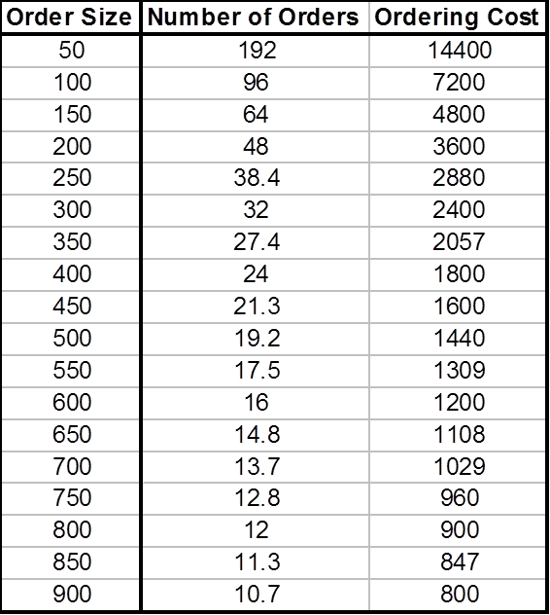

So in summary, as order size goes up, number of orders goes down.  Because we have fixed cost per order, total ordering cost per year goes down.  This is number of orders per year.  This is ordering cost per year.

**Example 4a.**



**Example 5.**

The curve looks like this—S times D divided by Q looks like this:

**Figure 5: Ordering Cost per year Curve**

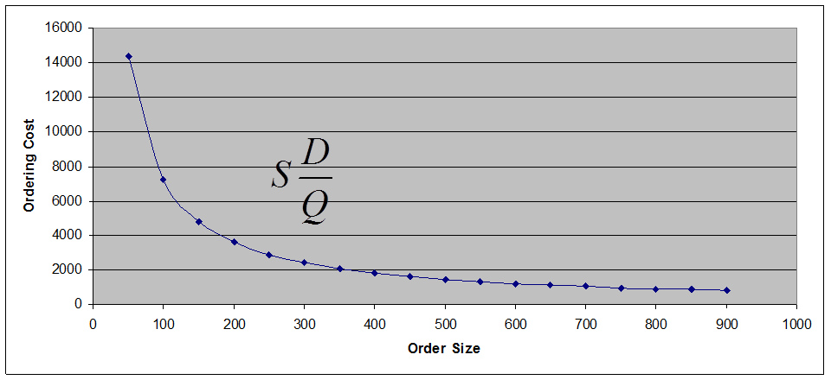

It decreases as ordering size increases.  So it is a benefit to order as much as we can, and the best thing is to order all we need at the beginning of the year.  One order a year for 9,600 units at the cost of $75, but unfortunately the story has another side and that is inventory carrying cost.

**Example 5a.**

**Figure 5a: Annual Ordering Cost Chart**

## The Inventory Cycle

**Example 6.**

When we order, when we get this Q, whatever it is, if it is 100 you need or 9,600 at the beginning of the year, when we receive the order, this will be our quantity in hand.  Then we start using it with a constant rate.  So that is why it is a straight line coming down.  Usage rate is constant.  It comes down, down, down.  We are consuming it, consuming it, consuming it.  Then inventory reaches 0.  Before inventory reaches 0, suppose this is our lead time.  Suppose this is 4 days.  If this is our model, this is 1 day, 2 day, 3 day, 4 days.  We will go see demand in 4 days is how much.  So as soon as our inventory in hand reaches this much, we place an order.

**Figure 6. The Inventory Cycle**

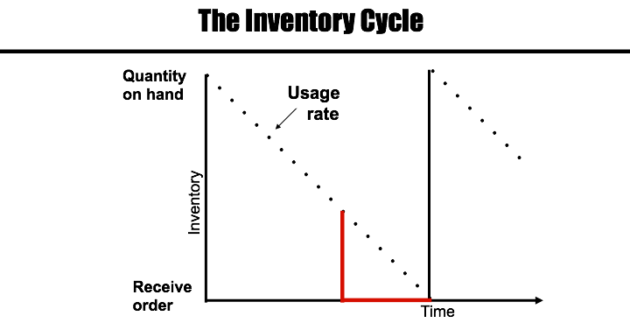

As soon as our inventory on hand reaches demand in lead time, what will see what we need in lead time, and then we place an order.  Because demand rate is fixed, usage rate is fixed.  And because lead time is fixed, exactly at the same time our inventory reaches 0, we will get the next order so we will not be out of stock.  Then we consume it.

Therefore, this is the story.  We get the inventory, and we consume it.  As soon as it gets to 0 we get the next batch.  We will then consume it again.  As soon as we get 0 inventory, we get the next batch.  This cycle with then constantly repeat.

**Example 6a.**

For the Macbook example, we know that demand is 15,000 units annually. Therefore D = 15,000. Assuming that we are seeking to reduce ordering cost, the optimal order size will be 15,000 units bought at the beginning of the year to give us 15,000 units on hand when the order is received. Apple would use these products at a constant rate (shown as a straight line with a downward slope) which can be calculated as Quantity on Hand/ Working Days.

Usage Rate: 15,000/ 300 = 50 Macbooks per day

Let’s say we have an order size of 500 units. To satisfy demand we order this quantity of Macbooks 30 times per year. In addition we can figure out the amount of time 500 units will last during the period.

**Example 7.**

**Figure 7. The Inventory Cycle: Order Quantity**

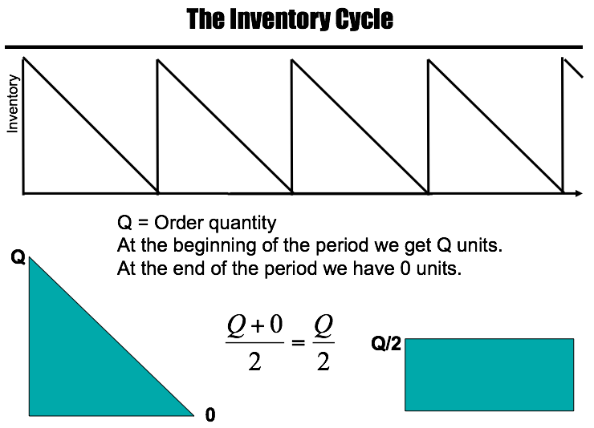

 Suppose this is one year (see Figure 7), we have 4.2 orders per year.  Correct?  Q, order quantity at the beginning of the period we get Q.  No matter what Q is 100, 9,600, or whatever, at the beginning of the period we get Q units.  At the end of the period we have 0 units; therefore, Q units in one course, 0 units in another course.  Your GPA is Q + 0 divided by 2, which equals to Q divided by 2. Therefore, if each time you get Q, and if that Q goes to 0 at the end of the period, this is like this throughout the period and your average inventory was Q divided by 2.  One day, you have a salary of Q dollars.  The other day, you have a salary of 0.  Your average salary during these two days is Q + 0 divided by 2, which is Q divided by 2.  Therefore, if each time we ordered Q and we don’t have any safety stock and our inventory reaches 0 and we get the next order.

**Example 7a.**

At the beginning of a period we start with Q units. At the end of a period we end with 0 units. Therefore we can compute the average.

Q= Order Quantity

Average: (Q + 0)/2

0

Q

If our order size was 15000 units, we’d have 15,000 as our beginning inventory Q. To calculate the average we would use the formula Average= (Q+0)/2 or Q/2.

(15,000+ 0)/2 = 7500 units

If our order size is 500 units our beginning inventory is 500. Average would be equal to 250.

(500+0)/2 = 250 units.

## Average Inventory per Period and Average Inventory per Year

**Example 8.**

Look at this story. **Average inventory per period** and **average inventory per year**.  This is a period, beginning of the period we have Q units, end of the period we have 0 units.  Average inventory is Q + 0 divided by 2, Q divided by 2.  This is our average inventory.  Average inventory per periodis whatever we ordered divided by 2.  That is what we do have throughout the period.  Average inventory per period is also known as **cycle inventory**, but what is average inventory per year?

**Figure 8. Cycle Inventory**

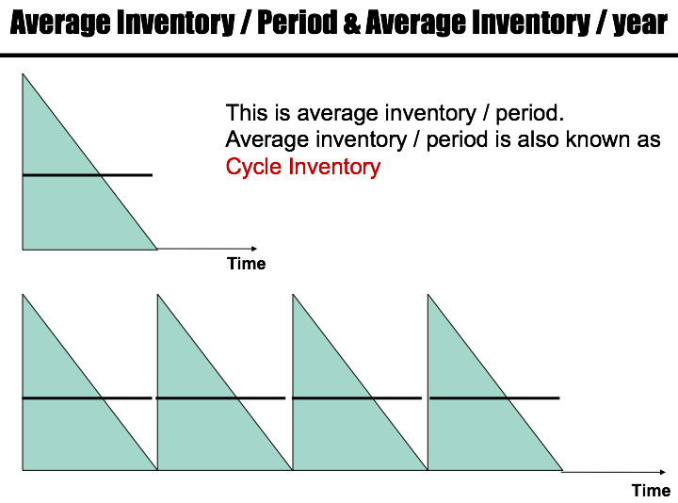

Suppose this is a year (see Figure 8).  In this year, we have 4 periods.  Average inventory per period is Q divided by 2.  What is average inventory per year?  Let’s say we have 9,600 total demand.  We have ordered 4 times, that is 9,600 divided by 4, which is 2,400.  Each time we ordered 2,400.  It goes to 0, 2,400, 0, 2,400, 0, 2,400, and 0.  In general, Q, 0, Q, 0, Q, 0, Q, 0.  Average inventory per period is Q + 0 divided by 2, which is Q divided by 2.  In this period is Q divided by 2.  For each period of the four periods, Q is divided by 2; therefore, average inventory per year is multiplied by 4.  That is Q divided by 2, Q divided by 2, Q divided by 2, Q divided by 2; therefore, throughout the period it is Q divided by 2 throughout the year.  Each time we order Q throughout the year, we have Q divided by 2 average inventories.

**Example 8a.**

Cycle Inventory

Q

Time (Year)

Time: 1 Year

Number of Periods: 5

Demand: 15,000 units

Inventory per period: 15,000 units/ 5 periods = 3000 units

Cycle Inventory = Average per period

= (3000 + 0) / 2

= 1500 units

Average inventory per year: Cycle inventory x # of periods

= 1500 units x 5

= 7500 units

## Inventory Carrying Cost

**Example 9.**

So Q is equal to order quantity in units per order.  Average inventory per year, each time we order Q is Q divided by 2.  H is inventory **carrying cost** for one unit per year; therefore, for one unit per year we have H cost if we are carrying 2 units per year, then our carrying cost is H times Q divided by 2.

Q = Order quantity in units / order

Average inventory / year = Q/2

H = Inventory carrying cost / unit / year

Annual Carrying Cost = H

If Q goes up, annual carrying cost goes up.  In the other scenario, cost structure we had, in ordering cost, when Q goes up, ordering cost comes down, but in this one, when Q goes up, cost also goes up.  We said we are system analysts.  We try to make the optimal solution for everybody and not for only inventory counting cost.  If we are talking about inventory counting costs, it tells us order as little as you can.  If we are talking only about ordering cost, it tells us order as much as you can.  These two solution solutions contradict each other, thus we should see what the benefit for the whole system is.

## Annual Carrying Cost

**Example 10.**

**Figure 9. Annual Carrying Cost Table**

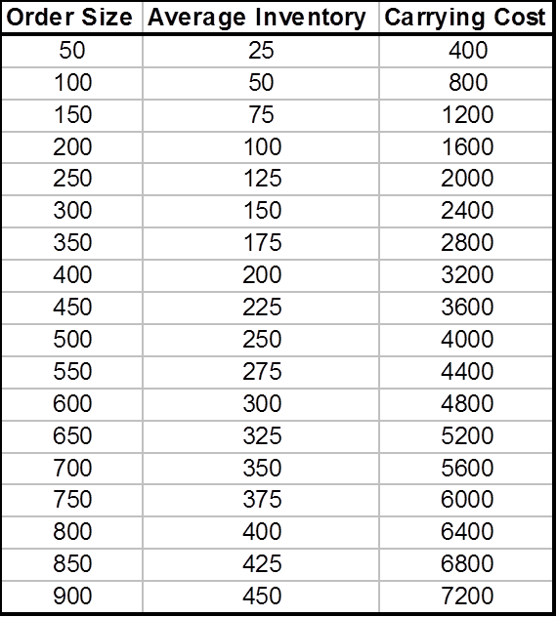

In this carrying cost, if order size goes up, then average inventory is here.  This order size—half of it is average inventory. Order size 600, average inventory 300.  Order size 800, average inventory 400.  Order size 900, average inventory 450.  So this is average inventory.  We should multiply by 16, and we will get this number.  As we go up, inventory carrying cost goes up.  And we have a curve like this.  H time Q divided by 2 increases as Q increases.

**Example 10a.**

**Figure 9a. Annual Carrying Cost Table for Macbooks**



**Example 11.**

**Figure 10. Annual Carrying Cost Curve**

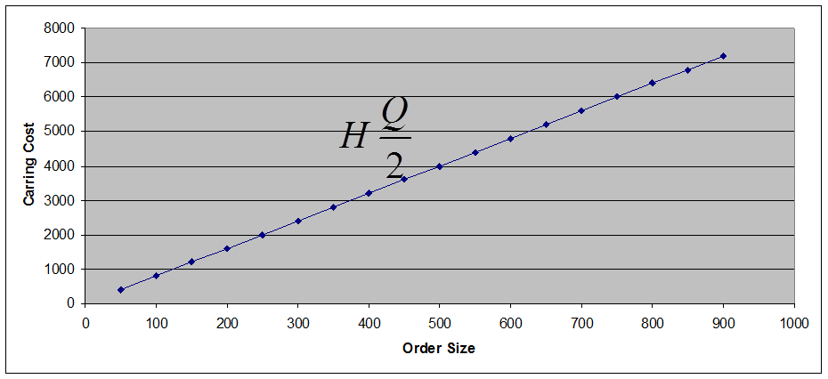

**Example 11a.**

**Figure 10a. Annual Carrying Cost Curve for Macbook**

## Total Cost

**Example 12.**

**Figure 11. Total Cost Table**

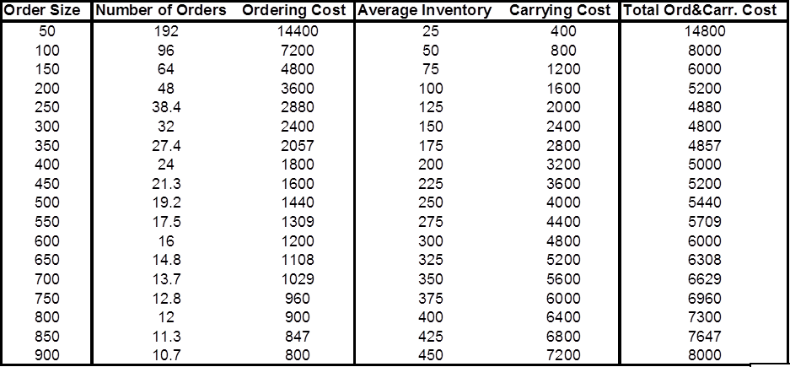

So we have order size, number of orders goes down as order size goes up, ordering cost goes down.  Average inventory goes up as order size goes up, carrying cost goes up, and total cost goes down and then goes up.  It’s like this.

**Example 12a.**

So let’s assume here that we have an annual demand for textbooks of 17,000 at the CSUN bookstore every year. D = 17,000. Then carrying cost of each textbook is $25 per unit, H = $25/per unit. The ordering cost per order is $60, S = $60/per order. Going off of this, CSUN has an order quantity of 2000 textbooks, Q = 1550. So with that, we can find out that they will need to put in 11 orders per year because Annual Orders Per Year = D/Q, which is 11 = 17,000/1550.

We then find our average inventory per year by dividing our quantity order by 2, Q/2 = 1550/2 = 775. We then we find the annual carrying cost by multiplying H, inventory carrying cost, with average inventory per year, H(Q/2) = $25 x 775 = $18,125. So with this information we can graph out the relationship between Ordering Cost and Carrying Cost to choose the right amount of Order Size for minimal total cost.

**Figure 11a. Total Cost Table**

|  |  |  |  |  |  |
| --- | --- | --- | --- | --- | --- |
| **Order Size** | **Number of Orders** | **Ordering Cost** | **Average Inventory** | **Carrying Cost** | **Total Ord. & Carr. Cost** |
| 100 | 170.0 | 10,200 | 50 | 1250 | 11,450 |
| 150 | 113.3 | 6,800 | 75 | 1875 | 8,675 |
| 250 | 68.0 | 4,080 | 125 | 3125 | 7,205 |
| 350 | 48.6 | 2,914 | 175 | 4375 | 7,289 |
| 450 | 37.8 | 2,267 | 225 | 5625 | 7,892 |
| 550 | 30.9 | 1,855 | 275 | 6875 | 8,730 |
| 650 | 26.2 | 1,569 | 325 | 8125 | 9,694 |
| 750 | 22.7 | 1,360 | 375 | 9375 | 10,735 |
| 850 | 20.0 | 1,200 | 425 | 10625 | 11,825 |
| 950 | 17.9 | 1,074 | 475 | 11875 | 12,949 |
| 1050 | 16.2 | 971 | 525 | 13125 | 14,096 |
| 1150 | 14.8 | 887 | 575 | 14375 | 15,262 |
| 1250 | 13.6 | 816 | 625 | 15625 | 16,441 |
| 1350 | 12.6 | 756 | 675 | 16875 | 17,631 |
| 1450 | 11.7 | 703 | 725 | 18125 | 18,828 |
| 1550 | 11.0 | 658 | 775 | 19375 | 20,033 |

**Example 13.**

**Figure 12. Total Cost Curve**

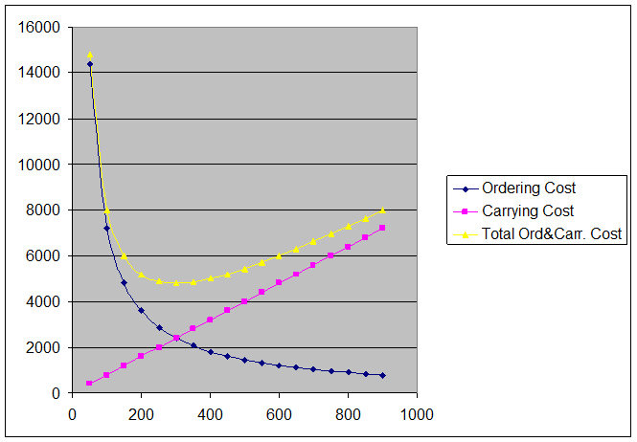

This is carrying cost.  This is ordering cost.  This is total cost.  It reached a minimum and then goes up.  The best strategy for us is to order this much.  This is what minimizes our total cost.  That is what we call EOQ, economic order quantity.

**Example 13a.**

**Figure 12a. Total Cost Curve**

Here we have ordering cost, carrying cost, and total cost.

## EOQ (Economic Order Quantity)

TC = (Q/2)H + (D/Q)S

EOQ is at the intersection of the two costs.

(Q/2)H = (D/Q)S

Q is the only unknown. If we solve it

**Total cost** is inventory carrying cost plus ordering cost.  You can use calculus computed derivative of TC with respect to Q and compute EOQ.  If you do that, you will find that EOQ is at the intersection of both costs.  EOQ is where ordering cost intersects with carrying cost.  Therefore, these two are equal at EOQ, and therefore, we can solve this equation and therefore we can find EOQ is equal to square root to 2D times S divided by H:

**Figure 13. EOQ Formula**

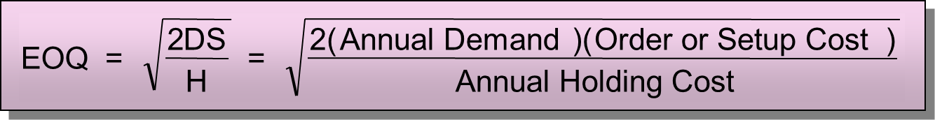

This is 2; this is demand per year, order cost per order, carrying cost per unit per year.  

## Back to the Original Questions

Now we go back to our previous example, and now we are in a good position to solve this problem.  So we know that annual demand is 9,600.  Ordering cost is 75, carrying cost is 16; how much should we order each time to minimize total cost, which is to order EOQ?

## What is the Optimal Order Quantity?

**Example 14.**

EOQ 2DS divided by H.  we put the numbers over there.  D is 9,600, H is 16, S is 75.  EOQ is 300.

D = 9600, H = 16, S = 75

The best strategy is to order 300, not 100, not 9,600, 300.  That is what minimizes our overall cost: both carrying cost and ordering cost.  And as we said we don’t include purchasing cost because purchasing cost plays no role in this play because no matter we order 100 units, 200 units, 300 units, or 9,600 units each time, we don’t get quantity discount.  We will buy it for the same price.

**Example 14a.**

So now we want to find out what our optimal order quantity would be with our given data using Economic Order Quantity.

D = 17000, H = 25, S = 60

So we find out that the best amount to be ordered is 286 books, which would result in the minimal overall cost between carrying and ordering cost.

## How Many Times Should We Order?

**Example 15.**

How many times should we order?  Annual demand is 9,600 units. How much do we order each time?  300.  Each time we order EOQ, therefore, how many times should we order?  We need 9,600.  Each time we order 300.  That is D divided by EOQ, which is 9,600 divided by 300, which is 32.

Annual demand for a product is 9600 units.

D = 9600

Economic Order Quantity is 300 units.

EOQ = 300

Each time we order EOQ.

How many times should we order per year?

D/EOQ

9600/300 = 32

**Example 15a.**

So now it is up to finding out what our amount of orders per year will be which will be easy:

Annual demand for books is 17000 units.

D = 17000

Economic Order Quantity is 286 units.

EOQ = 286

How many times should we order per year?

D/EOQ

17000/286 = 59.4, so 60 times.

## What is the Length of an Order Cycle?

**Example 16.**

 9,600 units are required for 288 days.  300 units are enough for how many days?  Each day, we need 9,600 divided by 288.  Each day, we need that much.  Then if we divide 300 by that number, it gets us the number of days.  Alternatively, we can say 9,600 are for 288 days, and 300, we divided by 9,600, which gives us a fraction of a year.  Then we multiply by 288 and get the number.  Just think about it.  You don’t need to memorize any formula.  Just manage it.  You have 288 days.  Each time you order 300 units, all you need during that 288 is 9,600.  How much is the length of each cycle?  It is 9 days.

Working Days = 288/year

9600 units are required for 288 days.

300 units are enough for how many days?

(300/9600) × (288) = 9 days

**Example 16a.**

So now we want to find out how much we a single order will last, or the length of an order cycle. This is relatively easy as well and can be found out with our given data. Assuming that an annual amount of work days is 300, we know that we need 17,000 books during those 300 days due to demand. So in order to find out how long an order lasts you can divide the EOQ (which is 286) by the demand of books (17000) and then multiply it by the amount of days in the year.

Working Days = 300/year

17000 units are required for 300 days.

286 units are enough for how many days?

(286/17000) × (300) = 5 days

## What is the Optimal Total Cost?

**Example 17.**

You can go through other different ways to come up with the same 9 days.  What is the optimal total cost? Total cost formula is Q divided by 2 times H + D divided by Q times S.  The economic quantity is Q.  All other things unknown.  We put them over there.  300 divided by 2 times 16 plus 9,600 divided by 300, times 75 gives us 2,400 plus 2,400.  Remember one test to know that your computations are correct is these two costs should come out equal at EOQ. Before EOQ, ordering cost is higher.  After EOQ, carrying cost is higher.  At EOQ, they are equal. Total cost is 4,800.  This is the optimal policy that minimizes the total cost.

The total cost of any policy is computed as:

TC = (Q/2)H + (D/Q)S

The economic quantity is 300.

TC = (300/2)16 + (9600/300)75

TC = 2400 + 2400

TC = 4800

**Example 17a.**

So now we want to find the Optimal Total Cost that we derive from using EOQ. To find total cost, we use the following formula:

TC = (Q/2)H + (D/Q)S

We know that our EOQ was 286 units, so that is Q, and we know that our carrying cost is 25 per unit, demand is 17000 units, and ordering cost is 60. Knowing all of this, we can apply it to the Total Cost equation as follows:

TC = (286/2)25 + (17000/286)60

TC = 3575 + 3566.4

TC = 7142

## Centura Health Hospital

**Example 18.**

Now, we solve another problem. You have Centura Hospital.  Demand in this hospital is 31,200 units per year.  In our current strategy, we order 6,000 units each time.  Ordering cost is $130, carrying cost is $0.90.  A year is 52 weeks.  What is the average inventory or cycle inventory?  Here, Q is 6,000.  It reaches 0 and goes up to 6,000. Therefore, average inventory is Q divided by 2, which is 3,000.

**Average inventory** = Q/2 = 6000/2 = 3000

What is total annual carrying cost?  This is average inventory per period and average inventory per year.  Therefore, on average we have 3,000 units in inventory and each one costing $0.90; therefore, carrying cost per units times average inventory is 2,700.  

**Carrying cost** = H(Q/2) = 0.9×3000=2700

How many times do we order?  Each time we order 6,000.  All we need is 31,200.  31,200 divided by 6 means 5.2.  We place 6 orders.  5 orders are completely utilized in this period and the 6th one, 20% of it is utilized this year and the remainder is utilized next year.  But we simply stay with this 5.2.  The number of order per year is 5.2

31200/6000 = 5.2

What is the total annual ordering cost?  You order 5.2 times, ordering cost per each time you order is $130.  It is S times D divided by Q, which is 130 times 5.2, which equals $676.

**Total ordering cost** = S (D/Q)

**Ordering cost** = 130 (5.2) = $676

**Example 18a.**

Assume you are running a restaurant that serves jumbo shrimp to its customers; they are essentially world renown for how great they taste. But the secret lies in the special spice that is used to marinate the shrimp in. Because of this essential ingredient the demand that the restaurant has for the spice is 72,000 crates (units) per year. The restaurant orders 9000 units each time at an ordering cost of $900 and carrying cost of $25. The year is 52 weeks long. So now you are asked to find the **Average Inventory**, **Annual Carrying Cost**, **Total Ordering Cost**, and the **EOQ** with this given data.

Q = 9000 and Avg. Inventory is Q/2, so…

**Average Inventory** =Q/2 = 9000/2 = 4500

So now that we have the average inventory, we can find the total annual carrying cost; which is the **Average Inventory** multiplied by the **Carrying Cost**. Our data states that H = 25 and Avg. Inventory is 4500, so…

**Annual Carrying Cost** = **H (**Q/2) = 25(4500) = 112,500

Now we want to find out the total annual ordering cost, which consists of using the demand, amount being ordered, and of course, the ordering cost of each unit. First we need to find the total amount of times we will be ordering given our **Quantity Ordered** (Q) and **Demand** (D).

Q = 9000, D = 72,000 so… D/Q = (72,000/9000) = 8 orders per year

Now we can find the Annual Total Ordering cost since we know that our ordering cost per order is $900 and we order 8 times per year:

**Total Annual Ordering Cost** = **S (**D/Q) = 900(8) = 7200

So now we see what our cost is when we order 9000 units, but we don’t know if this is the optimum amount we can order in order to have the lowest carrying and ordering cost! So in order to do this we use the EOQ (Economic Ordering Quantity) to see if 9000 is too much or too little.

**Economic Order Quantity** =

D = 72,000, H = 25, S = 900

Given this new ordering quantity we can test out and see the new carrying and ordering costs the restaurant would have:

**Annual Carrying Cost =** H (Q/2) = 25(1138.4) = **28,460**

**Annual Ordering Cost =** S (D/Q) = 900(72,000/2276.8) = **28,460.9**

Now we can see how much more money is saved by comparing the differences in annual carrying and ordering costs between the Q of 9000 and 2276.8.