## Chapter 6. Inventory management

**Importance of Inventory.** Poor inventory management ***hampers operations*, *diminishes customer satisfaction*, and *increases operating costs***.  A typical firm probably has about ***25% of its current assets*** in inventories or about ***90% of its working capital*** (the difference between current asset and current liabilities). For example, 20% of the budgets of hospitals are spent on medical, surgical, and pharmaceutical supplies. For all hospitals in the U.S., it adds up to $150 billion annually.  The average inventory in the U.S. economy is about $1.13 trillion, and that is for $9.66 trillion of sales per year. In the virtue of the Littles Law, 9.66T=1.13; each dollar spend in U.S. economy spends at least 1.13/9.66 = 0.115 year or about 1.38 months in inventory. We used the term “at least” because cost of goods sold (CGS) is less than sales revenue. If we assume that, the CGS is 2/3 of the sales revenue, or 6.44 trillion. Then each dollar spend in U.S. economy spends about 1.13/6.44 = 0.172 year or more than two months in different forms inventory (raw material, work in progress, finished goods, goods in transport, etc.)

There are *two types* of inventory counting systems**; P**eriodical **and Pe**rpetual.

In **periodical inventory system**, the available inventory is counted at the beginning of each period (end of the previous period). The required amount for the current period is computed, and the difference is ordered to satisfy the demand during the current period.   You may imagine it as a one-bin system: there is one bin in which a specific raw material, part, component, or products is stored.  We can look and see how full the bin is, and how much is empty.   Each time, we only order enough to refill the single bin.  The quantity that is ordered each time is variable, it depends on how much is needed to fill the bin, but the timing of order is fixed. The Re-order point (ROP) – when we reorder, is defined in terms of time.  It is the beginning of the period. The *advantage* is that the timing is fixed. In additions, we can order for many items at the same time. Our ordering costs may go down because of ordering for several items at the same time. The *disadvantage* of this system is that during the whole period, we have no information about inventory, because we only check it in the end of the current period, which is the beginning of the next period.

**Perpetual Inventory Systems.** In perpetual inventory system, when inventory reaches reorder point, we order a specific quantity. As opposed to the periodic inventory system, the quantity of order is fixed, where the timing of the order is variable.  We usually order an economic order quantity, which we will discuss later, when inventory on hand reaches ROP. The ROP is defined in terms of quantity, or inventory on hand (or inventory position).  You may imagine it as a two-bin system.  Whenever the first bin gets empty, we order enough raw material, parts, components, or products to fill it.  While waiting to get what we have ordered, we start using the inventory of the second bin. The benefit of this system is that it keeps track of inventory continuously.

Economic Order Quantity. Inventory models are perfect examples of applying mathematical models to real world problems.  In this section, we discuss how to compute economic order quantity (EOQ). The EOQ computation is an example of trade-off in operations management. Trade-off between ordering cost and carrying cost.

**Problem 1: Q and EOQ.** Consider a computer distribution firm with four retail stores in Northridge, Topanga, Sherman Oaks Galleria, and Glendale Americana. Each store at each mall sells an average of 40 laptops per day. Assume 30 working days per month. The cost of each laptop computer is $800. Each time a store places an order to get a set of products; the ordering cost (cost of placing and order plus transportation cost, which is independent of the volume of order) is $1500 ***per order***. The carrying cost (including financial, physical, and obsolescence costs) of storing ***one unit of product for one year*** is 15% of the cost. That is 0.15(800) = $120 ***per unit per year***. Assume a year is 360 working days, and a month is 30 working days.

The manager of Northridge-Store orders every 5 days, and manager of Topanga-store orders once a month. Which one do you follow?

Since the manager of Northridge-store orders every 5 days, she needs to place 360/5 = 72 orders per year. Each time 40(5) = 200 units.

The ordering cost is independent of the volume ordered, and it is ***$1500 per order***. That is 72(1500) =$108000. If the number of orders was not an integer, for example if we had ordered every 7 days and each time 7(40)=280 unites, the number of orders would have come out to 51.43 . In that case, the manager still places 52 orders. The cost of 51.43 orders, about $77145, will count towards this year’s costs, and the cost 0.57 order, about $855, accounts for the next year’s ordering costs. In our basic inventory model, one basic assumption is that everything remain the same from year to year.

Manager of Topanga-store orders every month. She needs to place 12 orders per year. Each times 40(30) =1200; total of 12(1500) = $18000 ordering cost. As order size, Q, goes up, number of orders, R/Q goes down. The cost per order, S, is constant, and does not depend on the order quantity. The following curve shows the relationship between ordering quantity and ordering costs. As order size, Q goes up, the number of orders, and therefore the ordering cost, SR/Q, comes down.

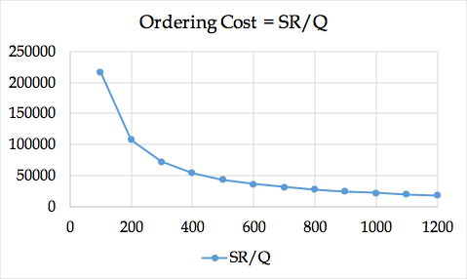

You are the manager of the Glendale-store; do you follow Topanga-store or Northridge-store policy?

We do not know; we need carrying cost.

The manager of Northridge-Store orders 200 laptops per order. Therefore, there will be a maximum of 200 units, which gradually goes down at the rate of 40 units per day and reaches zero at the end of day 5 (start of day 6). Exactly at the same time, a new order of 200 units will arrive. The average inventory is (200+160+120+80+40+0)/6 =100. Since the pattern is linear (decreases at a constant rate), we can just get the first and last number and average them (200+0)/2 = 100. The same pattern of changes in inventory level, as shown below, is repeated every month.

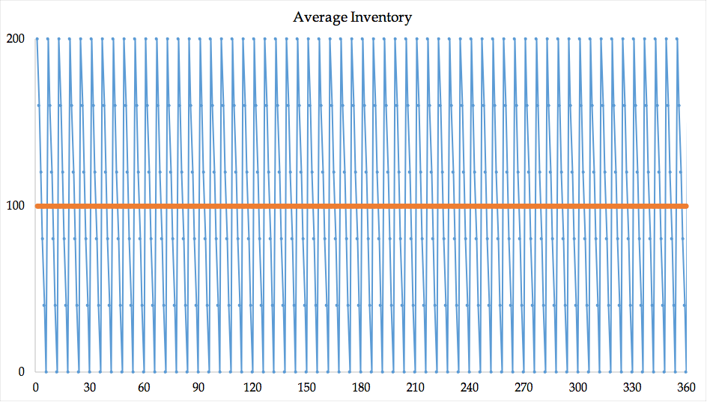

The average inventory in the first cycle (5 days) is 200/2 = 100. Since the pattern is repeated, the average inventory in each of the following cycles is also 100. In general if each time we order Q units, and if the inventory at the end of the period is zero, then the average inventory is (Q+0)/2 = Q/2. We refer to Q/2 (half of the order size) as cycle inventory. If we keep a safety stock of Is, the cycle inventory is still Q/2, while the average inventory is Q/2 + Is. Why? We will show it later.)Cost of carrying one unit of inventory for one year is $120. Since the average inventory 100 units, thus inventory carrying cost is 120(100) = $12000.

The manager of Topanga-store orders 40(30) =1200 units once a month. Therefore, there will be a maximum of 1200 units which gradually goes down at the rate of 40 units per day and finally at the end of day 30 (start of day 31) it reaches 0. The average inventory is then 1200/2 = 600. The same pattern as shown below is repeated every month.

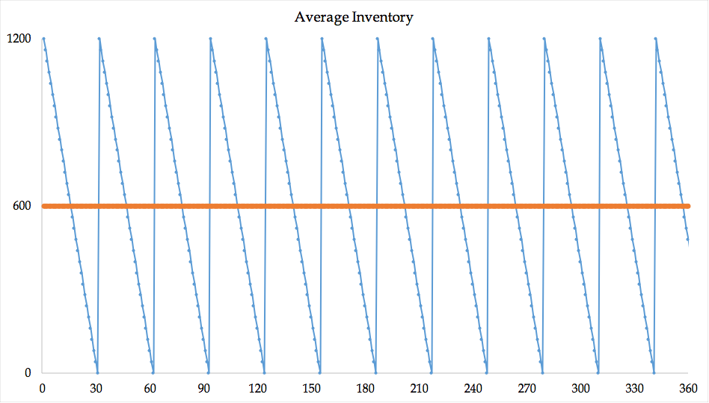

The average inventory during a single moth is 1200/2 = 600 units, the same pattern is repeated every month, thus, the average inventory per year is 600. Cost of carrying one unit of inventory for one year is $120, which means the inventory carrying cost is 120(600) = 72000. As order size goes up, maximum inventory and average inventory go up. Since carrying cost per unit per year is constant, as order quantity goes up, inventory carrying (or holding) costs go up.

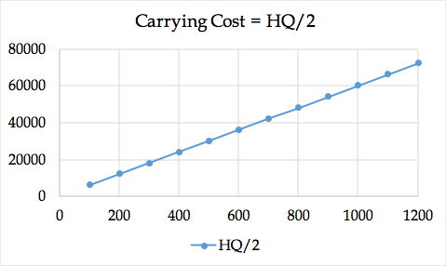

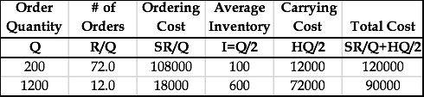

Out of these two practices, we follow the Topange-store’s policy because its total cost is smaller.

We can compute ordering costs (OC), carrying costs (CC) and total costs (TC) for alternative Q values.

Review of the parameters.

Demand per year = D = R = 360(40) = 14400 units.

Ordering cost per order = S = $1500 per order.

Carrying cost (holding cost) = $120 per unit per year

Order quantity = Q

# of orders = R/Q

Ordering cost =SR/Q

Average Inventory = Q/2

Carrying cost = HQ/2

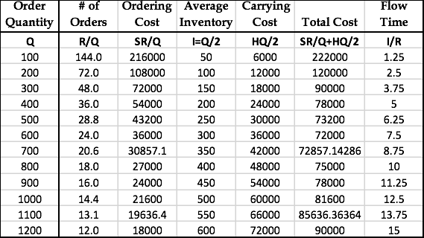

It can be shown that Economic Order Quantity (EOQ) is at the point where ordering cost and carrying cost equate. That is

1500(14400/Q) = 120Q/2 🡺 Q^2 = 2*1500*14400/120 ➔ EOQ = 600.

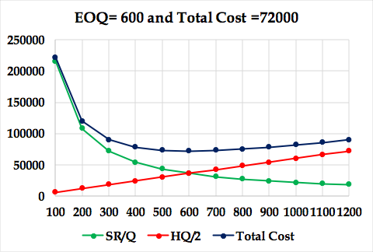

EOQ can be computed independently. We chose to remember it through equity of costs, since it is easier and makes us independent of memorizing the EOQ formula. While memorizing things or just having the formula and plugging in the numbers may look easier, understanding the logic behind formulas, even just a small piece of it, adds more value to our knowledge. For us, deriving EOQ using equality of the two costs is enough. One may derivate is independently, by derivation the total cost term of SR/Q+HQ/2 with respect to Q and set the derivative equal to zero.

**What we learned.** Here we have some points to mention.

As Q goes up, SR/Q goes down.

As Q goes up, HQ/2 goes up.

In the above model, we considered inventory holding costs and ordering costs. There are two other inventory related costs.

**Purchasing Costs** are defined as costs for purchased items and pure variable costs (materials and supplies, direct energy, but not human resource costs) for a production item. In our model, we assumed that purchasing costs in independent of order quantity. Over a period we need to order D (or R) units, if purchasing price is P (our pure variable cost is V), out total purchasing (production) cost is PR (or VR). It does not depend on Q (the quantity we order each time). We will later present inventory discount models.

We assumed that the purchase price of the product is independent of the volume ordered. Note that no matter how many units we order each time, over one year we need to order D=R=14400 units.

In the formula, instead of demand (or throughput) per year, we can have demand (or throughput) per month or per day. In all cases, S remains, as it is, $1200 in this example. However, we need to change H to 120/12= $10 per month, or (if a year is 360 days) to 120/360 = 0.333 per day.

We do not teach OM as isolated islands. Recall the Little’s Law. Throughput is equal to demand and we can show it by D or R. Average inventory is Q/2. In the virtue of the Little’s law, RT=Q/2, therefore, the flow time is Q/2R year.

EOQ is a mathematical formula for a portion of real world**.**  In this model, we assume that we only have one single product.  Demand is known and demand is constant throughout the year.  For example, we know that we need 5,000 units of product per year, and if a year is 50 weeks, then 1/50 of this number is needed every week.  If a week is 5 days, 1/5 of whatever we need per week we need per day, so demand is known and it is constant.  Every day, every minute, every hour, we have the same demand as any other minute, hour, or day.

Each order is received in a single delivery.  When we order, we have a waiting period or a lead time. This could be one day, 2 days, and 3 days. It is known, and it is fixed.  After lead-time, we receive the inventory that we have ordered. If lead-time is three days, as soon as our inventory reaches a level that we need for 3 days, then we order.  Because demand is fixed and constant, at the second we get the product, our inventory reaches 0, and then we replenish.

There are only two costs involved in this model: **ordering cost,** cost of ordering and receiving the order; and **holding** or **carrying costs,** costs to carry an item in inventory for one year; cost to count one item in inventory for one year.  Unit cost of product does not play any role in this model because we do not get a quantity discount.  It does not matter if we order one unit or one million units, the price is the same.

**Shortage costs.** These costs include lost profit and loss of goodwill. If we have stockouts, we may lose potential profits as well as customer loyalty. Models have been developed to include these costs in the EOQ models. We do not discuss these models. However, we will discuss shortage costs (underage costs) in our re-order point model.

**The excel file of this problem can be accessed at** [**Order-Quantity-Probs**](http://www.csun.edu/~aa2035/coursebase/inventory/sg-orderquant/eoq-sguide.xlsx) **The name of the worksheet is 1.EOQ-Q. If you have the slightest difficulty on this subject, I encourage you to watch my recorded lecture at** [**Inventory Model: Basic Recorded**](http://www.csun.edu/~aa2035/CourseBase/Inventory/Inventory.ToShare/Ch12a.html) **The PowerPoint slides of the lecture can be accesses at** [**Inventory Model: Basic**](http://www.csun.edu/~aa2035/coursebase/inventory/ch12a.ppt)

**Problem 2: Centralization and Pooling.** In this example, if all the parameters are the same for all four retail stores, S = $1200, R = 14400 per year (1200 per month or 40 per day), H=$120 per unit per year ($10 per unit per month, 33.333 cents per day), it is at the benefit of each store to order 600 at a time.

**Under optimal policy of Q= 600, how many orders a store places per year?**

R=14400, Q =600 ➔ # of Orders per year = 14400/600 = 24 times.

What is the length of each cycle? Cycle is the time interval between two orders.

24 orders per year, how often do we order? 1/24 year.

1/24 year is 360(1/24) = 15 days.

Alternatively, we could have said, demand per day is 40, we order 600, therefore, 600/40 = 15 days.

**What is the flow time?**

R = 14400 per year, or 1200 per month, or 40 per day.

I = Max Inventory divided by 2. I = Q/2 = 600/2 = 300. We also refer to Q/2 as cycle inventory. When we do not carry safety stock, cycle inventory is equal to average inventory. They differ in presence of safety stock.

Flow time

T = 300/14400 = 3/144 year.

Alternatively, T=300/1200 = 1/4 month.

Alternatively, T=300/40 = 7.5 days.

Alternatively, we could have said the time interval between two orders is 15 days. The first unit ordered will leave almost immediately; therefore, it will spend 0 days in the system. The last unit of an order will leave after 15 days (at the end of the cycle when the next order is about to arrive). Therefore, a unit, on average, spends (0+15)/2 = 7.5 days in the system.

Let us summarize. Each store orders 600 units at each order. They all together order 4(600) = 2400 per order. Average inventory among all four stores is therefore, 2400/2 = 1200. Throughput is 4*14400 per year, or 4*1200 per month, or 160 per day. Flow time, as computed earlier, can be recomputed as 1200/160 = 7.5 days. Each store orders in 15 days intervals.

**Centralization and Pooling.** We refer to the preceding ordering system of the four retail stores as Decentralized system. Now let us consider a centralized system. In a centralized system, the demand or throughput is 4(14400) = 57600 laptops per year. Inventory carrying costs remains the same. Ordering costs usually increases but not in the direct proportion of the demand, i.e., it does not become four times. For example, a truck, instead of having a round trip to a single store, needs to pass through multiple stations of all four stores. In this example for the purpose of simplicity, we assume that the ordering cost remains the same at $1500 per order. Now let us compute EOQ for all warehouses.

Therefore, all stores order 1200 per order that is 300 per store.

Average inventory in all stores is 600 units compared to 1200 in the decentralized case.

Average flow time is 600/(4*40) = 3.75 compared to 7.5 days in the decentralized case.

Total cost of decentralized systems for a single warehouse is

1500*14400/600+120*600/2 = 3600+3600 =7200

Total cost of the decentralized systems for all four warehouses is 4(7200) = 28800 per year.

Total cost of the centralized systems for all four warehouses per year is

1500*(4*14400)/1200+120*1200/2 = 7200+7200= 14400. The total costs has decreased by 50%

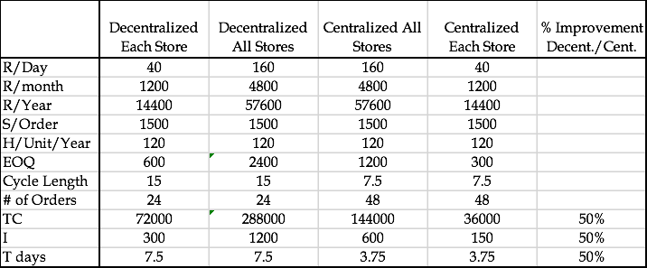

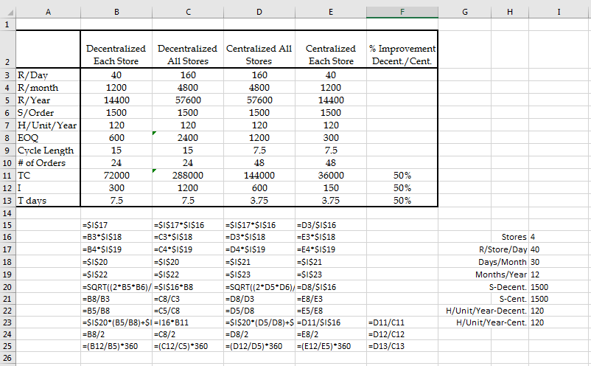

The same is true for inventory and flow time. They have reduced from 1200 to 600 and from 7.5 days to 3.75 days, respectively. A 50% reduction in all cases.

There are times where inventory may be at the detriment of a company. For instance, a company with a large work in process and finished goods inventory may discover that the market is shifting from one product to another product. In this case, the company will have a large amount of work in process and finished goods inventory of a product when customers have already shifted to another product.  Thus, the company will have *two choices*.

One choice is to **fire-sell** all inventories and finished goods what they have, which involves the selling of goods at extremely discounted prices. A drawback to fire selling is that it may turn into a significant loss because the inventory is potentially sold at 30 percent, 20 percent, or even 10 percent of their actual value. The second way is that they could sell their finished goods and at the same time, turn their work in process into sellable finished goods. Unfortunately, this means that there would be a lot of delay in entering the product into the market, and the company could lose a substantial portion of market share. Therefore, in both of these alternatives, they lead to loss. Thus, what is the message? We need to reduce our inventory as much as possible; we need to have minimal inventory.

Inventory adversely affects all competitive edges (Price/Quality/Variety/Time).

**Inventory has cost (**physical carrying costs, financial costs).

**Inventory has risk of obsolescence (**due to market changes, due to technology changes).

**Inventory leads to poor quality (**feedback loop is long).

**Inventory hides problems (**unreliable suppliers, machine breakdowns, long changeover times, too much scrap).

**Inventory causes long flow time, not-uniform operations**

We try to reduce inventory.

(a) By reducing EOQ

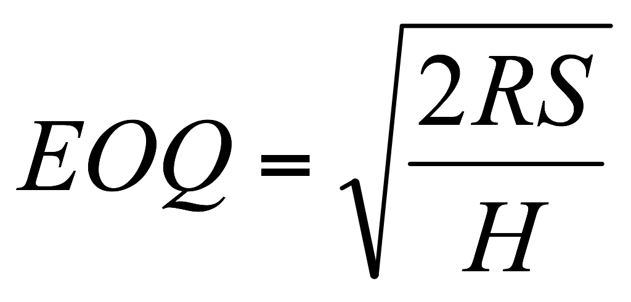

To reduce EOQ we may **↓R, ↓ S, ↑H**

Two ways to reduce average inventory

- Reduce S

- Postponement, Delayed Differentiation

- Centralize

S does not increase in proportion of Q

EOQ increases as the square route of demand.

- Commonality, modularization and standardization is another type of Centralization

**If centralization reduces inventory, why not everybody does it?**

* Higher shipping cost
* Longer response time
* Less understanding of customer needs
* Less understanding of cultural, linguistics, and regulatory barriers

These disadvantages my reduce the demand

**Please solve the problems at** [**Assignment Inventory Basics Problems**](http://www.csun.edu/~aa2035/coursebase/inventory/inventoryproblems/probleminventorybasics.pptx)

**Two Mathematical Proofs- Total Cost and Flow Time of Q and EOQ.**

Total cost of any Q.

TCQ = SR/Q + HQ/2

Total Cost of EOQ? The same as above, but can also be simplified

+ *=*

===

=

**Flow time when we order of any Q?**

Throughput = R, average inventory I = Q/2

RT = Q/2 ➔ T = Q/2R

Flow time when we order of EOQ?

Total Cost of EOQ? The same as above, but can also be simplified

**I = EOQ/2**

**===**

**T = I/R**

***T* = = =**

Inventory Classified. There are three types of inventory. Input inventory is composed of raw materials, parts, components, and sub-assemblies that we buy from outside. In-process inventory are parts and products, sub-assemblies and components that are being processed; part, products, sub-assemblies, and components that are there to decouple operations. For example, assume that operation B follows operation A. In order to not completely have operation B dependent on operation a, we may put a little bit of inventory between those two. In addition, the third type of in-process inventory is when we realize that if we buy at large volumes, we get lower expense due to economies of scale. Then we have output inventory. We need to have some inventory, because when customers come, we cannot ask them to wait (at least most of the time). The best strategy is to have a low flow time in which I can deliver manufactured product and give it to the customer. However, we are not there yet. Therefore, I should have inventory on shelf when customers come so that I can satisfy demand. Sometimes, the demand in one season is high and in another season is low. In this case, I should produce in low season and put it in inventory to satisfy demand in high season. Another type of output inventory is pipeline or transit inventories. This refers to products that are in a pipeline from manufacturing plants to warehouses, distribution centers, or retailers. The huge volumes of inventory on our highways are pipeline or in transit inventories.

Understocking is not good because we will not have enough products to satisfy demand. Customers will be dissatisfied, which will lead to a loss of sales. The customer may go to another vendor forever.

Overstocking is not good either because it has three types of costs: financial costs, physical costs, and obsolescence costs. Financial costs: Instead of having our money in a city or in a profitable business, we put it in inventory. Physical cost: Our inventory should be put in safe keeping somewhere. Thus, we either lease a warehouse or allocate a portion of our shop to a physical location of these products. Finally, we may have obsolescence cost: If we purchase for a large amount of inventory for a product that eventually gets low consumer demand, we may never be able to sell them. This renders the product obsolete.

A Classification Approach: ABC Analysis. In ABC analysis, the question is which type of inventory counting system is preferred? Is it periodical or perpetual? Perpetual is always better but more expensive because we need an automated system to continuously count our inventory. Therefore, we may conduct an ABC analysis.

Example: Here are our 12 parts (see Figure 3). Here is the annual demand of each part. Here is the unit cost of each part. If we multiply them, we will get the annual value of all items in our inventory system in our warehouse. If we sort them in non-increasing order, we will see that two items, which is 2 divided by 12 (15 to 20 percent of items), form 67 percent of the annual value. In addition, here, 7 items divided by 12 (about 55 percent of items), form 6 percent of the value. These are group C. These are group A and obviously, these are group B. For group A, we use perpetual. Fir group C, we may use periodical. For group B, we can use one of the two options.

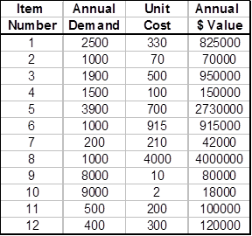 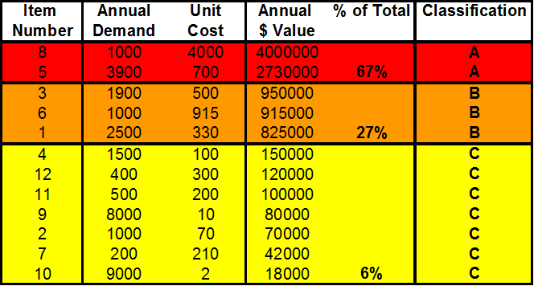

**Example 1a.**

Here we have 12 different video games along with their list of annual demand and unit cost. Using these values, we can find the annual dollar value, the percentage of their value, and then classify them as A, B, or C to see which type of inventory counting system is preferred.

