**On the Time to Graduation, Retention and Graduation Rates in a Business School**

**An Operations Management Perspective**

Ardavan Asef-Vaziri

Systems and Operations Management

College of Business and Economics

California State University, Northridge

**Operations Management Course.** Customers have certain expectations about products they buy or the service they render. These expectations can be physical such as comfort, convenience, and safety; psychological such as relaxation and peace of mind; social such as feeding the poor, and spiritual such as carrying less materialistic load. These expectations should be met within a budget. Operations, Marketing, and Finance are the three primary functions of business organizations. Operations management focuses on how managers can design and operate processes in business settings with discrete flow units. Examples of discrete flow include the flow of cars in an assembly plant, flow of customers in a branch of a bank, flow of patients in a medical center, flow of cash in an investment project, and flow of undergraduate students during their program in a business school. In all these systems in, inputs (natural resources, semi-finished goods, products, customers, patients, students, cash, etc.), referred to as flow units, flow through a set of Processes (formed by a network of activities and buffers) using human resources (such as a clerk, an operator, a repairman, a surgeon, etc.) and capital resources (such as equipment, buildings, tools) to become a desired outputs. The reason for the being of operations management is structuring (designing), managing, and improving processes to achieve the desired output as defined in a four-dimensional space of quality, cost, time, and variety (adopted from Anupindi, et al., 2012).

One of the most binding constraints of business school students – from the time they are admitted as raw material from high school, to the time they graduate and leave college as the final product, is their low quantitative and analytical skills. Believing that managers cannot go far if their quantitative and analytical capabilities are below a threshold, one of the key features of a course in operations management is to improve analytical capabilities and spreadsheet modeling skills of these school students, Asef-Vaziri (2015). The potential characteristics of an operations management course, and their relative importance is depicted Figure 1.

**Figure 1. Specific Features of Operations Management Courses.**

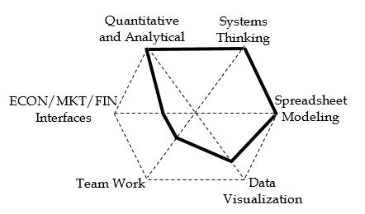

The Omni channels (Chopra, 2016) of supply chain of course delivery systems can be envisioned as (*i*) traditional, (*ii*) on-line, (*iii*) flipped/hybrid, and (*iv*) distributed. In a distributed channel, the lectures are delivered online, problem-solving and trouble-shooting tasks mainly handled by teams of students living in the same neighborhood. The problem-solving and trouble-shooting sessions will take place in a coffee shop, a park, etc. One of the competing channels, is the flipped classroom. By delivering the lectures on the basic concepts using the screen capture technology, students can learn the material at a time and location of their choice, which allows them to pause, rewind, or fast forward professor’s lectures when they need it. The class time is no longer spent on teaching basic concepts but rather on more value-added activities such as problem solving, answering questions, creative-thinking, systems-thinking, as well as real world applications and discussions, potential collaborative exercises such as case studies, and virtual world applications such as web-based simulation games (Asef-Vaziri, 2015). Benefits of active learning are depicted in Figure 2.

**Figure 2. Resources and learning processes of a flipped classroom.**

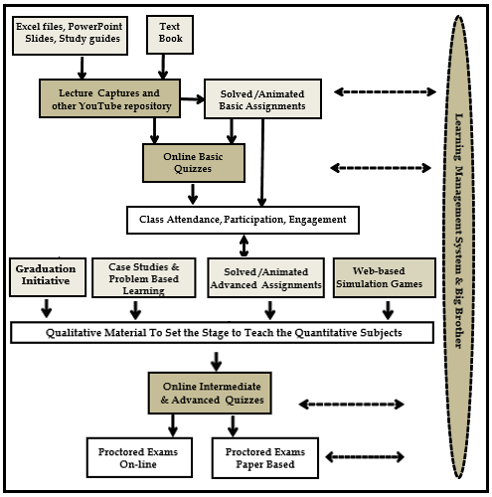

A flipped classroom can also be considered as online course, where the decision to go fully online is made students not be the educational institute. Where the students decide not to come to class, they then may stablish their own satellite group work with a remote communication with the professor and occasional class visit.

In this manuscript we will bring an urgent We will study the past 16-year’s performance of first-time-freshmen students (FTF) and first-time-transfer students (FTT) at DN-CBE on TtG and GR dimensions. We will implement prescriptive quantitative tools and software to provide insight to picture the governing constraints. Descriptive statistics such as categorical and numerical histograms, measures of centralization, coefficients of variations, percentiles and quartiles, 5-number box-plots, cross tabulations, goodness of fit-to-known probability distributions, correlation analysis, confidence intervals, test of hypothesis, and analysis of variance will be prepared to understand the past.

**Process View of Undergraduate Studies.**

**Prepare a process graph containing five elements of input, value added processes, non-value added processes, human and capital resources, and information infrastructure for undergraduate study.**

In operations management view everything as a process, and we believe every process can be improved. Five Components of Process View are : (1) inputs, (2) outputs, (3) human resources and capital resources, a (4) network of value added/non-value added activities and buffers, and an (5) information structure and value system. Inputs can be tangible or intangible, natural or processed resources, parts and component**s**, energy, data, customers, cash, etc. Outputs can be tangible or intangible items such as products, byproducts, energy, information, served customers, cash, relief, etc., that flow from the system back into the environment. In process flow mapping (process blue printing), material flow is shown by solid lines, and information flow is shown by dashed lines. When inputs pass through the network, they are referred to as flow units; when they leave the system they are output. Values added activities are the activities required to transform an input one step closer to its output form. They are shown by rectangle. Non-value added activities, mainly - buffers, storages, waiting lines, are shown by triangles. Not all waiting times are non-value added, for example, aging of cheese or the time required for hardening a concrete are value added activities.

Like any other production and service system, the undergraduate studies can be presented as a process. Inputs are first time freshmen, and transfers from community colleges, and outputs are graduates, drop-outs, and transfers to other institutes. There are human resources and capital resources—such as professors, teacher assistants, advisors, and administrators. Capital resources such as classrooms, hardware, software, recreation areas, etc. There is a network of value added and non-value added activities, such as learning processes inside the classrooms and over the internet, TA hours, waiting lines in front of the offices of administrators, professors, and teaching assistants. There is a value system such as being a student center learning environment. Finally, there is information infrastructure, such as grading, transcripts, etc. like our grading system and our transcripts. This process is pictorially represented in Figure 3.

**Figure 3. Pictorial representation of the undergraduate study.**

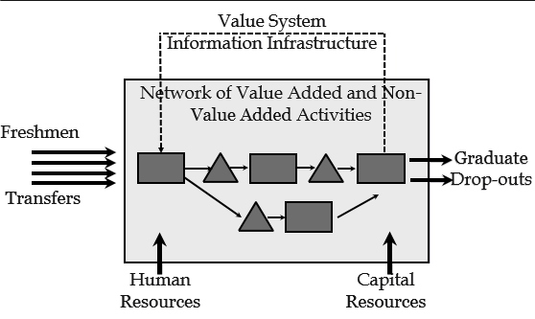

**Process Competencies.** As illustrated in Figure 4, any system should have a reasonable financial and value-chain performance. In this direction, the institute should satisfy its customers, as well as its stakeholders. It should understand the perceptions and expectations. All manufacturing and service systems, including an educational institute, offer a customer value proposition (CVP). They then develop resources and process competencies to be able to deliver the (CVP). The CVP is defined in four dimensional space of cost, quality, time, and variety. Process competencies are cost, quality, flow-time, and flexibility should be then aligned with the four dimensions of CVP.

**Figure 4. Strategy, Customer Value Proposition, Process Competencies.**

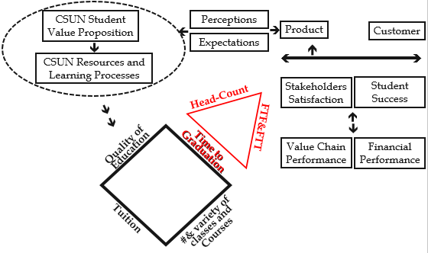

We first take a look at cost at our institute, and then extend the analysis to quality-to-cost. We continue to include the time dimension and finally the variety dimension.

**Cost Quality Efficient Frontier.**

This data, I have collected over a period of five or six years. I have asked about a thousand students what their perception is about Stanford, Berkeley, USC, Pepperdine, Lutheran University, and CSUN. And this is the score the students have provided, in a scale of zero to six. As we see, CSUN is not in a bad position. By the way, when I have asked our students to rank these six institutes, the way they have ranked themselves, is lower than when I have asked other people in other institutes to evaluate our students as compared to those other five institutes. Frankly, I’ve asked almost everyone about what they think regarding the performance of our students compared to the other institutes.

**Figure 5. Subjective *Quality Data 6 institutes in Southern California.***

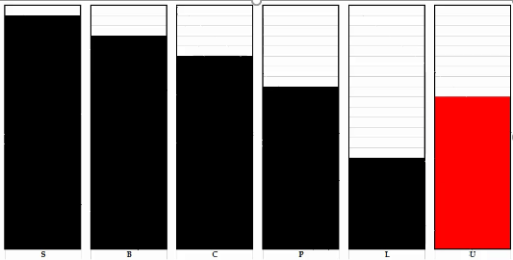

So now if I go ahead and draw that understanding on a vertical axis, and score these six institutes from zero to six, and if, on the horizontal dimension, I draw the cost—and cost is not good, because here, in vertical axis, I get better if I am getting *away* from the origin, but in cost-dimension I am not getting better when I move from the origin and the cost increases. Therefore, on this dimension, instead of cost, I prefer to put ‘cost efficiency’, which is defined by: 1/Cost. And here, I have assumed the tuition of the most-expensive university is $36,000 per year. Of course, it is higher than that. Therefore, in the numerator I have put 36,000 and in the denominator I’ve put the cost of that institute. Therefore, for example, if Stanford has a cost of $36,000, its cost efficiency comes out to 1, but if CSUN has a cost of $6,000, its cost efficiency comes out to 6. Therefore, for example, I will have CSUN here, while Stanford is around here.

**Figure 6. *Quality and Cost Efficient Frontier.***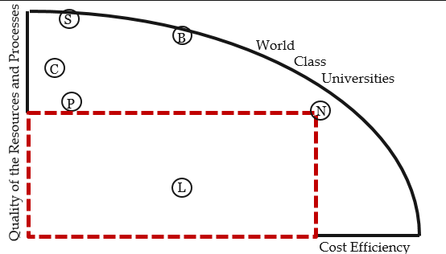

Now let’s look at this quality-to-cost efficiency graph. For example, here is institute L, which has a low quality and a medium cost efficiency. This is institute P, which has medium quality and low cost efficiency, so it is expensive. Institute C, a little bit better quality compared to P, but also less cost efficiency, more expensive. Institute B, this is a world-class organization. Firms operating on efficient frontiers, they are world-class organizations. When you are not on an efficient frontier, you can improve your situation in both dimensions of cost efficiency and quality. But on an efficient frontier, if you want to improve quality, you need to sacrifice cost efficiency, and vice versa. In other words, you can improve when you are on an efficient frontier, only due to outbreaks in something—either in cost saving, or in technology, or quality improvement.

*8:31*

We have a couple of institutes here on the quality and cost efficiency dimensions. Here on institute S, also on the efficient frontier; a very high cost institution, and at the same time, an extremely high quality institution. And, the data that they have collected from, maybe, close to 800 of our students, and the data that that I have collected from students of other institutes, and my friends who teach in other institutes, they all together indicate that, in quality dimension, CSUN is somewhere here. Now let’s see what this curve means. This institute, on cost dimension, is average. It has such a measurement in 1/Cost, and as we said, $36,000 over cost (or we can call it K/Cost), and in this dimension, it is quality. If I am looking for quality to cost, if I am going to *move* from the two-dimensional space of quality and cost to a one dimensional space. In this dimension, I have 1/Cost, in this dimension I have quality. It is enough to multiply them by each other. What that multiplication means, it means ‘just compute’. This rectangle, this is 1/Cost (1/C), this is quality, if you multiply this edge by this edge, you get the area, and this area is quality/cost (Q/C).

Now, let’s look at CSUN. A very big rectangle. Only institute B, in cost-to-quality dimension, could compete with CSUN. CSUN is doing *excellent*. CSUN is great in quality-to-cost. And I believe, if we really could get objective data on this quality dimension, and then divide it by cost, CSUN would definitely be among the 5% top institutes in the nation. David Nazarian College of Business and Economics is doing perfect in one-dimensional space of quality-to-cost. So, College of Business and Economics, for success, needs to have a reasonable value chain and financial performance. If we have a good value chain performance, hopefully it will lead to student success, and our stakeholders’ satisfaction. We have proposed something to our students that is what we call “CSUN Value Proposition,” and we need to develop resources and learning processes, and in general, process competencies, to be able to deliver this student value proposition, what we have proposed to our students. Perceptions and expectations between this side *(Stakeholders’ Satisfaction and Student Success)*, and this side *(CSUN Value Proposition and CSUN Resources and Learning Processes)* should be also aligned. In that case, then we can compete in a four-dimensional space of: quality of education, tuition, number and variety of classes and courses, and time to graduation, where time to graduation by itself is a function of head-count and the number of incoming students, and the number of graduates. Input and output, according to the Little’s Law, throughput times flow time is equal to inventory. Average of incoming and graduates each year times the time to graduation is equal to the headcount of students.

**Table 1. 16-year data on incoming students, headcount (population), and graduates.** 

FTF: first time freshmen student, FTT: first time transfer student, FTA: total FTF+FTT, IN: incoming, HC: headcount (population), GR: Graduates. Source: Institutional Research, California State University. The excel file is available at Appendix.excel

***Prepare the main descriptive statistics for the above table.***

**Table 2. Descriptive statistics for 16-year data on incoming students, headcount, and graduates.**



***Estimate the drop-outs for each year for FTF, FTT, and total. Paint the table using conditional formatting.***

**Table 3. Estimated drop-outs 2002-216.**



This negative drop-out means some of the drop-outs of previous years have come back. The maximum drop-outs were in 2009.

***Prepare an excel chart incoming, graduates, drop-out, and headcount over the past 16 years.***

**Figure 7. Incoming, graduates, drop-out, and headcount, 2001-2016.**



IN-FTA: all first time incoming students (FTF+FTT), HC-A: headcount of all students, GR-A: all graduates, DR-A: all drop-outs.

HC-A is inventory of College of Business and Economics that is in Little’s Law terminology, and in our terminology, that is our headcount. Average headcount over the past sixteen years is 6224, Incoming per year, 1653, graduate average per year in the past 16 years, 1348, and dropouts per year, 226. The title of the graph was prepared by referencing to a cell with a formula such as ="Averages: "&D23&", "&J23&", "&M23&", "&G23.

***Using the relation ship between the age of data in moving average and exponential smoothing, implement an exponential smoothing with an average data age equivalent to 6-period moving average. Prepare a curve for all incoming, graduates, and drop-outs.***

Age of data in an N period moving average is simply (N+1)/2. The oldest piece of data is N periods old, the youngest is just one year. By some mathematical manipulations, one can show that the age of data in exponential smoothing is 1/α. Therefore, α=2/(N+1), and for a 6 period moving average, α=0.29.

**Figure 8. Six-period equivalent moving average for incoming, graduates, drop-out, and headcount, 2001-2016.**



As we can see, with exception of two years, there is a gap between incoming students (FTA) and graduating students (GR-A).

***Analyze the trend in the ratio of the incoming freshmen students to incoming transfer students (IN-FTF/IN-FTT) and the ratio of the headcount freshmen to transfer students (HC/FTF/HC-FTT).***

**Figure 9. Ratio of the incoming freshmen students to incoming transfer students and the headcount freshmen to transfer students.**



While the ratio of incoming freshman to incoming transfer goes down over time, but the headcount of those who have come to CSUN as freshman, divided by those who have come to CSUN as transfers, continually goes up. This understanding may us to look at the best practices of transfer students, and try to advertise them to our freshman students. But let us first provide more evidence.

***Using the Little’s Law estimate TtG for each group of students for each year. Provide 95% confidence interval over the period of 16 years.***

The Little’s Law is stated as RT=I, that is the throughput times the flow time is equal to inventory. In our problem, throughput is approximated by the graduation rate, flow time is time to graduations, and inventory is headcount. The formula can be applied on the 16 years, and TtG for each year for FTF and FTT can be computed. Computation of confidence interval is straight forward using an excel unction CONFIDENCE.T(0.05,N26,COUNT(N$5:N$19), where the first argument is the confidence level, the second is the standard deviation, and the last argument is the number of observations included in the CI.

**Figure 10. 95% confidence interval for TtG of FTF and FTT.**



*Edges and Process Competencies at DN-CBAE*

The red curve is for FTF, and the blue curve is for FTT. This time for graduation has not been computed by going into one-by-one of students and compute the average. We have headcount and graduates for both group of students. We can approximate TtG by using the Little’s Law. Average TtG for FTFs 7.7, while it is 3.5 for FTT. The two numbers preceding and tailing each average are 95%LCL and 95%UCL, respectively. The average TtG for FTT students is less than half of the average TtG for FTFs. This is a little bit counterintuitive because, when we first approached this problem, what we had in mind was, those who first come to CSUN are better prepared in high school. Nevertheless, the 16—year data contradicts this perception.

All the above data&Information are available on the first tab of the excel file Appendix.exel

We realize that we are doing perfect in quality-to-cost, in quality of education to tuition, but when we transfer that space to quality-to-cost-to-time, the situation is not as good. If the students spend two years more than it should be, then we can say the cost goes up 50%. If the denominator goes up by 50%, the whole numerator divided by denominator will reduce to two-thirds. Furthermore, if we assume that in that two years which the student are paying tuition at CSUN they could of worked elsewhere, and they could have earned as much as their tuition, then the situation at CSUN in the space of quality to cost to time would be even worse. Finally if we assume the student could have additional income three times per tuition, and that is not too much because tuition is $6,000. If you have a bachelor’s degree from CSUN, getting 3 times of it, which would be $18,000 plus itself which is $24,000, having $24,000 per year is not too much, and then the rectangle would have changed to this. If you go to the same competition space, but here, we have changed the horizontal line to Quality-Time-Cost Efficiency, then performance of all colleges, CSUN and CSU, is not good at all. The rectangle has profoundly changed. In that situation, we could have ranked ourselves in the top three percent of the educational institutes in the nation. This one is not so bright.

In additions, if we add a fourth dimension of variety in customer value proposition, and the flexibility in our process competencies, then the situation gets even worse. We don’t offer enough elective courses. Core course in many hours during the day and minutes all days during the week, and the worst situation is that we do not even offer a capacity equal to the available demand.

Now the situation really needs to be considered, and something should be done about it. We also use the insides we have got from optimization, and especially from linear programming, to understand the binding constraints. What are the binding constraints, and which binding constraint has the highest shadow price? We cannot mathematically implement it, but conceptually, we need to think about it, find the binding constraints, subordinate everything to that binding constraint, exploit the binding constraint, and try to relax it.

Let us now provide more knowledge regarding preparation of the FTF and FTT. Lets look at their high school GPA, (HGPA), and quantitative and verbal SAT scores (SATM and SATV).

**Table 3. Mean, standard deviation, and sample size of the high school GPA, Verbal SAT, and Quantitative SAT for FTF and FTT, 2001, 2016.**



We fist conduct a two tail test at 90% confidence level. The null hypothecs and alternative hypothesis are stated as

*H0: µ(HGPA-F)- µ(HGPA-T) =0*

*H1: µ(HGPA-F)- µ(HGPA-T)≠0*

If the null hypothesis is not rejected, we can stay on it and conclude that with 90% confidence level, the incoming FTF and FTT show no difference. Otherwise, if the null hypothesis is rejected by a positive test statistic, we can stay on the assumption of FTF being better than the FTT with 95% confidence. If the null hypothesis is rejected by a negative test statistic, we can stay on the assumption of FTT being better than the FTF with 95% confidence. The same tests of hypotheses is stated for *µ(SATV-F)- µ(SATV-T)* and *µ(SATV-F)- µ(SATV-T),* and the same family of conclusions are derived.

The general formula for two tailed test of hypothesis on two samples of different sizes when standard deviation of population is known is

Lets assume *µ(*F)* and  *µ(*T),* as the means if one of the statistics associated with Freshmen and transfer students, respectively. Suppose *X̅(*F)* and  *X̅ (*T)*, are estimates of *µ(*F)* and  *µ(*T)* in sample sizes on n(*F) and n(*T), respectively.Similarly, assume *(*F)* and *(*T),* as the standard deviations of these statistics, and *s(*F)* and *s(*T),* as their estimates in the same samples, respectively.Thetest statistic in the two tail test assuming the test staytisticstest statistic *µ(*F) - µ(*T) = 0,*  has a mean of

*X̅(*F)* - *X̅ (*T)*. The standard deviation of the test statistics will fall in one of the following categories

|  |  |  |  |
| --- | --- | --- | --- |
| Standard Deviation | Sample Size | Distribution | Standard Deviation of the test statistic |
| Known |  | Normal | $$\sqrt{\frac{σ_{F}^{2}}{n_{F}}+\frac{σ_{T}^{2}}{n_{T}}}$$ |
| Unknown | Large | Normal | $$\sqrt{\frac{s_{F}^{2}}{n_{F}}+\frac{s_{T}^{2}}{n_{T}}}$$ |
| Unknown | Small | t | $$\sqrt{\frac{s_{p}^{2}}{n_{F}}+\frac{s_{p}^{2}}{n_{T}}}$$ $$s_{p}^{2}=\frac{\left(n_{F}-1\right)s_{F}^{2}+\left(n_{T}-1\right)s_{T}^{2}}{n_{F}+n_{T}-2}$$ |

for a lif one of the statistics associated with Freshmen and transfer students, respectively.

*x*

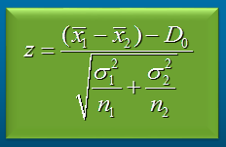

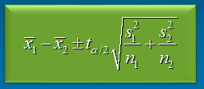

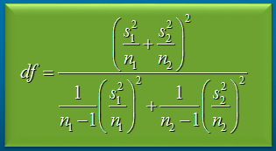

Where d0 is usually set to 0. However, since we do not have the standard deviation of the population, the following t-test is used.

However we used min(n1,n2)-1 as the degree of freedom, and the results remained unchanged.

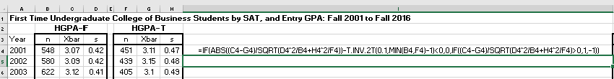

=IF(ABS((C4-G4)/SQRT(D4^2/B4+H4^2/F4))-T.INV.2T(0.1,MIN(B4,F4)-1)<0,0,IF((C4-G4)/SQRT(D4^2/B4+H4^2/F4)>0,1,-1))

**Figure 11. One tail test of hypothesis on High school GPA, Verbal, and Analytical SAT.**





A zero value indicates none overcomes the other, +1 is for H0: being rejected with 95% confidence level, while a-1 is for µ(HGPA-F)- µ(HGPA-T) ≤ 0 being rejected with 95% confidence level.

Regarding the high school GPT, out of 16 experiments, in seven we were able to reject the null hypothesis of *µ(HGPA-T)≥ µ(HGPA-F)*, and in one experiment we rejected the null hypothesis of *µ(HGPA-F)≥ µ(HGPA-T).* A ratio of 7/1 in the benefit of FTFs.

Regarding the high verbal SAT, out of 16 experiments, in one experiment we were able to reject the null hypothesis of *µ(SATV-T)≥ µ(SATV-F)*, and in four we rejected the null hypothesis of *µ(SATV-F)≥ µ(SATV-T).* A ratio of 4/1 in the benefit of FTTs.

The situation in quantitative SAT got even better for transfer students. No experiment supported the null hypothesis of *µ(SATM-T)≥ µ(SATM-F)*, while the null hypothesis of *µ(SATM-F)≥ µ(SATM-T)* was rejected nine times. It seems we can stay on the null hypothesis of the transfer students having a better SAT performance. According to Brint 2017, about two-thirds of the variance in six-year graduation rates in the United States can be explained by the average SAT/ACT score of entering freshmen.

All the above data&Information are available on the second tab of the excel file Appendix.exel

Now lets see if the FTFs understand their limitations in work load they select in each semester. The

**Table XX. Full Time Equivalent (FTE) of incoming FTF and FTT (columns 2 and 3), and FTE of all the student population who have entered as FTF and FTT, respectively (columns 4 and 5).**



Column 6 is simply column 4 minus column 2, and column 7 is column 5 minus column 3. By dividing these FTE numbers by their corresponding headcounts Figure XXX is obtained.

**Table XX. per capita FTE for incoming FTF and FTT, and the total FTF anf FTT student population net of current incomings.**



As we can observe, our brave FTF students, against their capabilities, continually carry more load compare to FTTs. Over the period of 16 years, FTF in their first year had a load 0.89/0.74= 1.2 times of the incoming FTT. The overall FTF population, net of the current hear incoming had a load of 0.83/0.72 = 1.15 times the overall FTT population, net of the current hear incomings. One of the best practices that can be bench marked is to encourage the FTF to take a smaller number of courses, both in the first semesters, as well as throughout their education.

TableXX.



=IFERROR(INDEX($C$5:$R$15,ROWS($C$5:C5),ROWS($C$5:C5)+COLUMNS($C$5:C5)-1),"")





*24:20 16-Years Retention and Graduatiholon Rates: Class 2001*

I have looked at 16 years of data, here is 2001; in 2001, this is the population in [College of Business and Economics] for the first year, for the second year, and this is the number of students that have been in the College of Business in the year 2001, for 10 years. Now, if I go to 2002, and look at those people who have been in CSUN for two years, then I get these numbers. And of course, these 422 are those 576, and the rest have dropped out. So if I continue on the diagram, this is the population of 2001 College of Business entering students through an 11 year period. I can do the same for 2002, and move on the diagonal and see what has happened to them, and 2003, and so forth. And then I can create this table.

*25:40 16-Years Retention and Graduation Rates: Class 2001*

*& 16-Years Retention and Graduation Rates: 2001-15*

So this is what has happened to 2001 students, and if you see that at the 11th point the curve a little bit goes up, it is because after 11 years, some of [the dropouts] have come back. This is 2002, 2003, 2004, 5, 6… and this is all the 16 years. I have the average over there, these are the maximums, and these are the minimums. Obviously, in the first four years, you want this curve as flat as possible. After that, we like to have a really sharp slope. This is the same thing with 95% confidence interval, so these are the maximums, these are the minimums, here we like the maximums, and here we like the minimums.

*26:45 16-Years Retention and Graduation Rates: UCL95%CI, LCL95%CL, Exponential Smoothing [g=0.29]*

These are 2015 entering students, freshman students, so they are about average. It is good. And these are 2014, and these are 2013 first-time freshman at College of Business and Economics, and all of them are about average, so things are getting relatively better here.

*27:09 Required Number of FTF Graduates*

Here is the number of graduates we need to follow a specific time to graduation. The black dots we see are our position in the past 16 years. The blue line is the required number of graduates to need an average of seven year time to graduation. As we see in 2016, we are around there, a little bit even better. In some years in the past 16 years, we were below average of seven year time to graduation, in some years we were above. If you are looking at five year average time to graduation, then the current headcount of College of Business and Economics, we need about 700 graduates per year.

*28:11 Required % Increase in # of Graduates*

These are the same numbers, but we have translated them into percentage increase in compared to our current position.And this is 6 year moving average of these numbers, or, an exponential smoothing of about 0.3 Therefore in the current position in 2016, this is our current situation, which is more or less about a seven years average time to graduation. We need about 20% increase if we want to go for six years’ time to graduation, about 45 to 50% increase if you want to go for an average of five years’ time to graduation, and about 75% increase in our current number of graduates if you want to go for four years’ time to graduation. About 75% increase in this number.

*29:24 160,000 Records for 16-Years Performance*

This is about 160,000 records in the past 16 years. I have collected about 10,000 records per year. I have partitioned our lower division courses and core courses into three groups; those with high taste of quantitative, those with high qualitative taste, and those in between. So here are before Gateway classes. I have defined Gateway as a milestone, to check what has happened and foresee what will happen, but in each of these periods, we implement qualitative tools to see what we think we will be in the future. This will be applied to groups of students. We can look it at the very macro-level, or we can go down and look at it at the very micro-level.

*30:44 Information-Analytics*

We try to implement descriptive analytics. Descriptive analytics is to understand *what* has happened in the past 16 years, and that is mainly to transfer data into information. Then we try to do diagnostic analytics to find the root and effect analysis. *Why* it happened, and that is indeed transformation of information into knowledge. Then we conduct predictive analytics, and we try to foresee *what is likely to happen*, and that is mainly transformation of knowledge into understanding. Finally, we try to develop Prescriptive Analytics models, and to learn *what* we should do about it, and it is mainly, hopefully, transformation of understanding into wisdom.

*32.04 Big Data*

We try to use tools such as Excel, Tableau, Tableau is not an analytical tool, Tableau is a visual tool, presentation tool, but we also use Jmp, which is more of an analytical tool, and also, we will use Frontline Solvers in this process.

*32:30 Systems Thinking; Rumi-Elephant in the Dark*

So we talked about one of our teachers, John Little, and we used the process flow concept to understand the flow. We talked about another teacher, George B. Dantzig , which, using his concepts in linear programming, we will try to find out which binding constraints have the highest shadow prices, and try to understand them exploit. Now we talk about our other teacher who tries to tell us to have a system here.

*21:45 Systems Thinking [VIDEO]*

*“In the nineteen fifties, the Dayak people of Borneo, an island in Southeast Asia, were suffering from an outbreak of Malaria, so they called the World Health Organization for help. The World Health Organization had a ready-made solution, which was to spray copious amounts of DDT around the island. With the application of DDT, the mosquitos that carried the Malaria were knocked down and so was the Malaria. There were some interesting side effects though. The first was that the roofs of people’s houses began to collapse on their heads. It turns out the DDT not only killed off the Malaria carrying mosquitos, but also killed a species of parasitic wasps that had controlled a population of thatch-eating caterpillars. Thatch being what the roofs at the Dayak people’s homes were made from. Without the wasps, the caterpillars multiplied and flourished and began munching their way through the villagers’ roofs. That was just the beginning. The DDT affected a lot of the island’s other insects, which were eaten by the resident population of small lizards called geckos. The biological half-life of DDT is around eight years, so animals like geckos do not metabolize it very fast. It stays in their system for a long time. Over time, the geckos began to accumulate pretty high levels of DDT. And while they tolerated the DDT fairly well the island’s resident cats, which dined on the geckos, did not. The cats ate the geckos, and the DDT contained in the geckos killed the cats. With the cats gone, the islands population of rats came out to play. We all know what happens when rats multiply and flourish. Pretty soon the Dayak people were back on the phone with the World Health Organization, only this time it wasn’t Malaria that was the problem, it was the plague, and the destruction of their grain stores, both of which were caused by the overpopulation of rats. This time though, the World Health Organization didn’t have a ready-made solution, and had to invent one. What did they do? They decided to parachute live cats into Borneo. Operation Cat Drop occurred courtesy of the Royal Air Force and eventually stabilized the situation.” “If you don’t understand the inter-relatedness of things, solutions often cause more problems.”*

*Rumi – An Elephant in the Dark*

*Some Hindus were exhibiting an elephant in a dark room, and many people collected to see it. But as the place was too dark to permit them to see the elephant, they all felt it with their hands, to gain an idea of what it was like. One felt its trunk, and declared that the beast resembled a water-pipe. Another felt its ear, and said it must be a large fan. Another its leg, and thought it must be a pillar. Another felt its back, and declared the beast must be like a great throne. According to the part which each felt, he gave a different description of the animal.*

[1] Anupindi, R., Chopra, S., Deshmukh, S. D., Van Mieghem, J. A., & Zemel, E. (2012). Managing business ﬂow processes (3rd ed.). New York. NY: Pearson Prentice Hall.

[2] Asef-Vaziri, A. (2015). The Flipped Classroom of Operations Management: A Not-For-Cost-Reduction Platform. Decision Sciences Journal of Innovative Education (13) 1.

[3] Briant, S. G., 2017. Keynote Address: Tips/Tools/Behaviors/Actions for Faculty to Help Improve Graduation Rates. CSUN Faculty Retreat 2017. <http://www.csun.edu/sites/default/files/retreat-program.pdf> Last checked 2/22/2017.

[3] Chopra, S., 2016. An Uncertainty Based Framework for Omni-Channel Retailing. Keynote Speaker, Decision Sciences Institute National Meeting, Austin, Texas.

[4] California State University Graduation Initiative 2025 CSU System and Campus Completion Goals and Plans <https://www.calstate.edu/bot/agendas/sep16/ED-POL-2-ADDENDUM-GI-2025.pdf>. Last checked 2/22/2017.

[6] UCR Graduation Rate Task Force Report, 2014. <https://chancellor.ucr.edu/docs/Graduation%20Rate>

%20Task%20Force%20Report%20January%2010%202014.pdf Last checked 2/22/2017.

[7] Buell, R.  Ryan, 2017. Breakfast at the Paramount: A Case Study on Queuing Dynamics. Harvard Business School Case 617-011, POMS Annual Conference. Teaching/Pedagogy in P/OM.

January 2015

Printed in the U.S.A.

Brint, S., 2017. Keynote speaker, California State University Northridge, Faculty Retreat.

* Babcock, Philip M. and Mindy Marks. 2010. “The Falling Time Cost of College: Evidence from a Half-Century of Time Use Data.” *Review of Economics and Statistics* 93: 468-78.
* Bound, John, Michael F. Lovenheim, and Sarah Turner. 2010. “Why Have College Completion Rates Declined?” *American Economics Journal: Applied Economics* 2: 129-57.
* Chingos, Matthew M. 2014. *Can We Fix Undermatching in Higher Education? Would It Matter if We Did?* Washington, DC: Brookings Institution.
* Crouch, Catherine H. and Eric Mazur. 2001. “Peer Instruction: Ten Years of Experience and Results.” *American Journal of Physics* 69: 970-7.
* Feldman, Kenneth A. 1976. “The Superior College Teacher from the Student View.” *Research in Higher Education* 5: 243-88.
* Hake, Robert R. 1998. “Traditional Methods vs. Interactive Engagement: A Six-Thousand-Student Survey of Test Data for Introductory Physics Courses.” *American Journal of Physics* 66: 64-74.
* Pennebaker, James W., Samuel D. Gosling, and Jason D. Ferrell. 2013. “Daily Online Testing in Large Classes: Boosting College Performance While Reducing Achievement Gaps.” *PLOS One*.
* Steele, Claude M. and Joshua Aronson. 1995. “Stereotype Threat and the Intellectual Test Performance of African Americans.” *Journal of Personality and Social Psychology* 69: 797-811.
* Wesch, Michael. 2007. *A Vision of College Students Today* (film).
* Yeager, David Scott and Carol S. Dweck. 2012. “Mindsets that Promote Resilience.” *Educational Psychologist* 47: 302-14.

[4] [Systems Thinking: Help Your Giving Create Greater Change](https://www.youtube.com/watch?v=Kk29LAoDspw&t=196s). <https://www.youtube.com/watch?v=Kk29LAoDspw&t=188s>

[5] [Ludwig von Bertalanffy](https://en.wikipedia.org/wiki/Ludwig_von_Bertalanffy) *General System Theory: Foundations, Development, Applications, 1968.*  New York: George Braziller.

* + - * Play next
      * Play now

[6] Tableau: <https://www.tableau.com/> Last checked 2/22/2017.

[7] Frontline Solver- Analytics for Spreadsheets and Web. <http://www.solver.com/> Last checked 2/22/2017.

[8] Ragsdale, 2015. Spreadsheet Modeling and Decision Analysis: A Practical Introduction to Business Analytics, Cengage Learning.

[9] UCLA, Data Mining: What is Data Mining? <http://www.anderson.ucla.edu/faculty/jason.frand/teacher/technologies/palace/datamining.htm> Last checked 2/22/2017.

[ 10] Chopra and Meindl, 2010. Supply Chain management: Strategy, Planning, and Operation. 4th edition. PEARSON Prentice Hall.

**Figure 2. Traditional Lectures vs. Interactive Engagement (Briant, 2017).**

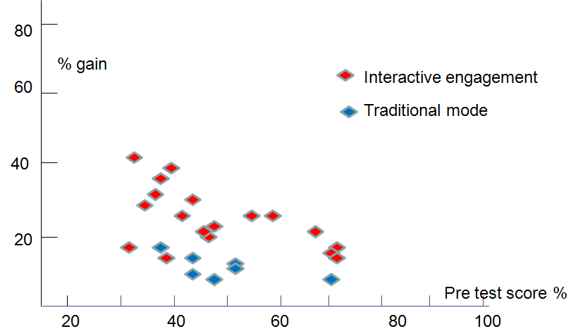

A flipped classroom includes components of both an online and a traditional course. It is an online course because its online components must compete with the best of the online courses. A flipped classroom is also a traditional course because not even a single class session is purposely cancelled while all the lectures are delivered online. This core concept is reinforced by a network of resources and learning processes, Figure 3, ensuring a smooth, lean, and synchronized course delivery system (Adopted from Asef-Vaziri,2015).

The main objectives of an operations management course may be summarized as follows

1. Creating a smooth flow.
2. Understanding Trade-offs
3. Reducing Variability
4. Balancing inventory buffer, capacity buffer, and time buffer.
5. Alighting the process competency with product attributes
6. Time to Graduation (TtG) and Retention Rate (RR). In an effort to better prepare and assist students, the California State University (CSU) system has established a plan to remove obstacles to receiving a baccalaureate degree. The CSU Graduation Initiative 2025 (GI-2025) was launched in January 2015 with a clear goal: to increase graduation rates for about half a million students across 23 campuses. The initiative established a series of objectives, which include increasing the 4-year and 6-year GRs to 40% and 70%, respectively [4,5,6], expecting to bring the total number of CSU graduates between 2015 and 2025 to more than one million
7. In this manuscript, we not only approach GI-2025 from an Operations Management and Business Analytics (OM&BA) perspective, and provide model-based, student-centered analysis, but also replace the problems of these two courses, by examples related to Time to Graduation (TtG) and Retention Rate (RR) in GI-2015. We replace some of the existing examples, which many not have a close link to the real life of our students, with examples which are related immediate real-life of the students on TtG and RR. Analysis of the student’s real life situations, could have profound impact on learning processes (see for example [7]).