1. **Processes View & Strategy**

Customers have certain expectations about products and services that they buy. These expectations can be *physical* such as comfort, convenience, and safety; *psychological* such as relaxation and peace of mind; and *social/spiritual* such as feeding the poor. These expectations should be met within customers’ budgets. Business processes create manufactured products and deliver services. Some examples include the flow of cars in a General Motors assembly plant, flow of customers in a Wells Fargo branch, flow of patients at the UCLA Medical Center, flow of cash in Fidelity Investments, and flow of students during their two-to-five year program at CSUN. In all these systems, flow units (natural resources, semi-finished goods, products, customers, patients, students, and cash) flow through a set of processes (formed by a network of activities and buffers) using Human resources and Capital resources (such as equipment, buildings, tools) and an information infrastructure and value system to become a desired output. We mainly focus on the systems with discrete flow units – such as the systems stated above - as opposed to continuous flow, which is the domain of chemical engineering.

**Specific Features of the Course.** One of the most binding constraints of business school students – from the time they are admitted to college as “raw material” from high school to the time they graduate and leave college as “the final product” – is their low quantitative and analytical skills. According to the CEO of American Express in his 2011 interview with Fareed Zakaria on CNN, the low level of quantitative capabilities of our graduates has kept us from excelling beyond the graduates of rising countries such as China and India. Organization for Economic Cooperation and Development (OECD) Skills Outlook (2013) compares the literacy, mathematics, and computer skills of U.S. residents with people in other OECD countries. In mathematics, U.S. trailed 18 countries and beat Italy and Spain.

Believing that managers cannot go far if their quantitative and analytical capabilities are below a threshold, we have tried to improve these qualifications through our Operations Management (OM) classroom. In a typical traditional OM class, about 2/3 of the class time is spent on delivering the content. The rest is mainly spent on problem solving and case studies, term projects and simulation games. We have tried to improve these capabilities through flipping our Operations Management classroom. By delivering lectures using screen capture technology, students can learn the material at a time and location of their choice, which allows them to pause, rewind, or fast forward professor’s lectures when they need it. The class time is no longer spent on teaching basic concepts but rather on more value-added activities such as problem solving, answering questions, creative-thinking, systems-thinking, as well as real world applications and discussions, potential collaborative exercises such as case studies, and virtual world applications such as web-based simulation games. A flipped classroom includes components of both an online and a traditional course. A flipped classroom is an online course because its online components must compete with the best of the online courses. A flipped classroom is also a traditional course because not even a single class session is cancelled while all the lectures are delivered online. This core concept is reinforced by a network of resources and learning processes, ensuring a smooth, lean, and synchronized course delivery system.

The specific features of the course and their relative importance are depicted below.

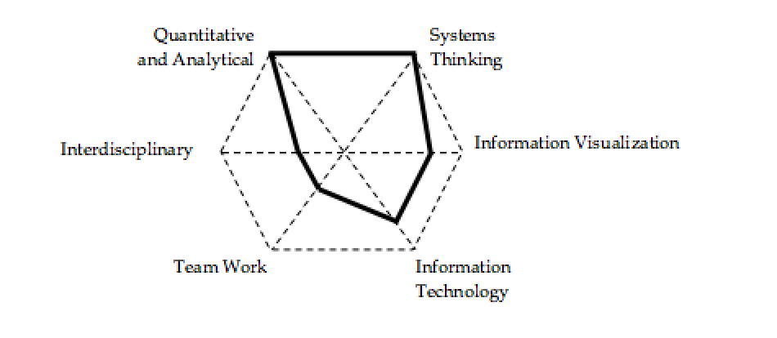

**Quantitative and Analytical.** We use Operations Management as a tool to improve the quantitative and analytical capabilities of our students. Students will learn to develop a structured, data-driven, analytical, and quantitative approach to discuss the core Operations Management concepts.

**Systems Thinking**. We try to improve systems thinking capabilities of our students by teaching the basic concepts of operations management not as isolated islands but as a total system designed towards improving process flow. Students will learn to implement the process view as the unifying paradigm to study the core concepts in the operations management (retrieved from Anupindi, et al., 2012).

**Visualization of Data and Information**. Besides quantitative representation (translating long writings into mathematical relationships), students will practice tabular representation (translating long writings into tables), and schematic representation (translating several pages of writing and tables into a graph, flow chart, or picture). Students also learn how to deal with large, unorganized, or erroneous big data sets.

**Information Technology.** We try to enhance students’ knowledge in spreadsheet modeling. We have learned that understanding the knowledge behind these models and developing small pilot spreadsheets leads to a better understanding of the course material. Through case studies, as well as web-based games, the stage is set to motivate the students to develop spreadsheet-based models.

**Teamwork.** We encourage collaborative learning and creative thinking. The first day of class is not spent on the syllabus but rather on the importance of teamwork. Students are encouraged to have weekly team meetings to go over the already solved assignments and gain new insights in the web-based games and case studies. Academic integrity and ethics are also implicitly addressed in the course.

In this course we look at everything as a process. Process view: Input 🡪 Process🡪 Output. Here: Inputs can be tangible or intangible, natural or processed resources, parts and component**s**, energy, data, customers, cash, etc. Outputs can be tangible or intangible items such as products, byproducts, energy, information, served customers, cash, relief, etc., that flow from the system back into the environment.

Examples of Input 🡪 Process🡪 Output

Raw material 🡪 Manufacturing Process 🡪 Finished goods

Data 🡪Accounting Process 🡪 Financial Statements

Accounts Receivable 🡪 Billing Process 🡪 Cash

Unsatisfied customer demand 🡪 Transformation Process 🡪 Satisfied customer demand

Five Components of Process View: (1) inputs, (2) outputs, (3) human resources and capital resources, a (4) network of value added/non-value added activities and buffers, and an (5) information structure and value system.

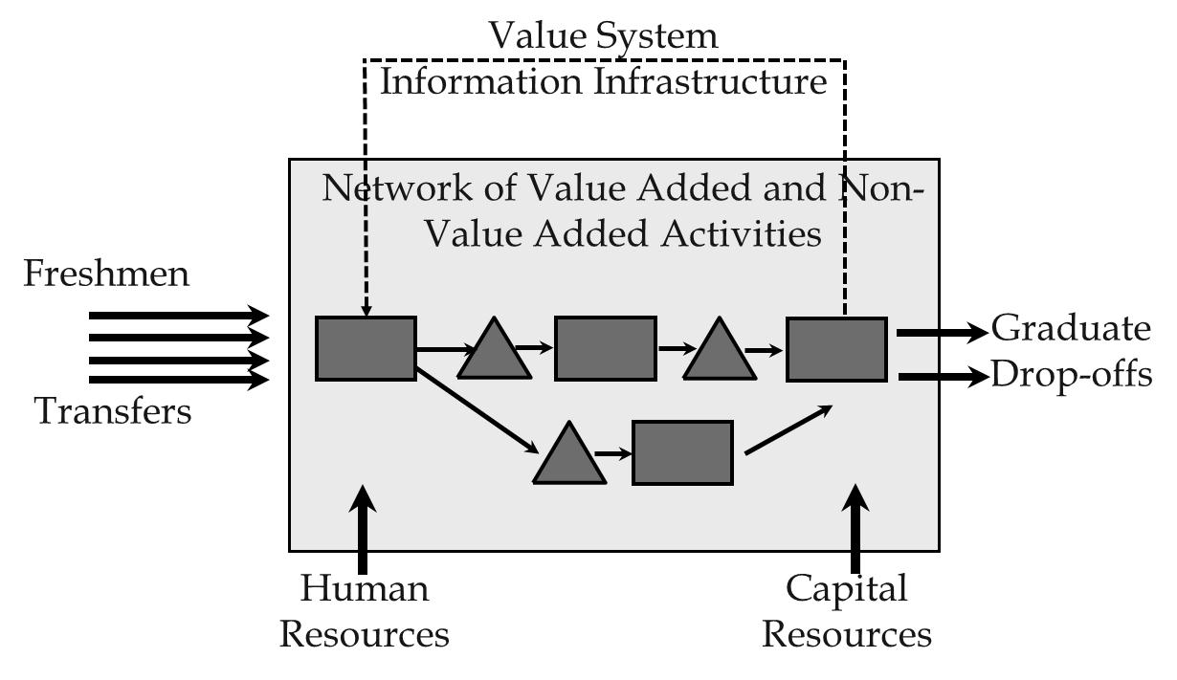

In process flow mapping (process blue printing), material flow is shown by solid lines, and information flow is shown by dashed lines. When inputs pass through the network, they are called flow units; when they leave the system they are output. A flow unit could be an item of inputs, outputs, or a combination of both-it depends on the reasons why we are looking at this process. Values added activities – activities making an input one step closer to its output form - are shown by rectangle; non-value added activities- buffers, storages, waiting lines- are shown by triangle. Not all writings are non-value added, for example, aging of cheese or hardening a concrete are value added activities.

The following are examples of different processes and their components. The fulfillment process starts from receipt of an order and ends at delivery of a product. Flow units of this process are orders. In an outbound logistics, process starts at the end of production and ends when the product is delivered to the customer; flow units are products. In a supply cycle, flow units are supplies; the system boundaries, the border limits of the system starts from issuing a purchase order and ends at receipt of the supplies. In a customer service process, customers are flow units. It starts from the point when an unsatisfied customer shows up until the point when the satisfied customer leaves the system. In a research and development process, flow units are projects. System starts from recognition of the need and ends at launching the project. In a cash cycle process, flow units are cash. The system boundary limits of the system start from the point when expenditure is accrued until the point when revenue is collected, regarding the product or services that this expenditure went through. So, this expenditure went to a product or a service; it went through a transformation process: it was sent it to a customer. Then, the revenue from the customer was collected, and that is from point when the cash was put into the system until the point that the cash was collected from the system.

Every component of a process is interconnected into a system. The relationship among those components and the objective is the goal of existence of this system. The battery limit of the system is the border between the environment and the system. Environment is everything outside the system. Usually, we do have control of variables and parameters inside the boundaries of the system, but we don't have much control over variables and parameters in the environment. Variables and parameters inside the system are called *endogenous* and outside the system-*exogenous.* A system is defined by its components, interrelationship between those components, and the objective of the system.

Systems can grow by increasing the number of their components. The second system in Figure 1 can be preferred to the first system because the second one has one additional component. Systems can also grow by increasing or enhancing their relationship between components. The third system can be preferred to the second system because the third one may have more integrated relationship between its components. Therefore, the third system can perform much better in a complex environment; it can also benefit from synergy between the components.

Figure 1.

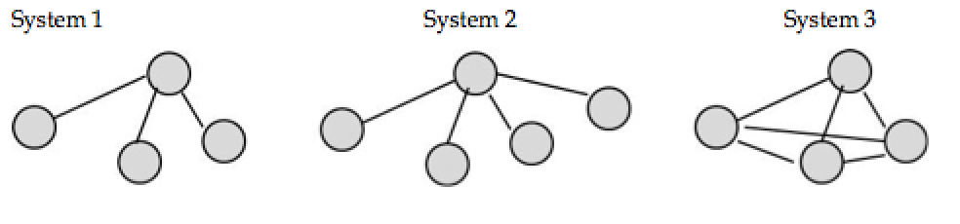

However, the whole system performs better than its components. In a system view, the whole is greater than sum of its parts; 2>1+1!



Imagine desires of Sales, Purchasing, and Production departments in a seasonal industry. Imagine a company with two branches. Process flow in both branches is similar and contains two sequential operations. The first operation takes 5 minutes, the second 10 minutes. The first branch has produced an average of 11 units per hour in Operation 1 and 4 units per hours in operation 2. The second branch has produced an average of 5 units per hour in Operation 1 and 5 units per hours in operation 2. Who deserves appreciation?

**Principle:** Performance measure of Sub-systems must be linked to the performance measure of the total system. Performance of a sub-system must be measured in terms of its impact on the performance of the total system.

Customers assign four attributes to a product; cost, quality, time, variety. These four attributes are often referred to as the four dimensional space. Companies develop a ***customer value proposition*** to fulfill customer expectations**.** Products have two classes of characteristics: order qualifiers and order winners. **Order qualifiers** are characteristics of a product that convince a customer to consider a product. **Order winners** are characteristics that convince the customer to buy the product.

Different market segments define order qualifiers and order winners differently. For example, order qualifiers in the eyes of a commercial airline flyer are entirely different from order qualifiers of a wealthy businessman who wants to buy a private jet.

Customers purchase products based on the value that they will derive from a product. That value is the greatest amount that the customer is willing to pay. Several companies might propose their products with different prices. If customers view different values in these different products then they will buy the product with the largest gap between the value they derive compared to the product or process that the manufacturer or service provider offers. We refer to the difference between that value in the eye of the customer and the market price of a product/service as **consumer surplus.**

**Process Competencies Cost**

Customers are defined in four dimensional space:how much they are willing to pay, the quality they expect to get, the time that it takes to get the product and the variety of options they do have. Firms define their Customer Value Proposition to meet and exceed those expectations.

In order to deliver the necessary customer value proposition, firms create **Process Competencies** in four-dimensional space of **cost, quality, time and flexibility.** Producers need to have process competencies in these four dimensions to reflect a Customer Value Proposition in the product that meets and exceed customer expectations.  For example, companies try to produce accurately priced products to satisfy the customer expectation in the price dimension. The cost dimension is the total cost of producing and delivering the products or outputs. Producers look at the process to discover what parts of the production process are value-adding and what parts are non-value adding. Non-value adding processes do not play a role in the transformation process of producing a product or delivering a service. Therefore, non-value adding processes are removed to lower production cost.

To keep quality high and costs low, producers also need to allocate appropriate resources to each activity. If resource cost is higher than activity cost, activity cost goes up. If resource cost is lower than activity cost, quality of process or product goes down. Therefore, producers need to find out exactly the appropriate resource cost is.

Producers also need to have high standardization and low variations in arrival time and processing time along with high utilization. Producers need to fully utilize human and capital resources in order to breakdown costs on a large number of products. This helps producers create products and processes low in cost in a timely and flexible fashion.

For example, Zara is a well-known name in the apparel industry. Zara's business is design/manufacture/distribution/retailing. Zara differentiates itself from competitors by timely fashion for the masses. CVP of Zara-timely yet limited variety at modest cost and quality. It looks for a market segment that is willing to buy timely fashion and is not particularly anxious about the variety. The price should be average and buyers will expect average quality.

**The production line** is a common method for creating high utilization in processes. The key concept in production cost is to allocate appropriate resources to each operation. An appropriate resource cost is one that is not lower or higher than what is needed. If the resource cost is too high, that increases the cost unnecessarily. If the resource used is lower than what is needed, it will lower the quality.

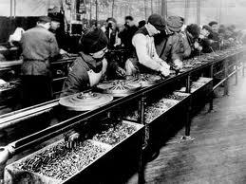 Once the appropriate resource is selected, producers need to reduce variability to help lower production costs. To do this, producers need to increase utilization of all human and capital resources to close to 100%. Reducing variability helps increase utilization. With high variability, it is impossible to reach even close to 100% utilization. Standardization, reduced variability, high utilization and appropriate

A production line at Ford Motor Companies, Highland Park in 1913

resources allocation are key components of cost reduction.

Process Quality and Quality at Source are both aspects of production lines. **Process quality** is the ability to deliver and produce quality products. **Quality at source**, is when products are produced and checked at the same minute. If there is a problem, the production line is stopped.

An example of the production line is Shouldice hospital in Canada. Shouldice focuses solely on hernia operations. They have created a production line where the hernia operation is done at a very high quality and very low price. They do this by performing standardized, repeatable outpatient procedures. They also minimize variability by rejecting patients with risk factors such as high blood pressure.

The second of the process competencies is flexibility. **Flexibility** is the ability to produce and deliver a variety of products at both high and low volumes. Key components for flexibility are **cross-trained workers,** **short setup time** **delayed differentiation.**

In order to create flexibility inside a production system producers need cross-trained workers. Cross-trained workers can shift from one operation to another. In addition to that, producers also need **general purpose equipment.** General purpose equipment is equipment that can produce many different types of products. Theoretically, all machines are general purpose but in order to transfer them from producing one product to another producers may need to spend infinite financial resources. A flexible machine has a short setup time.

**Delayed differentiation** is when producers postpone the differences that they make in the product to the latest steps. An excellent example of delayed differentiation is Home Depot's paint station. Home Depot offers hundreds and hundreds of different colors. However, if Home Depot wanted to have all those colors on their shelves all of Home Depot would need to be a painting department. Instead, they have a few base colors and mix them to create the needed colors. Home Depot has delayed differentiation to the last possible step.

For increased flexibility producers also need a small batch size. Small batch size is when each time you produce a small number of products. Producers do not generally produce a product for six months of demand. After six months, customers might change their preferences and might not want that product anymore. In addition to that, new technology may come and if producers have already produced six months worth of products, they will need at least six months to implement the new technology. Therefore, flexible systems are more responsive both to changes in customer preferences and also to changes in technology.

**Flow Time.** The fourth dimension of process competencies is process flow time, which means the total time to transform a flow unit from input into output and then delivery of the finished product or any services to the customer. Two main components of a short flow time are effective layout and smooth material. Other requirements of smooth flow time are including: less variability in arrival rate, processing rate, and quality.

In smooth flow time the activities must not stop because of starving. In starvation one station is waiting for the output of the previous station and therefore the station remains idle. Also, there is no blocking, which occurs when the activities have to stop due to the lack of space. Thus, in a smooth flow time is neither starvation nor blockage. In other words, smooth flow means no defect and no re-work.

Operation Management creates smooth flow. One aspect of the smooth flow is low production cost because the flow units should come into the process and leave quickly. Other characteristic of smooth flow is high quality since as soon as a problem in quality appears the production line must stop the production and a stop in production line doesn’t have smooth flow. High quality product is one requirement of smooth flow. Another feature of smooth flow is a flexible system as there is not too much inventory can easily respond to technological advances and changes in customer preferences and switch from one product to another. All of these characteristics apply to production systems, service systems such as distribution systems, healthcare systems, and entertainment systems and so on. There are some examples for process competencies including: Corolla that has flow shop, decentralized assembly plants close to market, shop flow time and low cost. Ferrari has job shop that is only a single plant in Italy, long flow time, and high cost. To recognize which of above companies is better, we require sufficient information with regard to the fundamentals of these companies. However, it depends on the strategy and the market segment that they have focused on. If they are synchronized with those elements they would be successful otherwise they are not.

Another example is McMaster-Carr that is a material, repair, and operations and what they usually call it MRO. It is a product distributor, a process with high flexibility, high quality and short response time and at the high price. Wal-Mart is another instance for process competencies. Operational Strategy of Wal-Mart is short flow time and low inventory while its Operations Structure is cross docking. Cross docking means when two trucks that one has red products and another one carries blue products go into a warehouse with a simply conveyor system and carts. Then there will be two other trucks both carry red and blue products to the Wal-Mart stores.

Figure 3. Trucks carry products from warehouse to the store. 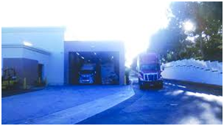

In summary, the process is done in the name of cross docking starts with two trucks one with the red product and another with the blue product reach suppliers in a place with a minimal storage using material handling systems. Then, in supply place these products are put into two trucks, which now carry both the blue and red products, and they go to the corresponding Wal-Mart stores.

|  |  |
| --- | --- |
| Figure 4. Blue and red products in warehouse. | Figure 5. Products are available to customers. |

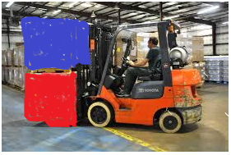 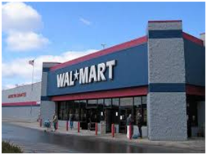

Cross docking is one stage of operations structure. Operations structure also have electronic data exchange, fast transportation system, focus locations which has enough market, and communication between the stores such that if inventorial product in one store is high and in another store is low and they can transfer products between these two stores.

Compare inventory turns in Wal-Mart and in Target. Inventory turns at retail stores: the times that inventory turns throughout the year in Wal-Mart is almost one and half times of the Target and Sales per square foot in Wal-Mart is more than $400 and in Target is less than at $300 per square feet.

**Operation Management and process competencies**. Operations management makes a smooth flow. It operates in hospital, university, bank, production system, assembly line, and in a distribution system as well. Consequently, operating management structures the process competencies in the direction of the customer value proposition. It develops measures to evaluate the effectiveness and efficiency of the processes. Thus, operations management develops process competencies to meet with customer value proposition. It develops measures to evaluate the effectiveness of these processes and efficiency of these processes. Operations management applies methods and techniques to improve process performance.

Process competencies are controllable whereas product attribute that are defined by customers are not controllable. Among the systems those ones are controllable, (such as process competencies, the environment and customer preferences) customer preferences that define the product attribute, are required to have a preparation of a customer value proposition which meets and exceeds product attribute. Then process competencies require to develop due to be able to deliver customer value propositions and that’s process competencies which are controllable and customers have control on them. There is no control on product attribute. There are three performance measures which help us to understand if the process competencies are the best fit for the product attribute: Financial performance measures, External performance, and internal performance measure.

**Competitive Space and Strategy**. Second part of process view and strategy is related to the competitive space and strategy. Customers define the product attributes that they want in four-dimensional space of price, quality, variety and response time whereas firms need to define process competencies in four-dimensional space of cost, quality, flexibility, and flow time. Therefore, to match these requirements, product attributes and process competencies are both defined in the four dimensional space.

Figure 6. *Match of four dimensional Space for two Product Attribute and Process Competency*

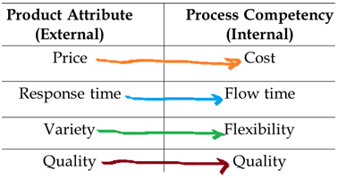

It is not possible to visualize a four dimensional space. This means there is no way to represent them graphically though they might be corresponded to mathematically by using matrix notation or vector. Also with regard to the three-dimensional space, even though the graphical representation of three-dimensional space is possible, the conception of such space is not as easy as that of a two-dimensional space. Therefore, the only way to demonstrate four-dimensional is using representation of two-dimensions.

The following is an example of the graphical illustration related to the two-dimensional space of variety and quality when two dimensions for the time are constant: For example, figure 7 represents two dimensional space of variety and quality. It shows company A has low variety and low quality whereas Company C has high variety and low quality. Thus, company C has a better situation compared to the company A in term of variety dimension. Company B has the same variety as Company A but quality of the product or quality of the process of company B is better than of A’s. Hence, B dominates A and D dominates all of them.

Figure 7*. Products of companies in terms of two dimensions of variety and quality*

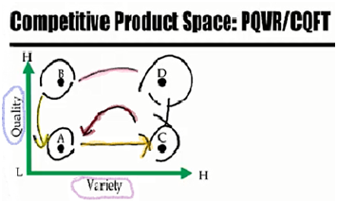

Consequently, in this 2 dimensional space, when move is from A to point B or from direction of A to C, a higher variety and higher quality will be created. As figure 8 demonstrates, enhanced products or process require moving outside of the origin.

Figure 8. *Superior products require moving outside of origin*

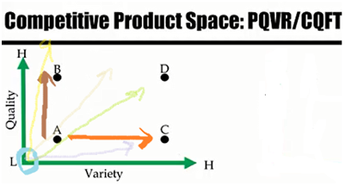

Figure 9 represents quality, the same as before, but in the horizontal direction with the variable cost instead of variety. The graph shows as long as quality is concerned, the company A and C are the same. Nevertheless, the difference is a higher cost compared to A and A dominates C. Both products of B and A have the same cost but quality of B is much higher than A and B dominates A. Also, products of D and B have the same quality but cost of B is very lower than D and then B dominates D.

In figure 9 that displays a quality-dimension, as moving is in direction to outwards, it will bring a higher quality. However, in the horizontal direction, direction towards origin (from right to the left) the situation would be better because costs will be dropped. In order to make these graphs consistent, cost would be replaced with the cost efficiency, which is resulted of the formula one divided by cost.

Figure 9. *The formula for efficiency*

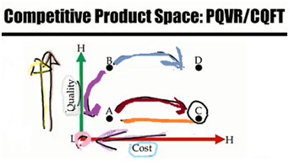

**Efficiency = 1/ cost**

As a result, if product C or process C has a high cost, it will have a low cost efficiency since 1/cost becomes small. In contrast, a low cost in formula, creates a high cost efficiency which shows a good point for products or process.

Figure 10. *The formula for Cost efficiency.*

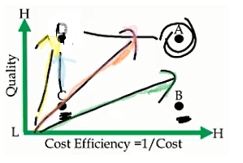

Figure 10 evidently demonstrates company B is more cost efficient compared to company C ; Product B has a higher cost efficient compared to product C; Process B is more cost efficient compared to C. C and D both have the same cost efficiencies, but D has higher quality. A and D both have the same quality, but A is more cost efficient and its cost is lower than D.

Basically, direction of outward moving makes a superior situation for the companies and products. This rule applies to the flow time variable. Figure 11 shows two variables of quality and flow time.

Figure 11. *Two quality and flow time dimensions*

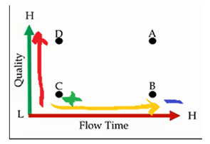

For quality, direction toward up creates a high quality and moving in horizontal direction from the left to the right side makes it worse. It means process requires more time or customer will get the product in the longer period of time, whereas moving from right to the left shows process takes less time. For this reason, on this dimension, flow time is replaced by responsiveness which is derived from 1/Flow Time.

Figure 12. *The formula of Responsiveness*

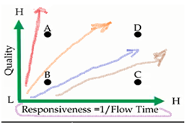

Figure 12 displays company C or product C or process C has a higher responsiveness compared to company B or process B or product B. Product D or process D has high responsiveness that means production or process takes a short period of time in a high quality. In this figure, moving outward makes an improved situation as well as the previous moving exhibited in prior figures.

In summary, one significant point in all figures is noticeable that when quality, variety, cost efficiency, and responsiveness move from the left to the right side or a direction to outward, an enhanced position will be made.

In figure 13 product B has high variety, but it has high cost because its cost efficiency is low.

Figure 13. *Compare of two firms with regard to the variety and cost efficiency.* 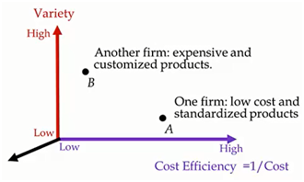

Product A has low variety, though at the high cost efficiency. One firm has a low cost and standardized product with a small variability; another firm has expensive product and customized product.

There is no possibility to determine which company would be more successful. It depends on the strategy and the market segment that these companies are looking at and the customer value proposition they have prepared.

Company A might be Wal-Mart and Company B can be a jet manufacturer which has a very wealthy customers. Nonetheless, both company may make high profit and both may get broke in a couple of years.

**Strategy positioning** defines those positions that the firm wants to occupy in the competitive product space such as the current position and the direction. There are two firms in a two-dimensional space of responsiveness and price or cost efficiency.

Figure 14. *Price efficiency formula and responsiveness*

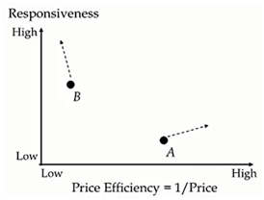

Firm B has higher responsiveness compared to firm A, but its cost efficiency or price efficiency is much lower. The direction of the firm A is going to move toward the right side that causes higher price efficiency and increasing responsiveness at the same time. Now, Company A has low responsiveness. It means it takes more time to produce and deliver product or service to the customers, even though the price efficiency or cost efficiency is quite high. As direction of moving in figure 14 shows, the strategy of this firm is to make a lower price and increase its responsiveness.

**Strategy should look like a sculpture.** A firm must ensure that its competitors are not capable to emulate its position. The strategy of a firm should be designed as a unique sculpture not as a block which could easily be copied or imitated. It is difficult for competitors to imitate an array of interlocked activities, interlocks processes.

For instance, when Southwest Airline became successful, many companies attempted to replicate it, but Southwest had created a resolute strategy similar to a single sculpture.

**Different Companies have Different Strategies:**

|  |  |
| --- | --- |
| Zara | Its strategy is timely, yet limited variety at modest cost and quality. |
| Aravind and Souldice | The strategy is low-cost, high quality, minimal variety, and average to long response time. |
| Corolla | Flow shop, decentralized assembly plants close to market, short flow time, low cost. |
| Ferrari | Job shop, a single plant, longer flow time, high cost. |
| McMaster-Carr | High flexibility, high quality, quick response time, and high price. |
| Walmart | Short flow time, low inventory, low cost, and average quality. |

**Some internal Measures and their relationship with process competencies.**

**Cost**

* Resource-Activity match
* High Utilization (Low Safety Capacity)
* Division of Labor (Job-Simplification)
* High Standardization and Modularization
* Effective Facility Layout
* Clear Material Flow Pattern
* Flow-Shop
* Value Analysis- Value Added and Non-Value Added
* Training
* Method Improvement
* Technology

**Flexibility**

* Cross-trained Workers
* Short Set-up Time
* Delayed Differentiation (postponement)
* Small Batch Size
* Job-Shop
* U-Shaped Layout
* Commonality
* Internal Uniformity vs. External Variability

**Flow Time**

* Small Batch Size –uniform operations – short flow time - low setup time –
* Small number of suppliers
* Long term relationship with suppliers.
* Suppliers located in short distances
* Inventory Turnover
* Reliability in flow time
* No Starvation or Blockage
* Centralization
* Commonality
* Pooling
* Variance Reduction
* Not high utilization

**Quality**

* Conformance of Design and Manufacturing
* Quality at Source
* Reliability (quality over time)
* Service Level
* No Defect and Re-work
* Training
* Method Improvement

**Efficient Frontier**

Figure 15. Efficient Frontier.

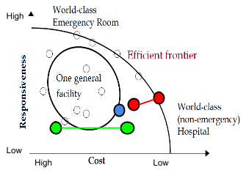

The small circles scattered around the graph are different products or different processes or different firms. For example, these two processes, highlighted in green, have almost the same responsiveness, but the left process is an expensive process, and the right process is an inexpensive process. Since the responsiveness’ are the same the one on the right is a better company.

These two companies, highlighted in red, demonstrate differences in responsiveness. The company on the right, along the efficient frontier, has higher responsiveness compared with the other and yet has lower cost. This process/product/company dominates this other process/product/company.

Efficient frontier is the minimal curve covering all the current positions in the industry. So if we want to find the minimal curve, it is on the efficient frontier. The processes/products/companies on the curve are world class organizations that are trying to push the efficient frontier outward. The organizations inside the curve are not world class organizations. However by improving themselves in both dimensions, these organizations, such as the one circled in blue, can push themselves onto the frontier and become world class, without or with little trade-off. If world class organizations along the frontier want to become more responsive, then there is a trade-off, and they must increase their costs. Non-world class organizations inside the curve may improve their standing by improving responsiveness and costs without trade-off.

**Focused Strategy**

A focused process or a focused organization occupies a small portion of the four-dimensional space of competitiveness. For example, in a two-dimensional representation, the focused process highlighted in yellow below, has small cost variations, and small responsiveness variations. Thus, it can produce products at a given cost or lower cost products at another cost, fast operations in one area, and smaller operations in another.

Figure 16. Focused Strategy. 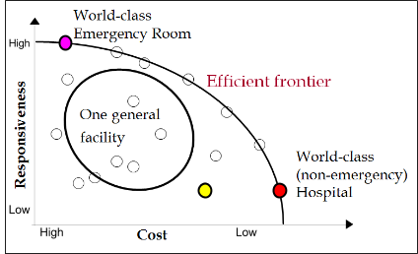

The yellow highlighted organization is a focused organization, yet not a world class focused organization because it is not on the efficient frontier. Every organization is focused because everyone occupies some portion of the four dimensional space (or in this example two dimensional space), yet some are world class while others are not. World class organizations will fall on the efficient frontier. For example, as we move right along the graph we are demonstrating low cost and low responsiveness. A non-emergency hospital (highlighted in red) would be an example of a world class organization falling on the efficient frontier, near the bottom right of the curve, due to its low responsiveness. You can also have the opposite. An emergency room or emergency hospital (highlighted in pink) is an example of a world class organization that would fall on the upper left side of the efficient frontier, due to its high cost and high responsiveness. Both of these examples are focused, because as long as responsiveness is concerned they fall on the upper left and bottom right of the efficient frontier, and as far as cost is concerned they are also placed respectfully along the curve. They do have operations, which do have small variations in cost and small variations in responsiveness. A general, unfocused organization will fall within the center of the graph. This is because it has some operations which are very inexpensive and require a long waiting time, and some operations which are very expensive that require fast responsiveness.

Figure 17. Cost Efficiency.

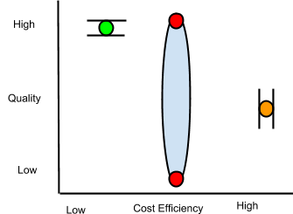

Within a focused strategy, if the graph above reflects cost efficiency and quality, the cost of operations will be in the mid level, far right range as pictured. Quality will also be in a similar small range. A quality focused organization will fall within a small range in the upper left portion of the curve with high cost. An organization within the center area of the graph will produce both high and low quality products. Companies that produce both high and low quality products at a similar cost cannot compete. A focused organization makes or has; all high, or average quality products; high cost, average cost, or low cost products; high, average, or low responsiveness products; high variety, low variety, or average variety in their products. It is impossible however to have a company that produces 1000 items ranging from high to low cost, or high to low quality all under the same management and operations.

A focused strategy is committed to a limited, congruent set of objectives, in terms of demand (product, market) and supply (inputs, technologies, and volumes). When we look at demand, this does not mean we produce 1000 types of products, for 100 different markets. We are committed to a limited number of products for a limited market(s). In terms of supply, we don’t use all types of input (low or high), all types of technologies (manual, or automated).

A focused process is not limited to a few products, but all the products should fall within a small region of the four dimensional product space. If they don’t all fall within that space then we require Plant-Within-Plant (PWP). This business strategy is diverse, but generally the entire business is divided into several mini plants, each with focused processes. One PWP may focus on low cost, while the other may focus on quick response. High and low volume products should be separated into different plants. High quality, high cost products should be produced in a separate plant than an average quality, low cost product. Different plants should also be under different management.

In a two dimensional space, with functions of cost efficiency horizontally and responsiveness vertically, unless world class organizations can push the boundary of the efficient frontier there is no way to increase or decrease cost without a trade off to responsiveness. Everything else within the curve is not world class unless it is along the frontier, yet it can move without a trade off by pushing simultaneously in multiple directions, on more than one dimension. One way to push the boundary of the efficient frontier is with new technologies.

Firms located on the same ray share strategic priorities. They all have the same cost efficiency, responsiveness, or tradeoffs. A trade off is simply the inability to increase one dimension or attribute, without decreasing, or without consequence to another. Firms on the frontier must trade off. Strategic positioning is the direction of the improvement from the previous position, or where the company wants to occupy along the efficient frontier. By not being able to move without tradeoffs, world class companies try and push the boundaries of the efficient frontier. As technology and management technologies advance, they help to push the frontier outward, yet this is not the same across all industries.

Different companies intentionally choose different processes to achieve the same goal, for instance, McDonald’s vs. In-N-Out. These different processes lead to different advantages and disadvantages, so we are always facing tradeoffs. Delivering books at a low cost can be easy. Delivering books fast can be easy. Delivering books fast and at a low cost however is not easy. You also cannot work and study for exams at the same time. The more you work, the less time you will have to study, and therefore the worse you will do on exams. The more you study, the better you will do on your exams, yet you will have less money. There is therefore a trade off between doing work and studying. We are always facing tradeoffs.

Operations management is a set of tools, techniques, and philosophies to create smooth flow. Operations management is also the knowledge necessary to understand tradeoffs, and come out with optimal tradeoffs. To create smooth flow we are forced to have high quality products, with little inventory, because products are made and quickly leave. In such a system, if there is a change in customer preferences, or a change in technology, or a change in inputs, and requires variation, the system can immediately respond. Smooth flow means flexibility, short flow time, and high responsiveness. As soon as someone desires our product, we can quickly get it to them. Smooth flow also means low cost, because products have less time to absorb overhead costs. By creating smooth flow we can determine the optimal tradeoffs. Operations management allows us to produce efficiently and determine the optimal levels of trade off.

**Operational Effectiveness**

Operational effectiveness is developing an operations strategy (encompassing the resources, processes values, and competencies within the four dimensional space of cost, quality, flexibility, and time) that supports the strategic positioning (customer value proposition), better than competitors.

In management the general definition of effectiveness is doing the right things. If the thing you are doing is right then you are effective. Efficiency is doing things right. You can be efficient but not effective. You may be doing something wrong very well or quickly, this does not make you effective. To be both effective and efficient, you should do the right things while doing things right.

In operations management however, we define efficiency as cost efficiency. A process is efficient if we can produce output with minimal inputs and resources: low cost operations. An effective process is a process that supports the execution of a company’s strategy in the four dimensions of cost, quality, flexibility, and time. A synchronized process does well in all four dimensions, while supporting the customer value proposition. We are efficient if we do well in the cost dimension. We are effective if we are doing well in all four dimensions.