**The Little’s Law**

**Example 1: The Coffee Shop.**

In your favorite coffee shop, between 8am- 11am and3pm-6pm, the entrance door opens four times per minute; twice for a customer to enter, and twice for a customer to leave. What is the throughput of this system?

Every one minute two customers enter and two customers leave.

R = 2 customers per minute, or 120 customers per hour. Throughput is a number with a time unit attached to it, e.g. per minute, per hour, per day, per week.

There are 5 customers in the system (4 in the waiting line and one with the server). We refer to them as inventory in the system (composed of for unites of inventory in the buffer and one unit of inventory in the processor). Buffer is represented in terms of numbers (with no time component attached). However, one can also represent a buffer in terms of value. For example if we have 5 units of an item in inventory, and if the value of each item is $50, then by the counting dimension we may state that we have 5 units of inventory, and by the cost dimension we may state that we have $250 worth of inventory. Through the Littles Law, we will learn to talk about inventory, not only in count and cost dimensions, but also in time dimension.

How long does a costumer stay in the coffee shop?

5 people are in the system (I=5), the system is emptied and refilled at a rate of two customers per minutes (R=2 per minute). How long does it take for the recently arrived customer to leave?

5 customers in the system, served at the rate (throughput) of 2 customers/ min 🡺 T=5/2 = 2.5 minutes.

We can look at the problem from a different perspective. You enter the coffee shop (the system), in the instance that you enter the line, one person is just fully served, and is leaving the system. Therefore, there are always 5 customers are in the system (including you). People join this line at rate of 2 customers per minute. Now, suppose it is the instant when you have been fully served, and are leaving the line. At that specific instance, you look over your shoulder and see other customers in the system. How many customers are in the line? 4, Right? Plus one customer that will join then at the instant you leave. A total of 5 customs. At what rate did they join the line? Two per minute. How many people are in the line? 5. How long did it take them to arrive?

Number Min

2 1

5 X

X= (1 $×$ 5)/2 = 2.5 minutes.

T=I/R 🡺 RT=I.

This is the Little’s Law: Throughput times Flow-Time = Inventory. The law indeed has a rigorous mathematical proof, but we derived it rather intuitively. As we can see, the law is simply a unit transformation.

We stated earlier that one can measure Inventory by two dimensions; numbers and dollar value. Now, we can add a third dimension. Note, that the little’s Law of T=I/R is nothing more than a unit conversion, converting numbers into time. It turned 5 units of inventory into 2.5 minutes of inventory. Suppose we have 100 units of item A, and 1000 units of item B. What item do we have more of? By the count dimension, item B has a higher inventory. Now suppose we use 4 units of item A per day (RA= 4/day), and 200 units of item B per day (RB=200/ day). By the time dimension we have 25 days of inventory for item A, and 5 days of inventory for item B. The inventory of item A, from the time perspective, is more than that of item B.

Units

Value

Inventory

Time

Now, suppose there are two lines. Suppose R is still 2 customers per minute and still on average there are 5 customers in the first line to pay for their order and get their non-exotic coffee. In addition, suppose there are 4 people in the exotic order (latte, cappuccino, etc.) waiting in line. 40% of the customers place exotic orders. What is the flow of time for a person who orders latte, cappuccino, etc.?

40%

40%

60%

Such a customer spends 2.5 minutes in the first line. Throughput of the second line is R= 0.4(2) = 0.8 customer per minute. Inventory of the second line is 4.

RT=I 🡺 0.8T=4 🡺 T= 5

Simple order T =2.5 minutes.

Exotic order T= 2.5+5 = 7.5 minutes.

What is the flow time of a customer? S/he is neither a customer who puts a simple order nor one with exotic order, but s/he is both.

Procedure 1- Not very good.

60% simple order: T = 2.5

40% exotic order: T=2.5+5= 7.5

A prototypical customer is 60% a simple order person (2.5 min.) and 40% an exotic order person (7.5 min).

T= 0.6(2.5) + 0.4(7.5) = 4.5 minutes

Procedure 2- Good.

Everyone goes through the first process and spends

5 minutes.

60% spend no additional time and leave.

40% spend 5 additional minutes.

0.6(0) + 0.4(5) = 2

2.5 + 2= 4.5 minutes.

Procedure 3- Even Better.

Throughput of the system is 2 per minute. There are 9 people in the system (5 at the register and 4 in the second line).

RT= I 🡺 2T=9 🡺 T=4.5

Throughput in this system was 2 per minute or 120 per hour or 720 per day (assuming 6 peak hours per day). But inventory in the system is always 9.

It has been reported that US residents spend close to 40 billion hours waiting in lines. Even a cost of $15 per hours adds up to $600 billion per year. The average American has been estimated to spend 2 years of their life waiting in line. Another factor to consider is the frustration and irritation people feel when waiting in the lines. The total product inventories in US Industries is about 1.8 trillion dollars.

**Example 2. College of Business and Economics.**

The college of business and economics in a State university over the past 12 years, on average had 1600 incoming students per year. Average headcount of the students over the same number of periods was 7200.

On average how long does a student spend in this college (average time to graduation)?

RT=I 🡺 1600T=7200 🡺 T=4.5 years.

Suppose 40% of the students are freshmen and the rest are transfer students. Suppose the time to graduate for freshmen students on average is 2.1 times greater than transfer students.

How long does it take freshman students to graduate? How long does it take transfer students to graduate?

T = Time to graduate for a transfer student (40% of all students)

2.1T = Time to graduation for a freshman student (60% of all students)

Time to graduation for all the students = 4.5 years

0.6T+0.4(2.1T) = 4.5 🡺 0.6T +0.84T = 4.5 🡺 T= 4.5/1.4 🡺 T= 3.125 years.

Time to graduation fora transfer student = 3.125 years.

Time to graduation of for a freshman student = 6.25 years.

Out of the 1600 incoming students, on average, 25% are accounting majors, 20% marketing, 20% management, 15% finance, and the rest are other majors. The business school has 2200 accounting, 1200 Marketing, 1200 Management, 1400 other majors, and the rest are finance students.

On average how many accounting students graduate each year.

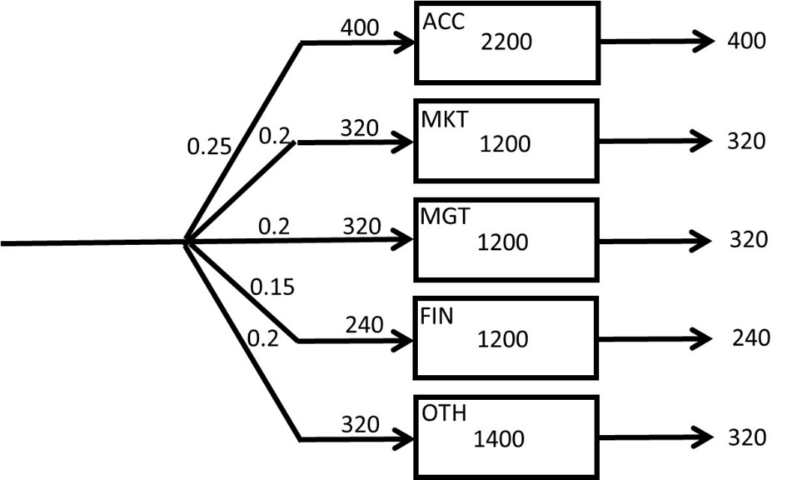

RACC = 0.25(1600) = 400 per year

b) On average how long does it take a finance student to graduate?

RFIN = 0.15(1600) = 240 /year

IFIN = 7200-(2200+1200+1200+1400) = 1200

TFIN = 1200/240 = 5 years

Students of what majors spent the least and the most amount of time at this school.​



ACC longest, MGT and MKT shortest

Suppose still 40% of the incoming students are freshmen and the rest are transfer students. Furthermore not all the students get graduated. Sadly, there are 15% drop-outs. Suppose the time to graduate for freshmen students on average is 2.5 times greater than transfer students, and the time that the drop-outs spend in CSUN is half of that of transfer students. How long does it take freshman students to graduate? all three categories of the students is

T: CSUN-life for a drop-out (@10%)

2T: time to graduate for a transfer student (@40%)

5T: Time to graduate for a freshman: 5T (@60%)

10%+40%+60 = 110%

We need to have the total weights = 100%, it is now 110%

T(10/110)+2T(60/110)+5T(40/110) = 3T=?

Suppose the average time to leave CSUN for an incoming student is still 4.5 years.

3T=4.5

T=1.5

The time a drop-out spend at CSUN

2T: time to graduate for a transfer student = 3

5T: Time to graduate for a freshman: 5T =7.5 Years

**Example 3. Fresh Juice.**

A recent CSUN graduate has opened up a cold beverage stand “CSUN-STAND” in Venice Beach. She works 8 hours a day. She observes that on average there are 320 customers visiting CSUN-a

**3a.** how many customers on average are waiting at CSUN-STAND?

1. 4
2. 2.75
3. 3.75
4. 3.25
5. 4.25

She is thinking about running a marketing campaign to boost the number of customers per day. She expects that the number of customers will increase to 480 per day after the campaign. She wants to keep the line short at the stand and hopes to have only 2 people waiting on the average. Thus, she decides to hire an assistant.

**3b.** what is the average time a customer will wait in the system after all these changes?

1. 4 min
2. 3 min
3. 2 min
4. 1 min
5. none of the above

**3c.** after the marketing campaign, a recent UCLA graduate has opened up a competing cold beverage stand. The UCLA grad is not as efficient as the CSUN grad, so customers must stay an average of 10 minutes at UCLA-STAND. Suppose there is an average of 3 customers at UCLA- STAND. The total number of customers for both CSUN- and UCLA- STANDs remains at 480 per day, as it was after the marketing campaign. But now it is divided between the CSUN- STAND and UCLA- STAND.

By how much has business at the CSUN- STAND has decreased?

1. 177 customers per day
2. 144 customers per day
3. 166 customers per day
4. 155 customers per day
5. 133 customers per day

**Question 4 to 6.** An insurance company processes 10,000 claims per year. Assume there are 50 weeks per year. The average processing time is 5 weeks. 50% of all the claims received are car insurance claims, 10% motorcycle, 10% boat, and the remaining are house insurance claims. On average, there are, 260 car, 150 motorcycle, 110 boat, and some house claims in process.

**Question 4.** What is the average number of claims that are in process?

1. 720
2. 360
3. 800
4. 400
5. 1000

**Question 5.** How long, on average, does it take to process a car insurance claim?

1. 1 week
2. 1.6 weeks
3. 2 weeks
4. 2.6 weeks
5. none of the above

**Question 6.** How long, on average, does it take to process a house insurance claim?

1. 4 weeks
2. 5 weeks
3. 8 weeks
4. 10 weeks
5. none of the above

**Example 4. Help Desk**

A help-desk clerk at CSUN help-desk receives 2000 emails per month. Assume 20 working days per month. On average there are 50 undecided emails in the mail box of this clerk. What is the average flow time of handling a request?

60% of the emails are responded to satisfaction without further investigation. 10% are forwarded to Administrator A (Admin-A) and the rest to Administrator B (Admin-B). On average there are 20 of these emails are waiting in the email list of each of Admin-A and Admin-B. 80% of the email sent to Admin-B are responded to satisfaction and the rest are considered out of scope of responsibilities. Half of the emails sent to Admin-An are responded to satisfaction and the rest are considered out of scope of responsibilities.

Compute average flow time.

Compute average flow time at Sub-Process A.

Compute average flow time at Sub-Process B.

Compute average flow time at Sub-Process C.

Compute average flow time of a response to satisfaction.

Compute average flow time of an out of scope response.

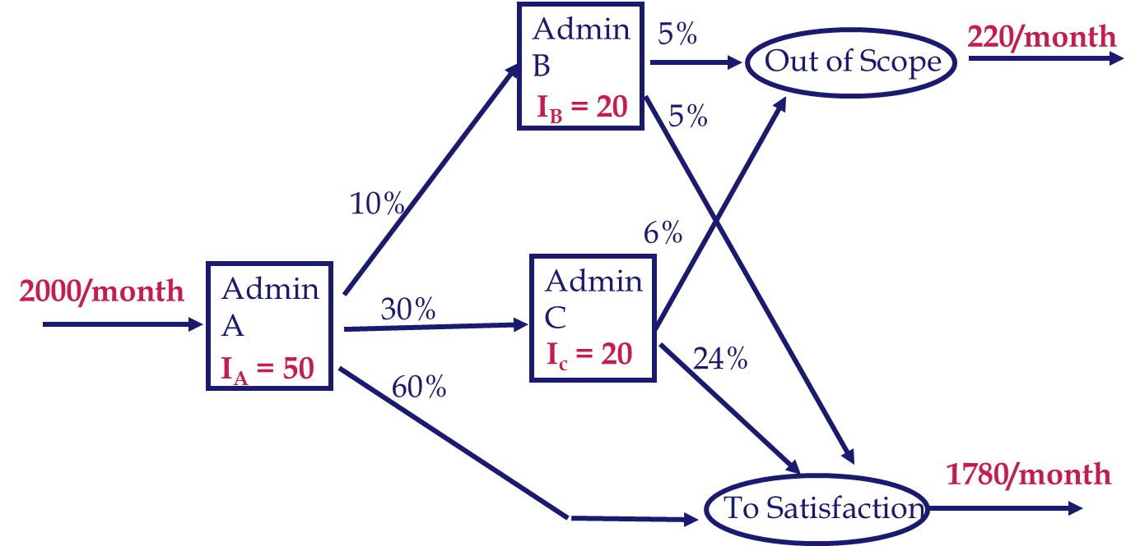

I = IC + IA + IB = 50 + 20 + 20 = 90

R = 2000 per month or 2000/20 = 100 per day or 100/8 = 12.5 per hour or

I is always 90. It does not carry a time unit.

T = I/R = 90/12.5 = 7.2 hours.

**Average Flow Time for sub-process A.**

Throughput *RC*= 12.5 emails/hour

Average Inventory *IC* = 50 emails

*TC* = 50/12.5 = 4 hours in sub-process A

**Average Flow Time for sub-process B.**

Throughput *RB*= 0.1 (12.5) = 1.25 emails/hour

Average Inventory *IB* = 20 emails

*TB* = 20/1.25 = 16 hours in sub-process B

**Average Flow Time for sub-process B.**

Throughput *RB*= 0.3 (12.5) = 3.75 emails/hour

Average Inventory *IB* = 20 emails

*TB* = 20/3.75 = 5.33333 hours in sub-process B

One flow unit at a very macro level: Email

2000 flow units/month at very micro level: Each specific email

Two flow units: To Satisfaction, Out of Scope

Five flow units: To Satisfaction-C, To Satisfaction-A, Out of Scope-A, To Satisfaction-B, Out of Scope-B

To Satisfaction -C: C

To Satisfaction -A: C, A

To Satisfaction -B: C, B

Out of Scope -A: C, A

Out of Scope -B: C, B

TC = 4 hours

TA = 16 hours

TB = 5.333 hours

We also need percentages of each of the five flow units

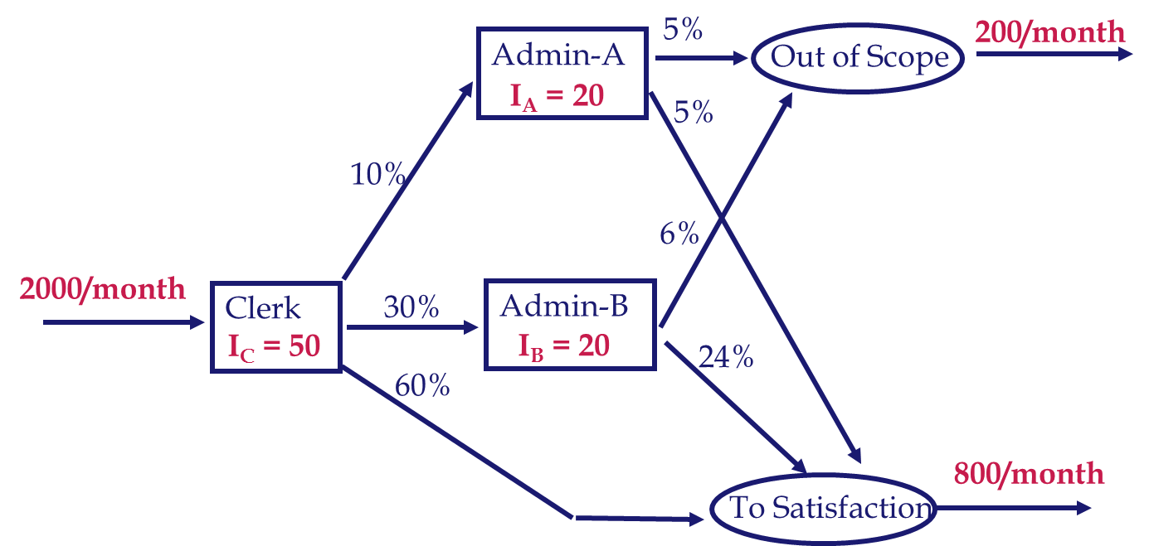

Out of Scope -A: C, A 🡺 4+16 = 20 🡺 Out of Scope -A: 5%

Out of Scope -B: C, A 🡺 4+5.3333 = 9.33 🡺 Out of Scope -B: 6%

Average Flow time of an Out of Scope email =?

[0.05(20) +0.06(9.333)]/ (0.05+0.06) = 14.18

To Satisfaction –C: A 🡺 4 @ 60%

To Satisfaction –A: C, A 🡺 4+16=20 @ 5%

To Satisfaction –B: C, B 🡺 4+5.333=9.333 @ 24%

6.34

Check our computations:

Average flow time of an application

0.89(4.18) +0.11(6.34) = 7.2

**Example 5. Healthcare**

80 patients per hour arrive at a hospital emergency room (ER).

All patients first register through an initial registration process. On average there are 9 patients waiting in the Rg-Buffer. The registration process takes 6 minutes. Patients are then examined by a triage nurse practitioner.  
On average, 91% of the patients are sent to the Simple-prescription process and the remainder to Hospital-admission.  
On average, there are 6 patients waiting in the Simple-prescription buffer (Sp-Buffer) in front of this process.  
On average there are 2 patients waiting in the Tr-Buffer in front of the triage process, and the triage classification process takes 5 minutes.

A physician spends 6 minutes on each patient in the Simple-prescription process.  
In addition, on average, 2 patients per hour are sent to the Hospital-admission buffer buffer (Hs-Buffer) after being examined for 6 minutes in the Simple prescription process.  
On average, 0.9 patients are waiting in the Hospital-admission buffer (Hs-Buffer).  
A physician spends 25 minutes on each patient in the Hospital-admits process.





The last two rows are incorrect





**Average flow time =**

**T = I/R =**

**43.68/(80/60) = 32.76**

**Average flow time = T = I/R = 43.68/(80/60) = 32.76**



Common: 6.75+6+1.5+5 = **19.25**

TSP= 19.25+**10.95** = **30.2**

TPA1= 19.25 +**30.87** = 50.12 ……(7.2 PA patients out of 9.2 PA patients)

TPA2= 19.25 +**10.95** +**30.87** = 61.07 (2 PA patients out of 9.2 PA patients)

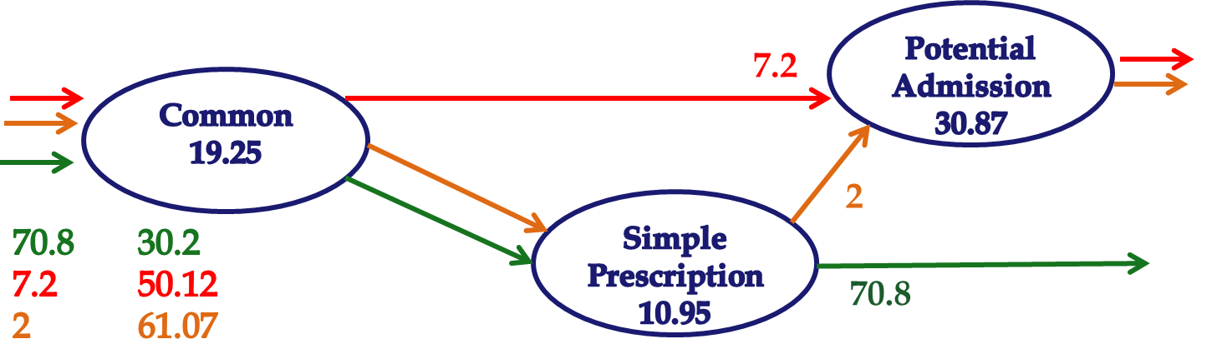

TPA = 50.12(7.2/9.2) + 61.07(2/9.2) =

TPA = 50.12(0.782609) + 61.07(0.217391) = **52.5**

We already have the Average flow time

T = I/R = 43.68/(80/60) = 32.76

T= 30.20(70.8/80) + 50.12 (7.2/80) + 61.07 (2/80)

**T = 32.76**