**The Little’s Law**

**Example 1: The Coffee Shop.**

You have experienced that in your favorite coffee shop, in time periods between 8am- 11am as well as 3pm-6pm, the entrance door opens four times per minute; twice for a customer to come in, and twice for a customer to leave. What is throughput of this system?

Every one minute two customers come in and two customer leave.

R = 2 per minute, or 120 per hour. Throughput carries a time component with it, e.g. per minute, per hour, per day, per week.

There are 5 customers in the line. We refer to these people as inventory or buffer. Buffer is represented in terms of numbers. However, one can represent a buffer in terms of value. For example if we have 5 units of an item in inventory, and if the value of each item is $50, then on the counting dimension we may sat we do have 5 unites inventory, and in cost dimension we may state that we have $250 inventory. Through the Littles Law, we will learn to talk about inventory not only in count and cost dimensions, but also in time dimension.

How long a costumer stays in the coffee shop?

5 people are in the line (I=5), the line is empties and refilled at the rate of two customer per minutes (R=2 per minute). How long does it take to empty the line? By to empty the line we mean to have the recently coming customer to leave?

5 in line, served at 2/ min 🡺 T=5/2 = 2.5 minutes.

We can look at the problem from a different perspective. You enter the coffee shop, in the instance that you enter the line, one person is just fully served, and is leaving the line. Therefore there are always 5 people in the line (including you). People join this line at rate of 2 per minute. Now suppose it is the instance when you have been fully served, and are leaving the line. At that specific instance, you look over your shoulder and see people in the line. How many people are in the line? 5. Right? At what rate they joined the line? Two per minutes. How many people are in the line 5. How long did it take them to come

Number Min

2 1

5 X

X= (1 $×$ 5)/2 = 2.5 minutes.

T=I/R 🡺 RT=I.

That is the Little’s Law which indeed has a rigorous mathematical proof, but we derived it rather intuitively.

We stated earlier that one can measure Inventory in two dimensions; numbers and dollar value. Now we can add a third dimension. Note that the Little’s Law of T=I/R in nothing more than a dimension conversion. Converting numbers into time. Suppose we have 100 units of item A, and 1000 units of item B. Inventory of what item is more? On count dimension, item B has a higher inventory. Now suppose we use 4 unit of item A per day (RA= 4/day), and 200 units of item B per day (RB=200/ day). On time dimension we have 25 days of inventory for item A, and 5 days of inventory for item B. The inventory of item A, from the time perspective, is more than that of item B.

Units

Value

Inventory

Time

Now suppose there are two waiting lines. Suppose R is still 2 per minute and still on average there are 5 customers in the first line to pay for their order and get their non-exotic coffee. In addition, suppose there are 4 people in the exotic order (latte, cappuccino, etc.) waiting line. 40% of the customers place exotic orders. What is the flow time of a person who orders latte, cappuccino, etc.

40%

40%

60%

Such a customer spends 2.5 minutes in the first line. Throughput of the second line is R= 0.4(2) = 0.8 customer per minute. Inventory of the second line is 4.

RT=I 🡺 0.8T=4 🡺 T= 5

Simple order T =2.5 minutes.

Exotic order T= 2.5+5 = 7.5 minutes.

What is the flow time of a customer. S/he is neither a customer who puts a simple order nor one with exotic order, but s/he is both.

Procedure 1- Not very good.

60% simple order: T = 2.5

40% exotic order: T=2.5+5= 7.5

A prototype customer is 60% a simple order person (2.5 min.) and 40% an exotic order person (7.5 min).

T= 0.6(2.5) + 0.4(7.5) = 4.5 minutes

Procedure 2- Good.

Every one goes through the first process and spends

5 minutes.

60% spend no additional time and leave.

40% spend 5 additional minutes.

0.6(0) + 0.4(5) = 2

2.5 + 2= 4.5 minutes.

Procedure 3- Even Better.

Throughput of the system is 2 per minute. There are 9 people in the system (5 at the register and 4 in the second line).

RT= I 🡺 2T=9 🡺 T=4.5

Throughput in this system was 2 per minute or 120 per hour or 720 per day (assuming 6 peak hours per day). But inventory in the system is always 9.

It has been reported that US residents spend close to 40 billion hours in waiting lines. Even a cost of $15 per hours adds it up to $600 billion per year. The average American has been estimated to spend 2 years of their life  waiting in line. Add to it frustration and irritation people feel when waiting in the lines. The total product inventories in US Industries is about 1.8 trillion dollars.

**Example 2. College of Business and Economics.**

The college of business and economics in a State university over the past 12 years, on average had 1600 incoming students per year. Average headcount of the students over the same number of periods was 7200.

On average how long a student spends in this college (average time to graduation)?

RT=I 🡺 1600T=7200 🡺 T=4.5 years.

Suppose 40% of the students are freshmen and the rest are transfer students. Suppose the time to graduation of freshmen students on average is 2.1 times of that of the transfer students.

What is the time to graduation of a freshman student? What is the time to graduation of a transfer students?

T = Time to graduation of a transfer student (40% of all students)

2.1T = Time to graduation of a freshman student (60% of all students)

Time to graduation of all the students = 4.5 years

0.6T+0.4(2.1T)= 4.5 🡺 0.6T +0.84T = 4.5 🡺 T= 4.5/1.4 🡺 T= 3.125 years.

Time to graduation of a transfer student = 3.125 years.

Time to graduation of a freshman student = 6.25 years.

Out of the 1600 incoming students, on average, there are 25% accounting major, 20% marketing, 20% management, 15% finance, and the rest are other majors. The business school has 2200 accounting, 1200 Marketing, 1200 Management, 1400 other majors, and the rest finance students.

On average how many accounting students get graduated each year.

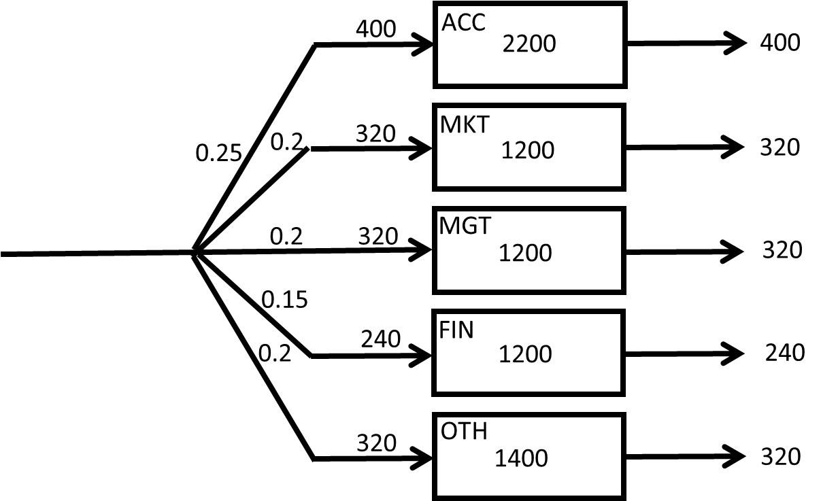

Racc = 0.25(1600) = 400 per year

b) On average how long does it take a finance student to get graduated.

Rfin = 0.15(1600) = 240 /year

Ifin = 7200-(2200+1200+1200+1400) = 1200

TFIN = 1200/240 = 5 years

Students of what majors spent the least and the most amount of time at this school.​



ACC longest, MGT and MKT shortest

**Example 3. Fresh Juice.**

**Question 1 to 3.** A recent CSUN graduate has opened up a cold beverage stand “CSUN-stand” in Venice Beach. She works 8 hours a day. She observes that on average there are 320 customers visiting CSUN-stand every day. She also observes that on average a customer stays about 6 minutes at the stand.

**Question 1.** How many customers on average are waiting at CSUN-stand?

1. 4
2. 2.75
3. 3.75
4. 3.25
5. 4.25

She is thinking about running a marketing campaign to boost the number of customers per day. She expects that the number of customers will increase to 480 per day after the campaign. She wants to keep the line short at the stand and hopes to have only 2 people waiting on the average. Thus, she decides to hire an assistant.

**Question 2.** What is the average time a customer will wait in the system after all these changes?

1. 4 min
2. 3 min
3. 2 min
4. 1 min
5. none of the above

**Question 3.** After the marketing campaign, a recent UCLA graduate has opened up a competing cold beverage stand. The UCLA grad is not as efficient as the CSUN grad, so customers must stay an average of 10 minutes at UCLA-stand. Suppose there is an average of 3 customers at UCLA-stand. The total number of customers for both CSUN and UCLA-stands remains at 480 per day, as it was after the marketing campaign. But now it is divided between the CSUN-stand and UCLA-stand.

By how much has business at the CSUN-stand has decreased?

1. 177 customers per day
2. 144 customers per day
3. 166 customers per day
4. 155 customers per day
5. 133 customers per day

**Question 4 to 6.** An insurance company processes 10,000 claims per year. Assume 50 weeks per year. The average processing time is 5 weeks. 50% of all the claims receives are car insurance claims, 10% motorcycle, 10% boat, and the remaining are house insurance claims. On average, there are, 260 car, 150 motorcycle, 110 boat, and some house claims in process.

**Question 4.** What is the average number of claims that are in process?

1. 720
2. 360
3. 800
4. 400
5. 1000

**Question 5.** How long, on average, does it take to process a car insurance claim?

1. 1 week
2. 1.6 weeks
3. 2 weeks
4. 2.6 weeks
5. none of the above

**Question 6.** How long, on average, does it take to process a house insurance claim?

1. 4 weeks
2. 5 weeks
3. 8 weeks
4. 10 weeks
5. none of the above

**Problem 4 of 6**

**Email Problem**

Linda receives 2000 emails per month. 60% of the emails did not require a response. The rest needed further investigation. The system can handle an average of 200 Emails. Assume 20 working days per month. What is the average flow time?

|  |  |  |  |  |  |  |  |
| --- | --- | --- | --- | --- | --- | --- | --- |
| |  | | --- | |  | |  |  |  |  | R =1200 /month |  |
| R = 2000/month |  | Initial Review=200 |  |  |  |  |
|  |  |  |  |  |  |  |
|  |  |  |  |  | R =800 /month |  |
|  |  |  |  |  |  |  |
|  |  |  |  |  |  | |

R = 2000 /month or 100 per day.

I =200

T = I/R = 200/100 =2 days.

Or average flow time is 2 days

Linda has an assistant now. Of the emails that come in, Linda deletes 10% right away and assigns 50% to her assistant for review. The rest she will review herself. Once reviewed the emails are either deleted or responded to. Assume there are 20 working days in a month.

|  |  |  |  |  |  |  |  |  |  |  |  |
| --- | --- | --- | --- | --- | --- | --- | --- | --- | --- | --- | --- |
|  |  |  |  |  |  |  | 40% |  |  |  | R =1200 /month |
| |  | | --- | |  |   R =800 /month  R=2000/month |  |  | 40% |  |  | Linda Review IL=30 | 88% |  |  |  |  |
|  | Initial Review  IR=60 |  |  |  |  |  |  |  |  |  |  |
|  |  |  |  | 50% |  | Asst Review IA=40 |  |  |  |  |  |
|  |  |  |  |  |  |  |  | 60% |  |  |  |
|  |  |  |  |  |  |  | 12% |  |  |  |  |
|  |  |  |  |  |  |  |  |  |  |  |  |
|  |  |  |  |  |  |  |  |  |  |  |  |
|  |  |  |  |  |  |  |  |  |  |  |  |
|  |  |  |  |  |  |  |  |  |  |  |  |
|  |  |  |  | 10% |  |  |  |  |  |  |  |
|  |  |  |  |  |  |  |  |  |  |  |  |

Given R =2000 /month =2000/20 per day =100 per day

Total Inventory =IR+IL+IA =60+30+40 =130 units.

The total inventory is less than the prior case.

Since R is a constant, and since I is reduced, T will be reduced.

T= I/R =130/100= 1.3 days.

After hiring the assistant, average flow time had reduced from 2 days to 1.3 days.

Let’s find the following

Compute average flow time.

Compute average flow time at Initial Review Process.

Compute average flow time for Linda.

Compute average flow time for assistant.

Compute average flow time of an email to respond.

Compute average flow time of an email to delete.

1. Average Flow time for Initial Review = TR= IR/R = 60/100 =0.6 days
2. Average Flow time for Linda’s review
3. Throughput for Linda’s process = RL =100*0.4=40 Emails per day
4. Average Inventory =IL=30
5. Hence Average Flow time for Linda’s process=TL = 30/40 =0.75 days
6. Average Flow time for Assistance’s process
   1. Throughput for Assistance process = RA =100*0.5=50 Emails per day
   2. Average Inventory =IR=40
   3. Hence Average Flow time for Assistance’s process=TA = 40/50 =0.8 days
7. The routing of each flow unit in the most granular level
   1. IR -------🡪IL-----🡪 Accepted
   2. IR--------🡪IL-----🡪 Deleted
   3. IR--------🡪IA----🡪Accepted
   4. IR-------🡪IA-----🡪 Deleted
   5. IR-------🡪 Deleted

The percentages of each of the above 5 flow units

* 1. 100% -------🡪100%*40%-----🡪 100%*40%*40% => 100%-🡪40%---🡪16%

Same as in f), the following percentages of the flow can be calculated.

* 1. 100%-------🡪40%-----🡪 24%
  2. 100%-------🡪50%----🡪44%
  3. 100%-------🡪50%-----🡪 6%
  4. 100%-------🡪 10%

This can be represented as in the following flow chart.

40%

16%

Linda Review IL=30

R =1200 /month

|  |  |  |  |  |  |  |  |  |  |  |  |
| --- | --- | --- | --- | --- | --- | --- | --- | --- | --- | --- | --- |
|  | R=2000/month | IR=60 |  |  |  |  |  |  |  |  |  |
|  |  |  |  |  |  |  | 44% |  |  |  |  |
|  |  |  | 50% |  | Asst Review IA=40 |  |  |  |  |  |  |
|  |  |  |  |  |  |  |  |  |  |  |  |
|  |  |  |  |  |  |  | 24% |  |  |  |  |
|  |  |  |  |  |  | 6% |  |  |  |  |  |
|  |  |  |  |  |  |  |  |  |  |  |  |
|  |  |  |  |  |  |  |  |  |  |  |  |
|  |  | 10% |  |  |  |  |  |  |  | R =800 /month |  |
|  |  |  |  |  |  |  |  |  |  |  |  |

1. Average Flow time for Linda and Assistant to respond

Total time for Linda to do her review =TR+TL=0.6+0.75 =1.35 days with percentage 16%

Total time for Assistance to do the review =TR+TA =0.6+0.8 =1.4 days with percentage 44%

Hence Average time to respond mail =(1.35*16%+1.4%*44%)/(16%+44%) = 1.3867 days

1. Average flow time for Linda and Assistance to delete the emails

Time for Initial deletion = TR =0.6 with percentage of 10%

Total time for Linda to delete email =TR+TL=0.6+0.75 =1.35 days with percentage 24%

Total time for Assistance to delete =TR+TA =0.6+0.8 =1.4 days with percentage 6%

Hence Average time to respond mail =(0.6*0.1+1.35*24%+1.4%*6%)/(10%+24%+6%) = 1.17 days

1. Check for Average time to complete the process = T

(Average time for responding)* (% of response)+(Average time of deletion )* (percentage of deletion) =1.387*0.6 +1.17*0.4 =1.3 days as calculated before.

**STOP**

**Problem 1: “The Coffee Shop”**

You enter the Pepperdine bookstore to buy your textbooks. At this time of day, the entrance door opens 12 times per minute; 6 times for new students to come in, 6 times for students to leave.

a) **What is throughput, R, of this system**? Every minute, six students come in and six students leave. Therefore,



b) **There are 18 students in the check-out line, how long does it take you to pay for your books and leave?**

Applying Little’s Law, Throughput (R) x Flow Time (T) = Inventory (I). Therefore,

T = 18 students in line / 6 students per min



Now suppose there is an additional waiting line for online-order pickups. Suppose R is still 6 students per minute, and there are still 18 students on average in the first line to pay for their textbooks. 40% of the Students have made an online pre-purchase and must proceed from the first line to the second line for online-order pickups. There are six students in this second line.

**c) What is the flow time of a student who orders online?**

Students spend 3 minutes in the first line. T1 = 3 minutes.

Throughput of the second line is R= 0.4(6) = 2.4 students per minute.

Inventory of the second line is 6 students. Therefore,

R x T2 = I => 2.4 x T2 = 6 => T2 = 2.5 minutes

Store bought book, T = 3 minutes, online-order T = T1 + T2

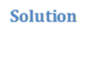

T = 5.5 minutes

d) **Assume a student is not only buying a book in-store, nor only made an online purchase, but s/he is both.** **What is the flow time of this student?** Applying Little’s Law to the entire system,

R x T = I= students/min x T = 24 students. Applying Little’s Law to the entire system, R x T = I

6 students/min x T = 24 students

**T=4 minutes**

Alternatively (self check):

60% students buy in store and take 3 minutes

40% students pre-order online and take 5.5 minutes

.6*3+.4*5.5=4 minutes

**Problem 2:** Monetary Flow

For the new euro introduction in 2002, Wim Duisenberg had to decide how many new Euro coins to stamp by 2002. Euroland’s central banks’ cash-in-coins handling was estimated at €300 billion per year. The average cash-in-coins holding time by consumers and businesses was estimated at 2 months. How many Euro coins were to be made?

R = 300 billion Euros/yr

T = 2 months = 1/6 yr

I = ?

Applying Little’s Law, R x T = I

300 billion euros/yr x ( 1/6 yr) = I

**I=50 Billion Euros**

**Problem 3**: The Pepperdine Westlake Campus recently opened a break room with an assortment of coffee, snacks, soda, and water. Assume it is open 10 hours a day. The administration observes that on average 300 students go in and out of the break room every day. They also observe that on average a student stays about 4 minutes.

**Question 1: How many students on average are waiting in the break room**?



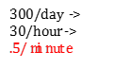  

R = 300 in 10 hours è R = 300/10 = 30 per hour

R = 30/60 = 0.5 per minute

T = 4 minutes

RT = I è I = 0.5(4) = 2 students are waiting

The Pepperdine administration is remodeling the break room to include more amenities to increase the number of students that utilize it per day. They expect the number of students to increase to 600 per day after the remodel. The administration would like to keep the line short with only 1 student waiting on average. Thus, one of the new amenities is an additional coffee station.

**Question 2**: **What is the average time a student will wait in line after all these changes**?



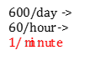 

R = 600 in 10 hours è R = 600/10 = 60 per hour

R = 60/60 = 1 per minute

I = 1

Average time a student will wait:

RT = I è T = I/R = 1/1 = 1 minute

**Question 3**: After the remodel and steady stream of students, the administration has decided to expand the Westlake Campus even more to include an on-site Starbucks. However, only one worker will staff the Starbucks so students must wait an average of 10 minutes. Suppose there is an average of 4 students waiting. The total number of students for both the break room and Starbucks remains at 600 per day, as it was after the remodel. But now it is divided between the break room and Starbucks. By how much has the amount of students at the break room decreased? Starbucks

  

At Starbucks we have:

I = 4 people and T = 10 minutes

RT = I è R(10) = 4 è R= 4/10= 2/5 per minute R = 60(2/5) = 24 students per hour or 24(10 hours per day) = 240 students/day

Activity at the break room has decreased by 240 students/day

**Questions 4 to 6**: Pepperdine’s Graduate Financial Aid Department processes 1,000 applications per year. Assume 50 weeks per year. The average processing time is 5 weeks. 50% of all the applications received are for the Merit Scholarships, 20% for the Endowed Scholarships, 10% for Private Scholarships and Grants, and the remaining are for Loans. On average, there are 40 Merit, 20 Endowed, 12 Private & Grants, and some Loan applications in the process.

**Question 4**: What is the average number of applications that are in the process?

R per week = 1,000/50 = 20 applications/week

RT = I

I = 20(5) = 100 applications waiting



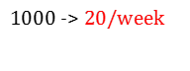

**Question 5**: How long, on average, does it take to process a Merit Scholarship application?

.5



I = 40 Merit Scholarships

R = 0.5(20) =10/week

RT = I è (10)T = 40

T = 40/10= 4 weeks

**Question 6**: How long, on average, does it take to process a Loan application?



Average # of applications in process = 100

100– 40 (Merit) –20 (Endowed) –12 (Private Scholarships & Grants) = 28

Average # of applications for a Loan: I = 28

Loan applications are 1- 0.5-0.2-0.1 = 0.2 of all applications

R = 0.2(20) = 4

RT = I è T = I/R è T = 28/4= 7 weeks

**Problems 5: Email Problem**

Linda receives 2000 emails per month. 60% of the emails did not require a response. The rest needed further investigation. The system can handle an average of 200 Emails. Assume 20 working days per month. What is the average flow time?

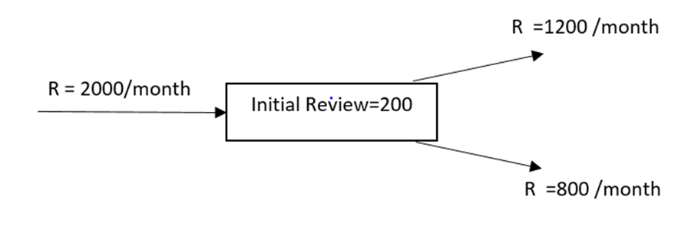

R = 2000 /month or 100 per day.

I =200

T = I/R = 200/100 =2 days.

Or average flow time is 2 days

Linda has an assistant now. Of the emails that come in, Linda deletes 10% right away and assigns 50% to her assistant for review. The rest she will review herself. Once reviewed the emails are either deleted or responded to. Assume there are 20 working days in a month.

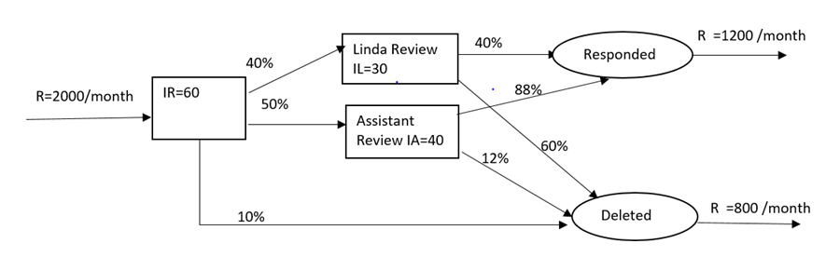

Given R =2000 /month =2000/20 per day =100 per day

Total Inventory =IR+IL+IA =60+30+40 =130 units.

The total inventory is less than the prior case.

Since R is a constant, and since I is reduced, T will be reduced.

T= I/R =130/100= 1.3 days.

After hiring the assistant, average flow time had reduced from 2 days to 1.3 days.

Let’s find the following

Compute average flow time.

Compute average flow time at Initial Review Process.

Compute average flow time for Linda.

Compute average flow time for assistant.

Compute average flow time of an email to respond.

Compute average flow time of an email to delete.

**1. Average Flow time for Initial Review** = TR= IR/R = 60/100 =0.6 days

**2. Average Flow time for Linda’s review**

a) Throughput for Linda’s process = RL =100*0.4=40 Emails per day

b) Average Inventory =IL=30

c) Hence Average Flow time for Linda’s process=TL = 30/40 =0.75 days

**3. Average Flow time for Assistance’s process**

a) Throughput for Assistance process = RA =100*0.5=50 Emails per day

b) Average Inventory =IR=40

c) Hence Average Flow time for Assistance’s process=TA = 40/50 =0.8 days

**4. The routing of each flow unit in the most granular level**

|  |  |  |  |
| --- | --- | --- | --- |
| a) | IR | IL | Accepted |
| b) | IR | IL | Deleted |
| c) | IR | IA | Accepted |
| d) | IR | IA | Deleted |
| e) | IR |  | Deleted |

The percentages of each of the above 5 flow units

f) 100% 100%*40% 100%*40%*40%

=> 100% 40% 16%

**Same as in f) , the following percentages of the flow can be calculated.**

g) 100% 40% 24%

h) 100% 50% 44%

i) 100% 50% 6%

j) 100% 10%

**This can be represented as in the following flow chart.**

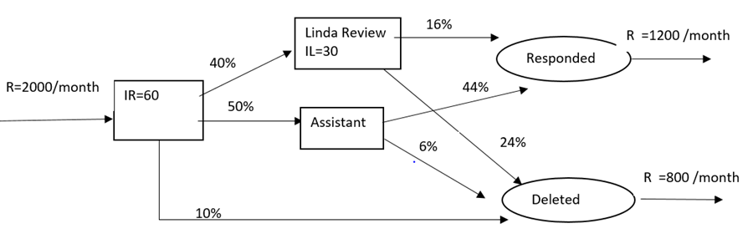

5. Average Flow time for Linda and Assistant to respond

Total time for Linda to do her review =TR+TL=0.6+0.75 =1.35 days with percentage 16%

Total time for Assistance to do the review =TR+TA =0.6+0.8 =1.4 days with percentage 44%

Hence Average time to respond mail

= (1.35*16%+1.4%*44%)/(16%+44%) = 1.3867 days

6. Average flow time for Linda and Assistance to delete the emails

Time for Initial deletion = TR =0.6 with percentage of 10%

Total time for Linda to delete email =TR+TL=0.6+0.75 =1.35 days with percentage 24%

Total time for Assistance to delete =TR+TA =0.6+0.8 =1.4 days with percentage 6%

Hence Average time to respond mail =(0.6*0.1+1.35*24%+1.4%*6%)/(10%+24%+6%) = 1.17 days

7. Check for Average time to complete the process

= T(Average time for responding)* (% of response)+(Average time of deletion )* (percentage of deletion) =1.387*0.6 +1.17*0.4 =1.3 days as calculated before.

**Problem 6: Project Problem**

Probabilities Inc. has an average of 150 new deliverable projects proposed to initiate every month. First, projects are budgeted; then they are sent to Development. All the projects that are going in will eventually be completed. 30% of these projects are critical and the rest are non-critical. On average 10 projects are waiting to get the budget estimate and 30 are already budgeted, but waiting to start IT development.

Budgeting will take an average of 2 days per project. The IT department has to spend 4 days for the critical projects and 12 days for the non-critical projects. Assume 30 days a month.

a) Draw the flow process chart

b) On average how long a will it take to complete a project?

c) On average how many projects are there for ABC Corporation?

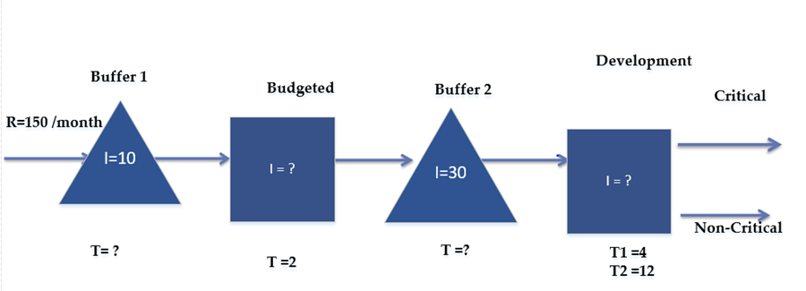

|  |  |  |  |  |
| --- | --- | --- | --- | --- |
|  | R | R per Day | I | Time in Days |
| Waiting Buffer 1 | 150 | 5 | 10 | 2 | T=I/R =10/5 |
| Budget Est | 150 | 5 | 10 | 2 |  |
| Waiting Buffer 2 | 150 | 5 | 30 | 6 |  |
| Development Average time | 150 | 5 | 48 | 9.6 | TD=30% *4+70%*12 |
| Average time of completion of the projects |  |  |  | 19.6 | 2+2+6+9.6 |

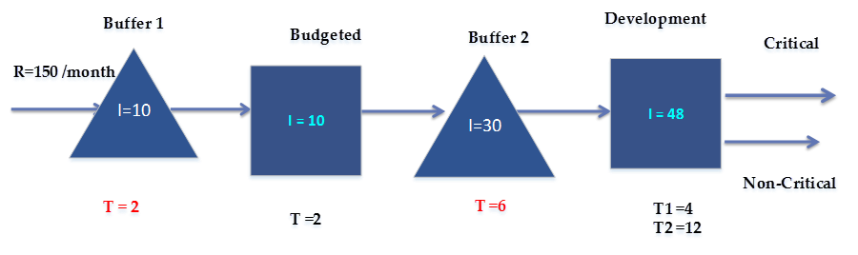

The updated flow chart with the numbers filled in is as follows

Total Inventory = 10+10+30+48 =98

Average flow time = 2+2+6+9.6 = 19.6 days

Average Flow time (Recheck) =I/R =98/5 = 19.6 days

**Scenario 2 :**

**As before-**

• 150 new deliverable projects proposed to initiate every month.

• On average 10 projects are waiting to get the budget. Budgeting will take an average of 2 days per project.

**Change-**

• The project management appoints a new Analyst. The new analyst will evaluate and categorize the projects as critical or non-critical. It will take a day for the analyst to do this.

• On Average there are 30 projects waiting for evaluation of the analyst.

• They also expect that there are 5 and 15 projects waiting in the development for critical and non-critical, respectively.

**As before-**

• 30% of the projects are critical and the rest are non-critical. The assumption is the analyst’s classifications are 100% accurate.

|  |  |  |  |  |
| --- | --- | --- | --- | --- |
|  | **R** | **R /day** | **I** | **T in days** |
| Waiting Buffer 1 | 150 | 5 | 10 |  |
| Budget Est | 150 | 5 |  | 2 |
| Waiting Buffer 2 | 150 | 5 | 30 |  |
| Analyst | 150 | 5 |  | 1 |
| Waiting Buffer3 | 45 | 1.5 | 5 |  |
| Dev-Critical (CR) | 45 | 1.5 |  | 4 |
| Waiting Buffer4 | 105 | 3.5 | 15 |  |
| Non Critical (NCR) | 105 | 3.5 |  | 12 |

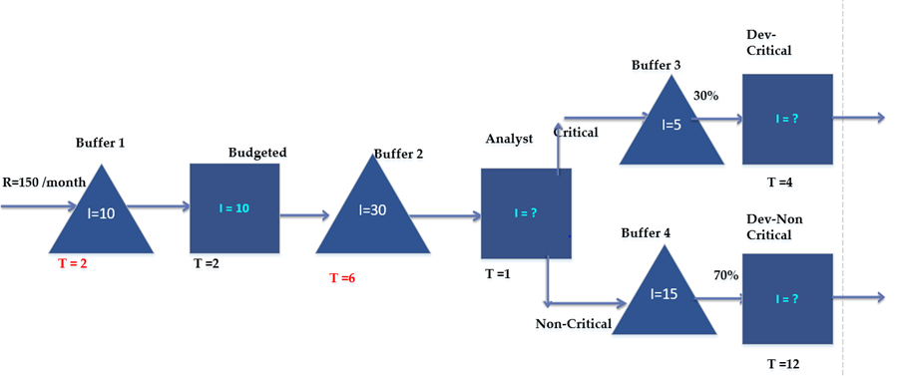

Using the Little’s Law, I= RT, the empty cells can be calculated as

|  |  |  |  |  |
| --- | --- | --- | --- | --- |
|  | R | R per Day | I | Time in Days |
| Waiting Buffer 1 | 150 | 5 | 10 | 2 |
| Budget Est | 150 | 5 | 10 | 2 |
| Waiting Buffer 2 | 150 | 5 | 30 | 6 |
| Analyst | 150 | 5 | 5 | 1 |
| Waiting Buffer 3 | 45 | 1.5 | 5 | 3.33333 |
| Dev-Critical (CR) | 45 | 1.5 | 6 | 4 |
| Waiting Buffer 4 | 105 | 3.5 | 15 | 4.28571 |
| Non Critical (NCR) | 105 | 3.5 | 42 | 12 |

* *Total Number of projects in the system = 10+10+30+5+5+6+15+42 = 123*
* *Average flow time =I/R =123/5 = 24.6 days*
* *Micro Method*
  + *TCR = 2+2+6+1+3.333+4 =18.333 (30% of the population)*
  + *TNCR=2+2+6+1+4.286+12 =27.286 (70% of the population)*
  + *Average flow time =0.3*18.333+0.7*27.286=24.6 days*

**Scenario 3**

As before everything is same, but the assumption that the analyst’s recommendation for categorizing Critical and Non-Critical is 100% has been changed. After going thru, the Development in Non-Critical category, it was discovered that the analyst’s estimate on 70% was inaccurate. The estimate to be in Non-Critical is really 65% and the rest should be critical.

a) Draw the Flow chart

b) What is the total Inventory?

c) What is the average flowtime?

|  |  |  |  |  |
| --- | --- | --- | --- | --- |
|  | R | R Per Day | I | Time in Days |
| Waiting Buffer 1 | 150 | 5 | 10 | 2 |
| Budget Est | 150 | 5 | 10 | 2 |
| Waiting Buffer 2 | 150 | 5 | 30 | 6 |
| Analyst | 150 | 5 | 5 | 1 |
| Waiting Buffer 3 |  |  | 5 |  |
| Dev-Critical (CR) |  |  | 0 | 4 |
| Waiting Buffer 4 | 105 | 3.5 | 15 | 4.28571 |
| Non-Critical (NCR) | 105 | 3.5 | 42 | 12 |

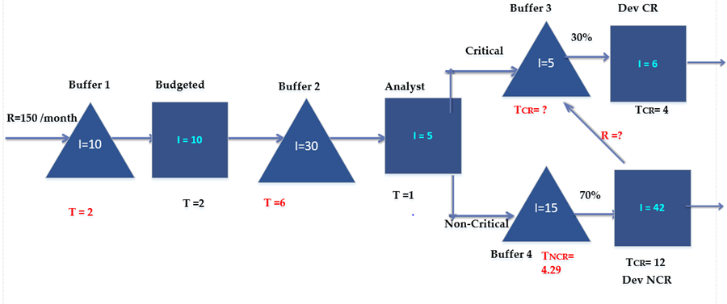

|  |  |  |  |  |  |
| --- | --- | --- | --- | --- | --- |
|  | **R** | **R per Day** | **I** | **Time in Days** |  |
| **Waiting Buffer 1** | 150 | 5 | 10 | 2 |  |
| **Budget Est** | 150 | 5 | 10 | 2 |  |
| **Waiting Buffer 2** | 150 | 5 | 30 | 6 |  |
| **Analyst** | 150 | 5 | 5 | 1 |  |
| **Waiting Buffer3** | 52.5 | 1.75 | 5 | 2.85714 | R=45+0.05*150 |
| **Dev-Critical (CR)** | 52.5 | 1.75 | 7 | 4 |  |
| **Waiting Buffer 4** | 105 | 3.5 | 15 | 4.28571 |  |
| **Non Critical (NCR)** | 105 | 3.5 | 42 | 12 |  |

• Total number of projects in the system= 10+10+30+5+15+42+5+7 =124

• Average flow time (Macro Method) =I/R =124/5 = 24.8 days

• Average flow time (Micro Method 1)

• TCR1 =2+2+6+1+2.857+4 = 17.857(30% of total)

• TCR2 =2+2+6+1+2.857+4+4.286+12 = 34.143 (5% of total)

• TNCR =2+2+6+1+4.286+12 = 27.286 = (65% of total)

• Average flow time =0.3*17.857+0.05*34.143+0.65*27.286 =24.8 days (Recheck)