

**DESC 656.64: Quantitative Analysis for Business Operations**

**Spring 2016**

*Professor: Dr. Asef-Vaziri Ardavan*

***Group Project – Study Guide***

*By Gina Cota and Sandra Mason*

Table of Contents

**Process Flow Analysis**3

Little’s Law & Process Analysis3

How to target improvements4

The Essence of Process Flow5

Problem Solving Examples5

**Process Capacity17**

Introduction17

Calculating Throughput18

Capacity & Takt Time19

Theoretical Capacity & Waste Factor22

Conclusion & Problem solving examples23

**Forecasting26**

Introduction26

Techniques & Components26

Time Series 27

Moving Average27

Mean Absolute Deviation29

Tracking Signal31

Exponential Smoothing32

Problem solving examples32

**Inventory38**

Introduction38

Classification & Models38

Economic Order Quantity38

Problem Solving Examples 39

Process Flow Analysis – Little’s Law

1. Define Little’s Law.

2. What is Process Flow Analysis?

Five elements of the process view

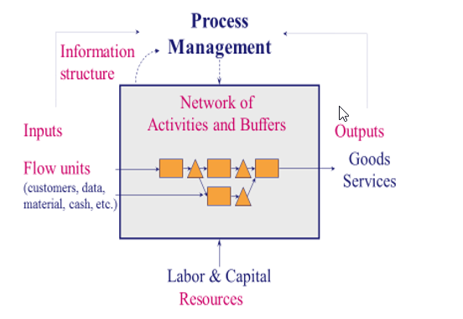

***\*Ardavan Asef-Vaziri***

How to target improvements?

Identify and monitor Operational performance measures.

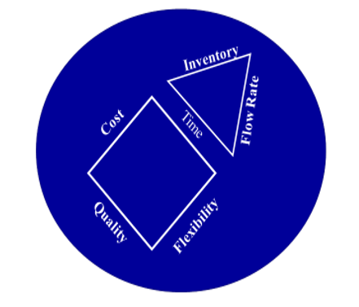

**Flow Time**: The time required by a flow unit to move through all the processes from entry to exit.

It is not the same for all flow units: there are different types of flow units & variability in the flow time of a flow unit.

Average flow time of a process is the average flow time of all flow units.

**Flow Rate**: The number of flow units passing a specific point (entry, exit or any intermediate point) in the process per unit of time.

It changes over time: variability in the flow rate & seasonality (e.g. tax season for a CPA)

Average flow rate in a stable process 🡪 Throughput

**Inventory**: The number of flow units within the boundaries of the process at any time.

The essence of Process Flow

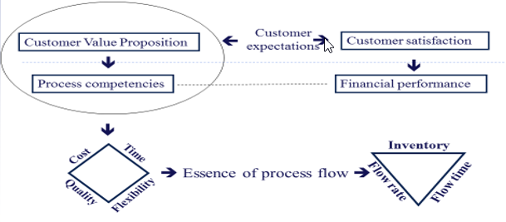

In a Stable Process, Average inflow rate is the same as average outflow rate.

Throughput (R) is the average flow rate. Ideally, R should be equal to the customer demand.

**Problem 1: “The Coffee Shop”**

You enter the Pepperdine bookstore to buy your textbooks. At this time of day, the entrance door opens 12 times per minute; 6 times for new students to come in, 6 times for students to leave.

a) **What is throughput, R, of this system**? Every minute, six students come in and six students leave. Therefore,



b) **There are 18 students in the check-out line, how long does it take you to pay for your books and leave?**

Applying Little’s Law, Throughput (R) x Flow Time (T) = Inventory (I). Therefore,

T = 18 students in line / 6 students per min



Now suppose there is an additional waiting line for online-order pickups. Suppose R is still 6 students per minute, and there are still 18 students on average in the first line to pay for their textbooks. 40% of the Students have made an online pre-purchase and must proceed from the first line to the second line for online-order pickups. There are six students in this second line.

**c) What is the flow time of a student who orders online?**

Students spend 3 minutes in the first line. T1 = 3 minutes.

Throughput of the second line is R= 0.4(6) = 2.4 students per minute.

Inventory of the second line is 6 students. Therefore,

R x T2 = I => 2.4 x T2 = 6 => T2 = 2.5 minutes

Store bought book, T = 3 minutes, online-order T = T1 + T2

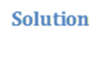

T = 5.5 minutes

d) **Assume a student is not only buying a book in-store, nor only made an online purchase, but s/he is both.** **What is the flow time of this student?** Applying Little’s Law to the entire system,

R x T = I= students/min x T = 24 students. Applying Little’s Law to the entire system, R x T = I

6 students/min x T = 24 students

**T=4 minutes**

Alternatively (self check):

60% students buy in store and take 3 minutes

40% students pre-order online and take 5.5 minutes

.6*3+.4*5.5=4 minutes

**Problem 2:** Monetary Flow

For the new euro introduction in 2002, Wim Duisenberg had to decide how many new Euro coins to stamp by 2002. Euroland’s central banks’ cash-in-coins handling was estimated at €300 billion per year. The average cash-in-coins holding time by consumers and businesses was estimated at 2 months. How many Euro coins were to be made?

R = 300 billion Euros/yr

T = 2 months = 1/6 yr

I = ?

Applying Little’s Law, R x T = I

300 billion euros/yr x ( 1/6 yr) = I

**I=50 Billion Euros**

**Problem 3**: The Pepperdine Westlake Campus recently opened a break room with an assortment of coffee, snacks, soda, and water. Assume it is open 10 hours a day. The administration observes that on average 300 students go in and out of the break room every day. They also observe that on average a student stays about 4 minutes.

**Question 1: How many students on average are waiting in the break room**?



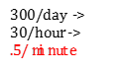  

R = 300 in 10 hours è R = 300/10 = 30 per hour

R = 30/60 = 0.5 per minute

T = 4 minutes

RT = I è I = 0.5(4) = 2 students are waiting

The Pepperdine administration is remodeling the break room to include more amenities to increase the number of students that utilize it per day. They expect the number of students to increase to 600 per day after the remodel. The administration would like to keep the line short with only 1 student waiting on average. Thus, one of the new amenities is an additional coffee station.

**Question 2**: **What is the average time a student will wait in line after all these changes**?



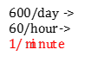 

R = 600 in 10 hours è R = 600/10 = 60 per hour

R = 60/60 = 1 per minute

I = 1

Average time a student will wait:

RT = I è T = I/R = 1/1 = 1 minute

**Question 3**: After the remodel and steady stream of students, the administration has decided to expand the Westlake Campus even more to include an on-site Starbucks. However, only one worker will staff the Starbucks so students must wait an average of 10 minutes. Suppose there is an average of 4 students waiting. The total number of students for both the break room and Starbucks remains at 600 per day, as it was after the remodel. But now it is divided between the break room and Starbucks. By how much has the amount of students at the break room decreased? Starbucks

  

At Starbucks we have:

I = 4 people and T = 10 minutes

RT = I è R(10) = 4 è R= 4/10= 2/5 per minute R = 60(2/5) = 24 students per hour or 24(10 hours per day) = 240 students/day

Activity at the break room has decreased by 240 students/day

**Questions 4 to 6**: Pepperdine’s Graduate Financial Aid Department processes 1,000 applications per year. Assume 50 weeks per year. The average processing time is 5 weeks. 50% of all the applications received are for the Merit Scholarships, 20% for the Endowed Scholarships, 10% for Private Scholarships and Grants, and the remaining are for Loans. On average, there are 40 Merit, 20 Endowed, 12 Private & Grants, and some Loan applications in the process.

**Question 4**: What is the average number of applications that are in the process?

R per week = 1,000/50 = 20 applications/week

RT = I

I = 20(5) = 100 applications waiting



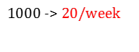

**Question 5**: How long, on average, does it take to process a Merit Scholarship application?

.5



I = 40 Merit Scholarships

R = 0.5(20) =10/week

RT = I è (10)T = 40

T = 40/10= 4 weeks

**Question 6**: How long, on average, does it take to process a Loan application?



Average # of applications in process = 100

100– 40 (Merit) –20 (Endowed) –12 (Private Scholarships & Grants) = 28

Average # of applications for a Loan: I = 28

Loan applications are 1- 0.5-0.2-0.1 = 0.2 of all applications

R = 0.2(20) = 4

RT = I è T = I/R è T = 28/4= 7 weeks

**Problems 5: Email Problem**

Linda receives 2000 emails per month. 60% of the emails did not require a response. The rest needed further investigation. The system can handle an average of 200 Emails. Assume 20 working days per month. What is the average flow time?

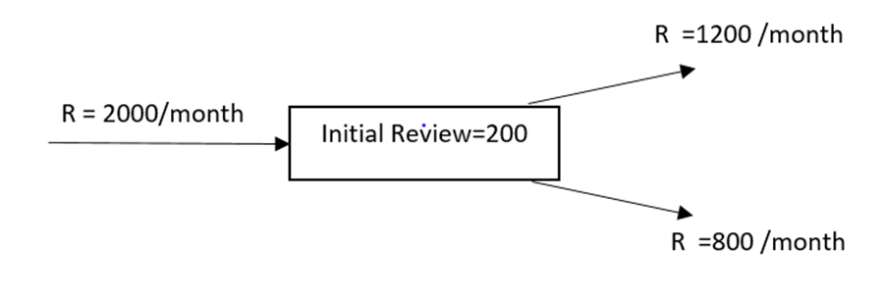

R = 2000 /month or 100 per day.

I =200

T = I/R = 200/100 =2 days.

Or average flow time is 2 days

Linda has an assistant now. Of the emails that come in, Linda deletes 10% right away and assigns 50% to her assistant for review. The rest she will review herself. Once reviewed the emails are either deleted or responded to. Assume there are 20 working days in a month.

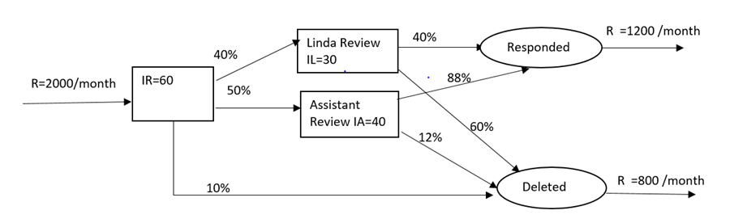

Given R =2000 /month =2000/20 per day =100 per day

Total Inventory =IR+IL+IA =60+30+40 =130 units.

The total inventory is less than the prior case.

Since R is a constant, and since I is reduced, T will be reduced.

T= I/R =130/100= 1.3 days.

After hiring the assistant, average flow time had reduced from 2 days to 1.3 days.

Let’s find the following

Compute average flow time.

Compute average flow time at Initial Review Process.

Compute average flow time for Linda.

Compute average flow time for assistant.

Compute average flow time of an email to respond.

Compute average flow time of an email to delete.

**1. Average Flow time for Initial Review** = TR= IR/R = 60/100 =0.6 days

**2. Average Flow time for Linda’s review**

a) Throughput for Linda’s process = RL =100*0.4=40 Emails per day

b) Average Inventory =IL=30

c) Hence Average Flow time for Linda’s process=TL = 30/40 =0.75 days

**3. Average Flow time for Assistance’s process**

a) Throughput for Assistance process = RA =100*0.5=50 Emails per day

b) Average Inventory =IR=40

c) Hence Average Flow time for Assistance’s process=TA = 40/50 =0.8 days

**4. The routing of each flow unit in the most granular level**

|  |  |  |  |
| --- | --- | --- | --- |
| a) | IR | IL | Accepted |
| b) | IR | IL | Deleted |
| c) | IR | IA | Accepted |
| d) | IR | IA | Deleted |
| e) | IR |  | Deleted |

The percentages of each of the above 5 flow units

f) 100% 100%*40% 100%*40%*40%

=> 100% 40% 16%

**Same as in f) , the following percentages of the flow can be calculated.**

g) 100% 40% 24%

h) 100% 50% 44%

i) 100% 50% 6%

j) 100% 10%

**This can be represented as in the following flow chart.**

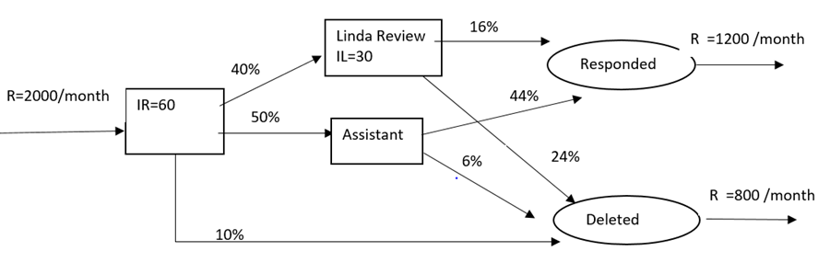

5. Average Flow time for Linda and Assistant to respond

Total time for Linda to do her review =TR+TL=0.6+0.75 =1.35 days with percentage 16%

Total time for Assistance to do the review =TR+TA =0.6+0.8 =1.4 days with percentage 44%

Hence Average time to respond mail

= (1.35*16%+1.4%*44%)/(16%+44%) = 1.3867 days

6. Average flow time for Linda and Assistance to delete the emails

Time for Initial deletion = TR =0.6 with percentage of 10%

Total time for Linda to delete email =TR+TL=0.6+0.75 =1.35 days with percentage 24%

Total time for Assistance to delete =TR+TA =0.6+0.8 =1.4 days with percentage 6%

Hence Average time to respond mail =(0.6*0.1+1.35*24%+1.4%*6%)/(10%+24%+6%) = 1.17 days

7. Check for Average time to complete the process

= T(Average time for responding)* (% of response)+(Average time of deletion )* (percentage of deletion) =1.387*0.6 +1.17*0.4 =1.3 days as calculated before.

**Problem 6: Project Problem**

Probabilities Inc. has an average of 150 new deliverable projects proposed to initiate every month. First, projects are budgeted; then they are sent to Development. All the projects that are going in will eventually be completed. 30% of these projects are critical and the rest are non-critical. On average 10 projects are waiting to get the budget estimate and 30 are already budgeted, but waiting to start IT development.

Budgeting will take an average of 2 days per project. The IT department has to spend 4 days for the critical projects and 12 days for the non-critical projects. Assume 30 days a month.

a) Draw the flow process chart

b) On average how long a will it take to complete a project?

c) On average how many projects are there for ABC Corporation?

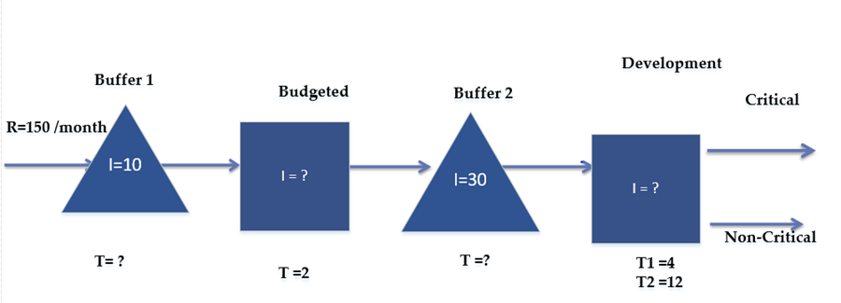

|  |  |  |  |  |
| --- | --- | --- | --- | --- |
|  | R | R per Day | I | Time in Days |
| Waiting Buffer 1 | 150 | 5 | 10 | 2 | T=I/R =10/5 |
| Budget Est | 150 | 5 | 10 | 2 |  |
| Waiting Buffer 2 | 150 | 5 | 30 | 6 |  |
| Development Average time | 150 | 5 | 48 | 9.6 | TD=30% *4+70%*12 |
| Average time of completion of the projects |  |  |  | 19.6 | 2+2+6+9.6 |

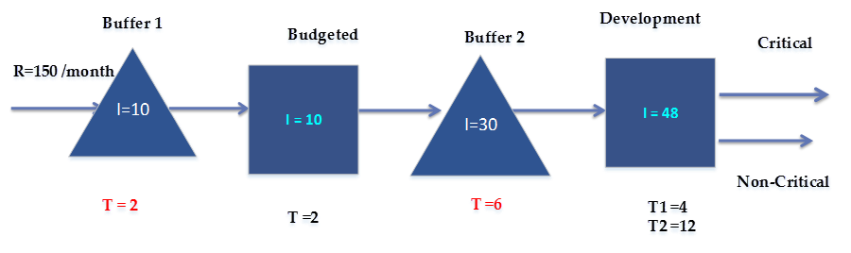

The updated flow chart with the numbers filled in is as follows

Total Inventory = 10+10+30+48 =98

Average flow time = 2+2+6+9.6 = 19.6 days

Average Flow time (Recheck) =I/R =98/5 = 19.6 days

**Scenario 2 :**

**As before-**

• 150 new deliverable projects proposed to initiate every month.

• On average 10 projects are waiting to get the budget. Budgeting will take an average of 2 days per project.

**Change-**

• The project management appoints a new Analyst. The new analyst will evaluate and categorize the projects as critical or non-critical. It will take a day for the analyst to do this.

• On Average there are 30 projects waiting for evaluation of the analyst.

• They also expect that there are 5 and 15 projects waiting in the development for critical and non-critical, respectively.

**As before-**

• 30% of the projects are critical and the rest are non-critical. The assumption is the analyst’s classifications are 100% accurate.

|  |  |  |  |  |
| --- | --- | --- | --- | --- |
|  | **R** | **R /day** | **I** | **T in days** |
| Waiting Buffer 1 | 150 | 5 | 10 |  |
| Budget Est | 150 | 5 |  | 2 |
| Waiting Buffer 2 | 150 | 5 | 30 |  |
| Analyst | 150 | 5 |  | 1 |
| Waiting Buffer3 | 45 | 1.5 | 5 |  |
| Dev-Critical (CR) | 45 | 1.5 |  | 4 |
| Waiting Buffer4 | 105 | 3.5 | 15 |  |
| Non Critical (NCR) | 105 | 3.5 |  | 12 |

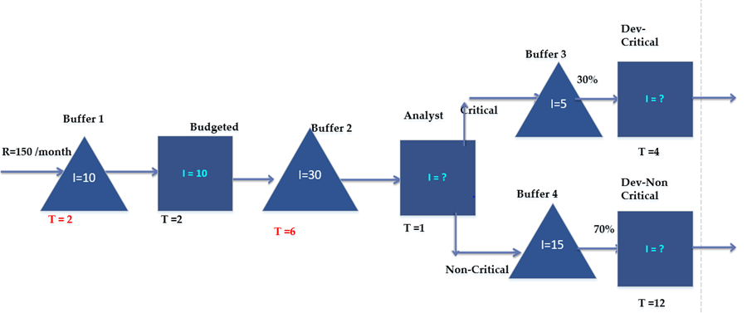

Using the Little’s Law, I= RT, the empty cells can be calculated as

|  |  |  |  |  |
| --- | --- | --- | --- | --- |
|  | R | R per Day | I | Time in Days |
| Waiting Buffer 1 | 150 | 5 | 10 | 2 |
| Budget Est | 150 | 5 | 10 | 2 |
| Waiting Buffer 2 | 150 | 5 | 30 | 6 |
| Analyst | 150 | 5 | 5 | 1 |
| Waiting Buffer 3 | 45 | 1.5 | 5 | 3.33333 |
| Dev-Critical (CR) | 45 | 1.5 | 6 | 4 |
| Waiting Buffer 4 | 105 | 3.5 | 15 | 4.28571 |
| Non Critical (NCR) | 105 | 3.5 | 42 | 12 |

* *Total Number of projects in the system = 10+10+30+5+5+6+15+42 = 123*
* *Average flow time =I/R =123/5 = 24.6 days*
* *Micro Method*
  + *TCR = 2+2+6+1+3.333+4 =18.333 (30% of the population)*
  + *TNCR=2+2+6+1+4.286+12 =27.286 (70% of the population)*
  + *Average flow time =0.3*18.333+0.7*27.286=24.6 days*

**Scenario 3**

As before everything is same, but the assumption that the analyst’s recommendation for categorizing Critical and Non-Critical is 100% has been changed. After going thru, the Development in Non-Critical category, it was discovered that the analyst’s estimate on 70% was inaccurate. The estimate to be in Non-Critical is really 65% and the rest should be critical.

a) Draw the Flow chart

b) What is the total Inventory?

c) What is the average flowtime?

|  |  |  |  |  |
| --- | --- | --- | --- | --- |
|  | R | R Per Day | I | Time in Days |
| Waiting Buffer 1 | 150 | 5 | 10 | 2 |
| Budget Est | 150 | 5 | 10 | 2 |
| Waiting Buffer 2 | 150 | 5 | 30 | 6 |
| Analyst | 150 | 5 | 5 | 1 |
| Waiting Buffer 3 |  |  | 5 |  |
| Dev-Critical (CR) |  |  | 0 | 4 |
| Waiting Buffer 4 | 105 | 3.5 | 15 | 4.28571 |
| Non-Critical (NCR) | 105 | 3.5 | 42 | 12 |

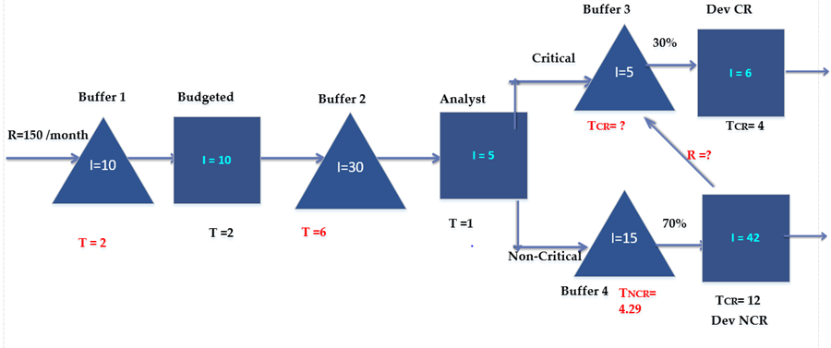

|  |  |  |  |  |  |
| --- | --- | --- | --- | --- | --- |
|  | **R** | **R per Day** | **I** | **Time in Days** |  |
| **Waiting Buffer 1** | 150 | 5 | 10 | 2 |  |
| **Budget Est** | 150 | 5 | 10 | 2 |  |
| **Waiting Buffer 2** | 150 | 5 | 30 | 6 |  |
| **Analyst** | 150 | 5 | 5 | 1 |  |
| **Waiting Buffer3** | 52.5 | 1.75 | 5 | 2.85714 | R=45+0.05*150 |
| **Dev-Critical (CR)** | 52.5 | 1.75 | 7 | 4 |  |
| **Waiting Buffer 4** | 105 | 3.5 | 15 | 4.28571 |  |
| **Non Critical (NCR)** | 105 | 3.5 | 42 | 12 |  |

• Total number of projects in the system= 10+10+30+5+15+42+5+7 =124

• Average flow time (Macro Method) =I/R =124/5 = 24.8 days

• Average flow time (Micro Method 1)

• TCR1 =2+2+6+1+2.857+4 = 17.857(30% of total)

• TCR2 =2+2+6+1+2.857+4+4.286+12 = 34.143 (5% of total)

• TNCR =2+2+6+1+4.286+12 = 27.286 = (65% of total)

• Average flow time =0.3*17.857+0.05*34.143+0.65*27.286 =24.8 days (Recheck)

Process Capacity

# **Introduction**

*Throughput* is the movement of inputs and outputs through a production process over a measurable time period. Throughput is used throughout the business world and helps companies measure their efficiency. For example, in business, throughput is the rate at which an organization reaches a given goal.

The concept of throughput is evident in every type of process and every type of unit. The process can be either a service or manufacturing process such as filing taxes, manufacturing a product or producing toys in a factory. One of the best examples of throughput in the foodservice industry is Chic-fil-A. Throughput, in this case, is the amount of time customers have to wait in line for their order. At Chic-fil-A, a customer rarely waits longer than 4 minutes from the time they get in line to having their tray of food. The process is simple, keep the menu limited and options limited. The customer is waited on by a cashier and while the cashier process your payment and delivers your drink, your food is ready for you.



Before we dive into throughput, it is important to understand where this concept came from. Throughput was mentioned when we discussed the Little’s Law. Here is a refresher:

***Little’s Law:***

Inventory= Throughput (R) x Time

Throughput= Inventory/Unit of time

Inventory= (Inventory/Unit of time) x Time

Symbolic Representation of the Equation:

I=R x T

Throughput is vital to measuring many different aspects of a production process. Without throughput, there would be no way to calculate the amount of time it takes for a unit to go through a whole system or specific subsystems. Similarly, without throughput there would be no way to calculate inventory within any process, whether it be manufacturing or service.

**CALCULATING THROUGHPUT**

Now the big question is: how do we calculate throughput. There are a multitude of factors to consider when calculating throughput. Are we examining the process at a peak time or are we examining it at a slow time? This concept is known as variability. Throughput is calculated in any process in three steps:

1. Witnessing the process multiple times

2. Calculating the number of elements that go into any system or subsystem per unit of time

3. Calculating the average of those calculated rates

For example, Brie wants to know the number of customers that, on average, go in and out of her fresh pressed juicery. This will help Brie determine her staffing schedule for the week. She wants to ensure she has the right amount of workers during peak and slow times in order to maximize profit. She collected the following data.

|  |  |
| --- | --- |
| 8 AM | 3 Customers/minute ()n Average) |
| 9 AM | 4 Customers/Min (On Average) |
| 10 AM | 1 Customer/Min (On Average) |
| 11 AM | 2 Customers/Min (On Average) |
| 12 PM | 5 Customers/Min (On Average) |
| 1 PM | 2 Customers/Min (On Average) |

In order to calculate throughput, you have to add the total number of customers divided by the number of hours.

Number of customers: 3+4+1+2+5+2= 17

Number of hours: 6

17/6= 2.83

Throughput= 2.83

Based on these calculations, she can determine that the average number of customers that visit her store per minute is 2.83 people/min.

This is a good example of how throughput can be described in the context of a flow system. In these cases, throughput can also be considered the average rate in which an object flows.

**CAPACITY**

A concept that is similar to throughput is capacity. While throughput is often seen as the rate of production, capacity is the maximum that can be produced on a machine, in a facility or group. Average throughput can be anywhere below capacity value. Throughput values for that specific process cannot exceed the capacity.

**CYCLE TIME AND TAKT TIME**

Cycle time is the total time from the beginning to the end of your process, as defined by you and your customer. Cycle time includes process time and takes place at the maximum capacity of unit inflows. On the other hand, throughput, the number of inflow of units per unit of time, focuses on the external demand for the specific process. Takt time is different from cycle time because it is more closely related to throughput. In addition, Takt time, unlike cycle time, focuses on external demand and measures how long an entire process takes at the average throughput or demand. Here

*Cycle Time= 1/Capacity*

*Takt time= 1/Throughput (Demand)*

Suppose Brie has a capacity of 30 people per hour. Her cycle time for the capacity would be:

*Cycle Time= 1/30 hours x 60 min/hour= 2 min*

Suppose Brie has an average throughput of 15 customers per hour coming in to her juicery. Her Takt time would be:

*1/15 x 60 min/hour= 4 min*

An important rule to remember is that are the important formulas for both: capacity should always be greater than throughput. This rule also ensures that cycle time will always be less than Takt time. It is important to keep these rules in mind because you need to know why they make sense to an organization. Once you have an understanding of these equations, you can apply concepts to make effective decisions within the workplace. As managers, if we want a smooth flow, we want to make the largest amount of product in the shortest amount of time. Therefore, our goal should always be to maximize capacity and throughput. This, in turn, also ensures that we decrease Takt and cycle time in order to increase efficiency.

**TERMS AND SYMBOLS RELATING TO THROUGHPUT AND CAPACITY**

From here on out, we will be using shorthand to describe throughput and capacity. Ra will refer to throughput and Rp will refer to capacity. In all problems related to throughput and capacity, we will be given resources. These resources can be people or objects performing each activity or sub process of an entire process. We will often encounter the unit load of a resource unit, or Tp for shorthand. Tp represents how long a resource needs to work for each flow unit produced. Once you have Tp, you can calculate capacity.

**THE PROCESS OF EFFECTIVE CAPACITY, THROUGHPUT, AND UTILIZATION**

Throughput, demand and capacity all help determine utilization. Utilization is the primary method by which asset performance is measured and business success determined. In basic terms, it is a measure of the actual revenue earned by assets against the potential revenue they could have earned. Once you have calculated effective capacity for resources, you compare it with demand or throughput to see the maximum capacity our individual activities are able to withhold. This leads us to determining our utilization which will help us make an efficient decision.

**CALCULATING EFFECTIVE CAPACITY FOR RESOURCE UNITS AND THEIR CORRESPONDING POOL**

Capacity is the maximum amount of resources a process can handle. There are two types of capacity: theoretical and effective. Theoretical takes into account Capacity Waste Factor while Effective does not. Continuing from the previous lesson of capacity, we can expand it to find out the effective capacity of each resource unit and resource pool. We, then, use the pool capacity (claims/min) to determine how many units are capable of going through a system each day or each month. This gives us great insight into the way the business is run, where it’s going, and where it could be.

***EXAMPLE***

You’ll go through this example to measure the effective capacity of each individual resource unit, such as workers, and the resource pool, which totals how many worker units the company has per resource position. We can then use these figures and the amount of hours that the workers work to determine utilization based on a throughput value.

In this example, we will review the overall process of Pepperdine’s Counseling Service. We will observe the number of people that enter the office and utilize the resources daily. We will also see the demand in comparison to the capacity each resource (worker) is capable of doing. By doing this, we can calculate utilization. Through this number, we will see if the counseling service office needs to do more advertising in order to reach out to more students.

The counseling office consists of two kinds of workers: A receptionist and a Counselor. There is one receptionist checking in patients at the front desk. There are five counselors giving therapy to students who walk in the door. The receptionist spends a maximum of 1.5 minutes checking in each student. The counselor spends a maximum of 60 min with each student in therapy. Using this information, we want to find out the effective capacity of each resource unit. In order to do this, we need to inverse the fraction. 1.5 minutes becomes 1/1.5 minutes. And 60 minutes becomes 1/60. We are turning min/claim into claims/minute. This is to give us an easier time calculating effective capacity. We then multiply the claim per minute by the number of resources, or workers, on the scene. We only have one receptionist. However, we have 5 counselors.

|  |  |  |
| --- | --- | --- |
| Effective Capacity of Resource Unit (1/TP) | Multiplied by | # of Resource Units in POC |
| 0.66666667 | x | 1 |
| 0.01666667 | x | 5 |

We do this because we need to find the capacity of the entire resource pool, so we can see what area of the process is the bottleneck of the entire process. The bottleneck of the process will be the resource with the minimum capacity. The number of people working on the job matters in how the job gets done. The first line contains the values of the receptionist; the second line contains the values of the counselors.

Now that we have the effective capacity of the resource pool, in other words, claims that they can handle per minute, we can calculate how many claims, or students, they can serve in a day. We do this by multiplying these values by the number of minutes they work in their shift. Both the receptionist and Counselors work 540 minutes in their daily shift. We multiply the effective capacity of the resource pool for each position by 540 to come to the number of people they are capable of serving a day.

|  |  |  |  |  |
| --- | --- | --- | --- | --- |
| Effective Capacity of Resource Unit (1/TP) | Multiplied By | Available Minute/Day | Equals | Daily Effective Capacity of Resource Pool |
| 0.66666667 | X | 1 | = | 360 |
| 0.01666667 | X | 5 | = | 45 |

The receptionist can serve a maximum of 360 people during his shift, while the counselors can only serve a maximum of 45 people per shift. Throughput for the counseling services has been calculated. It is 35 students in one day.

Using the current daily demand, we can compare it to the maximum effective capacity that each resource pool serves per day. We do so by dividing throughput by the capacity of each resource pool. We turn this into a percentage which gives us the utilization value.

|  |  |  |
| --- | --- | --- |
| Daily Effective Capacity of Resource Pool | Throughput (R) | Utilization (R/Effective Capacity) |
| 360 | 35 | 10% |
| 45 | 35 | 78% |

What does this tell us? Given the current demand, the receptionist only utilizes 10% of his capacity. Also, this table shows that given the current demand, the counselors utilize 78% of their capacity. Using these numbers, those who run the counseling services may decide to broadcast their services in order to reach out to the student population. As we all know, depression and suicide can be a major problem among young adults. Perhaps they may see a greater need to reach out to the student population more than ever before. They will have the quantitative capabilities to do so in addition to their qualitative motivations. Given the information from this specific case, we can also calculate values that we touched upon earlier

**OTHER CALCULATIONS**

*Rp (Capacity): 45*

*Cycle Time: 1/45*5*540=60*

*R (Throughput): 35*

*Takt Time: 1/35 *5*540=77*

*Flow Time: 60 + 1.5= 61.5*

**THEORETICAL CAPACITY AND CAPACITY WASTE FACTOR**

The effective capacity of a resource is defined as 1/TP. Unit load, a.k.a TP, is the time of production of a specific resource including any wasted time. If we want to calculate theoretical capacity, we first have to measure theoretical unit load. Theoretical unit load is the time of production of a resource unit with no wasted time included. This is also known as the most ideal situation a manager could be faced. Ideally, you do not want to have any wasted time, however, processes are not perfect. Your job is to create the least amount of waste time in your process.

*Effective Capacity= c/Tp (Unit load)*

*Theoretical Unit load= Tp * (1-CWF) (Capacity Waste factor)*

*Theoretical Capacity= c/Theoretical Unit load*

In these types of cases, capacity waste factor represents a percentage amount of time that was wasted due to set- ups or perhaps break downs. In these cases, the capacity waste factors will be given in each problem.

For example, in a nail salon, on average it takes a nail technician 45 minutes to give a client a manicure/pedicure. It has been determined that there is a capacity waste factor of 10% because the nail technician has to wait 3 minutes until the nails dry to finish the process. Here are the calculations:

*Unit Load= 45 min*

*Effective Capacity= c/Tp= 1/45*60min per minute or 1.3 per hour*

*Theoretical Unit Load= Tp*(1-CWF) = 45*(1-.10) =40.5*

*Theoretical Capacity= c/Theoretical Tp= 1/40.5 or .675 per hour*

**CONCLUSION.**  Understanding these concepts is crucial to creating a utilization percentage. Utilization will tell you how well your company is doing and can indicate your company’s weak points. You can see how far the business would be comfortable in increasing customer numbers without reaching the capacity and stressing workers. Or, perhaps, you can see how many customers a business needs to hire in order to find a new bottleneck and improve capacity or lessen time. At the same time, as managers, it is imperative to eliminate as many non-value added activities that account for Capacity Waste factor. By eliminating these types of activities, we will see that our Effective capacity will increase. Our goals must be to maintain that effective capacity as close as possible to the theoretical capacity. This will ensure our process is running smoothly by eliminating non-value added activities.

**PROBLEM 1:** On average, it takes a mechanic 30 minutes to do an oil change. During those 30 minutes, 5 of those minutes is wasted by the mechanic while he waits for the lift station to become available. If the mechanic works ten hours per day, what is his simple and theoretical capacity?

*CWF= 5/30= 0.166 or 17%*

*Unit load (Tp): 30 min*

*Effective Capacity= 1/Tp= 1/30*60= 2/hr.*

*Or 2/hr.* 10rhs/day= 20/day*

*Theoretical Unit Load (Ttp) = Tp-(1-.17) = 30min *.83=24.9 min*

*Theoretical Capacity: 1/TTP= 1/24.9*60= 2.41/hr.*

*Or 2.41/hr.*10hrs/day= 24.1*

This means that if the mechanic did not waste any time during oil changes, he would be able to do 4 extra oil changes per day. Now with this data, he can focus on decreasing his non value added activities so he can increase capacity.

**PROBLEM 2:** iFlora flower Company provides custom flower arrangements for wedding and funeral ceremony. Both flower arrangements need to go through the process of cutting, sorting and arrangement processes. For the wedding arrangement the cutting process takes 1 hours, the sorting takes 2 hours, and arrangement process takes 6 hours. On the other hand, the funeral arrangements requires 2 hours in the cutting, 3 hours in the sorting, and 5 hours in the arrangement. There are 8 hours in each working day. There are two people in the cutting process, four people in sorting process, and five people in arrangement process.

What is the capacity for each resource, and their corresponding pool?

|  |  |  |  |  |
| --- | --- | --- | --- | --- |
|  | Unit Load: Welding | Unit Load: Funeral | Unit Load:  60% Welding  40% Funeral | Number of Resources |
| Cutting | 1 Hour | 2 Hours | 1.4 Hours | 2 |
| Sorting | 3 Hours | 3 Hours | 2.4 Hours | 4 |
| Arrangement | 6 Hours | 5 Hours | 5.6 Hours | 8 |

*Cutting:*

*Unit load (Tp) = 1.4 hours*

*Capacity= 1/Tp= 1/1.4 hours*

*Sorting:*

*Unit load (Tp) = 2.4 hours*

*Capacity= 1/Tp= 1/2.4 hours*

*Arrangement:*

*Unit load (Tp) = 2.6 hours*

*Capacity= 1/Tp=1/2.6 hours*

|  |  |  |  |  |
| --- | --- | --- | --- | --- |
|  | Capacity per resource | *Number of resources* | *Capacity of Pool* | *Effective Capacity of R-pool per day (X8hours)* |
| Cutting | 11.4 hrs | 2 | 1.42/hr | 11.36/Day |
| *Sorting* | ½.4 hrs | 4 | 1.67/hour | 13.36/Day |
| *Arrangement* | ½.6 hrs | 5 | 3.08/hr | 24.64/Day |

In this case the bottleneck of this system is the cutting process because it is the one with the least capacity out of the entire pool

Cycle time= 8 hours /1.42= 5.6 hours

**PROBLEM 3.** Wan Fu Company produces many types of teas which manufactures around Asian. All of their teas have to go through a steaming process, drying & rolling process, and a roasting & blending process. However, every single process can only handle a certain demand for each type of tea. There is a demand 1,000,000 units for the month of April; half of the well-known Red tea, and the other half for the Green tea. Wan Fu manufactures the teas by orders of 1,000 units. In order to complete a Green tea order, it need to spend two hours in the steaming process, 8 hours in the drying & rolling process, and 4 hours in the roasting & blending department. On the other hand, the Red tea, on average, it spends three hours in the steaming process, six hours in the drying and rolling, and six hours in the roasting & blending process. What is the theoretical capacity for each resource, and their corresponding pool?

|  |  |  |  |  |
| --- | --- | --- | --- | --- |
|  | Unit Load: Green | Unit Load: Red | Unit Load:  50% Green  50% Red | # of Resources |
| Steaming | 2hrs/order | 3hrs/order | 2.5hrs/order | 2 Machines |
| Drying & Rolling | 8hrs/order | 6hrs/order | 7hrs/order | 5 Machines |
| Roasting & Blending | 4hrs/order | 6hrs/order | 5hrs/order | 4 Machines |

*Steaming:*

*Unit load (Tp) = 2.5hrs/order*

*Capacity= 1/Tp= 1/2.5hr*

*Drying & Rolling:*

*Unit load (Tp) = 7hrs/order*

*Capacity= 1/Tp= 1/7hr*

*Roasting & Blending:*

*Unit load (Tp) = 5hrs/order*

*Capacity= 1/Tp= 1/5hr*

|  |  |  |  |  |
| --- | --- | --- | --- | --- |
|  | Capacity/Resource | # of Resources | Capacity of Pool Resource | Capacity of R-Pool/Day |
| Steaming | ½.5hrs | 2 | 0.8/hr | 6.4/Day |
| Drying & Rolling | 1/7hrs | 5 | 0.71/hr | 5.7/Day |
| Roasting & Blending | 1/5hours | 4 | 0.8/hr | 6.4/Day |

Cycle time= 8 hours/ 5.7= 1.40 hours

FORECASTING

# **Introduction**

Forecasting is the prediction of the future value of a variable of interest, such as demand. It is required in many business functions. There are various types of forecasting. Accounting forecasting is used to provide cost and revenue estimates, while Finance forecasting is used to estimate cash flow. Forecasting appears in HR by the use of hiring and training plans, marketing for pricing and promotion, and operations for production planning.

The various types forecasting techniques include qualitative techniques and quantitative techniques. An example of a qualitative technique is Delphi, which is the use of subjective information (e.g. expert opinions, market surveys) to determine forecast values. Some examples of quantitative forecasting techniques are time series analysis and causal relationship forecasting. Time series analysis is utilized in the analysis of data in a given time period to determine whether or not there is a trend or pattern that exist over time.

**All forecasts have four common characteristics**.

1. Forecasts are usually wrong.

2. Forecasts should be accompanied by a measure of forecast error.

3. Aggregate forecasts are more accurate than individual forecasts.

4. Long-range forecasts are less accurate than short-range forecasts.

**Delphi**

Delphi is a forecasting technique, which uses the opinions of experts of a specific field to obtain a forecast of that respective field. It is based on intuition and estimates focusing on expert opinions, market research, and historical analogies.

**Time Series Techniques**

Time series is a type of forecasting technique, which uses data from the past hoping to find a trend for the future. Although time series can measure any variable of interest, we will focus on measuring the variable of demand unless stated otherwise. Time series shows systematic and random components.

**There are three different types of systematic components.**

• Level: Where demand is predicted to be present

• Trend: Growth or decline (this will change upward or downward over time)

• Seasonality: Predictable fluctuations

We can identify and quantify systematic components, but there is no way to predict or control random components. This is why forecasts will never be 100 percent accurate because we are assuming random conditions can be predicted.

The following sections discuss 3 popular time series techniques - Naïve Forecast, Moving Average, and Exponential Smoothing.

**Naïve Forecast**

Naïve forecast obtains its values for the next period by using the values for actual in the current period. Thus, the naïve forecasting method is inexpensive, simple and easy. Its simple derivation makes it ideal to use as a base to compare it to the quality of other forecasting techniques. If the quality of other forecasting techniques is lower than naïve forecasting, then the latter is always preferred. The following formula further emphasizes the simplicity of the Naive Forecast Method.

Ft+1 = At

Ft+1 = Forecast for the period after t

At = Actual demand in period t

**Moving Average**

This technique uses the average of the most recent actual data in a certain period to forecast the next period. As time passes, there is more information about the actual demand. Moving Average (MA) calculates the forecast using the newest pieces of data and removes the oldest data.

**Examples of Moving Average:**

Two period moving average for period 7:

MA72 = (A6+ A7)/2

Three period moving average for period 7:

MA73 = (A5+ A6 + A7 )/3

There is no actual limitation on how many periods should be used when calculating moving average. The general formula to calculate moving average for any n period moving average for period t is as follows:

MAtn = (At+ At-1+ At-2 +At-3+ ….+ At-n+1 )/n

At = Actual demand in period t

n = Number of periods in the moving average

The moving average calculated from the current period becomes the next period's forecast, therefore we can assume the moving average formula as follows:

Ft+1 =MAtn

Ft+1 = Forecast for the period after t

**Example - Moving Average Forecast**

Hot Wireless (a cellular phone company) is attracting more and more customers as time passes, but it still does not produce enough revenue to maintain a large inventory. The manager likes to have low inventory levels due to new models being released into the market and making current smartphones that have been in circulation for less than a year obsolete. The data is summarized below.

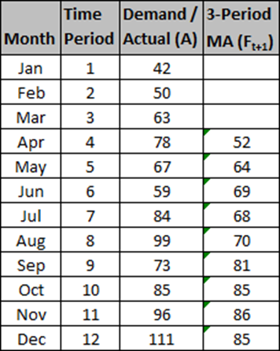

MA113 = (96+85+73)/3 = 85

F12 = 85

For a better understanding of the demand, the moving average can be calculated with different periods. The table below shows the results of a 6-period moving average calculation compared to the 3-period moving average previously calculated.

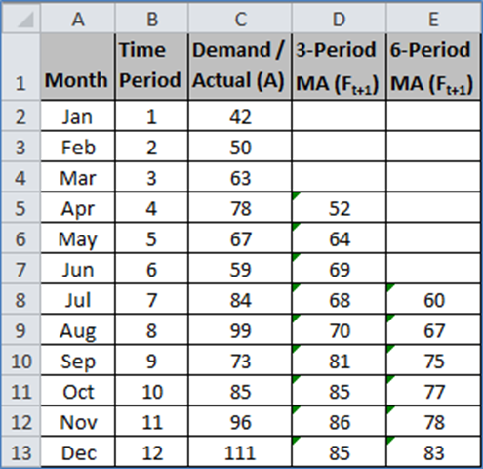

The graph below visually displays the same data in the table above.

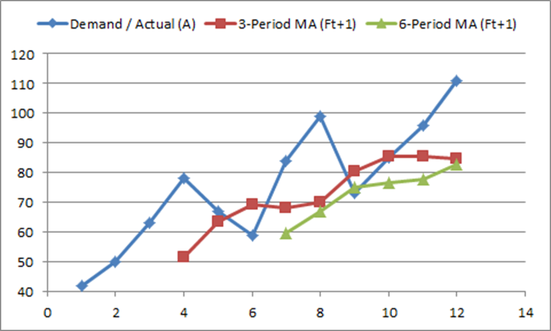

The 3-period moving average is more reactive to the changes in demand due to the smaller, more recent sample size. The 6-period moving average is less reactive due to the larger sample size which takes into account historical data. The smaller period moving average is better to forecast the demand in the short term, while the larger period moving average is better to forecast demand in the in the long term.

**Excel Tip**

To create the formula that will auto-calculate the 3-period moving average, refer to cell D5 in the above table. Select the cell and type in the formula below.



Excel will return a value of 52. Once this is complete, copy the formula into the cells in column D up to D13. The same operation can be performed for the 6-period moving average. Enter the formula below in cell E8 and copy down to E13.



**Mean Absolute Deviation**

The Mean Absolute Deviation (MAD) is used to determine the deviation of the forecasts compared with the actual numbers of a given period. The purpose of calculating MAD is to determine the effectiveness of the forecast. The smaller the MAD value, the better the forecasting technique will be. To find the mean error, absolute values are required. The formula for MAD is stated below.

MAD = ( | At - Ft |) / Number of Periods

At = Demand (Actual) for period t

Ft = Forecast for period t

**Example - Comparison of 3-Period MA MAD and 6-Period MA MAD**

The manager of Hot Wireless has seen the data for 3-Period MA and 6-Period MA and wants to determine which forecasting technique is better. MAD is calculated for each of the periods and is displayed below.

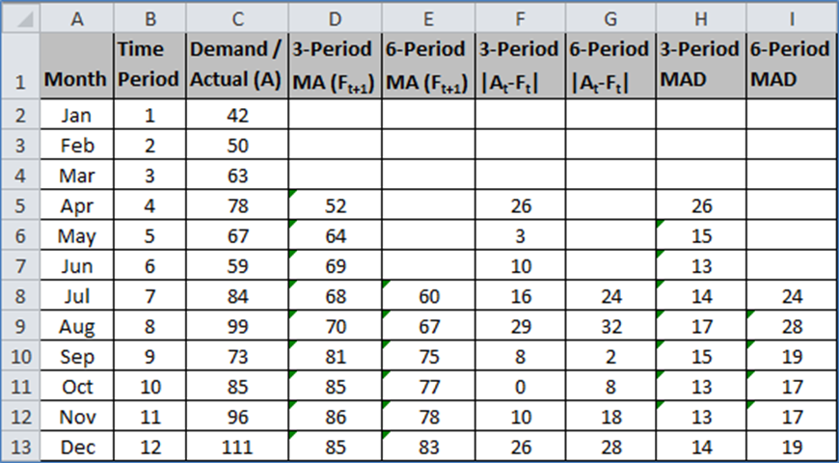

MAD, 3-Period MA = (16+29+8+0+10+26) / 6 = 14

MAD, 6-Period MA = (24+32+2+8+18+28) / 6 = 19

The MAD calculation started in July (period 7) because this is when both techniques had data for the given time period. Although there is forecasting data for the 3-Period MA for April, May, and June; it cannot be used since there is no equivalent data for the 6-Period MA.

Per the calculation above, the 3-Period MA MAD is 14 and the 6-Period MA MAD is 19. Since 14 is smaller than 19, the 3-Period MA MAD is the better forecasting method.

**Excel Tip**

To calculate MAD, the absolute difference between actual and forecast values must be performed. Enter the following formula in F5 and copy down to F13 for the 3-Period absolute difference between actual and forecast values.



Enter the following formula in G8 and copy down to G13 for the 6-Period absolute difference between actual and forecast values.



Once these values have been calculated, the formulas for the 3-Period and 6-Period MA MAD can be created. Select the H5 cell, enter the following formula, and copy down until H13. This is the 3-Period MA MAD. Note that the first cell is locked by using the “$” symbol so the MAD can be calculated with the range of values for that forecast period.



It is the same process for the 6-Period MA MAD with the formula below. It starts in cell I8, copied into the subsequent cells of the column, and ends with I13.



**Tracking Signal**

Another technique to evaluate the effectiveness of the forecast is the Tracking Signal (TS). The TS shows reliability of the forecast by meeting 2 criteria - 1) the value is within the Upper Control Limit (UCL) and Lower Control Limit (LCL) and 2) it is completely random and shows no pattern. Tracking signal is calculated by summing up all the differences between the demand and forecast values and dividing by MAD. The equation is as follows:

TS = (At - Ft) / MAD

The graph below illustrates the ideal TS and a reliable forecast.

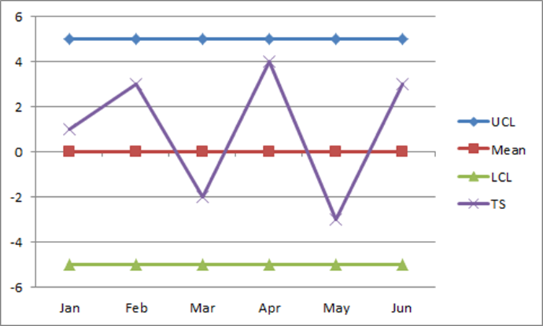

In contrast, the graph below shows a pattern where the TS values are all on the positive side of the graph. This is not a reliable forecast.

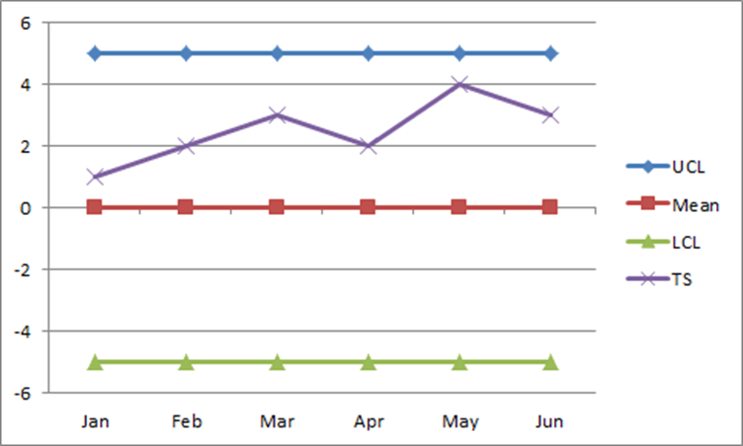

**Exponential Smoothing**

Exponential Smoothing (ES) is another effective forecasting technique. ES is similar to the weighted moving average technique. When comparing moving average with weighted moving average, there is a distinct difference between the two methods. In a moving average, the periods are all weighted equally and therefore given equal importance. In a weighted moving average, there is more “weight” given to the most recent data and less “weight” given to older data. The equations below clearly show these differences.

Moving Average (4-Period) = (At + At-1 + At-2 + At-3) / 4 or

0.25At + 0.25At-1 + 0.25At-2 + 0.25At-3

Weighted Moving Average (4-Period) = 0.4At + 0.3At-1 + 0.2At-2 + 0.1At-3

Note that the sum of all coefficients for each technique is equal to 1.

Exponential smoothing is similar to the weighted moving average method. The ES formula is stated below.

Ft+1 = Ft + ⍺ (At-Ft ) or Ft +1 = (1-⍺) Ft + ⍺At

At = Demand (Actual) for period t

Ft = Forecast for period t

𝛂 = Alpha, a weighting value

**Example - Raw Materials for Production**

In order to meet market demand for a rare disease medicine, the company Drugs-R-Us needs to purchase enough raw materials to support production requirements. However, the Warehouse Manager wants to keep inventory as low as possible while still supporting production. This will minimize tax expenses from storing surplus inventory at the end of each month. The table below shows the forecast for material purchases using the exponential smoothing method with an alpha of 0.4. It is noteworthy to mention that the forecast in period 2 was obtained using the Naive Method.

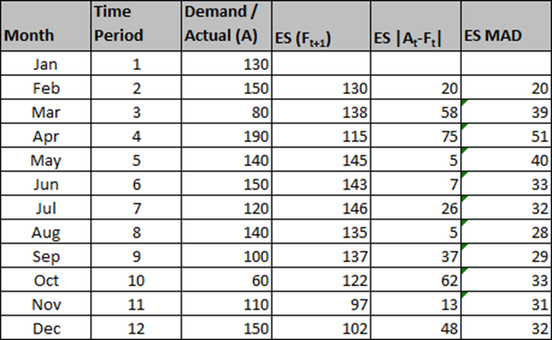

Another forecast was generated for comparison. The exponential smoothing results below were generated using an 𝛂-value of 0.8.

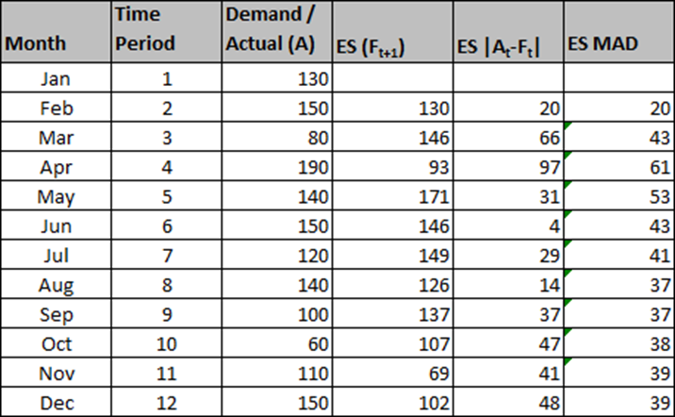

Since the MAD value for 𝛂 = 0.4 is smaller than the 𝛂 = 0.8, the better forecast is obtained with the smaller alpha.

To illustrate the impact 𝛂 has on the forecast values, the following graphs were generated using the forecast data above.

Alpha = 0.4

Alpha = 0.8

As the graphs clearly show, the smaller 𝛂-value is less reactive and is better for long range planning purposes. The larger 𝛂-value is more reactive and best utilized for short range forecasts.

These data sets were generated using 2 𝛂-values and it was determined 𝛂 = 0.4 is better than 𝛂 = 0.8. To determine the best 𝛂-value for the best exponential smoothing forecast, the following table was generated using the “What-If-Analysis” option in Excel and the MAD value of 32 for an 𝛂 = 0.4.

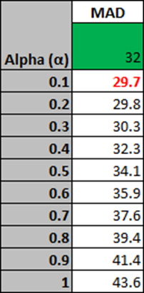

As the table clearly shows, the 𝛂-value with the lowest MAD is 0.1. Using this value will provide a better forecast. After replacing 0.4 with 0.1, the following table of exponential smoothing forecast values was generated along with the associated graph.

Alpha = 0.1

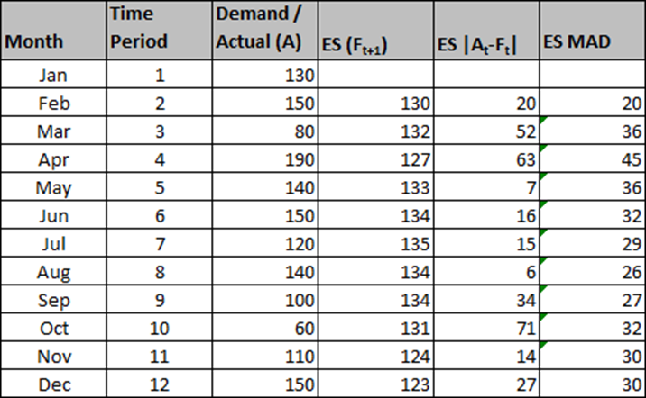

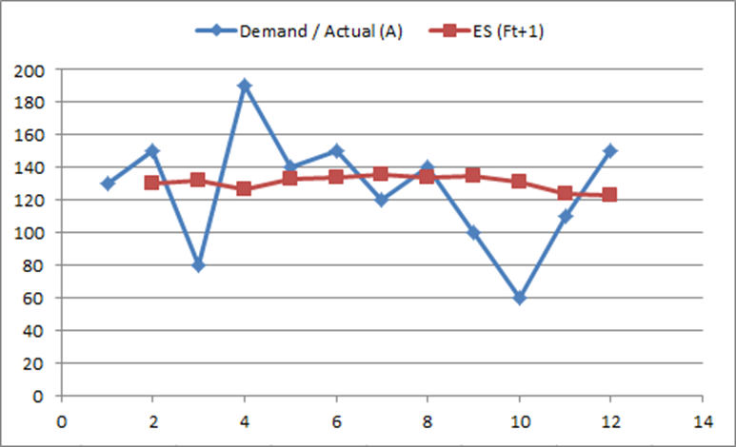

The MAD for this alpha is 30 and the graph shows a smoother line that is less reactive. This is a better forecast model than the ones generated above using the alpha values of 0.4 and 0.8 which had MAD values of 32 and 39, respectively.

Exponential smoothing takes into account all data. The forecast for period t is a function of the actual and forecast in the previous period. The actual is multiplied by 𝛂 and the forecast is multiplied by 1-𝛂. This is expressed in the following equation:

Ft = 𝛂At-1 + (1 – 𝛂)Ft-1

Each time we receive a new piece of data, we multiply it by alpha. However Ft-1 not only represents Ft-1, but the historical data from previous periods. The previous period of Ft-1 is a function of At-2 and Ft-2, where At-2 is multiplied by 𝛂 and Ft-2 is multiplied by 1-𝛂. If we replace Ft-1 with its equivalent equation, a new equation will emerge where each actual data value is multiplied by alpha. This is expressed in the following equations:

Ft-1 = 𝛂At-2 + (1 – 𝛂)Ft-2

add to the end of the original Ft equation above results in

Ft = 𝛂At–1 + (1 – 𝛂) 𝛂At–2 + (1 – 𝛂)2Ft–2

If we replace Ft-2 with its equivalent equation (listed below), the new equation for Ft is expressed as follows:

Ft-2 = 𝛂At-3 + (1 – 𝛂)Ft-3

add to the end of the latest Ft equation results in

Ft = 𝛂At–1 + (1 – 𝛂) 𝛂At–2 + (1 – 𝛂)2 𝛂At–3 + (1 – α) 3Ft–3

All pieces of data are still multiplied by alpha. A 1-period old data is multiplied by alpha. A 2-period old data is multiplied by 1-𝛂. A 3-period old data is multiplied by 1-𝛂 and raised to the power of 2. Continuing this general formula for Ft, it can be concluded that all actual data values are multiplied by alpha, but also by 1-𝛂 and raised to a certain power value. If data is t periods old, it is multiplied by 1-𝛂 and raised to the power of t-1.

For example, if the data is 4 periods old, it should be multiplied by 1-𝛂 and raised to the power of 3 (i.e. 4-1). If the data is 5 periods old, it should be multiplied by 1-𝛂 and raised to the power of 4 (i.e. 5-1). If the data is 6 periods old, it should be multiplied by 1-𝛂 and raised to the power of 5 (i.e. 6-1).

Alpha is equal to 0.5. For the 1st period, 1-0.5 raised to the power of 0 (i.e. 1-1) is 1. For the 2nd period, 1-0.5 raised to the power of 1 (i.e. 2-1) is 0.5. For the 3rd period, 1-0.5 to the power of 2 (i.e. 3-1) is 0.25. Since alpha will always be between 0 and 1, increasing the power to which it is raised will make alpha smaller and smaller. Therefore, exponential smoothing is a weighted moving average, which takes into account all actual pieces of data. As the data gets older, its coefficient gets smaller.

For a N-period moving average, the newest piece of data is 1 period old and the oldest piece of data is N-periods old. On average, data is 1 + N divided by 2 periods old, or 1+N/2. In exponential smoothing, the age of data is equal to 1 over alpha, or 1/α. Although these techniques are not exactly the same, they are similar enough to set them equal to each other. The equation is stated below. **(1+N)/2 = 1/𝛂**

For example in a 6-period moving average, the newest piece of data is 1 year old and the oldest piece of data is 6 years old. The average age of data is 3.5 periods old. Since the exponential smoothing equation is almost equivalent to the moving average equation, 3.5 is equal to 1 divided by alpha. The calculated alpha value is 0.28.

In a 10-period moving average example, the newest piece of data is 1 year old and the oldest piece of data is 10 years old. Using the left-hand side of the equation above, the average age of data is (1+10)/2 = 5.5 periods old. Completing and solving the equation, 5.5 = 1/𝛂, alpha is 0.18.

**Excel Tip**

To calculate a forecast using the exponential smoothing method, refer to the table below.

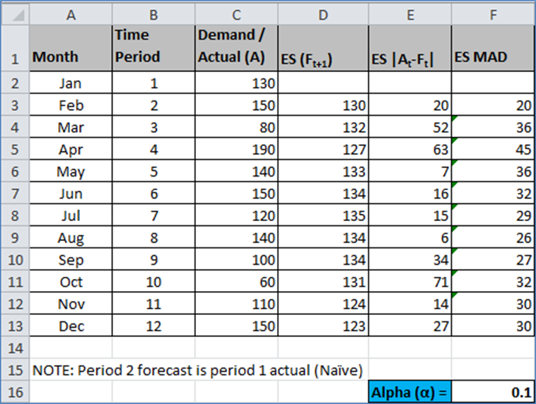

In cell D4, the following formula is entered. Note that alpha is in cell F16. The formula below locks cell F16. Copy the formula down until cell D13.



The same formula mentioned in the MAD section above can be used to calculate MAD for ES.

Inventory - Economic Order Quantity

**Introduction**

All organizations keep inventory of certain items for future use. Depending on the type of business, an organization may keep inventory of raw materials, components, subassemblies, finished products or supplies. There are two main reasons for keeping inventory. The first is to take care of uncertainty or fluctuations in supply and demand. Inventory kept for this purpose is called safety stock.

When we have a complete and exact knowledge of supply time (lead-time) and demand (usage), the resulting inventory models are known as deterministic. In deterministic models there is no reason to keep any safety stock and the replenishment begins when inventory is exactly zero.

The second reason for keeping inventory is to take advantage of buying or producing in a large quantity. The economic benefit may result from quantity discounts, purchasing costs (or set up costs), inspection, and order processing costs. Larger order quantities reduce such costs but may increase holding costs which include the cost of money tied up in inventory, cost of space, insurance, obsolescence, etc.

**Inventory Classified: There are three types of inventory**

1) Input inventory – composed of raw materials, parts, components, and sub-assemblies that we buy from outside.

2) In-process inventory – are parts and products, sub-assemblies and components that are being processed.

3) Output inventory – available inventory to meet the needs of customer.

The company management should manage inventory determining on level versus seasonal production. Too much inventory comes with higher carrying costs, and may even lead to obsolescence or perishability – but not enough inventory may cause higher ordering costs and will make customers go to competitors.

**Inventory Model**

Inventory models are perfect examples of applying mathematical models to real world problems. In general, an organization’s inventory is very expensive. For example, 20 percent of hospital budgets are spent on medical, surgical, and pharmaceutical supplies. For hospitals in the United States, it adds up to approximately $150 billion annually. The average inventory in the United States economy is about $1.13 trillion, and that is for $9.66 trillion of sales per year.

However, there are times where inventory may be at the detriment of a company. For instance, a company with a large work in process and finished goods inventory may discover that the market is shifting from one product to another product. In this case, the company will have a large amount of work in process and finished goods inventory of a product that customers find outdated. Therefore, companies need to determine the optimum inventory size, order quantity, usage rate, and similar considerations.

In developing an inventory model, the business must evaluate the two basics costs associated with inventory: the carrying costs and the ordering costs.

Carrying costs include interest on funds tied up in inventory and the costs of warehouse space, insurance premiums, and material handling expenses. The is also an implicit cost associated with the dangers of obsolescence or perishability and rapid price change. The larger the order we place, the greater the average inventory we will have on hand, and the higher the carrying costs.

Ordering cost consist of the costs it takes to place and order and to process inventory into stock. If a company maintains a relatively low average inventory in stock, it must order many times and the total ordering costs will be high.

As the order size increases, carrying costs go up because we have more inventory on hand. With larger orders, we will order less frequently and overall ordering costs will go down. The trade-off between the two can best be judged by examining the total cost curve. The best way to know how and when to order is to use the Economic Ordering Quantity formula.

Economic Ordering Quantity (EOQ)

With all the above in mind, we need to determine the optimal order size at the optimal cost. That is when we use the economic ordering quantity (EOQ) model. EOQ refers to the most strategic amount for the company to order each time, which is how to mathematically determine the minimum point on the total cost curve. To do so, the following formula is used:

EOQ = √(2 × Quantity × Cost Per Order)/Carrying Cost → √[(2DS)/H]

The terms in the EOQ formula are defined as follows:

D = Demand in units

S = Ordering Cost

H = Carrying cost per unit/year

**Example 1**

Let us assume that we anticipate selling 5,000.00 units; it will cost us $100.00 to place each order; and the price per unit is $10.00, with a 10 percent carrying cost to maintain the average inventory, resulting in a carrying charge per unit of $1.00. Plugging these values into our formula, we show:

EOQ = √[(2DS)/H] = √[(2 x 5,000 x $100)/$1] = √$1,000,000/$1 = √1,000,000 = 1,000 units

The optimum order size is 1,000 units. On the assumption that we will use up inventory at a constant rate throughout the year, our average inventory on hand will be 500 units. The average inventory equals EOQ/2.



**Example 2**

ABC Ltd. is engaged in sale of footballs. Its cost per order is $400 and its carrying cost unit is $10 per unit per annum. The company has a demand for 20,000 units per year. Calculate the order size, total orders required during a year, total carrying cost and total ordering cost for the year.

Solution

EOQ = SQRT(2 × 20,000 × 400/10) = 1,265 units

Annual demand is 20,000 units so the company will have to place 16 orders (= annual demand of 20,000 divided by order size of 1,265). Total ordering cost is hence $64,000 ($400 multiplied by 16).

Average inventory held is 632.5 ((0+1,265)/2) which means total carrying costs of $6,325 (i.e. 632.5 × $10).

