**Re-Order Point**

**Introduction**

In the previous chapter, we discussed how much to order. For instance, when there is no price discount, we order the economic order quantity (EOQ). Similarly, when there is a price discount we may order EOQ, or we may order more than EOQ. As long as cost is our main concern, we never order less than EOQ; however, if we are concerned with flow time rather than production cost, we may order less than EOQ. Why? In the previous chapter, we addressed how much to order, and now we are interested in determining when to order. When there is a periodic inventory system we always order at the start of the period, e.g. start (or end) of every week, start (or end) of every month. However, in perpetual (as opposed to periodic) inventory system, reorder point is defined in terms of quantity, not in terms of time. Instead of ordering whenever the end of the period is reached, we order when inventory on hand reaches a specific level. This defines the Re-Order-Point (ROP). In the previous chapter, we discussed how much to order (EOQ), in this chapter we discuss when to order (ROP).

In a periodic inventory system, ROP is the start (or end) of the period. However, in a perpetual inventory system or in continuous reviewing inventory system, reorder point is when inventory on hand drops to a predetermined quantity. In the EOQ model, we assume that there is no variation in demand, i.e. demand is known, constant, and it will remain constant. If there was no variation in demand and demand was solely constant, then ROP is when inventory on hand is equal to average demand during lead-time. If demand is constant, then demand will always be a specific number. Therefore, average demand during lead-time is equal to actual demand during lead-time. In contrast, if demand is a variable, average demand during lead-time differs from actual demand during the lead time. But if the demand is constant with no variation, demand during lead-time is average demand during the lead-time. Reorder point is a point when inventory on hand is equal to demand during lead-time.

**Lead-time** is the time interval from the moment an order is placed until it is received. If demand is fixed, we know what actual demand is during lead-time. But if demand is variable, we know average demand during lead-time and its variance. The greater the variability of demand during lead-time, the greater the need for additional inventory. These additional inventories help reduce the risk of shortages. The additional inventory is known as **safety stock**. Therefore, the more variability in the demand during lead time, the more safety stock that is needed. When variability exists in the demand or lead-time, actual demand during lead time will be different than average demand during lead time. It may be greater or less than the average demand during lead time. However, if there is no variation in demand during the lead-time, then demand during the lead-time is equal to average demand during the lead-time.

**Understanding ROP**

In the case of variability, we assume demand during lead-time follows a normal distribution. If I order at a point when inventory on hand is equal to average demand during the lead time, because normal distribution is a symmetric bell-shaped curve, the probability of being greater than average is 50% and probability of being less than average is 50%. Therefore, if my reorder point is at the point when inventory on hand is equal to average demand during the lead time, there is 50% probability that demand during lead time exceeds the average demand during the lead time. In a practical environment, if there is a 50% probability, it is likely that a store will not have a product requested by a customer. Hence, you do not have the product to satisfy the product demand. You will lose the profit that you could have made through the sale. However, if the client comes to the store once or twice after this occurrence and is told that the product is not available, this client will most likely shop at another store. Now the client’s store loyalty is lost. For this reason, usually retailers, manufacturers, and distributors don’t want a 50% probability of shortage. They want 1%, 5%, or 10%. Therefore, we would like to have a probability of 99%, 95%, or 90% to be able to fulfill your request. Therefore, you should order when inventory on hand is equal to average demand during lead-time. Safety stock is what you have to add to the average demand during the lead time. Thus, you order EOQ (or any other order quantity) when inventory on the hand is equal to average demand during lead time plus safety stock. When you order at this level of inventory on hand, it will reduce the probability of stock out during the lead-time. Reorder point in perpetual inventory control is the inventory level equal to the average demand during lead time plus a safety stock.

**Solving ROP- Example 1**

Suppose average demand for an inventory item is 200 units per day with a lead time of 3 days. There is no variation in demand, and no variation in lead time. Therefore, demand is constant and is completely known in advance. Hence, since there is no need for any safety stock, we set it equal to 0. We order at the point when inventory on hand is equal to the demand during the lead-time and when demand during the lead-time is known. Therefore, reorder point is equal to 3 x 200. Hence, whenever inventory drops to 600, we place an order. The demand during those 3 days is exactly 600 units. We will receive the order exactly in 3 days.

**Solving ROP- Example 2**

Average demand for an inventory item is 200 units per day. Lead time is 3 days, and safety stock is 100 units. What is the reorder point? In a perpetual inventory system the reorder point is the point at which inventory on hand is equal to the average demand during lead time plus safety stock. So lead time is 3 days, average demand during lead time is 200. 3 x 200=600 +100 = 700. When inventory level drops to 700 units, we place an order. Since there is variation in demand during the next three days, our demand is not 600. It may be 500, 400, 429, 678, 750 and so forth. Now that we have gone over two simple examples of ROP, the rest of the chapter will go further into depth.

**No Variation in Demand: Linear Relationship**

Figure 1 shows the inventory on hand. The y-axis represents inventory and the x-axis represents time. As we start consuming that inventory, it will gradually go down. Because demand is constant, it goes down in a linear fashion. If lead-time is three days, it will be 3 days until we expect inventory to reach 0. If the relationship between inventory and time is linear, we can assume that there is no variation in demand. Because we assume that lead time is 3 days, we can then draw a perpendicular line and find out whenever inventory reached this level or when an order should be placed. When we place an order at this level of inventory, after this many days we will receive the next order. No variation in demand, no variation in lead time.

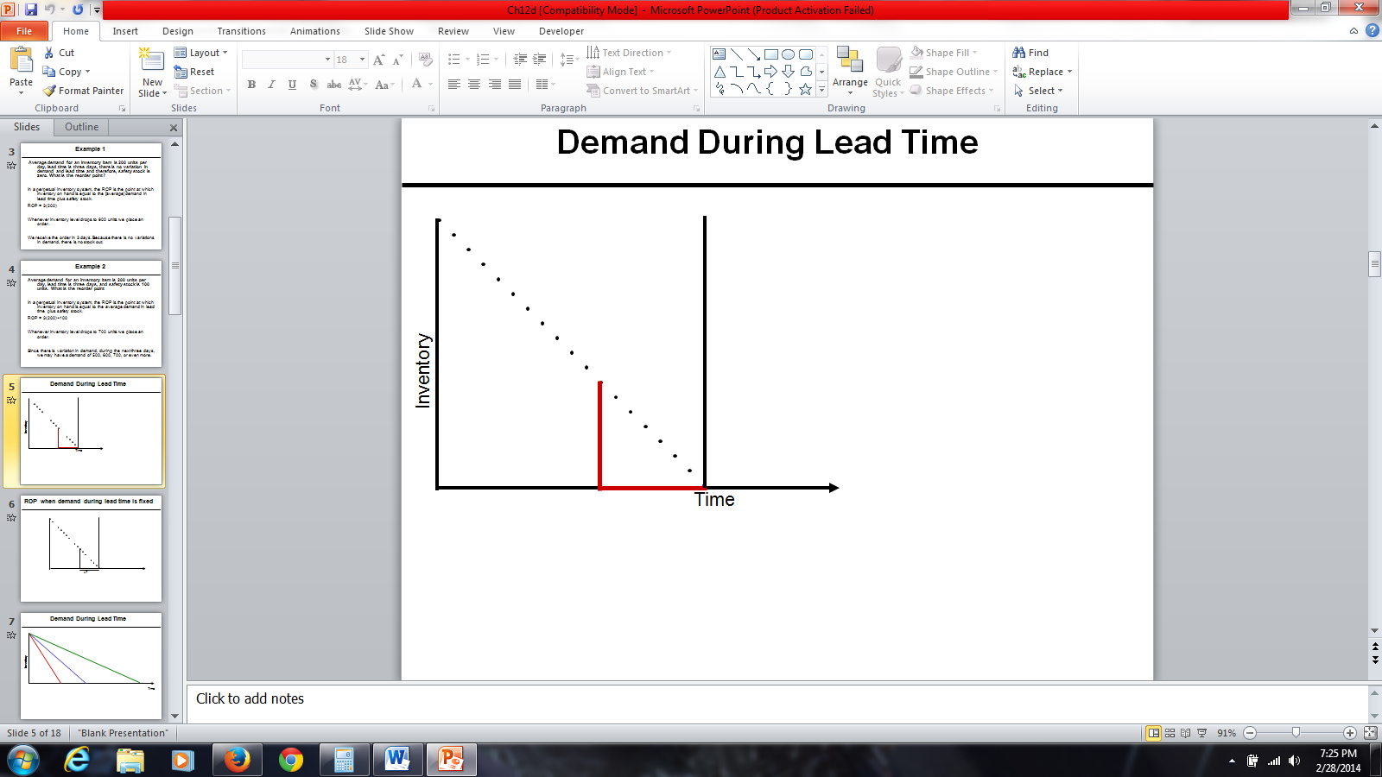

Figure 1: Demand During Lead Time

**Demand During Lead Time is Fixed**

Figure 2 represents lead time. This is the point that I expected the demand to become equal to 0. When inventory on hand is 0, we place an order. Inventory goes down at a fixed pace, and is represented by the linear downward line on the graph in Figure 2.

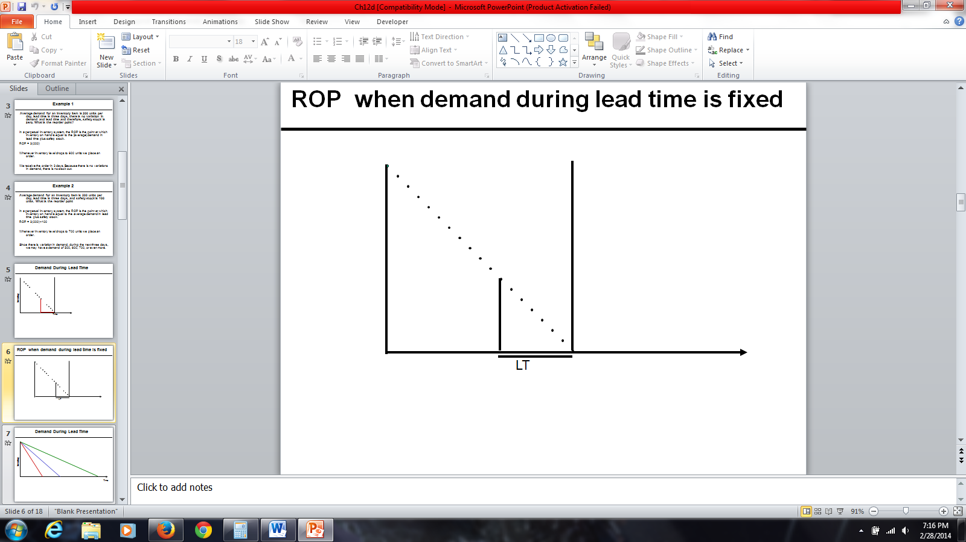

Figure 2: ROP When Demand During Lead Time is Fixed

Figure 3 represents demand during lead time. This graph shows three different lead times for the same amount of inventory. It is possible to consume the inventory at a faster rate. Suppose rather than consuming it at the speed represented by the red line, perhaps we can consume it at the speed of the green line. Thus, we would be reaching the reorder point earlier than the previous one. Alternatively, we may consume it with a slower rate. In all three cases, whenever inventory reaches this level we will put an order. Suppose rather than consuming inventory at the speed of the green line, we want to consume it at a speed of the blue line. Reorder point is determined based on inventory on hand. Inventory on hand is determined based on consumption rate. At a faster rate, inventory on hand reaches a specific level sooner. At a slower rate, inventory on hand reaches a specific level deferred in to the future.

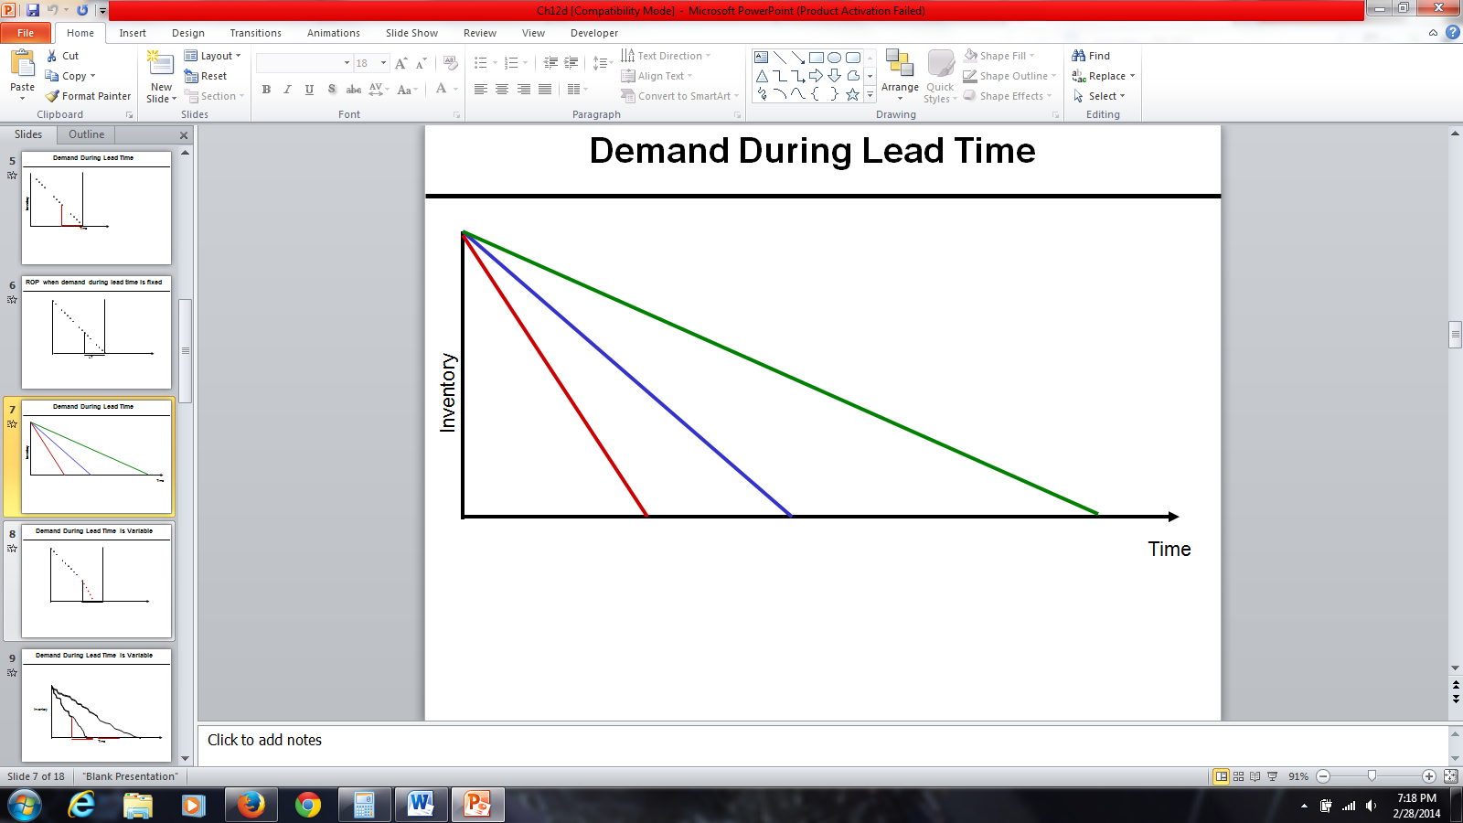

Figure 3: Demand During Lead Time

Figure 4 represents when demand during lead time is variable. Suppose we have a certain quantity of inventory and have reached reorder point. We expect to consume the inventory at the same linear rate; therefore, exactly at the point that inventory on hand reaches 0, we will get the next order. But who can guarantee that customers will come to the store based on the rate we have assumed? No one can guarantee that. Therefore, it is possible that the product is consumed at a faster rate. The red line represents the consumption at the faster rate. In that case, inventory on hand reached 0 at this point and we are left without inventory for the remaining days. Any customer who comes to the store asking for the product will not be able to purchase it because there will be no inventory on hand for the product in question. Thus, the customer will have to wait until the inventory arrives.

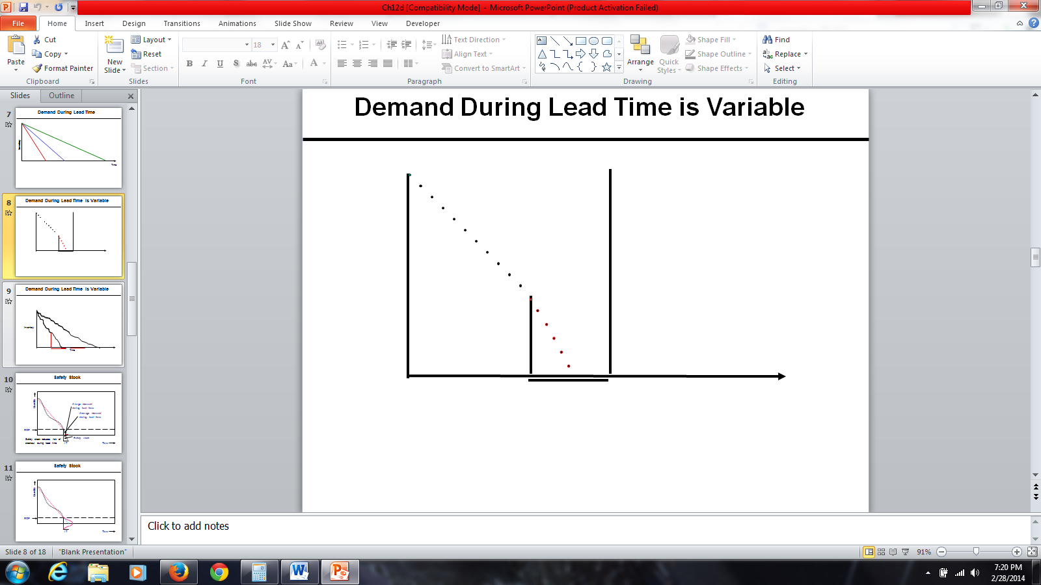

Figure 4: Demand During Lead Time is Variable

In general, customers do not come to the store to ask for a product in a linear fashion. There might be more or less customers, depending on the day. In contrast to the basic assumptions of the inventory model that demand is known and constant, suppose demand is unknown. If only average demand is known, we will need a computation for EOQ based on average demand. However, some days we may have more orders and other days we may not. In Figure 5, the first linear has a steeper slope, thus inventory drops quickly. In the second linear, the slope is less steep than the first, thus inventory drops slowly. As soon as inventory on hand reaches to the level in which we think inventory on hand is enough for average inventory during lead time, we will order. We expect to receive the order at this point, and consume this inventory at this rate. It is possible that we consume it at a faster rate. In that case, we will be out of stock for a certain amount of time. Suppose we reach the reorder point, but the demand after that was quite high. Therefore, before we get the next order, the entire inventory on hand was consumed. Alternatively, the demand may be less than the average demand that we have assumed. We expect to consume the inventory in a linear fashion, and we expect that by the next order, inventory on hand is equal to 0. But if we consume the inventory at the lower rate, we would still have inventory on hand by the arrival of the next order.

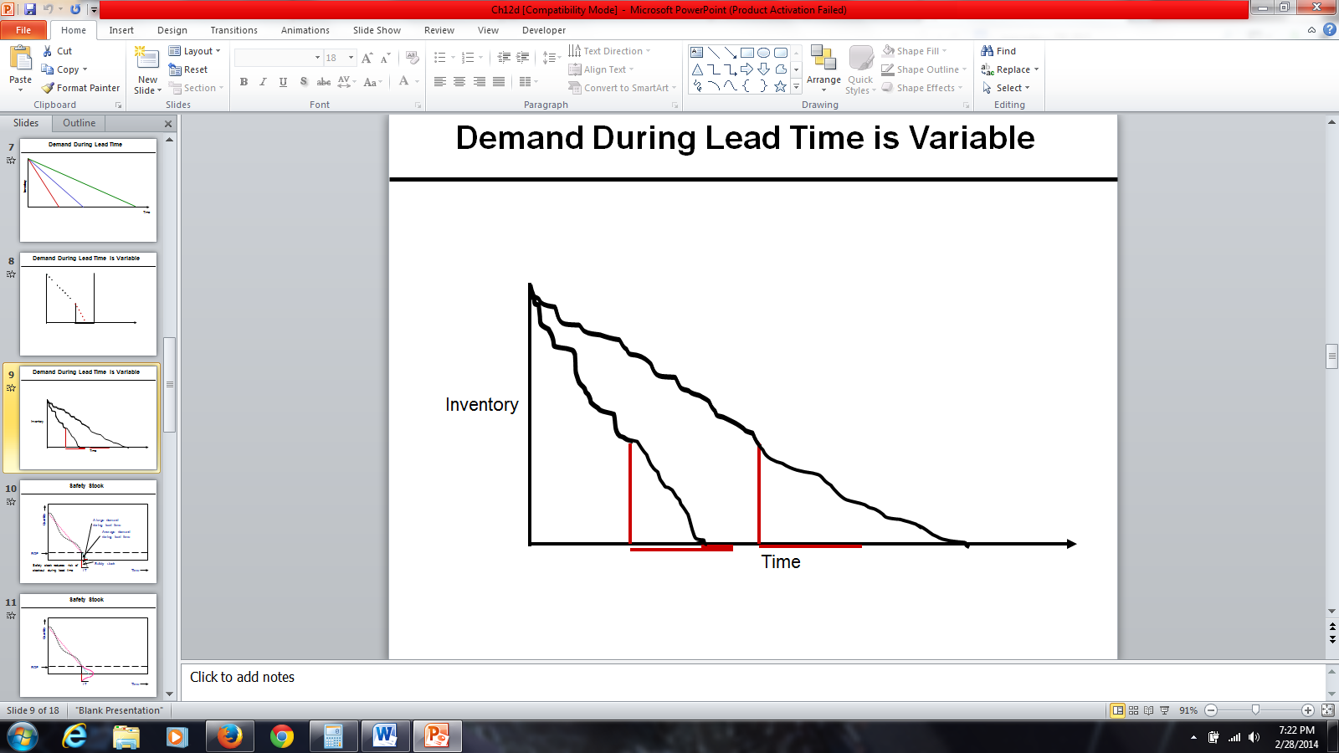

Figure 5: Demand During Lead Time is Variable

**Safety Stock**

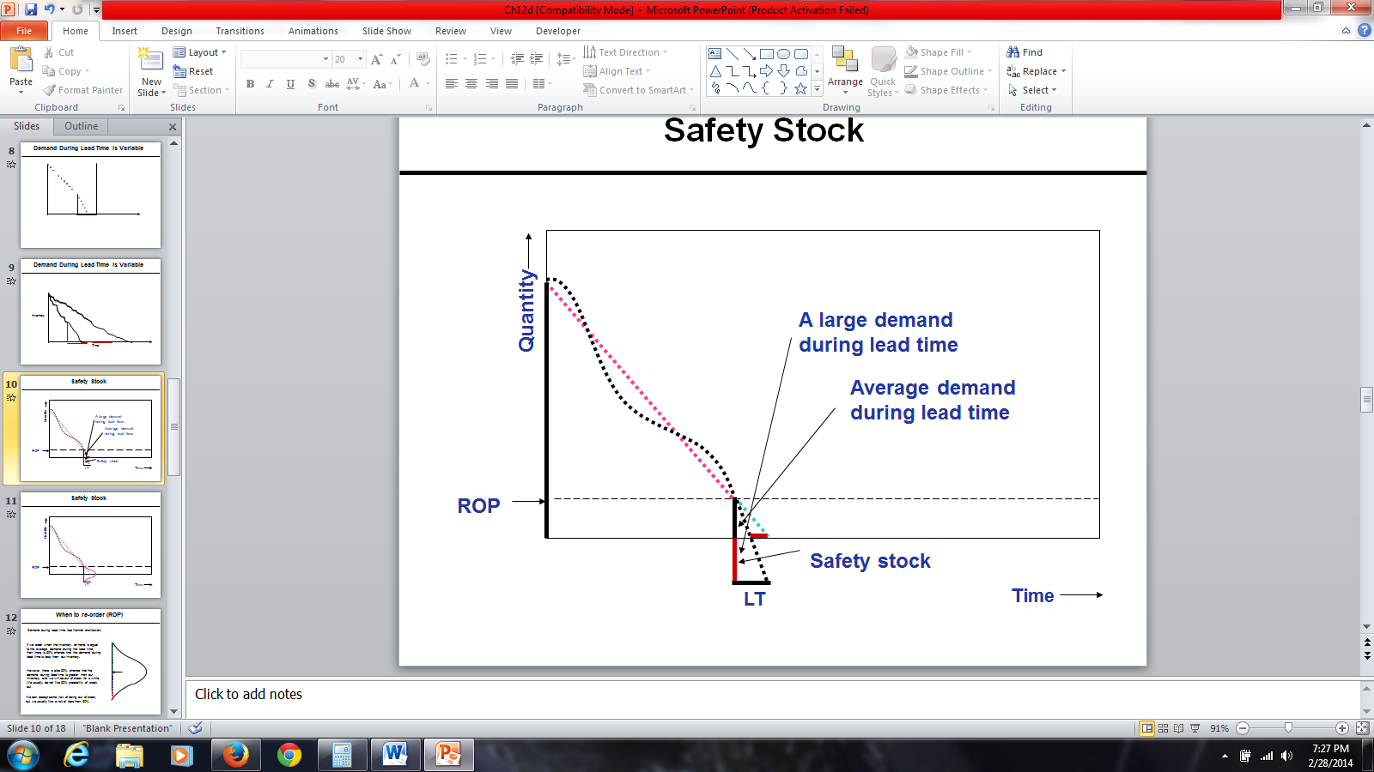

Figure 6: Safety Stock

Why do we need safety stock? We need safety stock because we want to reduce the probability of being short of stock. The y-axis shows quantity (inventory on hand). The x-axis represents time. This is the order that I have received; it is either EOQ or greater than EOQ. It doesn’t contain anything about when to order. It is either EOQ, or if we have a price discount, it is possible that it is greater than EOQ to take advantage of price discount. How much to order and when to order are completely different concepts.

We consume inventory in a non-linear fashion (a curve), which sometimes is steep or mild. To find the slope of this line, we will use average inventory. The vertical axis displays quantity and the horizontal axis displays time. In this pictorial representation, we want to show how inventory is consumed over time. It is either EOQ or if there is a price discount, it may be something more than EOQ to take advantage of price discount. In Figure 6, we assume that it is consumed in a linear fashion. It may be consumed either at a rapid rate or at a gradual rate. The slope of the line is equal to average demand. So we assume that it is consumed in a linear way with this slope, but in reality it may be consumed in a rate lower than that rate or in a rate higher than that rate. So while actual demand is non-linear, we assume it is linear because we want to model it and get some conclusions, some guidelines from that model. Don’t forget whenever we want to model a portion, we need to simplify it. Then based on that simplifications, we would be able to develop a mathematical formulation and collect information about the simplified version of the real world. However, later we need to incorporate at least some parts of complexities of real world into our simple model.

Whenever inventory on hand reaches average demand during lead time, we place an order. The reorder point is a point in which inventory on hand is equal to average demand during the lead time. It is possible that during lead time the demand is quite higher than what is expected, which depends on the slope of the line. Because demand during lead time was quite higher than the average demand, at this point inventory reaches 0. Therefore, for this much of time, which is almost half of the lead time, we don’t have any product to give to customers. Therefore, in order to reduce this probability, we need a safety stock. Safety stock reduces risk of stock out during the lead time. That is why we add to average inventory during lead time.

Figure 7 represents an illustration of safety stock with inventory on hand when we received the order along with the reorder point when we reorder. The reorder point is equal to average demand during lead time. We expect to consume this inventory at the average rate, and therefore we may go back this many days. Demand during the lead time is not constant. Demand during lead time has normal distribution. That amount is only average of the demand during lead time. Actual demand during lead time could be any of these numbers. If it is more than average, probability of stock out is 50%. If we want probability of stock out not to be 50%, but to be a smaller amount, then we will add safety stock. We order not at the point when inventory on hand is equal to 0 but at the point when inventory on hand is equal to average demand during lead time.

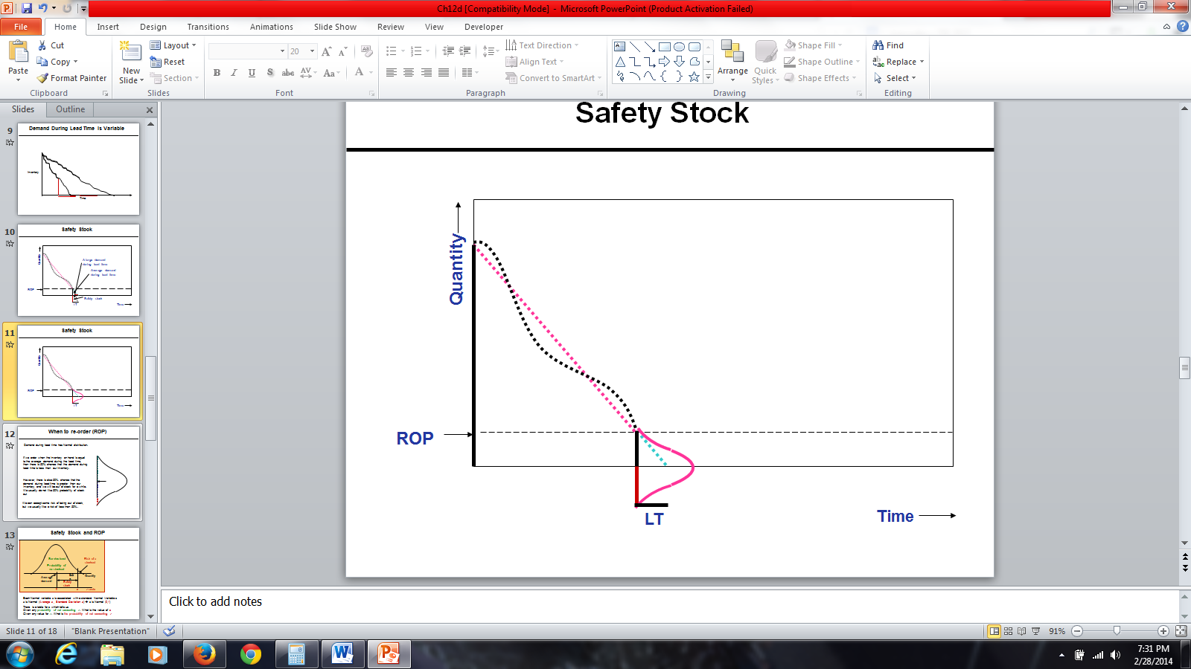

Figure 7: Safety Stock

Figure 8 illustrates a simple graph of reorder point. We assume demand during lead time has a normal distribution. This middle arrow is the average. There is 50% probability that demand is less than this average, and there is 50% probability that demand is greater than this average. Therefore, if we order at the point when inventory on hand is equal to average demand during the lead time, there is 50% probability that the demand during lead time is less than this average. It is also possible that demand during lead time is greater than average demand during lead time. There is 50% possibility that demand is greater than the average demand. Demand could be greater than the average demand. In all of these cases, we want to be able to satisfy the demand. We don’t want the probability of facing shortage to be 50%. We want it to be less than 50 percent. With 100% probability, we can satisfy all the demand. Therefore, we are ready to accept some risk to be out of stock. We want that risk probability that we will not be able to satisfy demand to be 1%, 5 %, 10%, but not 50%.

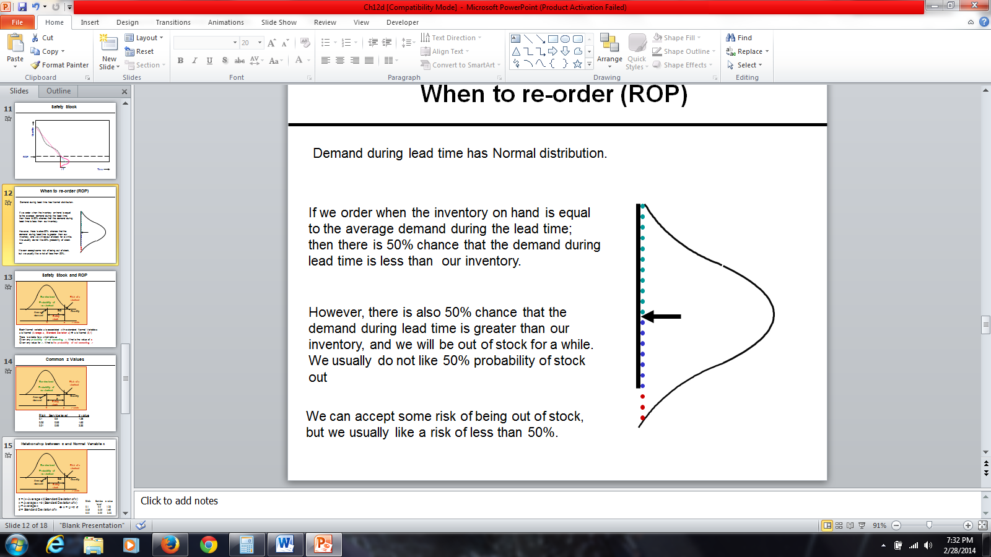

Figure 8: Re-Order Point

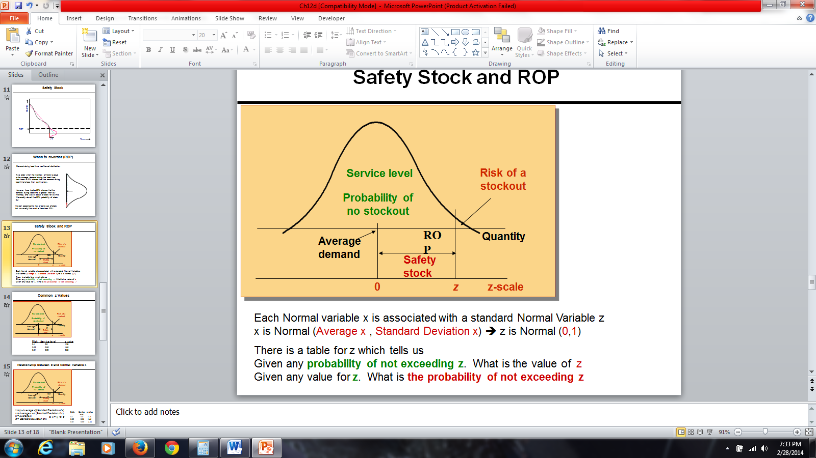

Figure 9: Safety Stock and ROP

Figure 9 represents a normal distribution. This is average demand during lead time. We are ready to accept this much risk to be out of stock. This risk could be 1%, 5%, 10%, depending on managerial policies. Probability of no stock out is quite high. Risk or probability of stock out is quite low compared to this probability. This is what we call a service level. If probability of risk is 5 %, service level is 95%. If probability of risk is 1%, service level is 99%. If probability of risk is 10%, service level is 90%. If management says with 90% probability we want to be able to satisfy the demand during lead time, we are ready to accept the risk of 10%. This is the safety stock, which is added to average inventory to ensure that this probability is less than 50 %.

Demand during lead time is a normal variable X. What do you know about this variable? It’s normal, so its distribution is bell-shaped. When we say it’s a normal variable X, we should also know its average, which we could say is a hundred units during lead time, and we should have its standard deviation. When we talk about a normal variable, we know it’s normal and has a specific mean, which could be anything, and has a specific standard deviation. This normal variable, this random normal variable has two attributes, mean, and a standard deviation, which could be any number. A normal variable X is associated with a standard normal variable Z. What is the attributes of a normal variable X? It has a mean, an average, and a standard deviation. But those two attributes in standard normal variable Z are 0 and 1, therefore, standard normal variable Z has mean of 0, and a standard deviation of 1. Given any probability of not exceeding a specific Z, that table will give us the value of Z. But this Z is a standard normal variable. It is not the variable X that we are looking for and it’s specific average and specific standard deviation.

So, if we know the service level or risk, which is one service level, then we can compute a specific Z, which is related to that risk and that service level. If we know a specific Z, we can find out what is the service level for that specific Z and what is the risk for that specific Z. The table in Figure 10 gives us service level and risk. While we are talking about a general normal variable with a specific average and a specific standard deviation, there is a relationship which connects that general normal variable X with a standard normal variable Z. We need this mapping because we don’t have a table of probabilities for all types of normal variables, such as different averages and different standard deviations. However, we have that table for standard normal variable which has mean of 0 and a standard deviation of 1. Also, we have a relationship which transforms any normal variable with any mean and any standard deviation into standard normal variable.

So if risk is 10%, service level is 1 minus 10%, which is 90%, and if we go to normal table, it will tell us Z value is 1.28. The Z value for the probability of service level is 90% and probability of risk is 10%, the specific Z is 1.28. If the average demand during lead time was 0, standard deviation of lead time was 1, inventory on hand is 1.28, then there is 90% probability that we could satisfy all the demand. There is 10% probability that we cannot satisfy all the demand. We usually don’t have Z distribution for my demand during the time. We have normal distribution, which can easily transform into Z distribution or standard normal distribution. The standard normal distribution table tells us if risk is 5% and service level is 95%, then your Z value is 1.65. If risk is 1% and service level is 99%, then the Z value is 2.33. So it simply tells us that the Z value for which the probability of being greater than Z is 1%, and the probability of being less than or equal to Z is 99%.

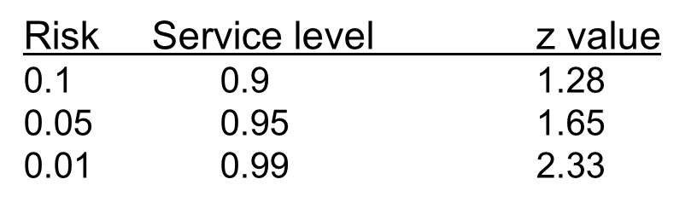

Figure 10: Common z Values

If we take any normal variable X, and subtract it from its average, and divide it by its standard deviation, we get Z value. We can find what Z is for each of the different percentages of risk. Therefore, we can find average demand during lead time, the standard deviation of demand during lead time. Hence we can find the reorder point. X is equal to average X + Z times the standard deviation of X. Mu is average of X. Sigma is the standard deviation of X. X is equal to Mu + Z times sigma. So if we know Z, we can transform it into X. If we have X, we can transform it into Z. Given any service level or any risk, we can easily compute Z value.

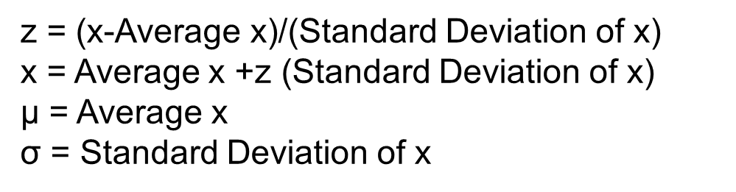

Figure 11: Relationship between z and Normal Variable x

LTD is lead time demand. Reorder point is average lead time demand + Z times the standard deviation of lead time demand. Reorder point is equal to average lead time demand + Z times the standard deviation of lead time demand, which is what we call safety stock. If we only reorder at a point when inventory on hand is equal to average lead time demand, then probability of stock out is 50%. But if we add safety stock to it and reorder at the point where the inventory on hand is equal to average lead time demand + safety stock, then the probability of stockout would be quite low. It could be 10 %, 5 %, or 1%. Therefore, if you want probability of stockout to be 10%, you will find 1.28, which is Z. Then you would take that Z and you multiply it by the standard deviation of lead time demand and that would be safety stock. Then you add it to average lead time demand, and that would give you the reorder point. If you order at that reorder point, probability of stockout would be 10%.

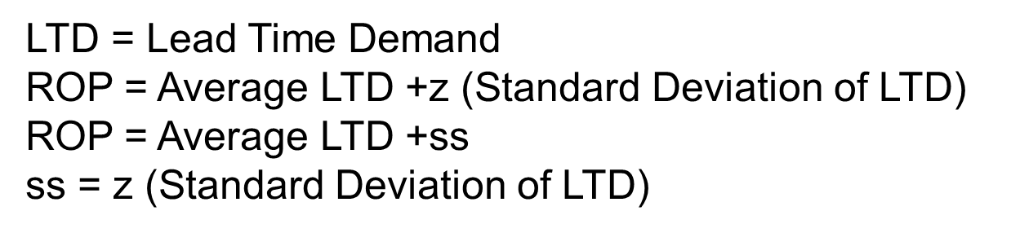

Figure 12: Relationship between z and Normal Variable ROP

**Practice Set #1**

1. **Demand for Honda cars in one week consist of 1400 units. (7 days). What is the average demand? Lead time is 2 days; there is no variation in demand and lead time. Safety stock is 0. What is the reorder point?**

**Solution: demand/n (1400/7)=200.**

**ROP= 2(200)=400.**

**Whenever inventory level drops to 200 units, we place an order. We should receive the order in 2 days.**

1. **Average demand for an inventory car part (tires) is 400 units per day, lead time is 2 days and safety stock is 50 units. What is the reorder point?**

**Solution: ROP=lead time (average demand)+safety stock.**

**Therefore, 2(400)+50 = 850.**

**Whenever inventory level drops to 850 units, we place an order. Since there is variation in demand, during the next two days we may have a demand of 650, 750, 850, or even more.**

**True or False?**

1. **Safety stock reduces risk of stock out during lead time. (True)**
2. **If we order when inventory on hand is less than the average demand during the lead time, then there is 50% chance that the demand during time is less than out inventory (False)**

**Practice Set #2**

1. **At Bed Bath & Beyond, customers purchase on average 21,000 Magic Bullets machines per week. The lead time is 20 days. Assuming zero safety stock. Compute ROP.**

**ISafety=0**

**L=10**

**R= (21,000U units/week) X (1week/7days)=3000 units/day**

**Solution: ROP= LTD+Isafety**

**ROP=LTD+0**

**ROP=L x R**

**ROP= 20 x 3000=60,000**

1. **The following week, the Magic Bullet gained media popularity. Customers at Bed Bath & Beyond demanded on average 105,000 Magic Bullets per week. The lead time increased to a month during the month of February. Assuming 50,000 safety stock. Compute ROP.**

**ISafety=50,000**

**L= 28 days (during the month of February, there are always 28 calendar days)**

**R=(105,000 units/week) x (1 week/7days)=15,000 units per day**

**Solution: ROP= LTD+Isafety**

**ROP= LTD+50,000**

**ROP= (28 x 15,000) +50,000=470,000**

1. **After a great success with the Magic Bullet, Bed Bath & Beyond decided to introduce a new product called the Pocket Hose. After a successful introduction, customer began to demand on average 1,000 units per day. The standard deviation of demand is 5 per day, and the lead time is 10 days. Compute ROP at 90% service level. Compute safety stock (round to nearest dollar) Assume demand is variable and lead time is fixed.**

**Questions to think about:**

**What is the average demand during the lead time?**

**What is standard deviation of demand during lead time?**

**L: Lead Time**

**R: Demand per period (per day, week, month)**

**R: Average Demand per period (day, week, month)**

**σR: Standard deviation of demand (per period)**

**LTD: Average Demand During Lead Time**

**LTD = L × R**

**σLTD: Standard deviation of demand during lead time**

σ_LTD=√L σ_R

**L: 10 days**

**R: 1,000 units/day**

**σR: Standard deviation of daily demand =5**

**LTD: Average Demand During Lead Time**

**LTD = L × R = 10 × 1,000 = 10,000**

**σLTD: Standard deviation of demand during lead time**

σ_LTD=√10 (5)=15.811

**Solution:**

**SL = 90% 🡺 z = 1.28**

**x = μ + z σ**

**ROP= LTD +z σLTD**

**LTD = 10,000**

**σLTD = 15.811**

**Thus,**

**ROP= 10,000+ 1.28 × 15.811**

**ROP= 10,000 + 20**

**ROP = 10,020.**

**Isafety = 20**

1. **Use the same information provided on problem 3. However, assume that demand is fixed and lead time is variable.**

**If Lead time is variable and Demand is fixed**

**L: Lead Time**

**L: Average Lead Time = 10 days**

**σL: Standard deviation of Lead time = 5 days**

**R: Demand per period = 1,000 per day**

**LTD: Average Demand During Lead Time**

**LTD = 10 × 1,000 = 10,000**

**σLTD: Standard deviation of demand during lead time**

σ_LTD=10,000(5) =50,000

σ_LTD=Rσ_L

**LDT = 10,000**

**σLTD = 50,000**

**SL = 90%**

**z =1.28**

**Thus,**

**ROP = LTD +zσLTD**

**ROP = 10,000 +1.28(50,000)**

**ROP = 320 + 64,000**

**Isafety = 64,000**

**5.) At the Arbor Grill, average lead time demand for potatoes (to make French fries) is 18,000 units. Standard deviation of lead time demand is estimated to be 9,000 units. The store can only order a 7-day supply, 21,000 units, each time the inventory level drops to 26,000 units. Due to its limited space, suppose holding cost is $3 per unit per year.**

**LTD = 18,000, *σLTD* = 9,000, ROP = 26,000, H=$3, R = 3,000 / day, Q or EOQ = 21,000.**

**a) Compute the service level.**

**ROP = LTD + Isafety 🡺 Isafety = 26,000 – 18,000 = 8,000**

**ROP = LTD +z *σLTD* 🡺 Isafety = z *σLTD* =8000**

**z(9,000) = 8,000 🡺 z = 8,000/9,000 = 0.89**

**z =0.89 🡺 P(z ≤ Z) = 0.8133 = 81.33%**

**In 81.33 % of the order cycles, Arbor Grill will not have a stock-out. Risk = 18.67%.**

**b) Compute the cycle inventory, and average inventory.**

**At reorder point we order 21,000 units.**

**Icycle = Q/2 = 21,000/2 = 10,500**

**Isafety = 8,000**

**Average Inventory = I = Icycle + Isafety =10,500 + 8,000 = 18,500.**

**c) Compute the total holding costs per year.**

**H(Average Inventory) = H(I) = 3 × 18,500 = 55,300/year**

**d) Compute the average flow time.**

**R = 3,000 / day, I = 18,500**

**RT = I 🡺3000T = 18,500**

**T = 6.167**

**6.167 days**

**6.)Wilson Inc. produces a 3-week supply of its FIFA World Cup Soccer Ball Model when stock on hand drops to 400 units. It takes 1 week to produce a batch. Orders average 350 units per week, and standard deviation of forecast errors is estimated at 175 units.**

**ROP=400, L=1 week, LTD 350/week, σ_LTD=175, Q=3(350)**

**LTD = N(350, 175).**

**ROP = LTD + Isafety**

**ROP = LTD +z *σLTD***

**400= 350+z(175)**

**50 = 175z**

**z = 50/175 = 0.29, Thus, risk is 61.41%**



|  |  |  |  |  |  |  |
| --- | --- | --- | --- | --- | --- | --- |
| SL | % change | Z | σLTD | Is =zσLTD | % change | ROP = LTD +Is |
| 0.8 | 100 | 0.84 | 175 | 147 | 100 | 497 |
| 0.9 | 113 | 1.28 | 175 | 224 | 152 | 574 |
| 0.95 | 119 | 1.64 | 175 | 288 | 195 | 638 |
| 0.99 | 124 | 2.33 | 175 | 407 | 276 | 757 |