|  |  |
| --- | --- |
| **Inventory models**  **An introduction to basic inventory model concepts** | *“One of the great responsibilities that I have is to manage my assets wisely, so that they create value.” -- Alice Walton*  Stephen Juarez and Brian Sullivan  Pepperdine University |

## http://www.greenappetite.com/wp-content/uploads/2009/07/watermelons-768x1024.jpgImportance of Inventory

You walk into your local grocery store to pick up some fresh produce, and realize that all the watermelons are sold out. Persistent to find your fruit of choice, you run over to Whole Foods and find a large outdoor lobby display of watermelons sitting on a pallet, and as a customer you’re happily satisfied. It could be watermelons, milk, or donuts, but having sufficient inventory control is critical for any business. Whole Foods, for example, maintains an inventory ratio of 21.1[1] that is calculated by the total cost of goods sold, divided by average inventory. So in this situation, Whole Foods replenishes its inventory on average roughly 21 times per year; ensuring that products are in stock and watermelons are plentiful. In case you are wondering, the grocery industry average inventory turnover is 14.6[2]. The industry as a whole inherently maintains a higher inventory turnover due to the nature of keeping products fresh.

**Inventory models** are perfect examples of applying mathematical models to real world problems. Whether at a local grocery store, non-profit, or large firm it is important for any organization to know what the *optimal* inventory level must be in order to serve the needs of customers. As we continue through the chapter, inventory optimization considers the necessary inventory to forecast upcoming demand, and the tradeoff choice of how much to spend from the firm’s cash or revenue in order to target a preferred inventory level. Trade-off costs become a critical variable as the firm decides if they must invest more to maintain an elevated inventory to satisfy all customers. Sometimes, a firm may decide that it is too costly to invest a higher percentage of cash flows to carry more “watermelons” in stock.

## Inventory Classified

There are three types of inventory classifications: Input, In-process, and Output.  **Input inventory** iscomposed of raw materials, parts, components, and sub-assemblies that we buy from outside. **In-process inventory** are parts and products, sub-assemblies and components that are being processed. For example, if operation B follows operation A, we cannot have operation B completely dependent on operation A. To prevent this dependency, we may put a little bit of inventory between operation A and B.  Identifying in-process inventories can be important when we realize that if larger volumes of material or goods are purchased, we can choose to take advance of supplier discounts due the larger scale of the inventory purchase.

**Output inventory** is inventory that is readily available for immediate consumption or use. It is inventory that sits idly on the visible retail shelf or warehouse floor ready for the consumer to pick up and purchase. The best strategy is to create a low flow time process to minimize any holding costs associated with storing inventory. Inventory doesn’t necessarily have to be an item for purchase. It can be a physical count of units within a process flow. If you look at a highway or street, an “inventory” of vehicles can be observed passing through. These are **pipeline** **inventories** within a process, arriving to a final destination.

## Inventory Challenges

Poor inventory management *hampers operations*, *diminishes customer satisfaction*, and *increases operating costs*.  A typical firm probably has about 30 percent of its *current assets* in inventories or about 90 percent of its *working capital* (and working capital as you may remember from accounting and from finance is the difference between current asset and current liabilities).

**Understocking** is a serious issue because it can lead to a loss of sales and customers. If a customer visits the business and desired product is not available, the consumer will search out alternatives and be forced to go to a competitor. Not only has the business lost the sales from that particular product, but is also in danger of losing out on repeat business from same consumer. If the competitor can fulfill their needs they may earn the consumers loyalty and therefore all future business.

**Overstocking** is not optimal either because it has three types of costs: financial, physical, and obsolescence. *Financial costs*, instead of having our money in a city or in a profitable business, we put it in inventory.  *Physical cost,* our inventory should be put in safe keeping somewhere.  Thus we either lease a warehouse or allocate a portion of our shop to a physical location of these products. Finally we may have *obsolescence cost*, if we purchase a large amount of inventory for a product that gets low consumer demand, we may never be able to sell them; thus rendering the product obsolete.

## Periodic Inventory [Counting] Systems

We have *two types* of inventory tracking systems.   The first is a **Periodical inventory system,** where at the beginning of each period, the existing inventory level is identified and the additional required volume to satisfy the demand during the period is ordered.  In other words, the variable is the quantity ordered. Time is fixed at the beginning of each period where the The **Re-order point (ROP)** occurs.

How do we order?  Imagine it as a one-bin system, that is, there is one bin where the product is stored. By examining the level in the bin we can determine how much product we need to order. The quantity which is ordered depends on how much is needed to fill the bin, but the timing is exact.  It is at the beginning of the period.  As mentioned previously Re-order point is defined in terms of time, not quantity.

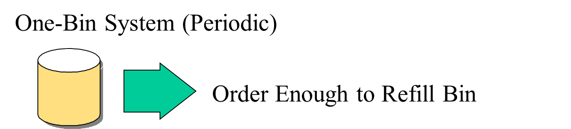**Figure 1. Periodic Inventory: One-Bin System**

The *disadvantage* of periodic system is the lack of information during the period. Inventory is only measured at the end of the period leading the possibility of running out of inventory during the period.  The *advantage of this system* is fact orders are placed for several items at the same time resulting in fewer orders and therefore minimizing order cost.

## Perpetual Inventory Systems

**Perpetual inventory system**s are an entirely different model.  When inventory reaches reorder point, we order a specific quantity, and usually we order **economic order quantity (EOQ),** which we will discuss later.  The quantity of order, unlike periodic inventory system is fixed, but the timing of the order is variable.  Whenever inventory has reached a specific level, a refill order will be placed. The reorder point is defined in terms of quantity, or inventory on hand.   Think of it as a virtual two-bin system.  Whenever the first bin gets empty, an order is placed to refill the bin.  While waiting on the delivery to restock the first bin, inventory is using the 2nd bin, therefore keeping inventory perpetually in stock.  The benefit for this type of system is that it keeps track of inventory continuously, thus monitoring current levels of each item

**Figure 2. Perpetual Inventory: Two-Bin System**

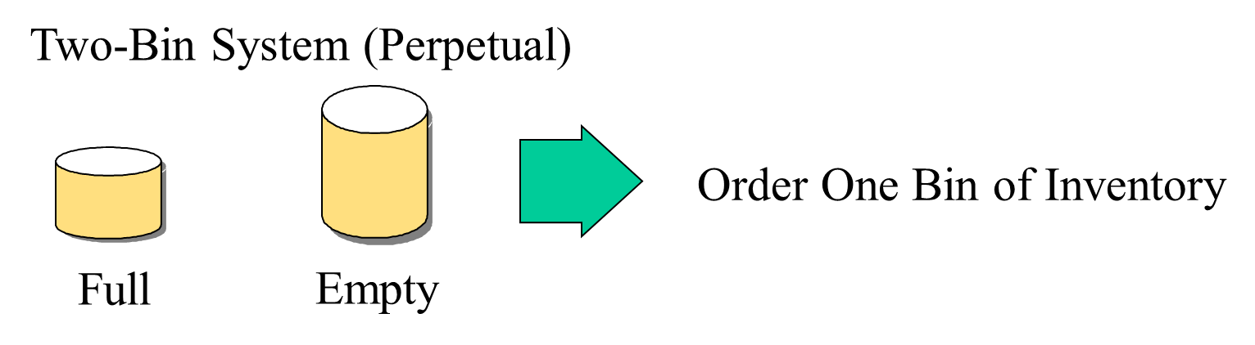

## A Classification Approach: ABC Analysis

In **ABC analysis**, the question is which type of inventory counting system is preferred?  Is it periodical or perpetual?  Perpetual is always better but more expensive because we need an automated system to continuously count our inventory.  Therefore, we may conduct an ABC analysis. Using ABC analysis we classify each inventory item with an A, B or C. Any items falling under classification A would use Perpetual and Periodic for Class C.

In figure 3 we use ABC analysis to determine which items should use Perpetual or Periodic. The first step is to multiply Annual demand by Unit cost which gives us Annual dollar value. After we have competed this for each item we can see 2 items make up roughly 67% of total inventory, item number 8 and 5. Because these items make up such a high percentage of total annual value we classify them as A and therefore use a Perpetual system. Items 3, 6, and 1 come next and make up 27% earning a B classification. Which means either a periodic or perpetual system can be used. That leaves us with the rest of the items that make up only 6 % and earn a C classification for a Periodic inventory system.

**Figure 3. ABC Analysis**

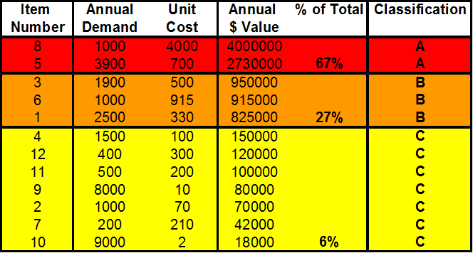

## The Basic Inventory Model: Economic Order Quantity

In this model, we assume that we only have one product. Demand is known, and demand is constant throughout the year. This will allow us to develop a mathematical formula call **economic order quantity**, or **EOQ**.

There are only two costs involved in this model: **ordering** cost which is thecost of ordering and receiving the items; and **holding** or **carrying costs,** defined as the costs to carry an item in inventory for one year. Unit cost of product does not play any role in this model because we do not get a quantity discount.  It does not matter if we order one unit or one million units, the price is the same.

## The Basic Inventory Model

Annual demand for a product is 9600 units.

D = 9600

Annual carrying cost per unit of product is $16.

H = 16

Ordering cost per order is $75.

S = 75

Annual demand for a product is 9,600 units (D), so we need 9,600 units per year.  Annual carrying cost per unit of a product is $16 per unit per year (H). What does this mean?  If we have one unit of inventory in our warehouse and if we keep it for one year, it costs us $16.  That includes, for example, financial cost, physical cost of holding this inventory, and obsolescence cost.  That is, $16 per unit per year, or inventory carrying cost.  And we show it by H, and that is equal to 16.  Ordering cost per order is $75 (S).  Each time we place an order, it costs us $75.

**How much should we order each time to minimize our total cost?**

## Economic Order Quantity

Now we need to answer this question, how much should we order each time to minimize our total cost?  That is one question.  Should we order 9,600 at the beginning of the year or should we order twice a year each time 4,800 units, or say 96 times a year each time 100 units.  What is the economic order quantity?  So like many other business problems here, we have two different cost structures.  One goes up if ordering cost goes up and the other goes down as ordering quantity goes down.

Then the other questions we should answer are how many times should we order?  What is the length of order cycle if we have 288 working days per year?  What is the total cost of this system?  As we said, we don’t consider purchasing cost because it is constant, and it does not depend on our strategy.

## Ordering Cost

So let’s look at **ordering cost**.  If we order one time a year (9,600 units at the beginning of the year) we have one order and therefore, one ordering cost.  But if we put an order for 100 units each time, then we have 96 orders and 96 ordering costs.  In this case, it is 96 times 75 because each order costs us $75.  That is our ordering cost, which is very high.  Alternatively, if we order at the beginning of the year, then ordering cost is 1 times 9,600.  So if D is demand in units per year, Q is what we order each time per order.  Therefore, the number of orders per year is equal to what?  This is all we need to calculate the required order.  Therefore, to find out how many times do we order we calculate what we need divided by what we order each time.  So that would be D divided by Q.

D = Demand in units / year

Q = Order Quantity in units / order

Number of orders / year =

S = Order Cost / Order

Annual Order Cost = S

## Annual Ordering Cost

If we order 50 units each time because we need 9,600 units per year, we will have 192 orders per year.  If we multiply 192 by 75, we get this number, 14,400, a large number.  If each time we order 100 units, we will have 9,600 divided by 100, which is 96 orders.  Then we multiply by 75 and we get 7,200.  So if we increase our ordering size and order 500 units each time, we will order 19.2 times.  19.2 times in this period means we order 20 times in this year, but 19.2 of it is for this year and 0.8 will go to next year.  So if you don’t get integer numbers here, don’t worry.  In the first year, you have 27 orders and one other order, which 0.4 of it is for this year and 0.6 of it is for next year.

Don’t forget all these assumptions are valid for the next year and next year after that.  This is the most basic inventory model.  We can develop all types of inventory models, but they are more difficult to develop, and we are sure you don’t want us to go through very difficult models.  So let’s first try to understand this basic model.  Then the pathways to others are not really difficult.  You only need interest and time.  So here if we order 800 units, we should order 12 times, and our cost is 900.

**Figure 4. Annual Ordering Cost Table**

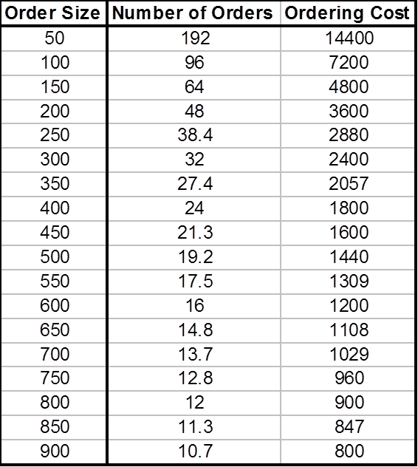

In summary, as order size goes up, number of orders goes down.  Because we have fixed cost per order, total ordering cost per year goes down.  This is number of orders per year.  This is ordering cost per year decreases as ordering size increases.  So it is a benefit to order as much as we can, and the best thing is to order all we need at the beginning of the year.  One order a year for 9,600 units at the cost of $75, but unfortunately the story has another side and that is inventory carrying cost.

## The Inventory Cycle

When we order, when we get this Q, whatever it is, if it is 100 you need or 9,600 at the beginning of the year, when we receive the order, this will be our quantity in hand.  Then we start using it with a constant rate.  Usage rate is constant, which is why it is a straight line coming down. It comes down, down, down.  We are consuming it, consuming it, consuming it.  Then inventory reaches 0.  Before inventory reaches 0, suppose this is our lead time.  Suppose this is 4 days.  If this is our model, this is 1 day, 2 day, 3 day, 4 days.  We will go see demand in 4 days is how much.  So as soon as our inventory in hand reaches this much, we place an order.

**Figure 6. The Inventory Cycle**

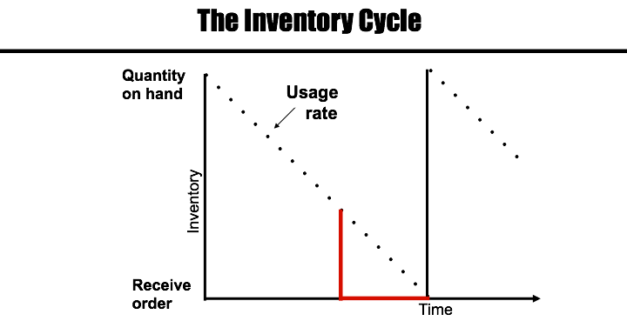

As soon as our inventory on hand reaches demand in lead time, what will see what we need in lead time, and then we place an order.  Because demand rate is fixed, usage rate is fixed.  And because lead time is fixed, exactly at the same time our inventory reaches 0, we will get the next order so we will not be out of stock.  Then we consume it.

Therefore, this is the story.  We get the inventory, and we consume it.  As soon as it gets to 0 we get the next batch.  We will then consume it again.  As soon as we get 0 inventory, we get the next batch.  This cycle with then constantly repeat.

**Figure 7. The Inventory Cycle: Order Quantity**

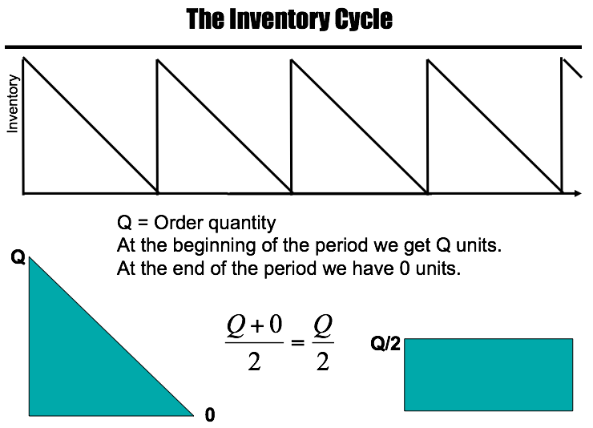

 Suppose this is one year (see Figure 7), we have 4.2 orders per year.  Correct?  Q, order quantity at the beginning of the period we get Q.  No matter what Q is 100, 9,600, or whatever, at the beginning of the period we get Q units.  At the end of the period we have 0 units; therefore, Q units in one course, 0 units in another course.  Your GPA is Q + 0 divided by 2, which equals to Q divided by 2. Therefore, if each time you get Q, and if that Q goes to 0 at the end of the period, this is like this throughout the period and your average inventory was Q divided by 2.  One day, you have a salary of Q dollars.  The other day, you have a salary of 0.  Your average salary during these two days is Q + 0 divided by 2, which is Q divided by 2.  Therefore, if each time we ordered Q and we don’t have any safety stock and our inventory reaches 0 and we get the next order.

At the beginning of a period we start with Q units. At the end of a period we end with 0 units. Therefore we can compute the average.

Q= Order Quantity

Average: (Q + 0)/2

Q

If our order size was 15000 units, we’d have 15,000 as our beginning inventory Q. To calculate the average we would use the formula Average= (Q+0)/2 or Q/2.

(15,000+ 0)/2 = 7500 units

If our order size is 500 units our beginning inventory is 500. Average would be equal to 250.

(500+0)/2 = 250 units.

## Average Inventory per Period and Average Inventory per Year.

**Figure 8. Cycle Inventory**

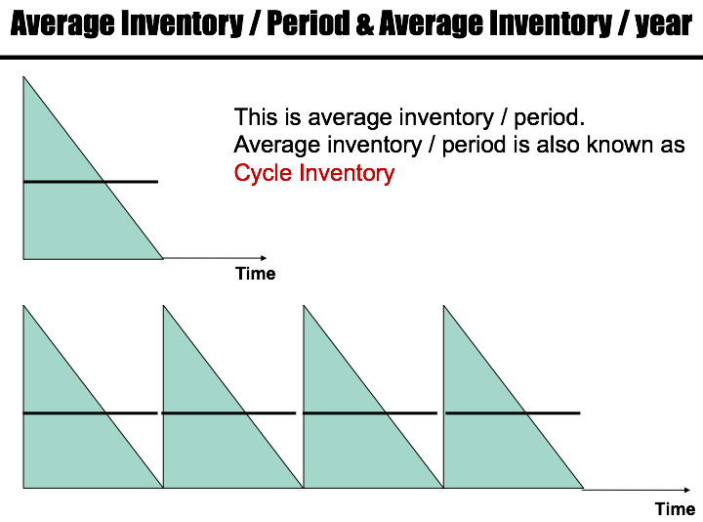

Suppose this is a year (see Figure 8).  In this year, we have 4 periods.  Average inventory per period is Q divided by 2.  What is average inventory per year?  Let’s say we have 9,600 total demand.  We have ordered 4 times, that is 9,600 divided by 4, which is 2,400.  Each time we ordered 2,400.  It goes to 0, 2,400, 0, 2,400, 0, 2,400, and 0.  In general the ordering pattern would be, Q, 0, Q, 0, Q, 0, Q, 0.  Average inventory per period is Q + 0 divided by 2, which is Q divided by 2.  In this period is Q divided by 2.  For each period of the four periods, Q is divided by 2; therefore, average inventory per year is multiplied by 4.  That is Q divided by 2, Q divided by 2, Q divided by 2, Q divided by 2; therefore, throughout the period it is Q divided by 2 throughout the year.  Each time we order Q throughout the year, we have Q divided by 2 average inventories.

**Example 1.**

Cycle Inventory

Q

Time (Year)

Time: 1 Year

Number of Periods: 5

Demand: 15,000 units

Inventory per period: 15,000 units/ 5 periods = 3000 units

Cycle Inventory = Average per period

= (3000 + 0) / 2

= 1500 units

Average inventory per year: Cycle inventory x # of periods

= 1500 units x 5

= 7500 units

## Inventory Carrying Cost

So Q is equal to order quantity in units per order.  Average inventory per year, each time we order Q is Q divided by 2.  H is inventory **carrying cost** for one unit per year; therefore, for one unit per year we have H cost if we are carrying 2 units per year, then our carrying cost is H times Q divided by 2.

Q = Order quantity in units / order

Average inventory / year = Q/2

H = Inventory carrying cost / unit / year

Annual Carrying Cost = H

If Q goes up, annual carrying cost goes up.  In the other scenario, cost structure we had, in ordering cost, when Q goes up, ordering cost comes down, but in this one, when Q goes up, cost also goes up.  We said we are system analysts.  We try to make the optimal solution for everybody and not for only inventory counting cost.  If we are talking about inventory counting costs, it tells us order as little as you can.  If we are talking only about ordering cost, it tells us order as much as you can.  These two solution solutions contradict each other, thus we should see what the benefit for the whole system is.

## 

## Annual Carrying Cost

**Figure 9. Annual Carrying Cost Table**

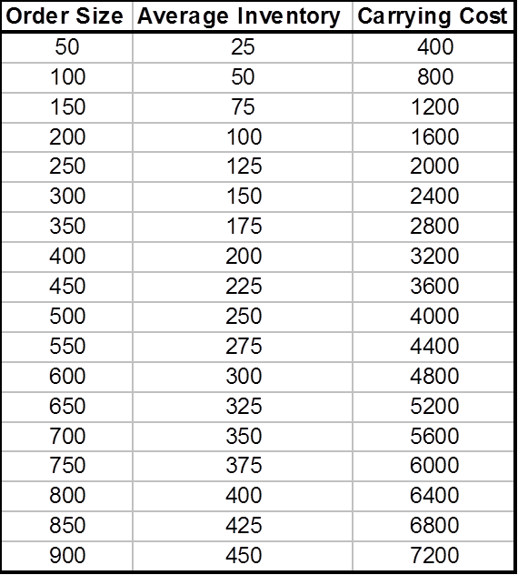

In this carrying cost, if order size goes up, then average inventory is here.  This order size—half of it is average inventory. Order size 600, average inventory 300.  Order size 800, average inventory 400.  Order size 900, average inventory 450.  So this is average inventory.  We should multiply by 16, and we will get this number.  As we go up, inventory carrying cost goes up.  And we have a curve like this.  H time Q divided by 2 increases as Q increases.

## Total Cost

**Figure 11. Total Cost Table**

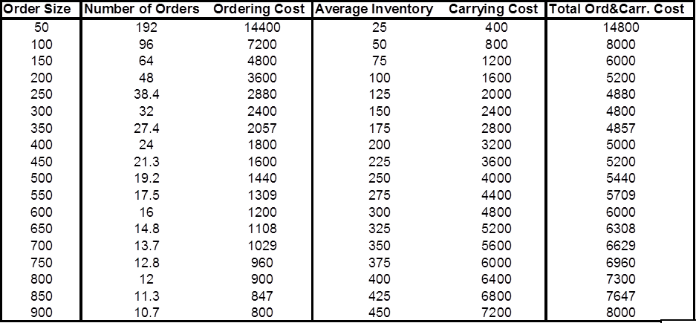

So we have order size, number of orders goes down as order size goes up, ordering cost goes down.  Average inventory goes up as order size goes up, carrying cost goes up, and total cost goes down and then goes up.

**Example 2.**

So let’s assume here that we have an annual demand for textbooks of 17,000 at the CSUN bookstore every year.

D = 17,000.

Then carrying cost of each textbook is $25 per unit,

H = $25/per unit.

The ordering cost per order is $60,

S = $60/per order.

Going off of this, CSUN has an order quantity of 2000 textbooks,

Q = 1550.

So with that, we can find out that they will need to put in 11 orders per year because

Annual Orders Per Year = D/Q, which is 11 = 17,000/1550.

We then find our average inventory per year by dividing our quantity order by 2,

Q/2 = 1550/2 = 775.

We then we find the annual carrying cost by multiplying (H), inventory carrying cost, with average inventory per year,

H(Q/2) = $25 x 775 = $18,125.

With this information we can graph out the relationship between Ordering Cost and Carrying Cost to choose the right amount of Order Size for minimal total cost.

**Figure 11a. Total Cost Table**

|  |  |  |  |  |  |
| --- | --- | --- | --- | --- | --- |
| **Order Size** | **Number of Orders** | **Ordering Cost** | **Average Inventory** | **Carrying Cost** | **Total Ord. & Carr. Cost** |
| 100 | 170.0 | 10,200 | 50 | 1250 | 11,450 |
| 150 | 113.3 | 6,800 | 75 | 1875 | 8,675 |
| 250 | 68.0 | 4,080 | 125 | 3125 | 7,205 |
| 350 | 48.6 | 2,914 | 175 | 4375 | 7,289 |
| 450 | 37.8 | 2,267 | 225 | 5625 | 7,892 |
| 550 | 30.9 | 1,855 | 275 | 6875 | 8,730 |
| 650 | 26.2 | 1,569 | 325 | 8125 | 9,694 |
| 750 | 22.7 | 1,360 | 375 | 9375 | 10,735 |
| 850 | 20.0 | 1,200 | 425 | 10625 | 11,825 |
| 950 | 17.9 | 1,074 | 475 | 11875 | 12,949 |
| 1050 | 16.2 | 971 | 525 | 13125 | 14,096 |
| 1150 | 14.8 | 887 | 575 | 14375 | 15,262 |
| 1250 | 13.6 | 816 | 625 | 15625 | 16,441 |
| 1350 | 12.6 | 756 | 675 | 16875 | 17,631 |
| 1450 | 11.7 | 703 | 725 | 18125 | 18,828 |
| 1550 | 11.0 | 658 | 775 | 19375 | 20,033 |

**Example 2 Cont.**

**Figure Example 2a. Total Cost Curve**

The point on the graph where Total Cost reaches a minimum is the most efficient place to order. We call this point the **economic order quantity** or **EOQ**

## EOQ (Economic Order Quantity)

TC = (Q/2)H + (D/Q)S

EOQ is at the intersection of the two costs.

(Q/2)H = (D/Q)S

Q is the only unknown. If we solve it

**Total cost** is inventory carrying cost plus ordering cost.  You can use calculus computed derivative of TC with respect to Q and compute EOQ.  If you do that, you will find that EOQ is at the intersection of both costs.  EOQ is where ordering cost intersects with carrying cost.  Therefore, these two are equal at EOQ, and therefore, we can solve this equation and therefore we can find EOQ is equal to square root to 2D times S divided by H:

**Figure 13. EOQ Formula**

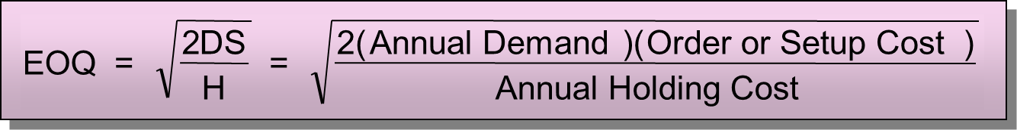

.  

## Back to the Original Questions

Now we go back to our previous example, and now we are in a good position to solve this problem.  So we know that annual demand is 9,600.  Ordering cost is 75, carrying cost is 16; how much should we order each time to minimize total cost, which is to order EOQ?

## What is the Optimal Order Quantity?

D = 9600, H = 16, S = 75

The best strategy is to order 300, not 100, not 9,600, 300.  That is what minimizes our overall cost: both carrying cost and ordering cost. As we said we don’t include purchasing cost because purchasing cost plays no role in this model because price remains the same regardless of quantity.

## How Many Times Should We Order?

Annual demand for a product is 9600 units.

D = 9600

Economic Order Quantity is 300 units.

EOQ = 300

Each time we order EOQ.

How many times should we order per year?

D/EOQ

9600/300 = 32

## What is the Length of an Order Cycle?

Working Days = 288/year

9600 units are required for 288 days.

300 units are enough for how many days?

(300/9600) × (288) = 9 days

## What is the Optimal Total Cost?

You can go through other different ways to come up with the same 9 days.  What is the optimal total cost?

The total cost of any policy is computed as:

TC = (Q/2)H + (D/Q)S

The economic quantity is 300.

TC = (300/2)16 + (9600/300)75

TC = 2400 + 2400

TC = 4800

:

**Example 3.**

## Centura Health Hospital

 Demand in the hospital is 31,200 units per year.  In our current strategy, we order 6,000 units each time.  Ordering cost is $130, carrying cost is $0.90.  A year is 52 weeks.

What is the average inventory or cycle inventory?

**Average inventory** = Q/2 = 6000/2 = 3000

What is total annual carrying cost?

**Carrying cost** = H (Q/2) = 0.9×3000=2700

How many times do we order?

31200/6000 = 5.2

What is the total annual ordering cost?

**Total ordering cost** = S (D/Q)

**Ordering cost** = 130 (5.2) = $676

**Example 4.**

## Jumbo Shrimp Restaurant

Assume you are running a restaurant that serves jumbo shrimp to its customers; they are essentially world renown for how great they taste. But the secret lies in the special spice that is used to marinate the shrimp in. Because of this essential ingredient the demand that the restaurant has for the spice is 72,000 crates (units) per year. The restaurant orders 9000 units each time at an ordering cost of $900 and carrying cost of $25. The year is 52 weeks long. So now you are asked to find the **Average Inventory**, **Annual Carrying Cost**, **Total Ordering Cost**, and the **EOQ** with this given data.

Q = 9000 and Avg. Inventory is Q/2, so…

**Average Inventory** =Q/2 = 9000/2 = 4500

So now that we have the average inventory, we can find the total annual carrying cost; which is the **Average Inventory** multiplied by the **Carrying Cost**. Our data states that H = 25 and Avg. Inventory is 4500, so…

**Annual Carrying Cost** = **H (**Q/2) = 25(4500) = 112,500

Now we want to find out the total annual ordering cost, which consists of using the demand, amount being ordered, and of course, the ordering cost of each unit. First we need to find the

**Example 4 cont..**

total amount of times we will be ordering given our **Quantity Ordered** (Q) and **Demand** (D).

Q = 9000, D = 72,000

D/Q = (72,000/9000) = 8 orders per year

Now we can find the Annual Total Ordering cost since we know that our ordering cost per order is $900 and we order 8 times per year:

**Total Annual Ordering Cost** = **S (**D/Q) = 900(8) = 7200

So now we see what our cost is when we order 9000 units, but we don’t know if this is the optimum amount we can order in order to have the lowest carrying and ordering cost! So in order to do this we use the EOQ (Economic Ordering Quantity) to see if 9000 is too much or too little.

**Economic Order Quantity** =

D = 72,000, H = 25, S = 900

Given this new ordering quantity we can test out and see the new carrying and ordering costs the restaurant would have:

**Annual Carrying Cost =** H (Q/2) = 25(1138.4) = **28,460**

**Annual Ordering Cost =** S (D/Q) = 900(72,000/2276.8) = **28,460.9**

Now we can see how much more money is saved by comparing the differences in annual carrying and ordering costs between the Q of 9000 and 2276.8.

**For Q of 9000:**

Total Cost = Ordering cost(7200) + Carrying Cost(112,500)

Total Cost = $119,700

**For Q using EOQ – 2276.8:**

Total Cost = Ordering Cost (28,461) + Carrying Cost(28,460)

Total Cost = $56,921

**Amount saved using EOQ**: $199.700 - $56,921 = S62,779

## Quantity Discount

Up until this point all of the models have assumed company will pay the same price if they order 1 units or 1,000 units. But what happens to inventory control where there are discounts available for buying in bulk?

When quantity discounts are offered, there is a unique total cost curve for each unit price(Figure 13.A). When the unit price decreases, the total cost curve drops. Therefore if we have a quantity discount we will need to compare the benefits of discount

**How do the curves shift?**

Larqe quantity purchases earn a price discount:

Purchasing cost

Fewer orders:

Ordering Cost

Increased Inventory:

Inventory Cost

Figure 13.A



**Example 5**

**Demand for a product is 816 units a year.**

D=816

**Ordering Cost is $12 per order**

S=12

**Carrying cost is $4 a unit per year**

H=4

**Price Schedule is as follows:**

Quanity(Q) Price(P)

1-49 20

50-79 18

80-99 17

100 or more 16

**What is the best quantity to minimize total annual cost?**

First step is to calculate EOQ:

EOQ = 70

Because Q=70 is in the 50-79 range the corresponding price is $18. We know P1 $20 is not an option based on figure Example 5.1. Next step is to calculate TC at P2(18), P3(17) and P4(16).

Figure Example 5.1



**TC = HQ/2 + SD/Q + PD**

TC ( Q = 70 , P = 18) = 4(**70**)/2 +12(816)/**70** + **18**(816)

TC = 14968

TC ( Q = 80 , P = 17) = 4(**80**)/2 +12(816)/**80** + **17**(816)

TC = 14154

TC ( Q = 100 , P = 16) = 4(**100**)/2 +12(816)/**100** + **16**(816)

TC = 13354

Answer:

As seen by the total cost calculations 100 is the best quantity to order to minimize cost.

1. CSI Market Analysis, Whole Foods Quarterly Report, March 5th, 2015.
2. The Retail Owners Institute®. Based on data from Risk Management Association Annual Statement Studies, 2014/2015. www.rmahq.org