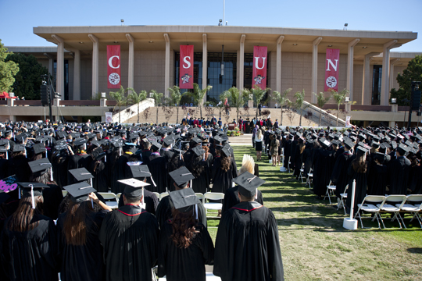

Are you getting ready to graduate this May or next year?

Join us in our Preparing for Commencement 2014 and Filing for Graduation 2015 workshop presented by an Undergraduate Degree Consultant and hosted by the Department of Child and Adolescent Development!

Monday, March 3, 2014  3:00 – 4:00 pm  Jacaranda 2521 | Learn:  -What the new Commencement changes mean for you  -When Grad Fest is and why you should go  -How to apply for graduation  -Participation in Commencement  -Receipt of diploma
RSVP by clicking here or emailing whitney.scott@csun.edu

