Introduction
The Degree Progress Report (DPR) details your progress toward completion of Master’s/Doctoral requirements. It places coursework into CSUN degree requirement sections and identifies requirements you still need to satisfy in order to graduate.
This guide explains how to navigate to and print a DPR.

Step 1
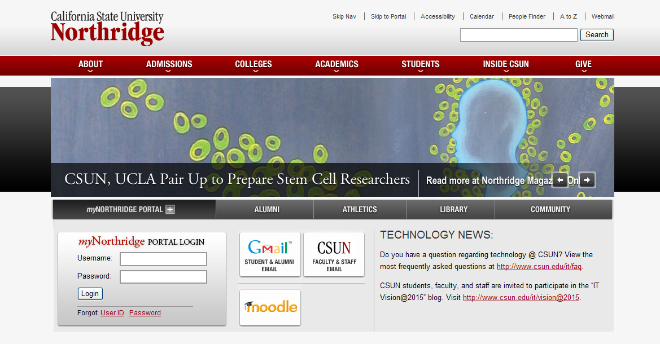Log into myNorthridge at www.csun.edu with your CSUN User ID and Password.

Step 2
Your myNorthridge page displays.
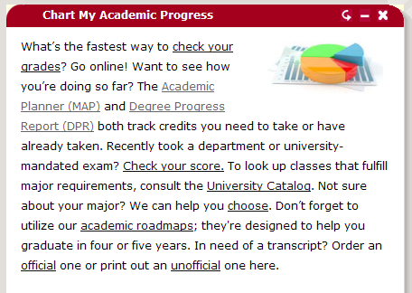
Select the Academics tab, locate Chart My Academic Progress (box), and click the Degree Progress Report (DPR) link.

Step 3
The Submit Report page displays.
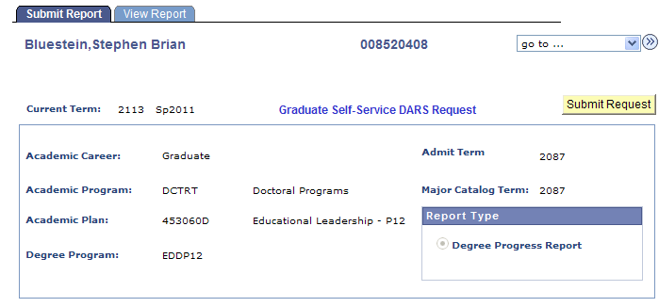
Student I.D.
Student’s Name
Click the Submit Request button.

Step 4
2
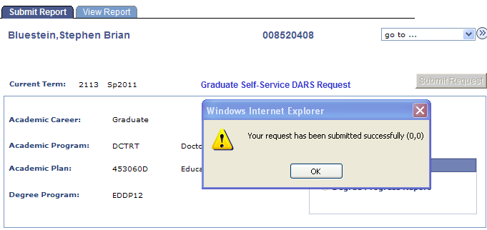
1
Student I.D.
Student Name
A message box appears indicating that your request has been submitted successfully.
Click the OK button.
Then click the View Report tab to change pages.

Step 5
On the View Report page
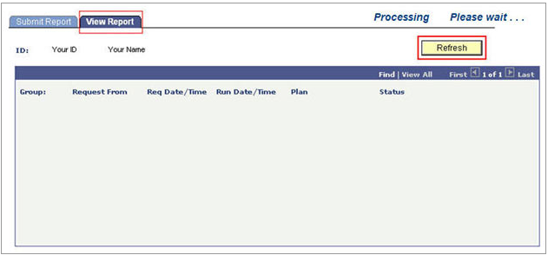
Click Refresh to display the report link. If the screen displays Processing, wait. If necessary, click Refresh until a View Report link appears.

Step 6
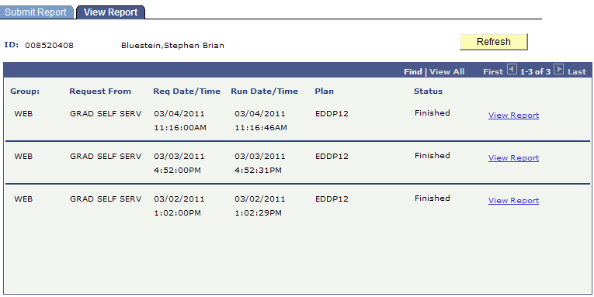
Student Name
Student I.D.
When your report is ready, the Status column displays Finished.
Click the View Report link.
Note: If you have recently requested any reports, several links may display. Select the link with the latest Run Date/Time to view your most current data.

Step 7
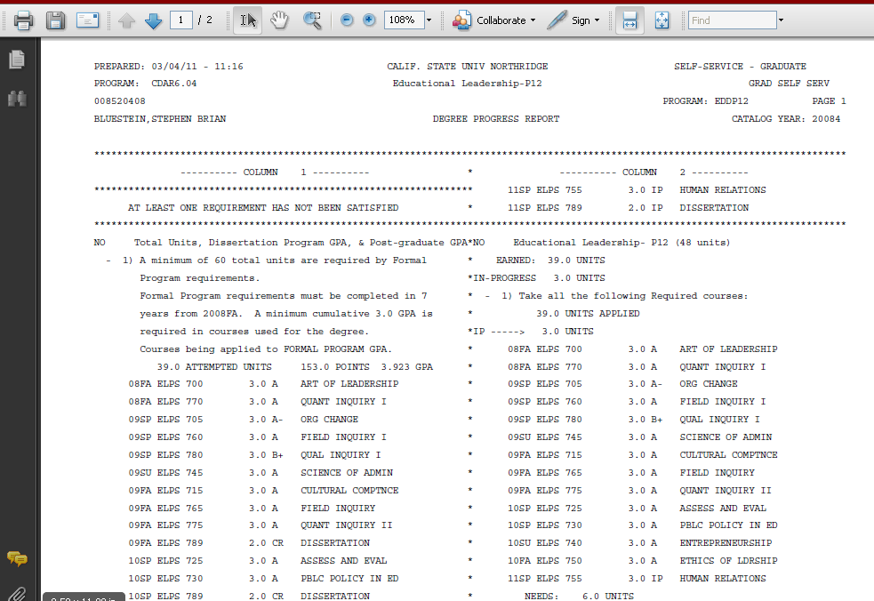
Student name & I.D.
Print the report as you would any document.

