New Graduate Student Orientation

Dear Graduate Students,

Welcome to California State University, Northridge. We in the Office of Research and Graduate Studies are delighted that you have joined us at CSUN- a very special place for graduate students.

CSUN offers outstanding graduate programs that give students the opportunity to work one-on-one with world-class faculty while simultaneously benefitting from all of the services that a large university campus can provide. Because so many of CSUN’s graduate programs focus on real world issues, our students can readily apply what they’ve learned. Indeed, whether studying water availability in Geography, biotechnology in Engineering, or Autism in Psychology, graduate students at CSUN are learning the tools needed to solve Southern California’s and the world’s problems.

This orientation is designed to introduce you to the CSUN campus. It provides an overview of our academic policies and procedures and to the many types of support available to CSUN graduate students. The Office of Research and Graduate Studies is here to help you meet the challenges of master’s and doctoral level educations. Whatever your goal, we look forward to watching you shine at CSUN.

Sincerely Yours,

Crist Khachikian, Ph.D.
Associate Vice President of Research and Graduate Studies and Graduate Dean

Maggie Shiffrar, Ph.D.
Assistant Vice President of Graduate Studies

Table of Contents
Welcome New Matadors 1
Understanding Your Admission Status 1
CSUN Graduate Student Essentials 2
How To Achieve Academic Success 3
Understanding Policies and Procedures 4
The Office of Graduate Studies 4
Financial Opportunities 5
Navigating the Campus 6
Health Wellness and Services 8
Campus Life 9
On Campus Amenities and Resources 10
Key Resources for Graduate Students 11
Contact Us 12
Welcome NEW MATADORS!

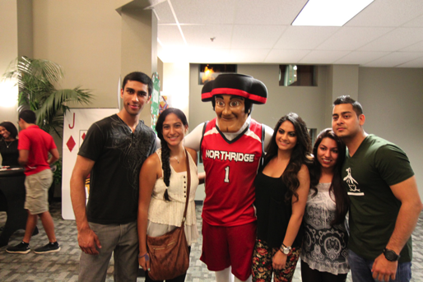

California State University, Northridge is a vibrant, diverse community of 38,310 students and more than 4,000 faculty and staff. The campus is located in the heart of the San Fernando Valley, and is minutes away from Hollywood, Downtown Los Angeles and numerous Southern California attractions. As you explore the university's web site, you will find ample evidence of CSUN’s commitment to the educational and professional goals of its students.

Understanding your Admission Status

Upon accepting your admission to CSUN, you agree to adhere to the university’s policies. As a graduate student, it is your responsibility to know the rules and regulations governing your program. Each student should read the University Catalog, which is located at http://catalog.csun.edu/. In addition, knowing your classification status is vital as you begin your graduate degree, your current classification is listed on your Graduate Admissions Evaluation or 1295 form. The two types of admission classifications are:

Classified: Students admitted with classified standing have met all university and department requirements for admission. Classified students are fully eligible to proceed with courses for their graduate program of study.
Conditionally Classified: Students admitted conditionally classified have not met all university or department requirements for admission. Conditionally admitted students are typically required to take the Upper Division Writing Proficiency Exam, prerequisite courses, the GRE, and/or other requirements. The student’s graduate program sets the specific conditions of the student’s admission status. If you have been admitted conditionally, please contact your Graduate Coordinator for specific information regarding these conditions

CSUN Graduate Student Essentials

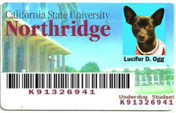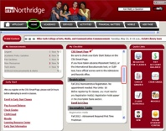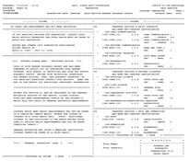

CSUN ID Card:
All incoming students are required to purchase a CSUN ID card. In order to purchase a CSUN ID, please bring $5.00 and an additional form of identification (valid drivers license, passport, or DMV ID card) to the Cash Services counter in Bayramian Hall Lobby.
A CSUN ID Card is required in order to participate in the following:
- To complete university related transactions via Admission & Records, Cash Services and Financial Aid.
- To access the CSUN library.
- To access health services via the Student Health Center.
- To purchase discounted tickets from the ticket office.

How to access your myNorthridge Portal: The myNorthridge Portal is your central hub for accessing academic and financial information such as, your admission status, financial aid awards, account holds, course registration dates, degree planning tools and campus resources. To access your myNorthridge Portal you need a CSUN user ID and password. For more information on how to navigate your myNorthridge portal, please go to http://www.csun.edu/mynorthridge/portal-help-guide.

How to access your CSUN Gmail Account: Once admitted to the university, you will be given a CSUN Gmail account. A letter from the Admission and Records Office will provide you with a CSUN email address and your initial password. This will be your official email account used for all university-related communications. Please make sure to check your CSUN email account regularly. To access your CSUN student Gmail account, go to www.gmail.com and sign in with your email and initial password. If you don't know your email address, log into the myNorthridge Portal and go to the Student Center (SOLAR). For more information on how to access your CSUN account, please contact the IT Help Center at 818-677-1400.

How to access your Graduate Degree Progress Report (DPR): The Degree Progress Report (DPR) is a text-based report available to both undergraduate and graduate students that tracks your academic progress, including completed requirements, suggested courses to satisfy outstanding
requirements, and your GPA. To view a step-by-step tutorial on how to access your DPR, please visit http://www.csun.edu/anr/soc/guides/NavigateDPRMAP.html.
How to Achieve Academic Success

Academic Advisement: One of the ways to achieve academic success is to become familiar with your graduate program. It’s important to meet the Graduate Coordinator who is assigned to help guide incoming and current graduate students. Please visit the following website to see a list of Graduate Coordinators and their contact information http://www.csun.edu/research-graduate-studies/graduate-programs-introduction.

Graduate Coordinator Roles:
- To assist with advisement regarding coursework and academic progress
- Resolve issues pertaining to classification, cumulating experience, graduation, course substitutions, course repeats etc.
- Release holds (temporary blocks that prevent students from registering for classes)
- Provide students with Career advisement and opportunities

Registration: As a CSUN student, you will receive a fall and spring registration date and time. Before fall or spring registration begins, all new students eligible for enrollment in the upcoming semester are sent an email to their CSUN account or a Registration Access Mailer for their first semester only. The mailer contains:
- Your priority enrollment date and time for the Registration-by-Appointment period
- Your name and nine-digit CSUN ID
- Your residency status for tuition fee purposes and information on how and when to pay tuition and other fees
How to complete your Online Registration:
- CSUN students register for classes online by logging into their myNorthridge portal. You can also log into the "Enroll in Classes" feature of the new CSUN Mobile App.
- To preview SOLAR self-service features, see the How To Guides for Students. No login is required.
Understanding Policies and Procedures

In order to be a successful graduate student it is important to understand the university and program specific policies and procedures. For a full explanation of the CSUN policies and procedures please refer to the University Catalog at (http://catalog.csun.edu/) or the Graduate Handbook (http://www.csun.edu/sites/default/files/Graduate-Handbook-8.1.11.pdf). Listed below are some of the items covered in the catalog:
- GPA Requirements
- Graduate Probation and Disqualification Policy
- Two-Year Time Limit on Thesis
- Seven-Year Rule
- Academic Leave
- Enrollment
- Further Information on Rules and Regulation

The Office of Graduate Studies
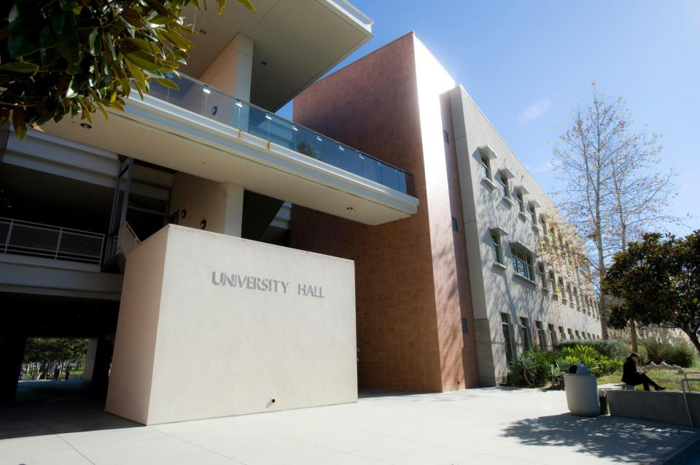

The Office of Graduate Studies is responsible for implementing university policies on graduate student classification, formal programs, culminating experiences, diplomas, probationary and advisement for incoming students. The Graduate Studies Division encompasses the Graduate Studies Committee (GSC) and Graduate Evaluation Services (GES). It is also responsible for Graduate student support programs, equity-based programs, and CSU system recruitment and support programs.

Graduate Student Events
Advancement To Graduate Education (AGE): The Advancement to Graduate Education (AGE) is an annual event in the fall term where students gain valuable information on how to successfully apply to graduate school on the Master’s Level and Ph.D. Students attend workshops where they gain information about the graduate admissions process, financing their education, test preparation exams, and much more. Admission is free and seating is limited. The AGE Conference is open to CSUN students only.
CSUN Annual Student Research and Creative Works Symposium: The CSUN Student Research and Creative Works Symposium takes place each February. Applications to participate are due the previous December. The purpose of the symposium is to highlight student achievement and to inform the campus community of the excellent quality and diversity of research and creative activity being conducted by undergraduate and graduate students across all academic disciplines. For the oral and poster sessions, cash awards are given to the outstanding undergraduate and graduate students in each discipline.

Financial Opportunities

The Office of Graduate Studies is proud to sponsor several programs, awards, and competitions designed to cultivate and encourage student research and scholarship for current graduate students. Please review our programs and visit our website for more information.

Thesis/Project/Dissertation Support: Funds are available for graduate students working on projects, dissertations, and theses. Awards up to $1,000 may be provided to selected students, based on review of an application, which outlines the project, dissertation, or thesis and anticipated costs. Costs associated with travel to a research site, supplies, minor equipment, recital costs and Software updates are examples of expenditures that are supported.

Graduate Student Conference Awards: The Office of Graduate Studies provides travel awards (up to $400) to graduate students who are presenting a paper, poster or performance at a peer-reviewed professional conference. For more information please visit http://www.csun.edu/research-graduate-studies/funding-sources.

California Pre-Doctoral Program (Spring only): The California Pre-Doctoral Program is designed to increase the diversity of the pool from which the California State University draws its faculty. It does so by supporting the doctoral aspirations of CSU students who have experienced economic and educational disadvantages. A special emphasis is placed on increasing the number of CSU students who enter graduate programs at one of the University of California campuses. Each of the applicants selected will be designated a Sally Casanova Pre-Doctoral Scholar and will work closely with a CSU faculty sponsor to develop an overall plan which leads ultimately to enrollment in a doctoral program. The plan should be tailored to the specific goals and career objectives of the student. For more information contact Hedy Carpenter, CSUN Pre-Doc Coordinator at hedy.carpenter@csun.edu or ext.2138 or to learn more about the program visit http://www.calstate.edu/PreDoc/.

Chancellor’s Doctoral Incentive Program (CDIP Spring only): The Chancellor's Doctoral Incentive/Forgivable Loan Program (CDI/FLP) provides student loans to a limited number of individuals pursuing full-time doctoral study at accredited universities throughout the United States. The goal of the program is to provide loans to doctoral students who are interested in applying and competing for CSU instructional faculty positions after completion of the doctoral degree. For more information contact Hedy Carpenter, Director of Graduate Studies at hedy.carpenter@csun.edu or 818-677-2138. To access the application go to:
http://www.calstate.edu/HR/CDIP/.

Student Awards
Association of Retired Faculty Memorial Award: The purpose of the award is to recognize and provide financial support to graduate students for excellent scholarship and creative activity. The award will support a project that is part of a master's program. Award criteria include a project description, two faculty letters of recommendation, and willingness to provide a brief presentation of the research project at the ARF annual brunch.

Robert H. Schiffman Memorial Award For Outstanding Research Promise: The determining factors for the award are based on early stages of conducting research, a minimum GPA of 3.5, record of scholarship and contributions to the field, and returning for the following academic year. The award is for a graduate student who shows promise in research.

Nathan O. Freedman Memorial Award For Outstanding Graduate Student: The determining factors for the award are based on a record of distinguished scholarship, a minimum GPA of 3.5, and contributions to the field. The award recipient will be announced at Honors Convocation.

Navigating the Campus

Financial Aid & Scholarships: To contact the Financial Aid and Scholarship please call 818-677-1200 or http://www.csun.edu/financialaid.

Admission and Records: To contact Admission and Records, please call 818-677-3700 or visit http://www.csun.edu/admissions-records.

Cash Services: To contact the Cash Services office, please call 818-677-8000 or visit http://www.csun.edu/stufin.

Oviatt Library: The Oviatt Library at CSUN provides educational services and resources to students and faculty. Its primary mission is to provide supplementary classroom material, promote independent learning and facilitate student and faculty research. For more information about the Oviatt Library please call 818 677-2287 or visit http://library.csun.edu/About.
Lynda.com: All students have access to a collection of 1,900+ video-based trainings on a variety of topics and software. Students can access these training videos from their tablets, smartphones, or desktops. For more information please visit www.lynda.com.

Matador Bookstore: The Matador bookstore provides textbooks, supplies and CSUN
merchandise for students. For convenience, you are able to order textbooks online and have them delivered to your home. At the Matador Bookstore you can purchase bestsellers, classics, study aids, reference books, test preparation manuals, CD's, magazines, and more. As part of the myCSUNtablet initiative, which seeks to increase the quality of learning materials for students, the bookstore also offers discounts and payment plans to purchase a tablet device. For more information please contact the bookstore at (818) 677-2932 or email matador@bkstr.com.

Police Services: For more information, please call 818-677-2111 for 24 hours Police service, the Dispatch: 818-677-2111, or the receptionist desk at 818-677-2266. In the event of an emergency, please dial 911.

Parking: The Parking & Transportation Division at CSUN is dedicated to assisting students with their parking needs. In order to park on campus, you need an annual parking permit or a daily parking permit that can be purchased at one of the kiosks located in each parking structure. Semester motorcycle permits may only be purchased in person at CSUN Parking Services and all motorcycles must be registered at the Parking Office. For more information about Parking Services, please call 818 677-2157 or visit http://www.csun.edu/parking/.

Matador Patrol: The Matador Patrol is a student-operated public service organization under the guidance of the Department of Police Services. They provide free personal safety escorts during the semester for students, faculty, staff and visitors on campus. They are available Monday-Thursday from dusk to 11:00 p.m. For a free Personal Safety Escort call 818-677-2111 from any campus phone or visit http://www.csun.edu/police/matador-patrol for more information.

Health Wellness and Services

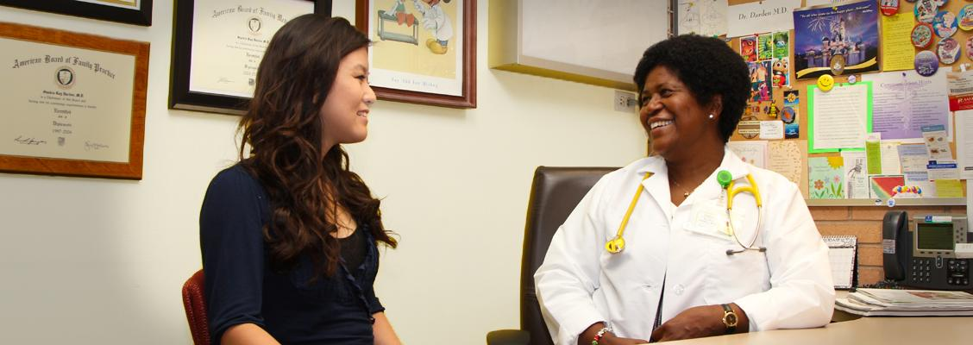

Klotz Student Health Center: The Klotz Student Health Center provides services at little or no cost to currently enrolled students. Physicians at the Heath Center are board-certified in family medicine, internal medicine, sports medicine, gynecology and a variety of other areas. For more information please call 818-677-3666, 818-677-3692 TTY or visit http://www.csun.edu/shc/.

Associated Students Childcare Center: The Associated Students Childcare Center aims to provide a high-quality program that is safe and nurturing for children. They foster an
environment in which children develop physical, social, emotional and intellectual skills. The facility is accredited by the National Association for the Education of Young Children (NAEYC).
For more Information please call (818) 677-2012 or visit http://www.csun.edu/as/childrens-center.

University Counseling Services: The University Counseling Department provides a variety of free services, including online assessments, personal counseling, group counseling, and outreach consultations. You can also see an ExCEL (Experience more Confidence and Enjoyment in your Learning) counselor. The University Counseling Services also provides a peer education programs that connects students to the CSUN community. For more information please call (818) 677-2366 or visit http://www.csun.edu/counseling.

Campus Life

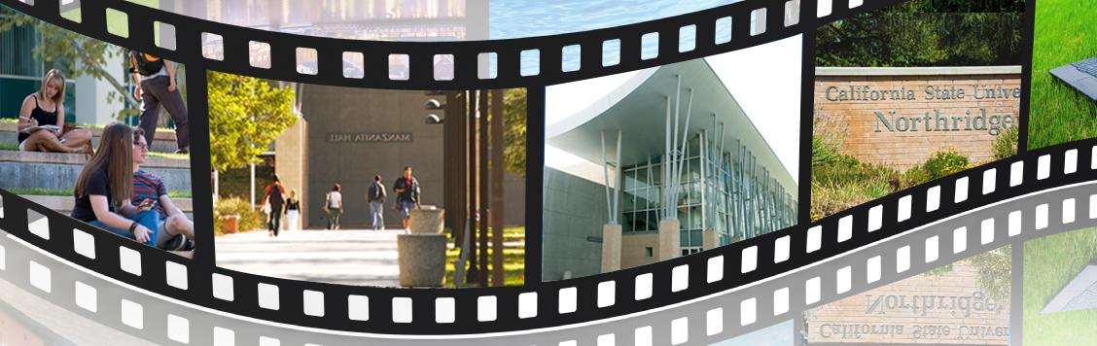

Student Recreation Center: As a graduate student, you will have an opportunity to workout in the 138,000 square foot student recreation Center. The rec center offers a plethora of amenities including: weight rooms, basketball courts, an in-door track, exercise classes as well as a pool. For more information please visit www.csun.edu/src or call 818-677-5434.

Valley Performance Art Center: The Valley Performing Arts Center (VPAC) offers a vibrant and diverse performance program to the University community every season, as well as serving as the intellectual and cultural heart of the San Fernando Valley. The Valley Performing Arts Center series at CSUN is known for its commitment to bringing engaging professional performances of the highest caliber to its exceptional venues. CSUN students get discount tickets to performances at the VPAC. For more information please contact 818-677-3000 or visit www.valleyperformingartscenter.org.

Associated Students: Associated Students (AS) is the primary advocate for students at CSUN. AS provides meaningful programs and services designed to create and enhance a spirited, learning-focused campus environment. Some of these programs include Recreation Sports, the Children's Center, Ticket Office, and Recycling Services. AS offers services and information on discounted event tickets, restaurant discounts, monthly transit subsidies, cell phone bill discounts, exciting outdoor group adventures and funding for academic conference travel. For more information please contact 818-677-2477 or visit www.csun.edu/as.

Student Housing: Student Housing is a gateway to the complete California State University, Northridge experience. Convenience, safety, academic assistance and constant support are qualities that make living at CSUN a great choice. For more information please contact 818-677-2137 or visit www.csun.edu/housing.

Campus Dining: Looking for on-campus dining please check out the video.
On Campus Amenities and Resources

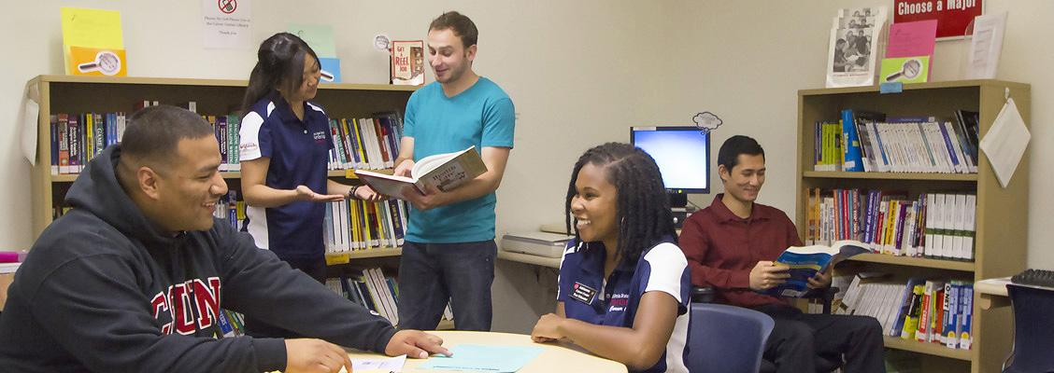

Career Center: The Career Center at CSUN offers career exploration, experiential learning, jobs and internship listings. For more information please call 818-677-2878 or visit www.csun.edu/career.

Pride Center: The Pride Center is an educational outreach organization that supports lesbian, gay, bisexual, transgender and queer (LGBTQ) students. For more information please call 818-677-4355 or visit www.csun.edu/pride.

Veteran Resource Center: The Veteran Resource Center offers services to students who are in active duty, Reserves and the National Guard. For more information, please call 818-677-4672 or visit http://www.csun.edu/vrc.

Disability Resources and Educational Services (DRES): Disability Resources and Educational Services (DRES) provide student services, testing, training and education programs to students with disabilities. For more information call 818-677-2684 or visit http://www.csun.edu/dres/.

National Center on Deafness: The National Center of Deafness department provides services to hard-of-hearing students who attend CSUN. Their services include interpreting, speech-to-text transcription, note taking, tutoring and academic advisement. For more information please call 818-677-2054 or visit www.csun.edu/ncod/

Key Resources for Graduate Students

Graduate Studies page http://www.csun.edu/research-graduate-studies/graduate-studies

Graduate Policies http://www.csun.edu/research-graduate-studies/graduate-policies

Graduate Studies Forms http://www.csun.edu/research-graduate-studies/graduate-studies-forms

University Catalog http://catalog.csun.edu/graduate-programs/graduate-studies-research-and-international-programs/
Student Financial Opportunities http://www.csun.edu/research-graduate-studies/funding-sources

Student Awards http://www.csun.edu/research-graduate-studies/student-awards

Thesis Information http://www.csun.edu/research-graduate-studies/thesisdissertation-guidelines

ETD (Thesis Upload site) https://etd.csun.edu

Online Thesis Archive http://scholarworks.csun.edu
(Scholar Works)

Human Subjects (IRB) http://www.csun.edu/research-graduate-studies/human-subjects-research

Research and Sponsored Projects http://www.csun.edu/research-graduate-studies/research-and-sponsored-projects

CSUN Virtual Software Library http://www.csun.edu/it/vsl

Research and Graduate Studies

University Hall 265
18111 Nordhoff Street
Northridge, CA 91330-8222
Monday – Friday, 8:00 a.m. – 5:00 p.m.
(818) 677-2138
Dr. Crist Khachikian, Associate Vice President of Graduate Studies
677-2138

Dr. Maggie Shiffrar, Assistant Vice President of Graduate Studies
mag@csun.edu

Hedy Carpenter, Director
hedy.carpenter@csun.edu

Gloria Rocklin, Administrative Analyst
gloria.rocklin@csun.edu

Wendy Brown-Danks, Administrative Coordinator
wendy.brown.102@csun.edu

Graduate Evaluations
University Hall 265
Monday – Friday, 8:00 a.m. – 5:00 p.m.
Location UN 353
(818) 677-4800

Lani Kiapos, DARS Coordinator
lani.kiapos@csun.edu
Tanya Kiapos, Graduate Evaluator (A-L)
tanya.kiapos@csun.edu

Judy Roberts, Graduate Evaluator (M-Z)
judy.roberts@csun.edu

