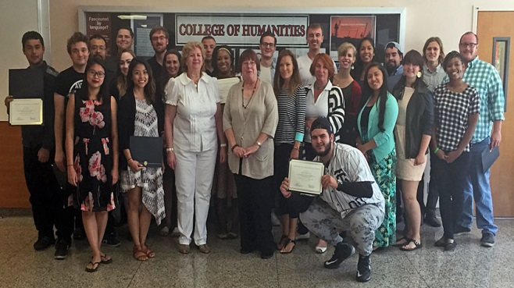

STARTALK Russian Language & Culture
Immersion Program
Summer 2016
ДОБРО ПОЖАЛОВАТЬ!

Want to expand your language and cultural fluencies, enhance your academic resume, and gain a competitive edge in the global workforce? CSUN’s Russian Language & Culture Immersion Program may be for you!

This intensive program is designed to provide highly motivated students with an opportunity to quickly acquire and/or improve proficiency in Russian, which has been designated by the U.S. government as a “critical need” language. Fluent Russian speakers are currently in high demand in international business, science, military, and government sectors. Participants will also learn about contemporary Russia’s influence, politics, national identity, and culture for a well-rounded, holistic view of a fascinating nation in transition.

Students who are accepted into this competitive program will engage in a six-week residential immersion program at CSUN during Summer 2016 upon grant approval.

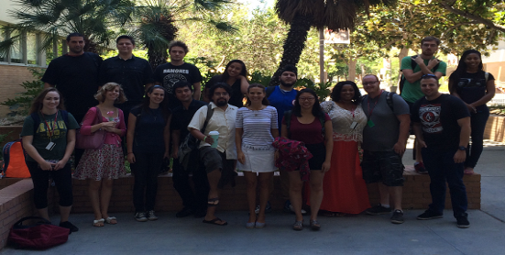
2016 SUMMER IMMERSION RESIDENTIAL PROGRAM

❖ Level of Instruction: Novice-Mid to Advanced

❖ Location: Campus of California State University, Northridge

❖ Duration: June 5, 2016- July 15, 2016

ELIGIBILITY: Russian language learners from any university, community college, ROTC program, or local high school are welcome to apply. Selected applicants will be screened and assessed by program staff.
Selected participants will be tested to determine entrance-level proficiency and placed in appropriate learning cohorts. Those admitted must commit to fully apply themselves to the program and to follow it to completion. Participants pledge to speak exclusively in Russian throughout the program.

❖ NUMBER OF STUDENTS TO BE ACCEPTED: 20

❖ 2016 APPLICATION PERIOD: February 10 – March 31

❖ FOR MORE INFORMATION: Contact Dina Mokhnatkin

E-mail: dina.mokhnatkin@csun.edu; phone: 818-677-3593 or 818-677-3450

Website: http://www.csun.edu/humanities/startalk

Mail to: Dina Mokhnatkin; California State University, Northridge; Liberal Studies, EA 100
18111 Nordhoff Street, Northridge, CA 91330-8247

