How to Create a Great Bug, Feature, or Support Issue

Log into Redmine

- Go to http://studentaffairs.csun.edu/support
- Log in using your CSUN user id and password
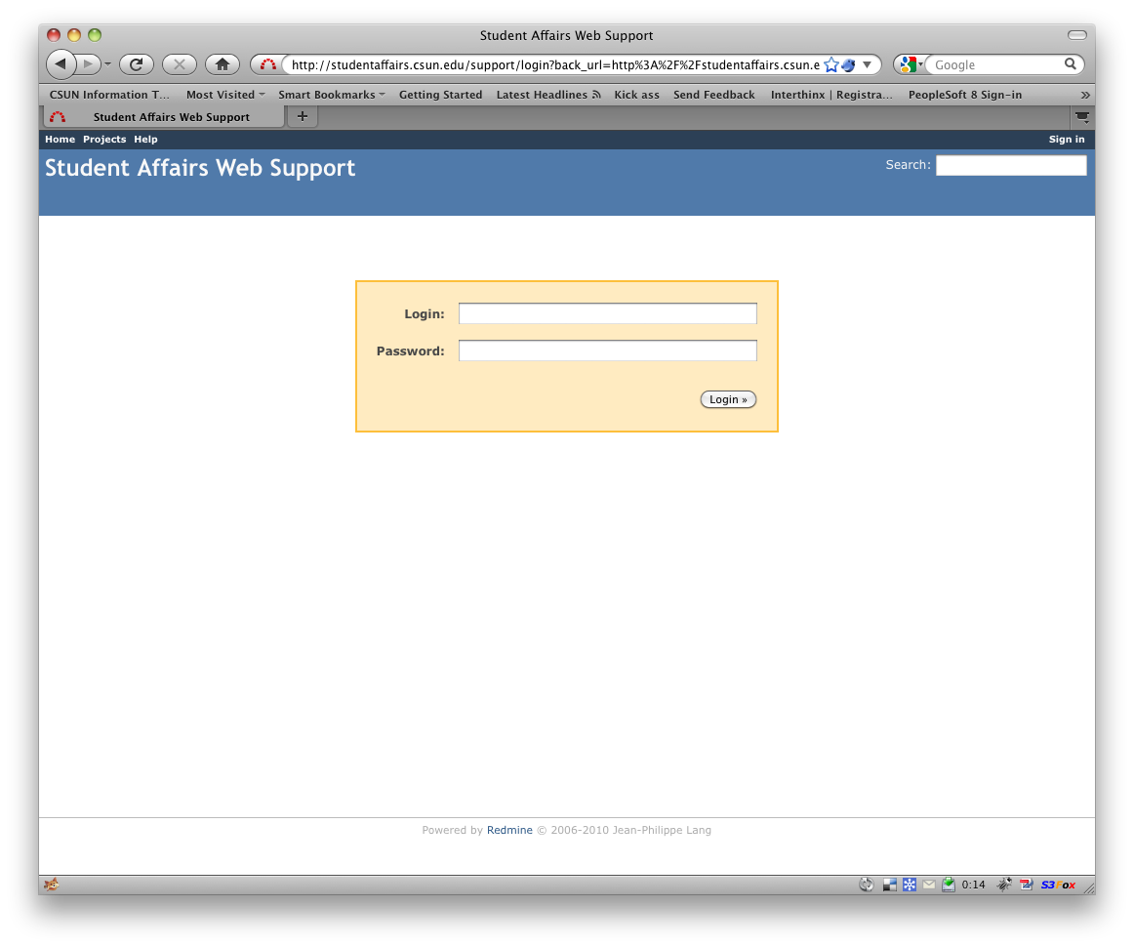

Create a New Issue

- Select Bug, Feature, or Support from the drop-down menu
  - Use bug to report something that is broken.
  - Use feature to request new functionality or a design element.
  - Use support to provide information or make a request that is not quite a bug or a feature. Example: “Add Joe Smith to e-mail notification list”.
- Enter a concise Subject. It should be a unique summary of what you need. Try to use a verb and do not enter issues that use the same subject…if you do, they’ll all look the same to us! Example of a good Subject: “Add text field to capture student first name”.
- Enter a description. Be as precise as possible, using URLs when appropriate.
- Select Watchers. A watcher will be notified by e-mail when the case is updated.
- Attach a file if necessary. This can be a screen shot (jpeg, gif, or png) or any other document that helps explain what you need. If you’re attaching a Word document that’s the size of a book, you should probably split this into more than one issue.
- Click the Create and continue button.

