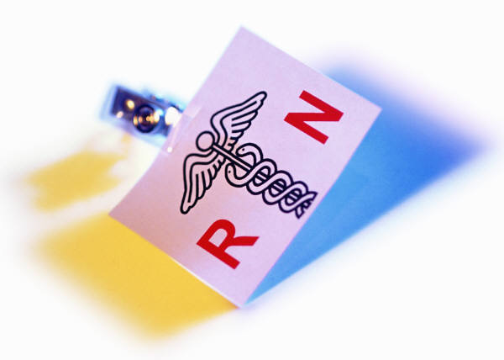****

COMMON PRE-REQUSITES FOR THE RN-BSN PATHWAY:

Lower division on each of the following with a lab: Anatomy, Physiology, Chemistry, and Microbiology with a minimum grade of “C”. Other courses include Epidemiology: Study of Disease, Intro to Statistics, Principles of Human Behavior, Intro to Lifespan Psychology and Intro to Sociology. Also, General Education courses from the following sections: Oral Communication, Written Communication and Critical Thinking.

# Registered Nurses (RN’S) provide and coordinate patient care, educate patients and the public about various health conditions, and provide advice and emotional support to patients and their family members. For more information check out the Bureau of Labor Statistics’ Occupational Outlook Handbook at http://bls.gov/ooh/

What does a Registered Nurse Do?

REGISTERED NURSE

HOW TO BECOME A REGISTERED NURSE

Registered nurses usually take one of three education paths: a bachelor’s of science degree in nursing (BSN), an associate’s degree in nursing (AND), or a diploma from an approved nursing program. To become licensed, nurses must graduate from an approved nursing program and pass the National Council Licensure Examination, or NCLEX-RN. In all nursing education programs, students take courses in nursing, anatomy, physiology, microbiology, chemistry, nutrition, psychology and other social and behavioral sciences, as well as in liberal arts. BSN programs typically take four years to complete; AND diploma programs usually take two to three years to complete.

HOW MUCH DOES A REGISTRED NURSE MAKE?

The median annual wage of registered nurses was $64,690 in May 2010.

## DUTIES OF A REGISTERED NURSE

## Record patients’ medical histories and symptoms

## Give patients medicines and treatments

## Set up plans for patients’ care or contribute to existing plans

## Observe patients and record the observations

## Consult with doctors and other healthcare professionals

## Operate and monitor medical equipment

## Help perform diagnostic tests and analyze results

## Teach patients and their families how to manage their illnesses or injuries

## Explain what to do at home after treatment