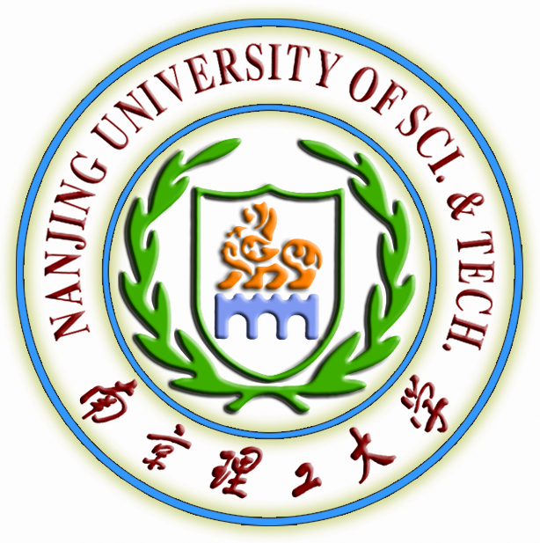
Nanjing University of Science and Technology
Scholarship Program for American Students studying in China

Introduction
Located in the Zhongshan scenic area, Nanjing University of Science and Technology (NUST) is one of the national key universities under the Ministry of Industry and Information Technology. After fifty-eight years’ development, it has become a multi-disciplinary university incorporating science, engineering, liberal arts, economics, business, management, law and education, with special emphasis on engineering. NUST is dedicated to training superior personnel with qualities harmoniously integrated humanistic spirit, scientific cultivation and innovative ability.
NUST is qualified to grant Chinese Government Scholarship to international students. This scholarship program is based on one of the Chinese Government Scholarship, which provides free tuition fee and free dormitory to American students who come to study courses longer than three months this fall semester and the credits which they acquire after taking courses could be admitted to change into their home universities’ .
Both graduate and undergraduate courses listed as below are available in different specialties as well as some liberate arts courses and language learning courses, they all are provided in English in 2012 fall semester.
Welcome to join us!
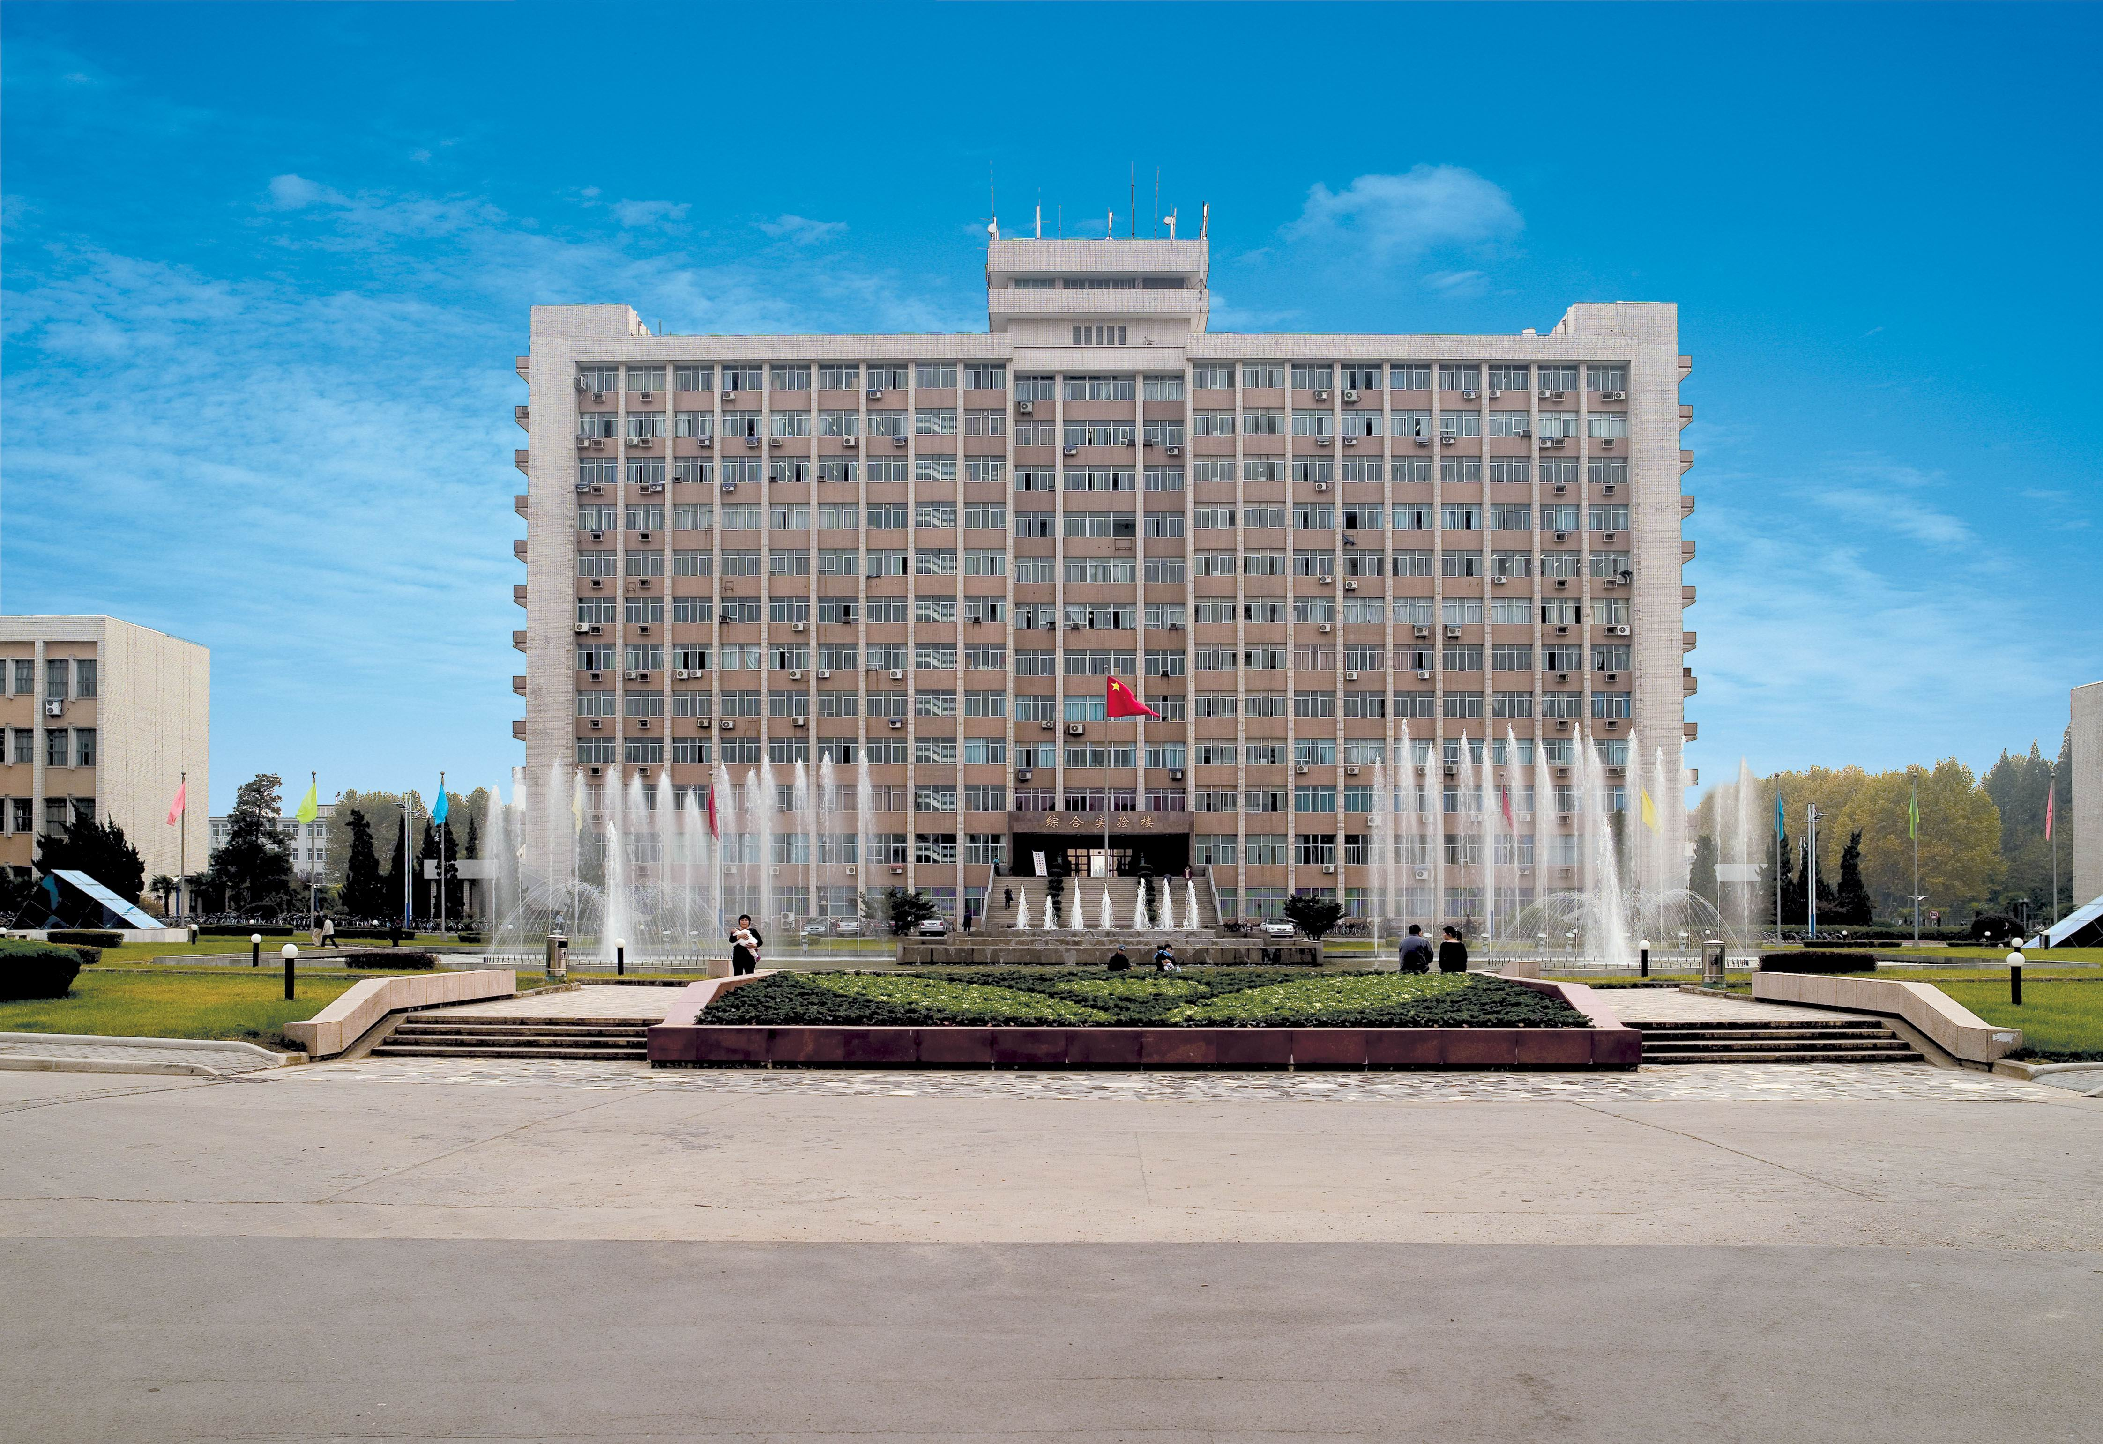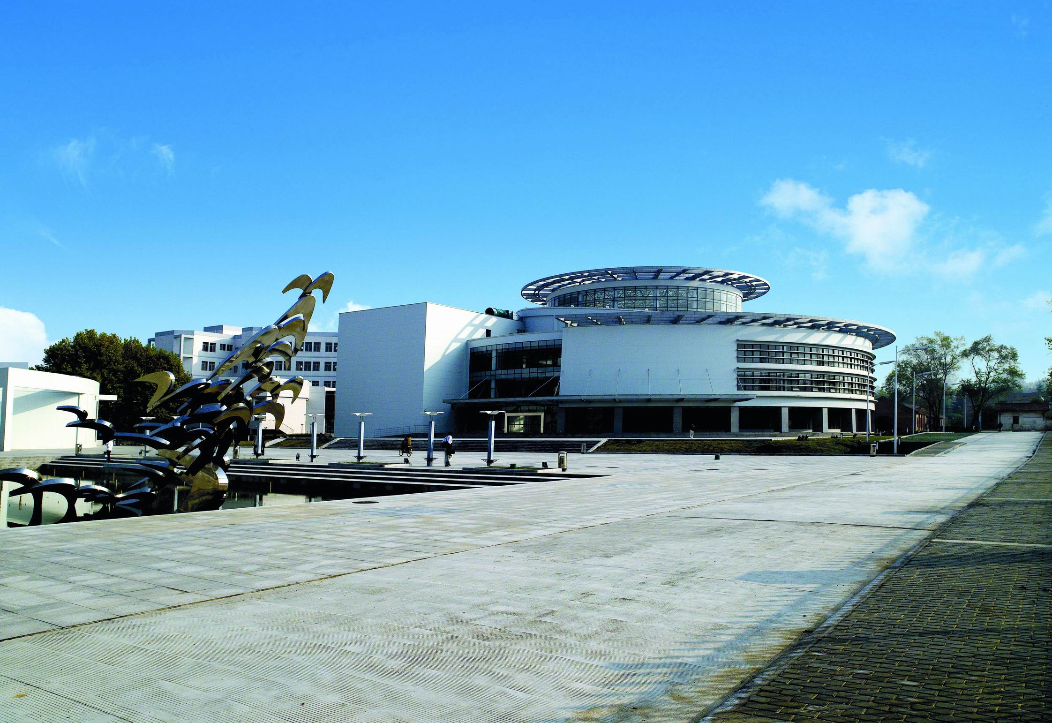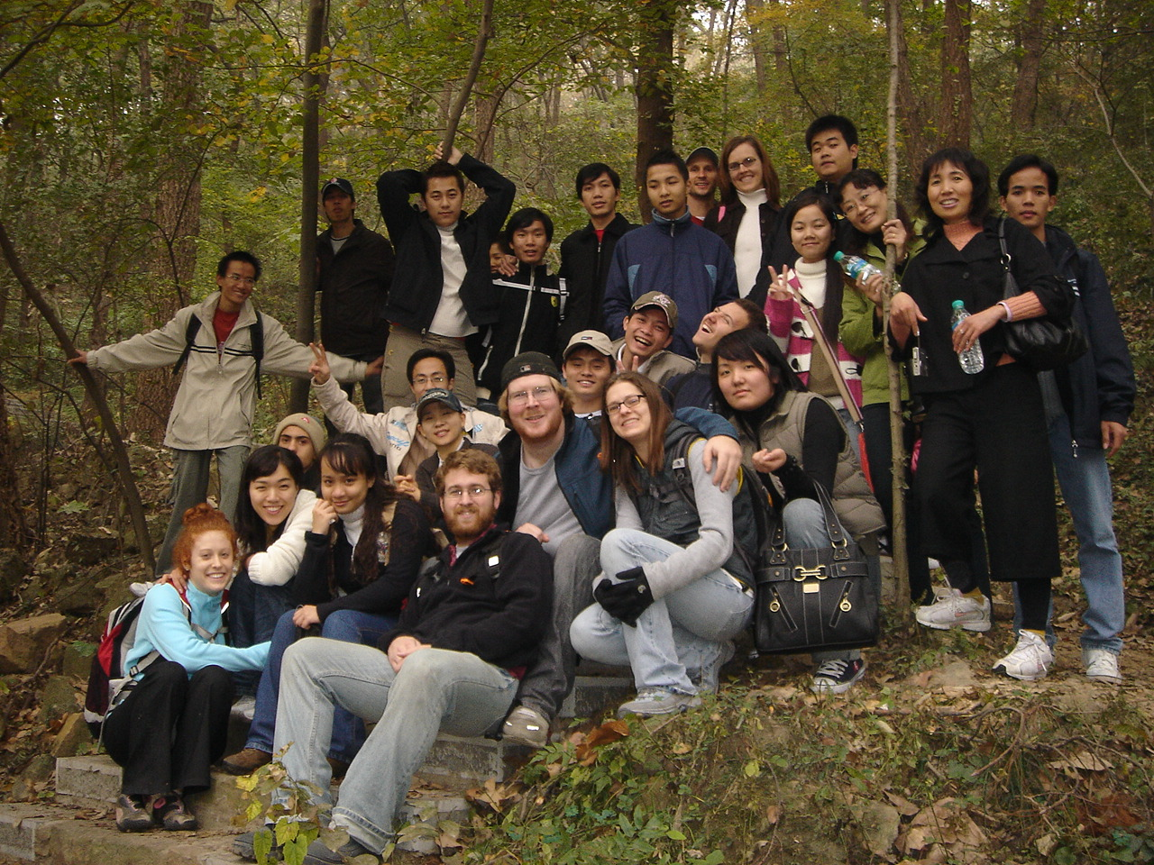

Ph.D. Level Courses
Chemical Engineering & Technology
Progress in Materials Science (2 credits)
Design of Organic Molecular (2 credits)
Master Degree Level Courses
Chemical Engineering & Technology
Nanomaterial Science (2 credits)
Organic Functional Materials (2 credits)
Catalytic Theory (2 credits)
The Design and Application of Composite Particles (2 credits)
Advanced Physical Chemistry (2 credits)
Modern Spectroscopy (2 credits)
Optical Engineering
Infrared Imaging Arrays and Systems (3 credits)
Introduction to Fourier Optics (3 credits)
Measurements of Optical Radiation (2 credits)
Computer Science & Technology
Modern Approaches in Artificial Intelligence (2 credits)
Digital Image Processing and Analysis (2 credits)
Pattern Recognition Technology (2 credits)
Advanced Compiler and Optimization Technologies (2 credits)
International Trade
International Economics (2 credits)
Development Economics (2 credits)
International Trade Practice (2 credits)
International Brand Management (2 credits)
Microeconomics (2 credits)
Macroeconomics (2 credits)
Undergraduate Level Courses
Software Engineering
Object-oriented Modeling (3 credits)
Human-computer Interaction Techniques (2 credits)
Data Structure (4 credits)
Java Programming Language (4 credits)
Computer Networks (3 credits)
Algorithm Design and Analysis (3 credits)
Software Architecture (3 credits)
Photoelectrical Information Engineering
Applied Optics (4 credits)
Introduction to Photoelectrical Information Technology (2.5 credits)
Physical Optics (4 credits)
Laser Technology and Application (3 credits)
Fourier Optics (3 credits)
Digital Image Processing (2 credits)
International Economics & Trade
Macroeconomics (3 credits)
Statistics (3 credits)
Game Theory (2 credits)
Industrial Economics (2 credits)
Econometrics (3 credits)
International Economics (2 credits)
Practices of International Trade (3 credits)
International Trade in Services (2 credits)
World Economy (2 credits)
Operational Research (3 credits)
International technology Trade (2 credits)
Geography of International Trade (2 credits)
International Commercial Law (2 credits)
International Business and Negotiation (2 credits)
Study on International Trade Issues (2 credits)
International Banking (2 credits)
International Credit (2 credits)
Materials Science and Engineering
Properties of materials (4 credits)
Fundamentals of mechanical design (3 credits)
Fundamentals of Inorganic Materials Science (4 credits)
Semiconductor Physic (3 credits)
Engineering Materials (4 credits)
Numerical Simulation Technology of Materials Engineering (3 credits)
Degradation and failure of materials (3 credits)
Polymeric materials (3 credits)
Functional Materials (3 credits)
Biomaterials (2 credits)
Liberal Arts Courses
An Introduction to Chinese Culture (2 credits)
Contemporary Chinese Society, Politics & Public Policy (2 credits)
Chinese Political Geography (1 credit)
Language Learning Courses
Comprehensive Chinese (4 credits)
Note: a credit requires 16 class hours.

Estimated Costs of Self-financed International Students Studying in NUST
Application fee: Free
Tuition fee: Free (Original : Undergraduate in English ￥13500 /semester; Postgraduate in English￥18000 /semester, Ph.D. in English ￥22500 /semester)
Accommodation: Free (Original: ￥1800/month(single bed); ￥900/month(double-bed))
Food: ￥1000/month in campus canteen

Application Deadline
June 30, 2012
Contact Information
International Student Office
School of International Education
Nanjing University of Science & Technology
200 Xiao Ling Wei Street, Nanjing 210094
P. R. China
Tel: 0086-25-84303232 / 84303222 / 84315466
Fax: 0086-25-84315134
Email: zhuping@mail.njust.edu.cn
Website: http://www.njust.edu.cn

2012中美人文交流项目外国学生入学申请表

Enrolment Application for American Students

Nanjing University of Science & Technology (NUST)
□ Mr. □ Mrs. □ Miss. □ Ms. □ Dr.  姓/Family name: 名/Given name: |  |  |  |  | 照片/Photo
国籍/Nationality: | 护照号码/Passport No: |  |  |  | 照片/Photo
出生日期Date of birth: __ __day______ month ______ year |  |  |  |  | 照片/Photo
通讯地址/Home mailing address: |  |  | 电话/Phone:
 |  |  | 传真/Fax:
 |  |  | 电邮/Email:
学习院校/Home University : |  | □协议院校/ Credits Recognized Partnership University  □未来协议院校/ Potential Credits Recognized Partnership University
学生类别/Program undertaking:  □ 本科生/BSc □硕士研究生/Msc □博士研究生/PhD |  |  |  | 年级/ Grade : ______
来华学习专业/Desired study field at NUST: |  |  |  | 来华学习期限Duration : 2012 Fall Semester  month to month
来华拟选修课程名称/Desired study courses at NUST（Select from the courses list of program introduction）
母校学分认证/ Credits recognized by Home university: □ Yes □ No.
备注/Remarks (If you have any special requirement for your study please attach the details)

请把该表直接寄给/Please return this application directly to:

中华人民共和国 Mrs. Zhu Ping
南京孝陵卫200号 School of International Education
南京理工大学 Nanjing University of Science and Technology
国际教育学院 200 Xiao Ling Wei, Nanjing, P.R. China
朱萍 老师 210094

Phone: +86-25-84303232 Fax: +86-25-84315134 Email: admission@njust.edu.cn

