2014-2015 Annual Program Assessment Report
Please submit report to your department chair or program coordinator, the Associate Dean of your College, and to james.solomon@csun.edu, director of assessment and program review, by September 30, 2015. You may, but are not required to, submit a separate report for each program, including graduate degree programs, which conducted assessment activities, or you may combine programs in a single report. Please identify your department/program in the file name for your report.
College: MCCAMC
Department: MUSIC
Program: MUSICIANSHIP
Assessment liaison:
- Please check off whichever is applicable:
A. __X_____ Measured student work.
B. ___X____ Analyzed results of measurement.
C. ____X__ Applied results of analysis to program review/curriculum/review/revision.

2. Overview of Annual Assessment Project(s).
In 2014-2015 the music department elected to assess our musicianship (ear training and sight-singing) curriculum. Each Bachelors of Arts (B.A.) student must take four semesters of musicianship and each Bachelors of Music student (B.M.) student must take six. This curriculum anecdotally had been in need of improvement for some years and the department has been looking to revise it; it has been several years since this program was assessed. Dr. Arthur J. McCaffrey was hired in 2014 to oversee and improve the musicianship curriculum, which is an invaluable part of our B.A. and B.M. programs.

a. The musicianship faculty took cross-sectional data of several musicianship courses this year. PLO 1, “demonstrate the ability to hear, identify, and work conceptually with the elements of music, through sight-reading, basic keyboard proficiency, and musical analysis,” was assessed.
In this first year of the process, the department gathered data on how students were faring in musicianship, based on the direct measures of an entrance and exit exam which measured their ability in melodic and harmonic dictation (the ability to hear music horizontally and vertically respectively). The same dictations (see Appendix 1) for B.A. and B.M. students in the gateway class (MUS112) , an intermediate class (MUS211), and a capstone class for B.A. students (MUS 212) were used. In addition, because B.M. students are required to take two additional semesters of musicianship (MUS 311) and (MUS312), we assessed these two classes as well. The results initially have shown in both the B.A. and B.M. programs that there is a general decline in student performance on melodic dictation, whereas the results in the harmonic dictation have shown minor improvement. In the B.M. program, where students must take two additional semesters of musicianship, there was an improvement in melodic dictation and there was a significant decline in performance. (See Appendix 2). We would like to see student improvement at 80% or above on both melodic and harmonic dictations in the subsequent course level.
In addition an antiquated computer program (MacGamut) will be eliminated from the curriculum in 2015-2016. This program was implemented in half of the musicianship sections in 2014-2015 and initial data showed that this program was ineffective in improving student performance.

b. The musicianship instructors believe that the decline in performance in melodic dictation among B.A.s through MUS 212 is due to uneven pace of curriculum—material became more sophisticated and difficult quite quickly. New coursepacks will hopefully introduce more consistency to pacing and sequence of topics. Performance among B.A.s in MUS 211 & MUS 212 in harmonic dictation is fairly consistent with definite room for improvement. The performance of B.M. students in melodic dictation declines between MUS 311 and MUS 312, and performance in harmonic dictation declines between MUS 212 and MUS 311. As with MUS 211 and MUS 212, we believe this is due to pacing of topics and, more specifically, a lack of opportunity for students to connect what they had learned in MUS 211 and MUS 212 to this new material. New coursepacks will address this issue.

Coursepacks draw from the following texts:

Ear-training:
http://www.cengage.com/search/productOverview.do;jsessionid=05E877C19007D0BFCB7A2F3910422F27?N=4294963670&Ntk=P_EPI&Ntt=111913770413866191888461048821765089914&Ntx=mode%2Bmatchallpartial

Sight-singing:
http://www.cengage.com/search/productOverview.do?N=4294922390+4294966035&Ntk=P_Isbn13&Ntt=9781133307976&Ntx=mode%2Bmatchallpartial
Units in both sight-singing and ear-training are now synced (for example, the "unit 4" topic in ear-training is identical to the "unit 4" topic in sight-singing). This was impossible to coordinate using our old coursepacks and MacGamut. We anticipate an improvement in dictation performance now that singing material can more topically and directly reinforce and support dictation strategies.
Additionally, topics are more consistently paced in these texts than they were in our old coursepacks. There, the material tended to move suddenly into areas of greater sophistication with little preparation. Older coursepacks also contained little review material and were strictly arranged by semester week with one topic per week. The quantity of singing materials per week was low. Instructors whose classes moved more slowly or quickly than the coursepacks had no alternative materials to present to their students other than what they would photocopy out of other textbooks, and had no other way to practice the topic.
"Music for sight-singing" provides a greater quantity of singing material than our previous coursepacks, and presents a sequence of topics much more aligned to our harmony courses than before. The range of styles and levels of difficulty for these materials is also much broader than in our previous coursepacks. For example, singing material for a topic is typically presented first through as series of warm-up exercises that focus exclusively on the new material, and then incorporated into a series of melodies that increase in length and difficulty as the unit continues.
Additionally, the excerpted chapters for both texts in each new coursepack overlap with the years before and after (see below) to allow for review of topics as needed. This was not the case with the old coursepacks. This is an extremely important consideration for our musicianship classes, as we have many students testing into or transferring into our musicianship sequence at different levels, and review materials are essential to ensuring a more consistent experience for all students in our classes.
Re: dictation:

Old system: students had to access the dictation program "MacGamut" using a cumbersome CD-ROM and file system. Progress through topics in this program was strictly linear and students could not deviate from the sequence without significant involvement from either their instructor or MacGamut Technical support. Students had to use this program's outdated and inefficient user interface to complete assignments and receive credit for them. This interface was unique to the MacGamut program and as such imparted no useful music notation and/or music literacy skills to our students, and in fact made writing down a dictation twice as time-consuming as it would have been in class. Instructors could not choose or customize materials to assign and had no way to ensure that dictation activities completed in MacGamut in any way corresponded to what was being concurrently covered in class. Additionally, the software's "practice mode" was limited to marking students' work either "correct" or "incorrect"; there was limited-to-no feedback for either students or instructors on what kind of errors students were making.
New coursepacks: "Music for Ear-training" comes with an access card for a website with streaming audio for dictations. Students can access this website from any computer as long as they have the correct login info. Topics are clearly presented and sequenced, both in terms of concept and level of difficulty. Students can access topics in any order under the guidance of their instructor. There is extensive practice and quiz material for each unit. Practice material allows students to see answers after attempt(s) to allow feedback-guided learning. Students transcribe dictation material by hand into corresponding sheets in coursepack to be submitted to the instructor, so the "interface" is much simpler and the instructor feedback much more consistent. Instructors have access to all dictation materials and audio files as well and can customize assignments and quizzes based on student need. Instructors can suggest practice material for any deficiencies in topics after assessing student work. Instructors can also ensure that dictation and singing topics mutually reinforce each other through these customized assignments.
Coursepacks are organized according to year and are excerpted from these two main texts as follows "Year One" also includes an excerpt from a music fundamentals text for review]:

Year One bundle (Musicianship I & II)
•Ear-training: Units 1-6; Sight-singing: Units 1-6
•Theory: "Part I" from Techniques and Materials of Music

Year Two bundle (Musicianship III & IV)
•Ear-training: Units 1, 4-16; Sight-singing: Units 4-16

Year Three bundle (Musicianship V & VI)
•Ear-training: Units 1, 13-26; Sight-singing: Units 14-26

These divisions were determined to provide as much material to students at as low a cost per bundle as possible.
Finally, all coursepacks include a 20-page supplement created by the coordinator of musicianship. This supplement contains a complete sequence of exercises that asks students to sing through chord progressions using "movable do" solfège syllables, just as they would in "Music for sight-singing". The objective of this supplement is to provide students with another way to integrate their singing activities with the harmonic and melodic dictations. Here as well, topics are arranged to allow for easy integration into the curriculum presented in the ear-training and sight-singing texts from Cengage.

c. Student progress in courses will continue to be assessed using entrance and exit exams with embedded examples in 2015-2016, the pilot year for our curriculum modifications. We hope to make further curriculum modifications, specifically, moving from a six-semester to a more comprehensive four-semester sequence for both B.A.s and B.M.s in the future.

d. As a core sequence, our musicianship classes serve the complete range of music majors - students from two different degree tracks and eleven different options, coming from both high school and transfer institutions. As such, we serve students from the widest possible range of backgrounds in terms of access to musical and academic training, instruction, and experience. Because of this, musicianship classroom instruction focuses heavily on presenting students with numerous dictation problem-solving strategies. We encourage students to engage in pedagogical self-reflection in and out of class to determine which strategy or strategies are most complementary to their personal learning styles and which methods best lead to student success.
Up to now, due to the limitations of both our coursepacks and computer-assisted instructional materials (MacGamut), we have been unable to provide our students with the infrastructure and opportunities that they need to successfully engage in this self-reflection and try our different strategies, particularly outside of the classroom. We believe our new course materials provide students with access to a broader, more inclusive and more comprehensive range of multi-media learning tools and materials with which to pursue their musical and academic goals in the musicianship sequence.

- Preview of planned assessment activities for next year.

  - Music Industry Studies (B.A.) program
This program will be evaluated using entrance/exit exams to measure Undergraduate PLO 6: “demonstrate professional competence in the execution of business processes and practices commonly employed within their area of specialization.” Test questions will be developed by the Music Industry faculty in consultation with the assessment advisor. Entrance exam will be administered in the gateway course to the Music Industry Studies program (MUS 293/L: Field Experience in the Music Industry) during the Fall semester (October). Exit exam will be administered in the course taken just prior to the capstone internship experience (MUS 493C: Music Industry Practicum) during the Spring semester (April).
b. Music Industry Administration (M.A.) program
This program will be evaluated using entrance/exit exams to measure Graduate PLO 5: “develop interdisciplinary skills and entrepreneurial qualities necessary for career effectiveness within an evolving global music industry.” Test questions will be developed by the Music Industry faculty in consultation with the assessment advisor. Entrance exam will be administered in the gateway course to the Music Industry Administration program (MUS 580: Music Industry Developments) during the Fall semester (October). Exit exam will be administered in the course taken just prior to the capstone comprehensive exam (MUS 693: Current Trends in the Music Industry II) during the Spring semester (May). This PLO has not previously been measured at the graduate level.

Appendix 1: Dictation Exams
Assessment materials, 2014-2015, Musicianship, dictation

Rubrics for melodic dictation (all courses):

• 2 points for each correct pitch (partial credit (1 point) for missing or incorrect accidentals; partial credit for “off-by-x” pitches in which a set of exact pitches were incorrect but the contour and sequential intervals were correct (1 point per note)).

• 2 points for each correct rhythm (partial credit for “off-by-x” rhythms in which a succession of rhythmic durations were correct but were displaced by a small rhythmic value (1 point per note)).

All melodic dictations were presented in the same manner for all sections:
•Students had sheet with clef, key, time signature, starting pitch and duration, and the corresponding blank measures for the dictation.
•Key, tempo and starting pitch were established aurally by instructor
•Melody was played aurally for class six total times with a gap of 30 seconds in between each listening

Rubrics for harmonic dictation (all courses):

• 2 points for each correct highest-voice (“soprano”) pitch per chord (partial credit (1 point) for missing or incorrect accidentals).

• 2 points for each correct lowest-voice (“bass”) pitch per chord (partial credit (1 point) for missing or incorrect accidentals).

• 4 points per Roman numeral identification: 1 point each for a) correct numeral, b) correct quality (indicated through Roman numeral case and additional symbol as needed), c) correct inversion symbol if needed, and d) correct identification of triad or 7th chord via the inversion symbol.

All harmonic dictations were presented in the same manner for all sections:
•Students had sheet with clefs, key, pitches and Roman numeral indication of the starting chord, and the corresponding blank measures for the dictation.
•Key, tempo and pitches of the first chord were established aurally by instructor
•Harmonic progression was played aurally for class six total times with a gap of 30 seconds in between each listening

MUS 112: Melodic dictation (student exit and entrance exams).
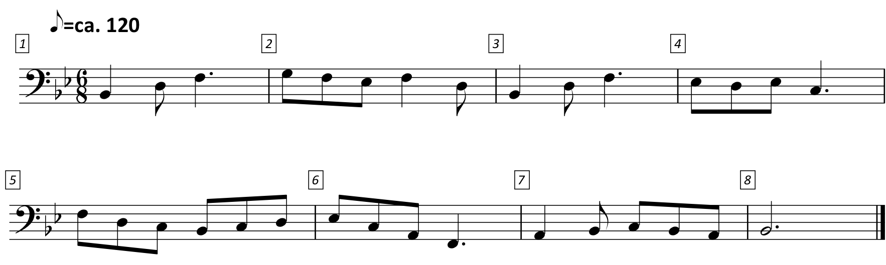

MUS 211: Melodic dictation:
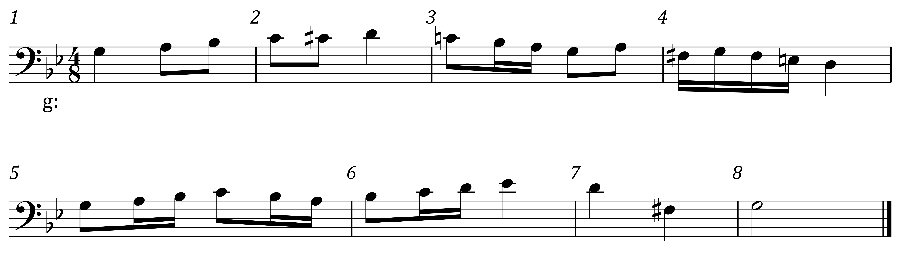

MUS 211: Harmonic dictation
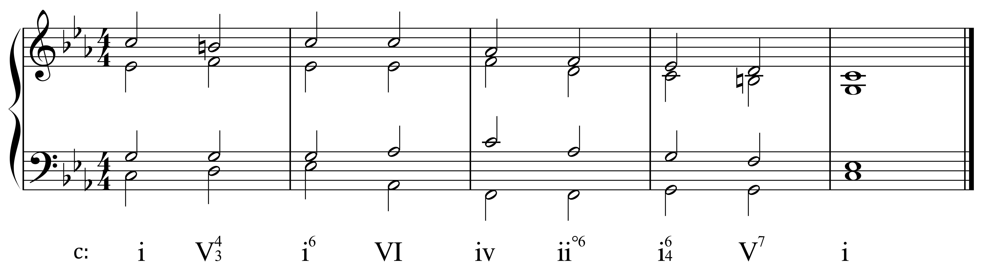

MUS 212: Melodic dictation
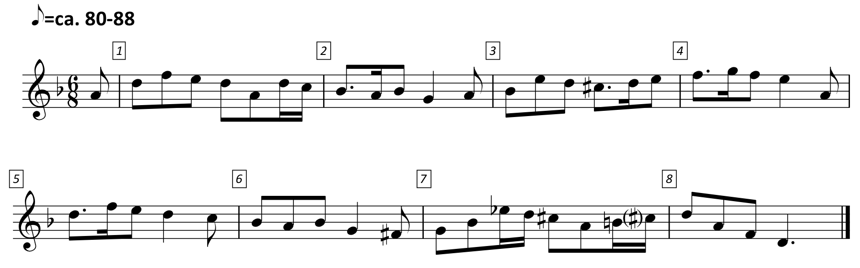

MUS 212: Harmonic dictation
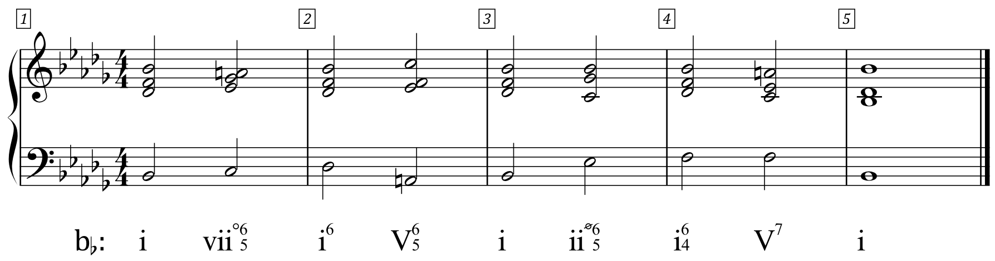

MUS 311: Melodic dictation
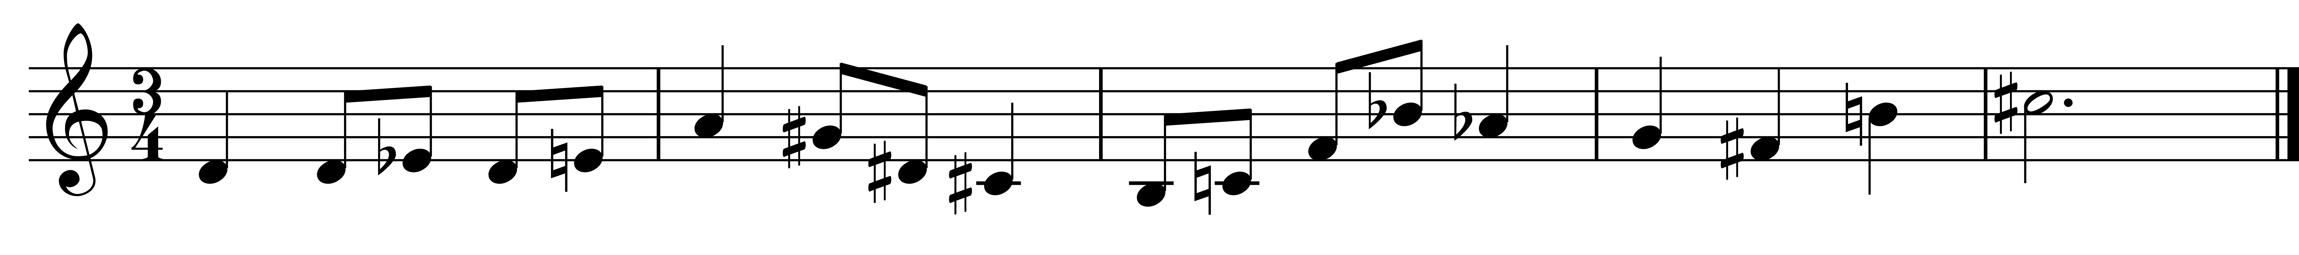

MUS 311: Harmonic dictation
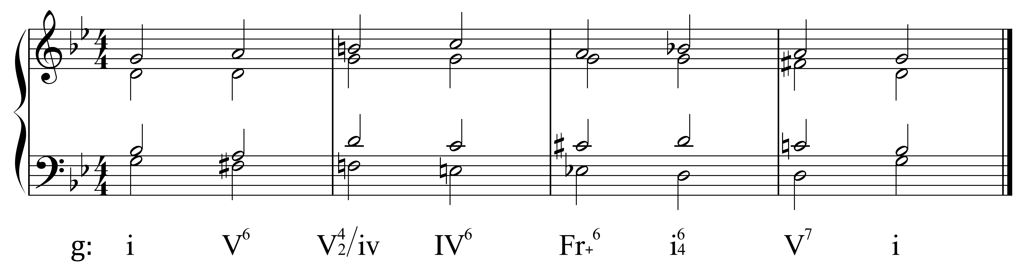

MUS 312: Melodic Dictation

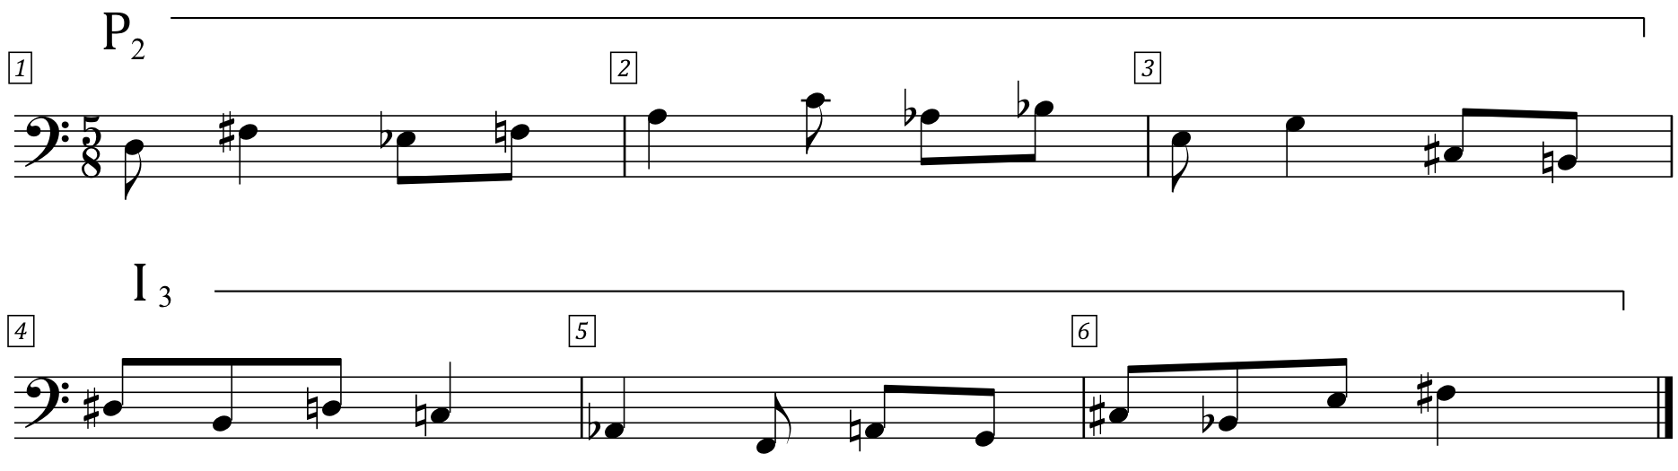

Appendix 2: Cross-Sectional Exam Results

Course: | MUS 112/L | MUS 211/L |  | MUS 212/L |  | MUS 311/L |  | MUS 312/L
Topic: | Melodic | Melodic | Harmonic | Melodic | Harmonic | Melodic | Harmonic | Melodic
Count: | 25 | 51 |  | 80 |  | 25 |  | 42
Average: | 67.4 | 88.2 | 81 | 73.9 | 83.3 | 80.5 | 74.9 | 70.1
Median: | 68 | 92 | 85 | 78.5 | 86.5 | 80 | 80 | 69
Mode: | 55 | 100 | 96 | 88 | 92 | 100 | 93 | 100
Range: | 88 | 47 | 52 | 90 | 46 | 43 | 53 | 90

