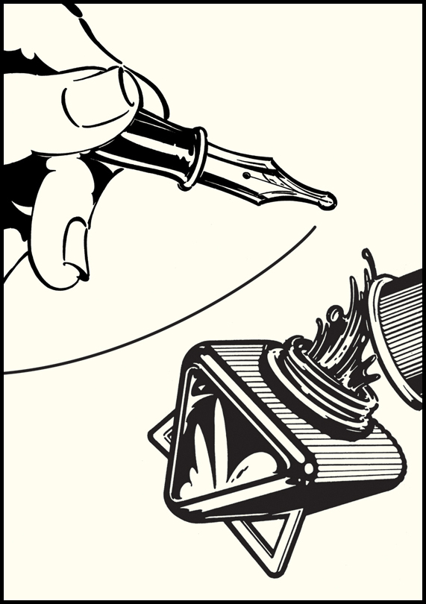
Drawing Attention
By John Van Hamersveld
August 26-October 12, 2013
Artist Reception: Saturday, September 7 4–7 pm
Gallery Talk: Monday, September 9 10 am

The iconic imagery and graphic designs of legendary Los Angeles artist John Van Hamersveld will be in the spotlight this fall at the upcoming exhibition Drawing Attention by John Van Hamersveld, premiering at California State University, Northridge Art Galleries. In collaboration with Coolhous Studios, the CSUN Art Galleries are delighted to have organized this national and international traveling exhibition.

Drawing Attention includes 45 years of Van Hamersveld’s work in a 3,000-square-foot exhibition space, providing a rare opportunity to see his personal drawing collection in one cohesive package. The exhibition reveals the depth of his work, his core consistency and his evolution as an artist. It opens August 26 and runs through October 12.

Van Hamersveld has attracted international attention with his designs for record jackets for pop and psychedelic bands since the 1960s. Albums include “Magical Mystery Tour” by The Beatles, “Crown of Creation” by Jefferson Airplane and “Exile on Main Street” by The Rolling Stones. He also designed the iconic “Endless Summer” movie poster.

The 84 images that make up the exhibition include the Billabong Pipeline Wave, Bono as the “Million Dollar Rock Star,” Jimi Hendrix, Cream, Eric Clapton, the “New Composer” series with Mozart and Beethoven, the Grateful Dead Skull, the “Buffalo Skull,” the American “Stussy Revolution” series, the Indian Chief, the “Stomping Grounds” movie poster and the abstract “Box Paintings.”

Accompanying the exhibition is a 160-page book, Drawing Attention by John Van Hamersveld. Published by Gingko Press, the book tells the story behind Van Hamersveld’s prolific artistic output as well as his creative process. Seymour Chwast, renowned graphic designer and founding member of New York’s legendary Push Pin Studios, wrote the forward to the book.

“Drawing Attention provides a compelling context for a discussion about the power of drawing as a path to artistic development,” says James Sweeters, director of CSUN’s Art Galleries. “Using the mighty pen, or pencil, throughout his career, Van Hamersveld invests his designer’s dignity in every work.”

Gallery hours are Monday through Saturday, from noon to 4 p.m., and on Thursday, from noon to 8 p.m. For more information, call CSUN’s Art Galleries at (818) 677-2156 or visit www.csun.edu/artgalleries.

All images Copyright 2013 Coolhous Studio, LLC and John Van Hamersveld - www.johnvanhamersveld.com

