FINANCIAL ACCOUNTING

Topic 9: Define and Compute Liquidity, Solvency, and Profitability Ratios

Reference: Kimmel, Paul. D., Weygandt, Jerry. J. & Kieso, Donald. E. (2006). Financial Accounting: Tools for Business Decision Making (4th ed.). Hoboken, NJ: John Wiley & Sons. Used with permission from the publisher.

Introduction

Ratio analysis expresses the relationship among selected items of financial statement data. A ratio expresses the mathematical relationship between one quantity and another. The relationship is expressed in terms of either a percentage, a rate, or a simple proportion.

To illustrate, Best Buy has current assets of $5,724 million and current liabilities of $4,501 million. We can determine a relationship between these accounts by dividing current assets by current liabilities, to get 1.27. The alternative means of expression are:

Percentage: | Current assets are 127% of current liabilities.
Rate: | Current assets are 1.27 times as great as current liabilities.
Proportion: | The relationship of current assets to current liabilities is 1.27:1.

For analysis of the primary financial statements, we classify ratios as follows.
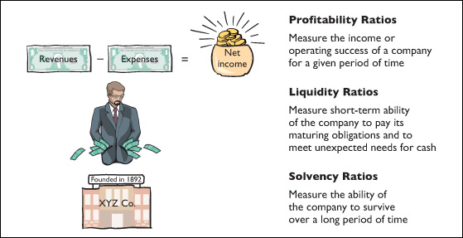

 | Illustration 1 | Financial ratio classifications

Ratios can provide clues to underlying conditions that may not be apparent from examination of the individual items on the financial statements. However, a single ratio by itself is not very meaningful. Accordingly, in this and the following chapters we will use various comparisons to shed light on company performance:

1. | Intracompany comparisons covering two years for the same company.
2. | Industry-average comparisons based on average ratios for particular industries.
3. | Intercompany comparisons based on comparisons with a competitor in the same industry.
Best Buy Company generates profits for its shareholders by selling electronics goods. The income statement reports how successful it is at generating a profit from its sales. The income statement reports the amount earned during the period (revenues) and the costs incurred during the period (expenses). Illustration 2 shows a simplified income statement for Best Buy.
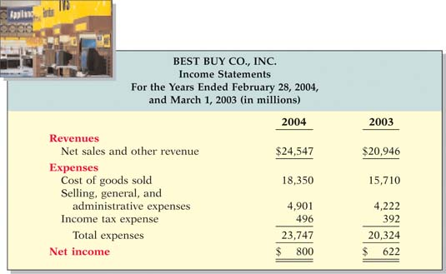

 | Illustration 2 | Best Buy's income statement

From this income statement we can see that Best Buy's sales and net income both increased during the year. Net income increased from $622,000,000 to $800,000,000. Best Buy's primary competitor is Circuit City. Circuit City reported a net loss of $787,000 for the year ended February 29, 2004.

To evaluate the profitability of Best Buy, we will use ratio analysis. Profitability ratios measure the operating success of a company for a given period of time.
Earnings Per Share
Earnings per share (EPS) measures the net income earned on each share of common stock. We compute EPS by dividing net income by the average number of common shares outstanding during the year. Stockholders usually think in terms of the number of shares they own or plan to buy or sell, so stating net income earned as a per share amount provides a useful perspective for determining the investment return. Advanced accounting courses present more refined techniques for calculating earnings per share.
For now, a basic approach for calculating earnings per share is to divide earnings available to common stockholders by average common shares outstanding during the year. What is “earnings available to common stockholders”? It is an earnings amount calculated as net income less dividends paid on another type of stock, called preferred stock (Net income − Preferred stock dividends).

By comparing earnings per share of a single company over time, one can evaluate its relative earnings performance from the perspective of a shareholder—that is, on a per share basis. It is very important to note that comparisons of earnings per share across companies are not meaningful because of the wide variations in the numbers of shares of outstanding stock among companies.

Illustration 3 shows the earnings per share calculation for Best Buy in 2004 and 2003, based on the information presented below. (Note that to simplify our calculations, we assumed that any change in shares for Best Buy occurred in the middle of the year.)

(in millions) | 2004 | 2003
Net income | $800 | $622
Preferred stock dividends | –0– | –0–
Shares outstanding at beginning of year | 322 | 319
Shares outstanding at end of year | 325 | 322

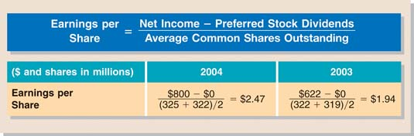
Illustration 3 | Best Buy earnings per share
Using a Classified Balance Sheet
You can learn a lot about a company's financial health by also evaluating the relationship between its various assets and liabilities. Illustration 4 provides a simplified balance sheet for Best Buy.
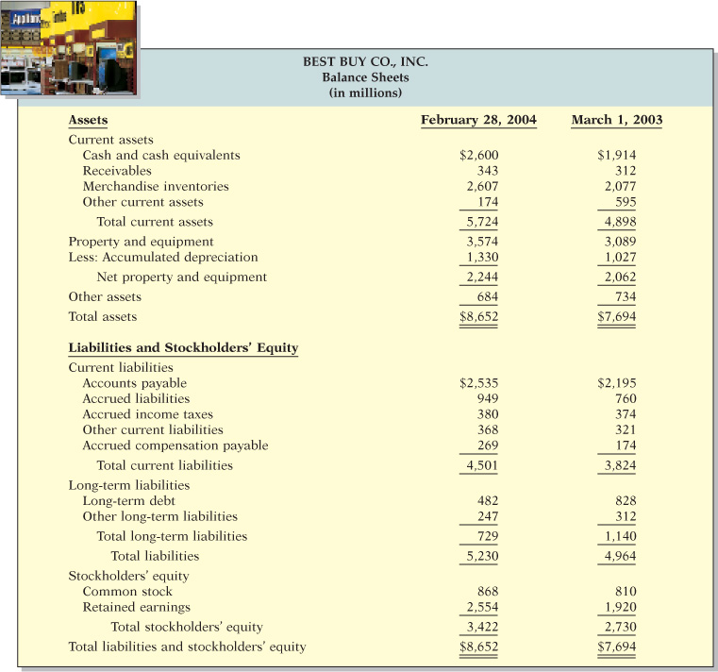

 | Illustration 4 | Best Buy's balance sheet

Suppose you are a banker at CitiGroup considering lending money to Best Buy, or you are a sales manager at Hewlett-Packard interested in selling computers to Best Buy on credit. You would be concerned about Best Buy's liquidity—its ability to pay obligations expected to become due within the next year or operating cycle. You would look closely at the relationship of its current assets to current liabilities.
Working Capital
One measure of liquidity is working capital, which is the difference between the amounts of current assets and current liabilities:

Illustration 5 | Working capital

When working capital is positive, current assets exceed current liabilities. When this occurs, there is greater likelihood that the company will pay its liabilities. When working capital is negative, a company might not be able to pay short-term creditors, and the company might ultimately be forced into bankruptcy. Best Buy had working capital in 2004 of $1,223,000,000 ($5,724,000,000 − $4,501,000,000).
Current Ratio. Liquidity ratios measure the short-term ability of the enterprise to pay its maturing obligations and to meet unexpected needs for cash. One liquidity ratio is the current ratio, computed as current assets divided by current liabilities.
The current ratio is a more dependable indicator of liquidity than working capital. Two companies with the same amount of working capital may have significantly different current ratios. Illustration 6 shows the 2004 and 2003 current ratios for Best Buy and for Circuit City, along with the 2004 industry average.
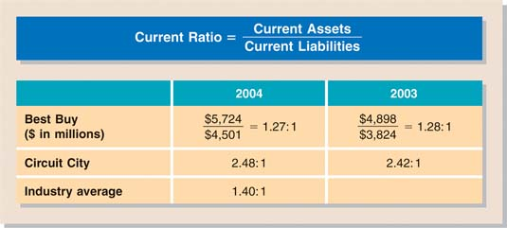

 | Illustration 6 | Current ratio

What does the ratio actually mean? Best Buy's 2004 current ratio of 1.27:1 means that for every dollar of current liabilities, Best Buy has $1.27 of current assets. Best Buy's current ratio decreased slightly in 2004. When compared to the industry average of 1.40:1, and Circuit City's 2.48:1 current ratio, Best Buy's liquidity needs further investigation.

The current ratio is only one measure of liquidity. It does not take into account the composition of the current assets. For example, a satisfactory current ratio does not disclose whether a portion of the current assets is tied up in slow-moving inventory. The composition of the assets matters because a dollar of cash is more readily available to pay the bills than is a dollar of inventory. For example, suppose a company's cash balance declined while its merchandise inventory increased substantially. If inventory increased because the company is having difficulty selling its products, then the current ratio might not fully reflect the reduction in the company's liquidity.
Solvency
Now suppose that instead of being a short-term creditor, you are interested in either buying Best Buy's stock or extending the company a long-term loan. Long-term creditors and stockholders are interested in a company's long-run solvency—its ability to pay interest as it comes due and to repay the balance of a debt due at its maturity. Solvency ratios measure the ability of the enterprise to survive over a long period of time.
Debt to Total Assets Ratio
The debt to total assets ratio is one source of information about long-term debt-paying ability. It measures the percentage of assets financed by creditors rather than stockholders. Debt financing is more risky than equity financing because debt must be repaid at specific points in time, whether the company is performing well or not. Thus, the higher the percentage of debt financing, the riskier the company.

We compute the debt to total assets ratio as total debt (both current and long-term liabilities) divided by total assets. The higher the percentage of total liabilities (debt) to total assets, the greater the risk that the company may be unable to pay its debts as they come due. Illustration 7 shows the debt to total assets ratios for Best Buy and Circuit City, along with the 2004 industry average.
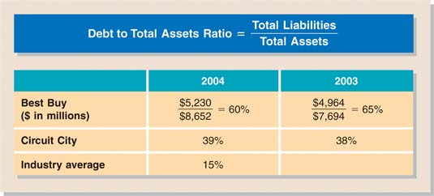

 | Illustration 7 | Debt to total assets ratio

The 2004 ratio of 60% means that Best Buy's creditors provided $0.60 of every dollar invested in assets by Best Buy. Best Buy's ratio exceeds the industry average of 15% and Circuit City's ratio of 39%. The higher the ratio, the lower the equity “buffer” available to creditors if the company becomes insolvent. Thus, from the creditors' point of view, a high ratio of debt to total assets is undesirable. Best Buy's solvency appears lower than that of Circuit City and lower than the average company in the industry.

The adequacy of this ratio is often judged in the light of the company's earnings. Generally, companies with relatively stable earnings, such as public utilities, can support higher debt to total assets ratios than can cyclical companies with widely fluctuating earnings, such as many high-tech companies. In later chapters you will learn additional ways to evaluate solvency.

Evaluating Profitability

Gross Profit Rate

A company's gross profit may be expressed as a percentage by dividing the amount of gross profit by net sales. This is referred to as the gross profit rate. For PW Audio Supply the gross profit rate is 31.3% ($144,000 ÷ $460,000).

Analysts generally consider the gross profit rate to be more informative than the gross profit amount because it expresses a more meaningful (qualitative) relationship between gross profit and net sales. For example, a gross profit amount of $1,000,000 may sound impressive. But if it was the result of sales of $100,000,000, the company's gross profit rate was only 1%. A 1% gross profit rate is acceptable in only a few industries. Illustration 8 presents gross profit rates of a variety of industries.
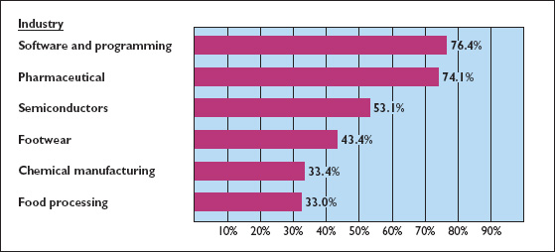

 | Illustration 8 | Gross profit rate by industry

A decline in a company's gross profit rate might have several causes. The company may have begun to sell products with a lower “markup”—for example, budget blue jeans versus designer blue jeans. Increased competition may have resulted in a lower selling price. Or, the company may be forced to pay higher prices to its suppliers without being able to pass these costs on to its customers. The gross profit rates for Wal-Mart and Target, and the industry average, are presented in Illustration 9.
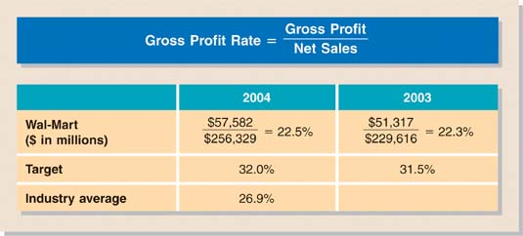

 | Illustration 9 | Gross profit rate

Wal-Mart's gross profit rate increased from 22.3% in 2003 to 22.5% in 2004. In its Management Discussion and Analysis (MD&A), Wal-Mart explained, “This increase in gross margin occurred primarily due to a favorable shift in mix of products sold and our global sourcing efforts (which resulted in lower cost of merchandise sold), offset by increased apparel markdowns (price reductions) in the second half of the year.”

At first glance it might be surprising that Wal-Mart has a lower gross profit rate than Target and the industry average. It is likely, however, that this can be explained by the fact that grocery products are becoming an increasingly large component of Wal-Mart's sales. In fact, in its MD&A, Wal-Mart says, “Because food items carry a lower gross margin than our other merchandise, increasing food sales tends to have an unfavorable impact on our total gross margin.” Also, Wal-Mart has substantial warehouse-style sales in its Sam's Club stores, which are a low-margin, high-volume operation. In later chapters we will provide further discussion of the trade-off between sales volume and gross profit.
Profit Margin Ratio
The profit margin ratio measures the percentage of each dollar of sales that results in net income. We compute this ratio by dividing net income by net sales (revenue) for the period.

How do the gross profit rate and profit margin ratio differ? The gross profit rate measures the margin by which selling price exceeds cost of goods sold. The profit margin ratio measures the extent by which selling price covers all expenses (including cost of goods sold). A company can improve its profit margin ratio by either increasing its gross profit rate and/or by controlling its operating expenses and other costs.

Profit margins vary across industries. Businesses with high turnover, such as grocery stores (Safeway and Kroger) and discount stores (Target and Wal-Mart), generally experience low profit margins. Low-turnover businesses, such as high-end jewelry stores (Tiffany and Co.) or major drug manufacturers (Merck), have high profit margins. Illustration 10 shows profit margin ratios from a variety of industries.
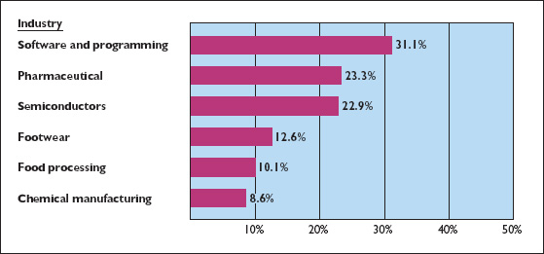

 | Illustration 10 | Profit margin ratio by industry

Profit margins for Wal-Mart and Target and the industry average are presented in Illustration 11.
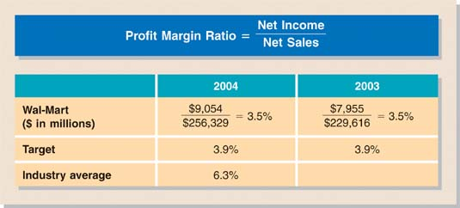

 | Illustration 11 | Profit margin ratio

Wal-Mart's profit margin remained constant at 3.5% in 2003 and 2004. This means that the company generated 3.5 cents on each dollar of sales. How does Wal-Mart compare to its competitors? Its profit margin ratio was lower than Target's in both 2003 and 2004 and was less than the industry average. Thus, its profit margin ratio does not suggest exceptional profitability. However, we must again keep in mind that an increasing percentage of Wal-Mart's sales is from groceries. The average profit margin ratio for the grocery industry is only 3.1%.

Analysis of Inventory

For companies that sell goods, managing inventory levels can be one of the most critical tasks. Having too much inventory on hand costs the company money in storage costs, interest cost (on funds tied up in inventory), and costs associated with the obsolescence of technical goods (e.g., computer chips) or shifts in fashion (e.g., clothes). But having too little inventory on hand results in lost sales. In this section we discuss some issues related to evaluating inventory levels.

Inventory Turnover Ratio

The inventory turnover ratio is calculated as cost of goods sold divided by average inventory. It indicates how quickly a company sells its goods—how many times the inventory “turns over” (is sold) during the year. Inventory turnover can be divided into 365 days to compute days in inventory, which indicates the average age of the inventory.

High inventory turnover (low days in inventory) indicates the company is tying up little of its funds in inventory—that it has a minimal amount of inventory on hand at any one time. Although minimizing the funds tied up in inventory is efficient, too high an inventory turnover ratio may indicate that the company is losing sales opportunities because of inventory shortages. For example, investment analysts at one time suggested that Office Depot had gone too far in reducing its inventory—they said they were seeing too many empty shelves. Thus, management should closely monitor this ratio to achieve the best balance between too much and too little inventory.

The following data are available for Wal-Mart.

(in millions) | 2004 | 2003 | 2002
Ending inventory | $ 26,612 | $ 24,401 | $22,053
Cost of goods sold | 198,747 | 178,299

Illustration 12 presents the inventory turnover ratios and days in inventory for Wal-Mart and Target, using data from the financial statements of those corporations for 2004 and 2003.
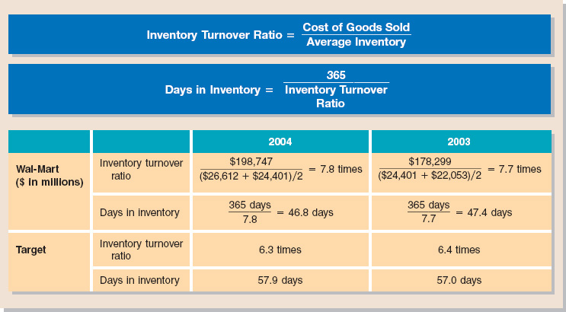

 | Illustration 12 | Inventory turnover ratio and days in inventory

The calculations in Illustration 12 show that Wal-Mart turns its inventory more frequently than Target (7.8 times for Wal-Mart versus 6.3 times for Target). Consequently, the average time an item spends on a Wal-Mart shelf is shorter (46.8 days for Wal-Mart versus 57.9 days for Target). This suggests that Wal-Mart is more efficient than Target in its inventory management.

Note also that Wal-Mart's inventory turnover, which was already better than Target's in 2003, improved slightly in 2004. Wal-Mart's sophisticated inventory tracking and distribution system allows it to keep minimum amounts of inventory on hand, while still keeping the shelves full of what customers are looking for.

Evaluating Liquidity of Receivables

Investors and managers keep a watchful eye on the relationship among sales, accounts receivable, and cash collections. If sales increase, then accounts receivable are also expected to increase. But a disproportionate increase in accounts receivable might signal trouble. Perhaps the company increased its sales by loosening its credit policy, and these receivables may be difficult or impossible to collect. Such receivables are considered less liquid. Recall that liquidity is measured by how quickly certain assets can be converted to cash.

The ratio analysts use to assess the liquidity of the receivables is the receivables turnover ratio. This ratio measures the number of times, on average, a company collects receivables during the period. The receivables turnover ratio is computed by dividing net credit sales (net sales less cash sales) by the average net accounts receivables during the year. Unless seasonal factors are significant, average accounts receivable outstanding can be computed from the beginning and ending balances of the net receivables.¹

A popular variant of the receivables turnover ratio is to convert it into an average collection period in terms of days. This is done by dividing the receivables turnover ratio into 365 days. Companies frequently use the average collection period to assess the effectiveness of a company's credit and collection policies. The general rule is that the average collection period should not greatly exceed the credit term period (i.e., the time allowed for payment).

The following data (in millions) are available for McKesson Corp.

 | For the year ended March 31,
 | 2004 | 2003
Sales | $69,506.1 | $57,120.8
Accounts receivable (net) | $ 5,418.8 | $ 4,594.7

Illustration 13 shows the receivables turnover ratio and average collection period for McKesson Corp., along with comparative industry data. These calculations assume that all sales were credit sales.
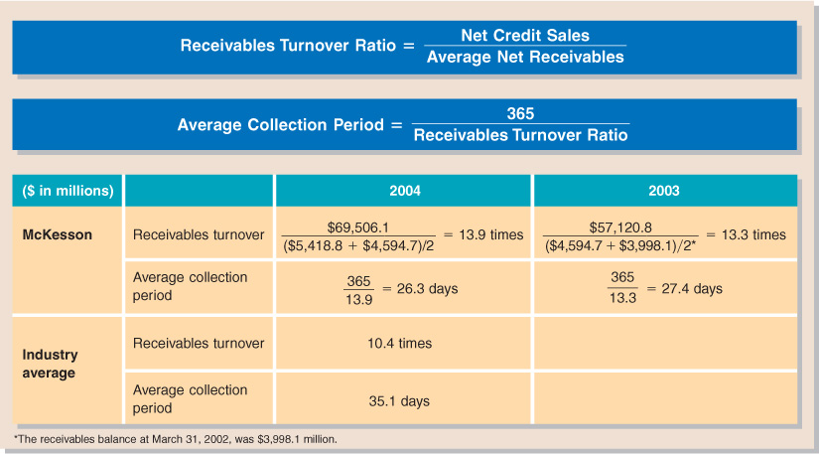

 | Illustration 13 | Receivables turnover and average collection period

McKesson's receivables turnover was 13.9 times in 2004, with a corresponding average collection period of 26.3 days. This was slightly better than its 2003 collection period of 27.4 days. It compares favorably with the industry average collection period of 35.1 days. What this means is that McKesson is able to turn its receivables into cash more quickly than most of its competitors. Therefore, it has a better likelihood of paying its current obligations than a company with a slower receivables turnover.

In some cases, receivables turnover may be misleading. Some companies, especially large retail chains, encourage credit and revolving charge sales, and they slow collections in order to earn a healthy return on the outstanding receivables in the form of interest at rates of 18% to 22%. On the other hand, companies that sell their receivables on a consistent basis will have a faster turnover than those that do not. Thus, to interpret receivables turnover, you must know how a company manages its receivables. In general, the faster the turnover, the greater the reliability of the current ratio for assessing liquidity.

The presentation of financial statement information about plant assets enables decision makers to analyze the company's use of its plant assets. We will use two measures to analyze plant assets: return on assets ratio, and asset turnover ratio.
Return on Assets Ratio
An overall measure of profitability is the return on assets ratio. This ratio is computed by dividing net income by average assets. (Average assets are commonly calculated by adding the beginning and ending values of assets and dividing by 2.) The return on assets ratio indicates the amount of net income generated by each dollar invested in assets. Thus, the higher the return on assets, the more profitable the company.

Information is provided below related to AirTran and Southwest Airlines.

AirTran (in millions) | Southwest Airlines (in millions)
Net income, 2004 | $ 12 | $ 313
Net income,* 2003 | 63 | 171
Total assets, 12/31/04 | 906 | 11,337
Total assets, 12/31/03 | 808 | 9,878
Total assets, 12/31/02 | 473 | 8,954
Net sales, 2004 | 1,041 | 6,530
Net sales, 2003 | 918 | 5,937

Illustration 14 presents the 2004 and 2003 return on assets of AirTran, Southwest Airlines, and industry averages.
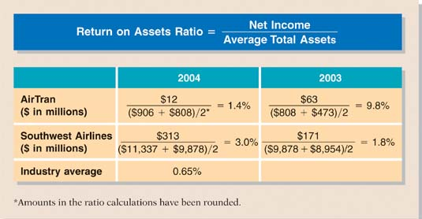

 | Illustration 14 | Return on assets ratio

Southwest Airline's 2004 return on assets was better than that of AirTran and the airline industry, but its 2003 return was less than AirTran's. The airline industry has experienced financial difficulties in recent years as it attempted to cover high labor, fuel, and security costs while offering fares low enough to attract customers. Such difficulties are reflected in the very low industry average for return on assets and in the volatility of this ratio between years for a single airline.
Asset Turnover Ratio
The asset turnover ratio indicates how efficiently a company uses its assets—that is, how many dollars of sales a company generates for each dollar invested in assets. It is calculated by dividing net sales by average total assets. When we compare two companies in the same industry, the one with the higher asset turnover ratio is operating more efficiently: It is generating more sales per dollar invested in assets.

Illustration 15 presents the asset turnover ratios for AirTran and Southwest Airlines for 2004.
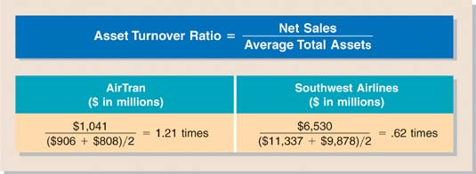

 | Illustration 15 | Asset turnover ratio for 2004

These asset turnover ratios tell us that for each dollar invested in assets, AirTran generates sales of $1.21 and Southwest $0.62. AirTran is more successful in generating sales per dollar invested in assets, perhaps due in part to its decision to purchase older planes. The average asset turnover ratio for the airline industry is .75 times, more in line with Southwest's asset turnover.

Asset turnover ratios vary considerably across industries. The average asset turnover for electric utility companies is .34; the grocery industry has an average asset turnover of 2.89. Asset turnover ratios, therefore, are only comparable within—not between—industries.

Investors are interested in both a company's dividend record and its earnings performance. Although those two measures are often parallel, that is not always the case. Thus, investors should investigate each one separately.
Dividend Record
One way that companies reward stock investors for their investment is to pay them dividends. The payout ratio measures the percentage of earnings a company distributes in the form of cash dividends to common stockholders. It is computed by dividing total cash dividends declared to common shareholders by net income. Using the information shown below, the payout ratio for Nike in 2004 and 2003 is calculated in Illustration 16.

 | 2004 | 2003
Dividends (in millions) | $194.9 | $142.7
Net income (in millions) | 945.6 | 740.1*

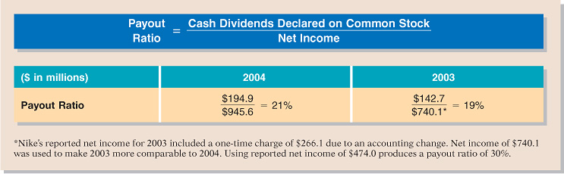

 | Illustration 16 | Nike's payout ratio

Companies that have high growth rates are characterized by low payout ratios because they reinvest most of their net income in the business. Thus, a low payout ratio is not necessarily bad news. Companies that believe they have many good opportunities for growth, such as Nike and Reebok, will reinvest those funds in the company rather than pay high dividends. In fact, dividend payout ratios for the 500 largest U.S. companies currently are very low relative to historical rates. However, low dividend payments, or a cut in dividend payments, might signal that a company has liquidity or solvency problems and is trying to free up cash by not paying dividends. Thus, investors and analysts should investigate the reason for low dividend payments.
Earnings Performance
Another way to measure corporate performance is through profitability. A widely used ratio that measures profitability from the common stockholders' viewpoint is return on common stockholders' equity. This ratio shows how many dollars of net income a company earned for each dollar invested by common stockholders. It is computed by dividing net income available to common stockholders (Net income − Preferred stock dividends) by average common stockholders' equity.

Using the additional information presented below, Illustration 17 shows Nike's return on common stockholders' equity ratios, calculated for 2004 and 2003.

(in thousands) | 2004 | 2003 | 2002
Net income | $ 945,600 | $ 740,100 | $ 668,300
Preferred stock dividends | 30 | 30 | 30
Common stockholders' equity | 4,781,400 | 3,990,400 | 3,838,700

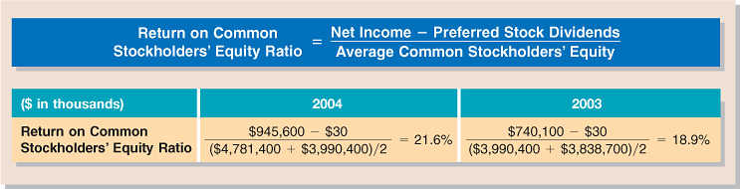

 | Illustration 17 | Nike's return on common stockholders' equity

From 2003 to 2004, Nike's return on common shareholders' equity increased more than 14%. As a company grows larger, it becomes increasingly hard to sustain a high return. In Nike's case, since many believe the U.S. market for expensive sports shoes is saturated, it will need to grow either along new product lines, such as hiking shoes and golf equipment, or in new markets, such as Europe and Asia.
Price-Earnings Ratio
Earnings per share is net income available to common stockholders divided by the average number of common shares outstanding. The market value of a company's stock changes based on investors' expectations about a company's future earnings per share. In order to make a meaningful comparison of market values and earnings across firms, investors calculate the price-earnings (P-E) ratio. The P-E ratio divides the market price of a share of common stock by earnings per share.


 | Illustration 18 | Formula for price-earnings (P-E) ratio

The P-E ratio reflects investors' assessment of a company's future earnings. The ratio of price to earnings will be higher if investors think that earnings will increase substantially in the future and therefore are willing to pay more per share of stock. A low price-earnings ratio often signifies that investors think the company's future earnings will not be strong. In addition, sometimes a low P-E ratio reflects the market's belief that a company has poor-quality earnings.

