GRADUATE FIELD WORK
EDUCATIONALLY BASED RECORDING

The use of the Educationally Based Recording is a requirement of the Social Work Program. The Educationally Based Recording can be completed in a variety of styles and formats. The complete process recording format requires a verbatim recording of all events that took place in an interview/interaction, both verbal and non-verbal. Some formats provide a basic structure and outline of topic areas or a summary of the interview or interaction. Other models of recording are more suited to meetings or group situations, ranging from therapeutic or educational groups with clients, to staff meetings, administrative meetings, etc. The confidentiality of the client will be preserved at all times.

The written reconstruction of an interview/interaction assists the student and facilitates the learning process in a variety of ways. It provides an opportunity for the student to rethink the interview, with a focus on remembering the interview content, analyzing the various interventions, and developing an understanding of their experiences and perceptions of these interactions. The process of completing the recording allows the student the opportunity to reflect upon the interaction with the client(s) and focus on transference and counter-transference issues. As a supervisory tool, the Educationally based recording provides a picture of the student’s interview styles, and is a reflection of the student’s ability to integrate knowledge and theory gained in the classroom.

Requirements for Educationally Based Recordings
First Year Field Work- Academic first year field students are required to complete one educationally based recordings per week throughout the first year of field work. The format for educationally based recordings may be a combination of process recordings and another type of format (see attached). 50% of the recordings must use the process recording format. Field Instructors and students are also encouraged to use other teaching/learning tools such as audiotapes, videotaped, observed interviews and one-way mirrors in place of written recordings.

Second Year Field Work - Academic second year field students are required to complete one educationally based recording per week throughout the second year of field work. Recordings can be completed on direct practice cases, special assignments, and/or administrative assignments. Students in a direct practice placement will be required to complete process recordings. Students in an administratively focused placement may be requested observe and record activities and interactions in a variety of situations (i.e. meetings, events). The ability to accurately conceptualize and analyze events will be a primary learning focus in these situations. Field instructors and students are encouraged to use other teaching/learning tools, such as audiotapes, videotapes, observed interviews and one-way mirrors in place of written recordings.
Requirements for All Students

Educationally based recordings are learning tools that should be utilized in the supervisory sessions with the field instructor. The student and field instructor will need to develop a system whereby the field instructor will have a copy of the recording prior to the supervisory session, to enable the instructor to review the document(s) and prepare for discussion.

The faculty field liaison will review the recordings during the scheduled agency site visit, and may request that an example be brought to the field seminar.

All students are responsible for any documentation that is required by the agency itself for its own records and files. Educationally based recordings do not take the place of, nor should they be used as, documentation on a client chart.

Students complete the educationally based recordings during their internship hours. They should be allowed one hour to complete each recording.

Samples of various formats are attached as well as a Bibliography on articles and books related to educationally based recordings.

THIS PACKET INCLUDES:

EBR Formats
- #1: Clinical Individual (Process Recording)
- #2: Small Client Group Meetings
- #3: Macro Practice
- #4: Community/ Organizations/ Groups
Attachments for Reference
- Attachment A: Emotion Chart
- Attachment B: Therapeutic Interventions for
- Attachment C: Macro Social Work Practice Interventions

A sample format for recording the content of the interview in a process recording format: This page for example only – (Do not turn in as part of your recording). You should have several pages of content, but the entire session does not need to be recorded. Select a significant part of the interaction.

SUPERVISORY COMMENTS | INTERVIEW CONTENT | STUDENT’S GUT LEVEL FEELINGS | CLIENTS FEELING/AFFECT | INDENTIFY INTERVENTIONS AND MAJOR THEMES
In this column, the supervisor can make remarks, comments, etc. regarding the interactions, student feelings or analysis that took place during the interview.  Let’s discuss opening interview techniques. | Record word for word what happened in the interview, including both verbal and non-verbal communication.  If there were Unscheduled interruptions or activities, record these also.  Student: Hello Mrs. J I am your social worker and would like to talk with you to see if I can help you.  Client Well I’m not sure why I need to see you. (silence, client looks away) | Indicate how you were feeling as the activity or interaction was taking place. Use the feelings list (attached) or come up with your own.  Nervous | Your impression of how client is feeling and the observations to support it.  Shy & anxious no direct eye contact | What themes are present in the interaction? What intervention(s) did you use? (see attached list therapeutic interventions)  Intervention: Introduction / encouragement  Theme: resistance

Student’s Name: Client’s Name: (alias so as to preserve client’s confidentiality)
Interview Date: Session #:

SUPERVISORY COMMENTS | INTERVIEW CONTENT | STUDENT’S GUT LEVEL FEELINGS | CLIENTS FEELING/AFFECT | INDENTIFY INTERVENTIONS AND MAJOR THEMES

FOR EACH PROCESS RECORDING ANSWER THE FOLLOWING QUESTIONS:
- PURPOSE OF THE SESSION: (Statement of the purpose that is concise, clear and specific. Show relatedness between this session and the previous session or what you know about the client if applicable).

- Description of any non-verbal observations/interactions (client’s appearance, affect, body language/facial expressions, eye contact, behavior)

- What is the influence of the cultural aspect with your client? How did you utilize cultural humility in your interaction with the client?

- Diagnostic Summary and impressions (working diagnoses, diagnoses to rule out, traits, behaviors and other collateral knowledge of the client and their relationships/interactions with others)

- Professional Use of Self: What professional interventions did you use? What strengths does this client have? What recommendations would you make for this client? Why?

- Code of Ethics: What ethical principle or value applies to this interaction? Why?

- What interventions did you apply in this interaction?

EDUCATIONALLY BASED RECORDING

FOR SOCIAL WORK PRACTICE WITH

SMALL CLIENT GROUP SESSIONS/ MEETINGS
(Therapy Groups, Support Groups, Family Sessions, Psycho-Education Groups)

Please write in narrative format – No longer than 2 ½ pages

A. Information about the Group

Group Name or Type
Meeting Number & Date
Group Members present:
Physical configuration of meeting participants:

B. Purpose of the Group or Meeting

- Write a brief statement on the overall purpose of the group
  - This statement is included only in the first process recording, or if there is an agreed upon change in the group’s overall purpose.
- Write a concise statement about the goals of the meeting of the group being recorded.
  - How were these goals perceived by the group?
  - How did you perceive these goals?
  - What are the similarities or differences between the group’s perception of these goals and yours?

C. Group Process at the Meeting

- Initial Observations
  - Describe briefly, in general terms, the physical and emotional climate at the beginning of the group meeting.
  - Describe briefly your initial impressions of the attitudes and feelings of the group members at the beginning of the meeting.
  - Describe any significant changes in the appearance or feelings or attitudes f the group members since the last meeting.
- Group Member Interaction (Group Process)
  - Describe what went on within the group during its meeting. For example:
    - Describe the means of interaction, e.g., program activity, discussion, debate, tasks, etc.
    - Describe the feeling reactions of the members to this interaction.
    - Describe your feeling reactions to this interaction.
  - Describe the effectiveness, vitality, and responsibility of the group’s members during the interaction.
  - Describe your role in the group’s interaction.
  - Describe the ways the group moved toward attainment of its goals
  - Describe how the group’s members dealt with obstacles to attainment of the meeting’s goals.

D. Analysis of the Group Meeting

- Describe your understanding of the nature of the interaction of the group members, including you, at this group meeting.
- Indicate the theoretical or other knowledge, learned in you other courses, that helps you to understand the process and content of this group meeting.
- On the basis of your analysis, what is your current assessment of:
  - The stage of the group’s development;
  - The commitment of the group members to the group’s purpose;
  - The climate and tone of the group;
  - If relevant, discuss specific roles played by individual group members and how they impact the group process.

E. Plan for the Group’s Next Meeting

- Write a brief statement of the plan for the next meeting of the group.
  - Explain how the members of the group, including you, arrived at this plan.
  - Explain how the plan relates to the purpose of the group.
- Describe what you and the other group members are to do prior to, and in preparation for, the next group meeting.

F. Analysis of the Student Social Worker’s Practice

- Discuss your use of social work practice knowledge and skills during the group meeting.
  - What specific social work skills and/or techniques, learned in your practice courses, did you use during the group meeting?
  - What were the strengths and weaknesses in your practice during the group meeting?

EDUCATIONALLY BASED RECORDING: MACRO PRACTICE

Student Name: _______________________ Activity/Project Title:

New project On-going project

Recording Date:_________ Recording is for the week of:_____________

Date Reviewed with field instructor:__________

1. Purpose of the Activity/Project: Describe background and context of the macro activity/project. What are the goals and objectives for the activity/project, (Or if this is an ongoing activity/project, discuss progress made since the last recording and how it relates to overall goal).

2. What resources from within the agency and outside the agency must be obtained to complete the project?

3. Identifying Macro Skills: Identify and describe some of the macro-practice skill(s) you selected and implemented during the process. If applicable, highlight any macro skills used by other staff involved in the activity/project (refer to macro interventions checklist).

4. Identifying Micro Skills: Describe your use of any micro-level (clinical) skills, if applicable. Consider the skills you used to engage and communicate with the community, group, organization, and/or individuals involved in the activity/ project?

5. Application of Theory/Models/Frameworks: Identify and describe at least one macro theory/model/framework that could apply to this project/activity. Include relevant concepts that might help explain the situation and support your approach (e.g. social systems theory, organizational behavior theories, asset mapping).

6. Obstacles & Challenges: Describe any obstacles or challenges you encountered during the planning or implementation process. What steps did you take to deal with obstacles or challenges?

7. Evaluation: Evaluate the process to this point or evaluate the final outcome. Did you feel the activity/project was successful? Do you believe the original objectives are being accomplished? Why or why not. Is there anything that you would do differently to overcome challenges or improve the outcome?

8. Personal Reflection/ Process: Describe how you were feeling as the activity/project was taking place. Describe how the community/agency/group reacted to your interventions and your use of self. Were there any specific factors that had an impact on you? Identify any newly acquired insights, self-awareness, and/or areas of improvement.

9. Future Plans: What possible next steps are recommended? What changes or plans might be required? What steps can you take to enhance professional development and improve skills at the micro or macro level.

10. Additional Comments (Student and/or Field Instructor):

EDUCATIONALLY BASED RECORDING
FOR SOCIAL WORK PRACTICE WITH

COMMUNITY AND ORGANIZATIONAL GROUPS

Please write in narrative format – No longer than 2 ½ pages

A. Identifying Information

- Name of the Group (Committee, Task Force, Board, etc.)
- Overall purpose of the group (Committee, Task Force, Board, etc.)
- Date of the meeting or activity being process recorded.
- Types of persons present and absent at the meeting or activity.
- Name of the person who called the meeting or activity.
  - Indicate this person’s position.
  - Indicate the method of notification for the meeting or activity.
  - Indicate how much time was allowed between notification and the date of the meeting or activity.

B. Pre-Meeting or Pre-Activity Goals and Perceptions

- Describe briefly the goals stated for the meeting or activity.
  - Attach an agenda, if there is one.
  - Include a discussion of the task and process goals specified for the meeting or activity in your description.
- Describe briefly your own goals expectations, as a student social worker, for this meeting or activity.
  - Include a brief statement of your own task and process goals in your description.

C. Meeting or Activity Process

- Describe the role played by the chairman or leader.
  - Indicate how he or she played this role(s).
  - Indicate the impact/influence of the chairman or leader on the actions of the others present, including you.
- Summarize the overall interaction of those present.
  - Indicate the interactional roles played by different group members.
  - Describe any cliques, leadership patterns, or other factors that develop during the interaction.
  - Describe the atmosphere of the meeting or activity.
- Describe any decisions made or actions taken during the meeting or activity: how they were introduced and how the decisions were made.
- Describe plans for the next meeting or activity of this group, e.g., future agenda items. Include a brief discussion of how the group decided on this plan(s).

D. Analysis of the Meeting or Activity

- Analyze the actions, decisions, conclusions or other interactions that occurred in the group and indicate why you think they occurred.
  - Include a brief discussion of roles that members played that were significant to the interaction.
  - Include a consideration of the cliques, leadership patterns, or other significant variables that influenced the interaction in your analysis.
  - Consider the personal motivations of members in regard to the roles, cliques, patterns and other behavior that emerged in the meeting or during the activity and how these personal motivations might be influencing the interaction.
- On the basis of your analysis, what is your current assessment of:
  - The commitment of the people involved in this committee, task force, board, etc. to the group’s purpose;
  - The motivation of the community or agency people involved to achieve this purpose;
  - Evaluate the growth of leadership in this committee or activity, including the group’s capacity to solve the problems or tasks facing it.

E. Analysis of the Student Social Worker’s Practice

- Identify and analyze your feelings during the meeting or activity.
  - Describe briefly, and analyze your feelings about specific people during the meeting or activity.
  - Describe briefly and analyze your feelings about the content of the meeting or activity, e.g., apprehension, elation, anger, fear, frustration, etc.
- Analyze how your feelings influenced the actions and course of the meeting or activity, including your own action or non-action.
- Were your goals for the meeting or activity attained? Explain how you attained them or why they were not attained.
  - What specific social work skills and/or techniques, learned in your practice courses, did you use during the meeting or activity?
  - What specific social work skills and/or techniques, learned in your practice courses, do you think you could have used during the meeting or activity?
  - What were the strengths and weaknesses in your practice during the meeting or activity?

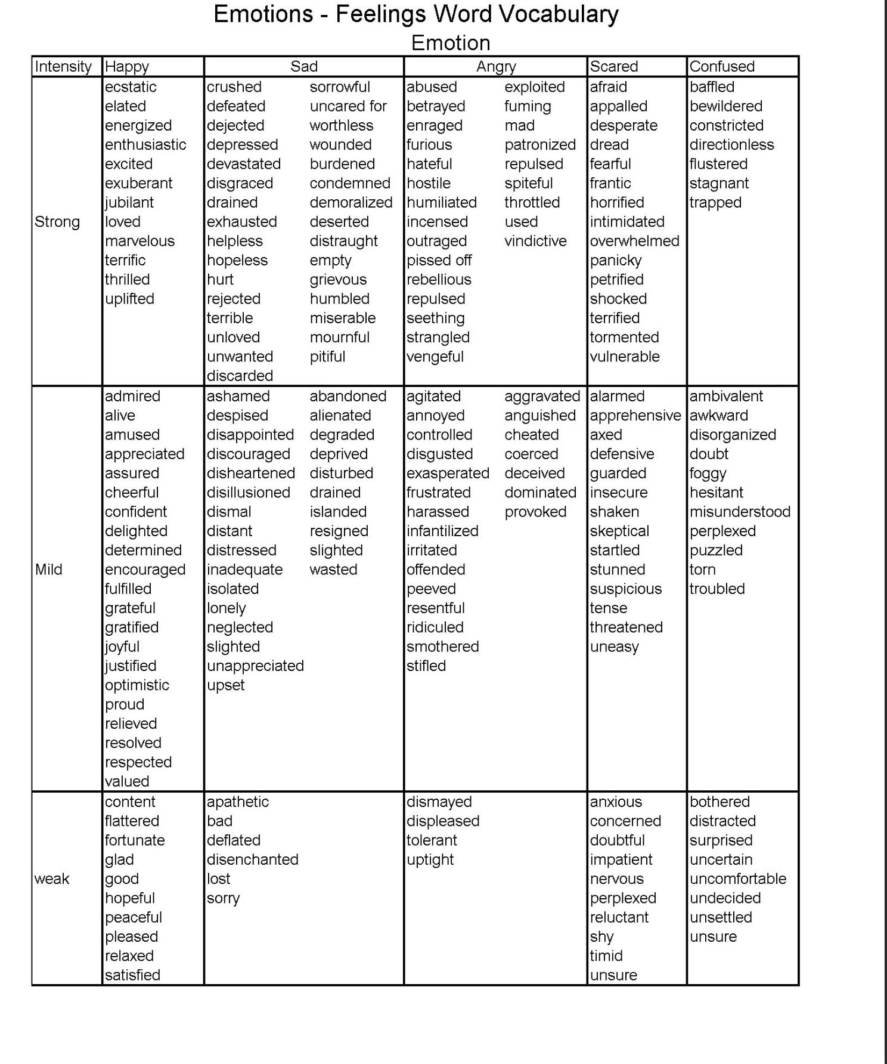

Therapeutic Interventions For Process Recordings & Progress Notes
Foundation Year
- Establish rapport/trust
- Review limits of confidentiality
- Create a safe space
- Provide psycho-education
- Re-frame events, story, reaction to events and offer alternative perspective
- Active listening
- Unconditional positive regard
- Empathic listening
- Offer support
- Identified and reinforced strengths
- Mirroring
- Reflection of feelings
- Paraphrasing
- Reinforcement (positive and negative)-
- Explanation of dynamics
- Clarification
- Process feelings
- Address concerns
- Respect client's decision to...
- Confront maladaptive patterns observed or reported (e.g. aggression, opposition, defiance, etc.)
- Self-monitoring
- Self-control
- Response-cost
- Provided:
- Reassurance
- Acceptance
- Explored…Defense mechanisms and linked to problems/symptoms (cite)
Concentration Year
- Interpreted present behavior (cite) and linked it to:
- Past feelings or events
- Pattems reported in different settings
- Present stressors
- Precipitants, antecedents in environment
- Client's reaction to current or past events
- Dynamics inherent in the relationship
- Discussed
- Present behaviors (cite) alternative behaviors (cite)
- Adaptive/maladaptive behaviors (cite)
- Expectations
- Reinforced cooperation/compliance
- Provided verbal praise for. ..
- Provided an opportunity for client to .
- Addressed cognitive distortions by..
- Assisted client in...
- Supported client by...
- Consulted with teacher or parent
- Encouraged, suggested, recommended...
- Identified:
- Stressors
- Precipitants
- Response pattern that encourages non-compliance, etc.
- Behavior (cite) during the session
- Ignored/extinguished
- Provided structure and firm limits
- Modeled for the client/ Taught:
- Affect modulation (controlling emotions)
- Cognitive coping (re-framing)
- Empathy
- Assertiveness
- Positive interactions Use of "I" statements
- Active listening
- Modeled for the parent/others how to:
- Set limits
- Guidelines
- Rules and consequences
- Time-out
- Firm tone
- Reviewed with the parents:
- Logical consequences
- Natural consequences
- Storytelling technique to encourage disclosure/venting of feelings (cite)
- Allowed for venting
- Utilized play therapy…
- to explore feelings, perceptions, beliefs, etc.
- to explore family dynamics
- to explore classroom dynamics
- Observed (cite behavior) and reframed it in the context of the family dynamics
- Observed (cite behavior) and explored alternative response In vivo role play/rehearsal
- Explained needs of the child due to: (psycho-education)
- Mental disorder
- Learning disability
- Developmental stage
- Helped child to discover link between feelings and behavior (cite)
- Explained realistic expectations in light of:
- Diagnosis
- Developmental needs
- Learning disability
- Offered alternative solutions to (problem)
- Practiced/taught effective communication (e.g. "I" statement):
- How to manage teasing
- How to relate to peers
- Taught and encouraged the use of:
- Time out
- Self-calming
- Self-talk (stop, think, do)
- Encouraged alternative perspective
- Identified the problem and facilitated problem-solving:
- Generated alternative/options
- Discussed alternatives and their potential consequences
- Engaged in therapeutic game focusing on...
- Engaged in guided imagery/relaxation techniques
Macro Social Work Practice Interventions

Organizational Practice Skills:
- Program development and consultation
- Program planning and implementation
- Program evaluation
- Budgeting and financial management
- Board development
- Strategic planning and capacity building
- Quality assurance
- Management information systems and other technology
- Human resources management
- Staff development/training
- Nonprofit leadership
- Marketing and communication
- Media/public relations
- Fundraising/resource development
- Grant writing/contracting

Community Practice Skills:
- Community needs assessment, asset mapping
- Fundraising (donor development)
- Community mobilizing
- Coalition building and maintenance
- Planned change techniques
- Networking, collaborating with other agencies
- Leadership development and citizen participation
- Small group decision making techniques
- Community organizing
- Task force membership development and retention
- Economic development and entrepreneurship

Policy Practice Skills
- Legislative advocacy ( lobbying skills)
- Policy analysis and development
- Social policy research

