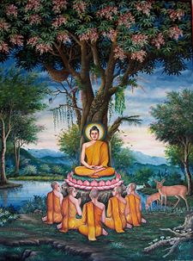
RS 390: BUDDHISM
SPRING 2016 • CSU Northridge
Tuesdays and Thursdays
12:30-1:45pm in SH192

Instructor: Vikas Malhotra
vikas.malhotra@csun.edu
Office Hours: Tues/Thurs from 11-12:30 in SN 418

Course description
This course is an introduction to the wide range of the Buddhist ideas and practices that have developed within the diverse regions of South, Central, and East Asia. The course also introduces students to diverse Buddhist literary and artistic expressions and covers a wide range of Buddhist traditions: Theravāda, Mahāyāna, Vajrayāna, Chan/Zen, Pure Land Buddhism, and so on. It focuses on a variety of pertinent issues: on the historical continuities and discontinuities of Buddhism across Asia, the ways in which the pre-Buddhist ideas shaped the Buddhist Tradition in the given geographical areas, and on the social and political conditions that have facilitated ideological and practical changes within various Buddhist traditions.

COURSE SLOs:
1. Identify and define the major Buddhist schools and their philosophies.
2. Ability to analyze Buddhist texts and describe in detail the central teachings and practices of Buddhism.
3. Demonstrate an understanding of the variations of Buddhism in the context of diverse Asian cultures.
4. Describe the growth of Buddhism in the West, especially in the United States.

GE SLOs: Goal: Students will understand the diversity and multiplicity of cultural forces that shape the world through the study of cultures, gender, sexuality, race, religion, class, ethnicities and languages with special focus on the contributions, differences, and global perspectives of diverse cultures and societies.

Student Learning Outcomes
Students will:
1. Describe and compare different cultures;
2. Explain how various cultures contribute to the development of our multicultural world;
3. Describe and explain how race, ethnicity, class, gender, religion , sexuality and other markers of social identity impact life experiences and social relations;
4. Analyze and explain the deleterious impact and the privileges sustained by racism, sexism, ethnocentrism, classism, homophobia, religious intolerance or stereotyping on all sectors of society;
5. Demonstrate linguistic and cultural proficiency in a language other than English.

Required Textbooks:

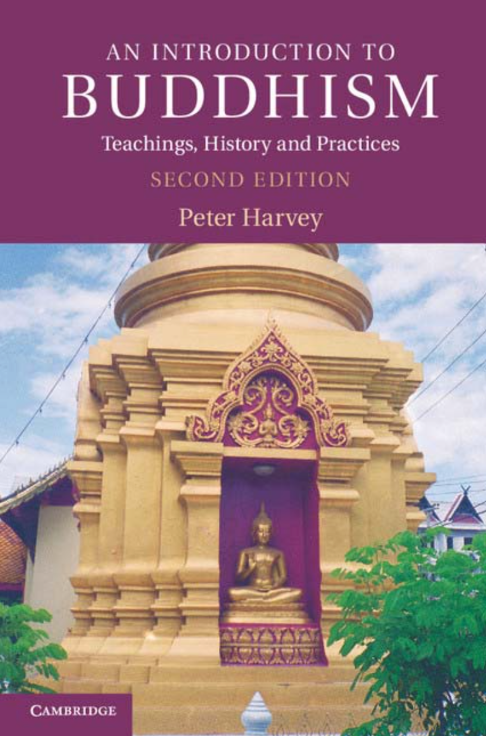 | 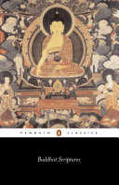 | 1. Peter Harvey.  An Introduction to Buddhism: Teachings, History and Practices. (2nd Edition). Cambridge University Press  2. Donald Lopez.  Buddhist Scriptures. Penguin Books
Reading the required textbooks is required to pass the course. CSUN library holds multiple copies. I strongly recommend that you purchase or obtain a copy of this text before class begins. Available at the CSUN bookstore or online.

Course Requirements and Grading:
Requirements  Class Attendance and Participation 20%  Assignments 20%  Quizzes 20%  Mid-Term Exam 20%  Final Exam 20% | Grading Scale  92-100 = A 78-79 = C+  90-91 = A- 72-77 = C  88-89 = B+ 70-71 = C-  82-88 = B 60-69 = D  80-81 = B- Below 60 = F

Class Attendance and Participation 20%
You are required to come to all classes and arrive on time. One unexcused absence will be allowed, but any more than this will result in lowering your grade, up to a maximum of 20%.

Assignments 20%
- MOVIE RESPONSES (11 TOTAL): Watching selected movies and writing a response to it will be an important component of this class. Video is an wonderful means/tool to convey abstract concepts and transmit knowledge that cannot be solely understood from reading texts alone. Of course, these need to always be watched with a critical and “suspicious” eye. After watching each video reflect on it and write a one page, single-spaced, response – your reactions, new information you learned from it or were surprised about, critiques, revelations (did the video change your previously held views), etc. Be specific rather than general (i.e. use examples from videos). Generally movie responses will be due by Friday by 11:55pm. Late responses will result in loss of points.
- TEAM PRESENTATIONS: On various weeks groups of 3-4 students will do a team presentation on a section of primary readings that they are assigned. As a group, you will lead a brief discussion (15-20 mins), pointing out the main points of the primary readings (Buddhist scripture) and how it relates to the readings from the “Intro to Buddhism” book and from my lectures. Each person will also be responsible for coming up with 1-2 critical questions based on the readings which are to be discussed in class. A powerpoint presentation is encouraged, but not necessary. What you present and your questions should be emailed to me before the class begins. Only those members who participate will receive points for the team presentation.
Quizzes (5 Total): 20%
Quizzes will generally be multiple choice and/or short essay questions that you will complete in class and will be related to the previous weeks readings and lectures. Only the four highest grades will be counted. If you miss a quiz you must communicate with me beforehand to find out if you can make it up or not.

Mid-Term Exam/Paper: 20%
This will be a take home short essays exam and will consist of a 2-3 page paper on topics that I choose related to the readings and lectures.

Final Paper: 20%
There will not be a final exam, rather there will be a final paper that will be 8 pages, double spaced, on a topic within Buddhism you are interested in and that must be approved by me.

Extra Credit:
Opportunities for extra credit will be made available later in the semester

General Expectations:
Academic Integrity: Academic honesty is a core value at CSUN. As such, students are expected to perform their own work. When practiced, academic honesty ensures that all students are fairly graded. Cheating, plagiarism, and other dishonest practices undermine the educational process and will not be tolerated. Cheaters and all who assist them will be subject to disciplinary action with could result in suspension, expulsion, or other disciplinary actions.
Taking good notes and paying full attention in class is also expected and will only help you in the long run. You are required to complete all the readings before class and full participation and engagement with the class is an absolute must. This means no cellphones and or “sneakily” browsing the web. You are welcome to have course materials open on your tablet or phone during class discussions, or to take notes on your laptop, but do not engage in any other online activities during class time as you will be distracted and potentially distracting others. Any breach of this will force me to kick you out of class and you will not receive credit for attendance.

Also, in general, please respect others around you at all times as you would expect to be respected (this includes me). Course material may sometime involve contentious and often sensitive topics. It is imperative that we create a non-judgmental space where we can discuss and explore those topics in an atmosphere of intellectual freedom and without disrespecting others or getting personal.

Course Schedule:
WEEK 1: Intro and Background
1/26 Tuesday | - Intro and Syllabus overview
1/28 Thursday | - An Introduction to Buddhism, p. 8-14  - Selected readings from the Vedas and Upanishads (Moodle)

WEEK 2: The Life and Death of the Buddha
2/2 Tuesday | - An Introduction to Buddhism, p. 14-31  - MOVIE: The Buddha (2010) - The Life of the Buddha https://www.youtube.com/watch?v=lRiKLkH7pLI
2/4 Thursday | - Buddhist Scriptures, Chapters 14-16, 19  - Team presentation – Group 1
2/5 Fri | - Movie Response Due

WEEK 3: Early Buddhist Worldview: Cosmology & the Doctrines of Karma & Rebirth
2/9 Tuesday | - An Introduction to Buddhism, Chapter 2: “Early Buddhist Teachings: Rebirth and Karma.” p. 32-50  - MOVIE: BBC The Story Of INDIA Part 2 (The Power Of Ideas)  https://www.youtube.com/watch?v=OcT5J0l3HNU
2/11 Thursday | - Buddhist Scriptures, Chapters: 1-4 and 6  - Team presentation – Group 2
2/12 | - Movie Response Due

WEEK 4: The First Turning of the Wheel of Dharma - The Four Noble Truths
2/16 Tuesday | - An Introduction to Buddhism, Chapter 3: “Early Buddhist Teachings: The Four Noble Truths” p. 50-88
2/18 Thursday | - Buddhist Scriptures, Chapters: 28, 37  - QUIZ 1

WEEK 5: Early Stages of Buddhism in India (Theravāda Buddhism)
2/23 Tuesday |  | - An Introduction to Buddhism, Chapter 4: “Early Developments in Buddhism” p. 88-114  - MOVIE: The Mindful Way - Buddhist Monks of the Forest Tradition in Thailand  https://www.youtube.com/watch?v=Anf1yhX9VQo
2/25 Thursday |  | - Buddhist Scriptures, Chapters: 25-27, 35  - Team presentation – Group 3
2/26 | - Movie Response Due

WEEK 6: Mahāyāna Buddhism
3/1 Tuesday | - An Introduction to Buddhism, Chapter 5 “Mahāyāna Philosophies: The Varieties of Emptiness” p. 114-151
3/3 Thursday | - Buddhist Scriptures, Chapters: 7-8, 38, 43, 51, 60  - Quiz 2 – On Theravada and Mahayana

WEEK 7: Mahāyāna Buddhism
3/8 Tuesday | - An Introduction to Buddhism, Chapter 6 “Mahāyāna Holy Beings, and Tantric Buddhism” p. 151-179
3/10 Thursday | - Buddhist Scriptures, Chapter: 12, 20, 47, 52  - MOVIE: “The Oracle - Keeper of Wisdom”  https://www.youtube.com/watch?v=zQ1VvvrAILo  - Team presentation – Group 4
3/11 | - Movie Response Due

WEEK 8: The Rise of Vajrayāna/Tantric Buddhism
3/15 Tuesday | - An Introduction to Buddhism, Chapter 6 “Mahāyāna Holy Beings, and Tantric Buddhism” p. 180-194  - David G. White. Tantra in Practice (Moodle) p.7-18  - MOVIE: “Yogis Of Tibet”  https://www.youtube.com/watch?v=sFSjxc2Vg14
3/17 Thursday | - “Overthrowing the Tyranny of Ordinary Experiences” from Introduction to Tantra: The Transformation of Desire (both on Moodle)  - Buddhist Scriptures, Chapter: 53-55  - Quiz 3 – On Mahayana and Vajrayāna
3/18 | - Movie Response Due

WEEK 9: The Spread of Buddhism Outside of India
3/22 Tuesday | - An Introduction to Buddhism, Chapter 7 “The Later History and Spread of Buddhism” p. 194-210  - MOVIE: The Tibetan Book of the Dead  https://www.youtube.com/watch?v=iEX5mBqa554
3/24 Thursday | - Buddhist Scriptures, Chapter 48  - Team presentation – Group 5 on Chapter 48 and movie  - Movie Response Due by midnight  - MIDTERM EXAM will be given
3/25 | - MIDTERM EXAM PAPER DUE online by midnight (no exceptions)

WEEK 10: Buddhism in China
3/29 Tuesday | - An Introduction to Buddhism, Chapter 7 “The Later History and Spread of Buddhism” p. 210-224  - Buddhist Scriptures, Chapters 9, 10, 31-33  - MOVIE: To the Land of Bliss  http://search.alexanderstreet.com.proxy.library.ucsb.edu:2048/view/work/765512
3/31 Thursday | NO CLASS: Holiday – Cesar Chavez Day 2016  - Movie Response due

WEEK 11: Buddhism in Japan
4/5 Tuesday | - An Introduction to Buddhism, Chapter 7 “The Later History and Spread of Buddhism” p. 224-236  - MOVIE: The Zen Mind  http://www.dailymotion.com/video/xla6g6_the-zen-mind_shortfilms
4/7 Thursday | - Buddhist Scriptures, Chapters 34, 41-42, 56-59  - Quiz 4 – On Chinese and Japanese Buddhism
4/8 Fri | - Movie Response Due

WEEK 12: Meditation and Wisdom
4/12 Tuesday | - An Introduction to Buddhism, Chapter 11 “Buddhist Practice: Meditation & Cultivation of Experience-Based Wisdom” p.318-344  - Buddhist Scriptures, Chapters: 39
4/14 Thursday | - An Introduction to Buddhism, Chapter 11 “Buddhist Practice: Meditation & Cultivation of Experience-Based Wisdom” p.344-376  - Team presentation – Group 6

WEEK 13: Devotion in Buddhism
4/19 Tuesday | - An Introduction to Buddhism, Chapter 8 “Buddhist Practice: Devotion” p. 237-264  - MOVIE: The Wheel of Time  https://www.youtube.com/watch?v=UJZAb830qEc
4/21 Thursday | - Buddhist Scriptures, Chapters: 11, 22-24  - Team presentation – Group 7
4/22 Fri | - Movie Response Due

WEEK 14: Ethics & The Buddhist Community
4/26 Tuesday | - An Introduction to Buddhism, Chapter 9 Buddhist Practice: Ethics p. 262-284  - Buddhist Scriptures, Chapters: 35-36, 44-46
4/28 Thursday | - An Introduction to Buddhism, Chapter 10 Buddhist Practice: The Sangha 287-314  - Buddhist Scriptures, Chapter: 29, 49-50  - MOVIE: The Monk Buddhism  https://www.youtube.com/watch?v=bib8NzZ0xF0
4/29 Fri | - Movie Response Due

WEEK 15: Buddhism Beyond Asia
5/3 Tuesday | - An Introduction to Buddhism, Chapter 13 Buddhism Beyond Asia p. 419-421, 424-431 (skip section on “Scholarship”)
5/5 Thursday | - NO CLASS: Attend Religious Studies Lecture for Extra Credit  - Wallace et al. “Mental Balance and Wellbeing: Building Bridges between Buddhism and Western Science” (Moodle) – will discuss next week.  - Take Home Quiz 5 – (TBA)

WEEK 16: Buddhism in America
5/10 Tuesday | - An Introduction to Buddhism, Chapter 13 Buddhism Beyond Asia  p.431-440  - MOVIE: Dhamma Brothers  https://www.youtube.com/watch?v=N3dyVYm4tho
5/12 Thursday | - Team presentation – Group 8 and final wrap up
5/13 Fri | - Movie Response Due

FINAL PAPER
5/19 Thursday | 12:45PM - 2:45PM in Sierra Hall 192

