RS 304 Women and Religion
Spring 2016

Instructor: Xochitl Alvizo Email: xochitl.alvizo@csun.edu
Assistant Professor of Religious Studies Phone: (818) 677-2742
Office Hours: Tuesday, 10:50-11:50am and 1:50-2:50pm
Office Location: Santa Susana Hall (SN) 233
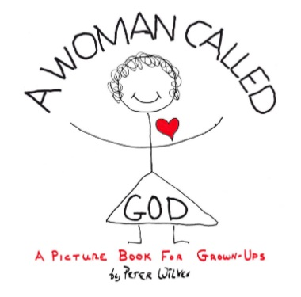
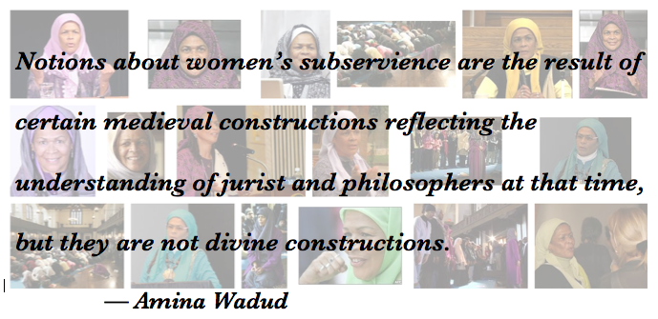

To exist humanly is to name the self, the world, and God. – Mary Daly

What will we learn in this class?
The quotes and images above give you a sense of the kinds of discussions and questions we will engage in this this course. At the most basic level, we will examine religious views of women in oral and literary cultures, focusing on the roles, symbols and concepts of women within an international and historical framework, while also addressing women’s own perspectives on religion, as reflected in historical sources and in contemporary theology and religious life – but that description doesn’t begin to do justice to the depths, and breadths, and heights of our inquiries!
The topic of Women and Religion is wide ranging and, many times, controversial. Charges of patriarchal oppression have been raised of almost all religious traditions by women and men alike. In this class we will focus on investigating women's experiences, contributions, and participation across major religious traditions (Hinduism, Buddhism, Confucianism and Daoism, Judaism, Christianity, Islam), along with newer religious movements such as Goddess Spirituality.
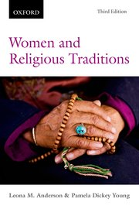
We will investigate these using three orienting lenses: 1) Sources of Authority, 2) Women’s Experience, and 3) Women’s Participation and Subversion within each tradition. The course will take an interdisciplinary and critical studies approach to the study of religion and will emphasize feminist, womanist, and mujerista methodologies.
The course readings include two anthologies that are designed to allow you to focus on your particular area of interest. I will supplement the readings with occasional articles, book chapters, and primary sacred texts from other sources. I’ve designed the class assignments so that you engage in a variety of practices and activities. Its format is minimally didactic (lecture) with more emphasis placed constructivist activities like class discussion, TV and film review and analysis, and in-class presentations of your work.
This course is an Information Competence (IC) course and is available for General Education, Arts and Humanities. As a result of this course, you will:
- Be able to think logically and analytically about various religious traditions;
- Grasp the historical and lived-religions approach (as exemplified in the textbook) to the study of religion;
- Be able to explain and reflect critically on the search for and evidence of the “feminine sacred” and its persistence, meaning, and expression in pre-history and history;
- Be able to demonstrate their basic use of strategies to analyze and interpret the roles, symbols and concepts of and about women in religion in oral and literary cultures;
- Demonstrate basic familiarity with select histories and contemporary experiences of women and religion in diverse global traditions;
- Be able to analyze, interpret, and reflect on the development of feminist theologies and theories in both the Western and Eastern religious traditions and societies;
- Produce essays (following IC guidelines) on women and religion that utilize one or more of the several methodologies introduced in the course and the reading. Become a more proficient and critical reader through careful study and discussion of primary texts and a written survey of selected religions.
In other words, as you complete the various assignments, you will have the opportunity to showcase your ability to think logically and analytically about the development of feminist theologies and theories in both the Western and Eastern religious traditions and interpret and write about the roles, symbols and concepts of and about women in religion. This will be fun!
You become courageous by doing courageous acts. – Mary Daly

How do you prepare for this class?
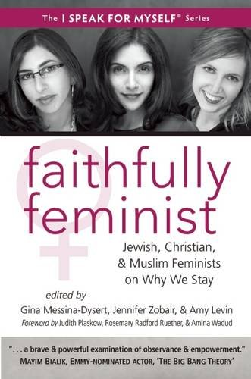
First and foremost, come to class ready to jump into the day’s readings. Before you arrive, complete the scheduled readings for the specific day, bring them with you in hardcopy form (or on your computer) – not on your phone (it’s too small a gadget to be helpful). Bring also with you any notes or questions you jotted down as you read.
Taking notes as you read—jotting down illuminating sentences, confusing ones, and any other questions or thoughts that occur as you read—is a great habit for enhancing your learning. It helps you remember the topic, thesis, and key points in the text, recall your questions, reactions, and analysis, and arrive to class prepared to contribute to the discussion.
Guiding principles—the following guidelines are a solid basis for meaningful class discussion: 1) Assume nothing; 2) Respect is key; 3) Support your arguments by engaging the texts. Together, these will help us remain open to discovery, learn from each other, and have informed and substantive discussions.
Below is a list of the texts we will rely on for our class discussions. Please make sure to get a hold of a copy of each of these books so you have one available to use throughout the semester.
- Women and Religious Traditions, 3rd edition, eds. Leona M. Anderson Pamela Dickey Young, Oxford University Press, 2015; ISBN-13: 978-0199006199; ISBN-10: 0199006199.
- Faithfully Feminist: Jewish, Christian, and Muslim Feminists on Why We Stay, eds. Gina Messina-Dysert, Jennifer Zobair, Amy Levin, White Cloud Press, ISBN-10: 193595248X, ISBN-13: 978-1935952480
- Women Studies in Religion: A Multicultural Reader, eds. Kate Bagley and Kathleen McIntosh, Pearson prentice Hall, ISBN-13: 978-0131108318
- OPTIONAL: Weaving the Visions: New Patterns in Feminist Spirituality, eds. Judith Plaskow and Carol P. Christ, Harper San Francisco, 1989; ISBN-10: 0060613831, ISBN-13: 978-0060613839.
- SUPPLEMENTARY: Articles and excerpts of sacred texts will be available on course Moodle.
This course is designed to give you the opportunity to take ownership over your learning and pursue the specific topics that most interest you within the broad category of Women and Religion. I encourage you to engage the course material from your specific context, location, and interests. It is an opportunity for you to think contextually about the subject matter and to bring your insights, questions, and concerns to bear upon it. The assignments are designed for you to think creatively and dialectically about the religions of the world and women’s particular participations, contributions, and subversions.
What exactly will you do?
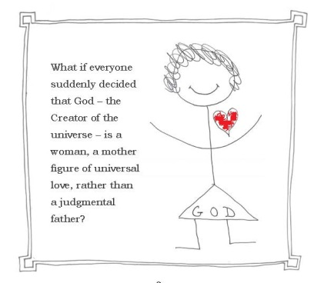
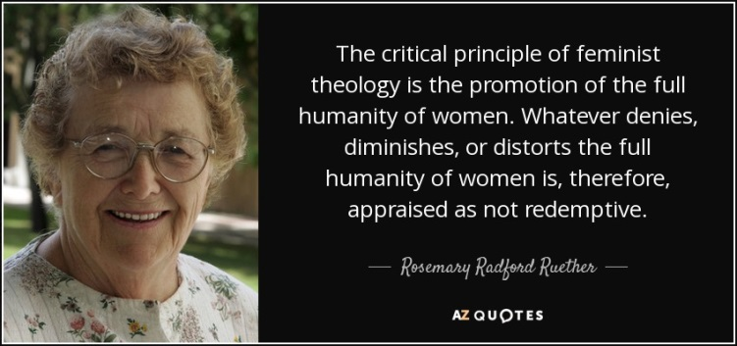

1. Page from Peter Wilkes's Book
A Woman Called God

Throughout the semester you will have various opportunities to dig deep into the readings, engage in critical dialogue, demonstrate your comprehension, and connect the readings and topics to your own context and research interests. Following is the breakdown of what you will contribute to the class and to our collective learning:
- Reading Quizzes—research shows quizzes help reinforce your learning and deep engagement with the reading. In that spirit, you will take weekly online quizzes based on the reading that you will complete by midnight the night before class on the date the reading is due. (15%)

- Notes on Reading Questions—we will all participate in contributing to our class discussion and collective learning. On days on which you don’t have a Reading Quiz scheduled and are not presenting your Creative Integration Project, you will type up one substantive paragraph (4-6 sentences typed) in response to the reading questions that I will provide for you. You will reference these during our class discussion.
  - Reading Questions will be posted on Moodle. These writing assignments will be graded according to whether you have made a serious effort to fulfill the assignment—engaging critically with the reading and demonstrating your comprehension. Formatting is not important for these assignments, but they must be typed and completed before class begins and turned in at the end of class. (15%)

- Author Profile—you will write one short (2-pages, double-spaced typed) author profile showcasing the scholarship and contribution of a particular woman who has made an impact on her particular religious tradition. The author must a public figure or scholar who is living or contemporary (having lived within the last 1oo years) who actively participates/ed in and made an impact in her religious tradition.
  - To deepen your understanding of Women and Religion through close observation and analysis of a specific person’s experience and participation in their religion and to reflect on the lived experience of said woman, you will use the three orienting lenses from our class, making sure to cover the relevant: 1) Sources of Authority, 2) Women’s Experience, and 3) Women’s Participation and Subversion within the tradition. The paper should be typed, double‐spaced, using a standard 12‐pt. font with 1” margins. (10% )
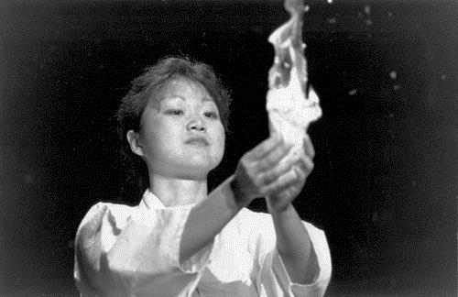
- Site Visit—you will observe and participate during a service at a site of a religion not your own. You can find a list of options at the end of the syllabus, it is not an exhaustive list – you may submit a different site to the professor for approval. After your visit, you will submit a typed 2-page, double-spaced, critical reflection and analysis paper; 1-page description and summary of event and 1-page critical response and analysis.
  - Please note: For all visits, please wear typical ‘church’ clothing (Hindu temple: clothes comfortable to sit on the floor, if need be). For Islamic centers or mosque, women need to wear loose pants or full skirt and bring a large scarf for head covering. Please bring at least one dollar to all sites as an offering (10% )

- Issues Paper—you will write a 4-page (double-spaced typed) essay on a specific issue related to Women and Religion that engages the course material and connects to your own research interests. The paper will be half summary and half analysis. It is essential that you keep an adequate balance between these two sections. The paper should be divided equally in the following way:
(I) Provide a concise summary of the issue within a particular religious tradition that you are engaging, presenting the issue from the perspective of the most relevant writers/scholars/ authorities in the field – referencing and drawing upon their scholarship. How do the relevant authors/thinkers develop their thesis, position, on the issue?
(II) Provide an evaluation of the issue and the various scholars’ perspectives you present in the first half. What is your own take on the issue? What position do you find most compelling? What did you find helpful, provocative, useful, disturbing, difficult, incomplete, or faulty? Why? An evaluation such as this is not a statement such as “I liked this...” or “I didn’t like that...” (in fact, avoid using the first person altogether) but rather a thoughtful, reasoned set of judgments about the issue and what the authors say in regard to it. The evaluation need not be negative, but it must be substantiated – refer back to the scholarship and textual sources.
The paper should be typed, double‐spaced, using a standard 12‐pt. font with 1” margins. (15% total)
- Creative Integration Project—you will showcase your learning from the course with a creative project on a topic of your choice, agreed upon together with me, through the medium you find most fitting. Think creatively about integrating the theories and learnings from the class to a specific context, issue, and/or audience. What is the impact of thinking of religion through the specific experience, participation, and contribution of women in particular in your own context? How might you bring these to bear on a specific concrete context? What are the creative and practical applications?
This assignment will be a creative project in which you will demonstrate how addressing women’s own perspectives on religion, as reflected in historical sources and in contemporary theology and religious life pertaining to and/or make a concrete difference to a particular context, community, or program you are interested in or familiar with. You have the option of making this a group project and may work in groups of up to three people. Your project should reflect:
I) your substantive engagement with a specific author and/or issue in women and religion
II) your analysis in relation and application of this to a specific context
In other words, select an audience that you most want to address with the ideas of the course and use the genre that is most appropriate for your audience. Have fun as you creatively articulate the significance of these issues for a specific community. You will submit and present your project to the class during our Women and Religion Mini-Conference. (30%)
Pre-Term Paper Writing Assignments: To prepare for your final showcase, you will submit two short pre-term paper assignments (each no more than one typed, single-spaced page) designed to help with your planning. Like the “Notes on Reading Questions,” these will be graded on the basis of whether you have made a conscientious effort to fulfill the assignment. Submit these in hardcopy form on the Thursday of the week they are due:
1) Précis: A short description of your proposed project – identifying the key questions, issues, and/or categories from the class, its medium, and a statement of the thesis you expect to present (even if through creative means), due on Week #11.
2) Annotated Bibliography: A list of two sources that are not assigned reading for this class, a list of any assigned readings for this class that you expect to use as sources, and a sentence or two about each source in which you tell me how the source informs and strengthens your project, due on Week #13.
- Class Participation – This is you bringing your engaged self to the class, assessed by your thorough completion of reading assignments, including the Reading Notes and class discussions. All students are expected to participate in making this class a worthwhile learning experience for all of us – myself included! (5%)
- Annotated Media Bibliography—Extra Credit—this is an extra credit opportunity in which you will create an annotated media bibliography of up to 10 current (occurring during the course of our semester) online news articles that relate to women and religion. Due in hard copy on the last day of class. [up to %10]
How will you be assessed?
Grades: Grades will be assessed on a plus/minus scale. Together all the assignment will make up 100% of the final course grade, with an Extra Credit option of up to 10%.

Highest | Lowest | Letter |  | Assignments | Percentage
100.00 % | 93.00 % | A |  | Reading Quizzes | 15%
92.99 % | 90.00 % | A- |  | Notes on Reading Questions | 15%
89.99 % | 87.00 % | B+ |  | Author Profile (2-pages) | 10%
86.99 % | 83.00 % | B |  | Site Visit (2-page) | 10%
82.99 % | 80.00 % | B- |  | Issues Paper (4-page) | 15%
- % | 77.00 % | C+ |  | Creative Integration Project | 30%
76.99 % | 73.00 % | C |  | - Précis
72.99 % | 70.00 % | C- |  | - Annotated Bibliography
69.99 % | 67.00 % | D+ |  | Participation | 5%
66.99 % | 60.00 % | D |  | [Annotated Media Bibliography—Extra Credit] | [10%]
59.99 % | 0.00% | F |  | Total | 100% [110%]
NOTE - All Assignments due in Hard Copy form at the beginning of class.

Collaboration is good!
Study Buddy Information
Please get the name, email address, and cell number of two classmates you can call for help in case you miss a class or have a simple question.

1. ______________________________________________________________________________________

2. ______________________________________________________________________________________

Help Along the Way

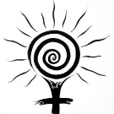
I am available to help and support your learning —you may reach me via email xochitl.alvizo@csun.edu or in person during my office hours (Santa Susana Hall, (SN) 233). If you email me, please indicate course number (Phil 406) and the content of the email in the subject line. I will do my best to respond within 48 hours—please plan accordingly; on weekends you may have to wait until Monday. You can also try my office phone, (818) 677-2742.

A helpful tip – The Syllabus is Your Friend!
Be sure to review the syllabus and see if the information you need is already there.

Also, if you prefer to be called by a different name than the one with which you are enrolled, I will be happy to accommodate.

Accommodations: I wish to make this course as accessible as possible to students with disabilities or medical conditions that may affect any aspect of course assignments or participation. If you require specific accommodations, please contact me as soon as possible. Please also register with the Disability Resources and Educational Services (DRES) office or the National Center on Deafness (NCOD). The DRES office is located in Bayramian Hall, room 110 and can be reached at (818) 677-2684. NCOD is located on Bertrand Street in Jeanne Chisholm Hall and can be reached at (818) 677-2611. If you would like to discuss your need for accommodations with me, please contact me to set up an appointment.

Sexual violence: In this class, the topic of sexual violence may emerge in readings, films, and class discussions. Making personal connections with the topics studied can be a meaningful and important project, but please be aware of the following policy regarding confidentiality and disclosures of incidents of sexual violence.

In the event that you choose to write or speak about having survived sexual violence, including rape, sexual assault, dating violence, domestic violence, or stalking and specify that this violence occurred while you were a CSUN student, federal and state education laws require that, as your instructor, I notify the Campus Title IX Coordinator of such incident(s), including any identifying information. The Campus Title IX Coordinator will contact you to assist with on- and off-campus support services, and to let you know about your rights and options as a survivor, including possibilities for holding accountable the person who harmed you.

The Campus Title IX Coordinator is: Susan Hua, Director of Equity and Diversity; Phone: (818) 677-2077 E-Mail: susan.hua@csun.edu; University Hall Room 285; Hours: 8:00 a.m. to 5:00 p.m., Monday through Friday http://www.csun.edu/eqd

CSUN also provides confidential resources where you can speak with the following people on campus and in the community. The following resources, with limited exceptions, may not report information about the sexual violence incident without your consent.

Confidential Resources

Campus Care Advocate: Katie LaRue; Phone: (818) 677-7492; e-mail, katelin.larue@csun.edu; Klotz Student Health Center Room 140G

Strength United 24/7 Crisis Hotline: Phone: (818) 886-0453 or (661) 253-0258 http://www.csun.edu/eisner-education/strength-united

University Counseling Services; Phone: (818) 677-2366; Bayramian Hall Room 520; Hours: 8:00 a.m. to 5:00 p.m., Monday through Friday; After hours, urgent care assistance (818) 677-2366, option 3; http://www.csun.edu/counseling

Klotz Student Health Center; Phone: (818) 677-3666 Located east of the bookstore, across from the National Center on Deafness; Hours: 8:00 a.m. to 5:00 p.m., Monday through Wednesday; 9:00 a.m. to 5:00 p.m., Thursday; 8:00 a.m. to 5:00 p.m., Friday http://www.csun.edu/shc

CSUN HelpLine; (in conjunction with UCS and Associated Students, Inc.); Phone: (818) 349-HELP (4357) – ALL CALLS ARE CONFIDENTIAL; Hours: 6:00 p.m. to 12:00 a.m., Sunday through Thursday; 7:00 p.m. to 10:00 p.m., Friday and Saturday http://www.csun.edu/helpline

If it is determined that a perpetrator poses an imminent or immediate threat to you and/or the broader campus community or if person(s) under 18 years of age are involved, CSUN employees are required to notify the Campus Title IX Coordinator and/or CSUN Police Services:

Captain Scott VanScoy; Phone: (818) 677-5582; E-Mail: scott.g.vanscoy@csun.edu; Located on the corner of Darby Ave. & Prairie St.; Hours: 8:00 a.m. to 5:00 p.m., Monday through Friday; 24 Hour Police Dispatch: (818) 677-2111; http://www.csun.edu/police

For more information regarding your rights and options as a victim/survivor of sexual violence, please visit the University’s Title IX website: www.csun.edu/shinealight or the Office of Equity & Diversity’s website: www.csun.edu/eqd.
Some final details:
A Note on Due Dates—Since deadlines are stated clearly at the outset, I expect you to meet them. However, if you have extenuating circumstances, please do talk to me as soon as possible, and as much in advance as possible, to arrange an extension. I will always prefer late work to plagiarism. Don’t put yourself in that bind.
What is Plagiarism?—Generally speaking, it is any attempt to take credit for work done by another person. While we all rely on the work of others to shape our knowledge and interpretations, we must always acknowledge our sources through footnotes and/or direct textual references to influential books, articles, and ideas. You can find and read CSUN’s Academic Dishonesty policy, just type “academic honesty” in the Search CSUN box and then select the PDF titled “ACADEMIC DISHONESTY.”
Remember, too, that much of the information posted on the Internet is protected by U.S. copyright laws. Passing off this information as your own is plagiarism and carries the penalties outlined above.
Writing Standards—All papers must be written according to basic scholarly standards appropriate for university level work. Not only does this include proper citation as well as grammar, punctuation, and syntax, but also serious reflection on the topic. There are many sources available to you for help with this—the most important is the Writing Program at CSUN’s Learning Resource Center, 3rd floor/East Wing of the Oviatt Library: http://www.csun.edu/undergraduate-studies/learning-resourcecenter/writing-center-and-freshman-writing-lab.
Inclusive Language— I will conscientiously attempt and all students are encouraged to use inclusive language, images, and metaphors in both their speaking and writing.
In order to cultivate an environment of inclusion and non-discrimination and to ensure clarity in written communication, students should use non-gendered pronouns and nouns when referring to mixed-gender groups (e.g., “humanity” rather than “man” or “mankind”) or when the gender of a subject is unknown.
Scholars agree that in regard to “God” or diety language is insufficient to capture the manifold understandings people hold. Moreover, sacred texts typically use masculine, feminine, and an expanse of metaphors to explain or speak of God. Students are encouraged to avoid using gender-specific pronouns for God or to use a variety of pronouns interchangeably. If the use of gender-specific pronouns is necessary to make an argument about a particular sacred text, that usage should be acknowledged in a footnote.
Student Learning Outcomes for RS 304 as an Information Competency Course— Goal: Students will progressively develop information competence skills throughout their undergraduate career by developing a basic understanding of information retrieval tools and practices, as well as improving their ability to evaluate and synthesize information ethically. Outcomes—Students will:
- Determine the nature and extent of information needed.
- Demonstrate effective search strategies for finding information using a variety of sources and methods.
- Locate, retrieve and evaluate a variety of relevant information, including print and electronic formats.
- Organize and synthesize information in order to communicate effectively.
- Explain the legal and ethical dimensions of the use of information.
Student Learning Outcomes for Arts and Humanities — Goal: Students will understand the rich history and diversity of human knowledge, discourse and achievements of their own and other cultures as they are expressed in the arts, literatures, religions and philosophy. Outcomes—Students will:
- Explain and reflect critically upon the human search for meaning, values, discourse and expression in one or more eras/stylistic periods or cultures.
- Analyze, interpret and reflect critically upon ideas of value, meaning, discourse and expression from a variety of perspectives from the arts and/or humanities.
- Produce work/works of art that communicate to a diverse audience through a demonstrated understanding and fluency of expressive forms.
- Demonstrate ability to engage and reflect upon their intellectual and creative development within the arts and humanities.
- Use appropriate critical vocabulary to describe and analyze works of artistic expression, literature, philosophy or religion and a comprehension of the historical context within which a body of work was created or a tradition emerged.
- Describe and explain the historical and/or cultural context within which a body of work was created or a tradition emerged.

Site Visit Guide
Observe and participate during a service at one of the following sites of a religion not your own. This is not an exhaustive list – you may submit a different site to the professor for approval.
Write a 2-page paper; 1-page description and summary of event and 1-page critical response and analysis. Further instructions on Moodle, but be sure to use the tools you have gained in class to make observations regarding myth, sacred text/sacred stories, sacred space, ritual, images of the sacred/divine, and cultural context.
Please note: For all visits, please wear typical ‘church’ clothing (Hindu temple: clothes comfortable to sit on the floor, if need be). For Islamic centers or mosque, women need to wear loose pants or full skirt and bring a large scarf for head covering. Please bring at least one dollar to all sites as an offering. . *student recommended
Hinduism: - Venkateswara Temple, 1600 Las Virgines Canyon Road, Calabasas, Ca.
- Hindu Temple Society, 18700 Roscoe Blvd., Northridge, CA
- Hindu Temple and Indian Cultural Center, 21213 Devonshire Blvd. Chatsworth, CA
Buddhism: * Hsi Lai Buddhist Temple, 3456 Glenmark Drive, Hacienda Heights, Ca
- West Los Angeles Buddhist Church, 2003 Corinth Avenue, West L.A., CA
- Wat Thai Temple, Corner of Coldwater Canyon and Roscoe Blvd.
Judaism: - Stephen S. Wise Reform Temple, 15500 Stephen Wise Dr. (Mulholland and 405), Los Angeles
- Valley Beth Shalom Temple, 15739 Ventura Blvd, Encino, CA
- Sinai Temple, 10400 Wilshire Blvd, West L.A.
Christianity: - Our Lady of Lourdes Church, 18405 Superior Street, Northridge, CA
- St. Sophia Greek Orthodox Church, 1324 South Normandie, Los Angeles, CA
- Mosaic Church, 7107 Hollywood Blvd, Los Angeles, CA, or another Protestant church, your choice
Islam: - The Islamic Center of Granada Hills, 11439 Encino Ave., corner of Encino and Rinaldi, Granada Hills
- The Islamic Center of Southern California, 434 South Vermont Avenue, Los Angeles
Other: - You can propose something to professor for approval – have fun!
Guidelines for Writing Assignments
Students are advised to keep the following details in mind when completing writing assignments –not everything listed applies to all the assignments for this class, but take note, these are important.
It is expected that students weave together insights gleaned from scholarly sources and their own critical and constructive thoughts in the development of any writing assignment. Furthermore, students should aim to make use of a variety of bibliographic sources.
While there are subjective components in any grading process, most professors are concerned that you become well educated in eight basic qualities of solid academic work – these guidelines reflect this professor’s expectations of your written work:
1. The presentation of a clear point of view or central argument – i.e. the thesis you will advance. In most of the writing you will do, you are expected to formulate a thesis statement or central point of view and to articulate it early on. Often this is conveyed through an explicit or recognizable thesis statement that provides a sense of your purpose and point of view or argument in the opening material. Think of the thesis as the plot of your written piece – that which keeps your writing moving forward step-by-logical-step toward a predetermined end.
2. Demonstration of unity and coherence. In well-written text, one thought is connected to another. The words, sentences, and paragraphs are arranged logically and coherently. As a result, the reader moves easily from one point to the next and understands how the individual points relate to the whole.
3. The offering of support for assertions and conclusions. In any type of writing, but especially in academic writing, it is important to support one’s assertions and conclusions. This can be done through the use of facts, statistics, experiential anecdotes, and direct quotes from credible sources.
4. Demonstration of an understanding of the content of texts and resources used—(Reading Comprehension). Your essay should provide a fair description and a clear understanding of the texts and resources it makes use of. In other words, grasp the ideas of or the points being made by the authors you use to support your assertions. This will be apparent in your ability to discuss precisely or accurately what an author has written or a speaker has said.
5. Appropriate documentation of sources. In academic writing, it is important that you cite the sources of any quotations, paraphrases, and facts or ideas that are not common knowledge. The three most commonly used styles are those of the Modern Language Association (MLA); the American Psychological Association (APA); and the Chicago Manual of Style. The MLS and APA styles are similar, in the sense that they use parenthetical references for in-text citations. The Chicago Manual Style uses footnotes at the bottom of the text or endnotes following the text. Because it is used extensively in the field of religious studies, I encourage students to familiarize themselves with the Chicago Manual Style. Find a “quick guide” reference sheet here: http://www.chicagomanualofstyle.org/tools_citationguide.html
6. Evidence of clear critical thinking that weighs the merits of viewpoints and conclusions. This involves and is conveyed through a) the ability to recognize the assumptions that underlie the ideas of authors; b) the ability to assess the strengths and potential limitations of other people’s ideas as well as of your own ideas and conclusions; and c) the willingness to imagine or to remain open to alternative perspectives.
7. Creativity that moves beyond reporting someone else’s ideas. This suggests that you should work to find your own voice and perspective in your writing. Your creative addition to academic discourse might include questioning, evaluating, or criticizing the ideas of others in a way that is objective and fair. But it can also include the development of your own viewpoint or the viewing of an issue from a unique perspective. The minimal requirement of academic work is correctly reporting what is read or discussed. Excellent work moves beyond repetition of another’s idea to the offering of unique questions, insights, perspectives, or correlations of ideas.
8. Sound grammar, spelling, and form. Good writing is a product of proofreading and clear communication. A brilliant idea can be lost in a paper that obscures its ideas with careless writing. Keep this in mind: Your readers and listeners should not have to guess what you mean. Help them by writing and speaking well. You can work towards this by making sure a) that generally accepted rules of grammar and syntax are followed; b) that correct words are used to convey the intended meaning; c) that spelling is correct; d) that punctuation (e.g. the placement of commas, apostrophes, and quotation marks), reflects standard usage, and; d) that you define any important terms you are using for your reader – don’t assume your understanding of the term coincides with theirs.
P.S. Final note on Formatting. Except for creative assignments (and unless otherwise noted), papers should be typed in Microsoft Word format, double-spaced, using a standard 12-pt. font (Times New Roman) with 1” margins all around. Use footnotes in Chicago Manual of Style, and always include a Works Cited/Bibliography page at the end of the paper [http://www.chicagomanualofstyle.org/tools_citationguide.html].

Weekly Course Schedule
Abbreviations:
WRT3 = Women and Religious Traditions, 3rd Edition, eds., Leona M. Anderson & Pamela Dickey Young
MCR = Women Studies in Religion: A Multicultural Reader, eds., Kate Bagley and Kathleen McIntosh
FF = Faithfully Feminist, Gina Messina-Dysert, Jennifer Zobair, Amy Levin
O / pdf = Other readings as specified, usually included as a pdf in Moodle

Quizzes = to be completed by 8:00 AM on the day indicated, based on that day’s reading.
Reading Notes = typed notes to be turned in at the end of class, in response to questions posted on Moodle
based on that day’s readings.

 | TOPICS | TUESDAY READING | THURSDAY READING | ASSIGN. DUE
 | UNIT ONE: FOUNDATIONS—EXPERIENCE, CONTRIBUTIONS, PARTICIPATION
1 | - Course Introduction  - Introducing Religious Studies  - ‘Women’ & ‘Religion’ | Jan. 26  O: Syllabus – read carefully  The Village | Jan. 28  O: “Troubling the categories,” Castelli, 1-6
2 | - Why study Women and Religion?  - Method and Approaches: feminist, womanist, mujerista | Feb. 2  MCR: Intro, vii-13  WRT3: Intro, xi-xv | Feb. 4  MCR: J. Grant, 48-55  pdf: hooks, Fem Spirituality |  | T: Quiz 1  TH: Reading Notes
3 | - Experience as Resource  - Personal Narratives  - Limits and Critiques | Feb. 9  FF: Foreword, Introduction, xi-xviii  FF: Messina-Dysert, 51-56 | Feb. 11 – Guest Speaker  O: pdf, A. Hidayatullah/T. Zamar, 49-76 (focus on selections) |  | T: Quiz 2  TH: Reading Notes
4 | - Three lenses: 1) Sources of Authority, 2) Women’s Experience, 3) Participation and Subversion | Feb. 16  MCR: Carol Christ, 97-105 | Feb. 18  MCR: Chung Hyun Kyung, 19-33  Optional: pdf, Daly, Exodus |  | T: Reading Notes  TH: Author Profile DUE in hard copy
5 | - Colonialism and World Religions  - Power, Epistemology, Knowledge Production | Feb. 23  O: Chryssides, 185-209  O: Aquino, 29-46 (selections) | Feb. 25  O: Chung, 392-394 “Come Holy Spirit”  FF: De la Rosa, 102-108  Optional:  O: blog, X. Alvizo, FiR |  | T: Quiz 3  TH: Reading Notes
 | UNIT TWO: WOMEN AND RELIGIOUS TRADITIONS
6 | - Women in Indigenous Traditions  - Start, Stop, Continue | Mar. 1  WRT3: Chapter 5 | Mar. 3  MCR: Hernández-Avila, 55-63  MCR: Mora, 82-84  I bring: Edyka, TEDx |  | T: Quiz 4  TH: Reading Notes
7 | - Women in Chinese Traditions  - “Listenings” and Unfamiliar Texts | Mar. 8  WRT3: Chapter 4 | Mar. 10  MCR: Kwok, 65-73 |  | T: Quiz 5  Th: Site Visit DUE in hard copy
8 | - Women in Christianity  - Metaphors | Mar. 15  WRT3: Chapter 6 | Mar. 17  FF: House, 188-193  FF: essay of choice written by Christian woman |  | T: Quiz 6  TH: Reading Notes
9 | SPRING BREAK — — — Mar. 22 and Mar. 24 — — — NO CLASSES
10 | - The Power of Anger  - Uses of the Erotic | Mar. 29  Choose one essay:  O: Harrison, 214-225  O: A. Lorde, 208-213 | Mar. 31  César Chávez Holiday  No Classes  Campus Closed |  | T: Issues Paper DUE in Hard Copy  T: Reading Notes (on selected essay)
11 | - Women in Judaism | April 5  WRT3: Chapter 2 | April 7  FF: Ruttenberg, 144-149  FF: essay of choice written by Jewish woman |  | T: Quiz 7  TH: Reading Notes  TH: Précis DUE in Hard Copy
12 | - Women in Islam  - Sufis | April 12  WRT3: Chapter 7 | April 14  FF: Zobair, 27-33  FF: essay of choice written by Muslim woman |  | T: Quiz 8  TH: Reading Notes
13 | - Women in Hindu Traditions | April 19  WRT3: Chapter 1 | April 21  O: Broom Goddess, Manushi Swachhnarayani |  | T: Quiz 9  TH: Annotated Biblio DUE in hard Copy
14 | - Women in Buddhist Traditions | April 26  WRT3: Chapter 3 | April 28  O: Choose one of Oxana’s blog post on FAR, Feminismandreligion.com |  | T: Quiz 10  TH: Reading Notes
15 | - Women in Western Spirituality Movements | May 3 – Online Class  WRT3: Chapter 9  O: Kate Brunner, FAR | May 5  Research for Creative Integration Project |  | T: Quiz 11 & Comment on FAR post
16 | Women and Religion Mini-Conference  Creative Integration Projects | May 10  Student Presentations  Peer-Evaluation | May 12  Student Presentations  Peer-Evaluation |  | TH: Extra Credit DUE  T/TH: Creative Integration Project Due

